- Create a ConfigMap from a directory containing multiple files and inject the variables into a pod as environment variables.

First create a directory
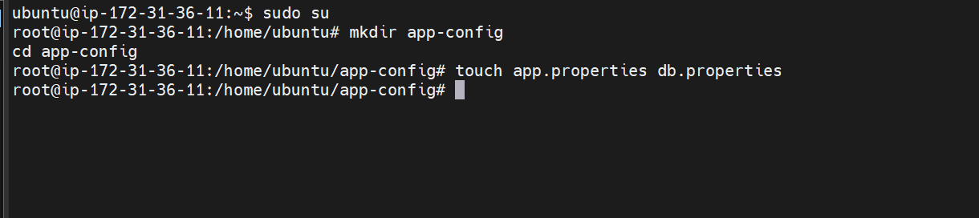
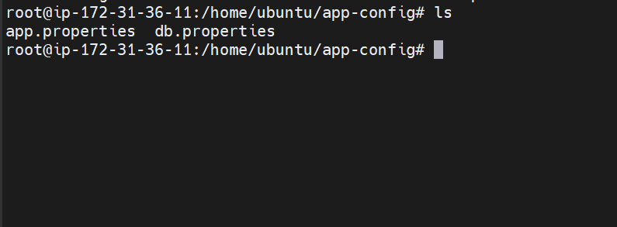
We have two files now inside app-config directory
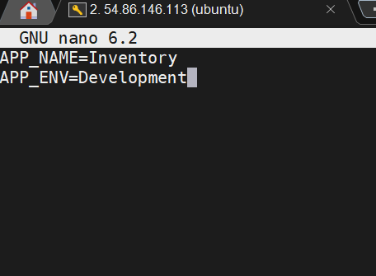

These are the two variables in app.properties file
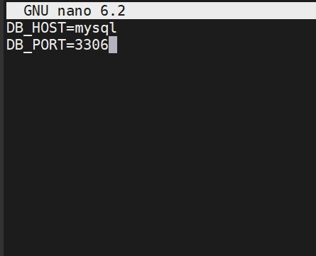

Variables in db.properties file
Lets now create a config map
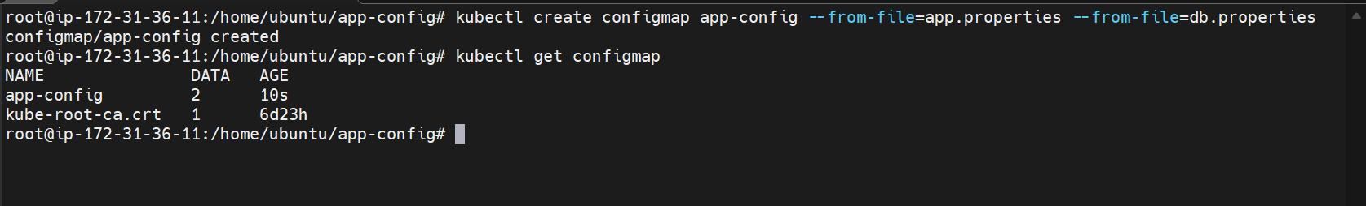
The config map is now created
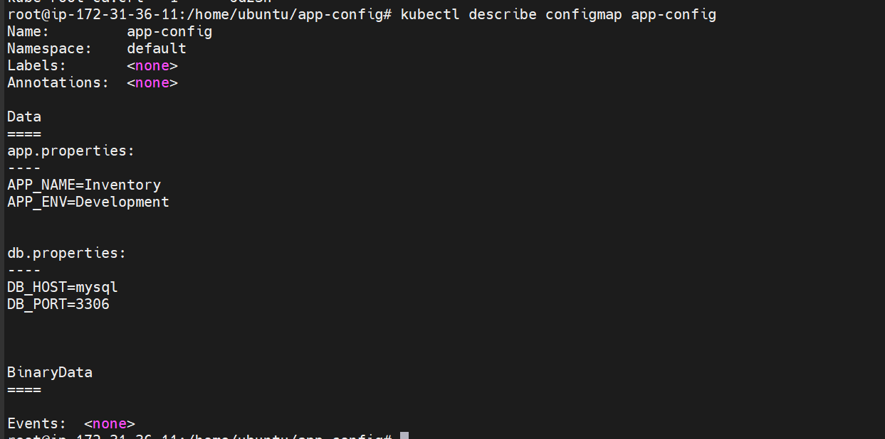
Now lets create a pod using the configmap
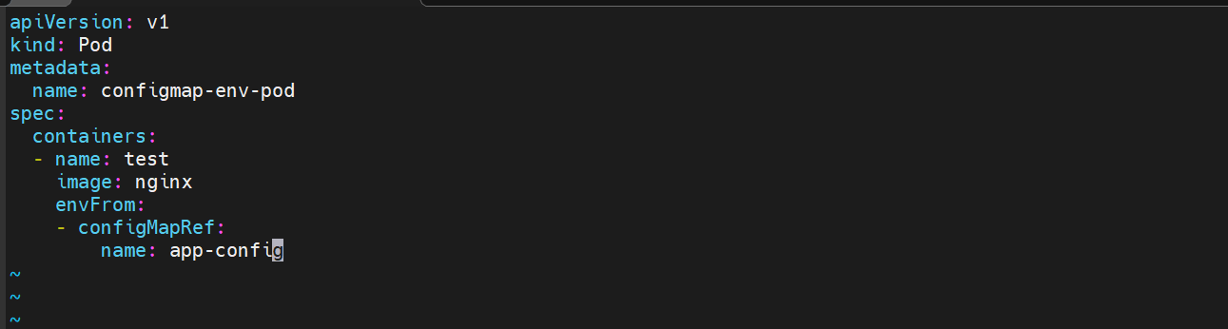

Here we are using the configmap file
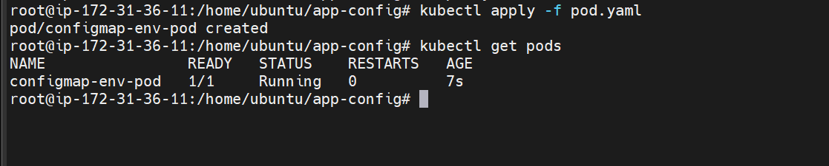

The pod is created now
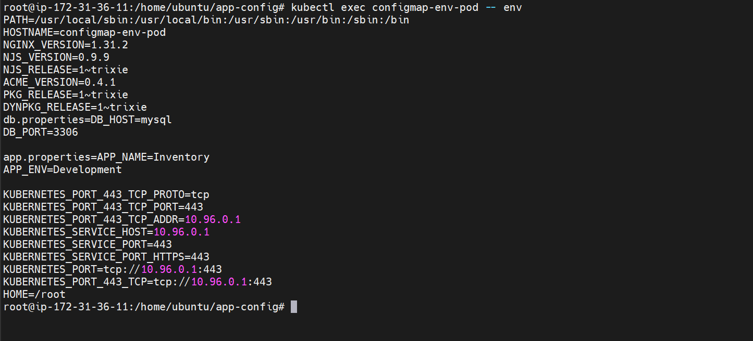
Here the environment variables which we passed in configmap can be seen.

- Create a ConfigMap from a file and mount it as a volume inside a pod, ensuring the configuration data is available as files.
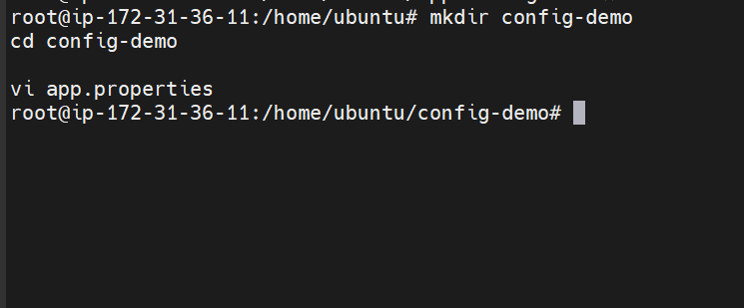

Creating a directory and file app.properties inside it
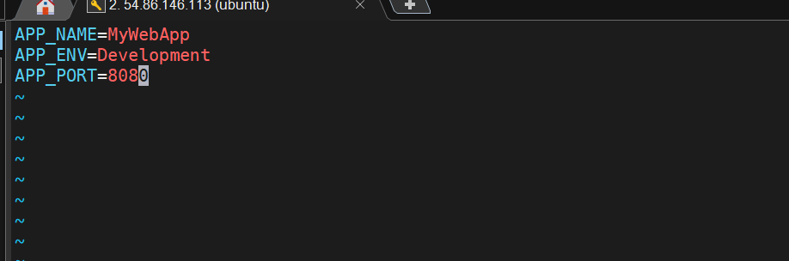
These are the variables inside the file
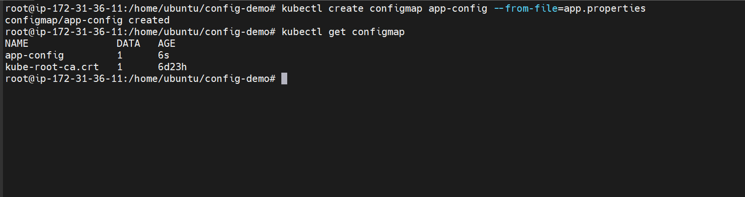
Created the config map from the file
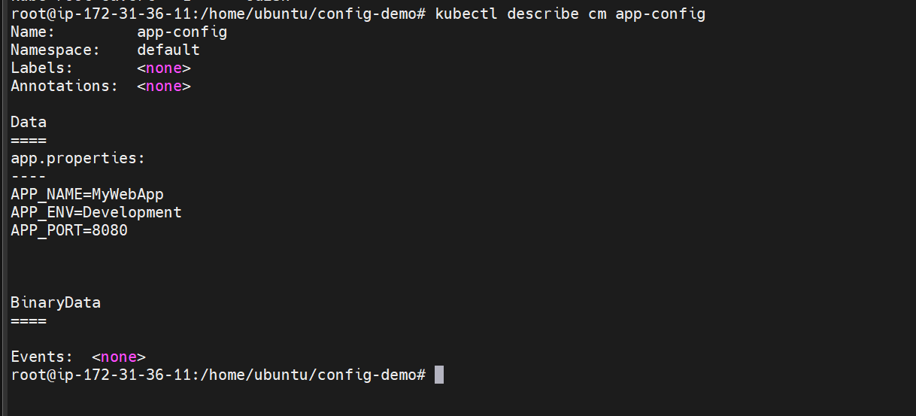

Lets now create a pod using the configmap and mount the configmap inside the pod
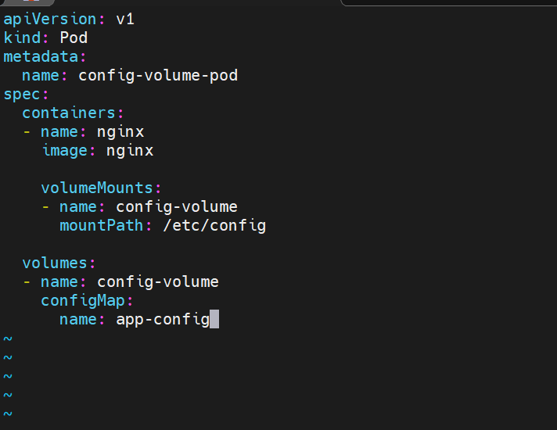

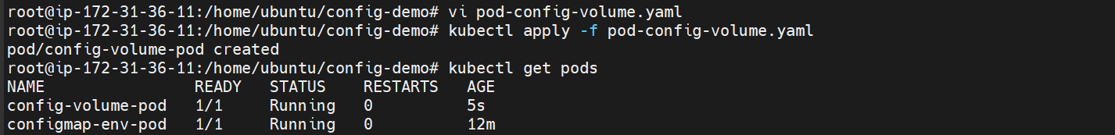
The pod has been created
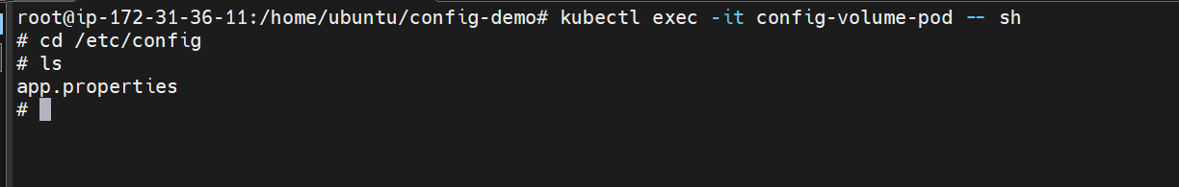
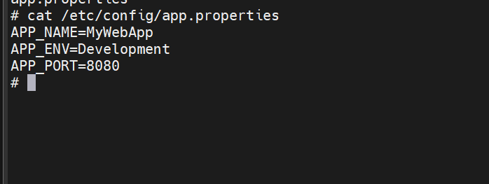
Getting inside the container and checking If the volume is mounted inside it or not

- Create a Secret with sensitive information (username and password) and inject it into a pod as environment variables.

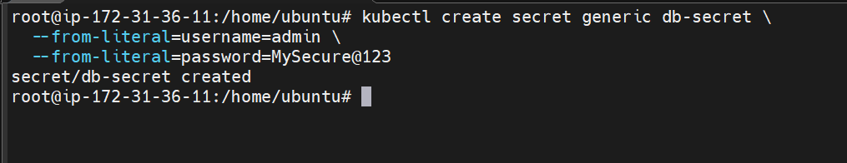

Here we are creating a generic secret named db-secret from the command line
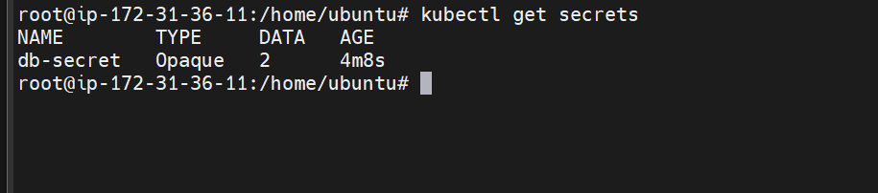
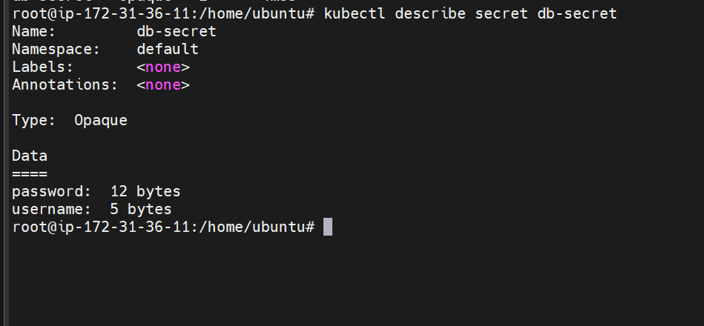

Here we cannot see the actual values because base64 encoded

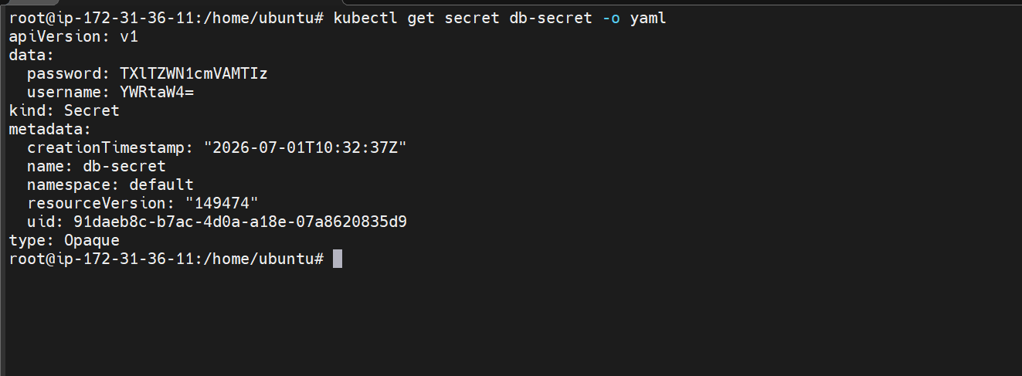

To view the encoded values we can use the above command

Lets create the pod now

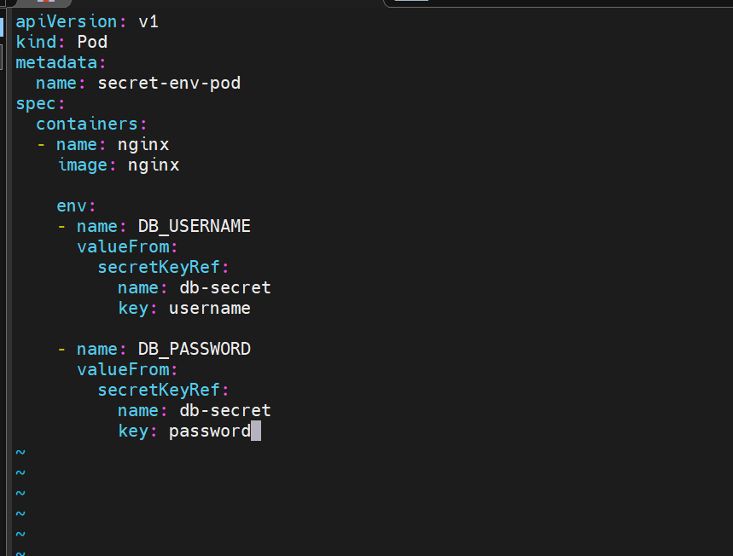

This means:
Create an environment variable called DB_USERNAME.
Read its value from the Secret named db-secret.
Use the value stored under the key username.
The same applies to the password.

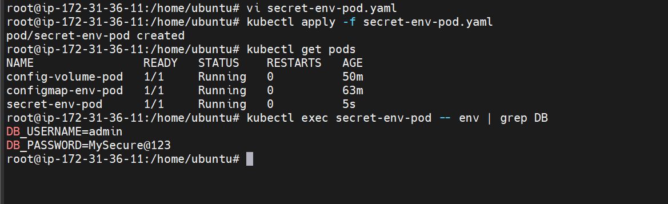
Creating the pod and verifying the secrets

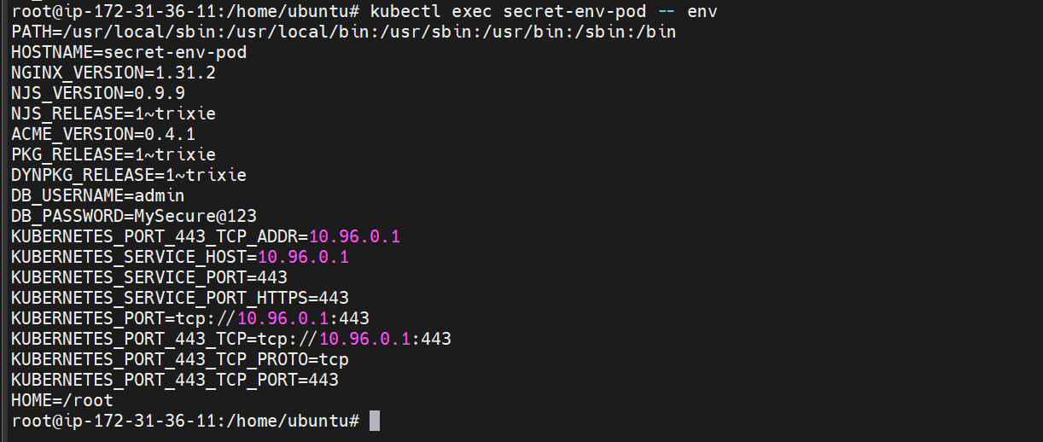

- Create a Secret using a YAML file, mount it as a volume in a pod, and verify the specific Secret values are available as files.

Username: admin
Password: MySecure@123

These are the variable values we are going to pass
First lets encode them
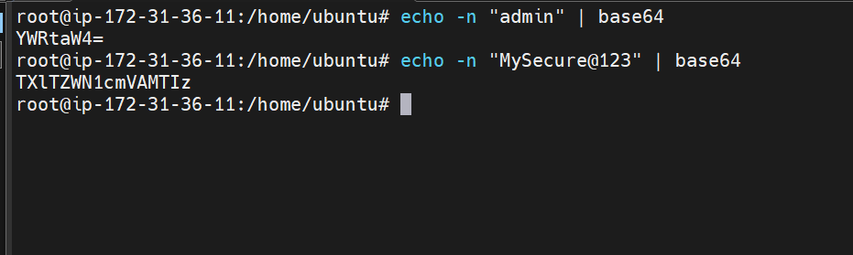
These are the base64 encoded values
Lets now use them in our secret.yaml file

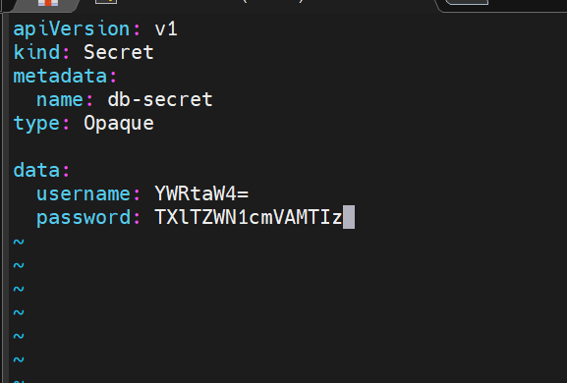

type: Opaque → Generic Secret.
data: → Stores Base64 encoded values.
username and password are the Secret keys.

Lets create it

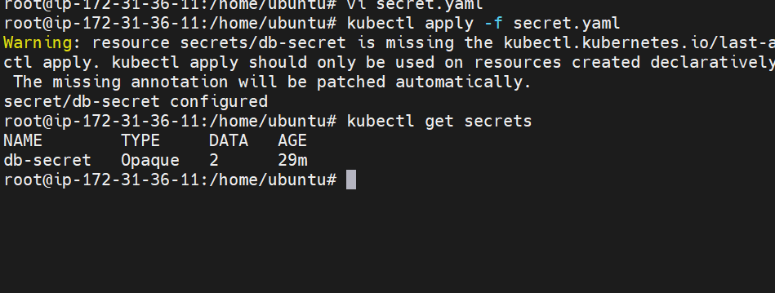

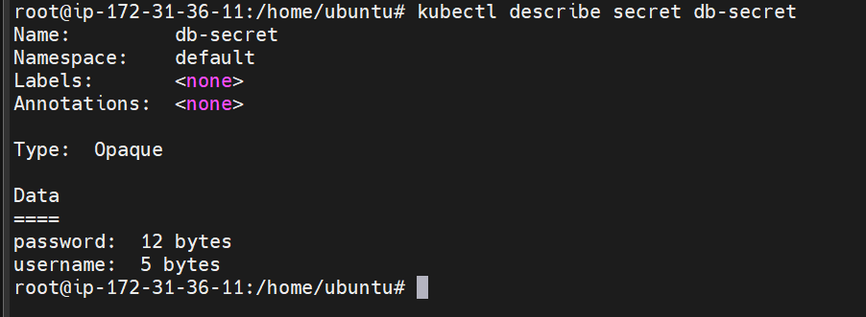

Lets now create a pod using the secret
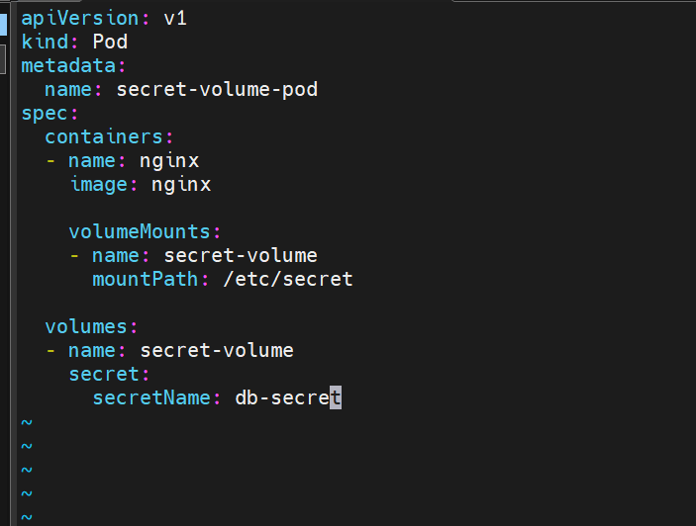

This means:
- Create a volume named secret-volume.
- Populate it using the Secret db-secret.
The container mounts that volume here:

Here we are creating a pod and we are using the secret which we have created before.
Also we are mounting it as a volume inside the pod.

Creating the pod now
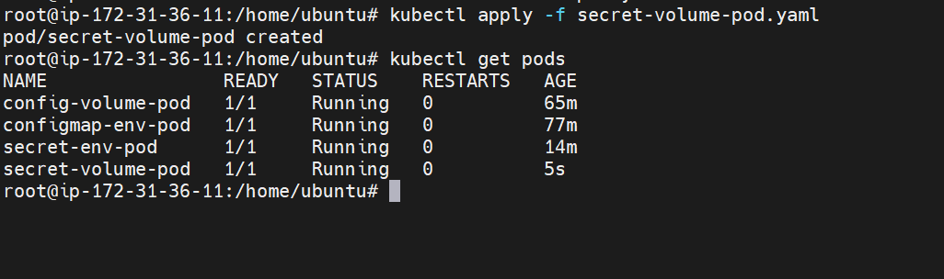

Now lets verify if the secret is mounted in the volume inside the container or not

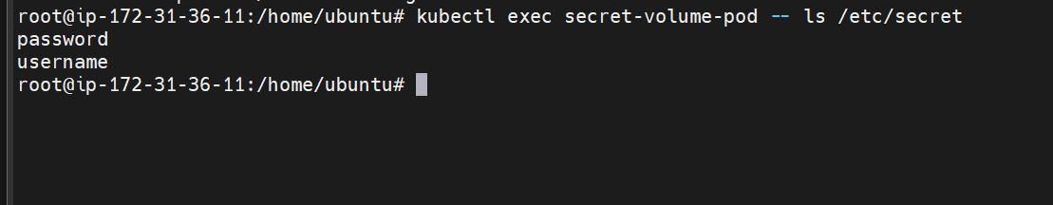

Here it can be seen the volume is mounted and the secret is stored inside it.

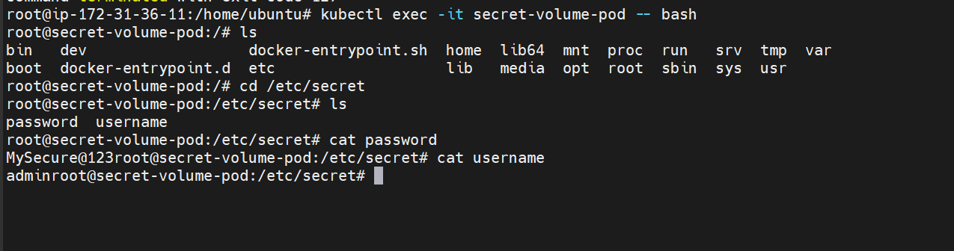

Getting inside the container and reading the values

- Inject a ConfigMap as environment variables and a Secret as files into the same pod, ensuring both are accessible within the pod.

First lets create a configmap

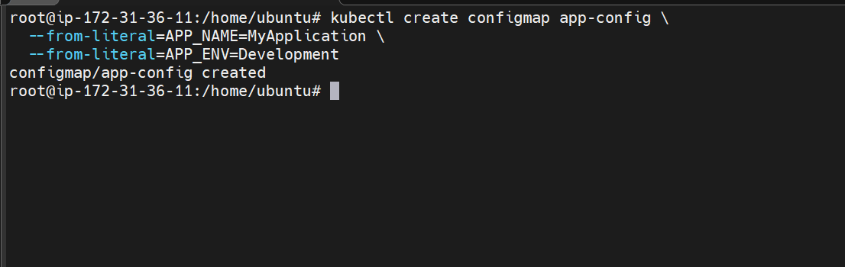

Here we have created a configmap with cli

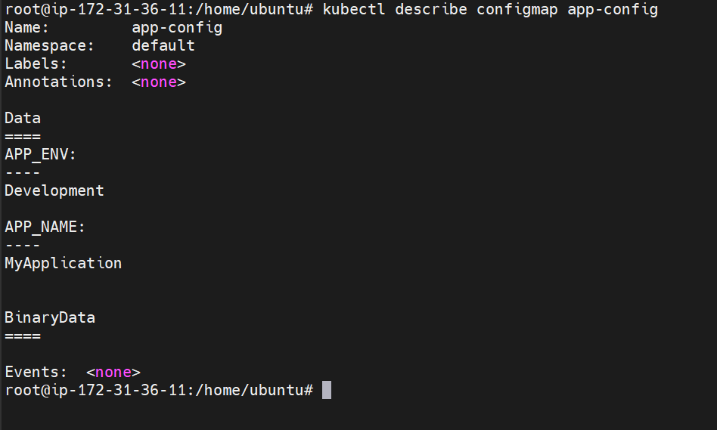

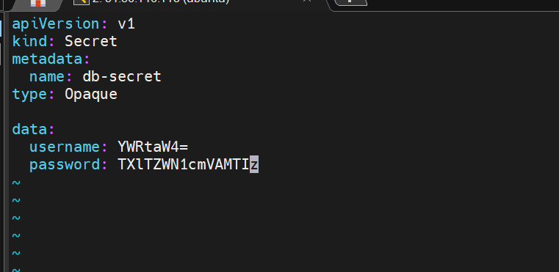

We have this secret file already so lets use the same

Now create the pod

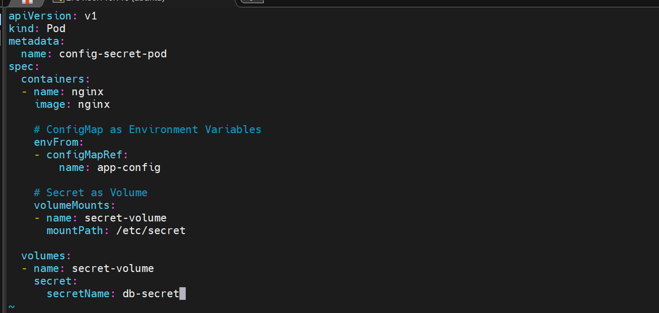

Here we are importing variables from app-config config map
Mounting a volume inside the container
Also create a volume from secret named db-secret

Lets create the pod now
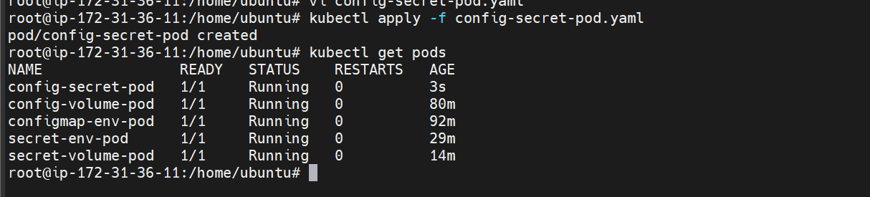

The pod is created now
Now get inside the container and verify the config map and secrets
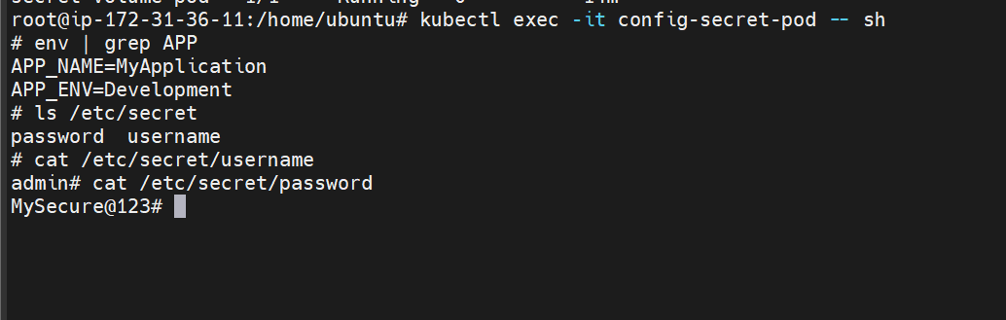
Here it can be seen that configmap and secret are now injected as files inside the pod.
Also they are both accessible inside the pod.

