- Create one Declarative pipeline job
- Source Code:https://github.com/betawins/spring3-mvc-maven-xml-hello-world-1.git

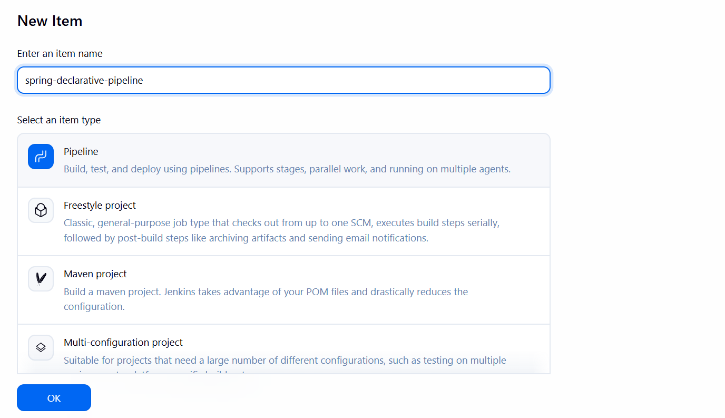

Creating a pipeline based job
pipeline {
agent any

tools {
jdk 'JDK21'
maven 'Maven3'
}

stages {
stage('Git Clone') {
steps {
git url: 'https://github.com/betawins/spring3-mvc-maven-xml-hello-world-1.git'
}
}

stage('Update Java Version') {
steps {
sh '''
echo "Before modification:"
grep -n "1.6\\|source\\|target" pom.xml || true

sed -i 's/1\\.6/1.8/g' pom.xml

echo "After modification:"
grep -n "1.8\\|source\\|target" pom.xml || true
'''
}
}

stage('Build') {
steps {
sh 'mvn clean package'
}
}

stage('Verify Artifact') {
steps {
sh 'ls -lh target'
}
}

stage('Archive Artifact') {
steps {
archiveArtifacts artifacts: 'target/*.war',
fingerprint: true
}
}
}

post {
success {
echo 'Declarative pipeline completed successfully.'
}

failure {
echo 'Declarative pipeline failed.'
}
}
}

This is our declarative pipeline
Which clones the source code from github, updates the java version, builds the code and verifies the artifact.
Lets build the pipeline
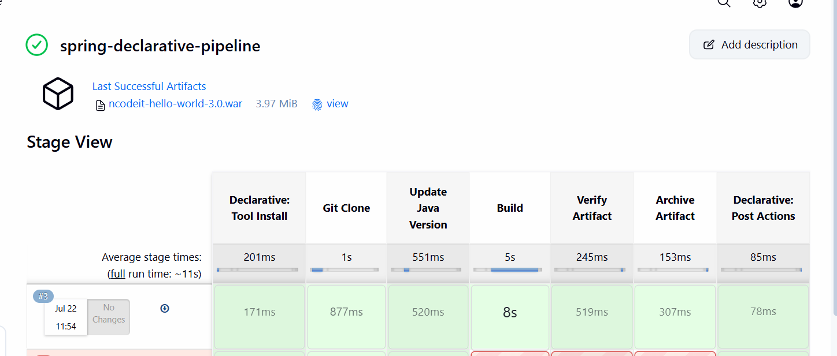
The pipeline ran successfully.

- Create one Scripted pipeline job
  - Source Code:https://github.com/betawins/spring3-mvc-maven-xml-hello-world-1.git

lets now create a scripted pipeline for the same repository
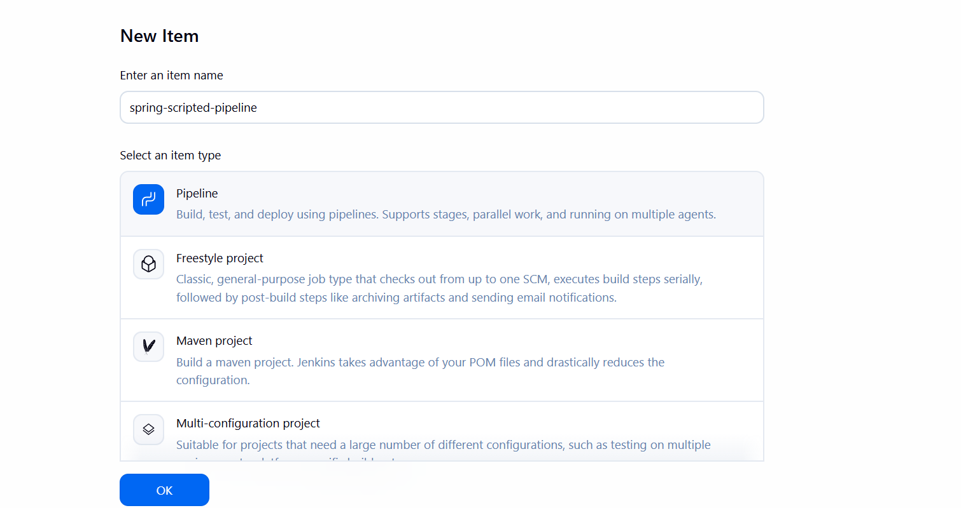

This is the same pipeline in scripted format
node {
stage('Git Clone') {
git url: 'https://github.com/betawins/spring3-mvc-maven-xml-hello-world-1.git'
}

stage('Update Java Version') {
sh '''
echo "Before modification:"
grep -n "1.6\\|source\\|target" pom.xml || true

sed -i 's/1\\.6/1.8/g' pom.xml

echo "After modification:"
grep -n "1.8\\|source\\|target" pom.xml || true
'''
}

stage('Build') {
sh 'mvn clean package'
}

stage('Verify Artifact') {
sh 'ls -lh target'
}

stage('Archive Artifact') {
archiveArtifacts artifacts: 'target/*.war',
fingerprint: true
}
}

This is our scripted pipeline
Which clones the source code from github, updates the java version, builds the code and verifies the artifact.
Lets build the job
The pipeline ran successfully.

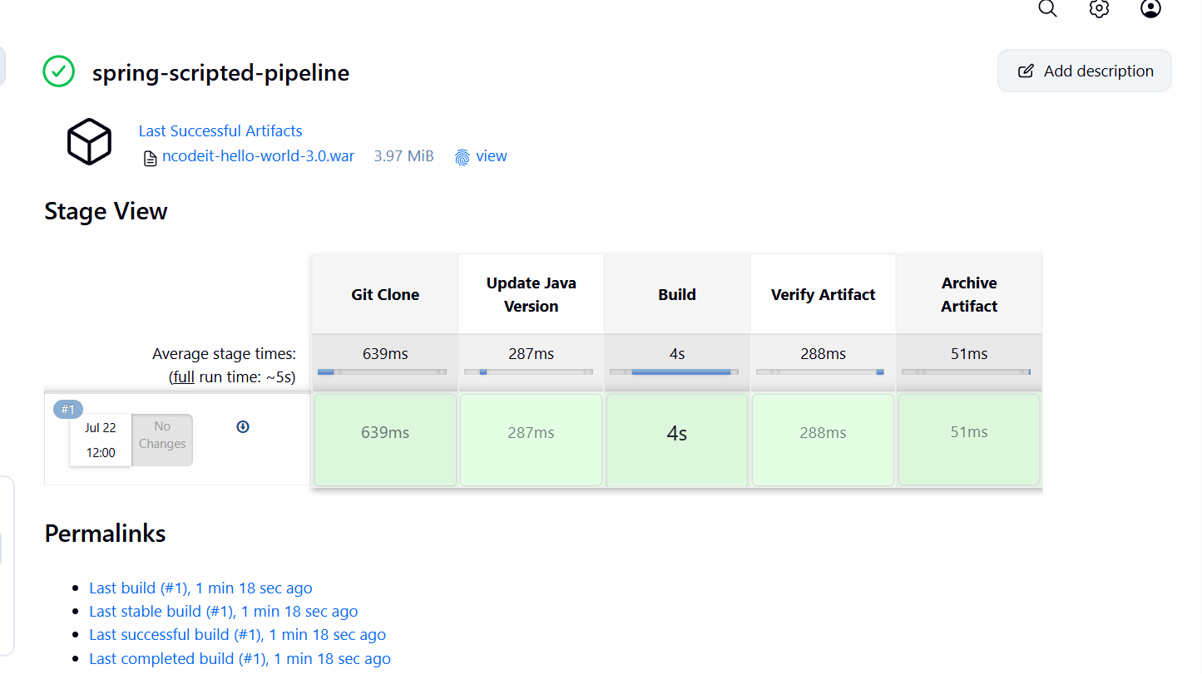

- Create one Parameterized job
Source Code:https://github.com/betawins/spring3-mvc-maven-xml-hello-world-1.git

Now creating a parameterized job

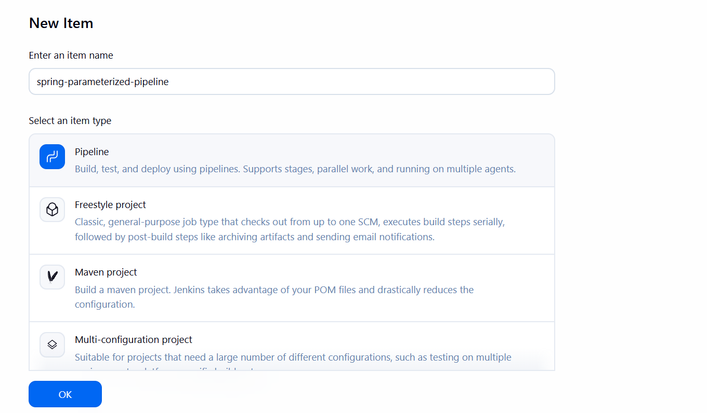
pipeline {
agent any

tools {
jdk 'JDK21'
maven 'Maven3'
}

parameters {
choice(
name: 'ENVIRONMENT',
choices: ['dev', 'test', 'prod'],
description: 'Select the target environment'
)

booleanParam(
name: 'RUN_BUILD',
defaultValue: true,
description: 'Select this option to run the Maven build'
)

string(
name: 'MAVEN_GOAL',
defaultValue: 'clean package',
description: 'Enter the Maven goal'
)
}

stages {
stage('Display Parameters') {
steps {
echo "Selected Environment: ${params.ENVIRONMENT}"
echo "Run Build: ${params.RUN_BUILD}"
echo "Maven Goal: ${params.MAVEN_GOAL}"
}
}

stage('Git Clone') {
steps {
git url: 'https://github.com/betawins/spring3-mvc-maven-xml-hello-world-1.git'
}
}

stage('Update Java Version') {
steps {
sh '''
sed -i 's/1\\.6/1.8/g' pom.xml
grep -n "1.8\\|source\\|target" pom.xml || true
'''
}
}

stage('Build') {
when {
expression {
return params.RUN_BUILD
}
}

steps {
sh "mvn ${params.MAVEN_GOAL}"
}
}

stage('Verify Artifact') {
when {
expression {
return params.RUN_BUILD
}
}

steps {
sh 'ls -lh target'
}
}

stage('Deploy Information') {
steps {
echo "Application is selected for ${params.ENVIRONMENT} environment"
}
}
}

post {
success {
echo 'Parameterized pipeline completed successfully.'
}

failure {
echo 'Parameterized pipeline failed.'
}
}
}

The above is the script which allows us to build the job with parameters.
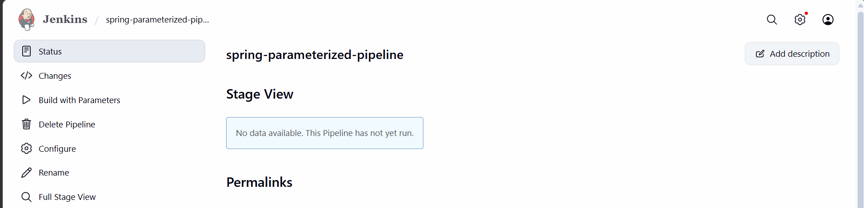

We have an option to build with parameters
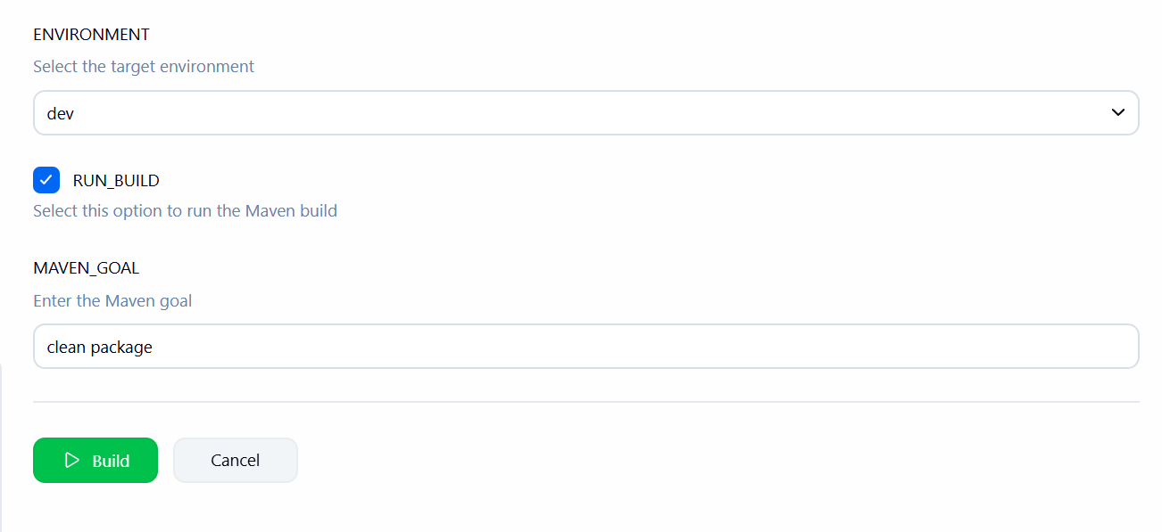
Here we are using the choice parameter
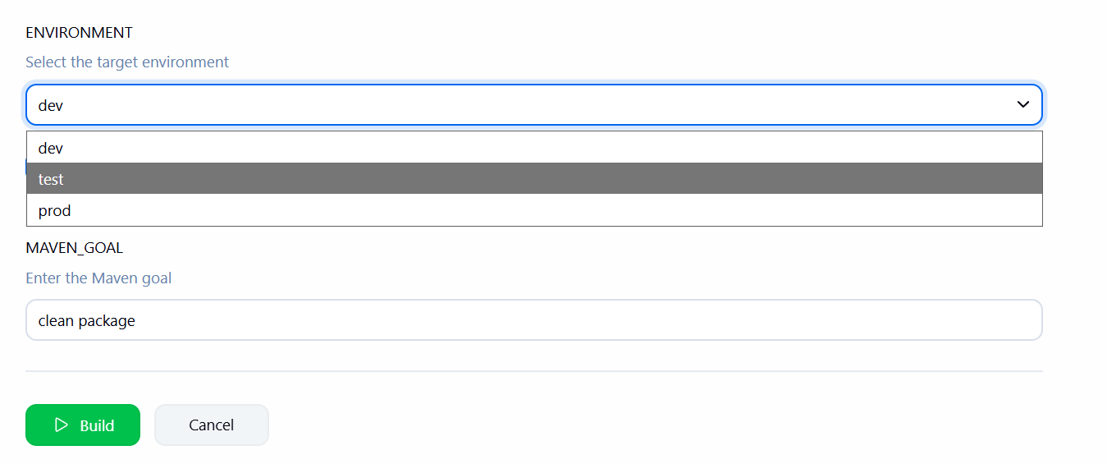
Lets build now on dev
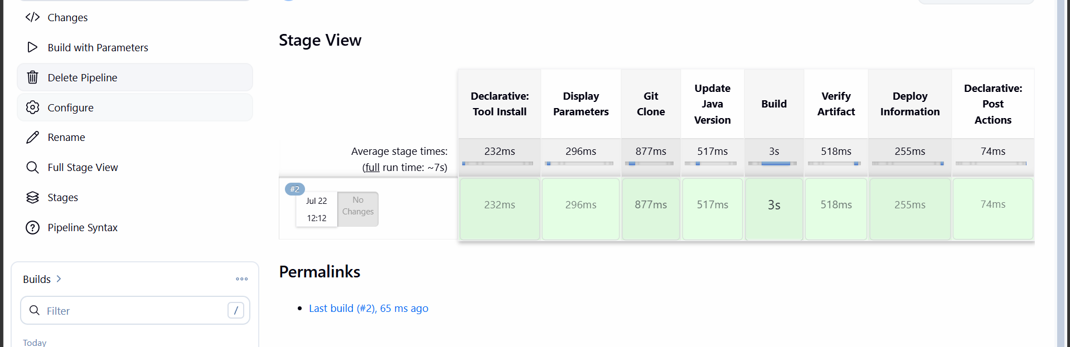

The pipeline executed successfully

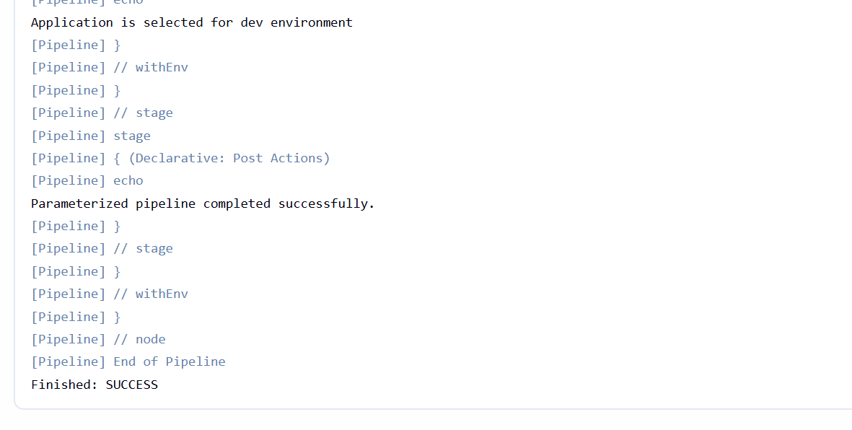

- Write sample skeleton for Declarative and Scripted pipelines

pipeline {
agent any

stages {
stage('Git Clone') {
steps {
echo 'Cloning source code'
}
}

stage('Build') {
steps {
echo 'Building application'
}
}

stage('Test') {
steps {
echo 'Running tests'
}
}

stage('Code Quality') {
steps {
echo 'Running SonarQube analysis'
}
}

stage('Deploy') {
steps {
echo 'Deploying application'
}
}

stage('Post Actions') {
steps {
echo 'Pipeline completed'
}
}
}
}

Scripted Pipeline
node {

stage('Git Clone') {
echo 'Cloning source code'
}

stage('Build') {
echo 'Building application'
}

stage('Test') {
echo 'Running tests'
}

stage('Code Quality') {
echo 'Running SonarQube analysis'
}

stage('Deploy') {
echo 'Deploying application'
}

stage('Post Actions') {
echo 'Pipeline completed'
}
}

The above are the skeletons of scripted and declarative pipelines.

- Create one Declarative job
Source Code:https://github.com/betawins/sabear_simplecutomerapp/tree/feature-1.1

Lets create a declarative pipeline for the given repo

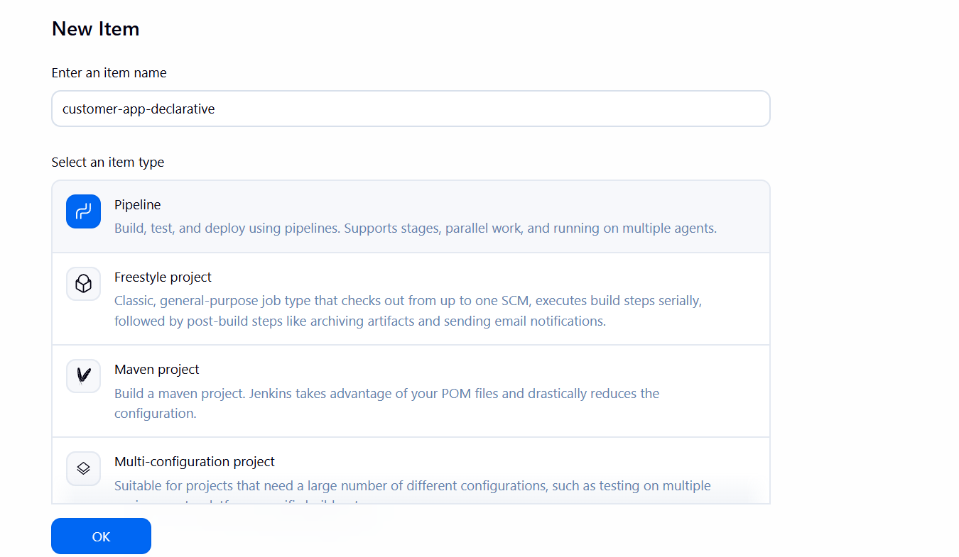

pipeline {
agent any

options {
timeout(time: 10, unit: 'MINUTES')
skipDefaultCheckout(true)
}

tools {
maven 'MVN_HOME'
jdk 'JDK21'
}

stages {
stage('Git Clone') {
steps {
git branch: 'feature-1.1',
url: 'https://github.com/betawins/sabear_simplecutomerapp.git'
}
}

stage('Build') {
steps {
sh 'mvn clean package -DskipTests'
}
}

stage('Verify Artifact') {
steps {
sh 'ls -lh target'
}
}

stage('Archive Artifact') {
steps {
archiveArtifacts artifacts: 'target/*.*',
allowEmptyArchive: false,
fingerprint: true
}
}
}

post {
success {
echo 'Customer application build completed successfully.'
}

failure {
echo 'Customer application pipeline failed.'
}

always {
echo 'Pipeline execution finished.'
}
}
}

The above is the declarative pipeline
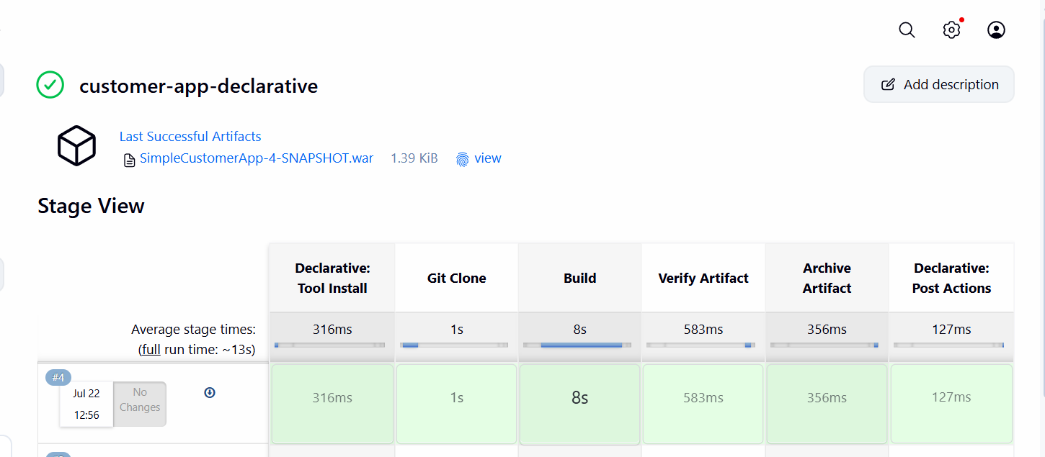

The build is successful

- Create one Declarative job
- Source Code:https://github.com/betawins/Trading-UI.git
For this we have to install nodejs and npm in our server
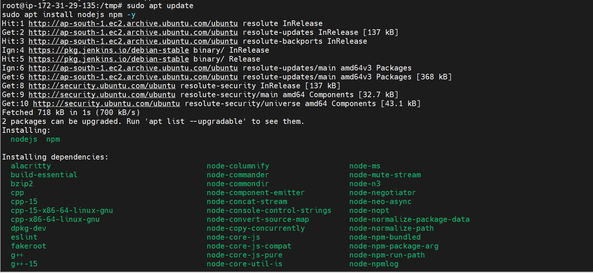

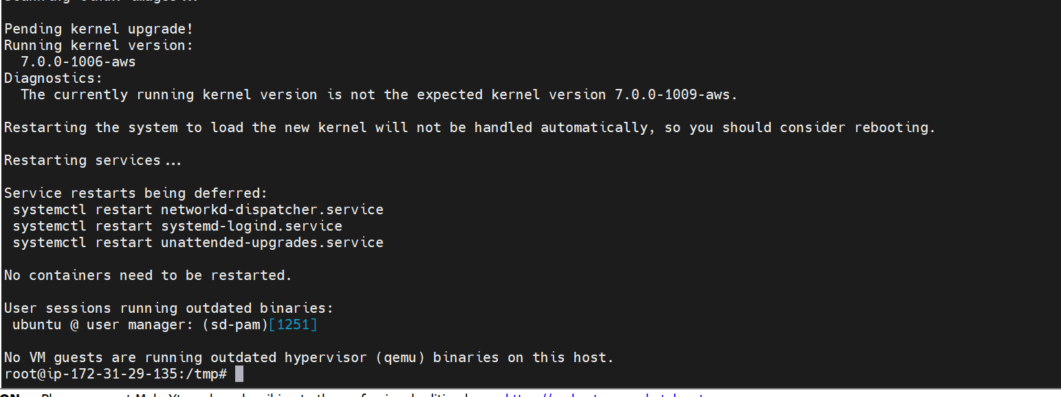

Create a new job

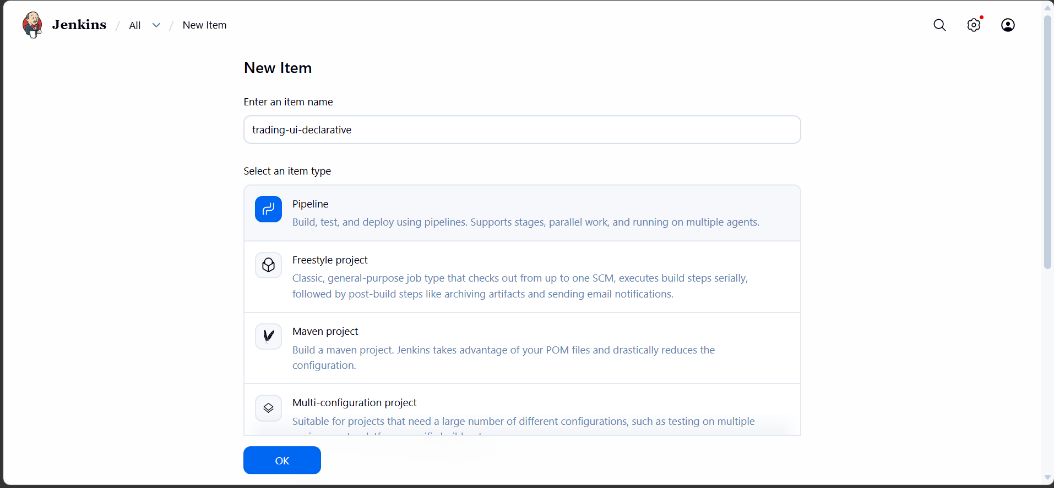
pipeline {
agent any

options {
timeout(time: 15, unit: 'MINUTES')
skipDefaultCheckout(true)
}

environment {
NODE_OPTIONS = '--openssl-legacy-provider'
CI = 'false'
}

stages {
stage('Git Clone') {
steps {
git branch: 'master',
url: 'https://github.com/betawins/Trading-UI.git'
}
}

stage('Check Versions') {
steps {
sh '''
node --version
npm --version
'''
}
}

stage('Check Files') {
steps {
sh 'ls -la'
}
}

stage('Clean Workspace Dependencies') {
steps {
sh '''
rm -rf node_modules
rm -rf build
'''
}
}

stage('Install Dependencies') {
steps {
sh 'npm install'
}
}

stage('Build Application') {
steps {
sh 'npm run build'
}
}

stage('Verify Build') {
steps {
sh '''
if [ -d build ]; then
echo "Build directory created successfully"
ls -lh build
else
echo "Build directory not found"
exit 1
fi
'''
}
}

stage('Archive Artifact') {
steps {
archiveArtifacts artifacts: 'build/**',
allowEmptyArchive: false,
fingerprint: true
}
}
}

post {
success {
echo 'Trading UI pipeline completed successfully.'
}

failure {
echo 'Trading UI pipeline failed. Check the Console Output.'
}

always {
echo 'Pipeline execution completed.'
}
}
}
The above is the declarative job

Lets build
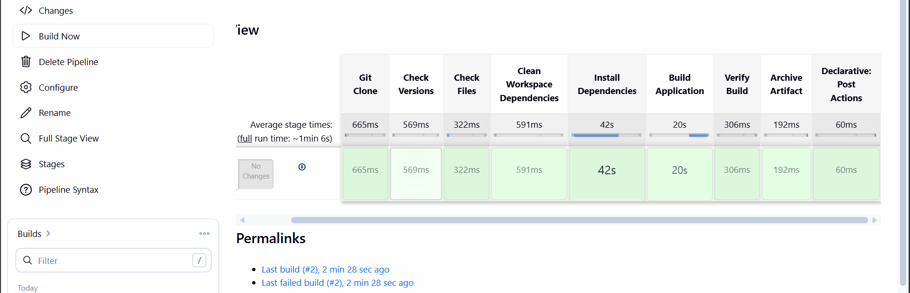

The pipeline script executed successfully.

- Execute parallel stages using Jenkins pipeline for any sample job
Lets now execute a sample job using parallel stages

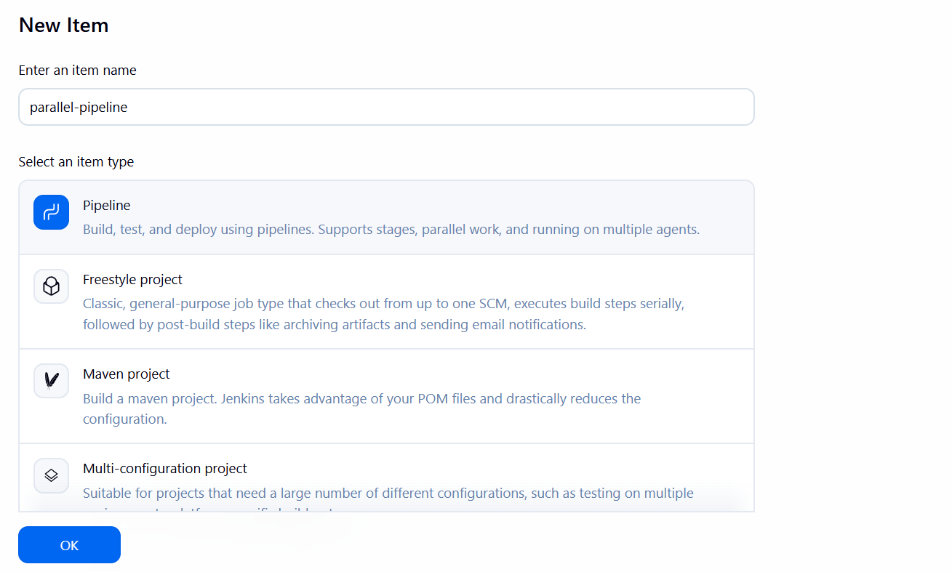

pipeline {
agent any

stages {

stage('Checkout') {
steps {
echo 'Cloning Source Code...'
sleep 5
}
}

stage('Parallel Execution') {
parallel {

stage('Build') {
steps {
echo 'Building Application...'
sleep 10
}
}

stage('Unit Test') {
steps {
echo 'Running Unit Tests...'
sleep 8
}
}

stage('Code Analysis') {
steps {
echo 'Running SonarQube Analysis...'
sleep 6
}
}
}
}

stage('Deploy') {
steps {
echo 'Deploying Application...'
sleep 5
}
}

stage('Verification') {
steps {
echo 'Application Verified Successfully'
}
}
}

post {
success {
echo 'Pipeline completed successfully.'
}

failure {
echo 'Pipeline failed.'
}
}
}
This above is the script

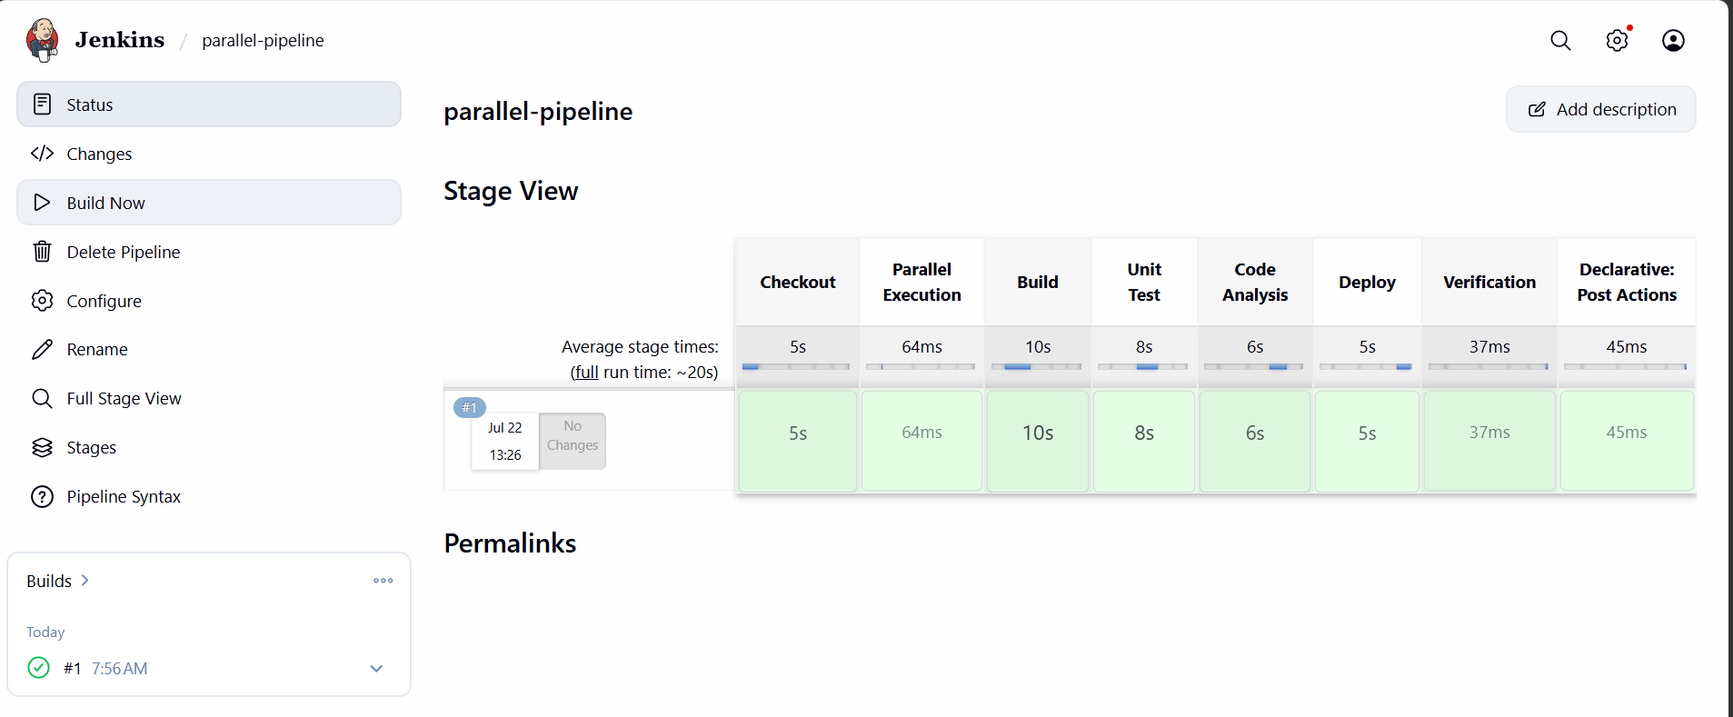
The job executed successfully
Build,test,Static code analysis are executed parallelly in the above script
These three stages run at the same time:
Build
Simulates building the application.
Takes 10 seconds.
Unit Test
Simulates running unit tests.
Takes 8 seconds.
Code Analysis
Simulates running static code analysis (e.g., SonarQube).
Takes 6 seconds.

- Execute Jenkins pipeline stages using shared libraries
A Shared Library lets you store reusable pipeline code in a separate Git repository and call it from multiple Jenkins pipelines. This reduces duplicated Jenkinsfile code. Jenkins Shared Libraries commonly use a vars/ directory, where each .groovy filename becomes a callable pipeline function.

For this lets create a github repository first
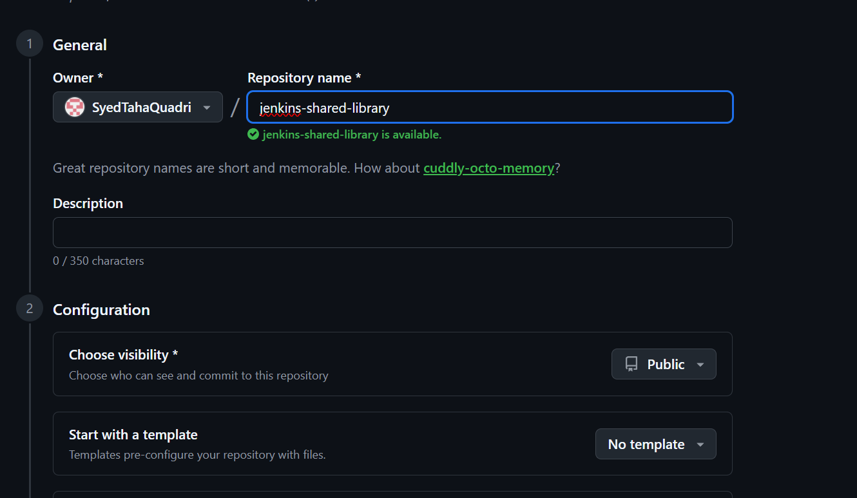

Lets clone this
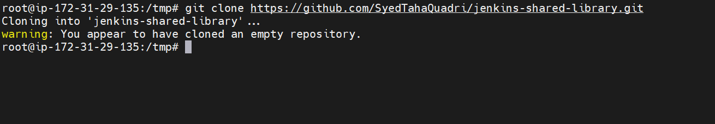

Create a directory
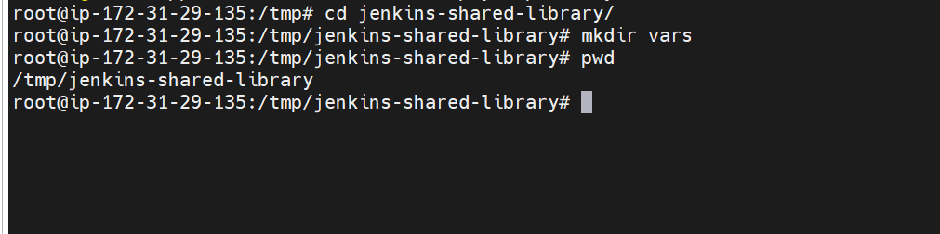

Create the shared staged files inside vars directory
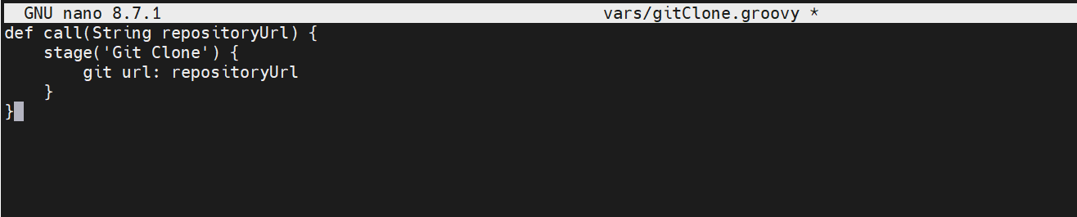
Clone stage file
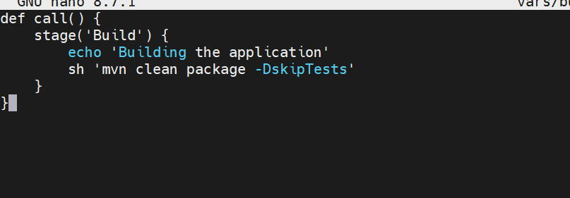
Build stage file
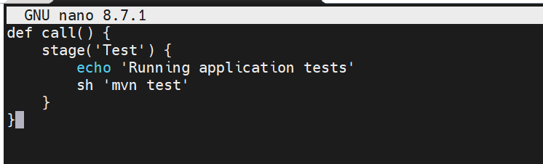
Test stage file
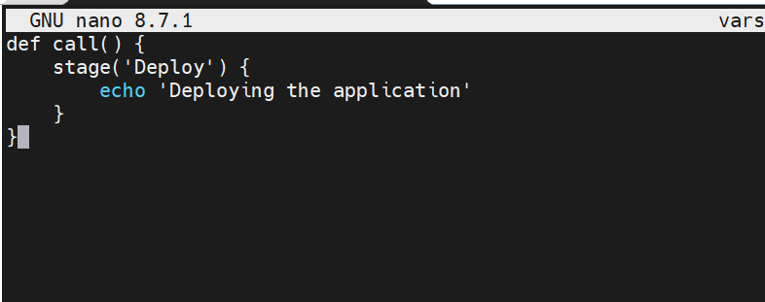
Deploy stage file
This is our directory structure now
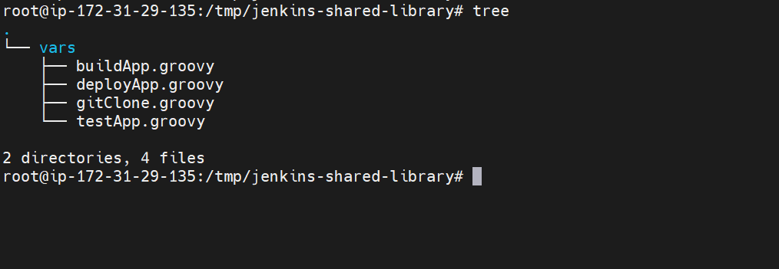
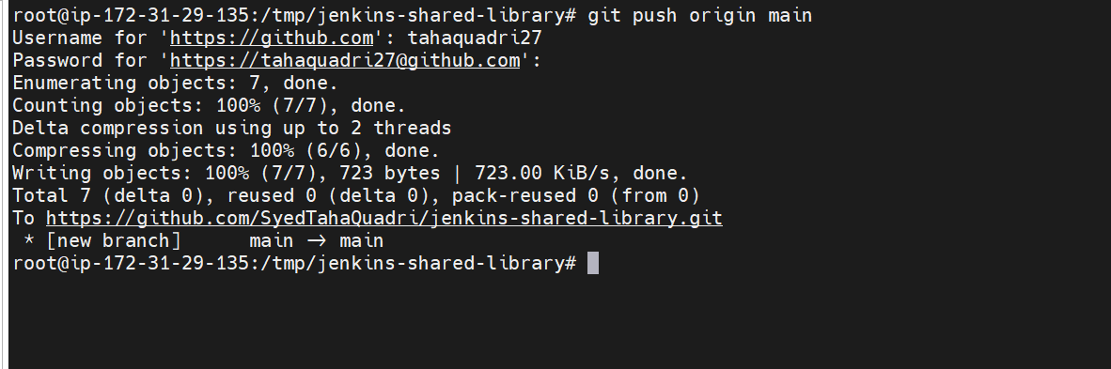
Pushed it to github
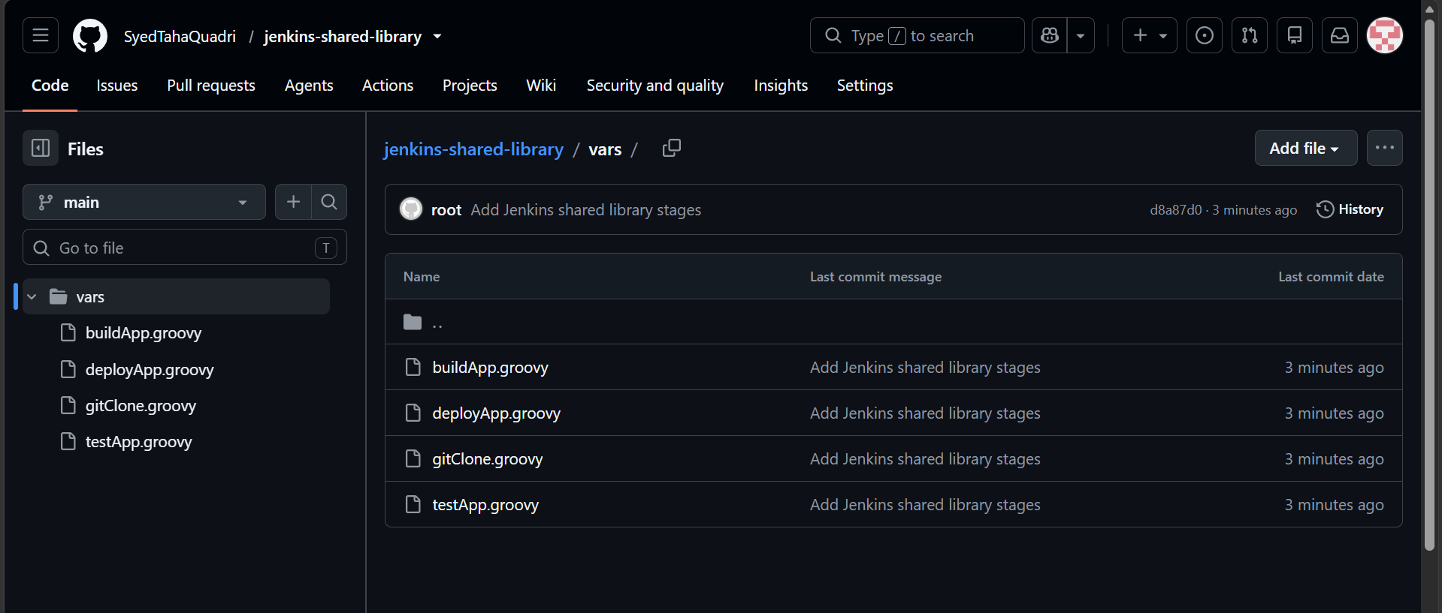

Now configure the shared library In Jenkins
Go to
Manage Jenkins
→ System
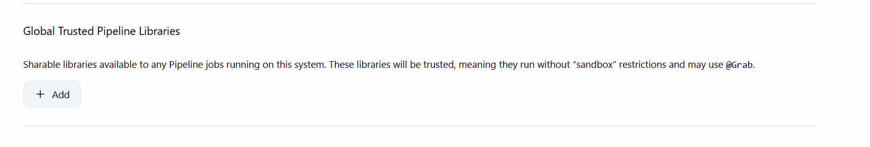
Go to global trusted pipeline libraries
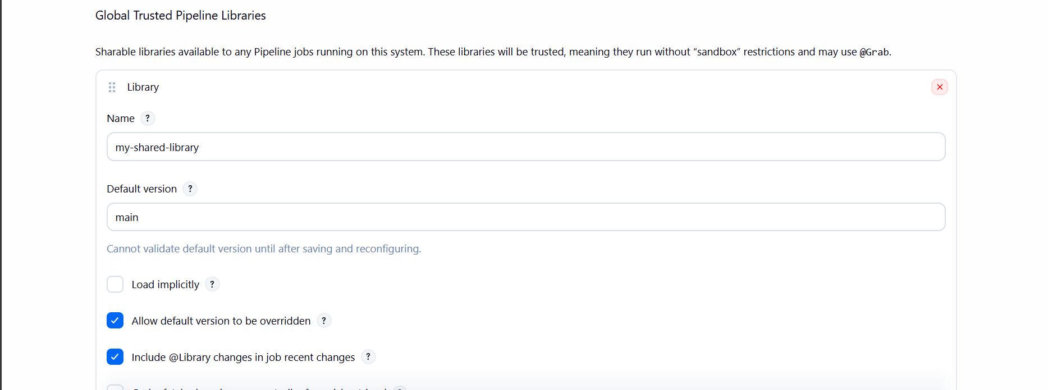

Add our created repo
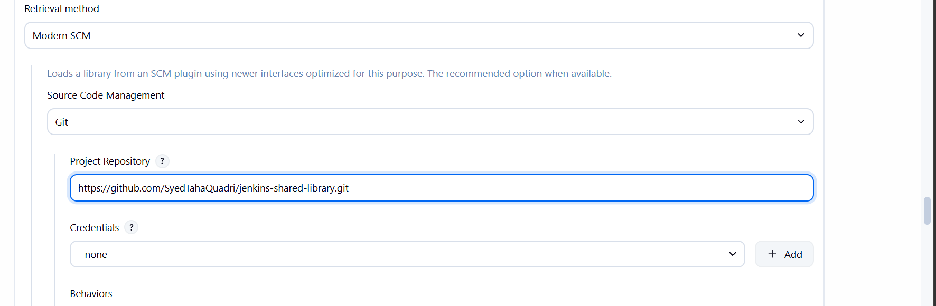

Save it

Lets now create a pipeline using shared library
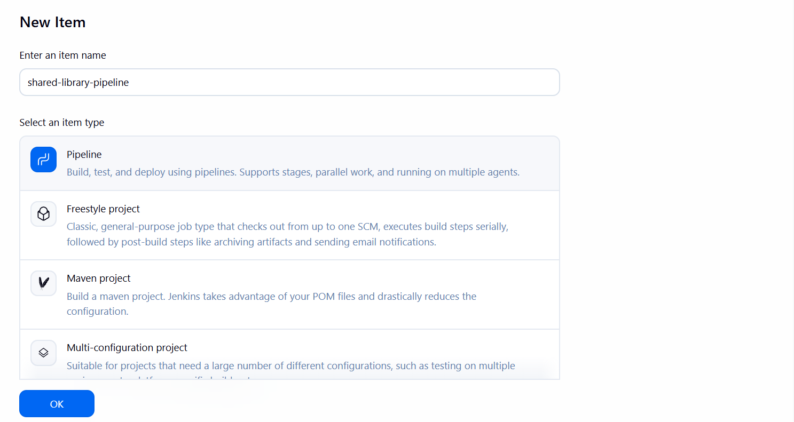

@Library('my-shared-library') _

node {
gitClone('https://github.com/betawins/spring3-mvc-maven-xml-hello-world-1.git')

stage('Update Java Version') {
sh '''
sed -i 's/1\\.6/1.8/g' pom.xml
'''
}

buildApp()

testApp()

deployApp()
}

The above is our pipeline script
In the first line we are mentioning the shared library
And we are calling the functions at the last

Lets execute the job now
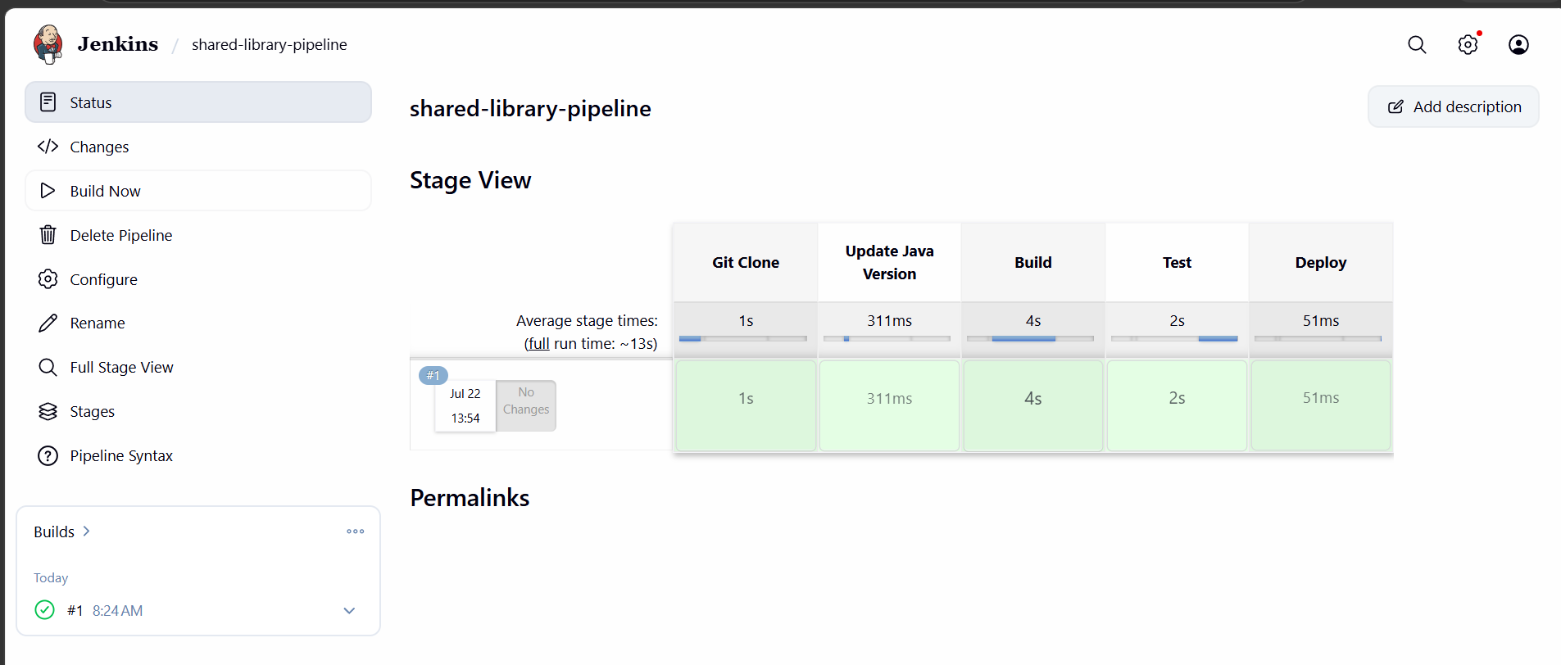
The job execute successfully
