Tasks: Execute all yaml files shown in video.
Taint a Node and Schedule a Tolerant Pod Taint a node with special=true:NoSchedule. Create a pod with a toleration that matches the taint, allowing it to be scheduled on the tainted node.
First lets create on pod

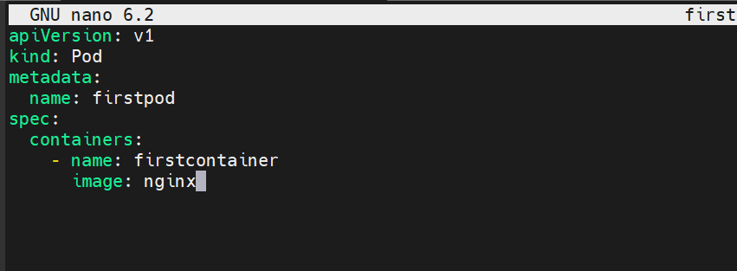
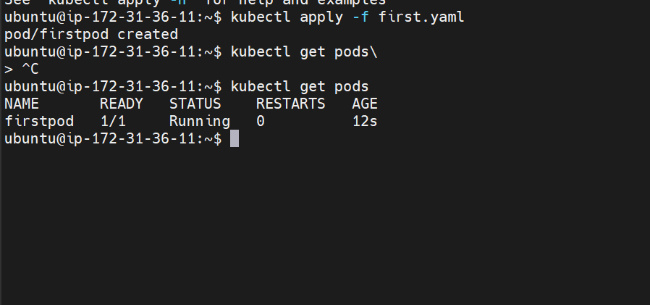
The pod is been created
Lets now taint one node
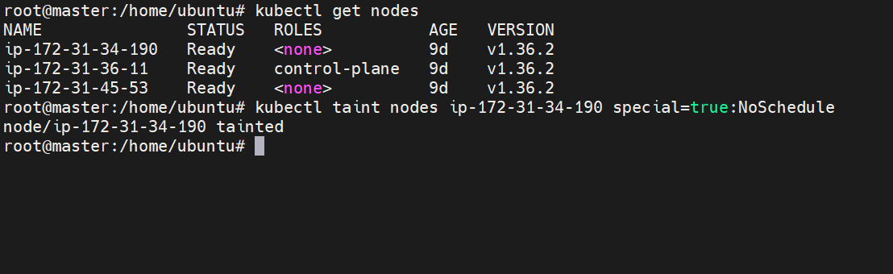
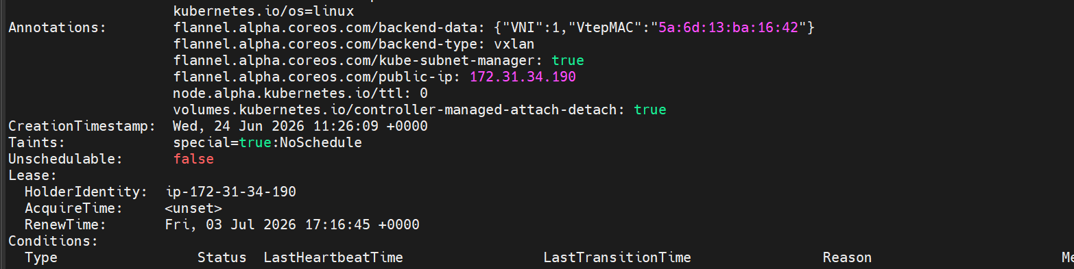

We can see the taint is added
This tells Kubernetes
"Do NOT schedule Pods on worker01 unless the Pod explicitly tolerates this taint."

Lets delete the pod and create again where the pod is getting scheduled
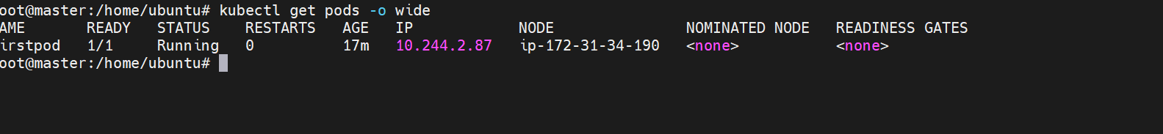
At the moment it is scheduled on worker-01 only i.e ip-172-31-34-190
ip-172-31-45-53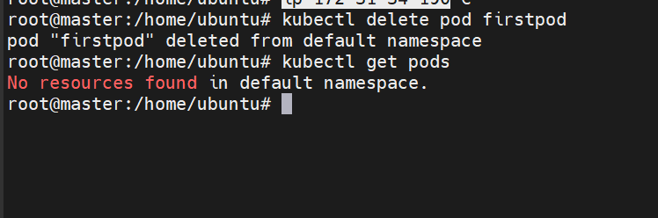
There are no pods at the moment
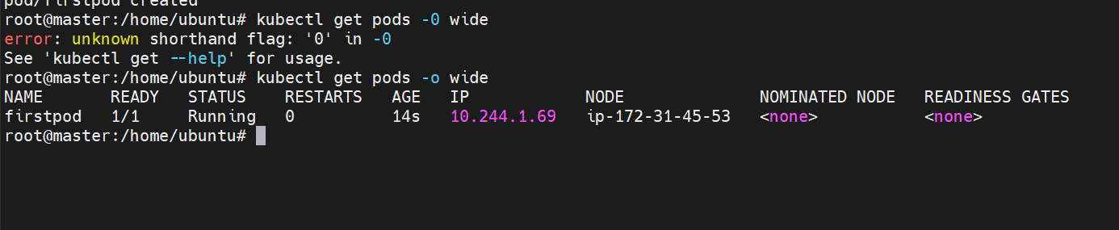
We can now see that the pod is scheduled on worker-02 i.e ip-172-31-45-53
Lets now create another pod and check if that is getting scheduled on worker-01
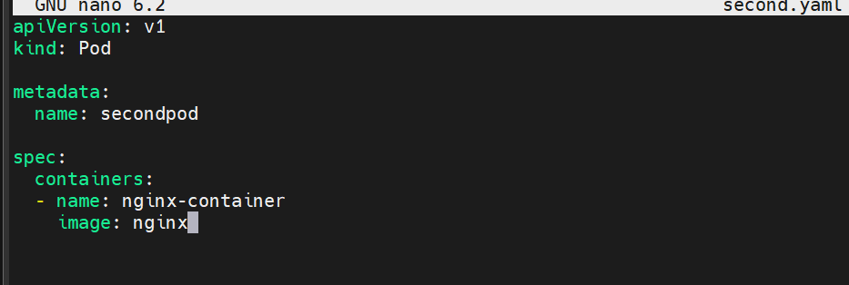

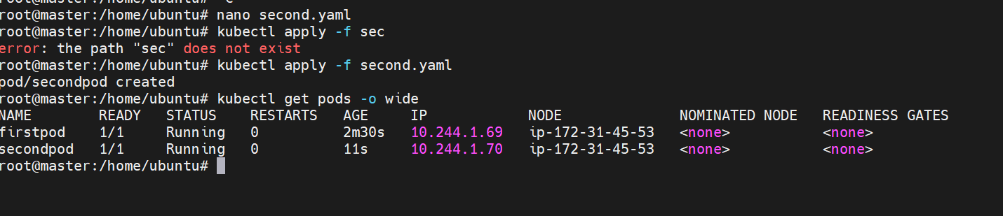

We can now see that both the pods are scheduled on worker-02 only
Lets now check NoExecute filter
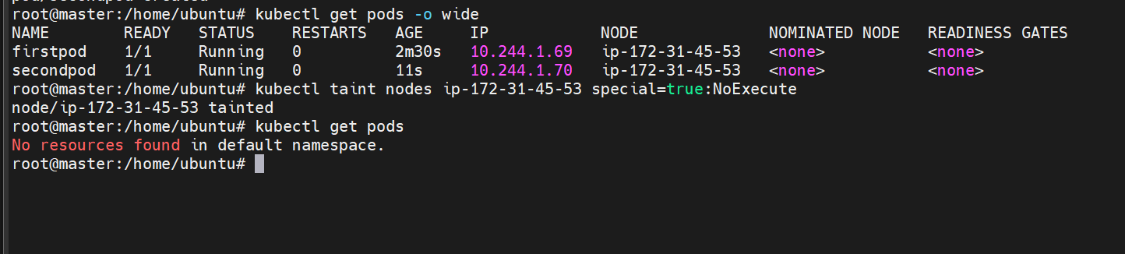
We can see that already running pods also have stopped
Let’ s try creating another pod
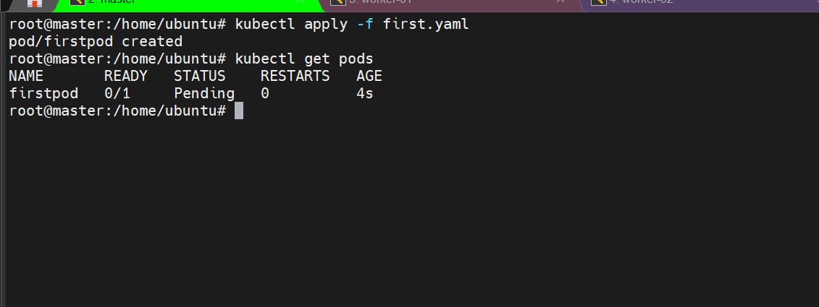
The pod is in the pending state because one node is marked as noschedule and another marked noexecute
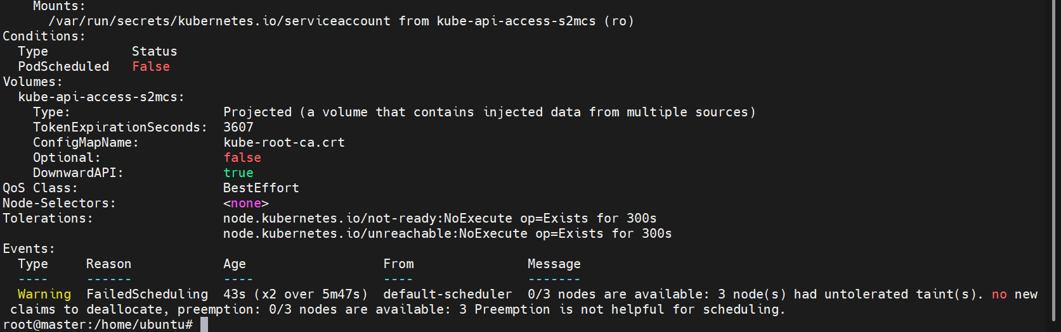
Lets now remove the taint
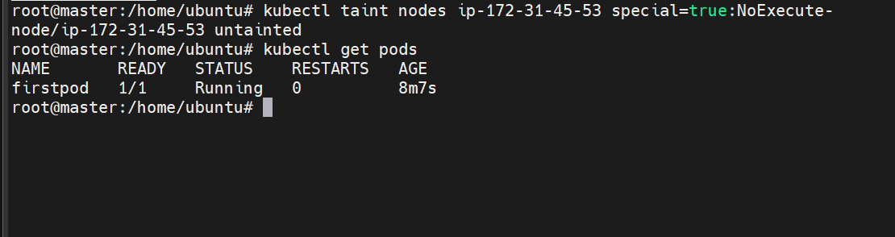
The pod is has started running
Removed the other taint as well
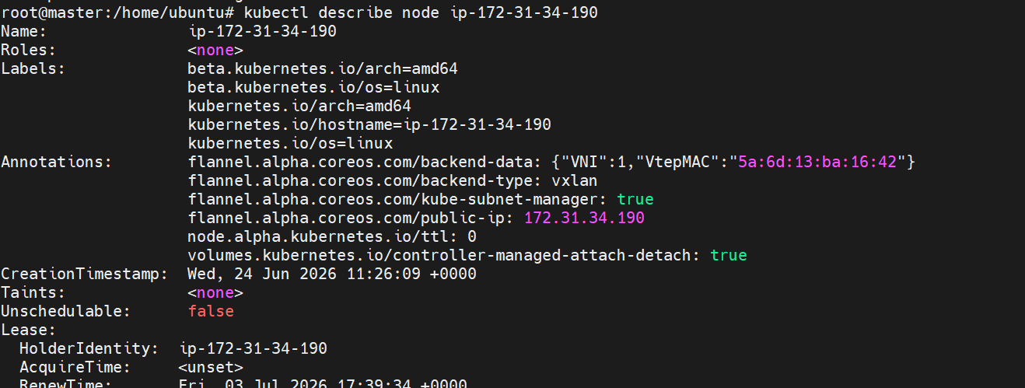
We can see that taint has been removed

Taint a Node and Schedule a Tolerant Pod Taint a node with special=true:NoSchedule. Create a pod with a toleration that matches the taint, allowing it to be scheduled on the tainted node.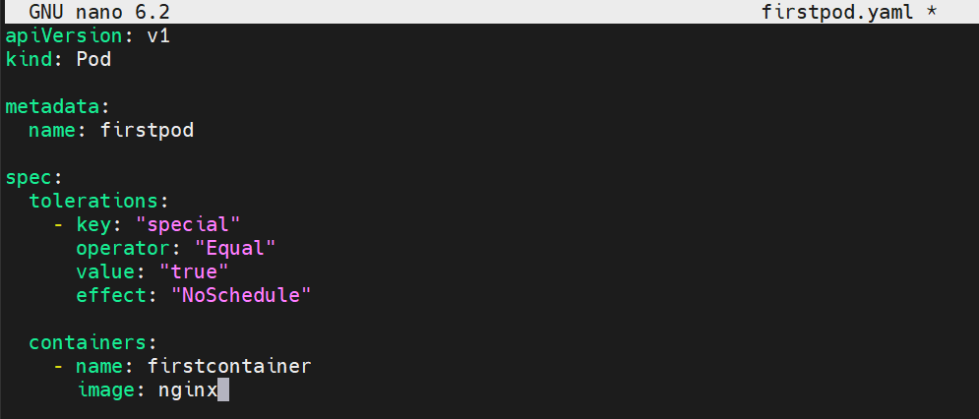
This is our yaml file
Creating the pod now
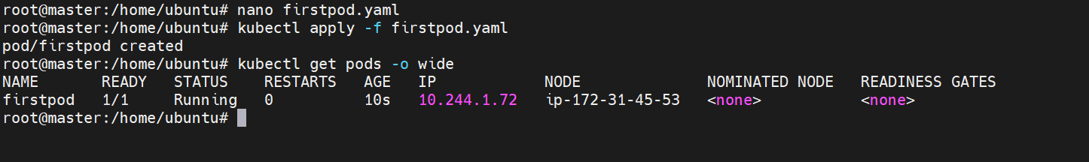
The pod is now created
Earlier the pod was not accepted
Now it accepts the Pod because
Node
special=true:NoSchedule
matches
Pod
special=true

Use NodeSelector to Schedule a Pod on a Specific Node Label a node with env=dev. Create a pod with a nodeSelector that schedules it only on the node labeled env=dev.
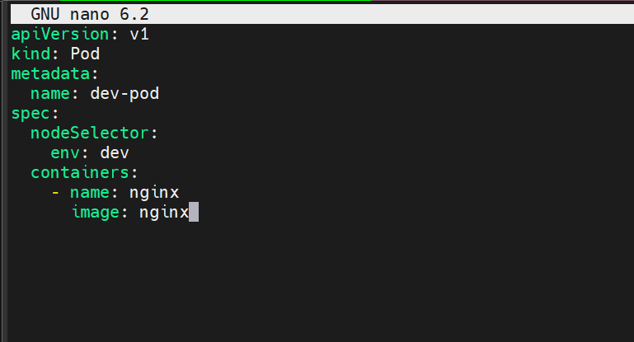
Yaml file for pod with env = dev
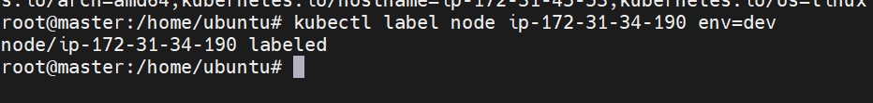
Assigned label to first node
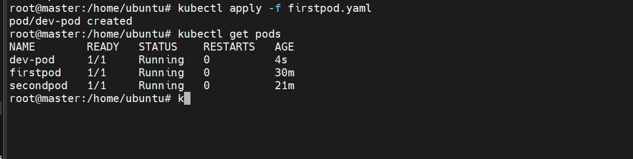
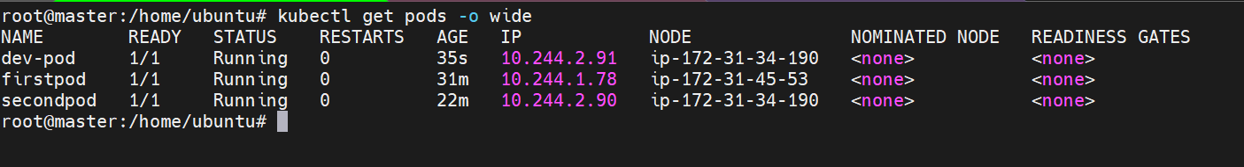
Scheduled on first node

lets work with exists operator
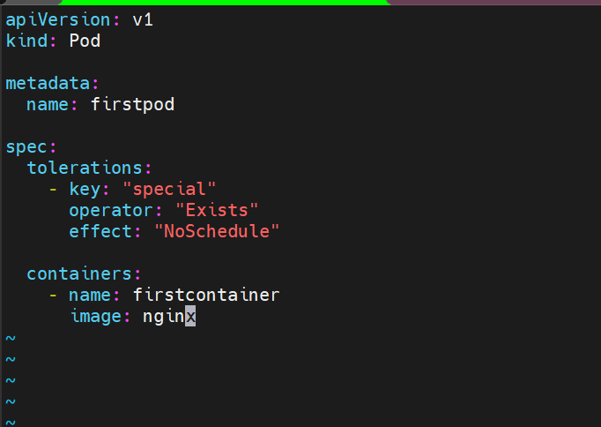

Apply the changes now
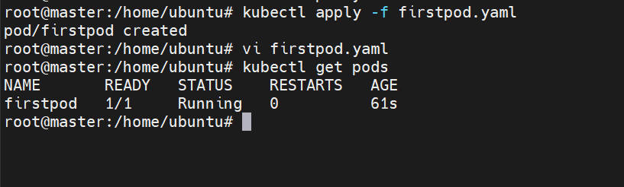
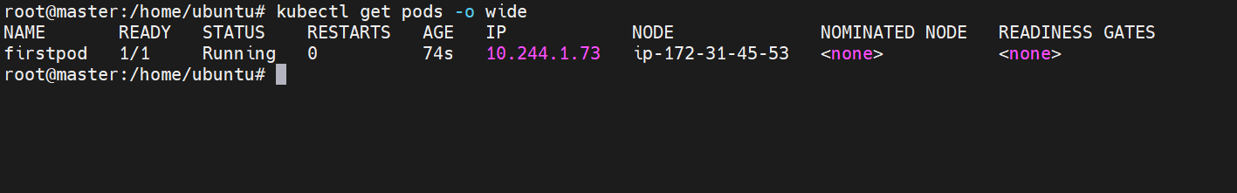
Lets now taint the the above node
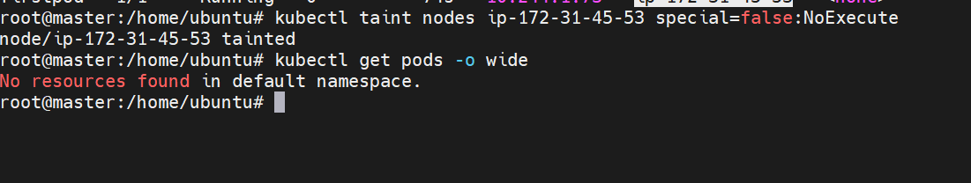

When we apply the taint the running pods are stopped
Without a toleration
Running Pods on ip-172-31-45-53
are immediately removed.

Taint a Node and Use NoExecute with Toleration Seconds Taint a node with special=true:NoExecute. Create a pod with a tolerationSeconds field (e.g., 60 seconds) and observe it gets evicted after 60 seconds on the tainted node.

Now lets use toleration second
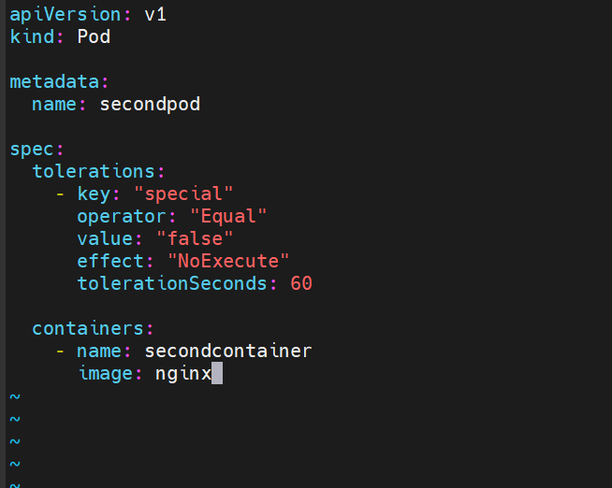

Here is our yaml file using toleration second
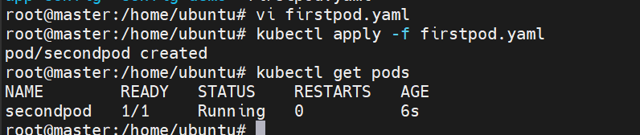
The pod is running
Lets now execute NoExecute Taint
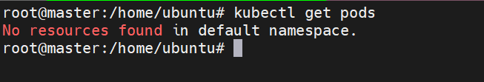
Now after 60s the pod has been deleted
Instead of immediate deletion it waits for 60s

Lets now work with node selector
First lets add a label to our node
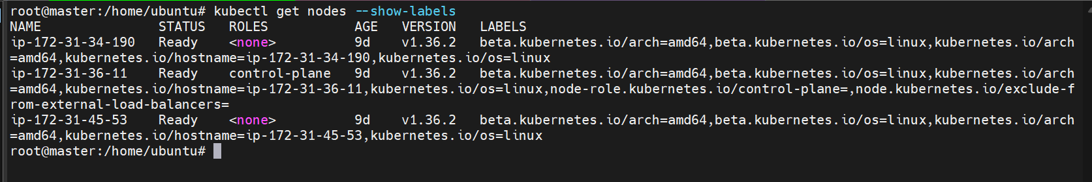
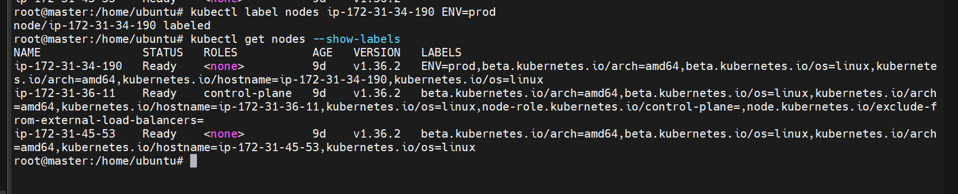
Added a label ENV=prod to first node
Now create a pod using node selector
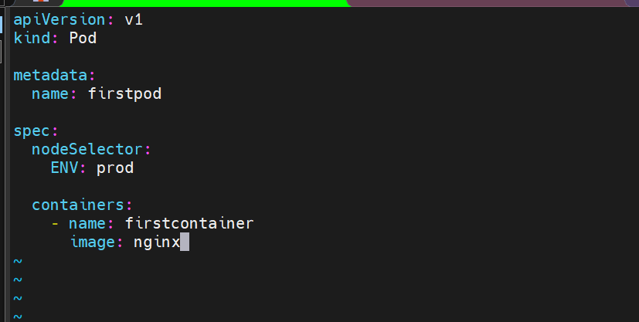
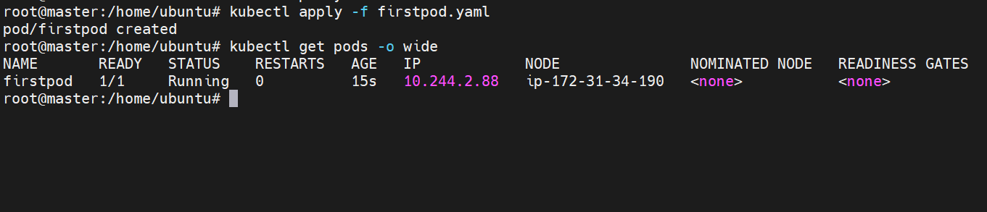
The pod has been created on first node
Lets now create another pod with different label
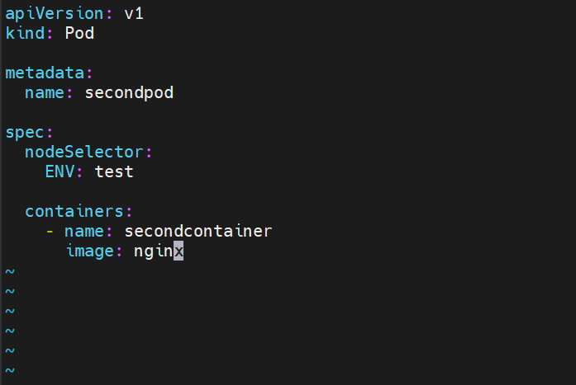
Here the selector is ENV=test
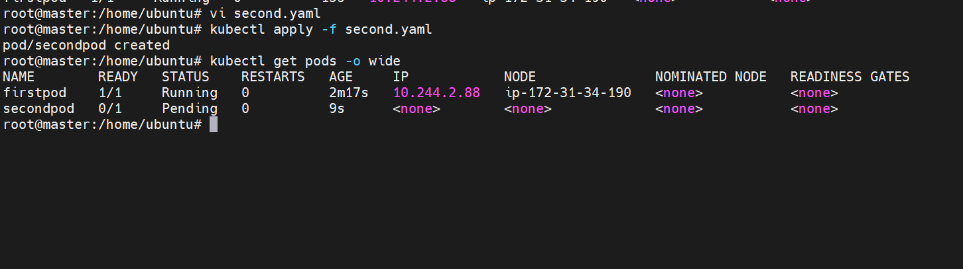
Here it can be seen that the pod is in pending state because no node has the selector label as test
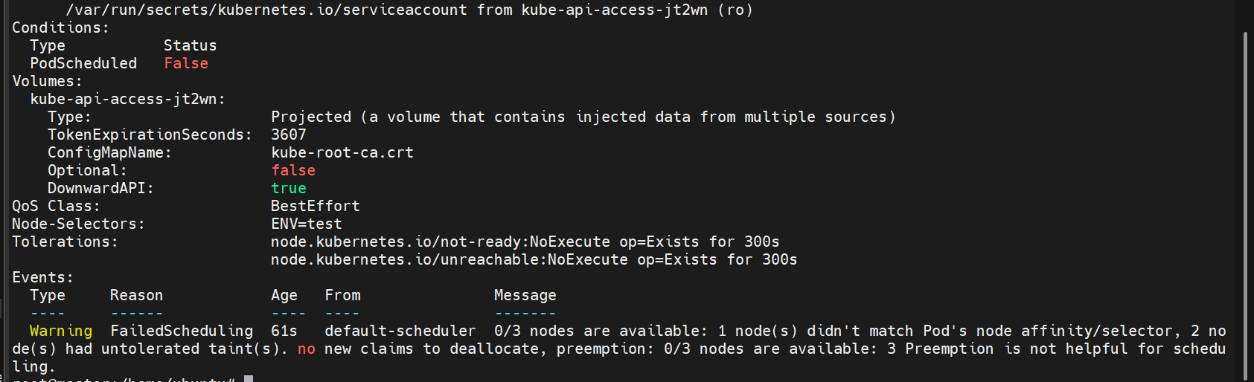
Lets now add the label to the second node
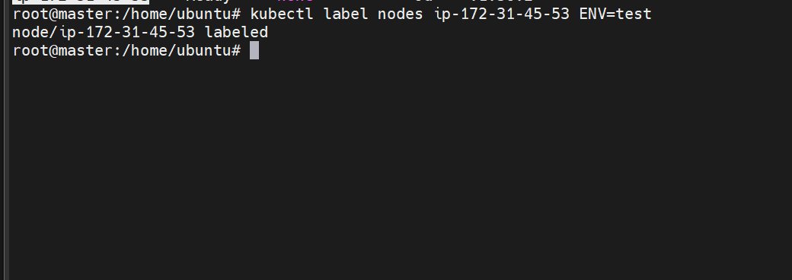
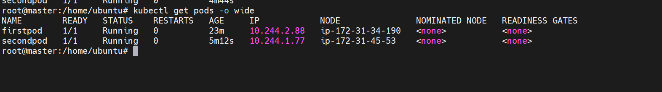
The pod is running now after we have added a label to another node

Use Node Affinity with Soft Scheduling Label a node with env=test. Create a pod with PreferredDuringSchedulingIgnoredDuringExecution node affinity, preferring to schedule it on a node labeled env=test. Remove the label and verify the pod continues to run.
Unlike nodeSelector
Affinity allows
- Multiple values
- Multiple operators
- Soft scheduling
- Hard scheduling

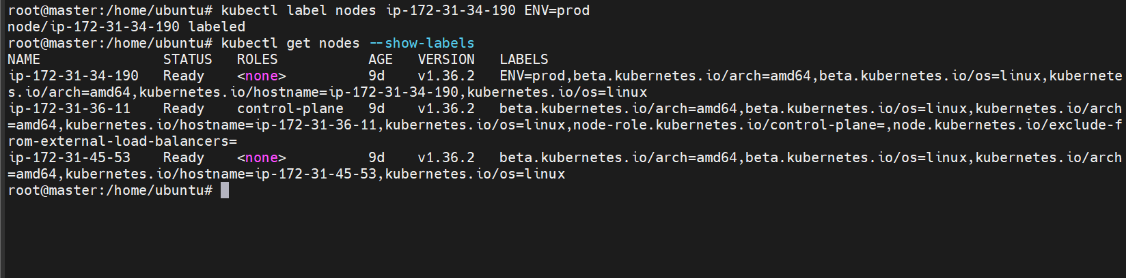
Labelled first node ENV=prod
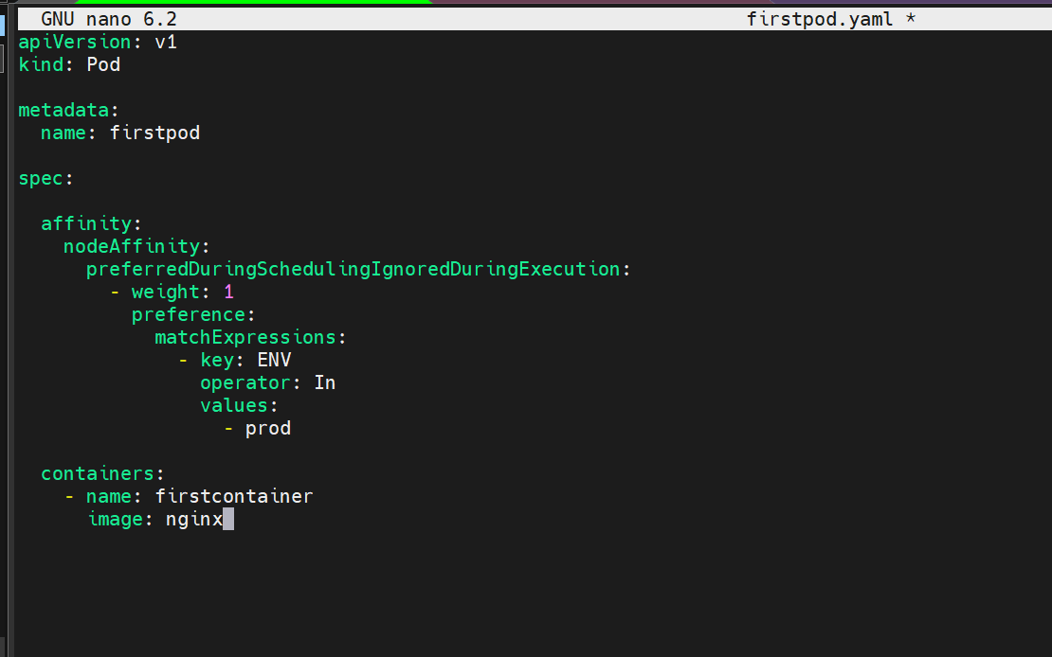
This is our yaml file with node affinity
preferredDuringSchedulingIgnoredDuringExecution
Soft scheduling rule.
Kubernetes tries
but does not guarantee.

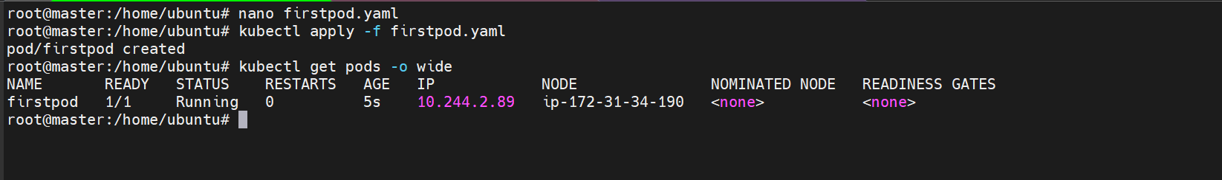
The pod is created
Lets now remove the label and check if the pod is still running
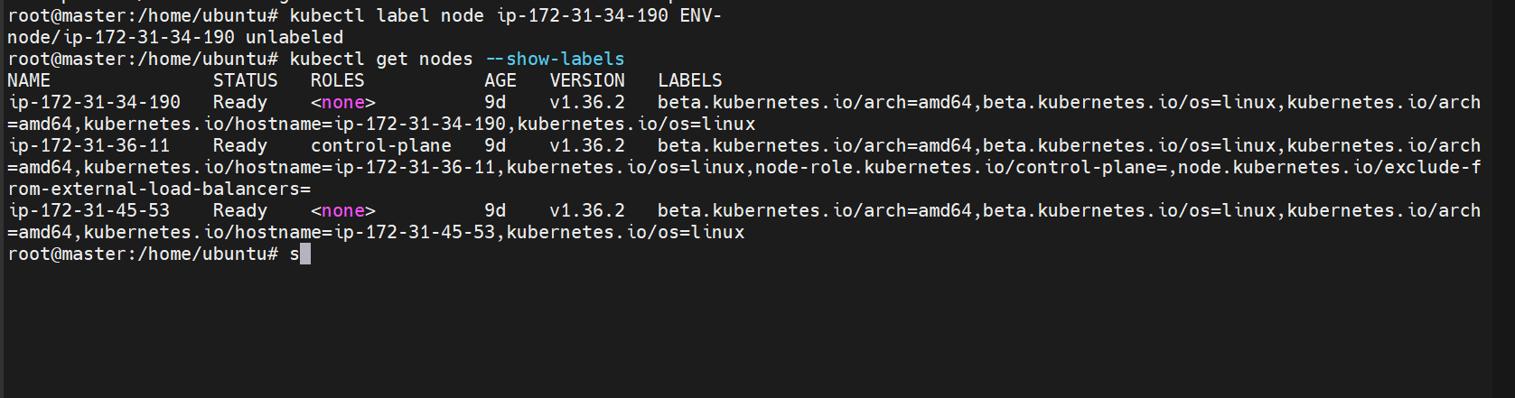
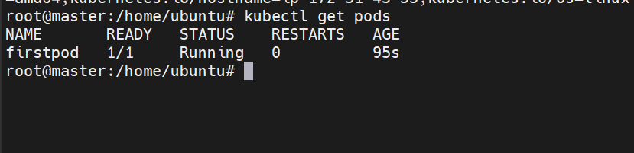
The pod is still running
The Pod
continues running.
Why?
Because
IgnoredDuringExecution
means
Once running
Kubernetes doesn't care if the label changes.

Lets now delete the pod and create again to check if it will run
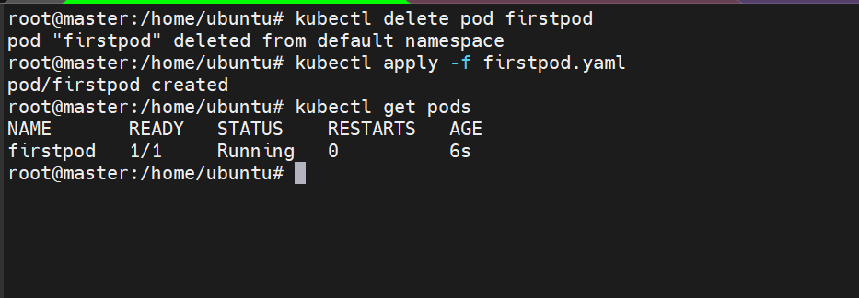
The pod is still running
Pod still runs. Why?
Because Preferred is only a recommendation. If no node matches
Scheduler picks another node.

Implement Node Affinity with Hard Scheduling Create a pod with RequiredDuringSchedulingIgnoredDuringExecution node affinity, ensuring it will only be scheduled on a node labeled env=prod. Verify the pod cannot be scheduled if no node has the env=prod label.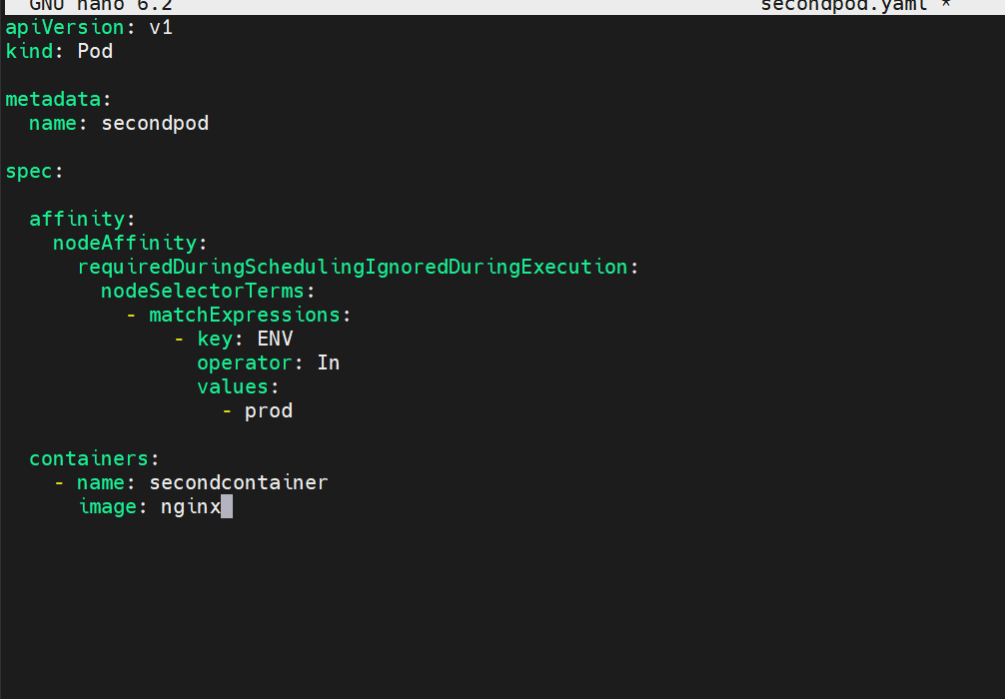

This is our yaml file using requiredDuringSchedulingIgnoredDuringExecution Affinity
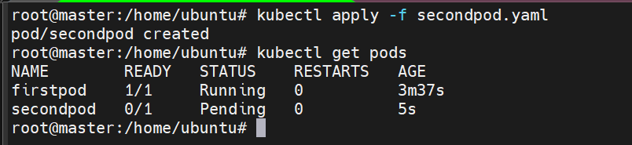
Here we can see that second pod is in pending state
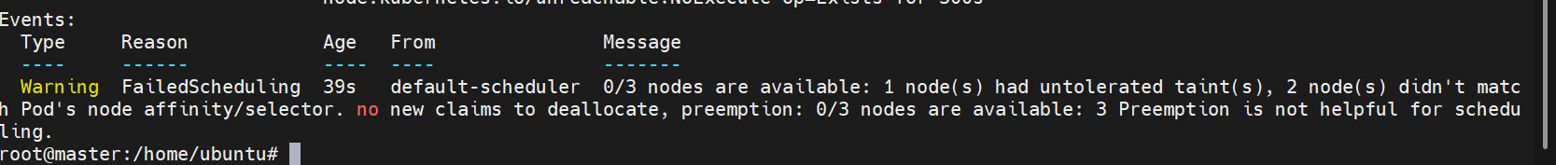
Because no node has the label ENV = prod
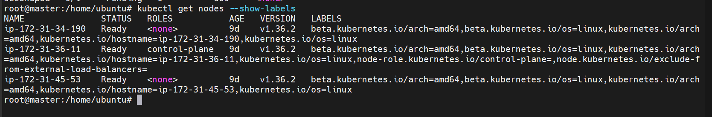
Lets add the label now
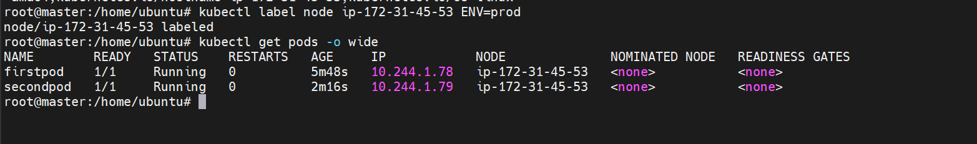
The pod is now running
Scheduler instantly assigns the pending Pod once the required label becomes available.
Lets now use the NotIn operator
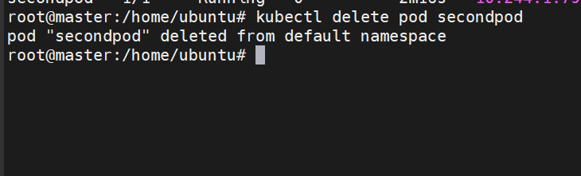
First delete the pod
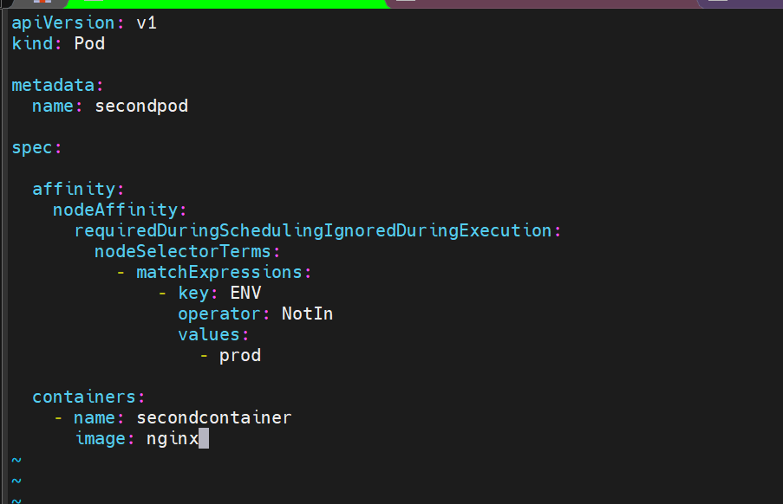
This is our yaml file with NotIn operator
What does NotIn mean?
Scheduler says
Run everywhere
except
ENV=prod
Lets apply now
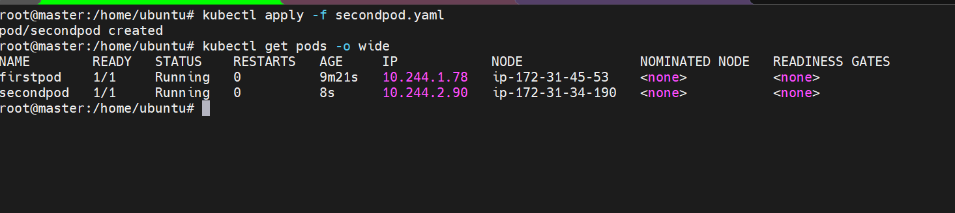
Because the second node has the label prod so it the pod has been scheduled on node-01
