- Create and Test a Kubernetes Pod with an EmptyDir Volume
What is an EmptyDir?
An EmptyDir is a temporary storage volume.
Think of it as a folder created when the Pod starts.
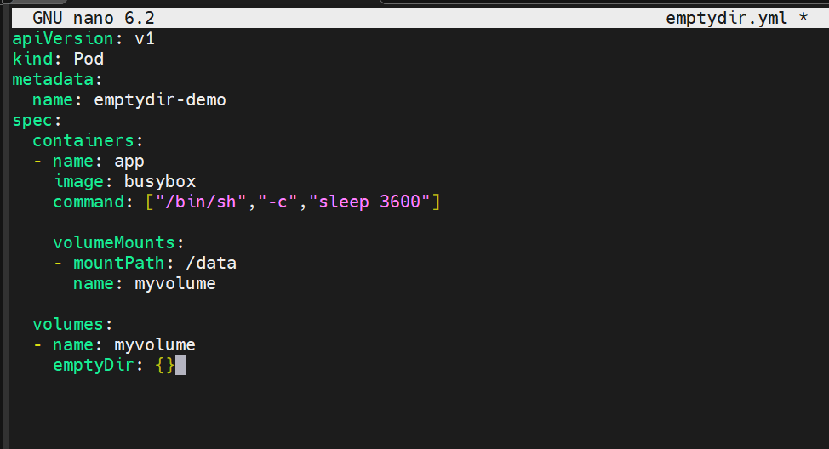
Here we are creating a pod with EMPTYDIR volume
And attaching it to the container
Lets create the pod now
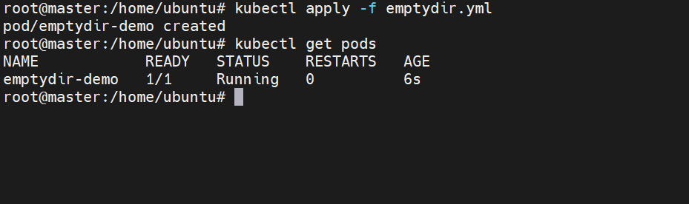
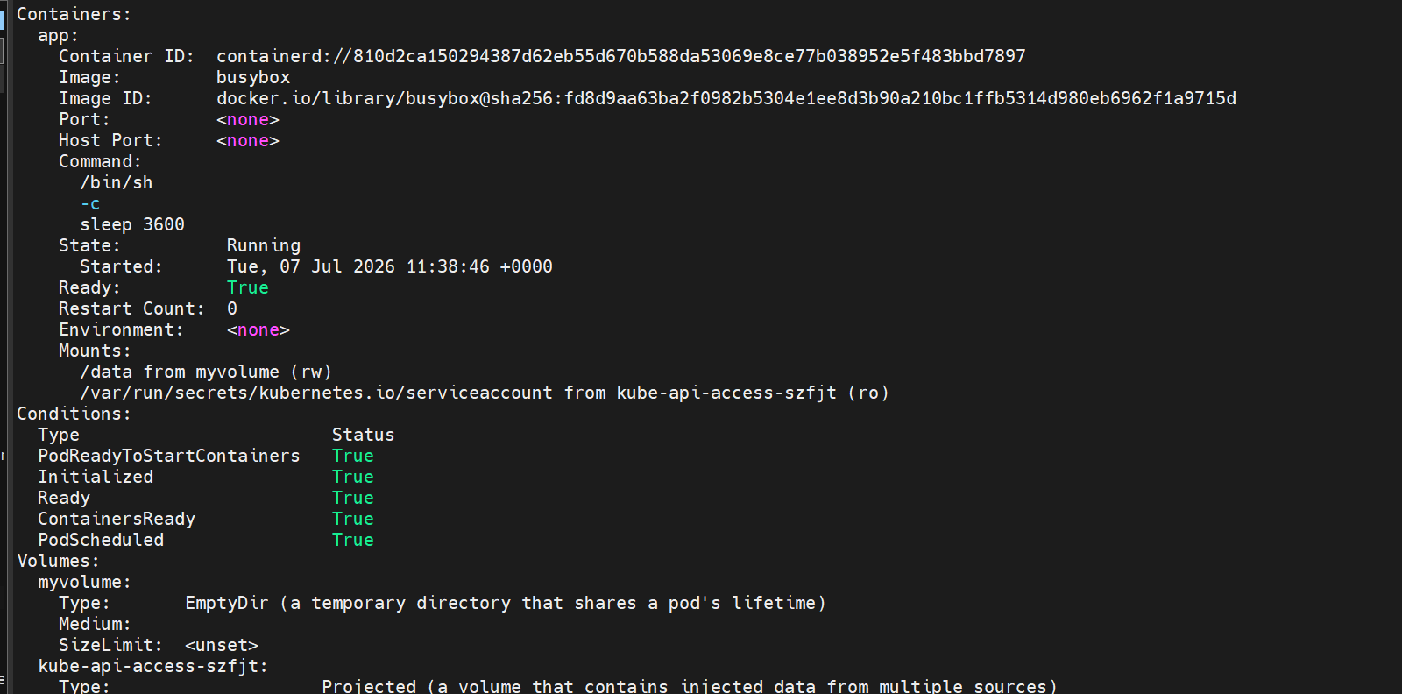
The pod is created and also the volume is mounted to that
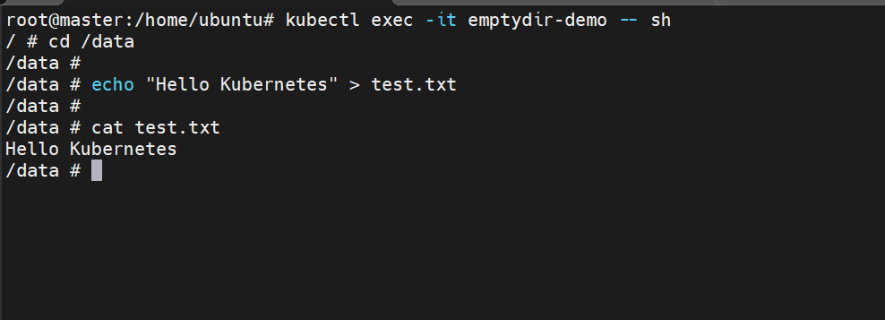
Getting inside the container and creating file inside the data folder.
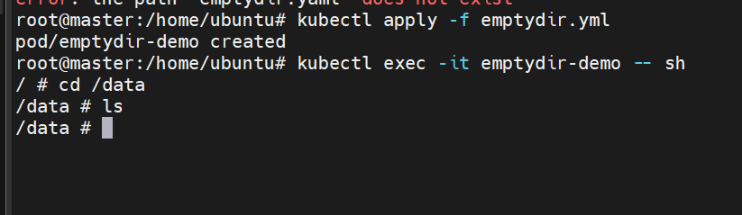
When we again create another pod the data will be lost
Because EMPTYDIR can survive container restart but not pod deletion
- Configure a HostPath Volume in Kubernetes and Validate Data Persistence

Lets now create a HostPath Volume
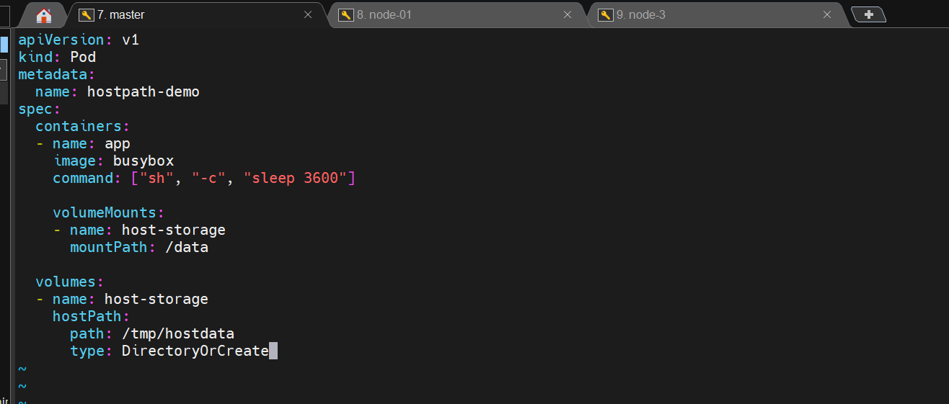

This is our yaml file to create a pod which mounts volume from host
Lets create it now

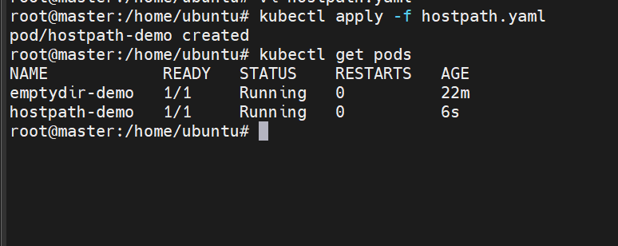

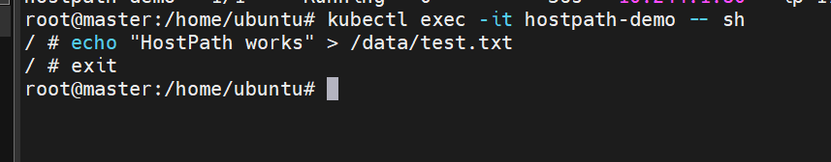

Lets check in the node as well if the folder is created
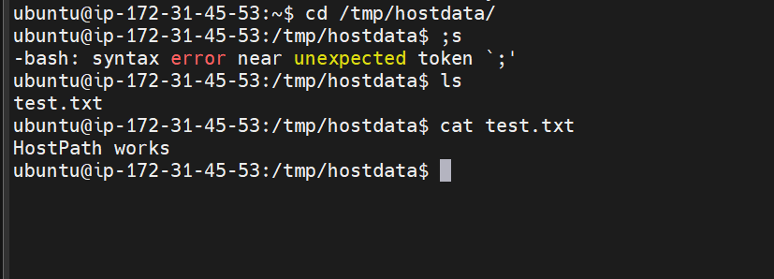

The folder is created
Lets now delete the pod
And again create the pod and see if the data exists

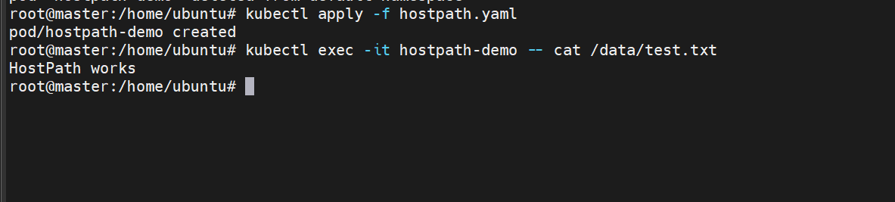

- Deploy an Amazon EBS Volume Using Persistent Volume and Persistent Volume Claim (PVC)

First lets create an EBS volume
It must me created in same region and same Availability zone

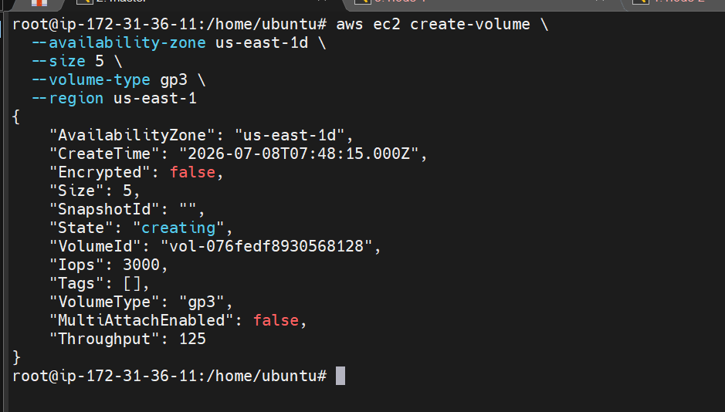
Here we are creating a 5gb volume in az us-east-1d
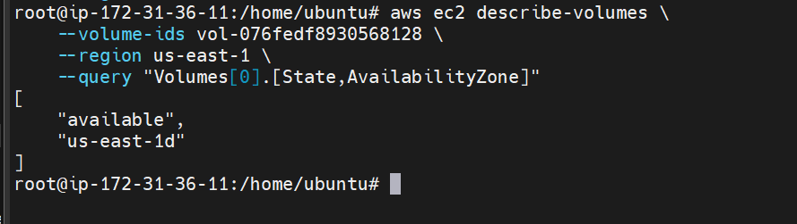
The volume is now created

Lets now create a role
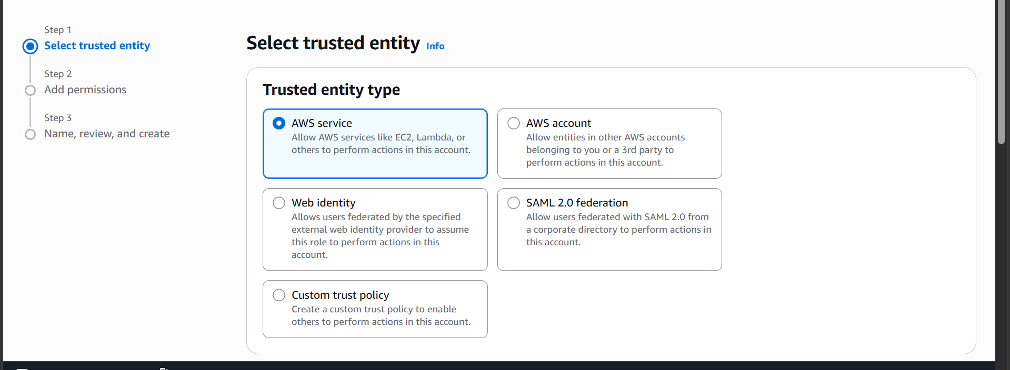
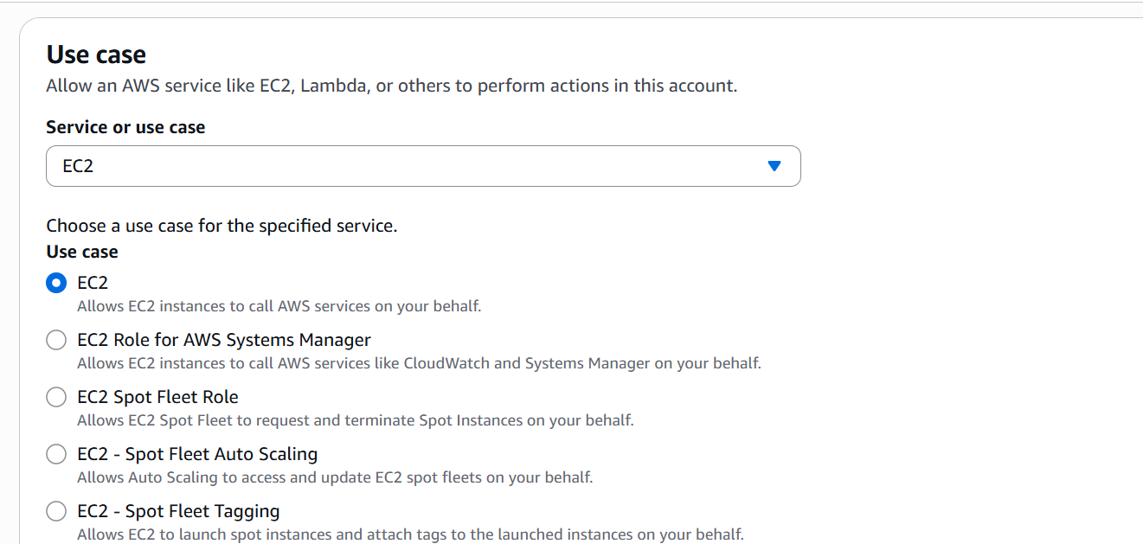

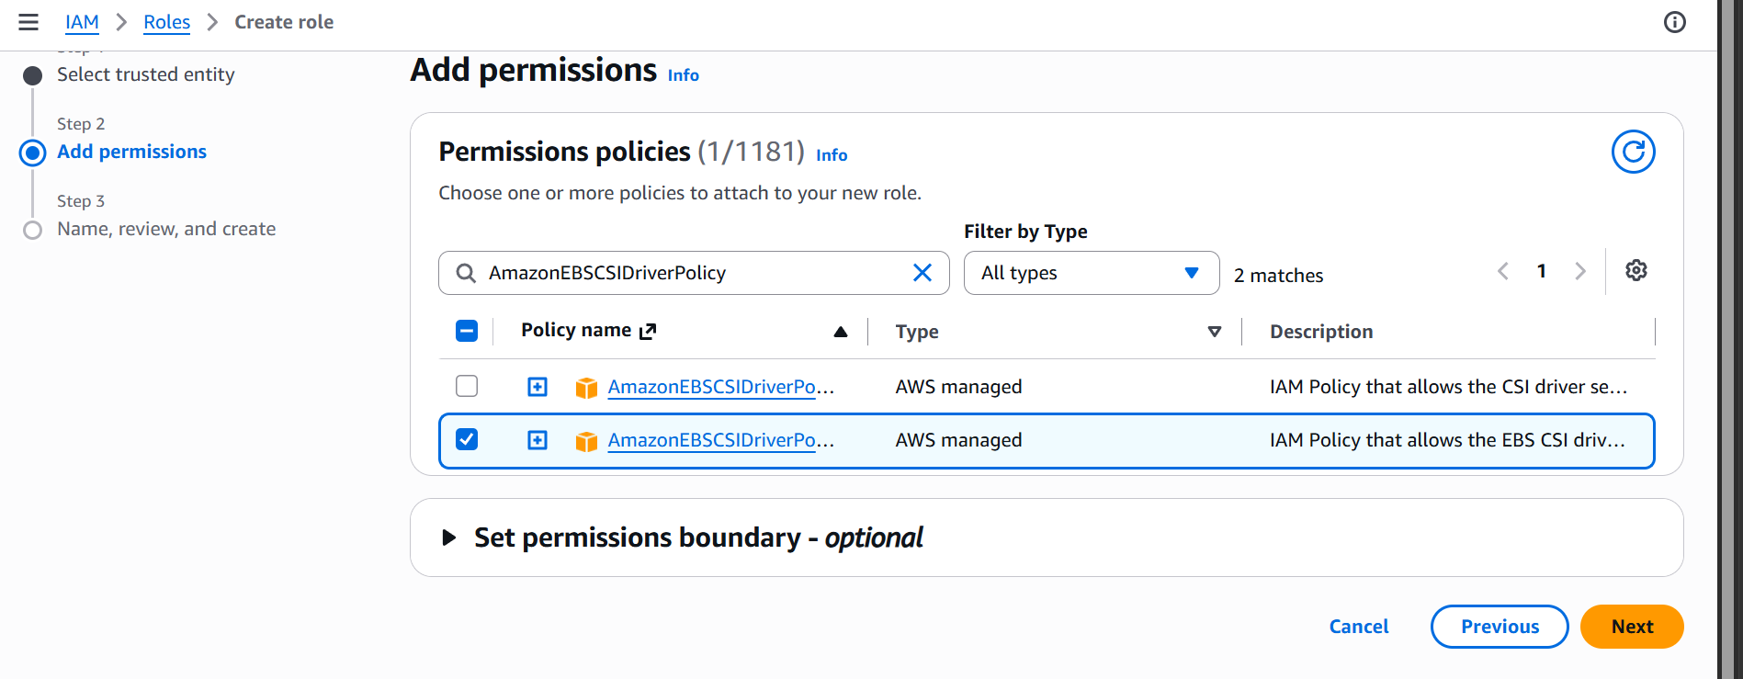

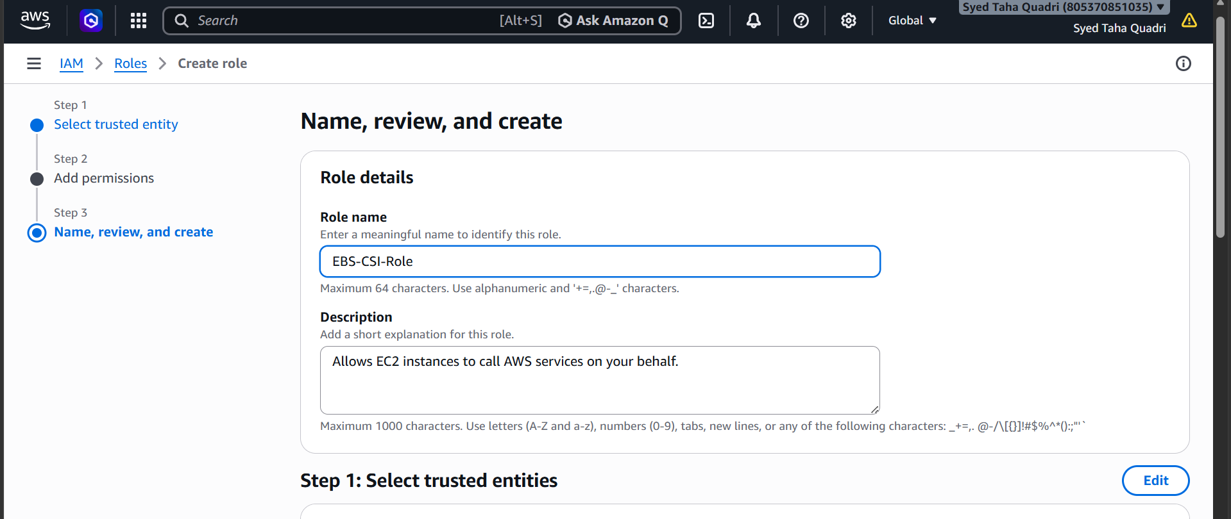

Now attach the role to all ec2 instances
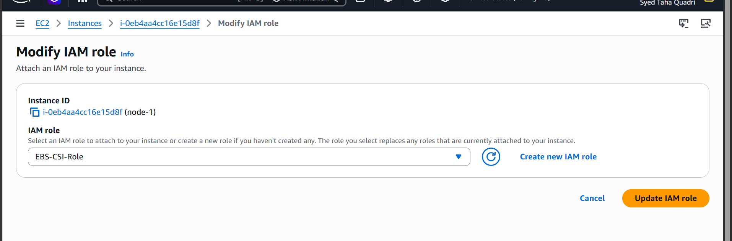

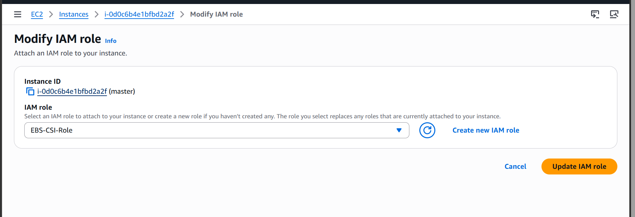

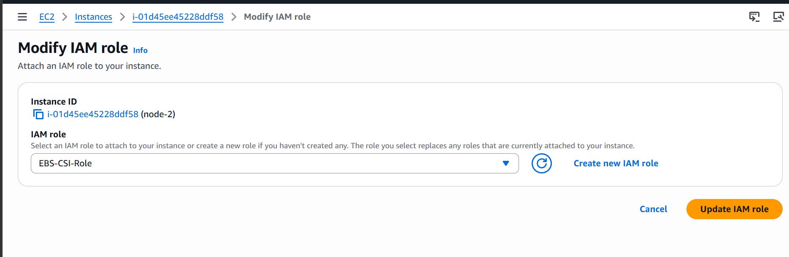

So now we have attached the role to master and nodes
Installing CSI driver
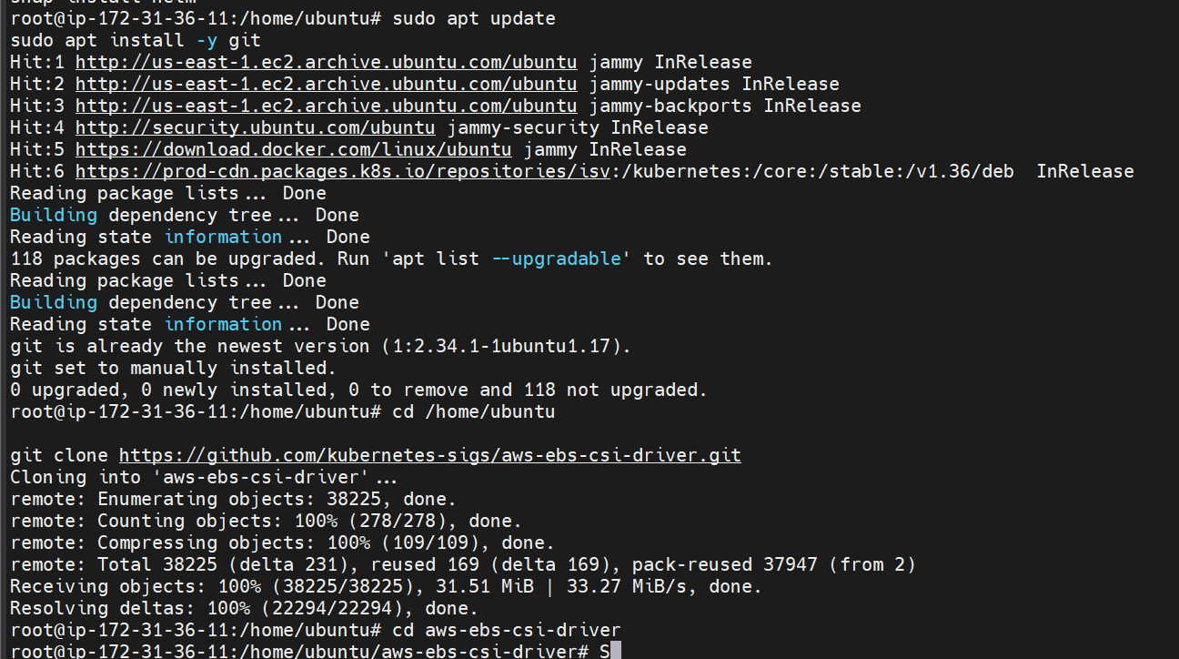
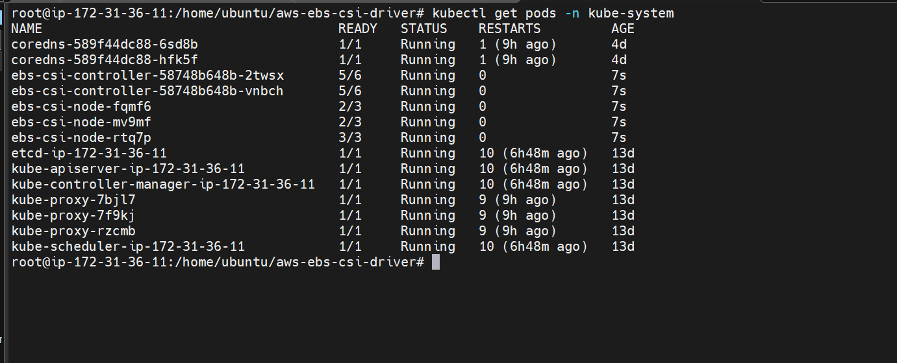

Csi driver is now installed

Now lets create the persistent volume

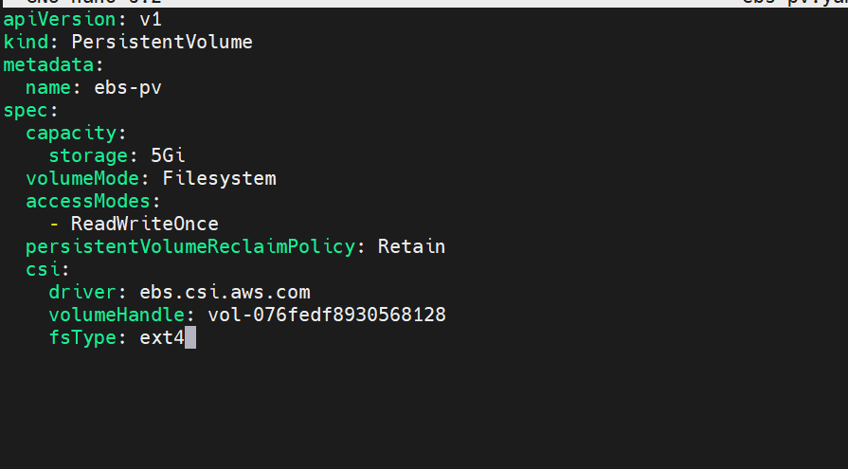

This is a yaml file which creates a PersistentVolume using the EBS volume which we created
Also one node can mount the volume for read/write at a time.

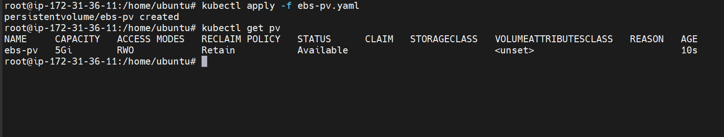

The persistent volume is now created

Now we have to claim the volume using PersistenVolumeClaim
Lets create the yaml file

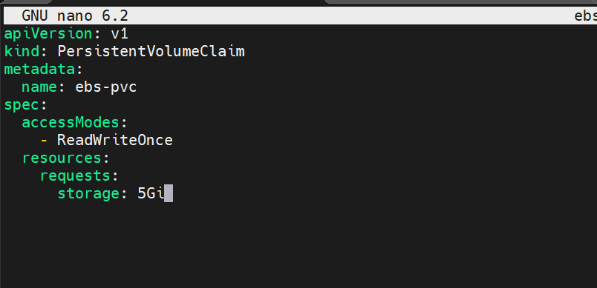

This is the file which claims the persistent volume

The pvc is now created
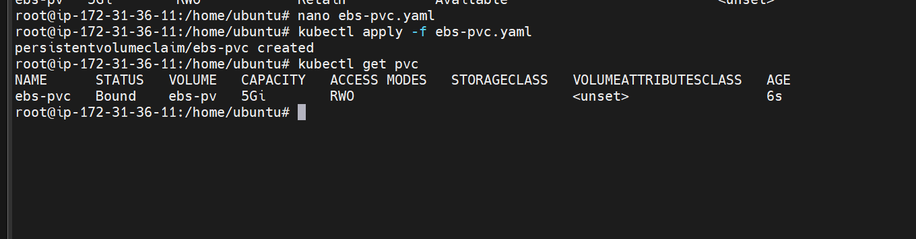
We can now see that the PersistentVolume status is now bound

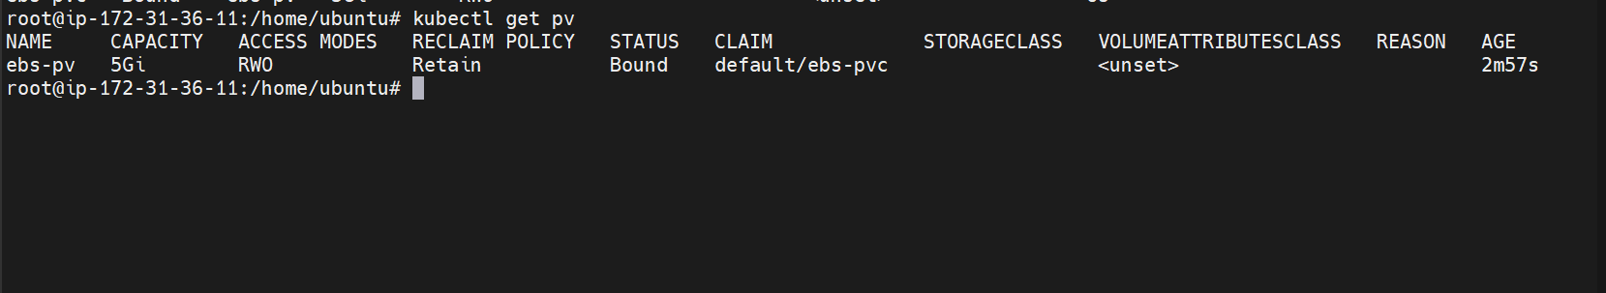
Now lets us create the pod using the pvc

Creating the pod using the pvc
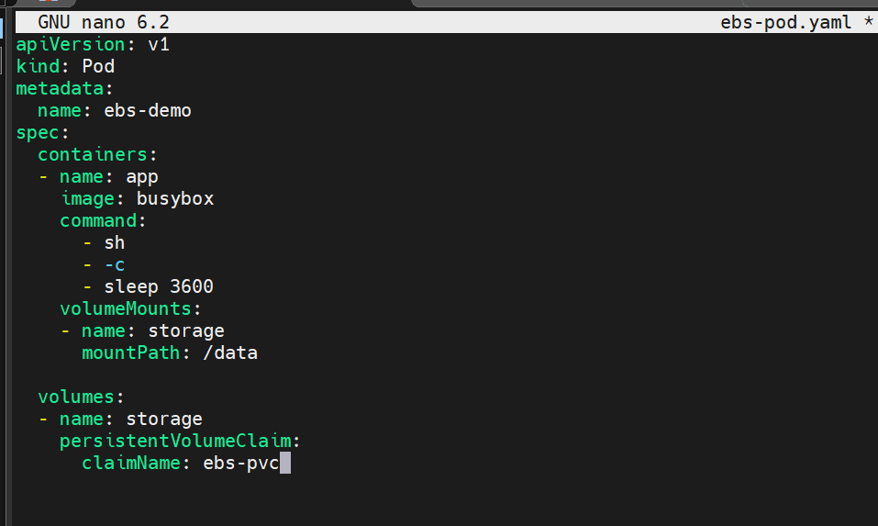

The pod is now created
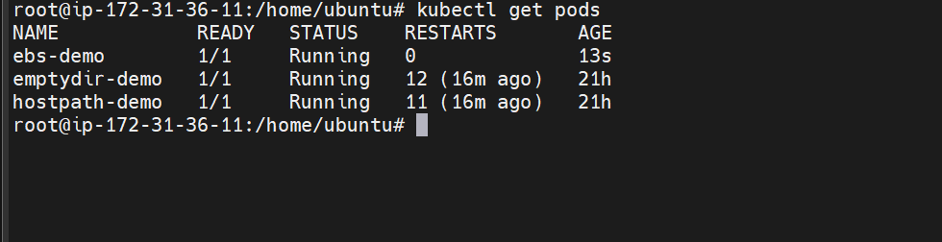

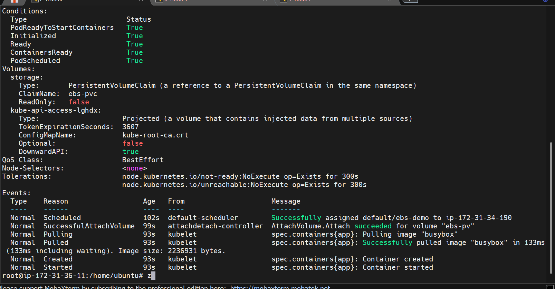

Now lets get inside the container and create a file
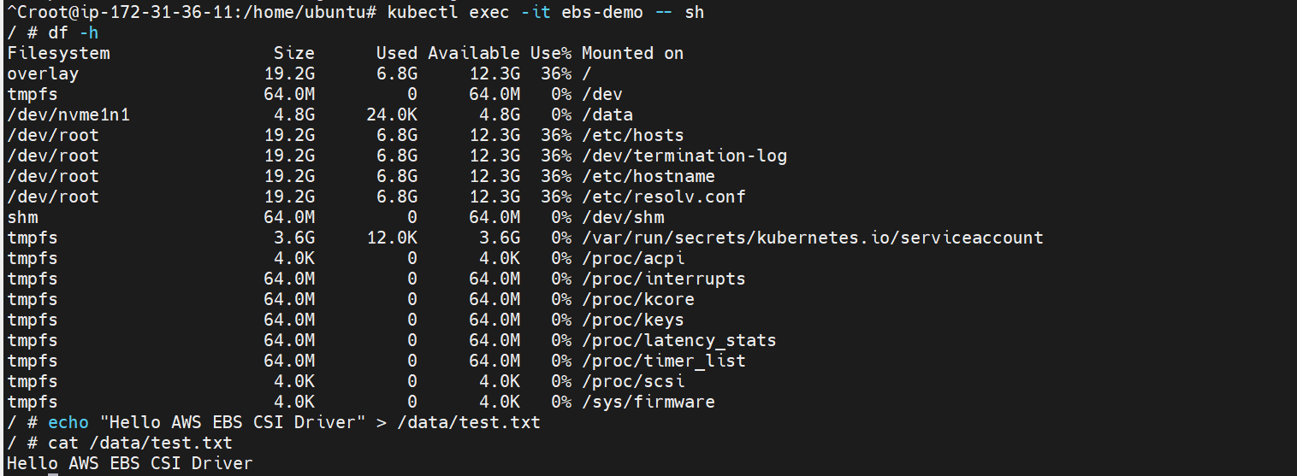

Lets now delete the pod and recreate the pod to check the persistent storage

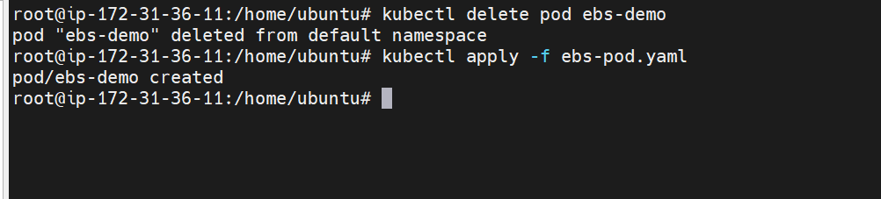

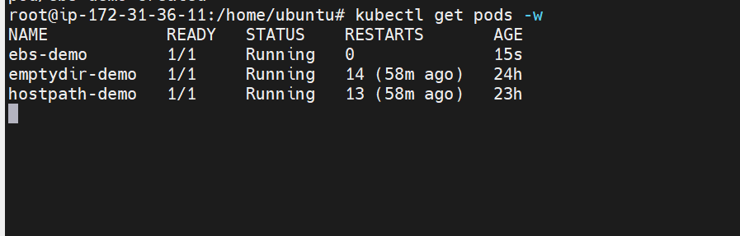

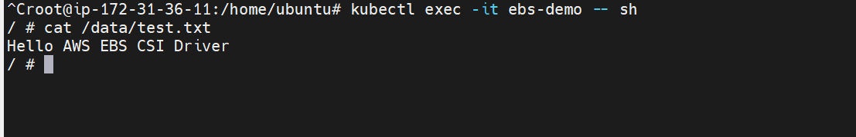
The data is available in the pod as well
So, the data is persistently stored in our volume.

- Set Up an Amazon EFS Volume and Attach it to Multiple Pods
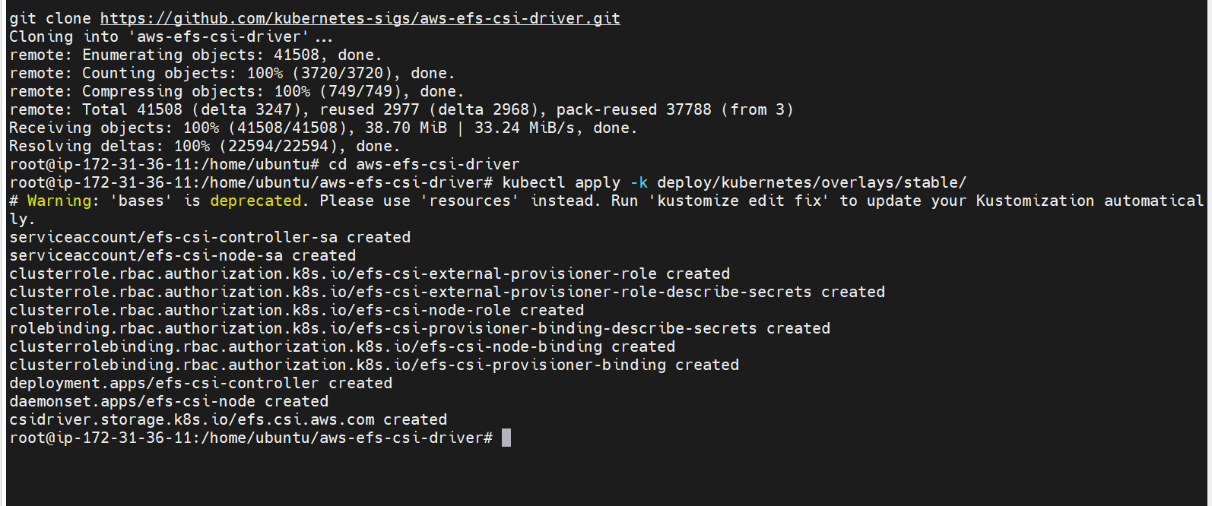

Installing CSI driver on Master
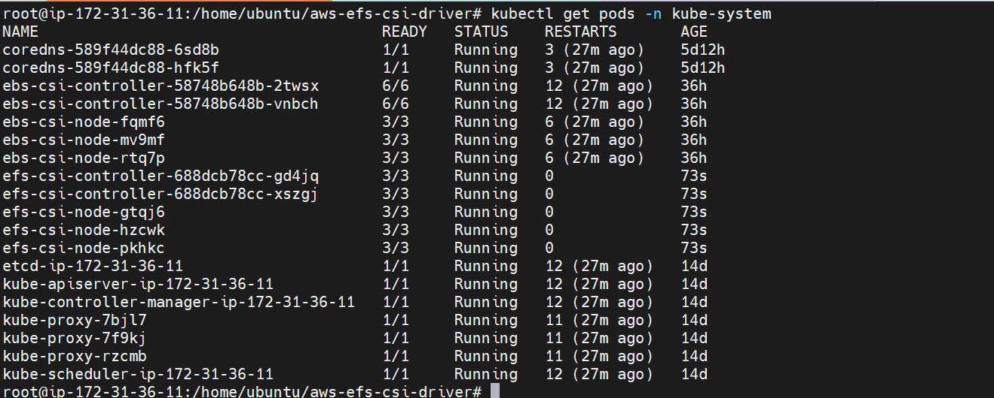

Now lets create EFS storage class
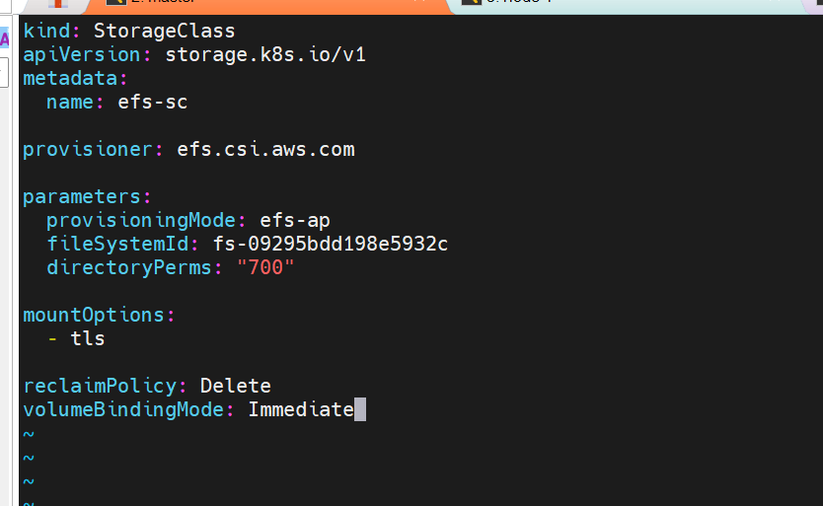

This the yaml file to create a storage class
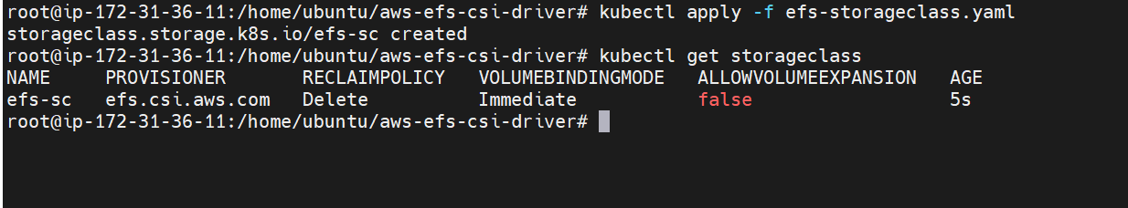
The storage class is now created

Lets now create EFS PVC
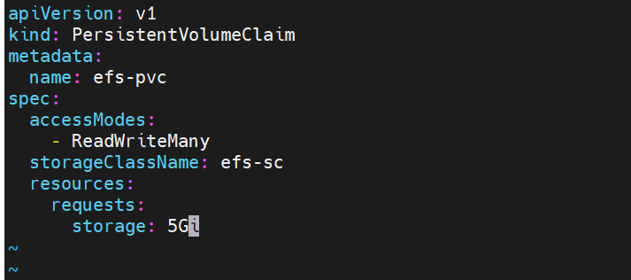
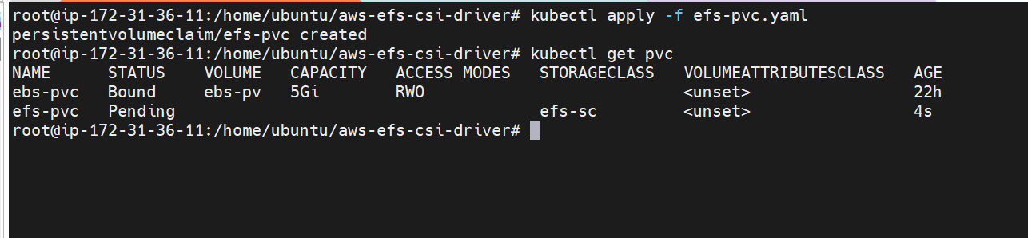
The PVC is now created
Attaching the EFS role to instances
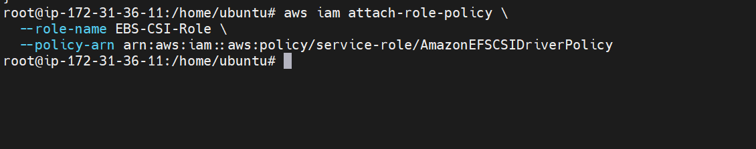
The EFS role is now attached to all the nodes

Now lets create the pods
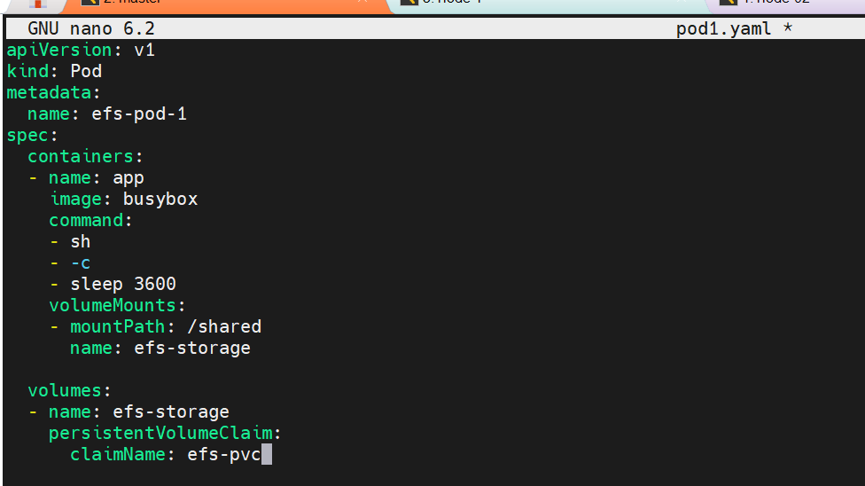

This the yaml file which creates pods and uses efs for persistent data storage
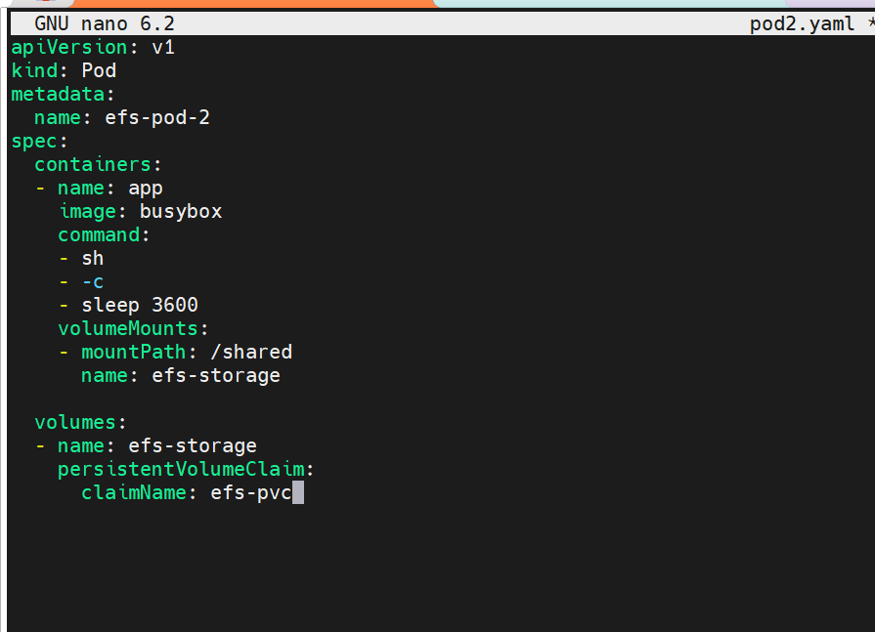
One more pod
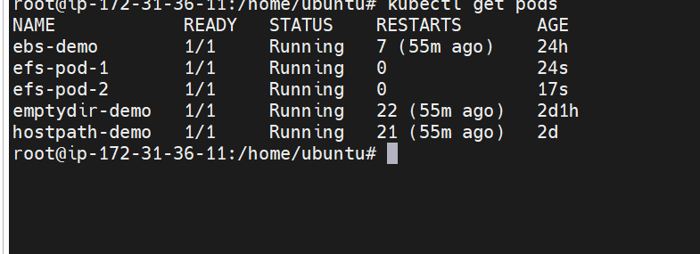

The pods are now created

Going inside the pod and checking the file system

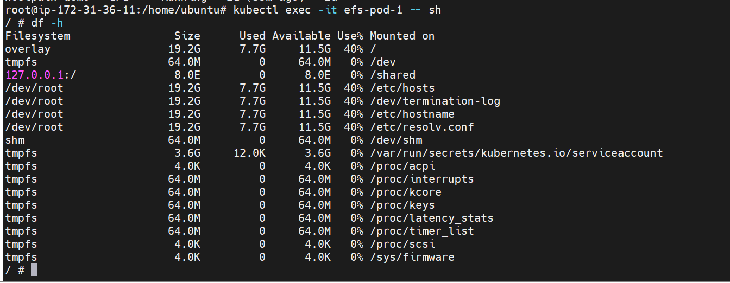

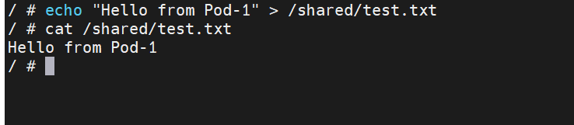
Adding the data in the pod1

Now lets get into the pod2 and check the data is available or not

7. We can see that file is present in the second pod as well
What are Liveness and Readiness Probes?

Probe | Purpose
Liveness Probe | Checks if the container is alive. If it fails repeatedly, Kubernetes restarts the container.
Readiness Probe | Checks if the application is ready to receive traffic. If it fails, the Pod stays running but is removed from Service endpoints.

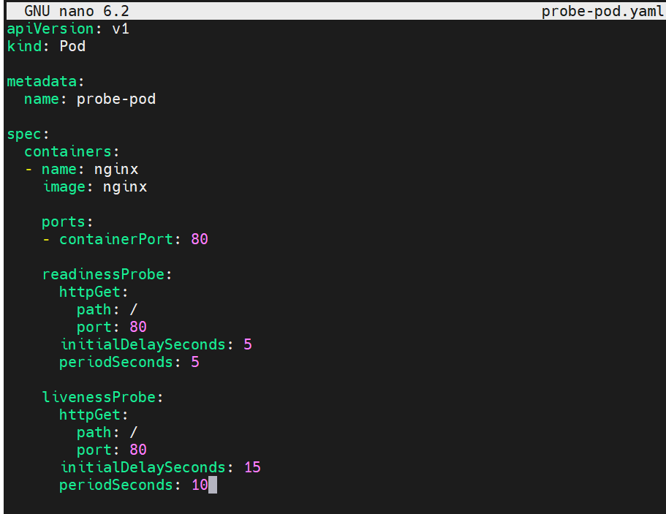

This is the yaml file to create the pod with liveness pod and readiness probe
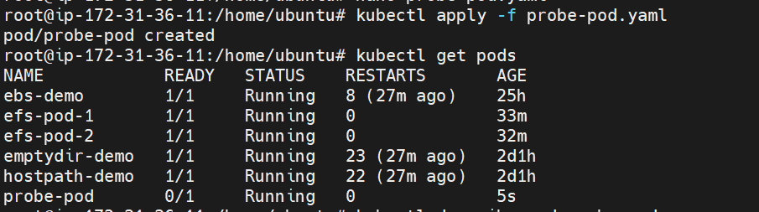
The pod is created
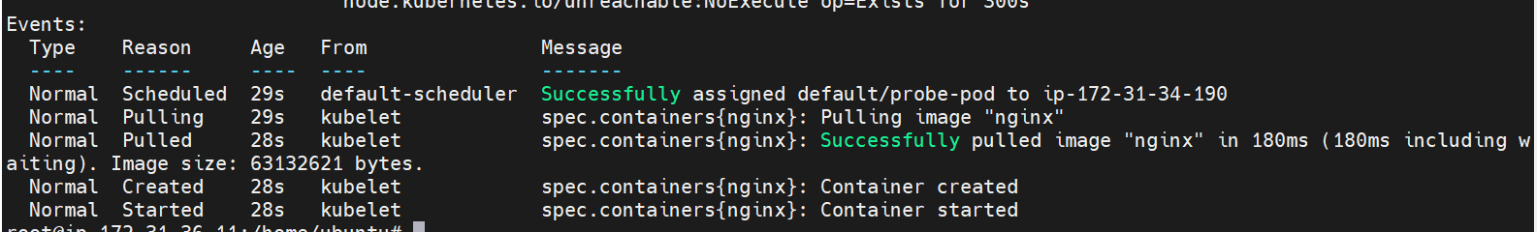

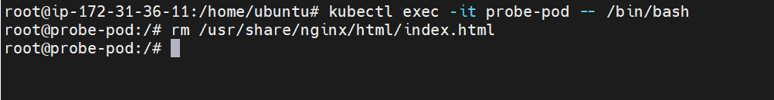

Getting inside the pod and deleting the file
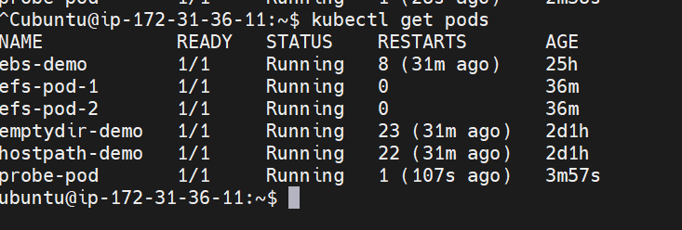

It can be seen that the pod is already restart
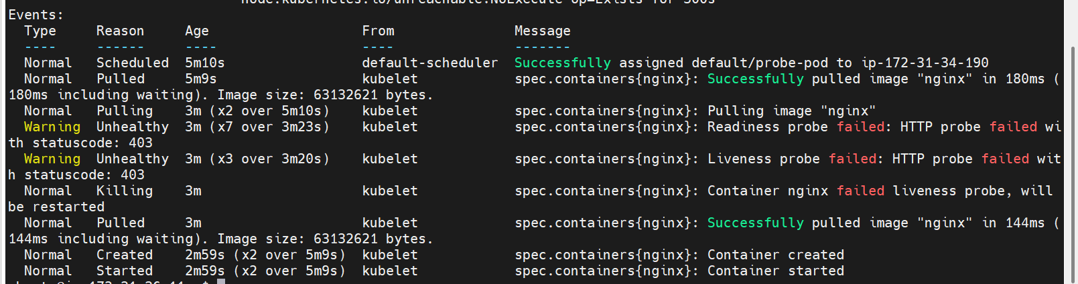

Readiness and liveness probe has been failed

