- Execute all the steps shown in video.

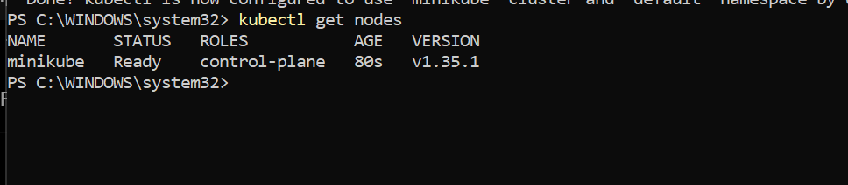
We have the minikube cluster ready
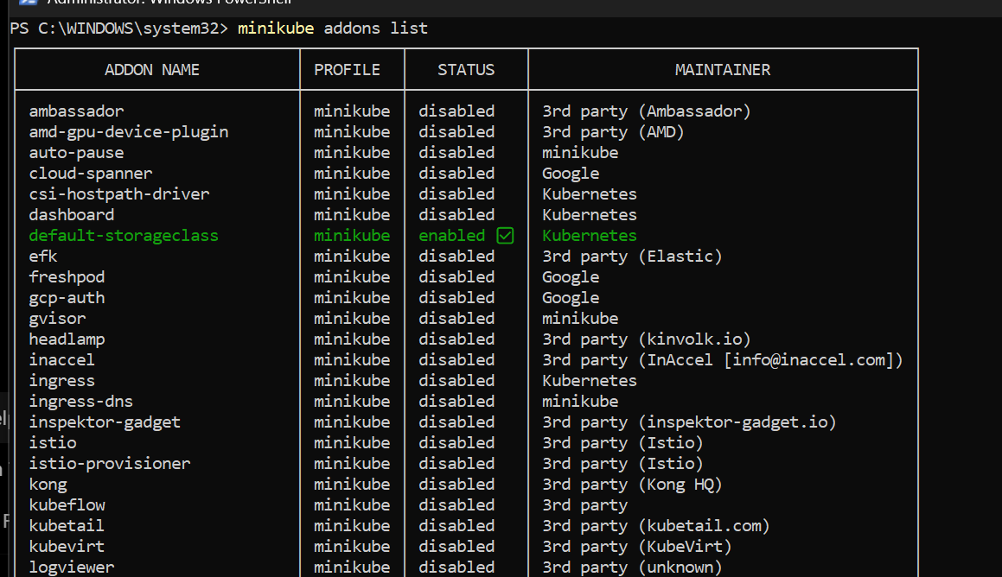
Enabling ingress add on
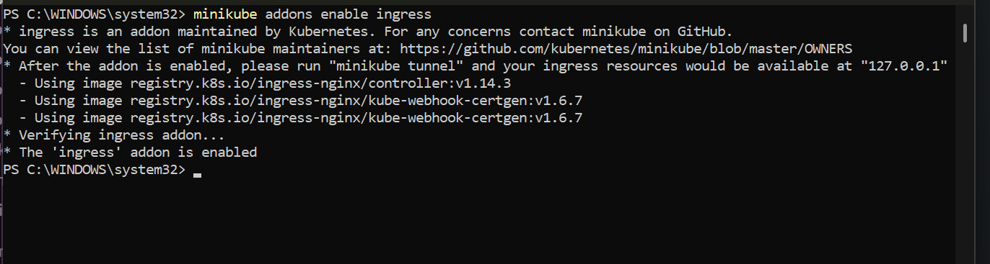
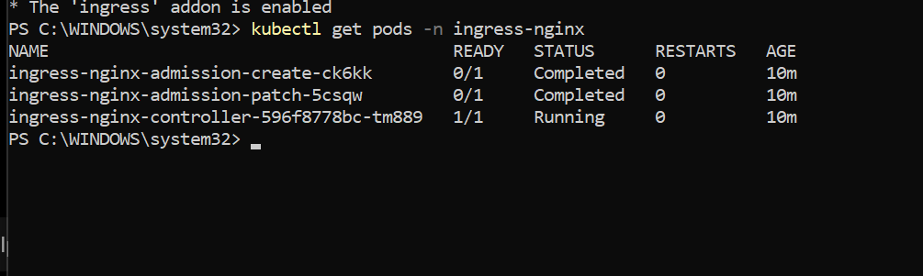

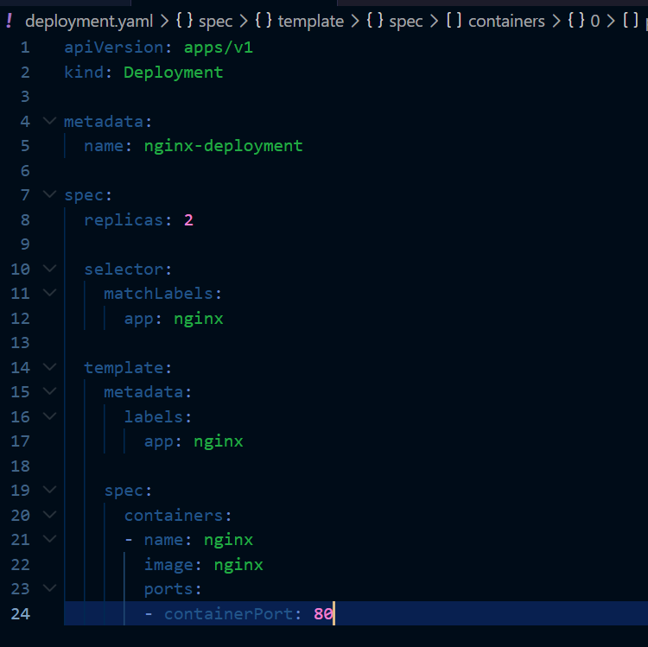
Creating a deployment with 2 replicas of nginx containers
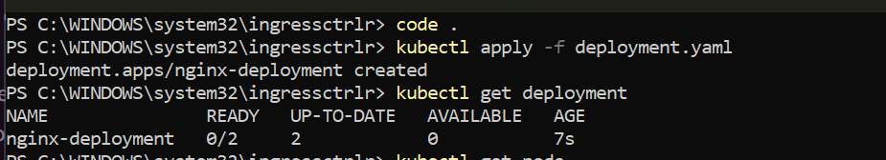
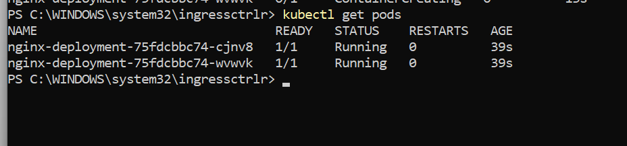
The deployment is now created
Creating a cluster Ip service for the deployment
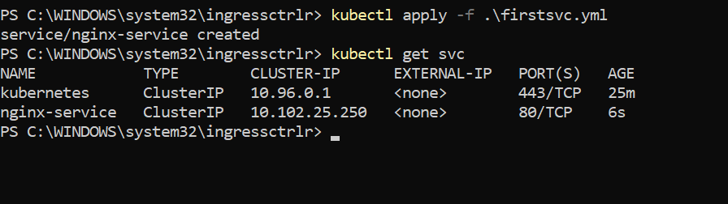
The service is now created
Now lets create the ingress resource
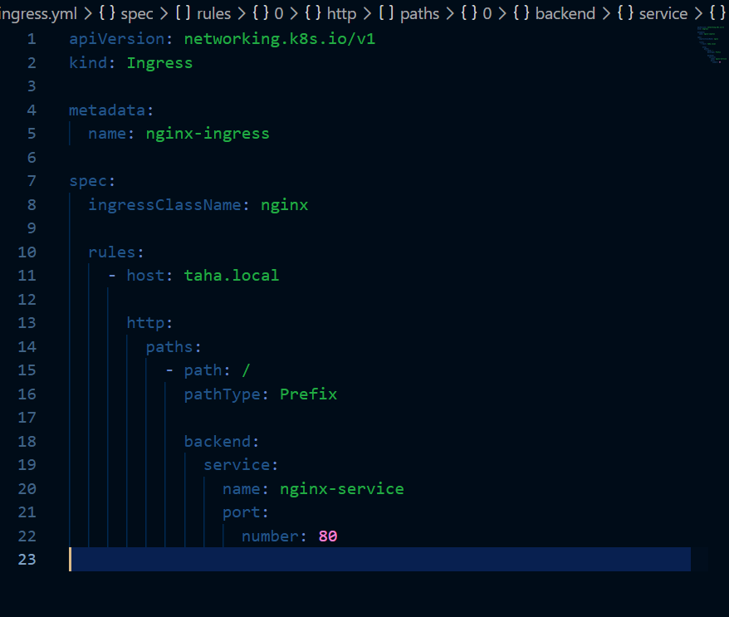
This is our ingress creation file
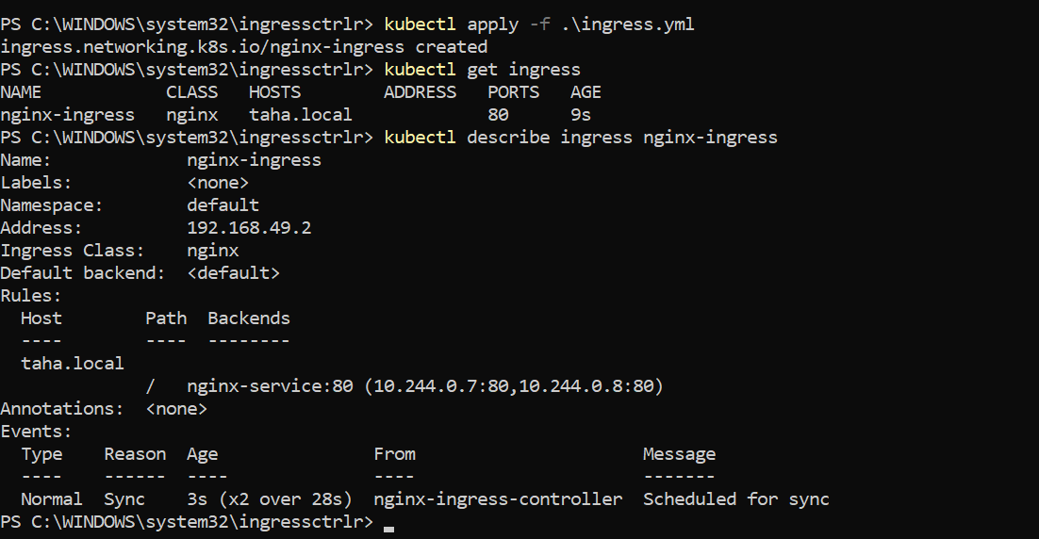
The ingress resource is now created
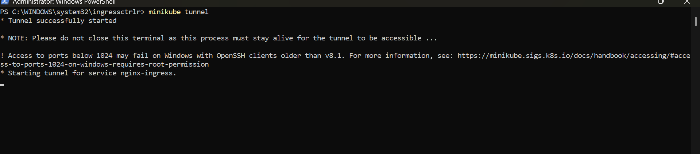
Starting the minikube tunnel
Edit the host file
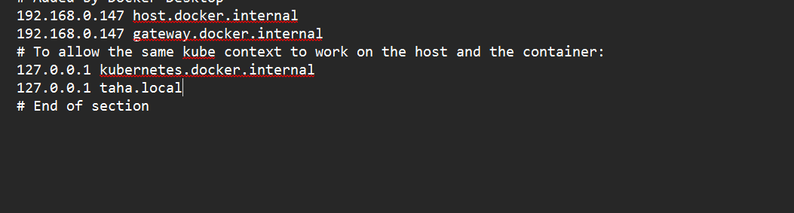

Lets try to access the url
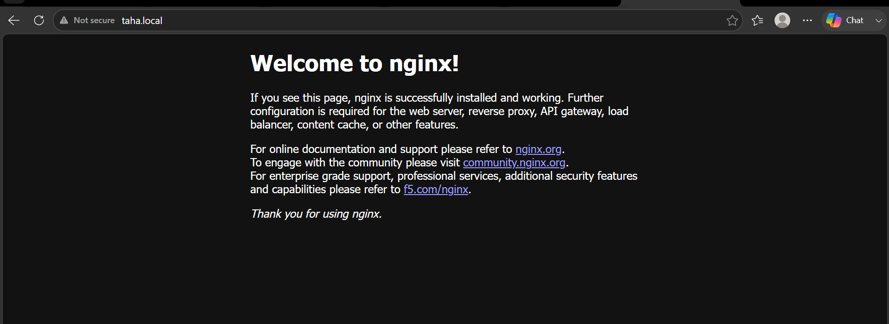
We are able to access our pod using the url

- Upgrading the k8s version

We have 1 master node and 1 slave machine in our k8s cluster which we created with k8s 1.35 version to complete the task

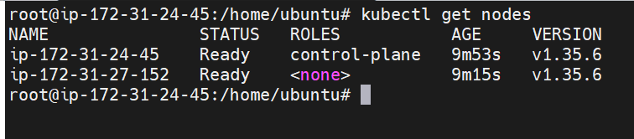
The Kubernetes version which we have is 1.35.6
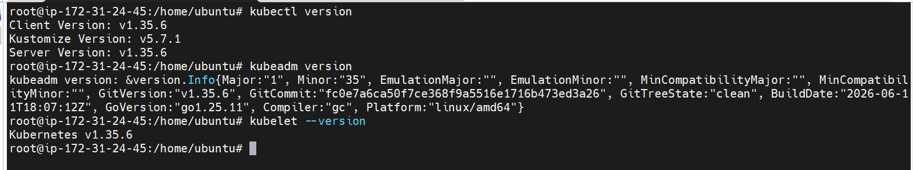

Lets now update it
Staring from the master
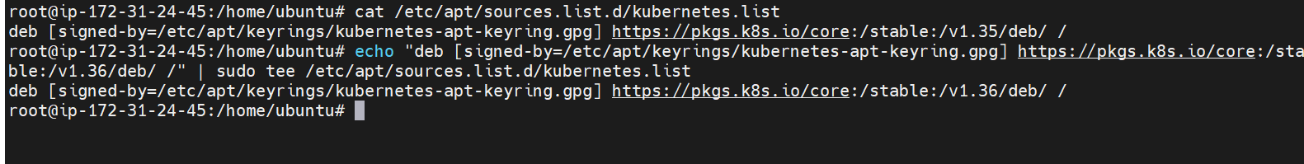

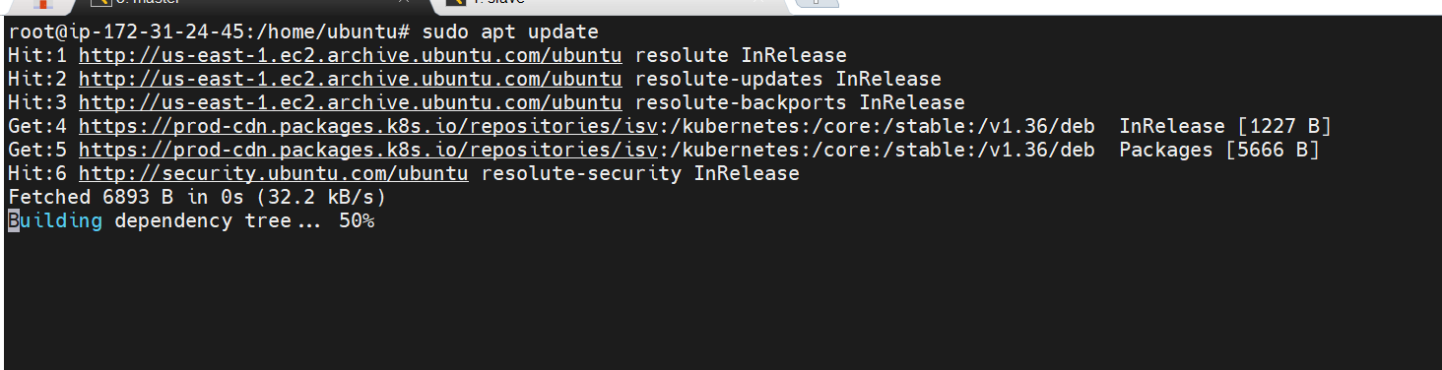
Updating the packages
First lets update kubeadm

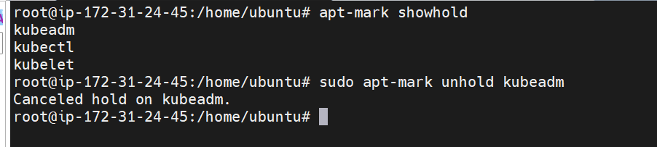

Cancelled the hold on kubeadm
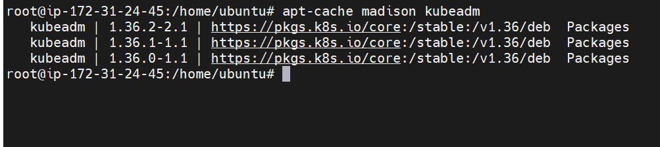

These are the updates available
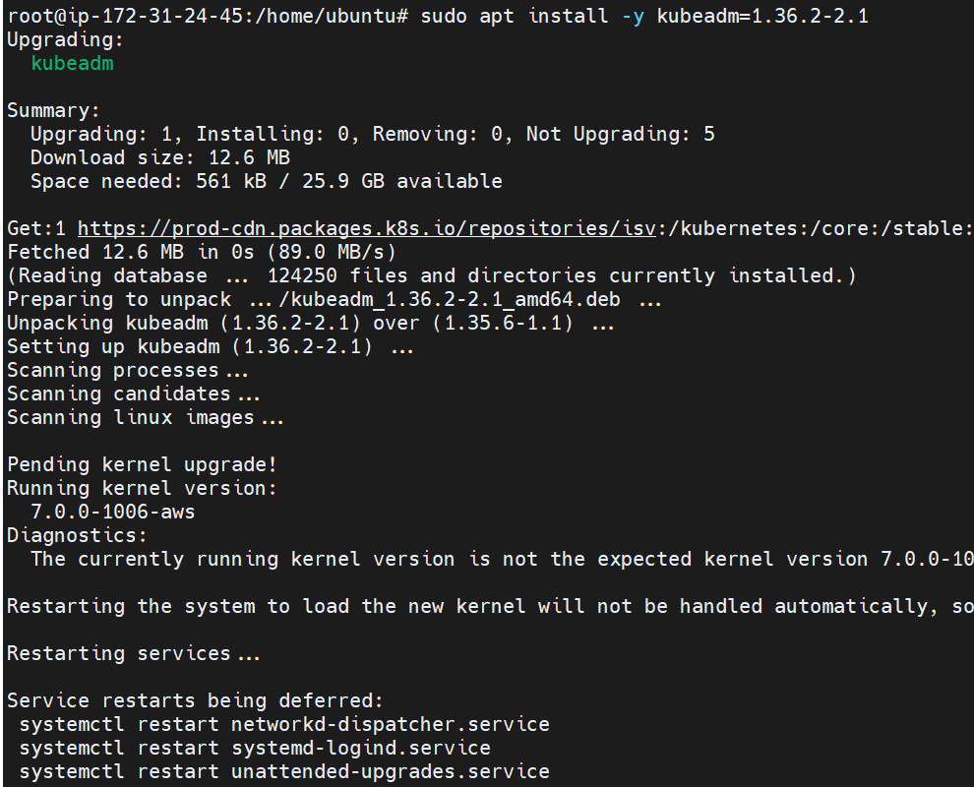

Updating the kubeadm
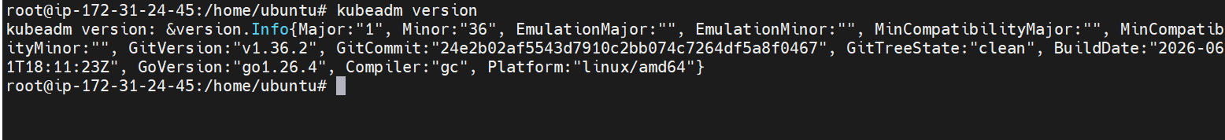
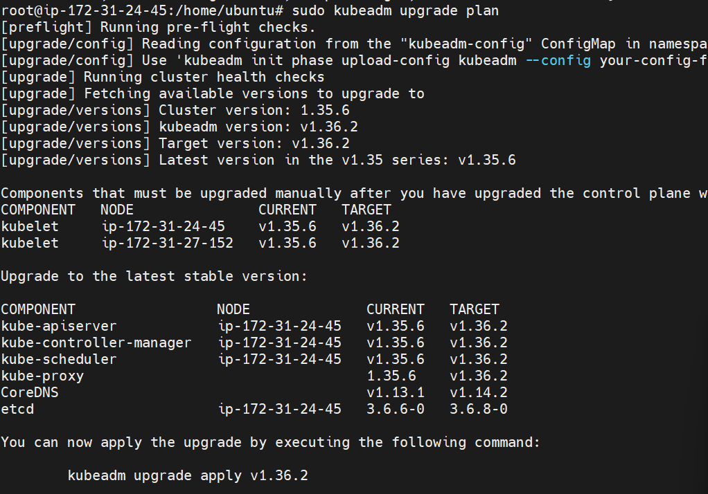

This is the update available
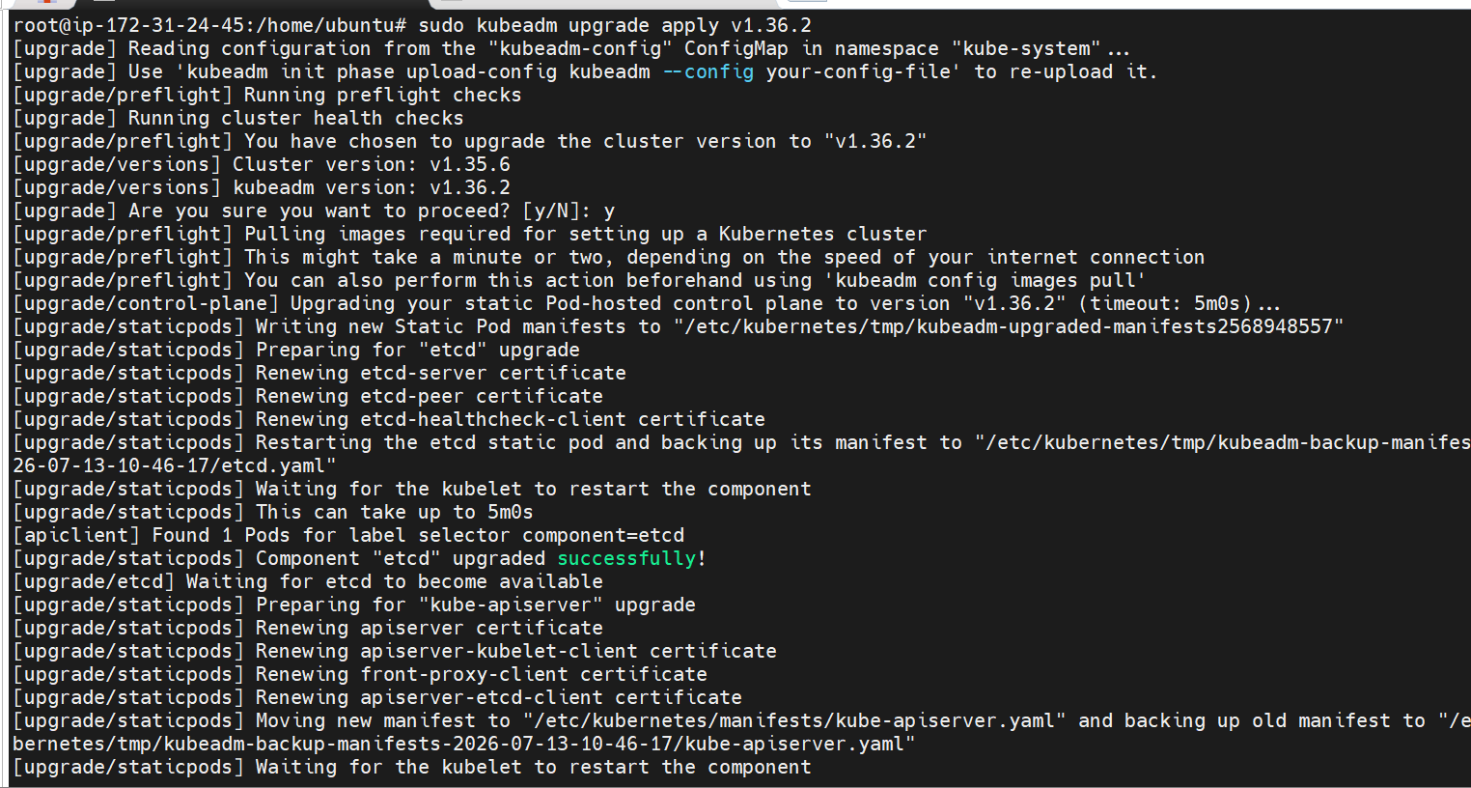
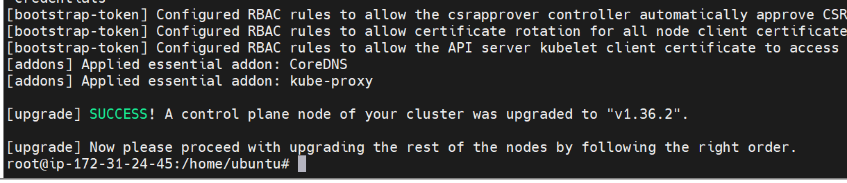
Upgraded to 1.36.2
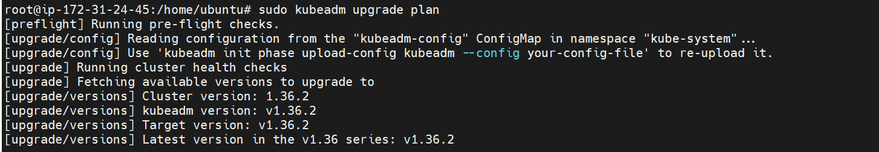

Let’s upgrade kubectl and kubelet
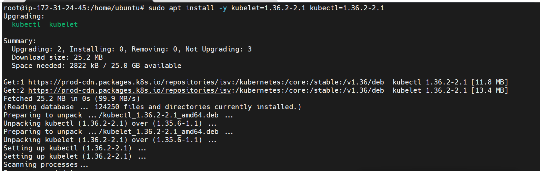

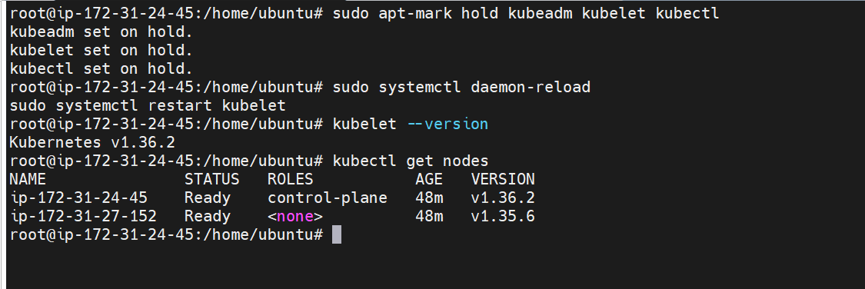

The kubelet is also upgraded
Let’s upgrade the node as well
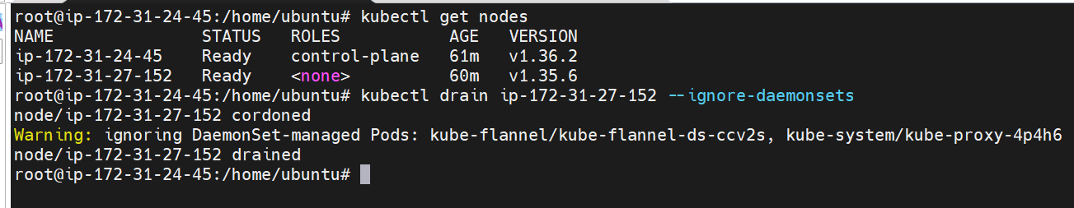
Draining the node
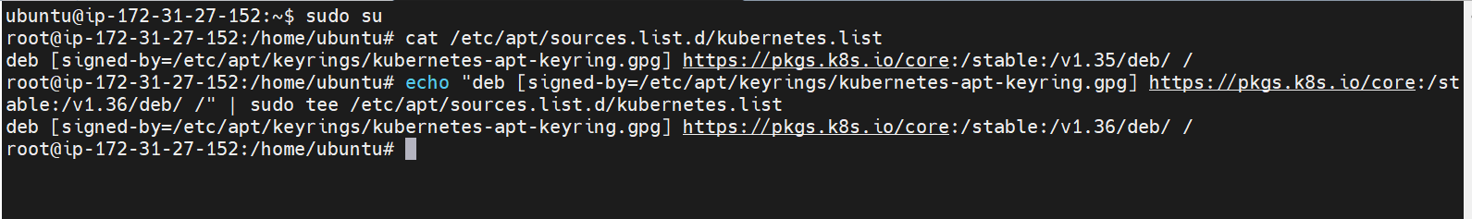
Updating the package
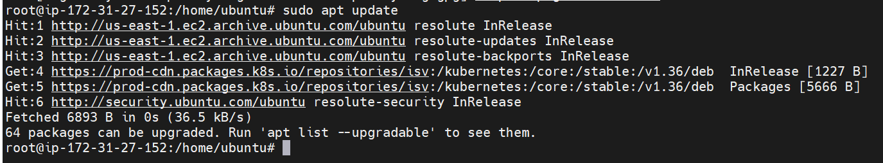

Un holding the kubeadm,kubelet and kubectl
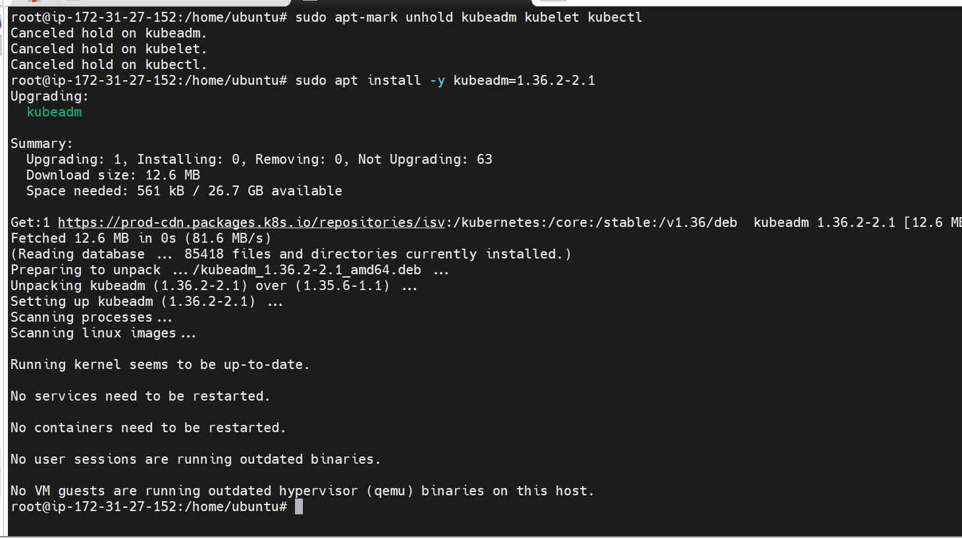

The node is updated as well
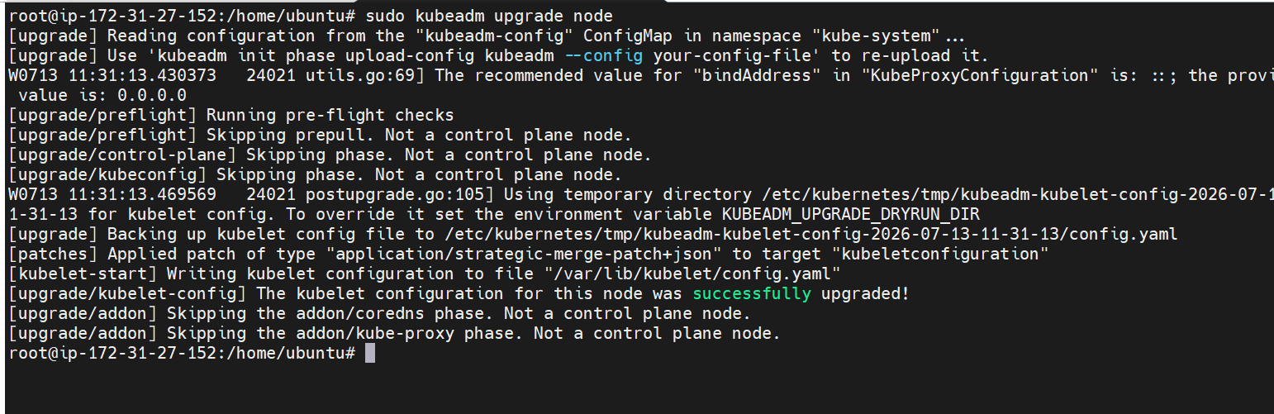
To 1.36.2
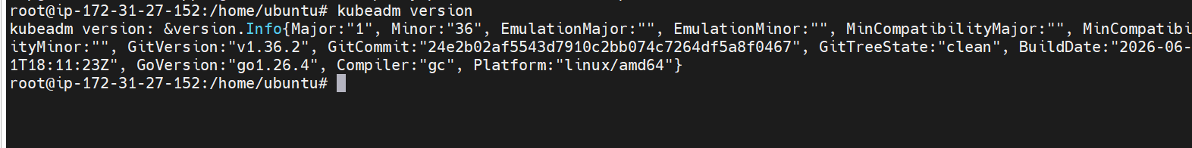
Now lets upgrade the kubelet and kubectl
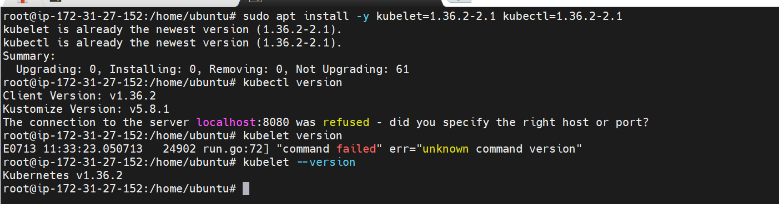
The kubectl and kubelet is also updated
The node is uncorded as well
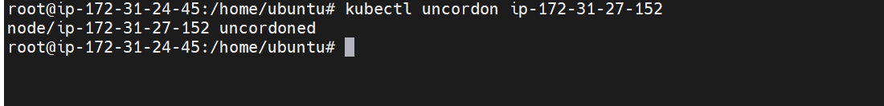
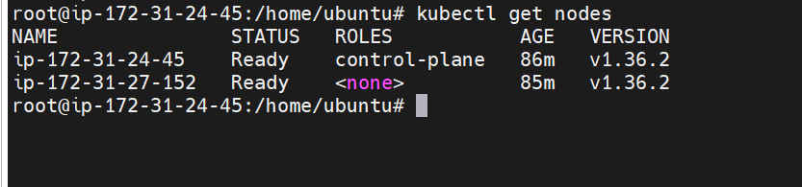

The control plane and data plane is updated

