- Setup eks cluster using eksctl
Lets setup the eks cluster using eksctl
We have all the required things installed
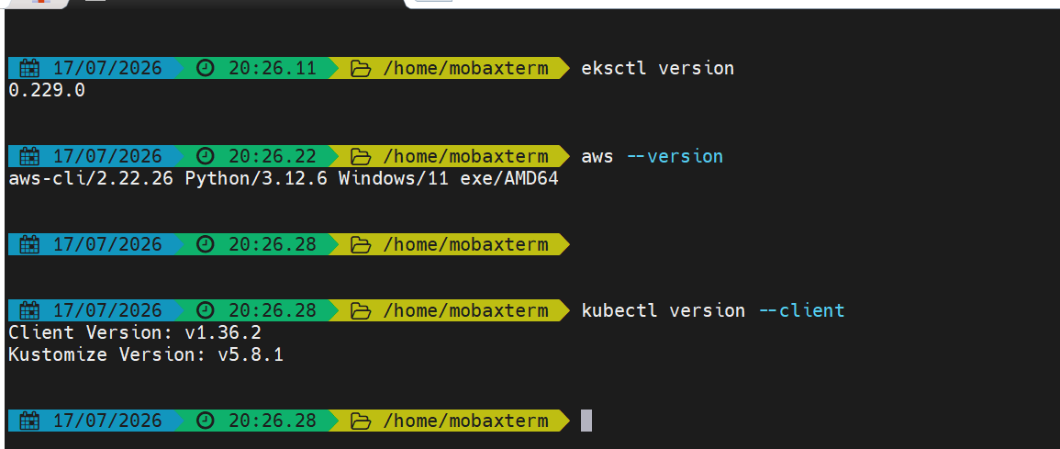

eksctl is an official CLI tool that automates EKS cluster creation.
Lets create the cluster first-cluster with 2 nodes with c7i-flex.large instance type
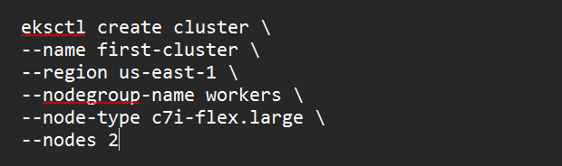

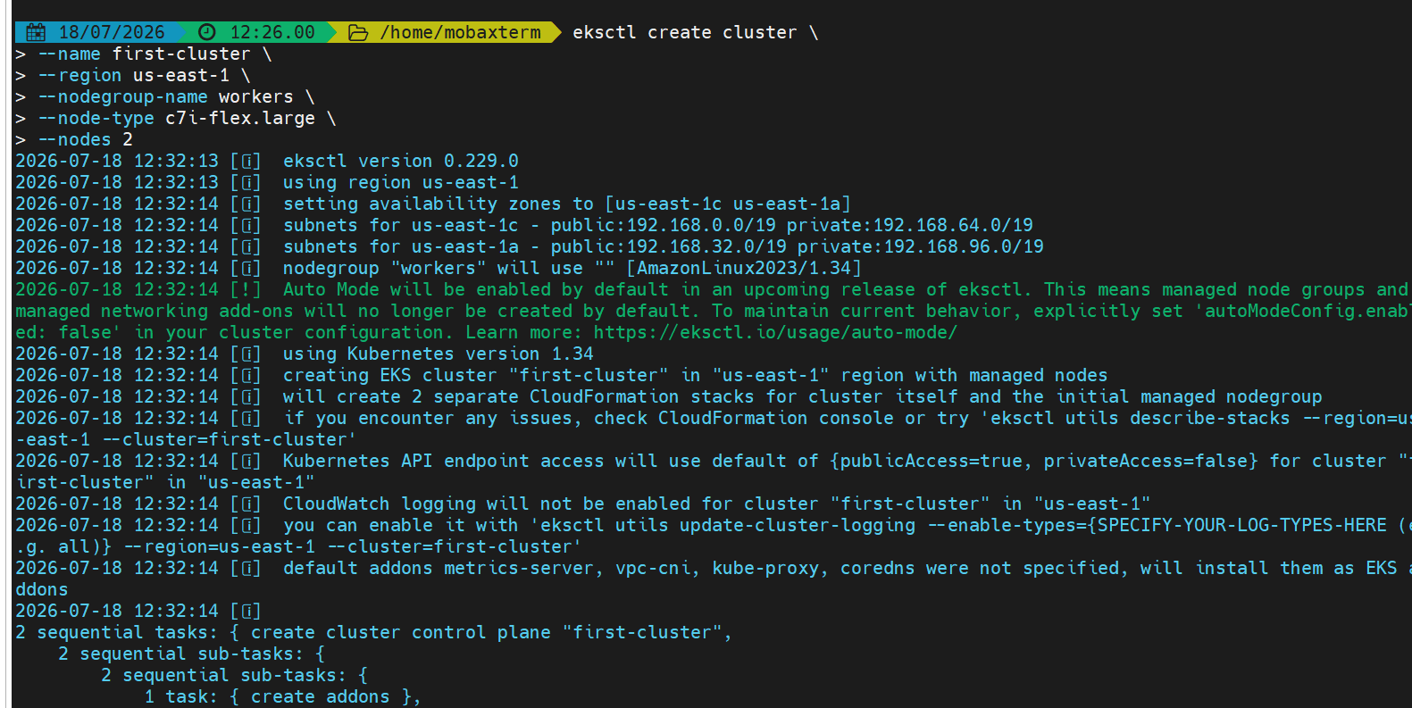

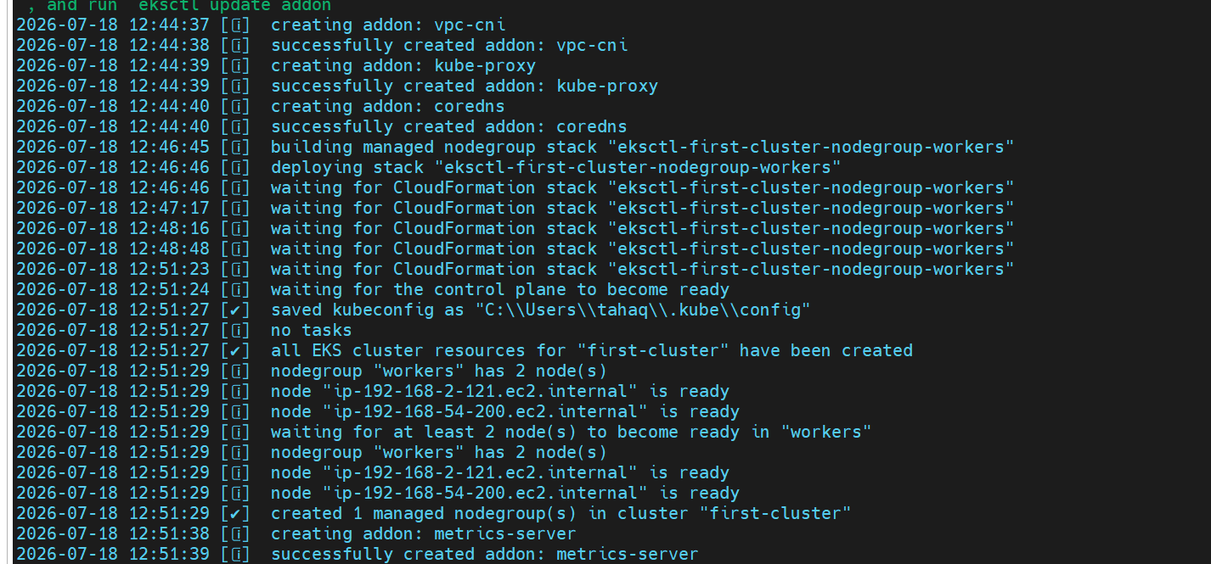
The cluster has been created
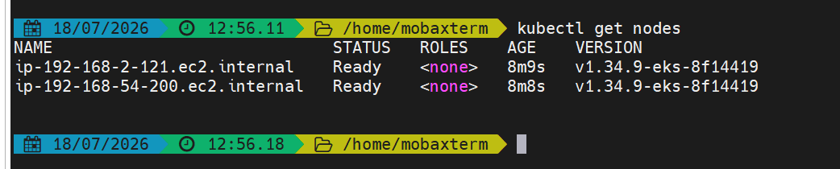
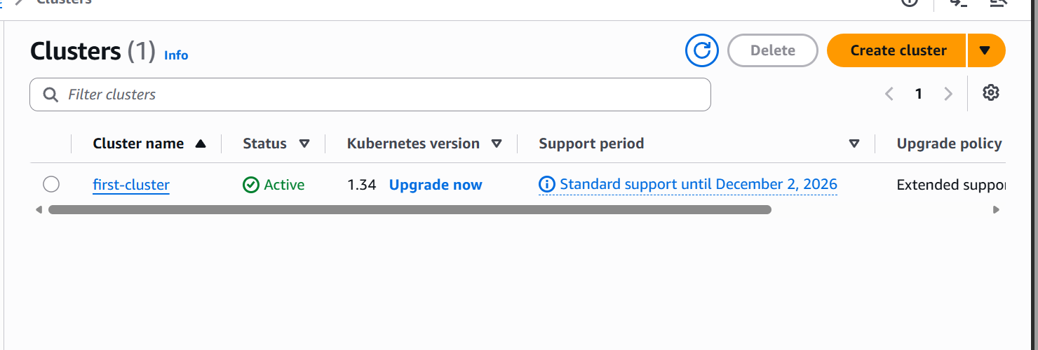

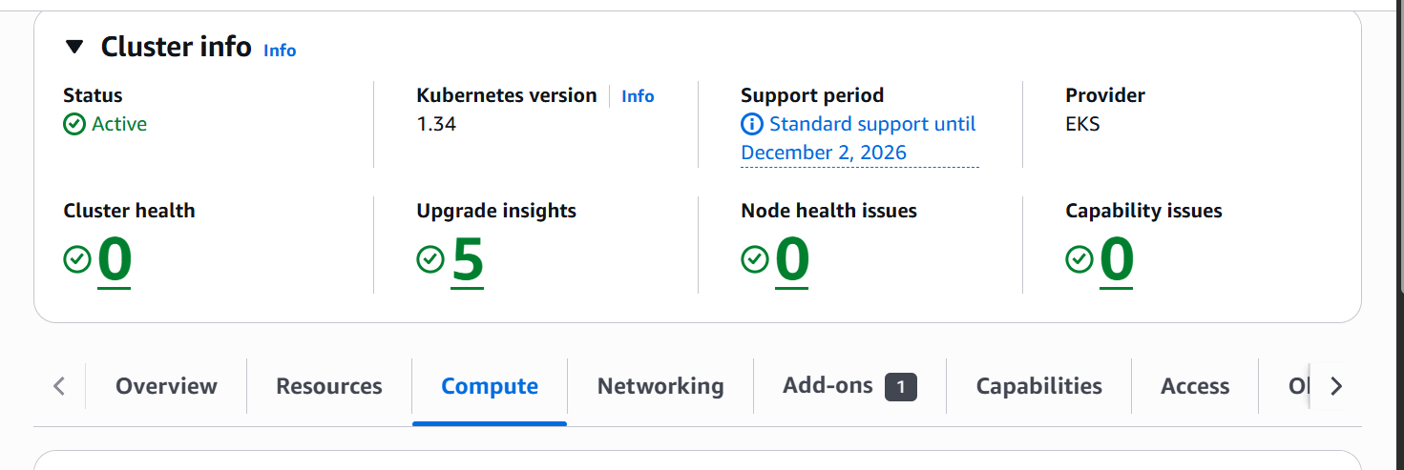

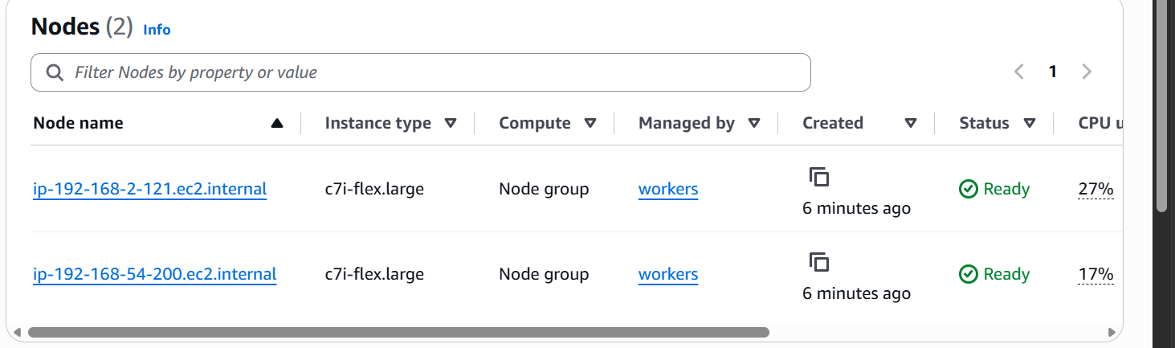

This is the node-group
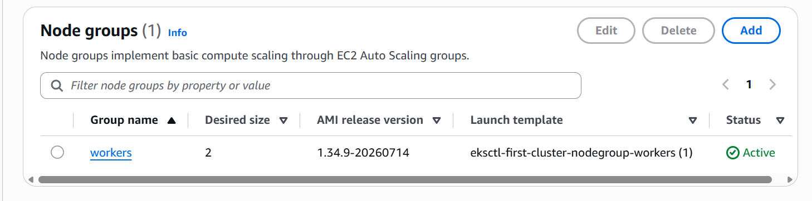
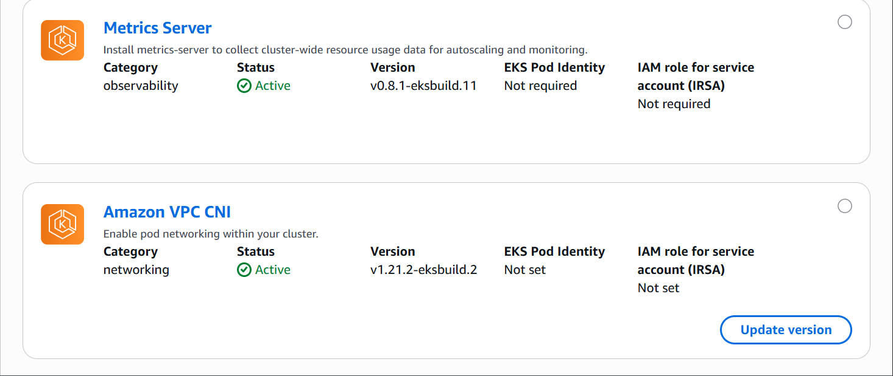
These are the addo-ons that the cluster has.

- Setup EKS cluster using console
First lets create an IAM role

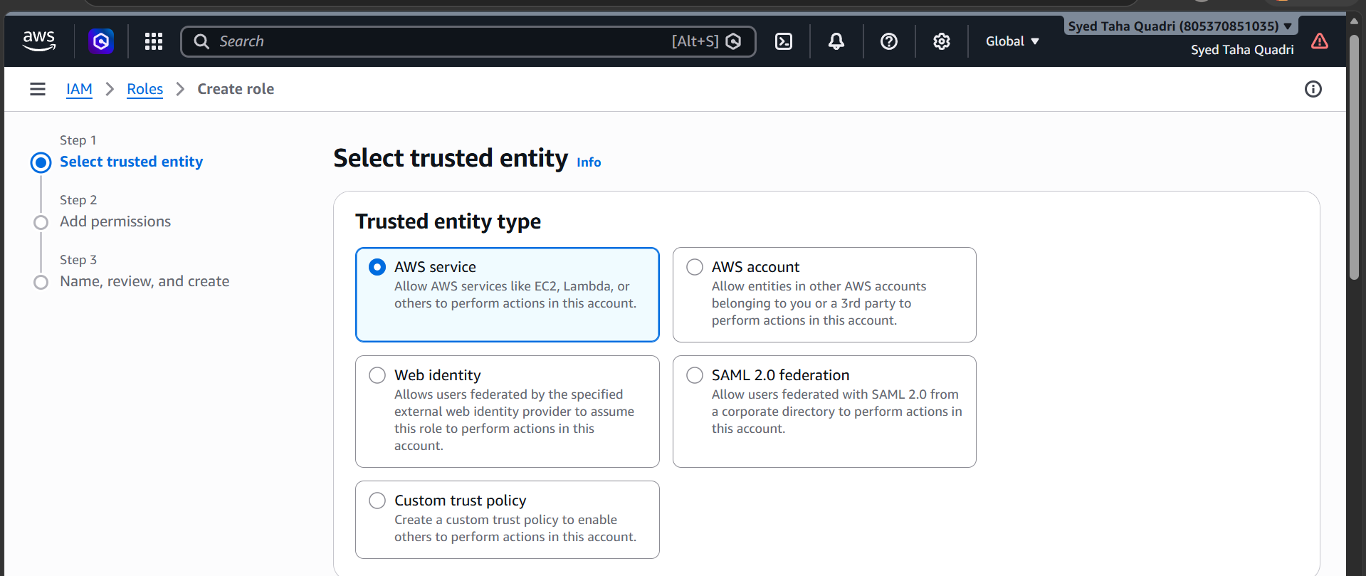

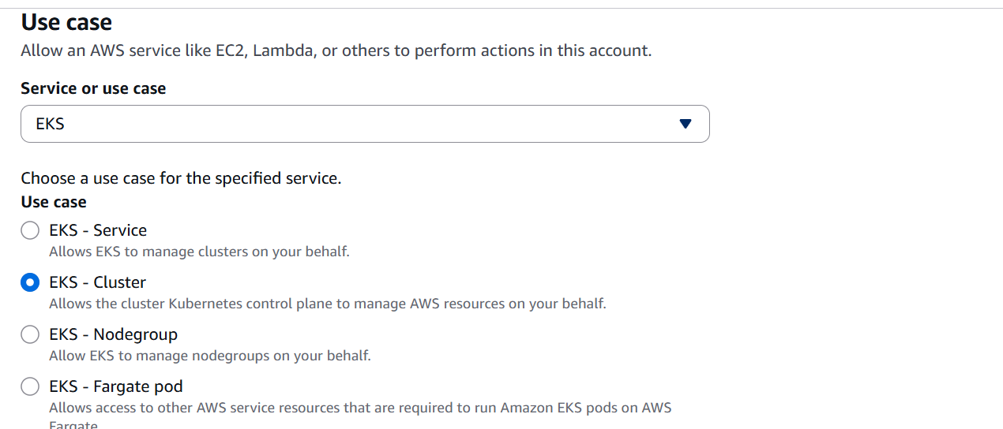
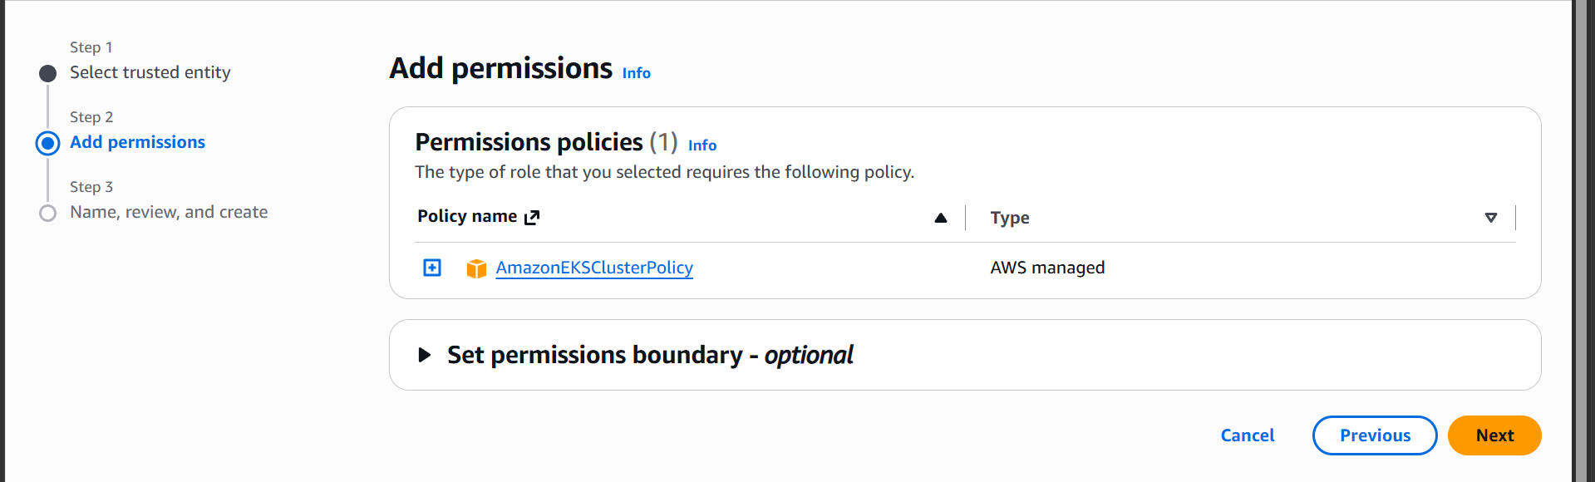
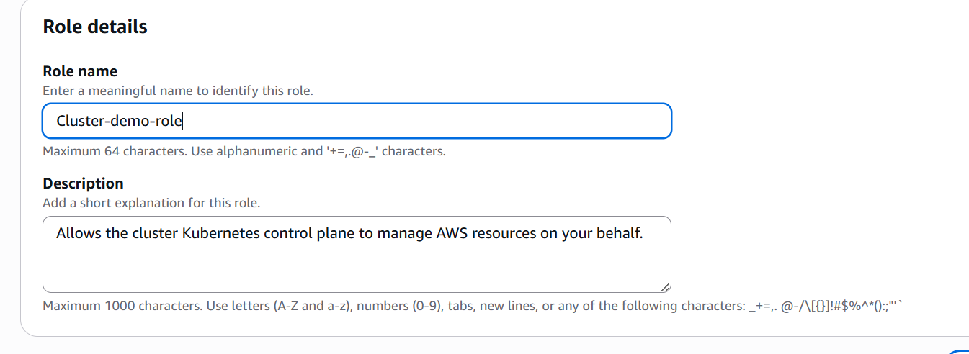
Lets create node group role
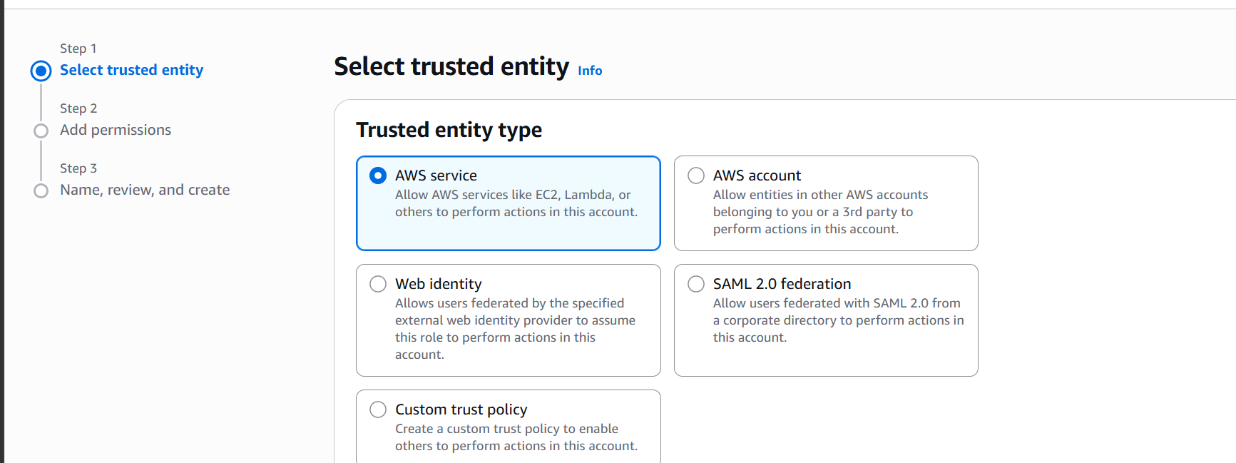
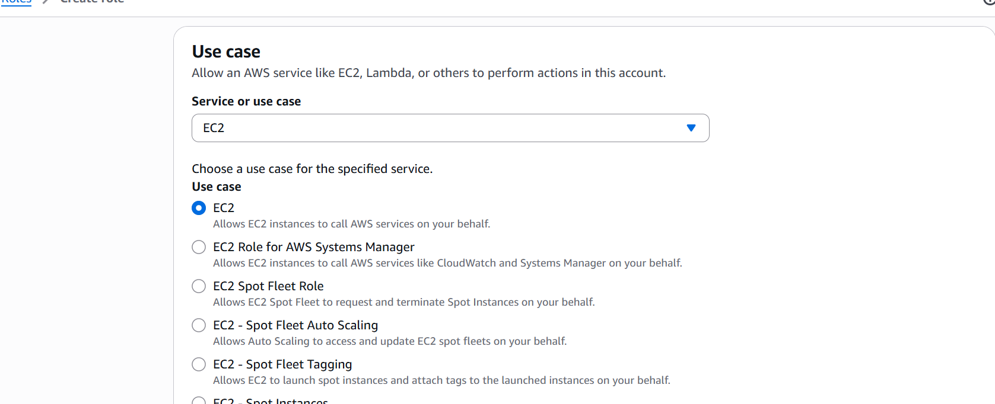
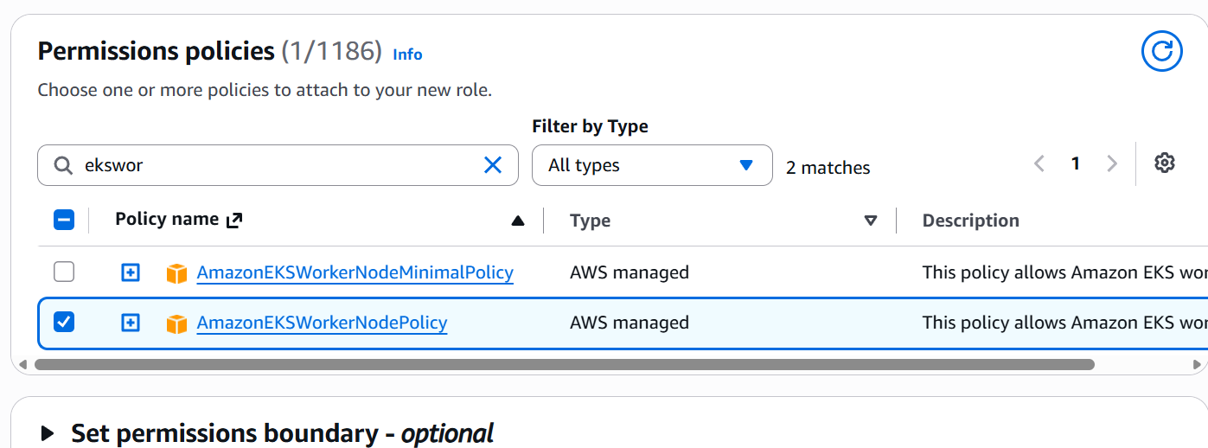
Attach these policies
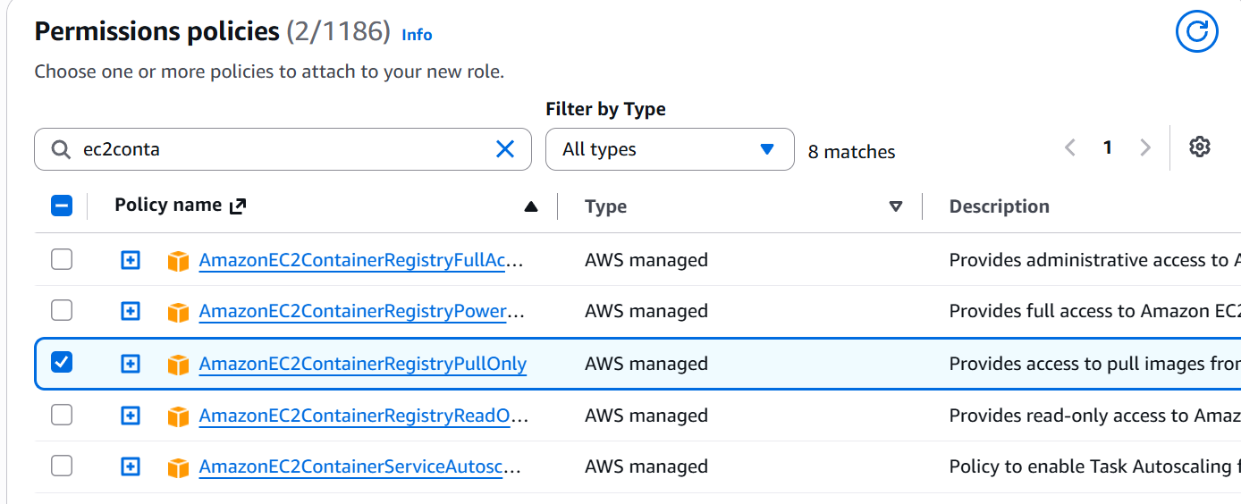
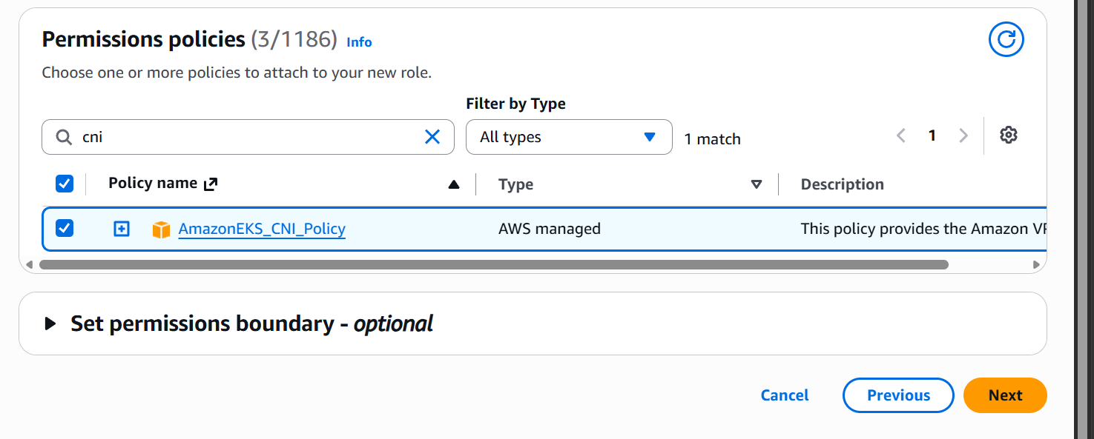
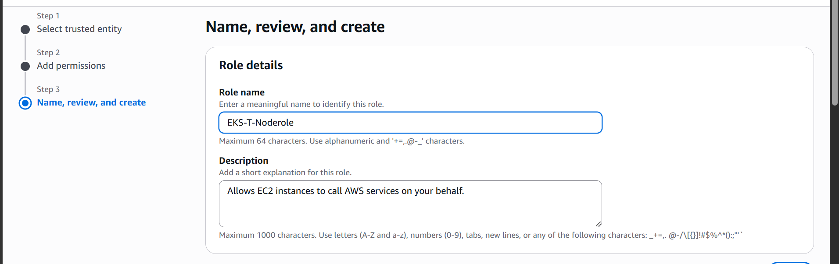

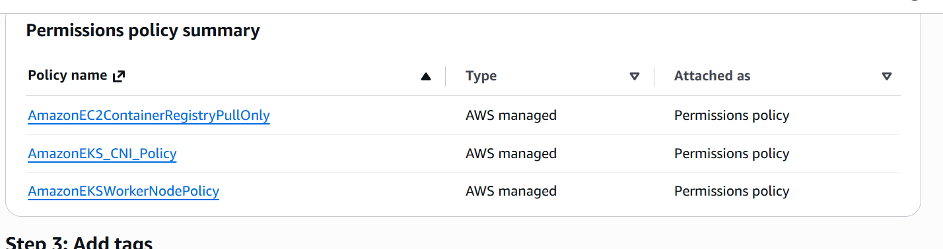

Now setup the eks cluster using the roles created

Search for EKS in search
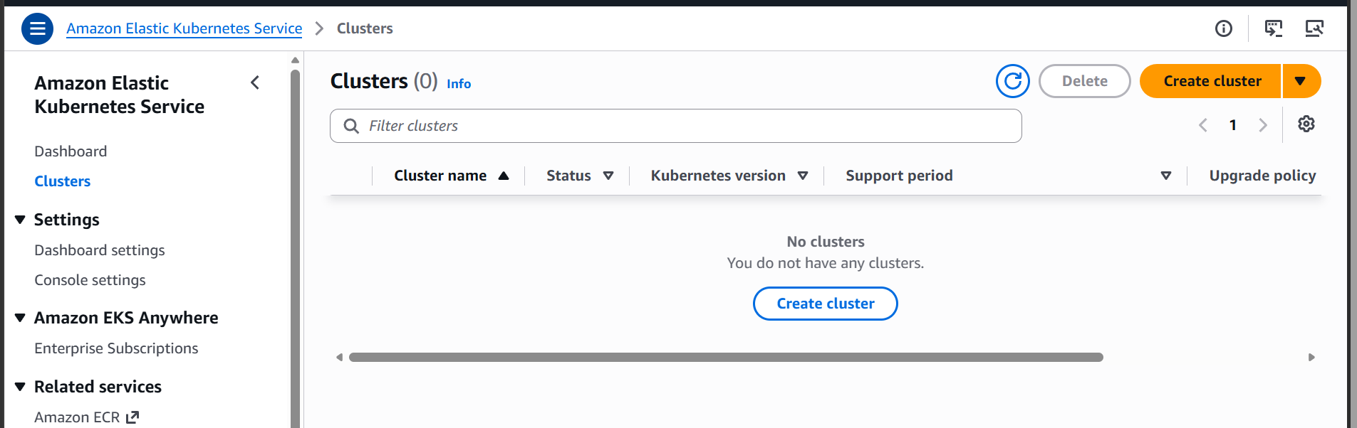

Click on create cluster

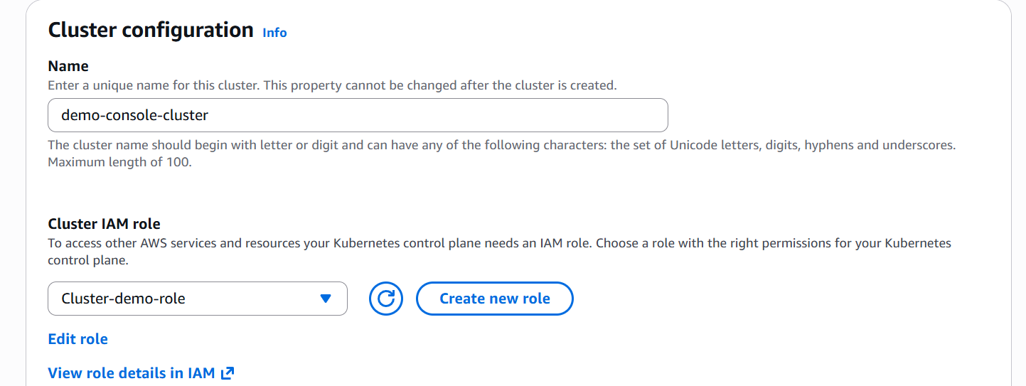

Select the role

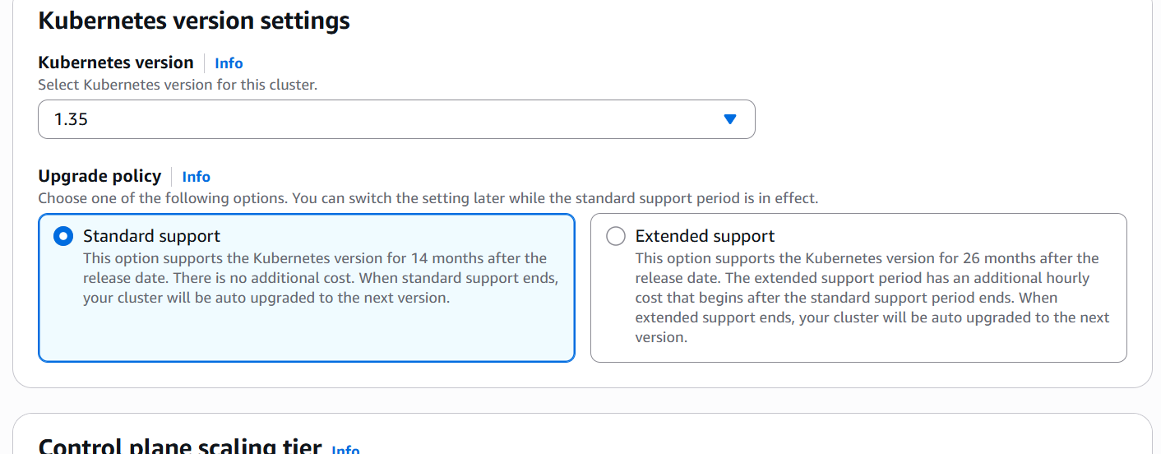

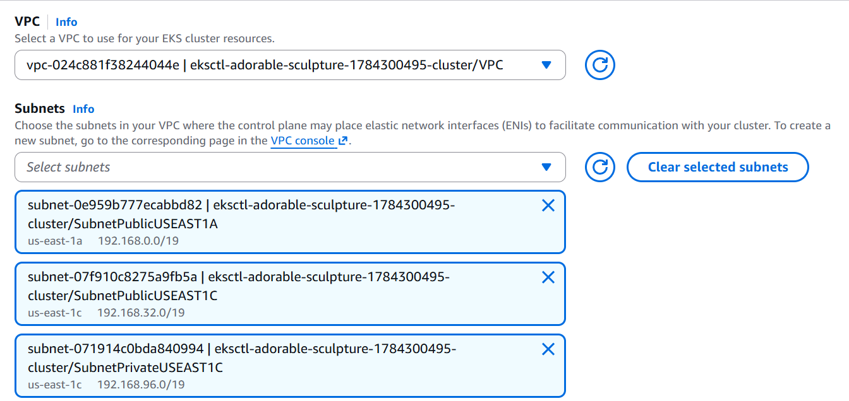

Selecting vpc

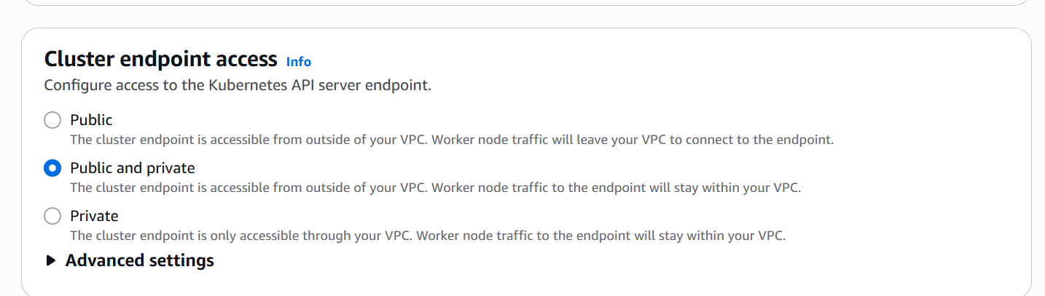

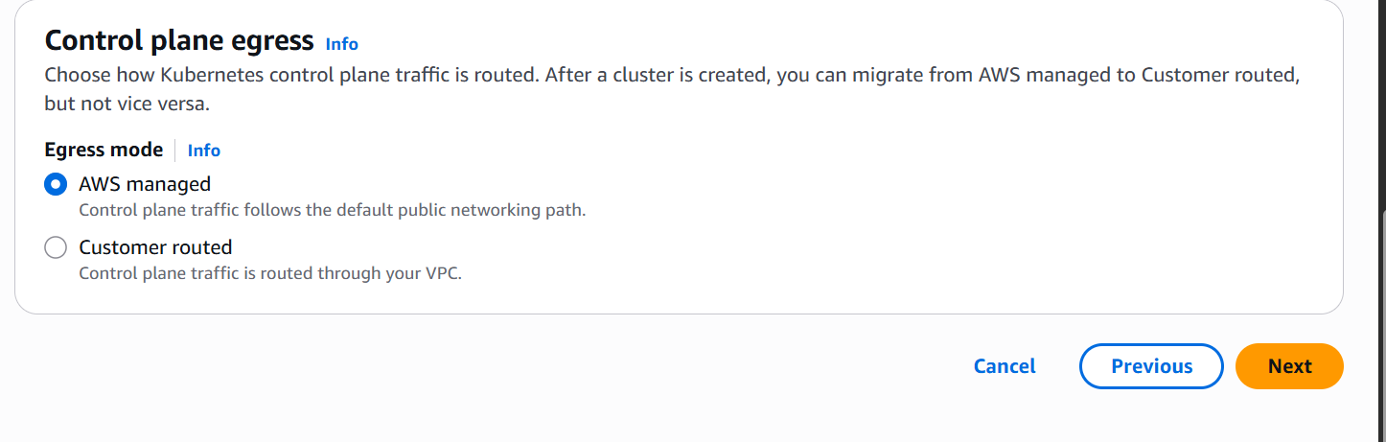
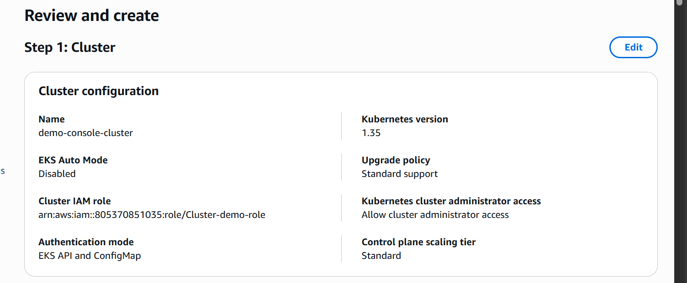
Click on create cluster wait for it till it is created
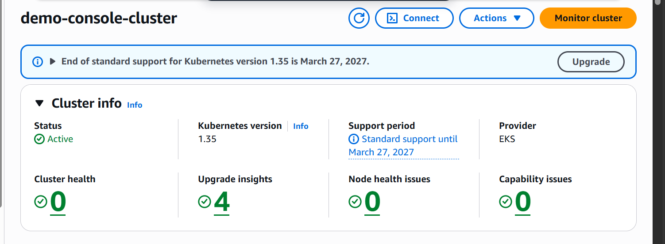’the cluster has been created now
Lets add node group

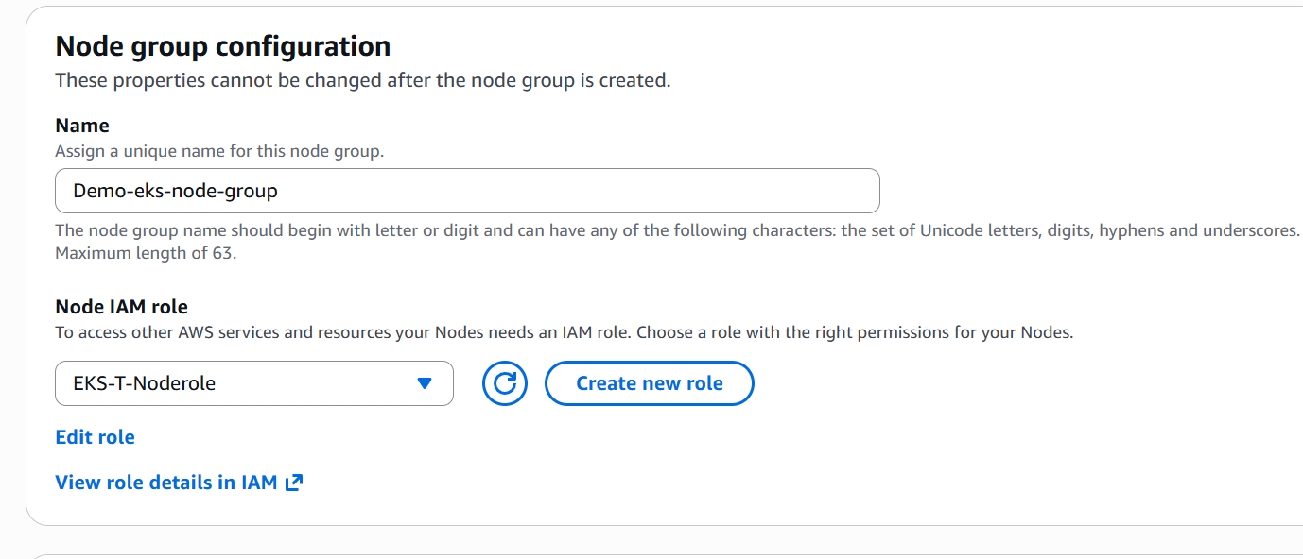

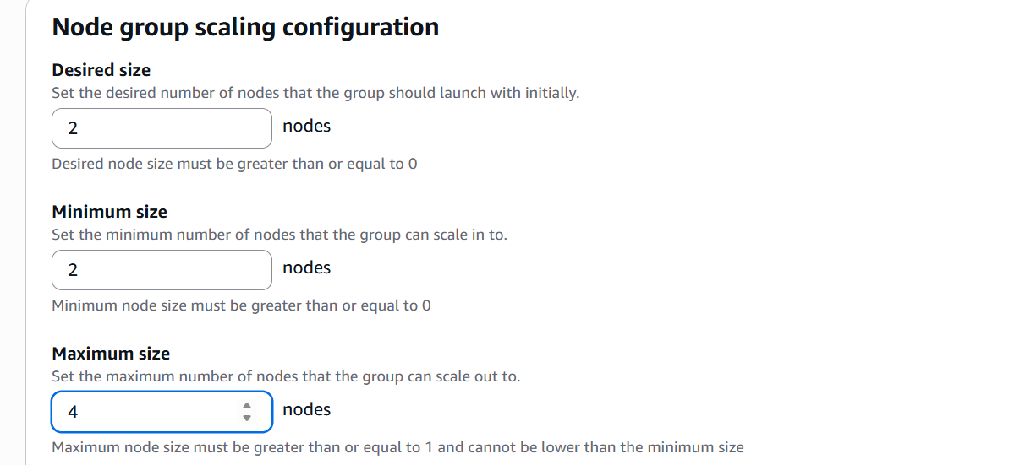

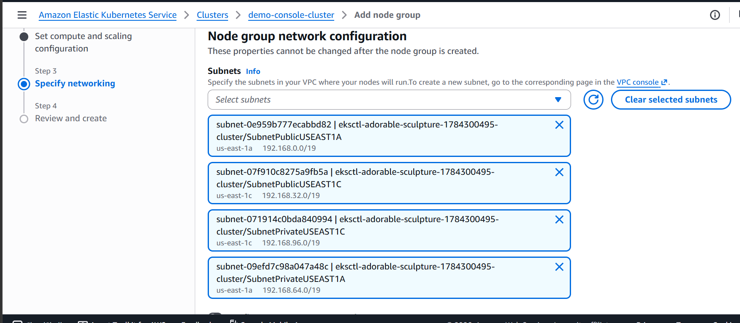

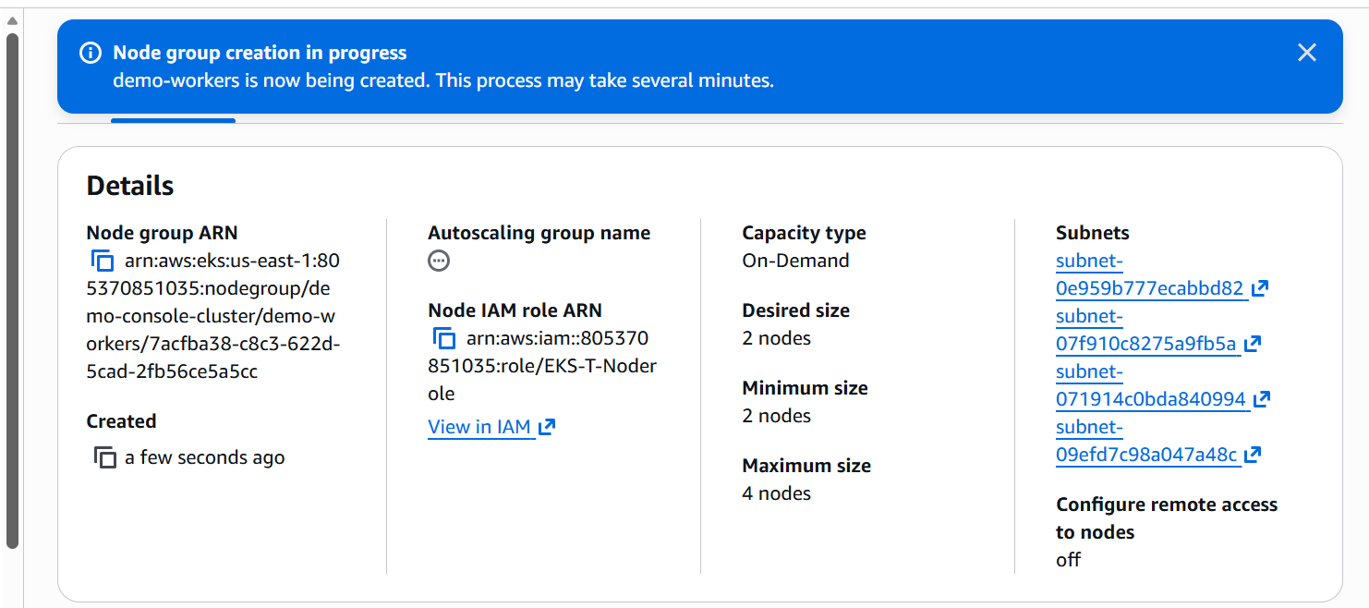

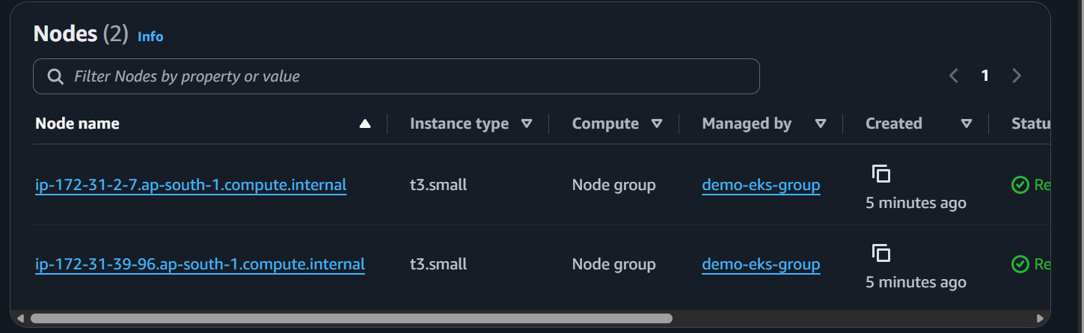

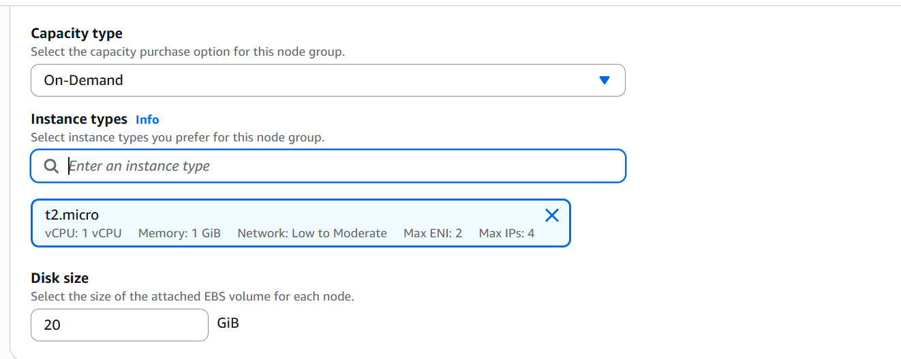

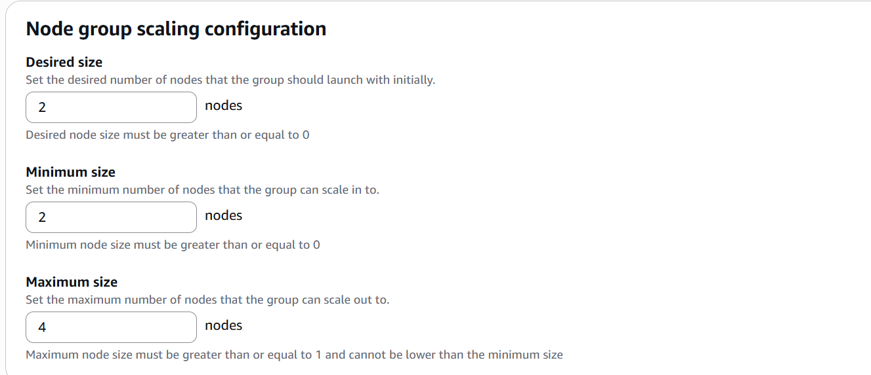

We now have 2 nodes t3.small

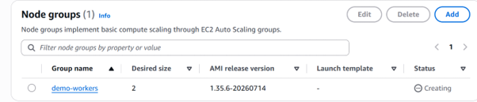

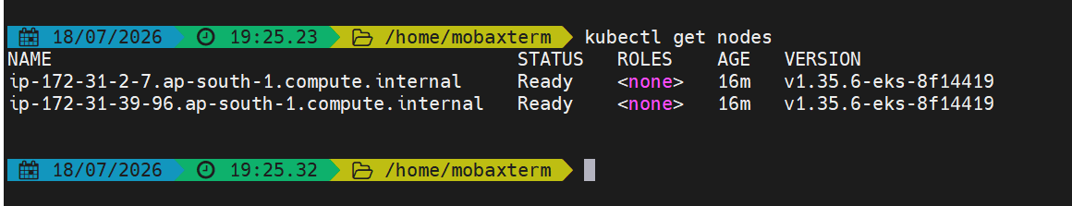

- Setup HPA
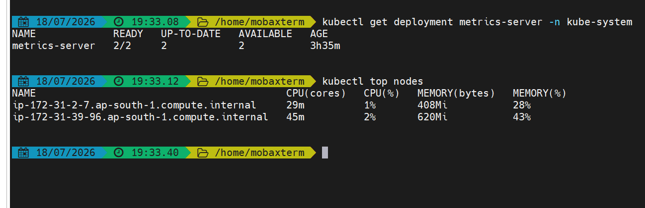
First confirm the metric server is available or not
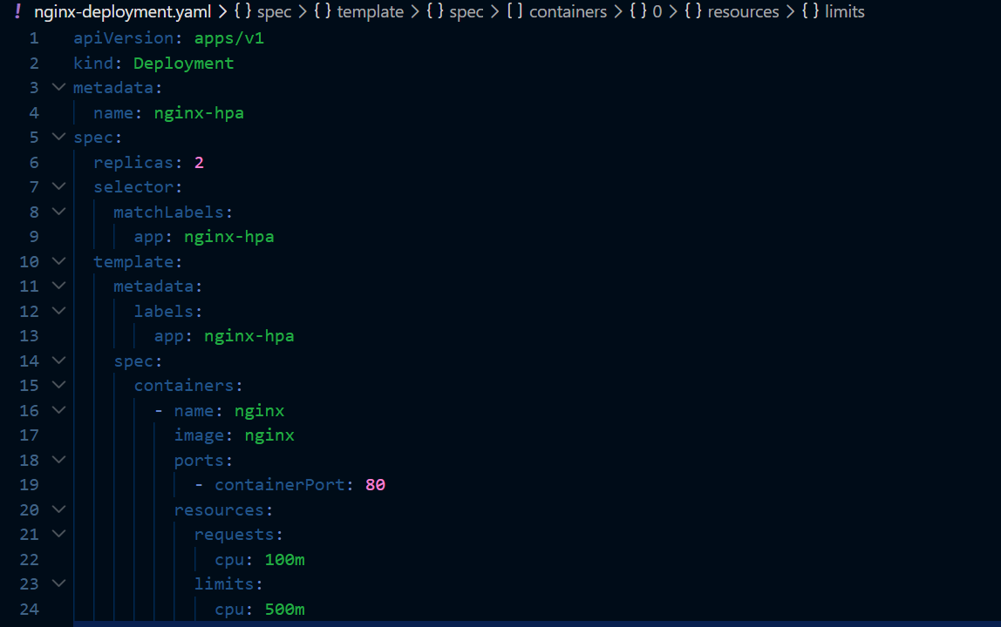

Create a deployment
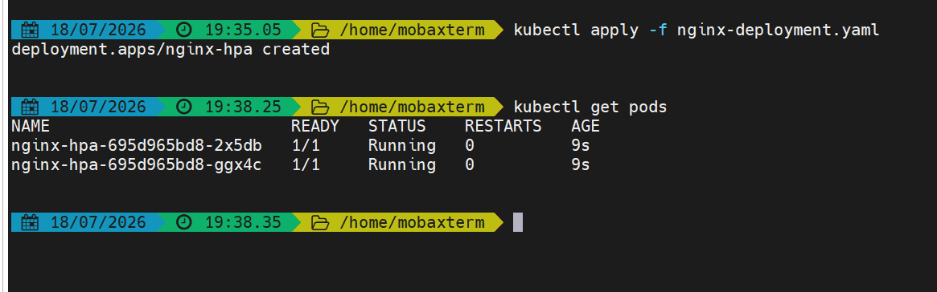
The deployment has been created
Exposing the deployment
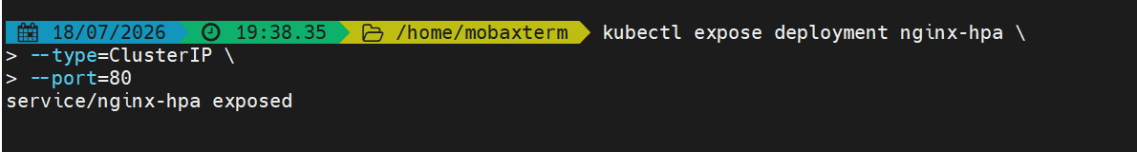
Now the hpa has been created
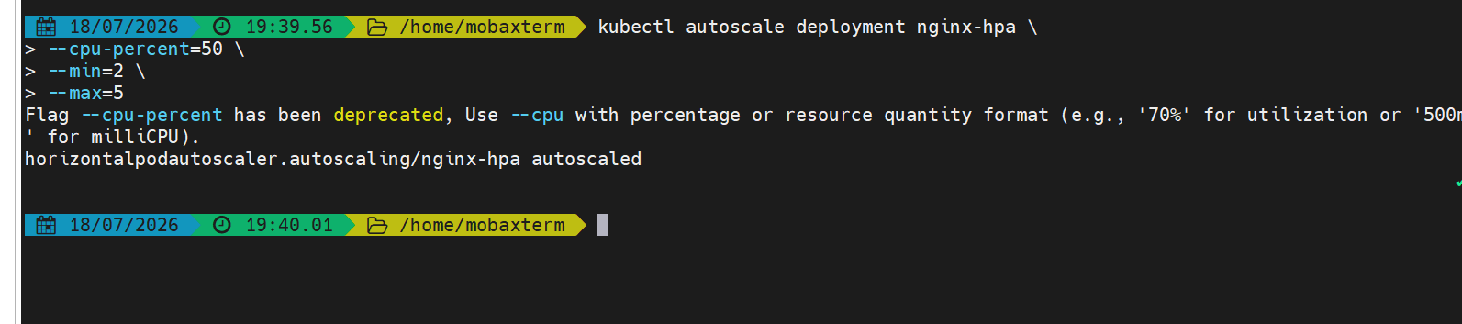

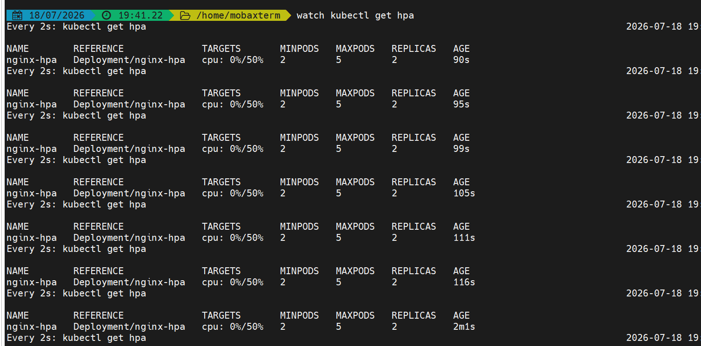

Now lets create some load
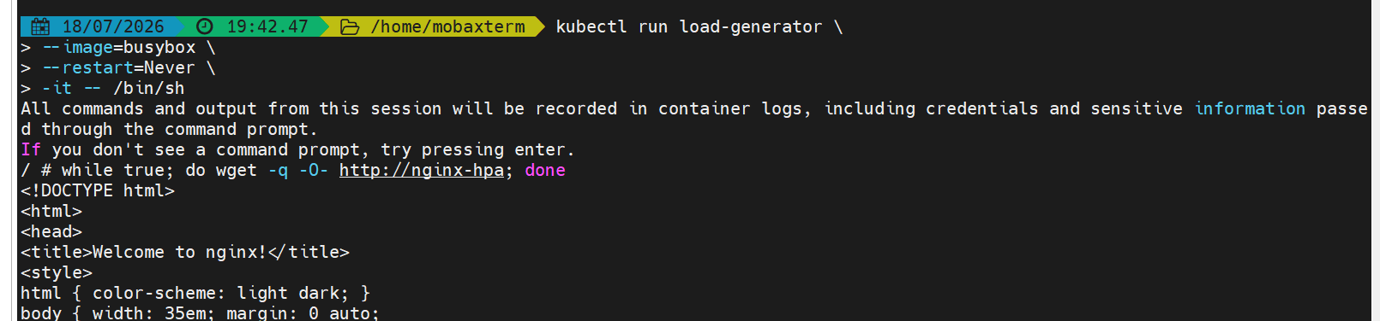
When the load exceeds the pods will scale to 5
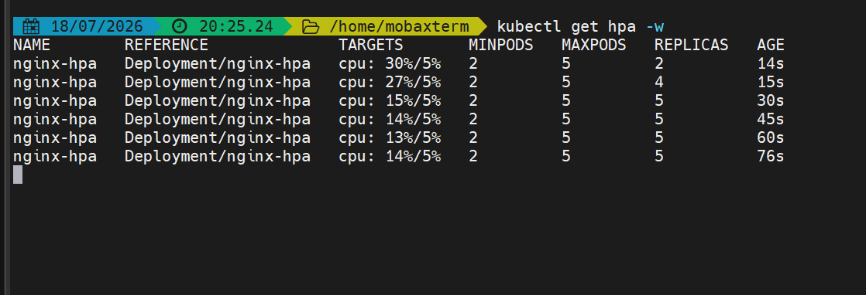
The pods have auto scaled horizontally

- Setup cluster autoscale

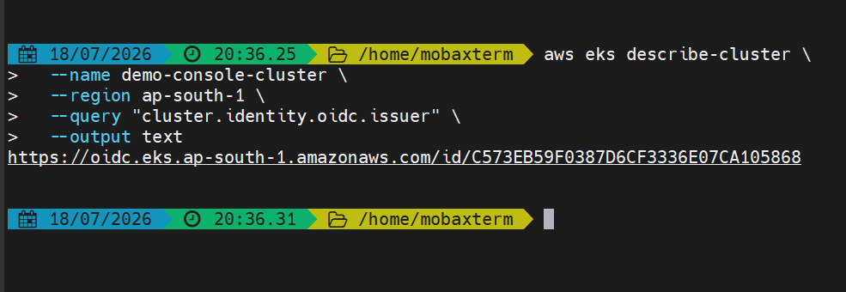

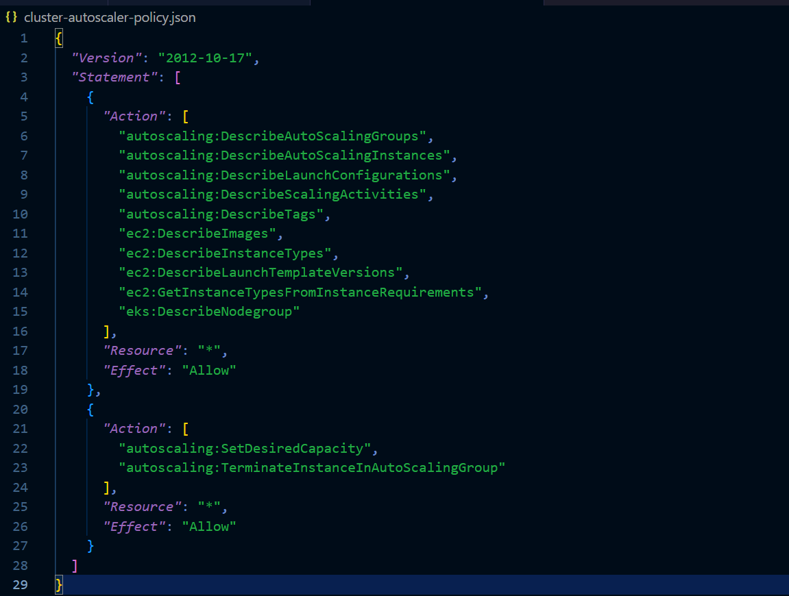

Creating the custom auto scaler policy
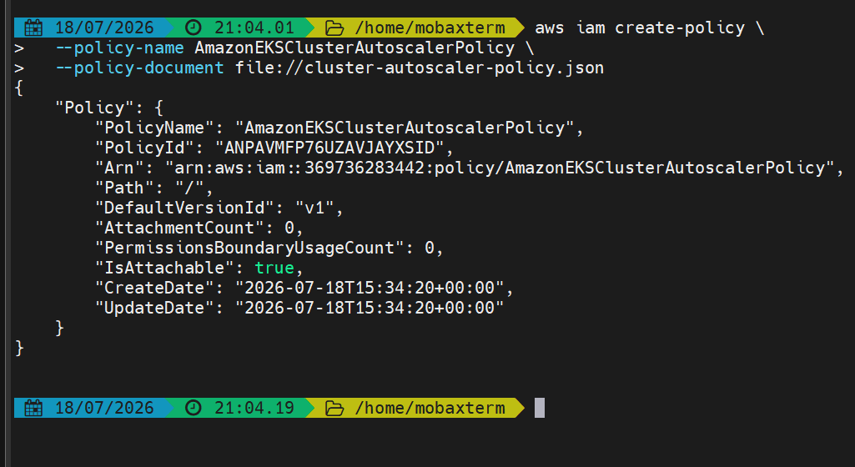
The policy is created now

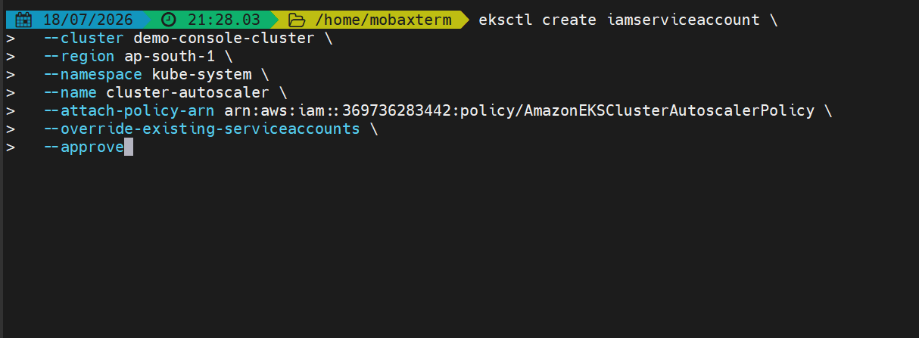
Creating an IAM role
Service account
A trust policy
And also it links the IAM role to service account
\
The service account has been created in kube-system namespace
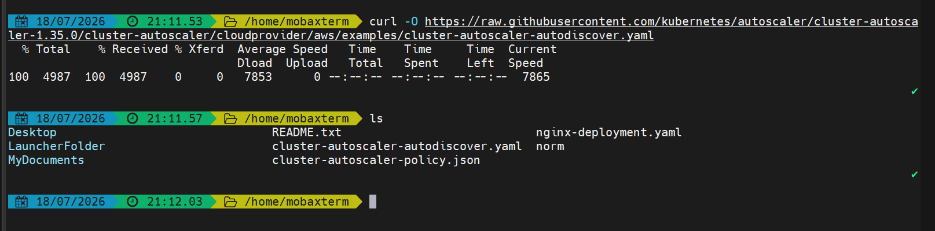
Downloading the auto scaler manifest
Edit the autoscaler manifest and add the cluster name
And k8s version
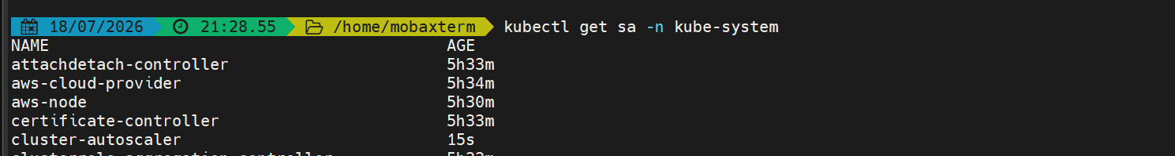

Lets now apply the cluster autoscaler

Cluster auto scaler created
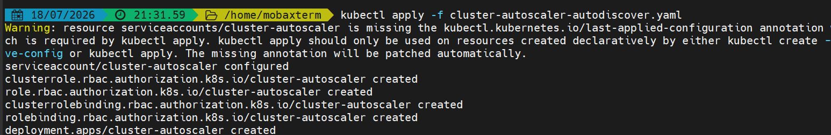
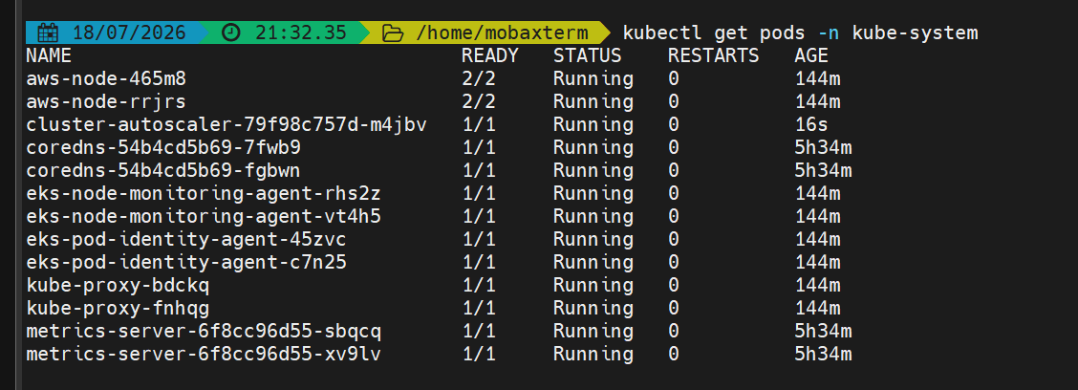
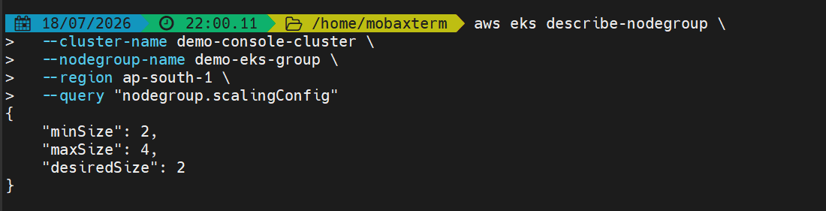

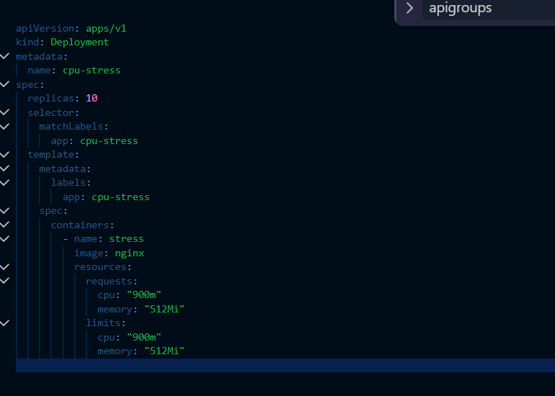
Adding stress.yaml file to check autoscaling
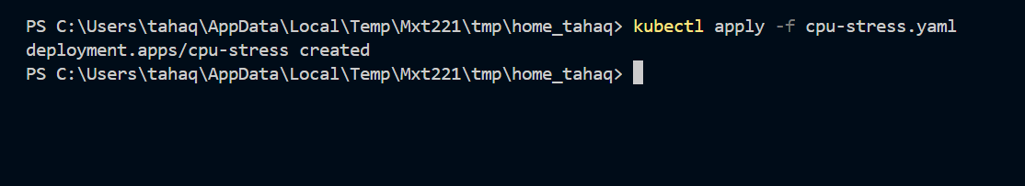
We can see that new pods are getting created
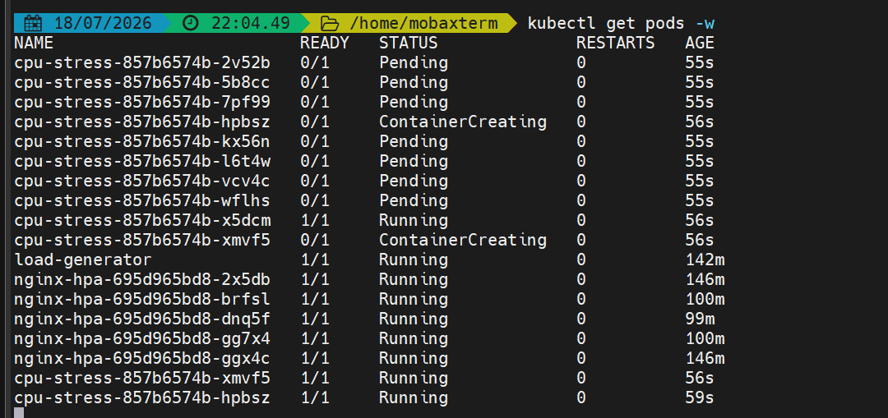

We can see that new instances are also getting created
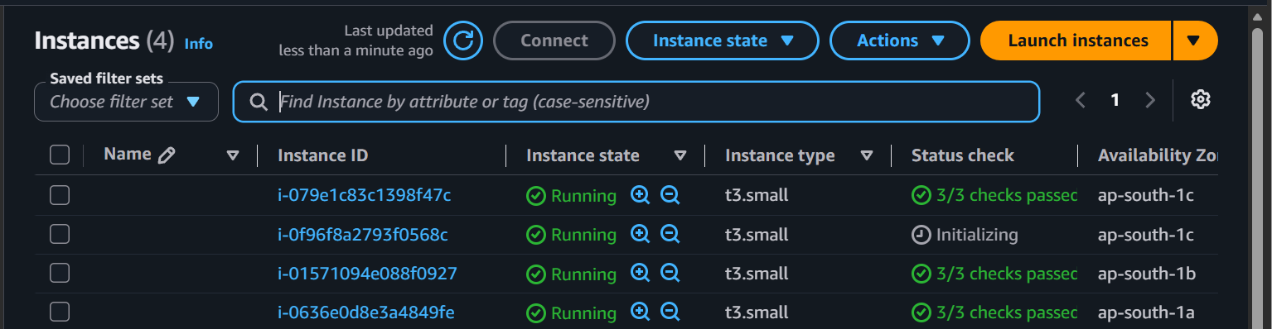

- Setup cronjob and job

Creating a job
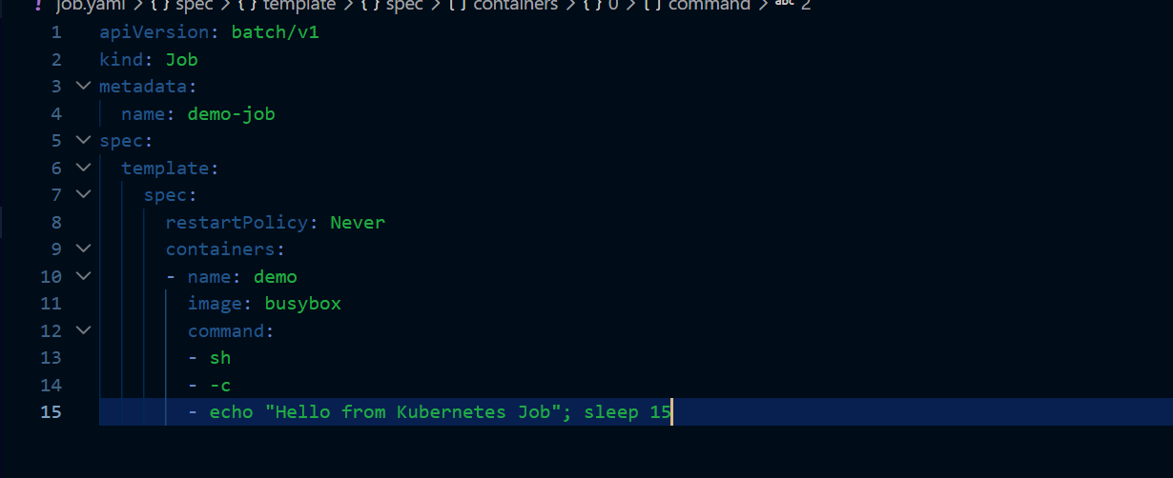

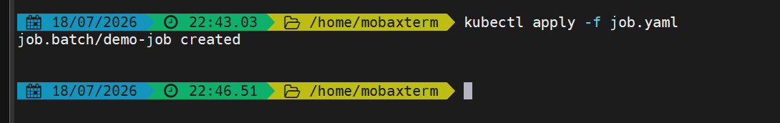

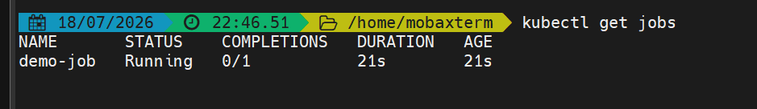

Verifying the job


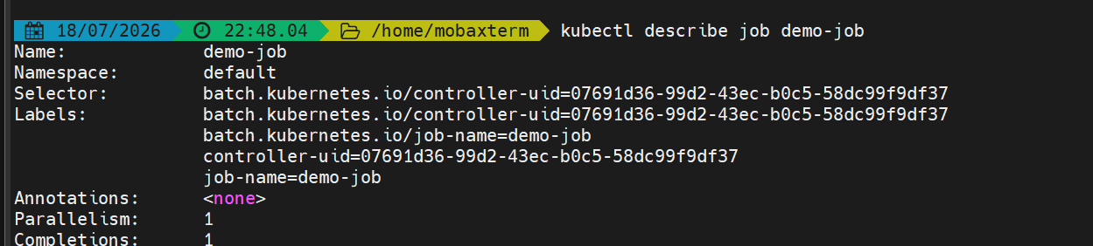
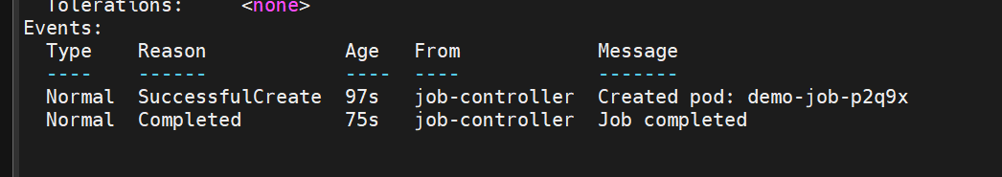

Creating a cronjob
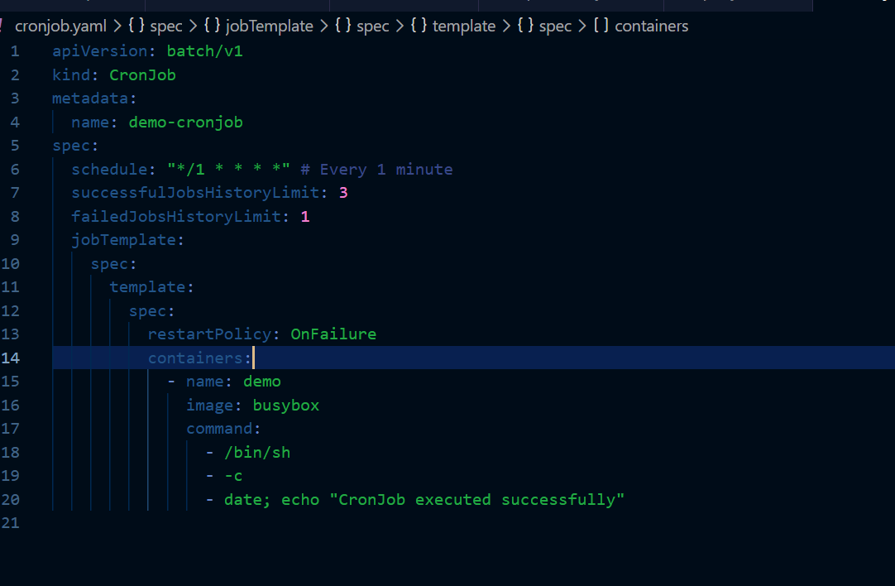
This is our yaml file to create a cronjob
This will run every minute
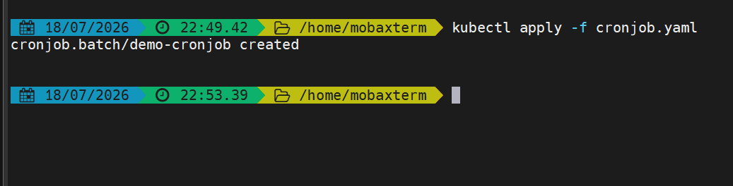
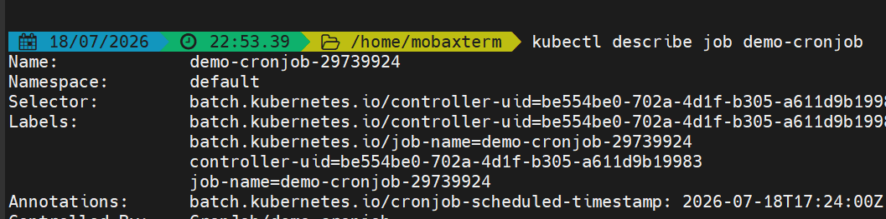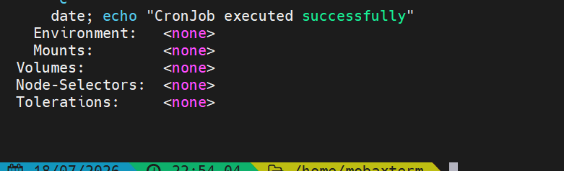the cron job executed successfully
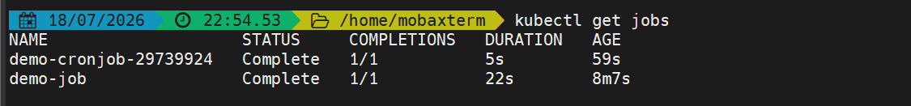
Two cronjobs created in 2 mins
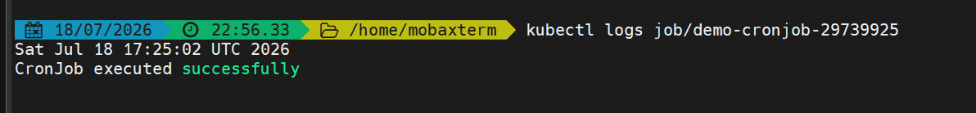

- Create secret and inject inside pod
First lets create a secret
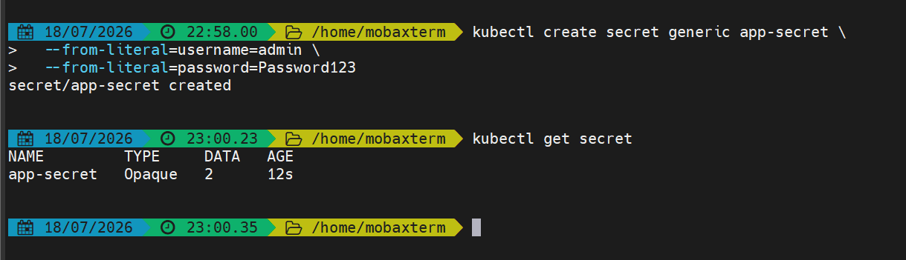
The secret has been created
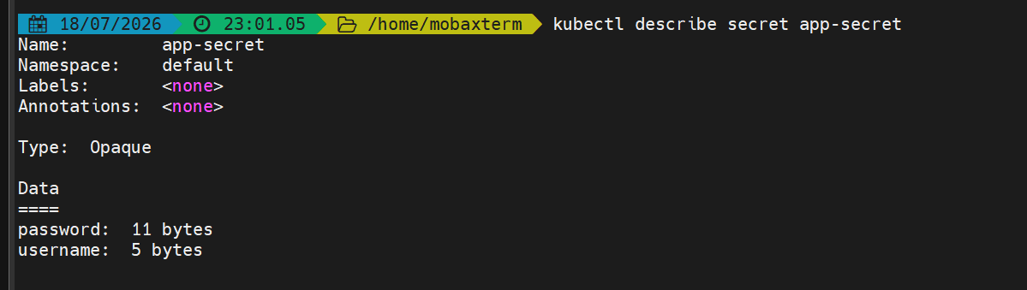

Injecting the secret in the pod
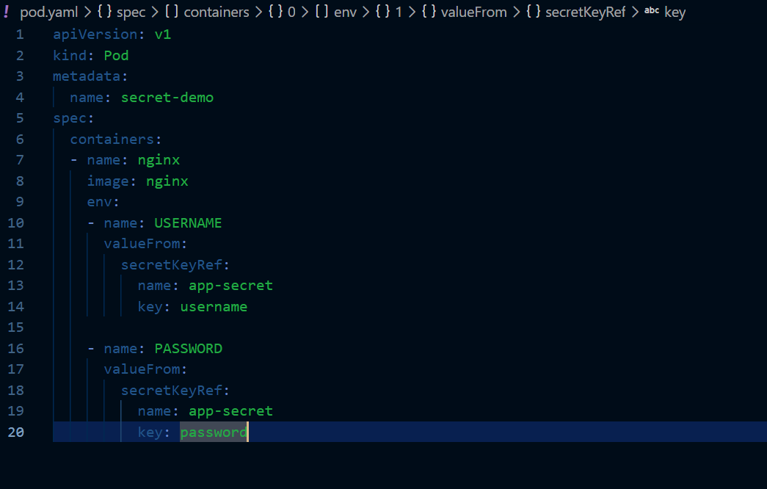

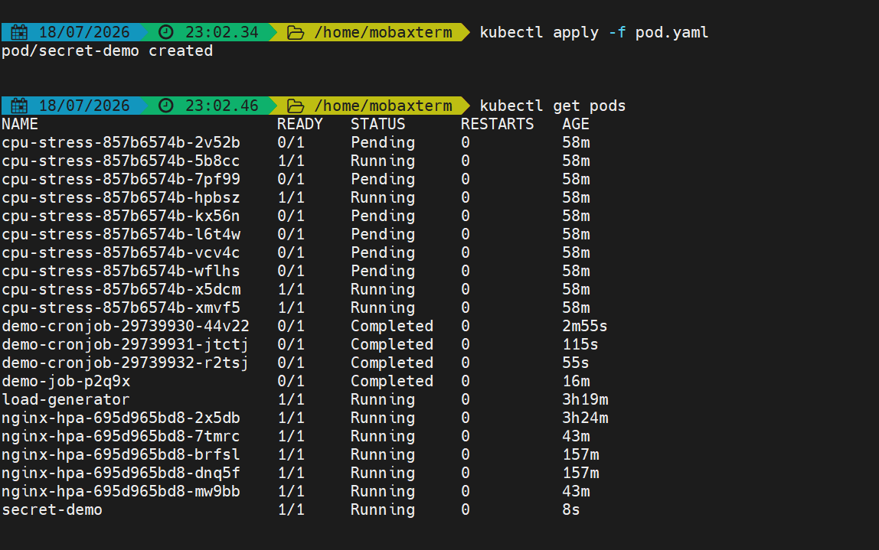

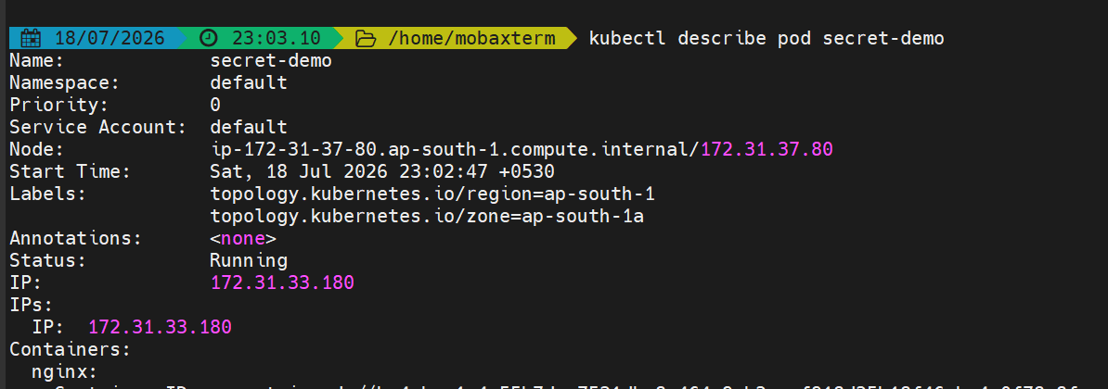

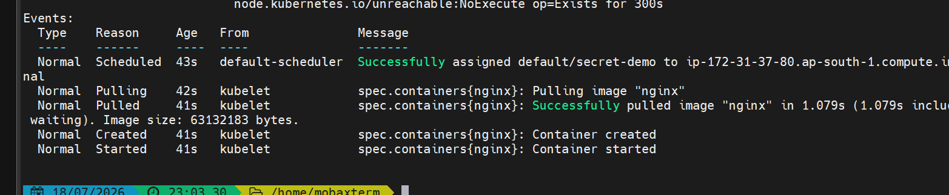

The secret has been successfully injected to the pod
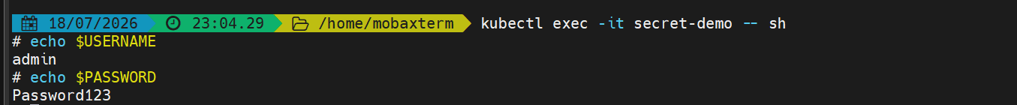
Getting inside the pod and verifying the secret values

- Check different add-ons available in eks.

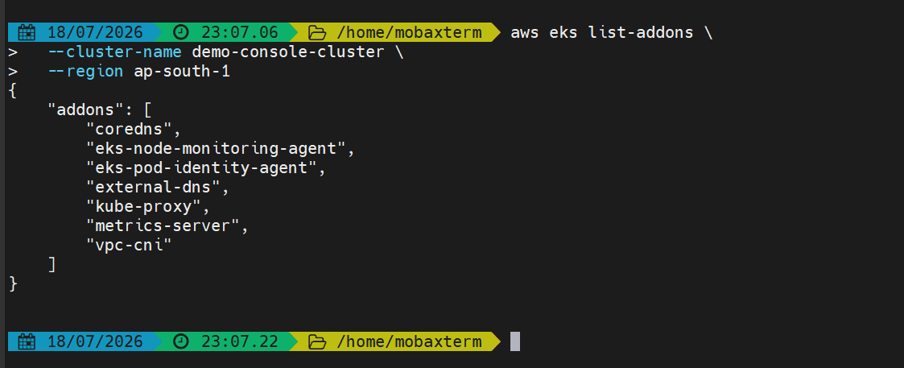
These are the addons available in our cluster so far
Lets describe on add on
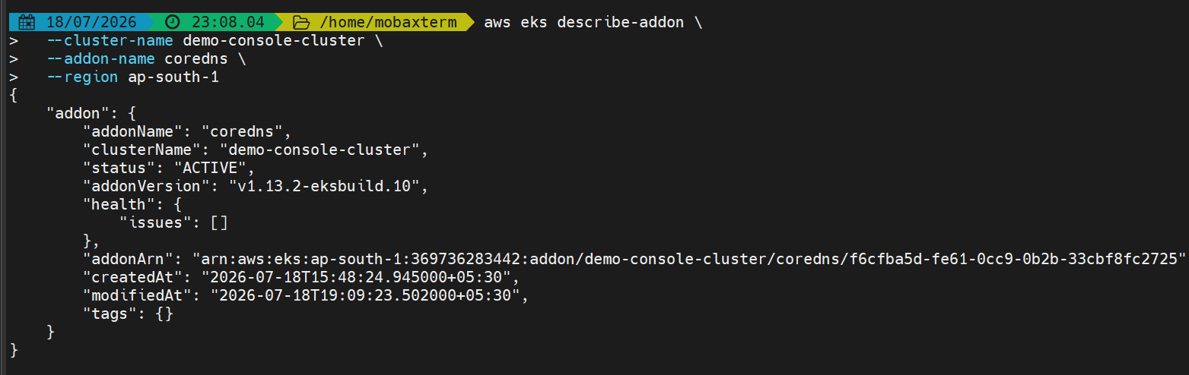
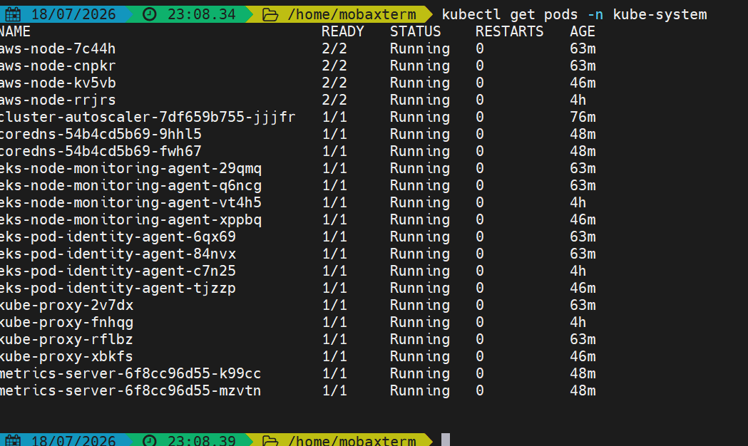
These are the addon pods available
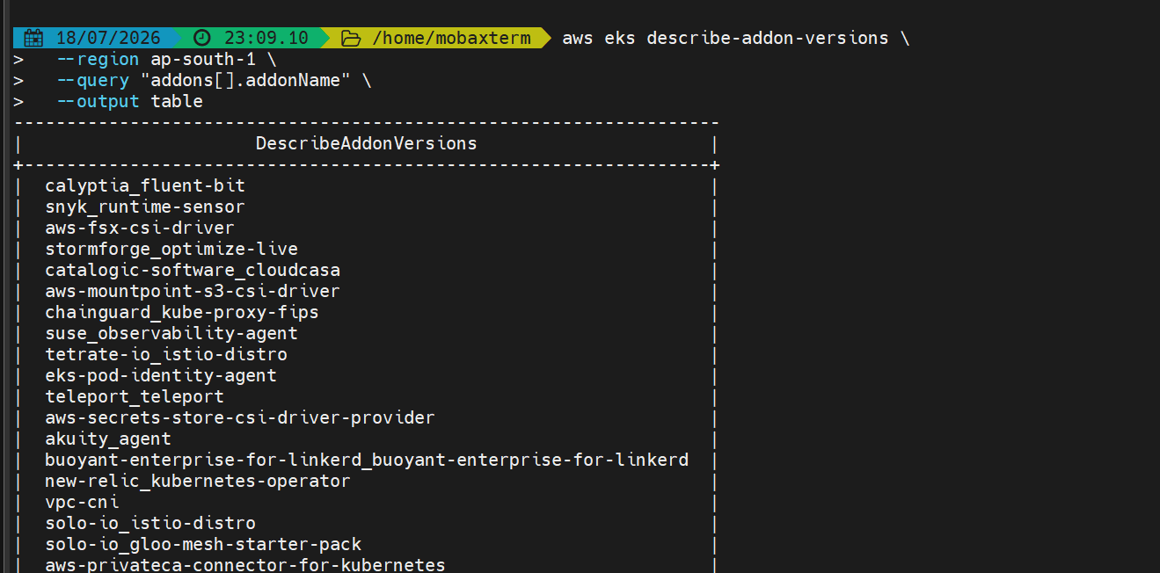
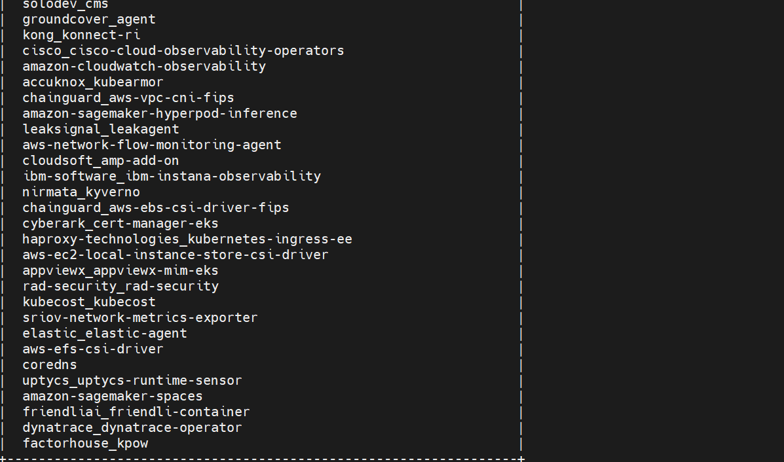

These are some addons supported by eks

- Upgrade eks cluster
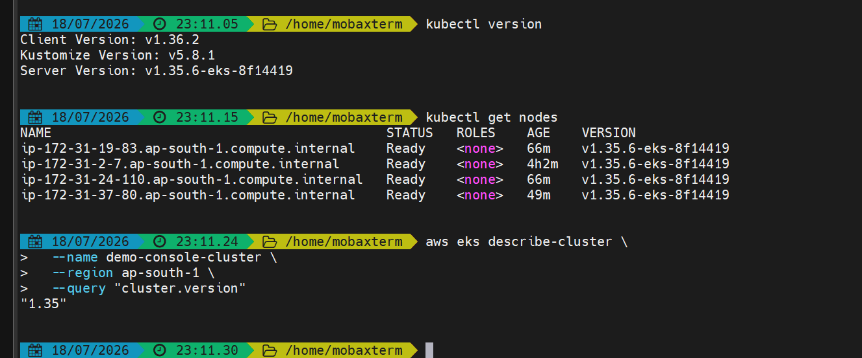
This is our current cluster version

Lets check the available versions
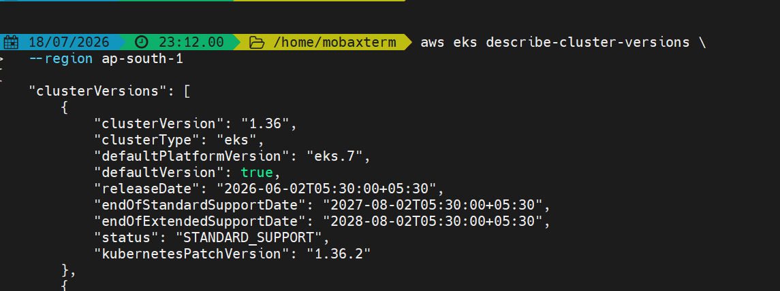
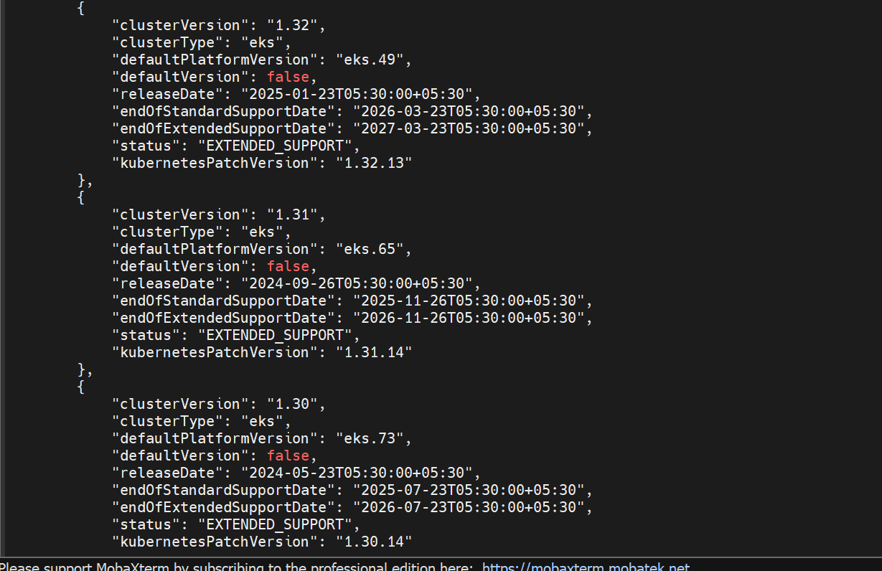

These are the versions available
Lets go to the console and update it

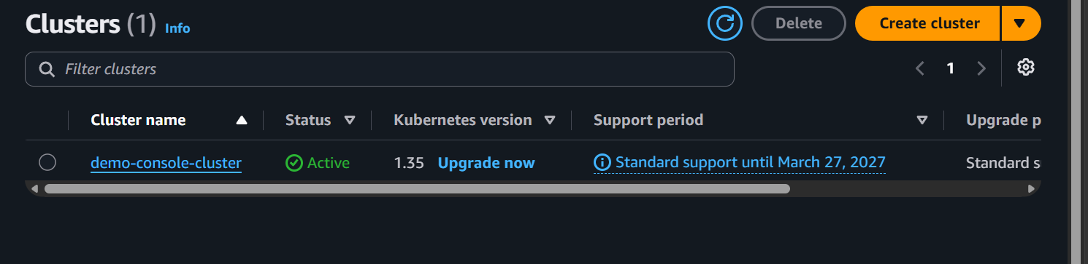

Here we can see the upgrade option
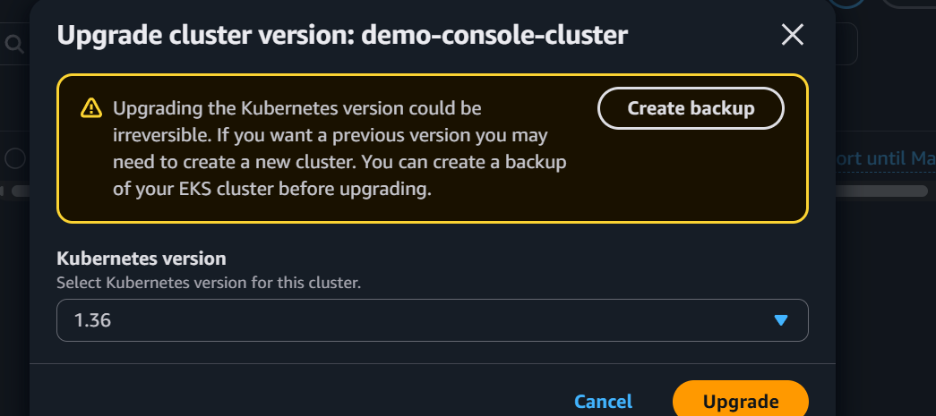

Click on upgrade
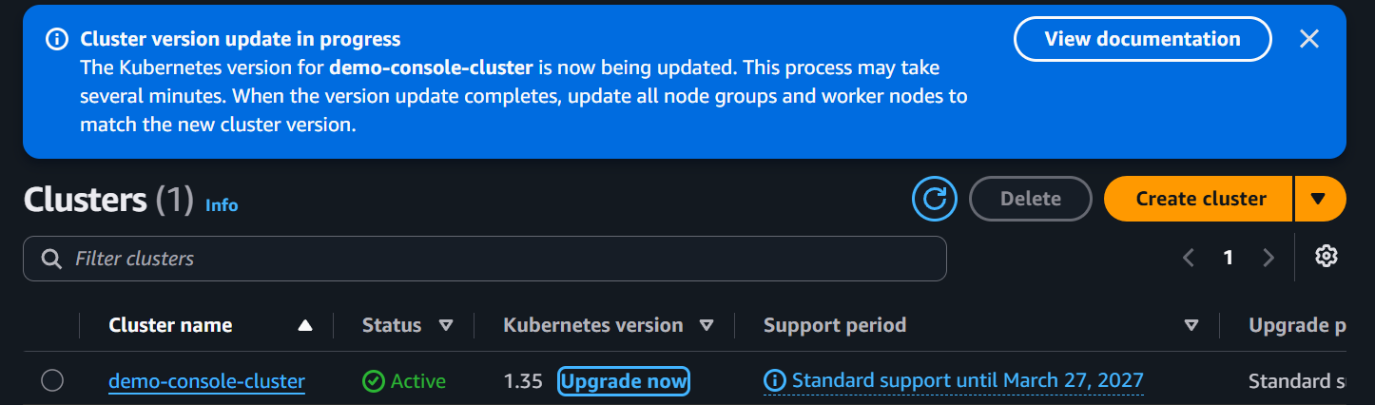

During this step, the control plane is upgraded. Your worker nodes continue to run and your applications remain available.

The control plane has been upgraded
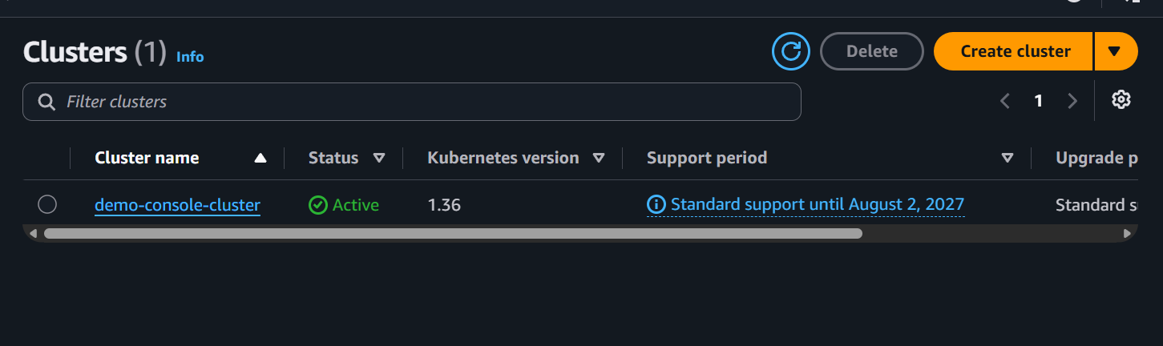

Now lets update the node group as well
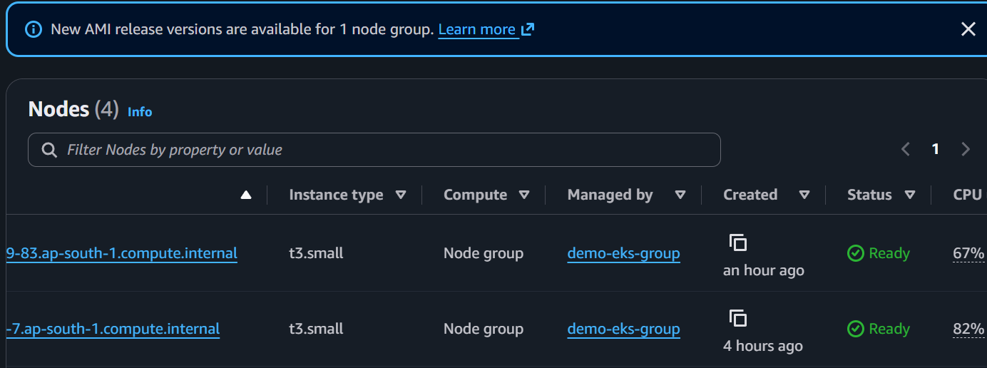
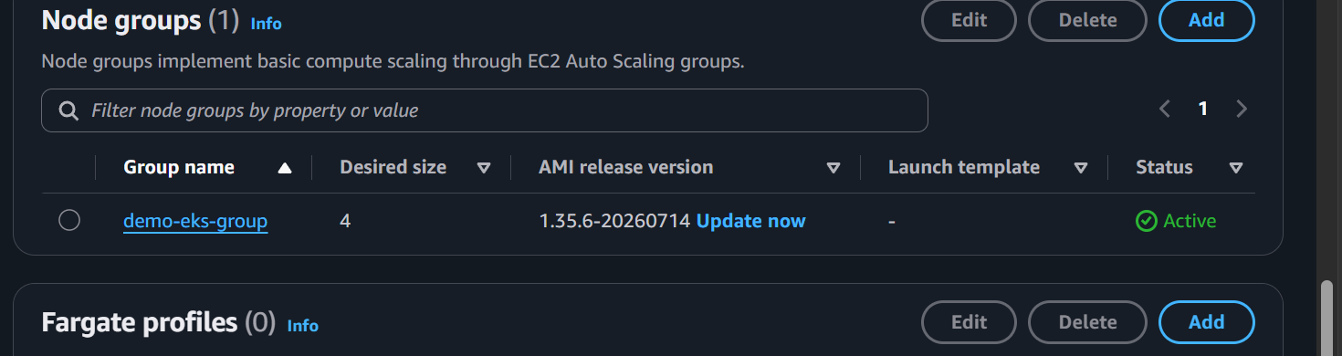
We can see the update now button click on it
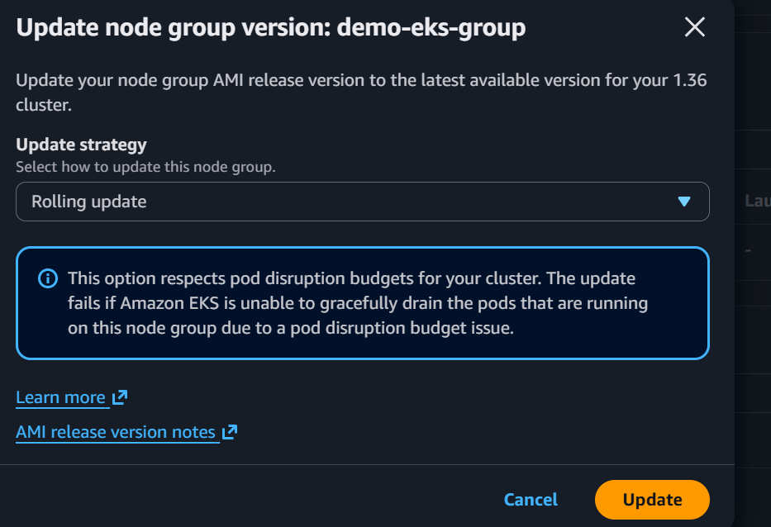

The deployment strategy is rolling update
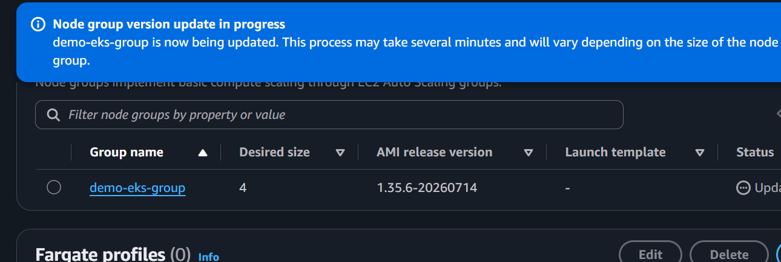

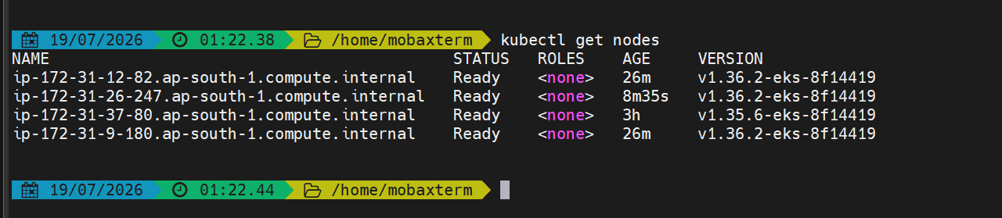
The data plane (node-group has also been upgraded)

