- Setup ARGO CD

First lets create the Kubernetes cluster
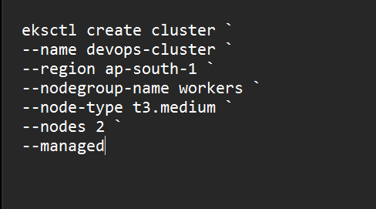

This creates:
- EKS Control Plane
- 2 Managed Worker Nodes
- VPC
- Subnets
- Security Groups
- IAM Roles
- Node Group

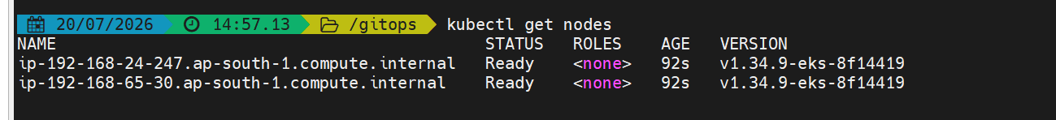
The cluster is now ready
Lets install argocd now

Creating a argocd namespace
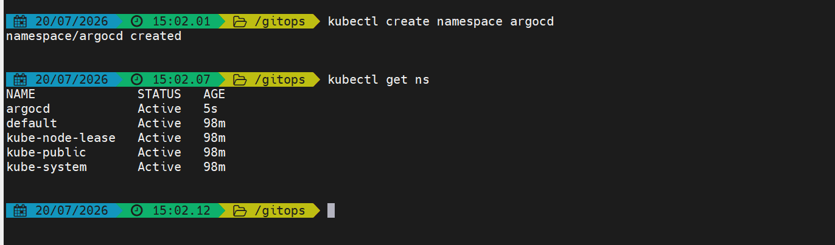
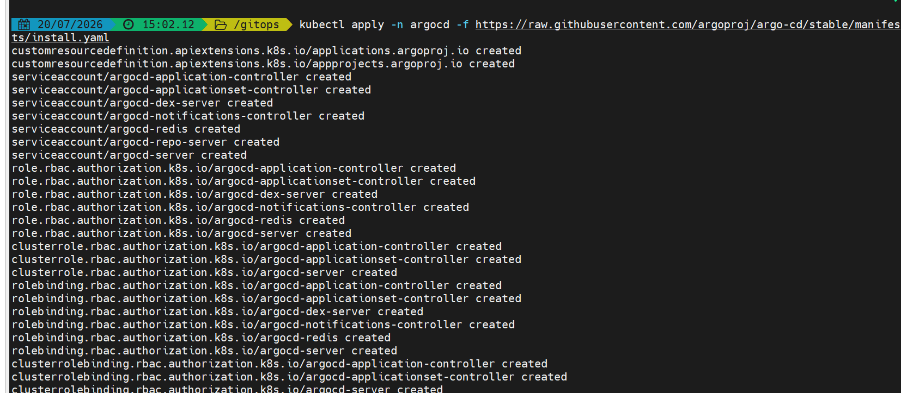
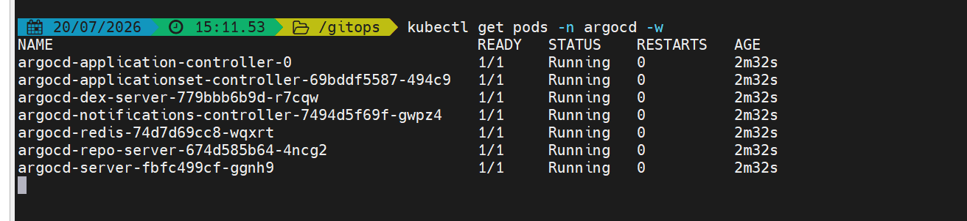

Change the server service to LoadBalancer
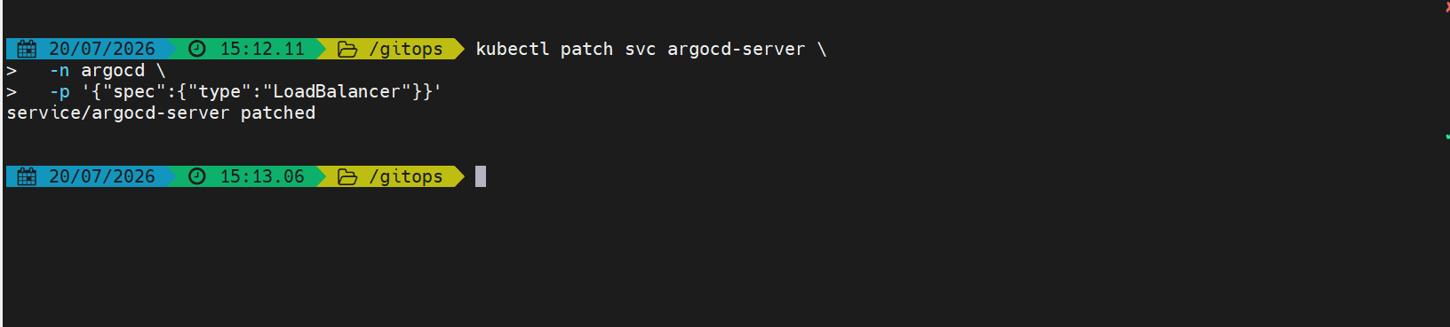

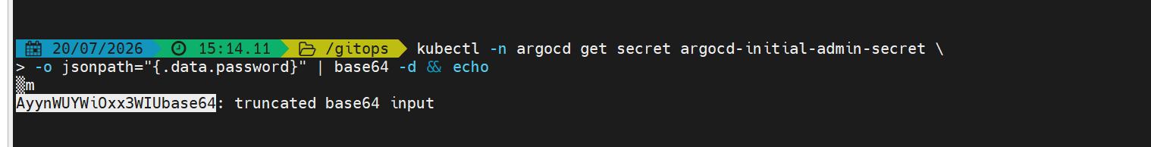
Get the initial password
Our argocd setup is done now

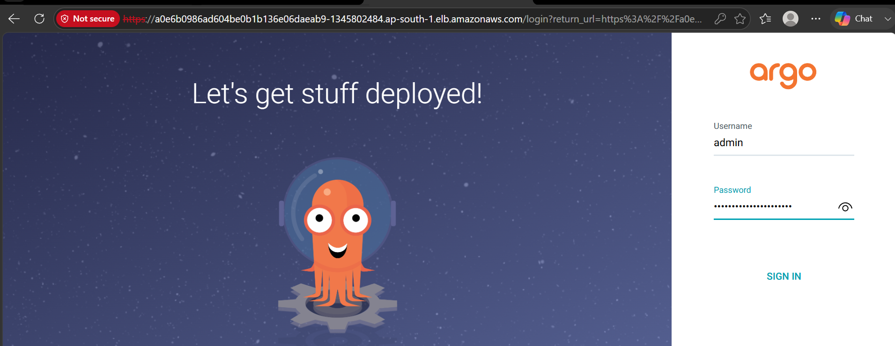
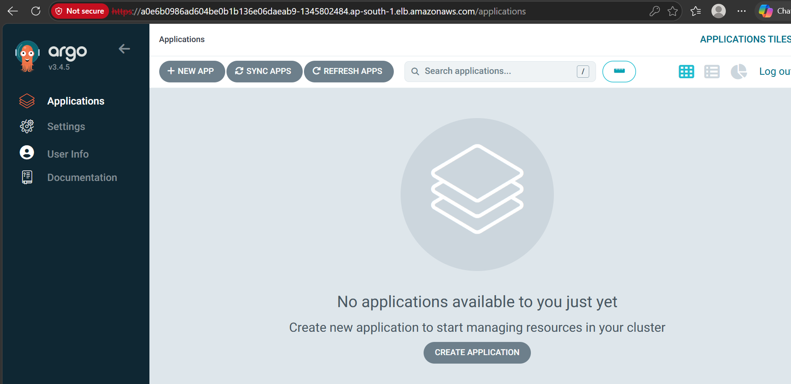

- Create Jenkins job for CI.

First lets install Jenkins

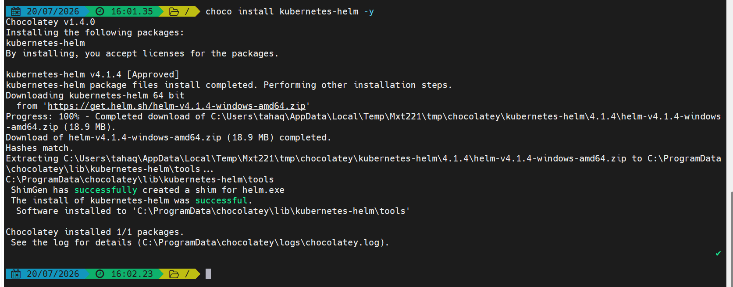

Installing helm

Add the Jenkins Helm Repository

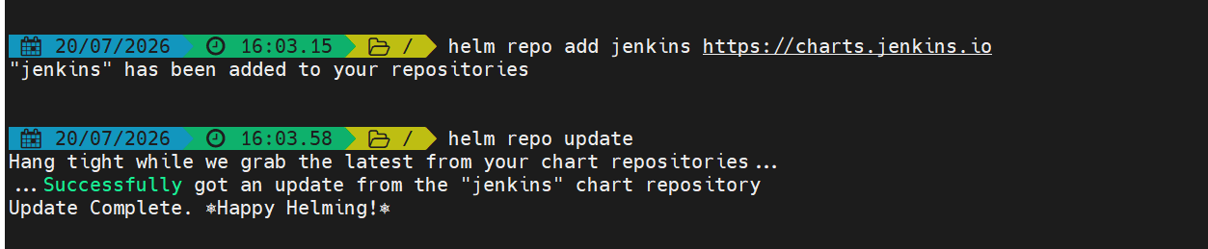

Creating Jenkins namespace

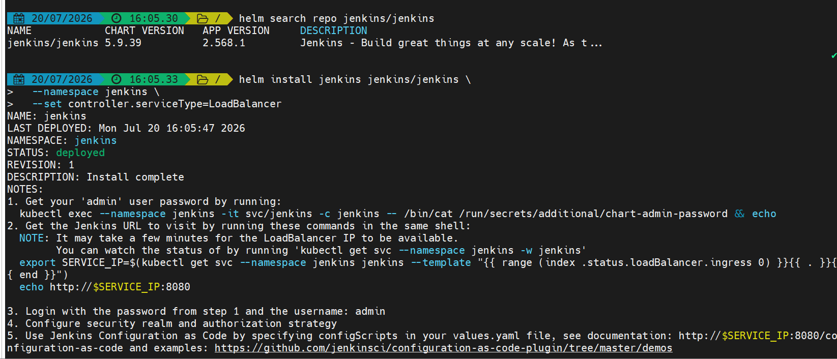

Now we have installed Jenkins inside our k8s cluster
This will create:
- Jenkins Controller
- Persistent Volume Claim
- Service Account
- RBAC
- LoadBalancer Service

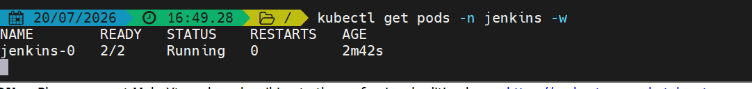

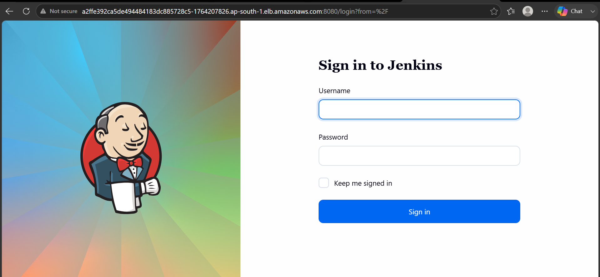

The Jenkins is now running in our k8s cluster
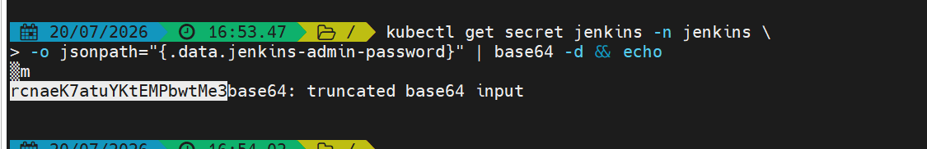
Get the Jenkins password like this

Lets now create the ci job
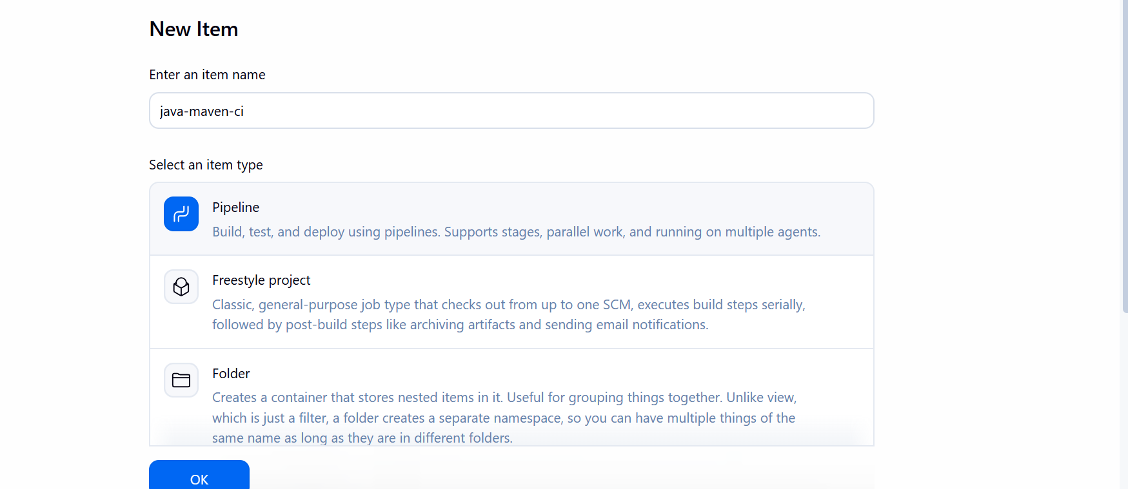

The below is the pipeline script
pipeline {
agent {
kubernetes {
yaml '''
apiVersion: v1
kind: Pod
spec:
containers:
- name: maven
image: maven:3.9.11-eclipse-temurin-21
command:
- cat
tty: true
resources:
requests:
cpu: "100m"
memory: "256Mi"
limits:
cpu: "500m"
memory: "768Mi"
'''
}
}

stages {
stage('Clone Repository') {
steps {
git branch: 'master',
url: 'https://github.com/jenkins-docs/simple-java-maven-app.git'
}
}

stage('Compile') {
steps {
container('maven') {
sh '''
java -version
mvn -version
mvn clean compile
'''
}
}
}

stage('Package') {
steps {
container('maven') {
sh 'mvn package -DskipTests'
}
}
}
}

post {
success {
echo 'CI Pipeline completed successfully.'
}

failure {
echo 'CI Pipeline failed.'
}
}
}
Lets now run the pipeline
Here in this pipeline we are using Kubernetes pod as an agent so the job will be running inside the pod
The Jenkins pipeline automates the continuous integration process by cloning the application source code from a GitHub repository, creating a temporary Kubernetes build agent, compiling the Java application using Maven with Java 21, and packaging it into a JAR artifact. Once the build is complete, the temporary Kubernetes agent is automatically terminated, ensuring each build runs in a clean, isolated, and reproducible environment.
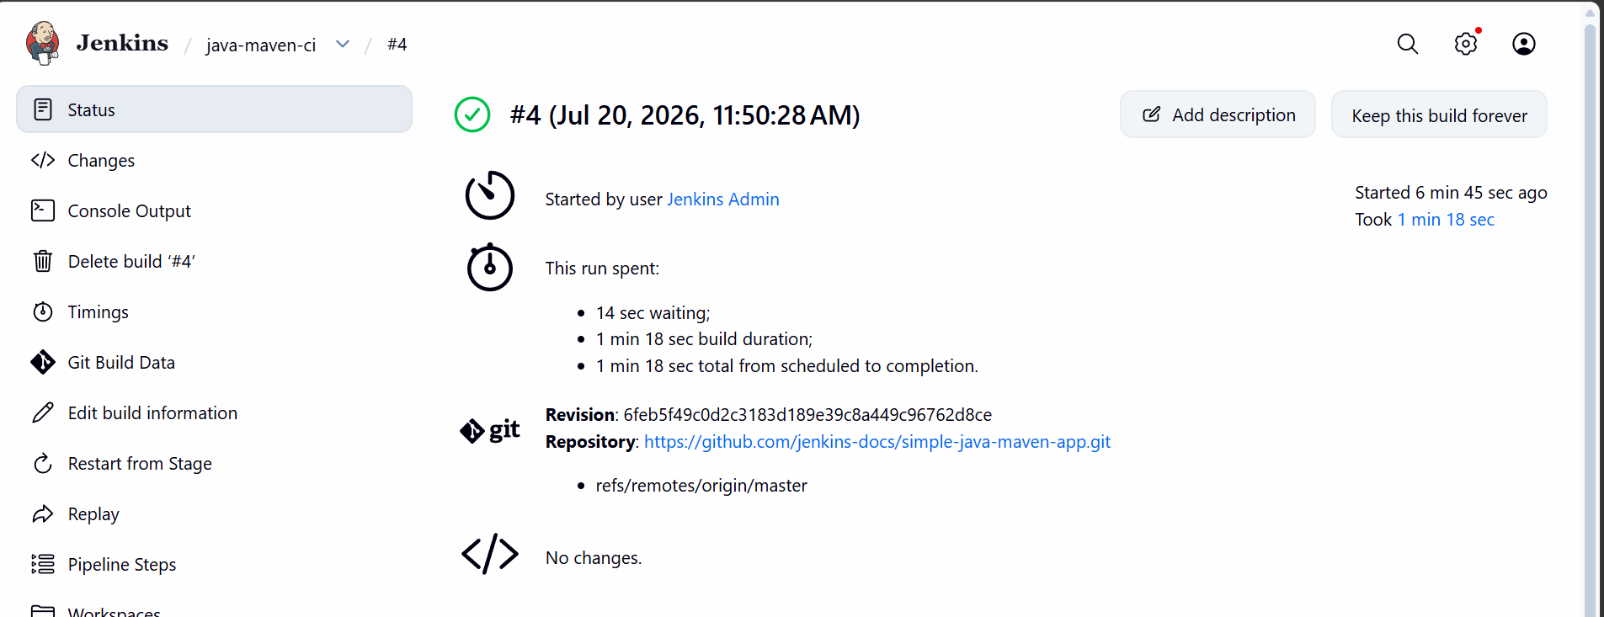

The job ran successfully

- Create Jenkins job to create docker image and build image.
pipeline {
agent {
kubernetes {
yaml '''
apiVersion: v1
kind: Pod
spec:
containers:
- name: docker
image: docker:28-cli
command: ["cat"]
tty: true
env:
- name: DOCKER_HOST
value: tcp://localhost:2375

- name: dind
image: docker:28-dind
securityContext:
privileged: true
env:
- name: DOCKER_TLS_CERTDIR
value: ""
'''
}
}

environment {
IMAGE = 'tahaquadri27/simple-java-app'
}

stages {
stage('Checkout') {
steps {
git branch: 'master',
url: 'https://github.com/SyedTahaQuadri/simple-java-maven-app22.git'
}
}

stage('Build and Push') {
steps {
container('docker') {
withCredentials([
usernamePassword(
credentialsId: 'dockerhub-credentials',
usernameVariable: 'USER',
passwordVariable: 'TOKEN'
)
]) {
sh '''
until docker info >/dev/null 2>&1; do
echo "Waiting for Docker..."
sleep 2
done

docker build -t $IMAGE:$BUILD_NUMBER .

echo "$TOKEN" | docker login \
-u "$USER" \
--password-stdin

docker push $IMAGE:$BUILD_NUMBER
'''
}
}
}
}
}

post {
success {
echo "Image pushed: ${IMAGE}:${BUILD_NUMBER}"
}

failure {
echo 'Docker build or push failed.'
}
}
}

This is the script that builds the docker image and pushed to docker hub

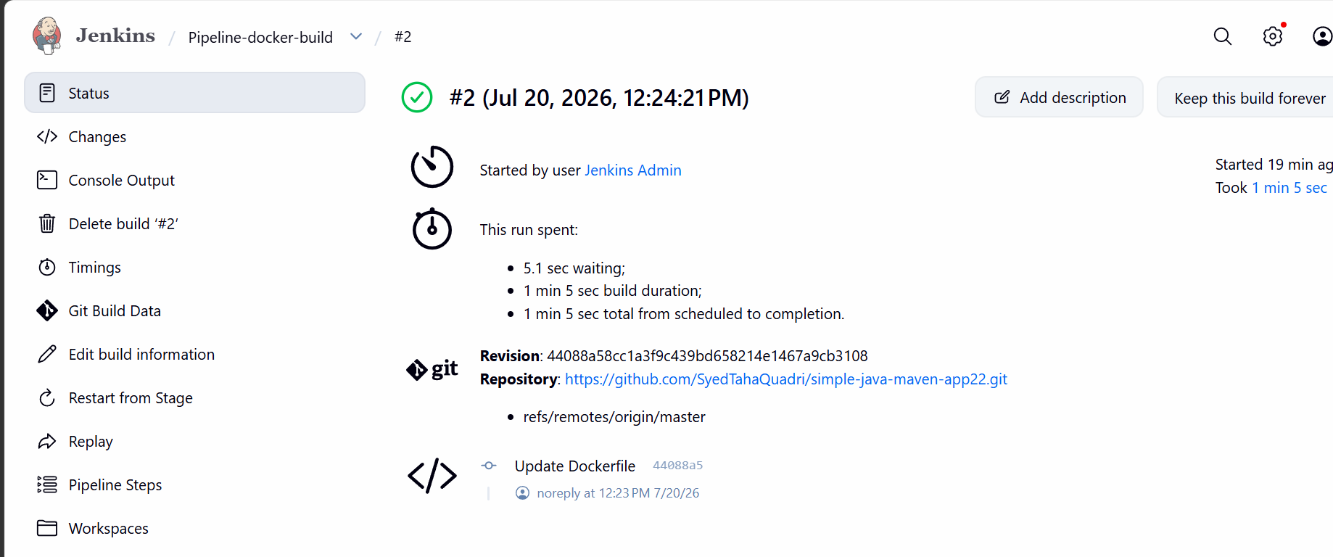

The job ran successfully
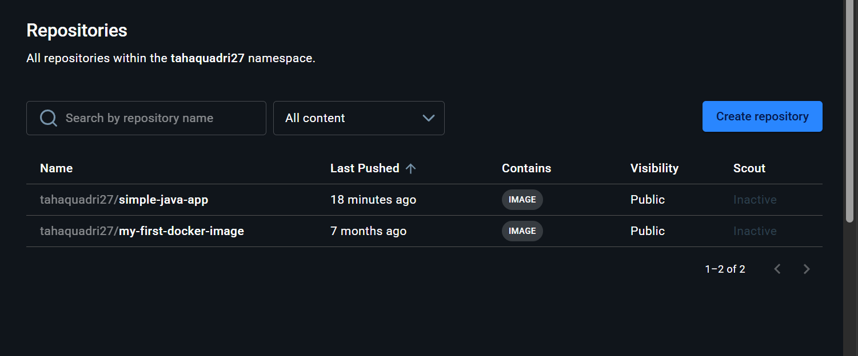
The image is pushed to docker hub

4. Create ArgoCD job to deploy on ek8s cluster.

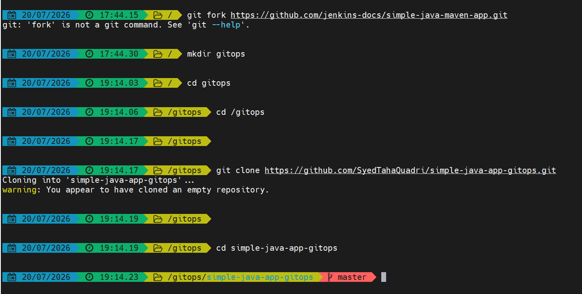

Creating a new repository
And cloning it in local
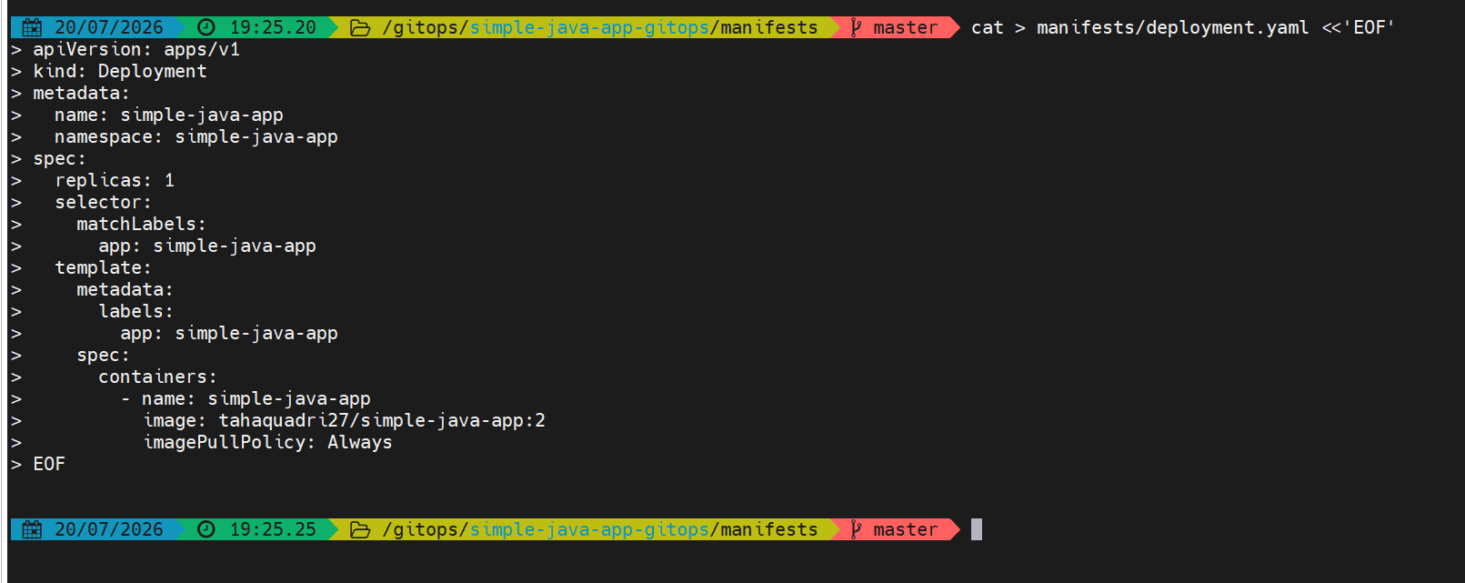
Adding the deployment.yaml file to github

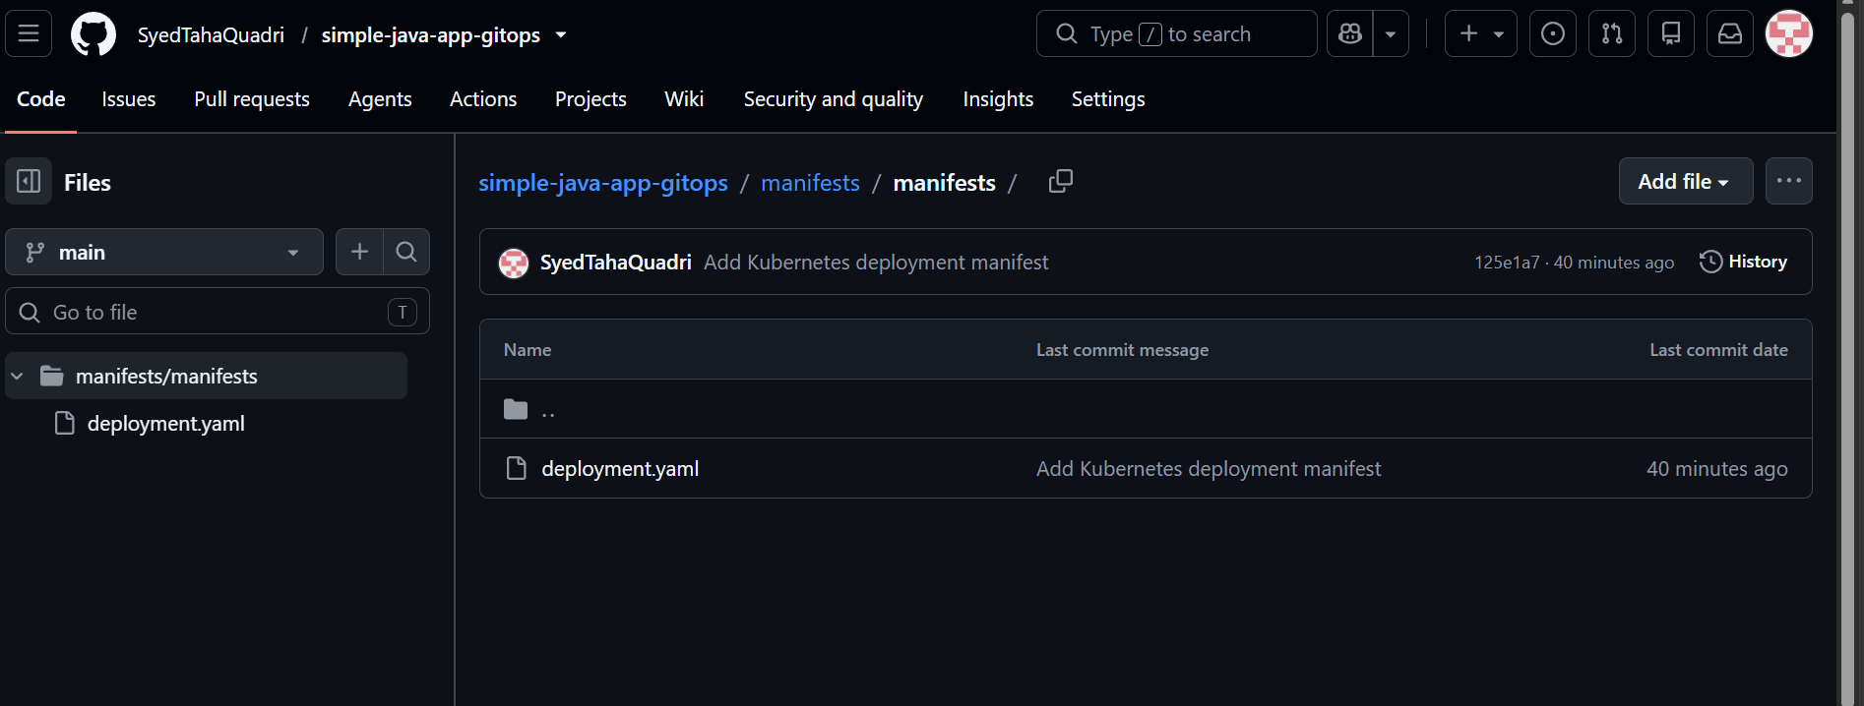

This is our application.yaml file

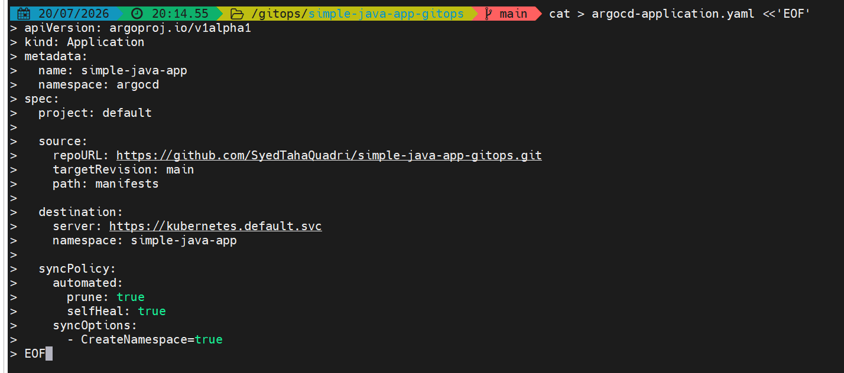

Creating the Application manifest
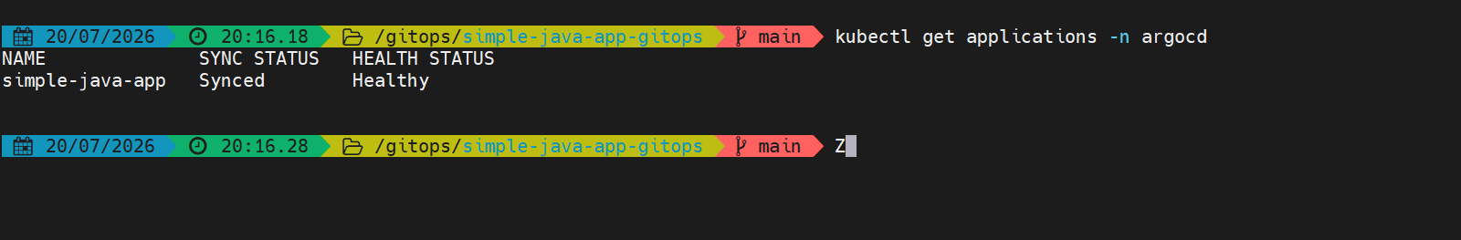
After the application was created, Argo CD connected to the GitHub repository and read the files from the manifests folder.
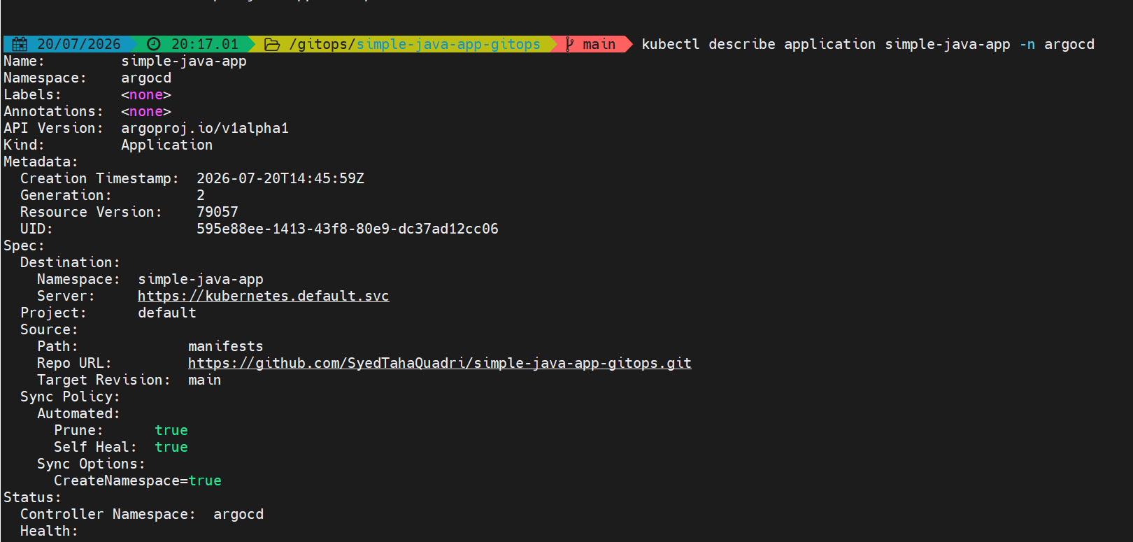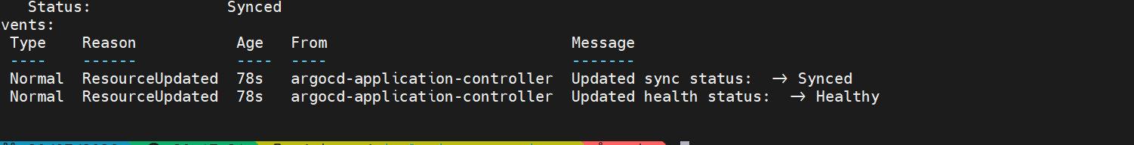
Synced means the live Kubernetes resources match the YAML files stored in GitHub.
Healthy means the deployed Kubernetes resources are running correctly.

The application is now deployed
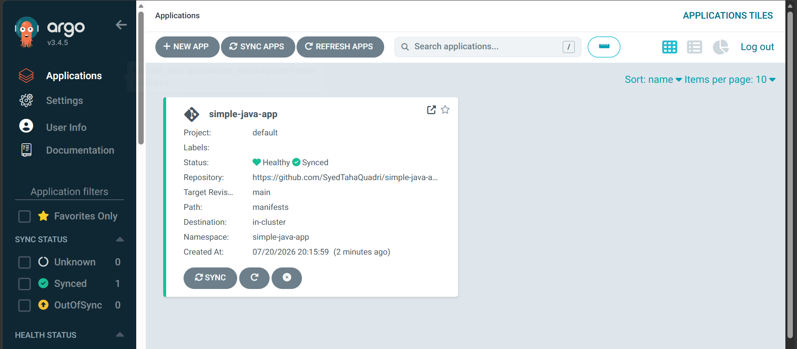

Because automated synchronization was enabled, any future change pushed to the GitOps repository will be detected by Argo CD.
For example, changing the Docker image tag:

