- Configure VPC peering in cross regions

First let’s create two VPCs in two different regions.

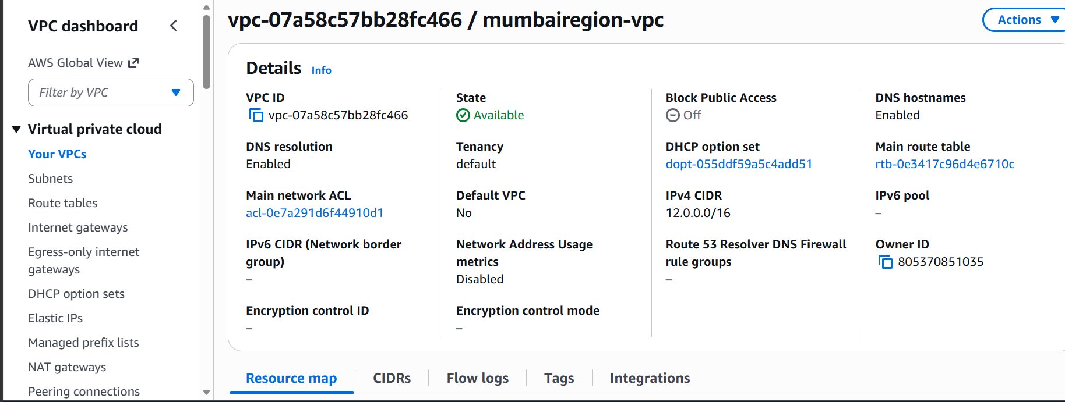

Created one vpc in Mumbai.

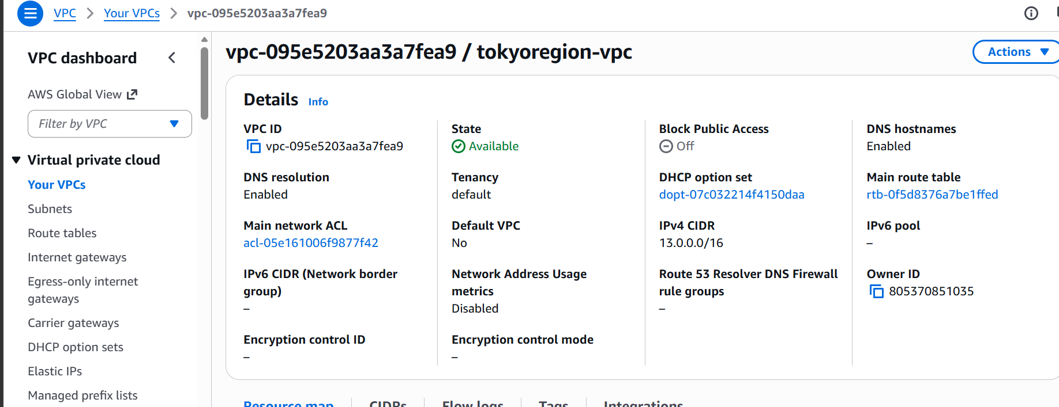

Created another vpc in Tokyo region

Now let’s create a peering request from mumbairegion-vpc.

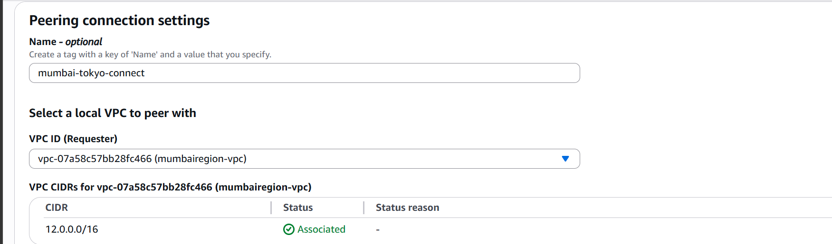

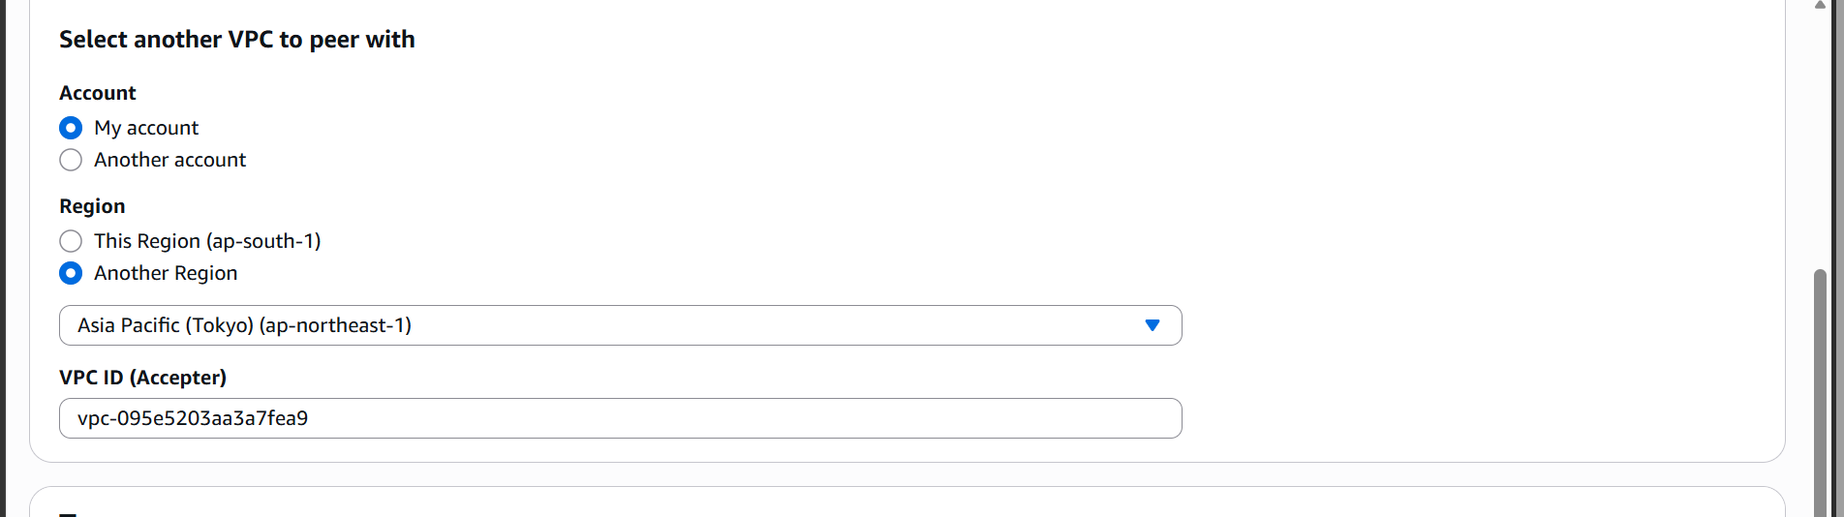

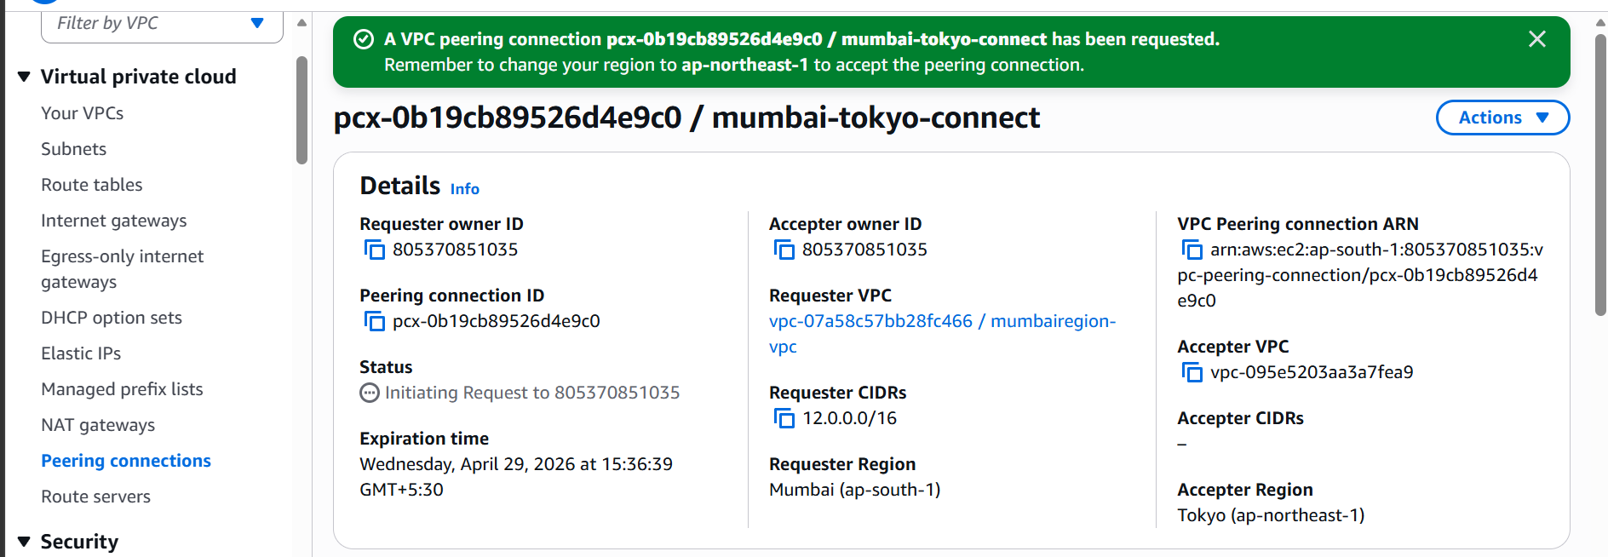

A peering request has been sent to tokyoregion-vpc

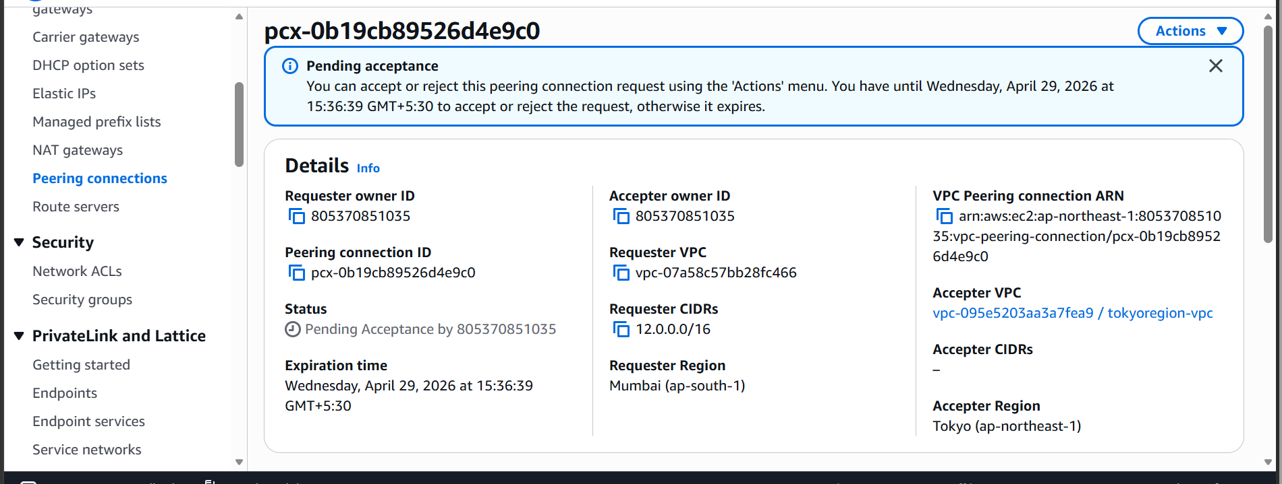

Let us now accept it

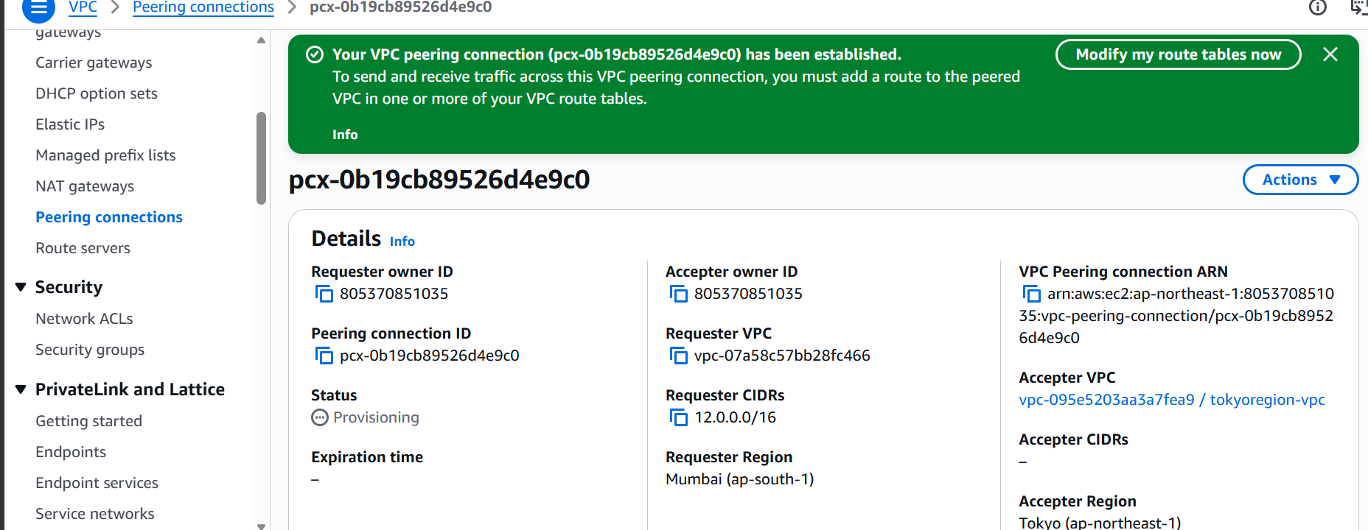

Now let us modify the route tables.

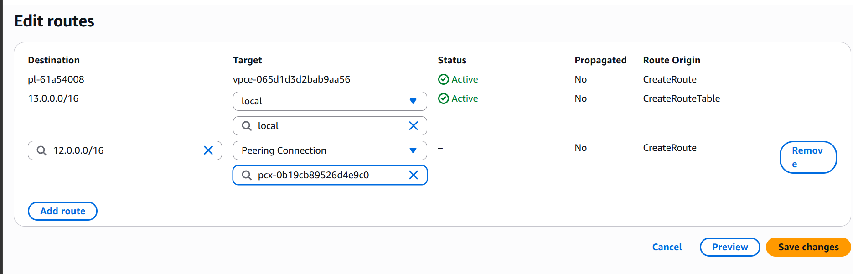

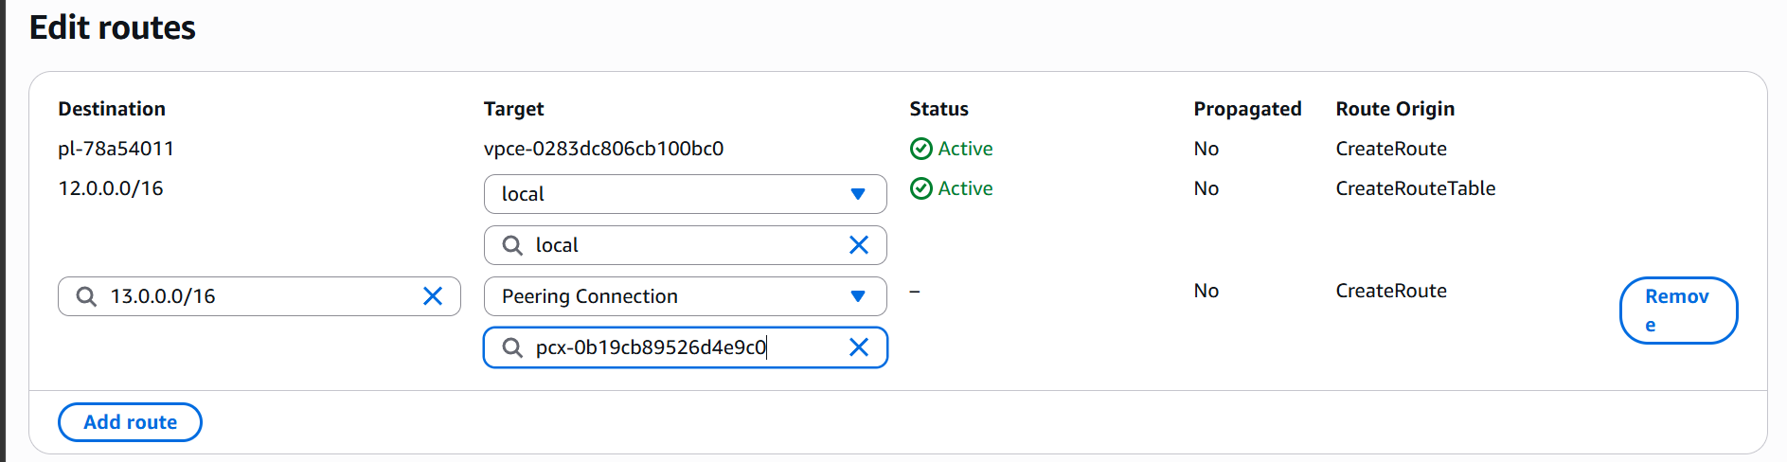

Now let us now launch two instances in each region and check the connectivity.

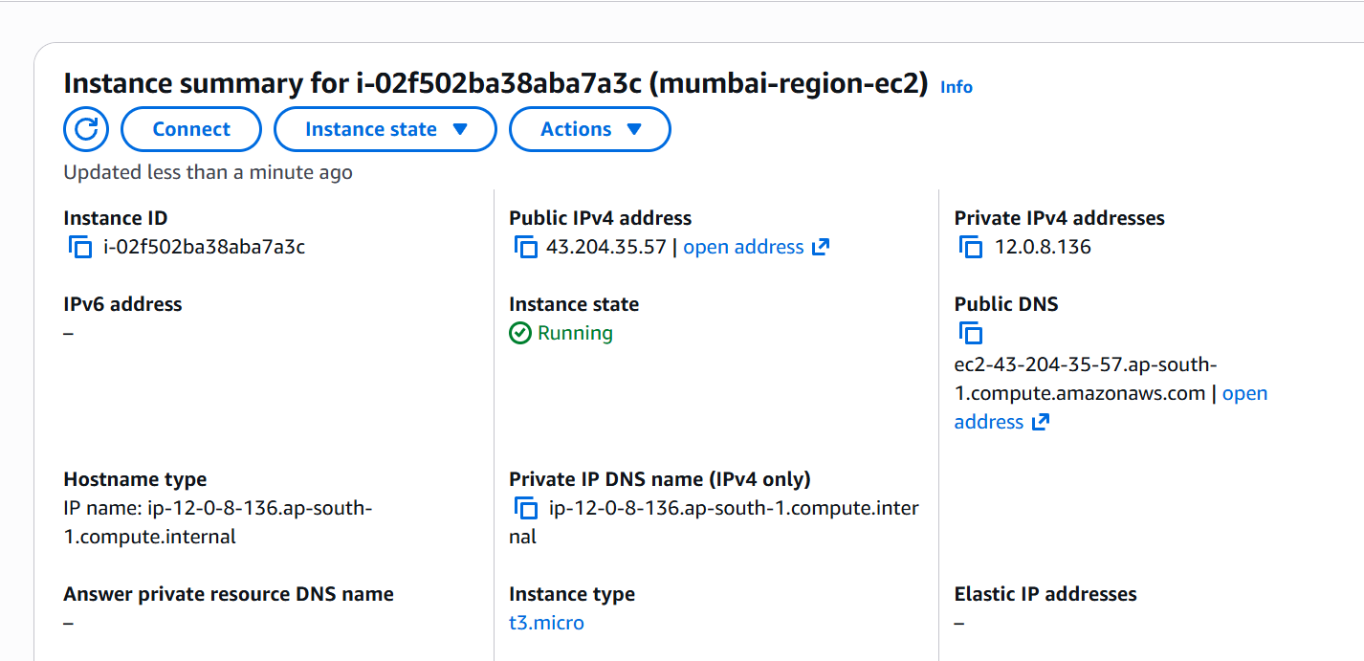

Ec2 in Mumbai region.

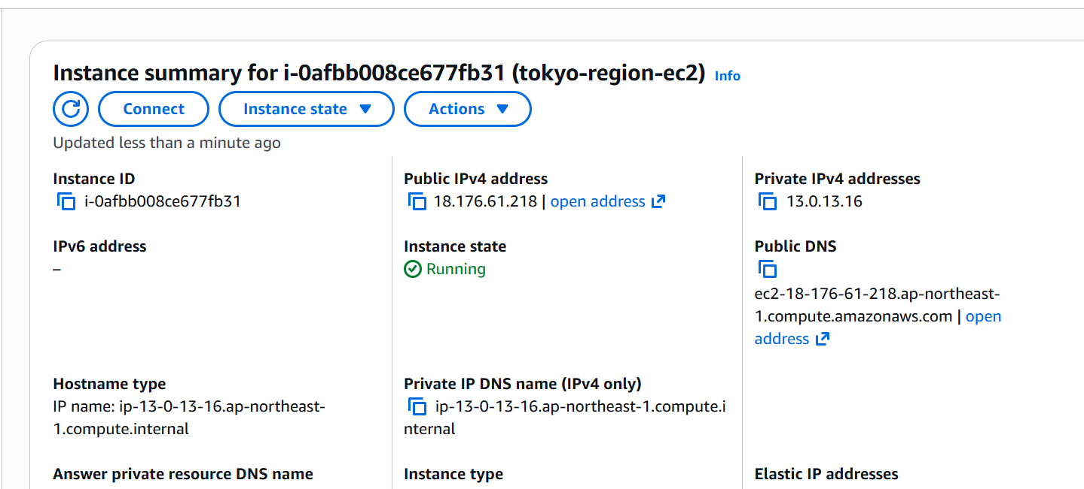

Ec2 in Tokyo region

Now let us ssh into one ec2 and check if we are able to connect another.

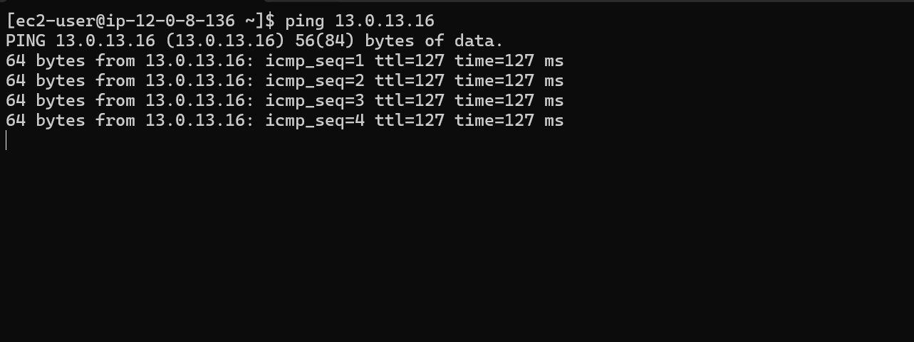

We are able to ping another instance.

Let’s check from another instance as well.

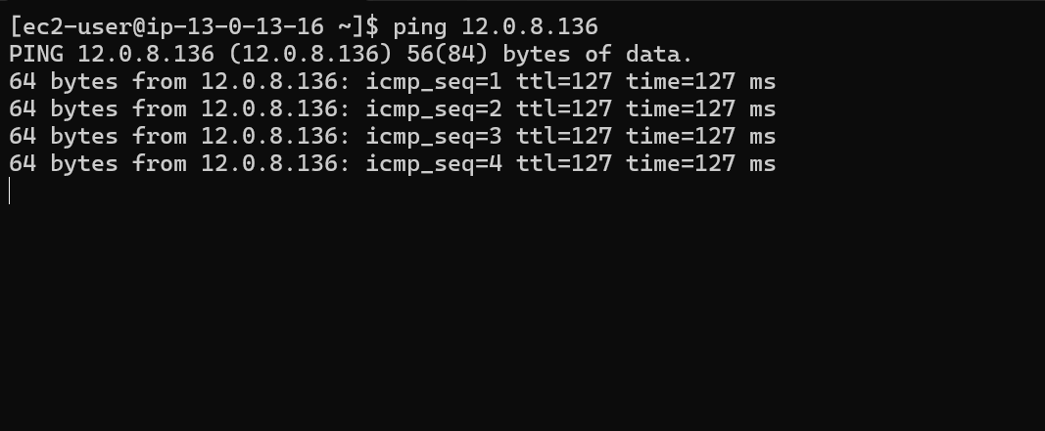

We have now successfully created a peering connection between both the VPCs of different regions.

- Purchase one domain from GoDaddy.
Lets go to GoDaddy website and purchase a domain.

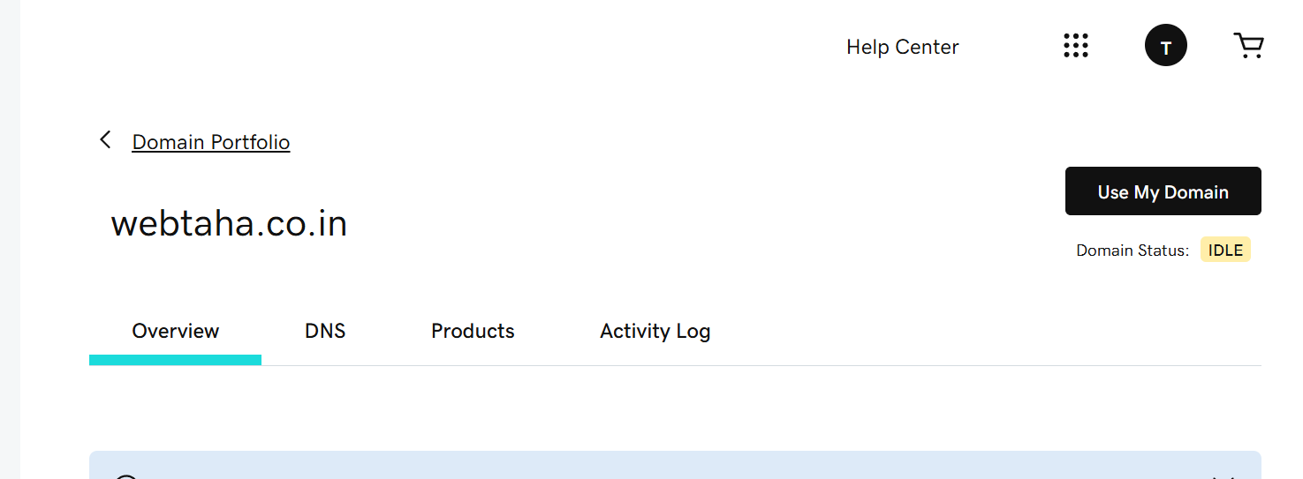

We have purchased this domain w e bta h a. c o .i n .

- Deploy static website in S3

Let us now create a s3 bucket and deploy a static website in it.

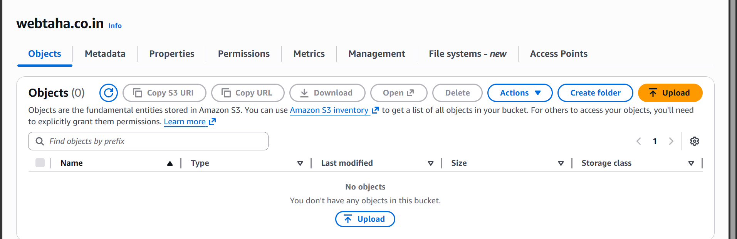

We h a v e now created a bucket with our domain name.
Now let us deploy a static website on it.

Go to bucket properties and scroll down.

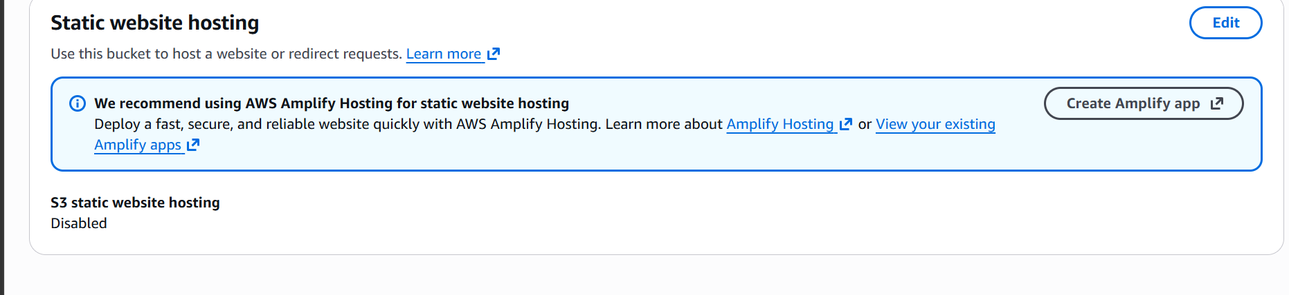

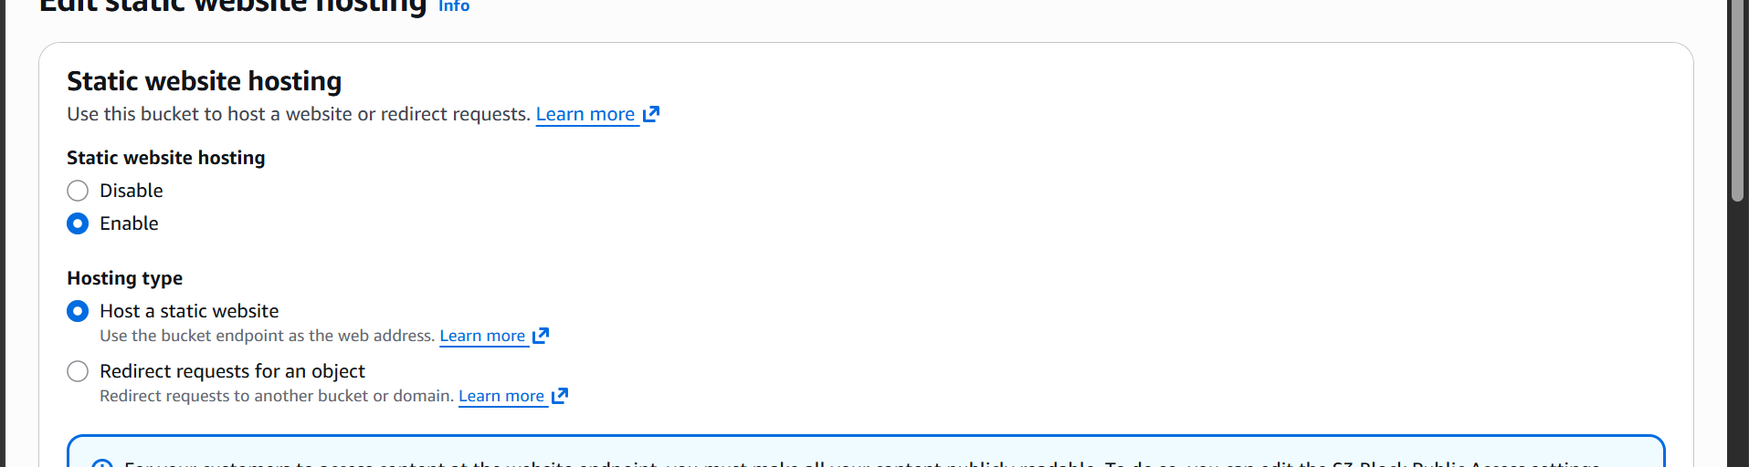

Give the html file names.

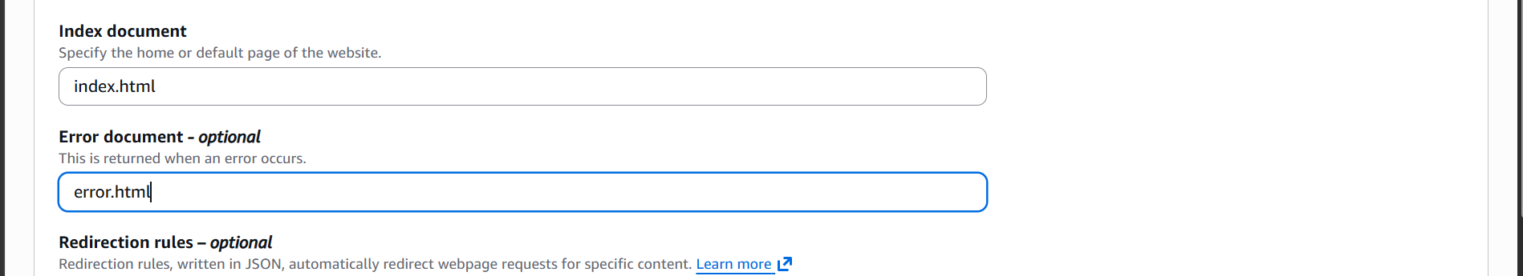

Now let us now upload our html files

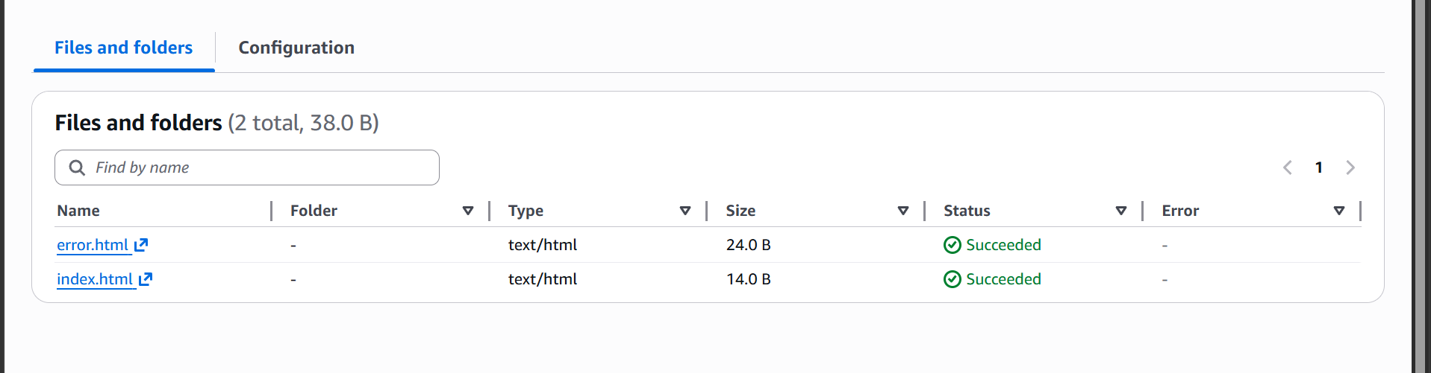

Now let us update the bucket policy.

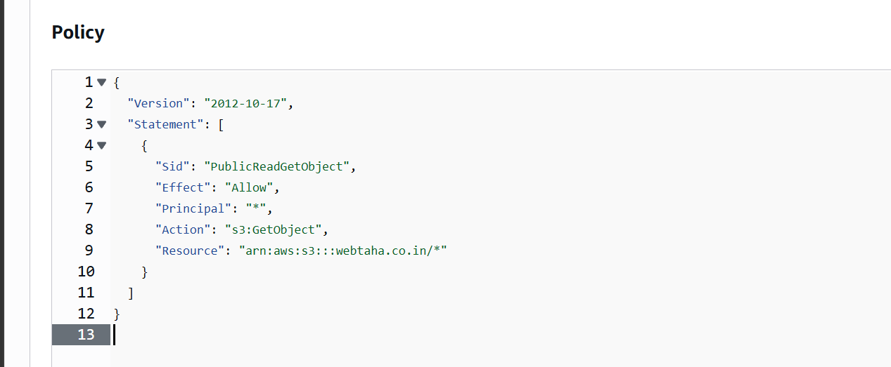

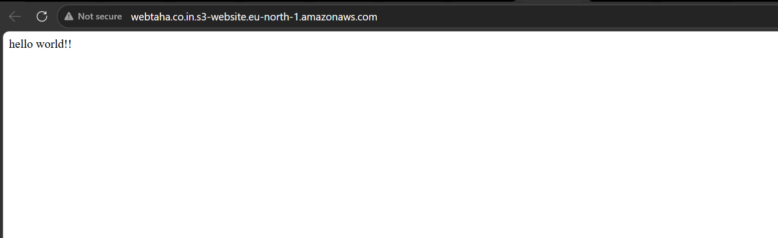

Our website is now accessible over internet.

- Create a CDN and attach one SSL certificate:

Now let us go and do cloud front setup.

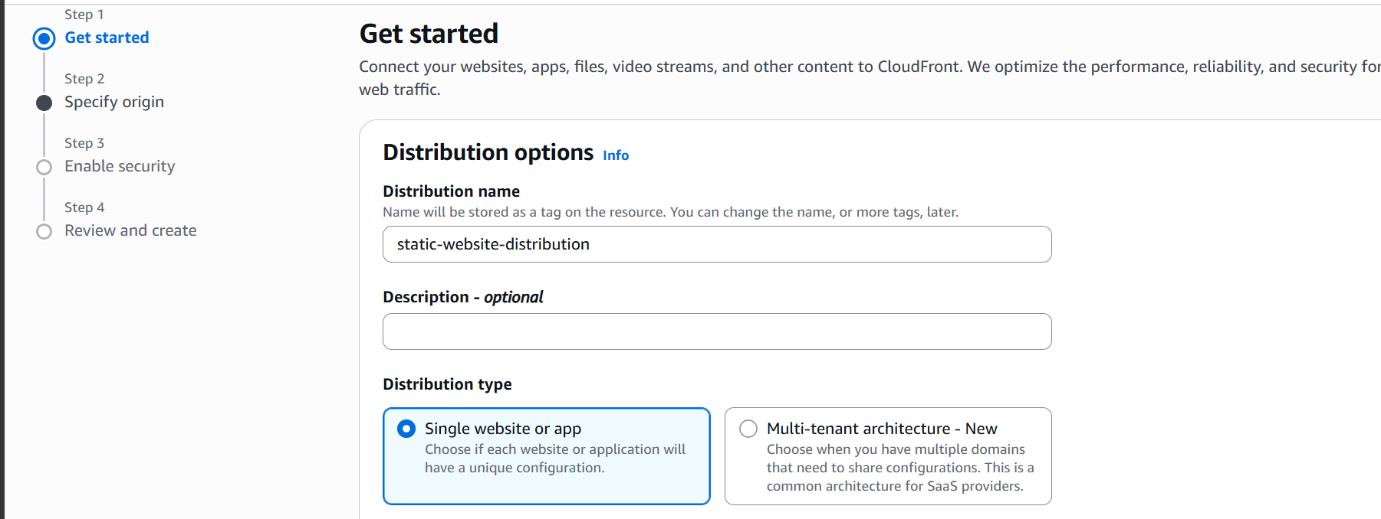

Select origin type as S3

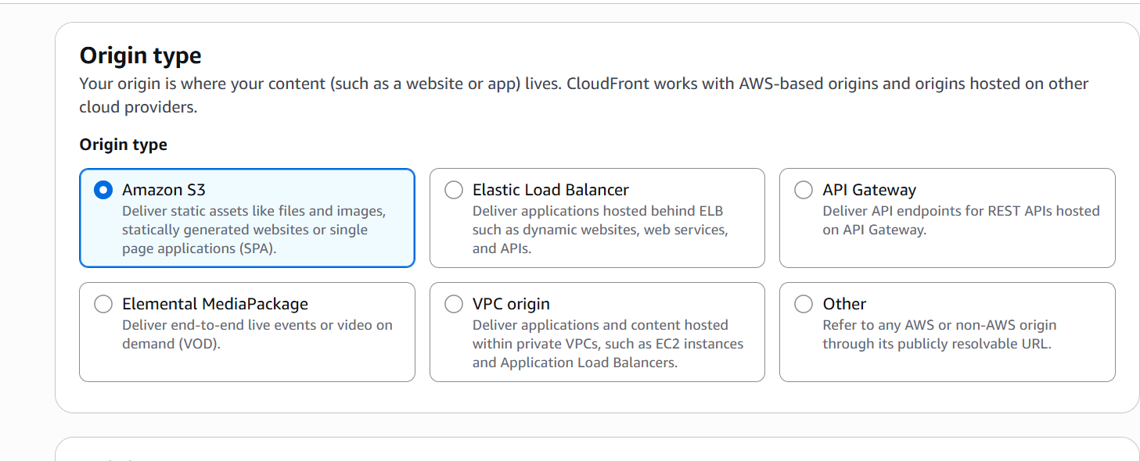

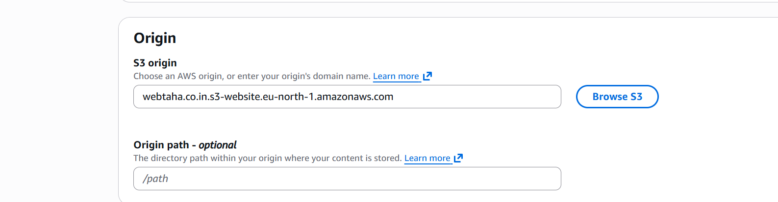



Go ahead and create the distribution
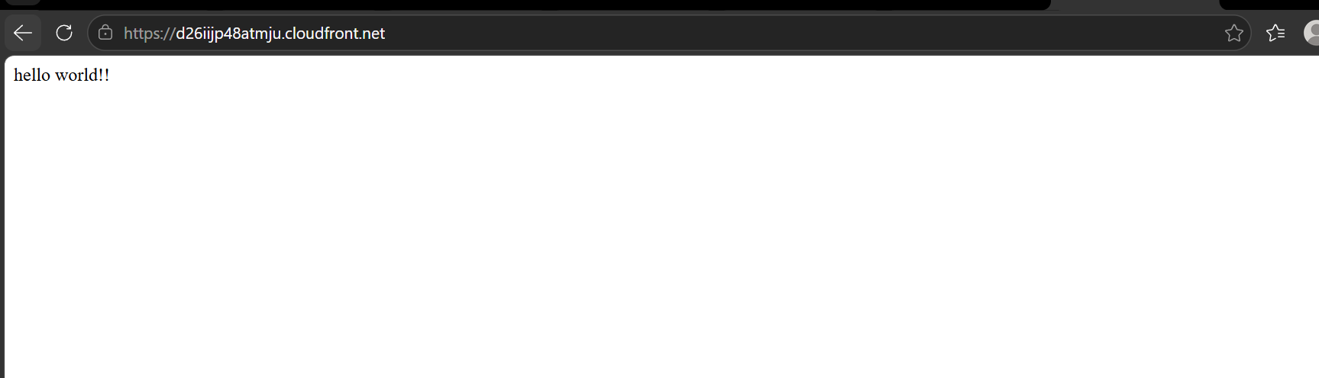
Now we are able to access our static website using cloudfront url.

let us request a public certificate:

Requesting a public certificate:
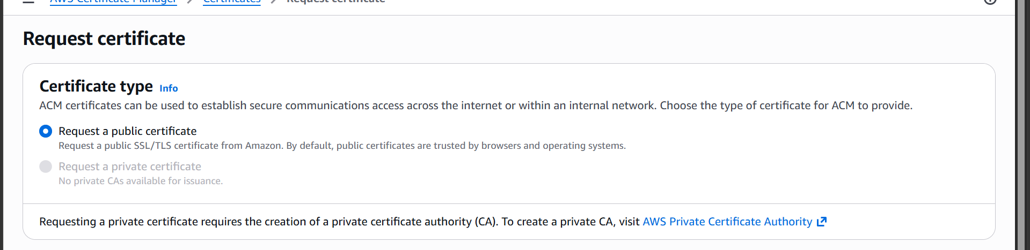

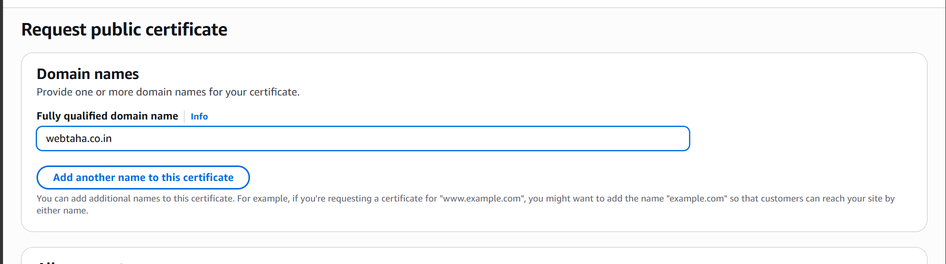

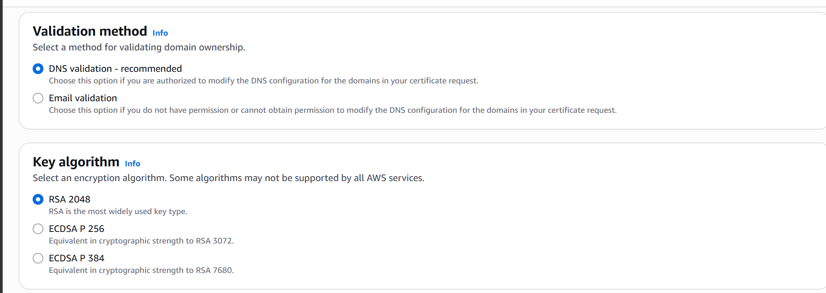

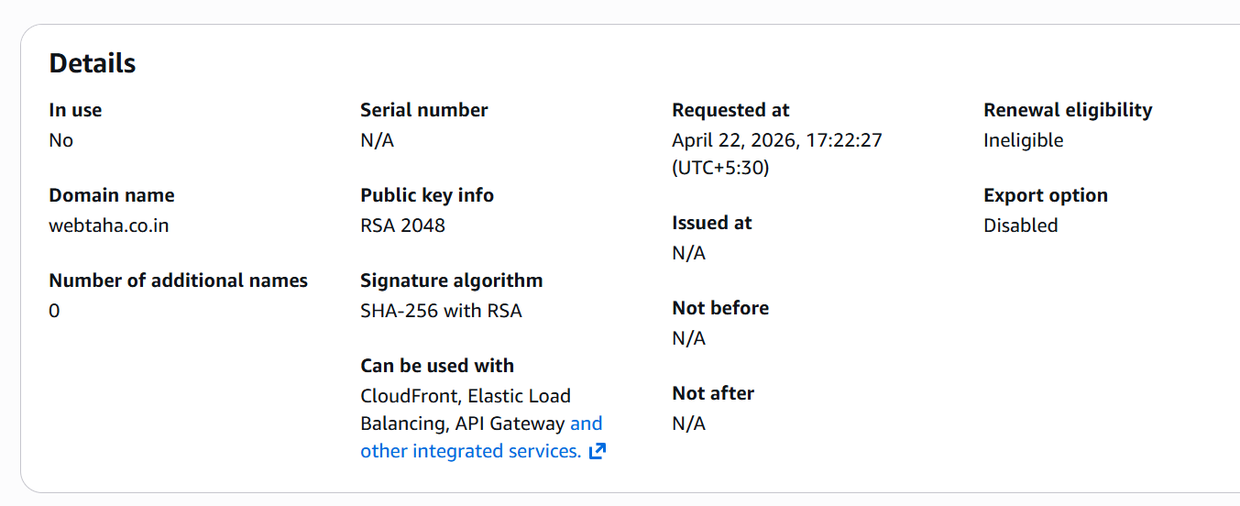

Let us now attach the certificate to the cloudfront distribution.

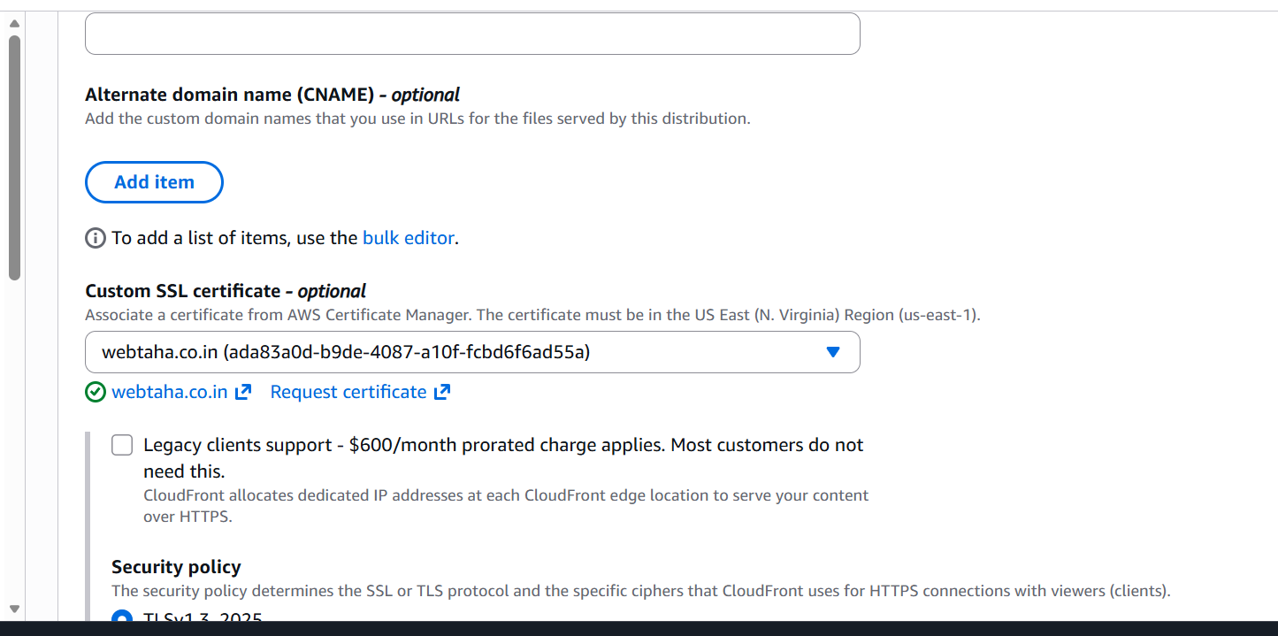

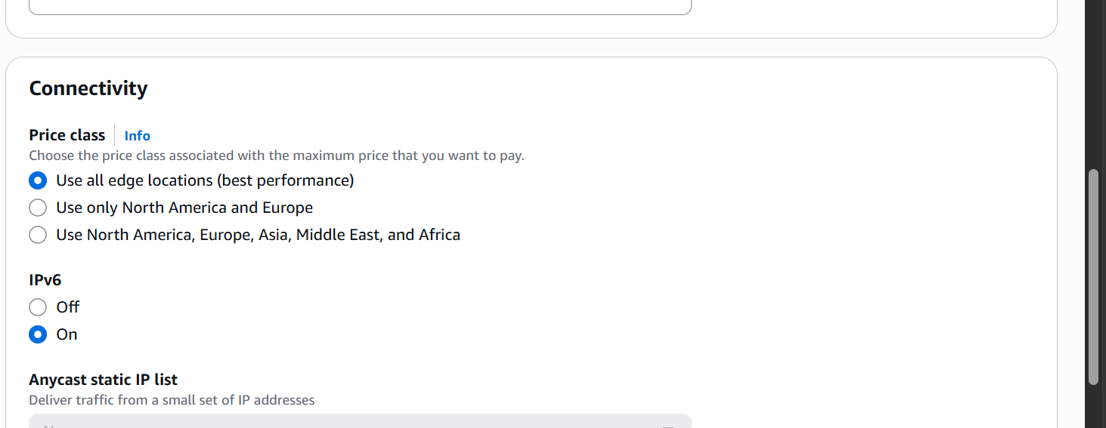

The certificate is now attached to our cloudfront dirstribution.

- Create a Route53 hosted zone and map the domain with the CDN

Let us now go to route 53 and create hosted zone.
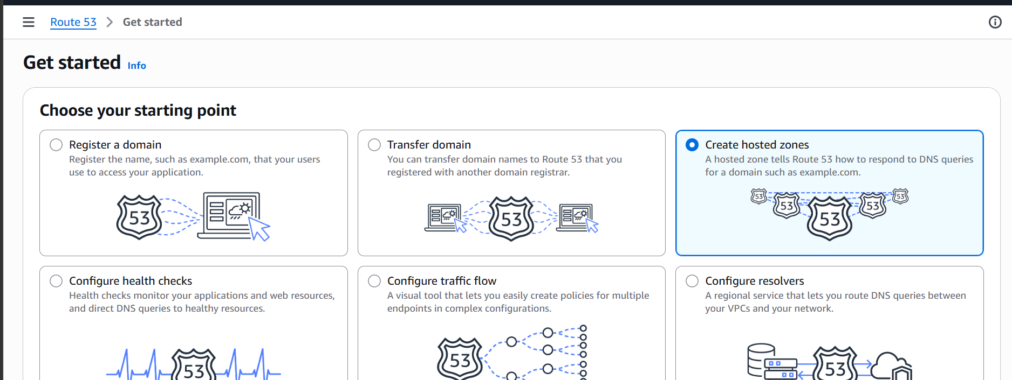

Click on create hosted zones.

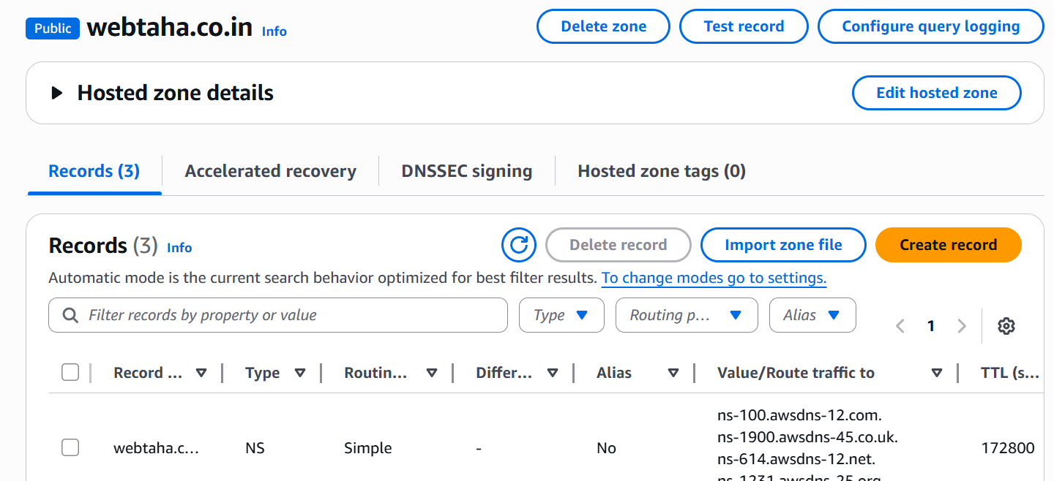

Hosted zone created now.
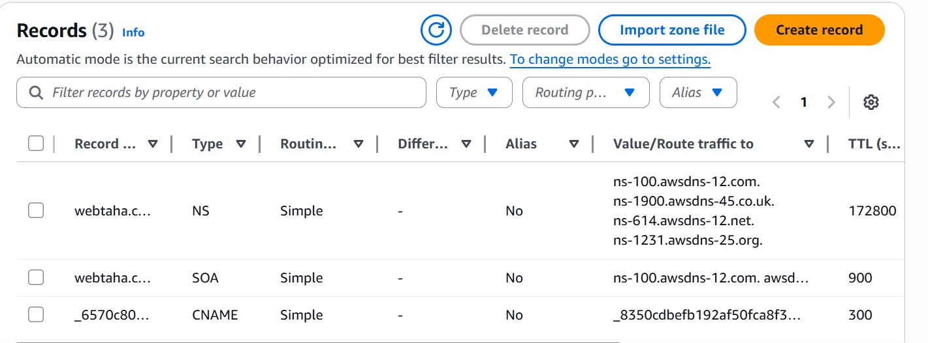

The hosted zone is now created now we need to add NS record in our domain providers DNS settings.

In GoDaddy.com go to my products.
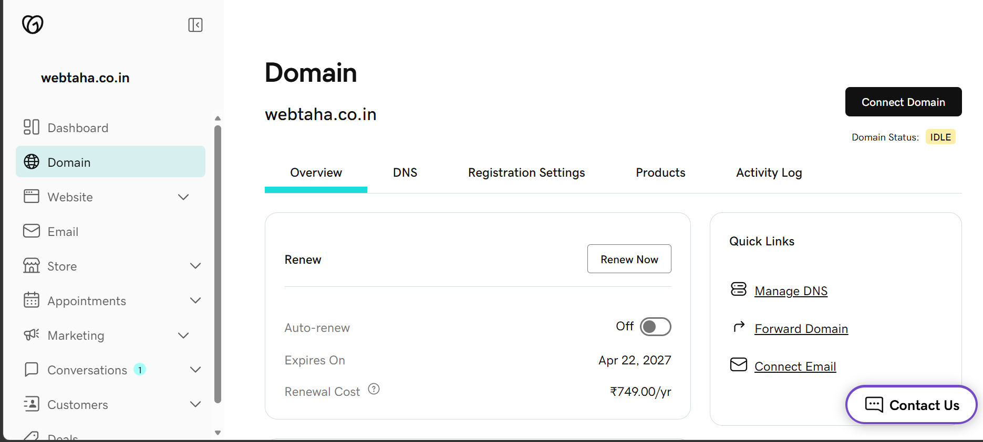

Click on Domain.

Then click on DNS
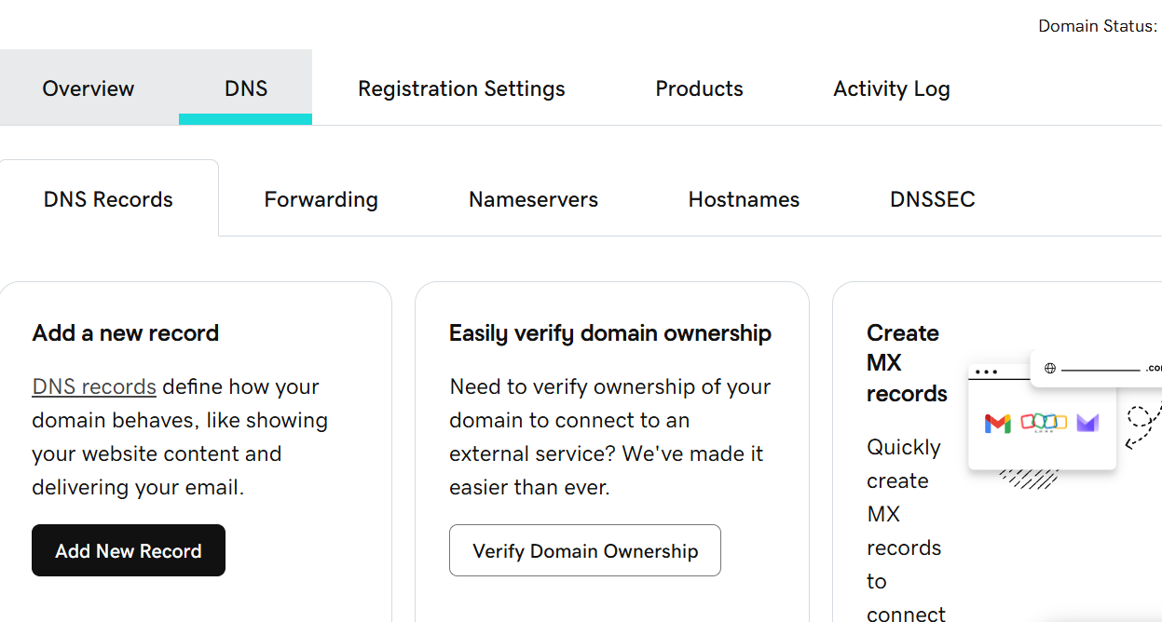

In DNS click on Nameservers
And then click on Change nameservers
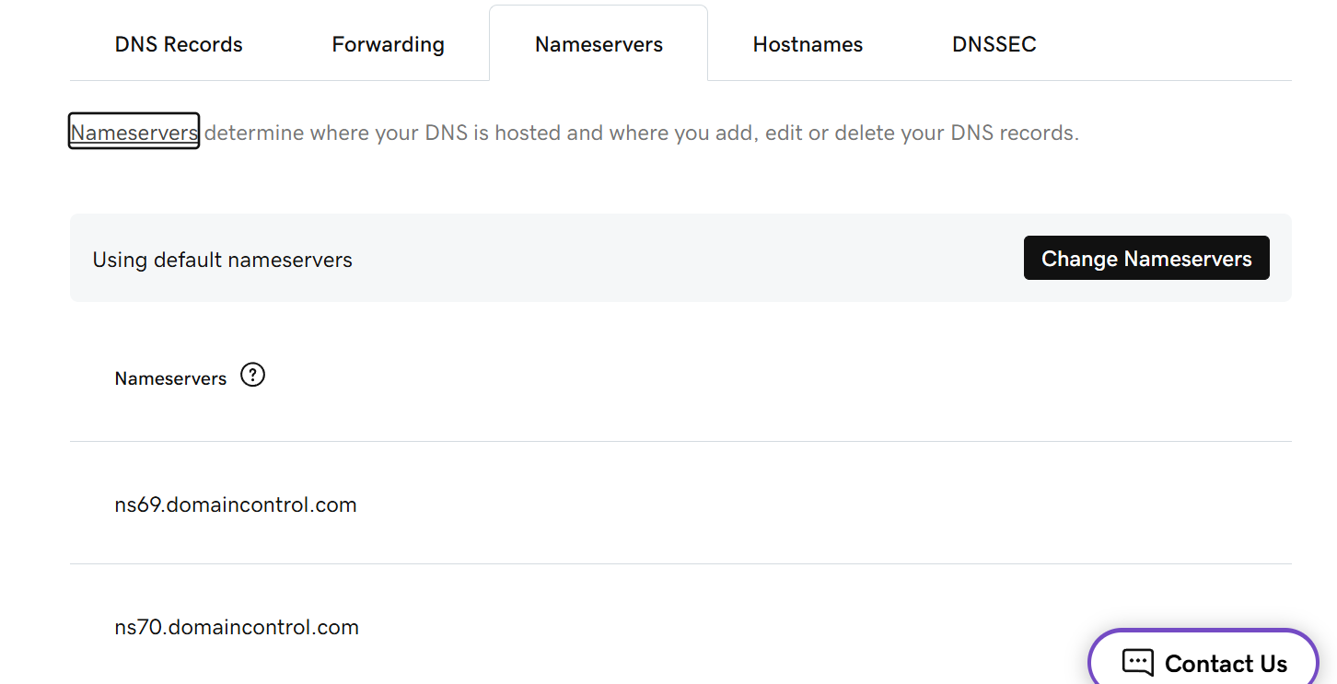

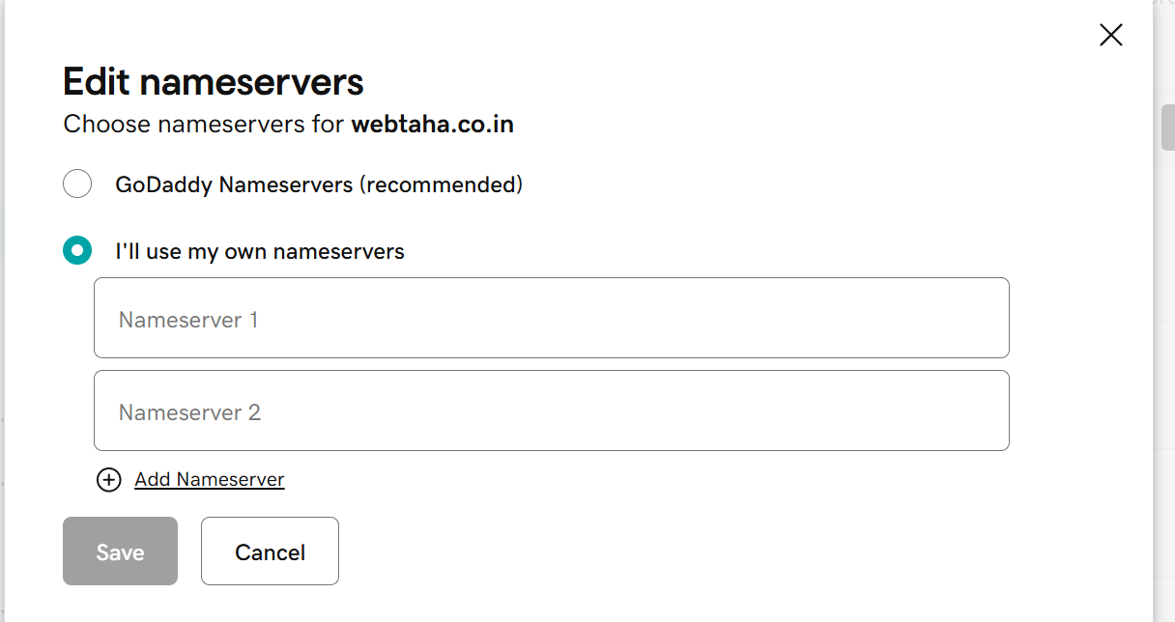

Click on I’ll use my own nameservers.
Add the nameserver records you get from hosted zones.
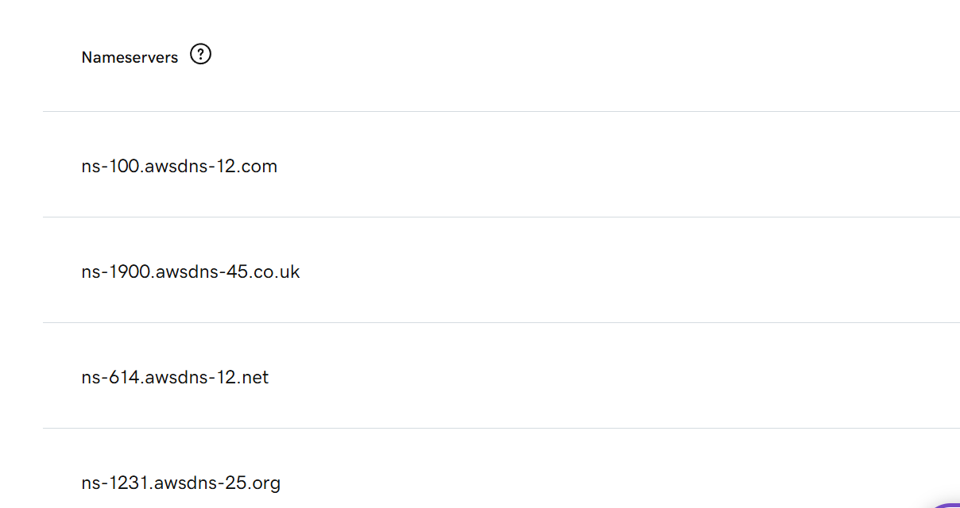

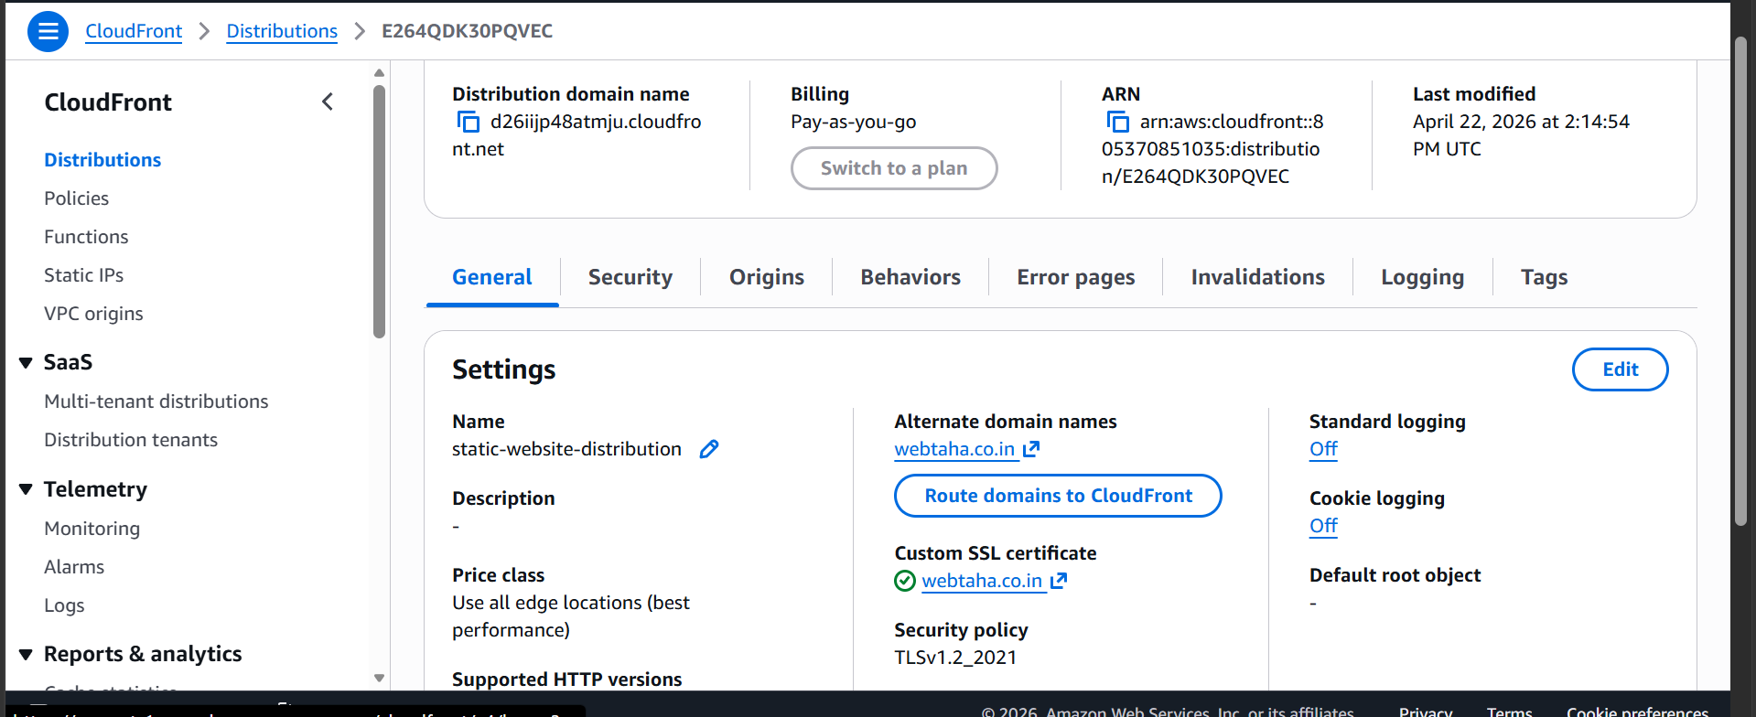

Our domain name and ssl certificate are now mapped to our cloudfront distribution.

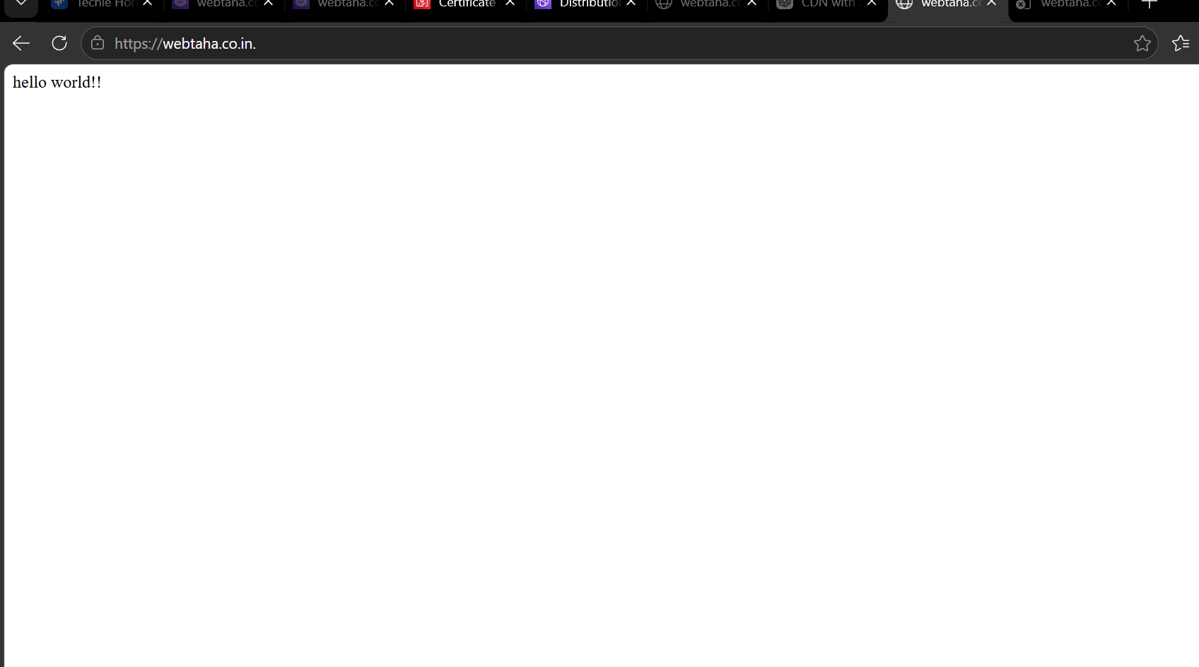

The static website is now working on our url.

- Update the index.html in the S3 bucket and ensure the updated file is accessible using the domain.

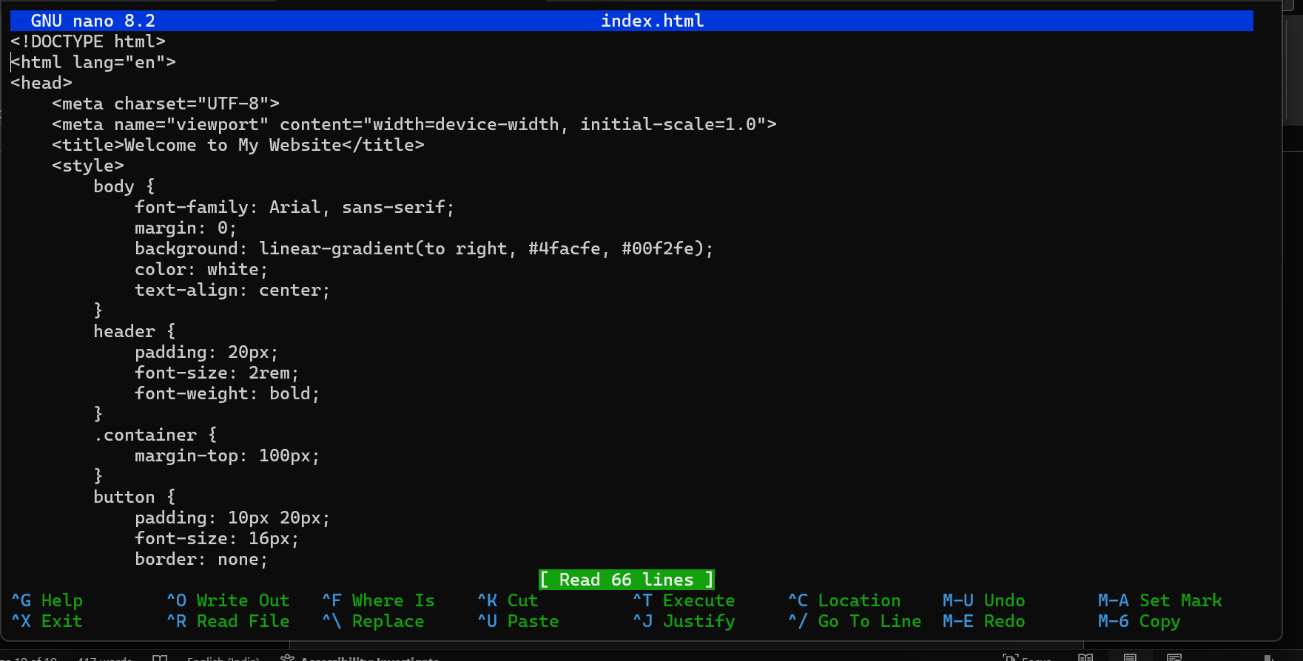

Updated the index.html

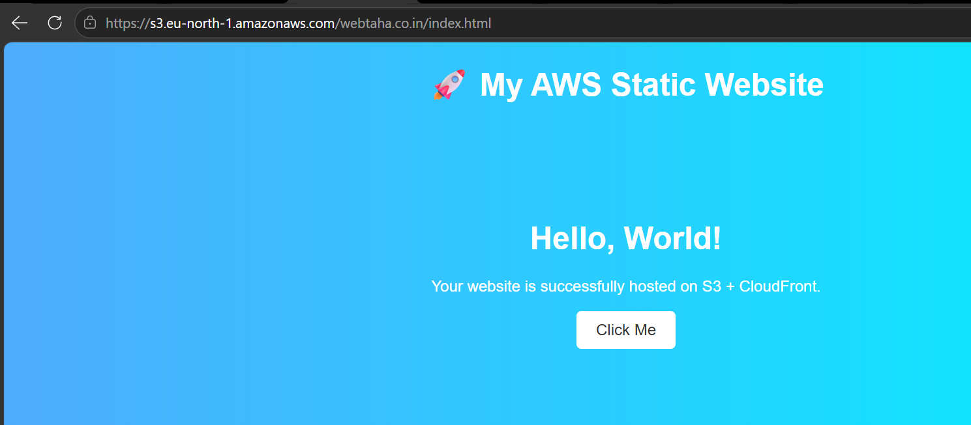

the updated web page is reflecting in our static website.

