Kubernetes-01

- Setup Minikube in your local machine
Installing minikube using chocolatey package manager
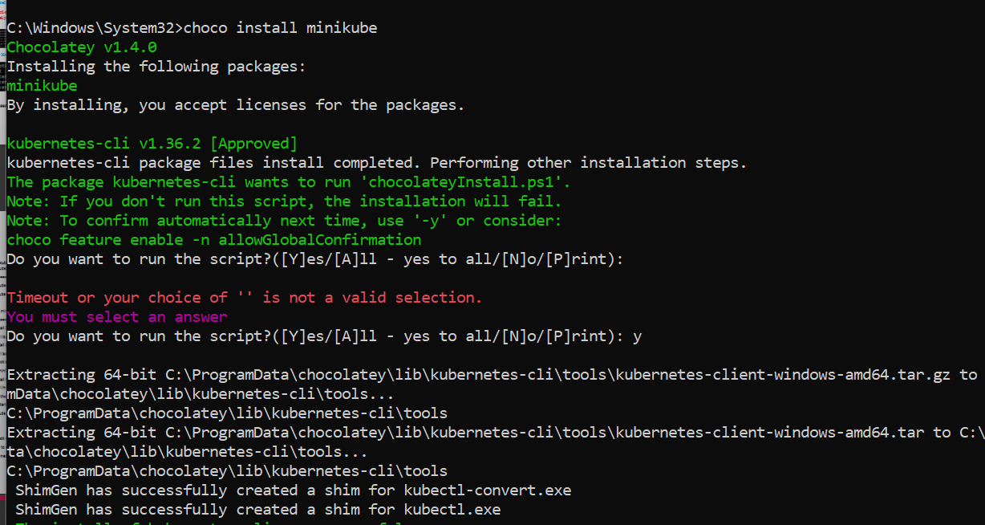
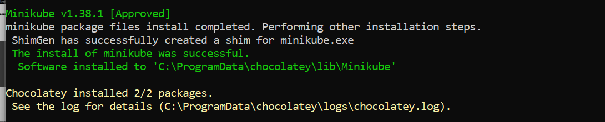
Starting the Kubernetes cluser
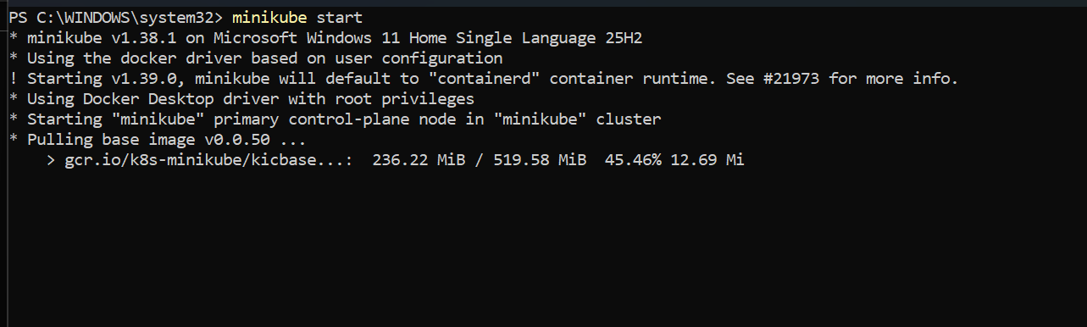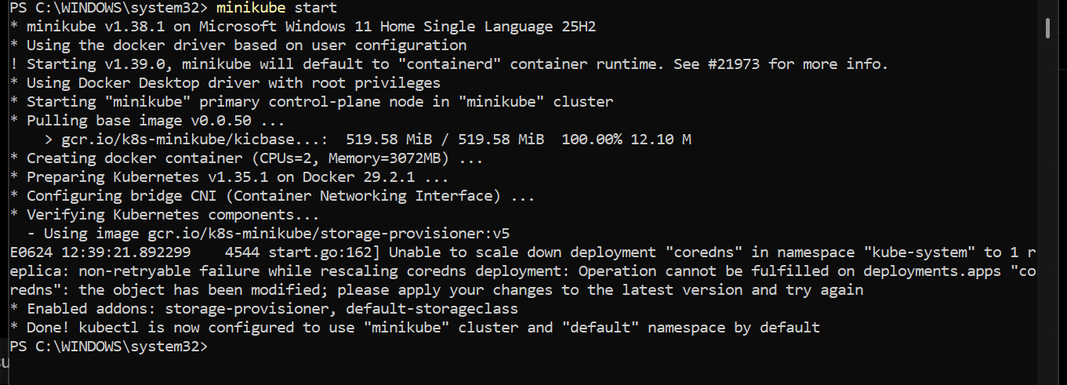
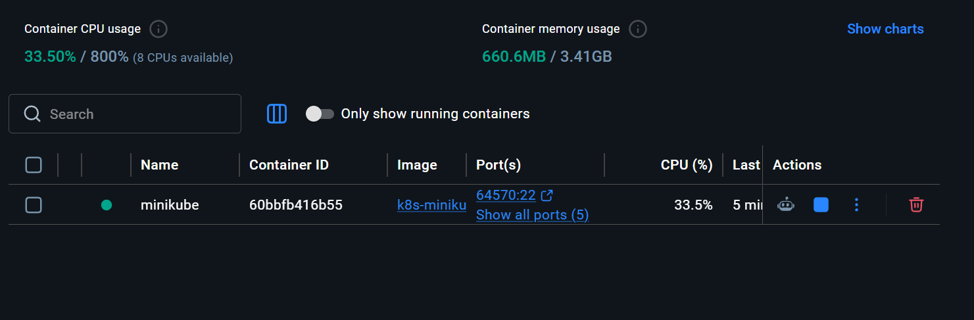

Minikube cluster is now running

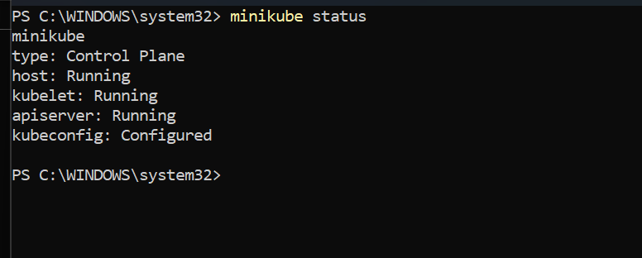
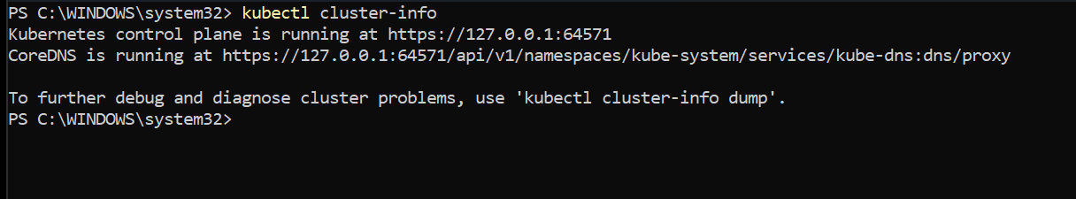
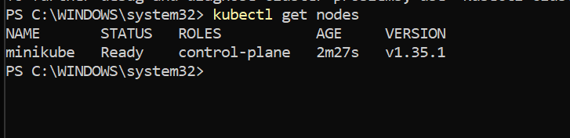

These are the running pods with all the master and control plane components

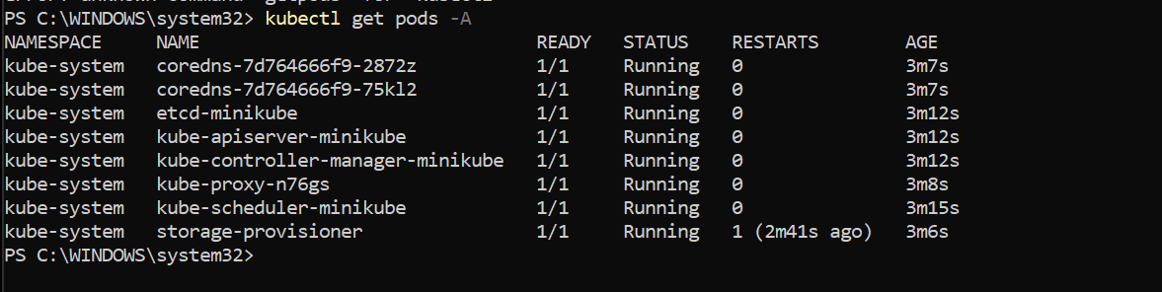

- Setup K8s master and worker nodes on ubuntu
First make sure that docker is installed on all the instances
Master and control plane
We have 3 instances 1 master and 2 nodes and we have installed docker on all of them
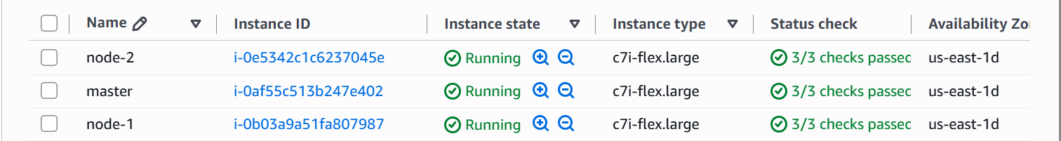

Setting up the master node
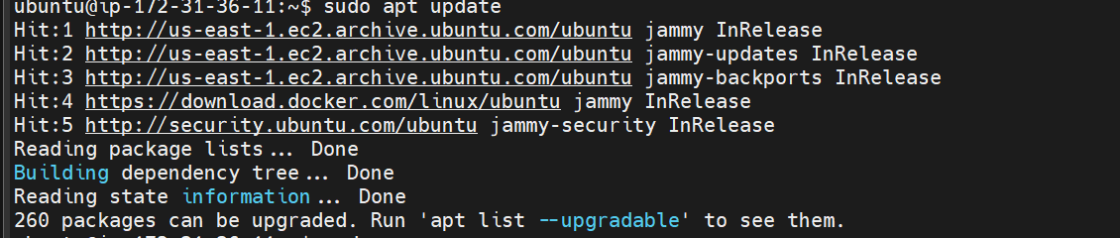
Download the public signing key for the Kubernetes package repositories. The same signing key is used for all repositories so you can disregard the version in the URL:

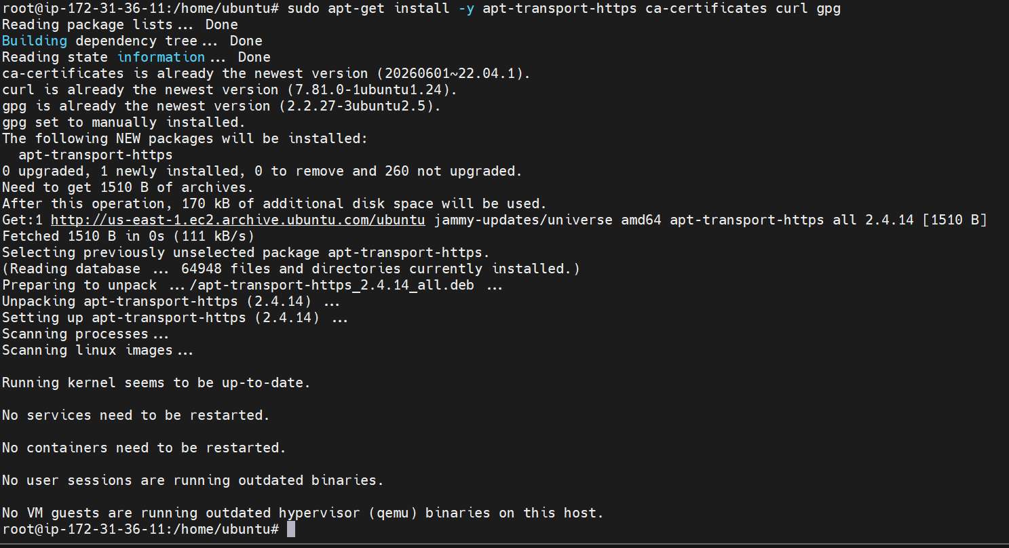
Add the appropriate Kubernetes apt repository. Please note that this repository have packages only for Kubernetes 1.36; for other Kubernetes minor versions, you need to change the Kubernetes minor version in the URL to match your desired minor version (you should also check that you are reading the documentation for the version of Kubernetes that you plan to install).
Update the apt package index, install kubelet, kubeadm and kubectl, and pin their version:
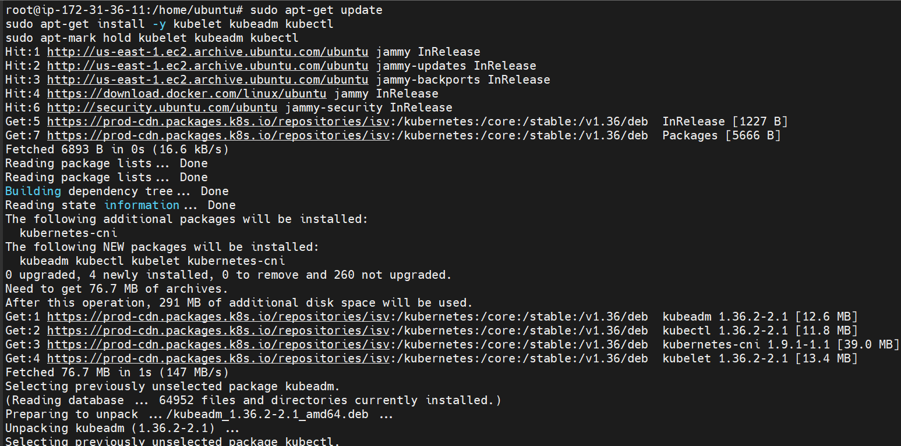

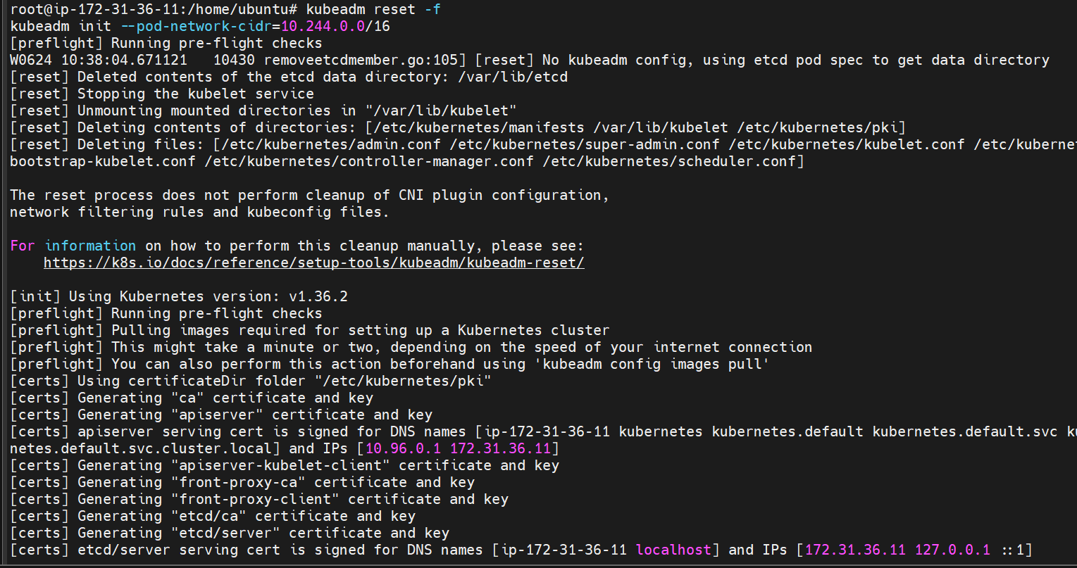
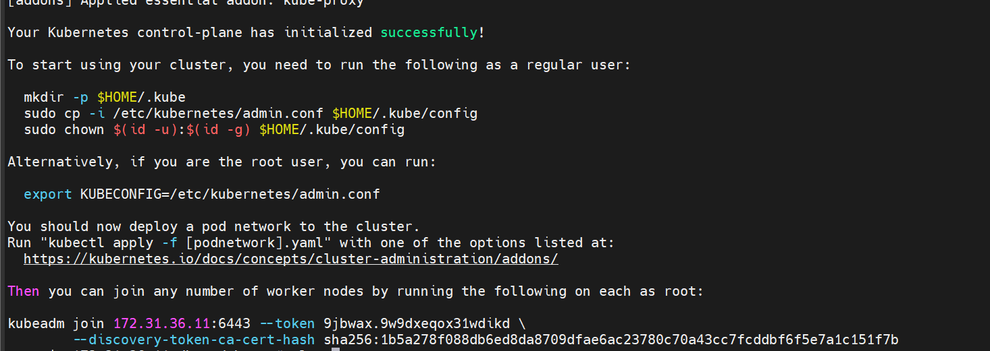
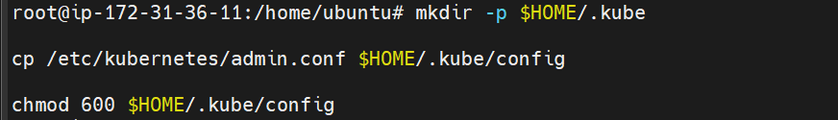
Setting up worker node
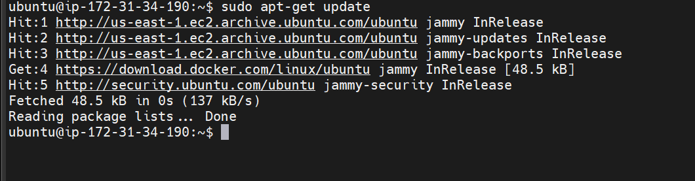
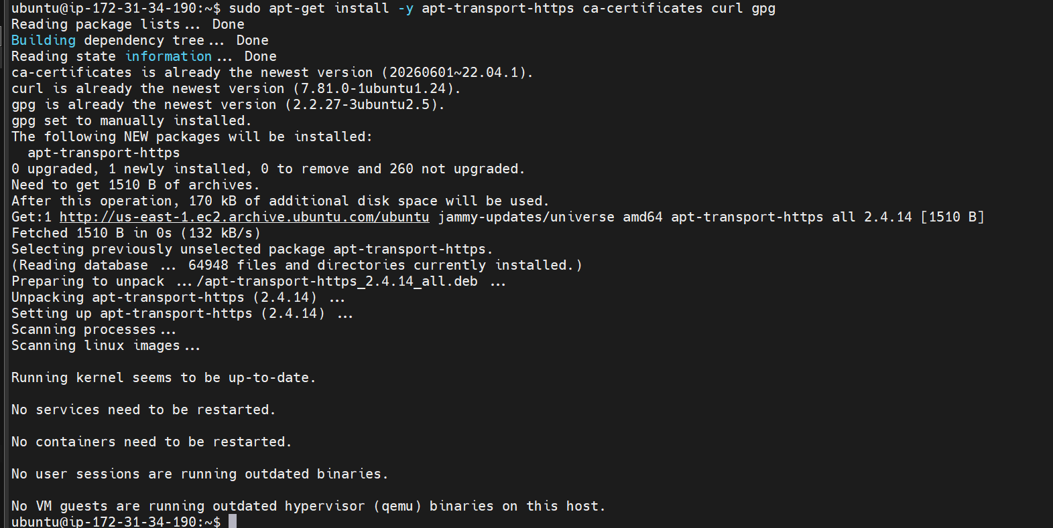

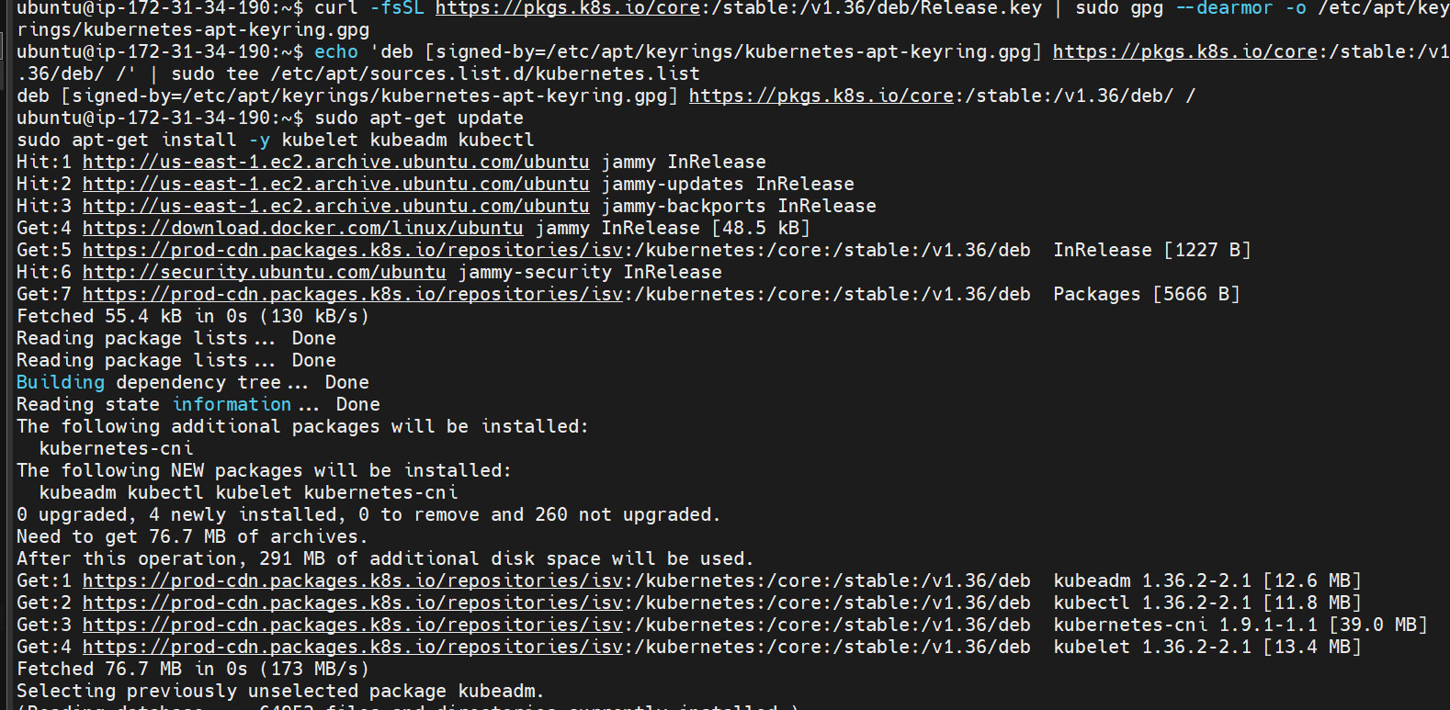

Kubeadm is now installed on node 1

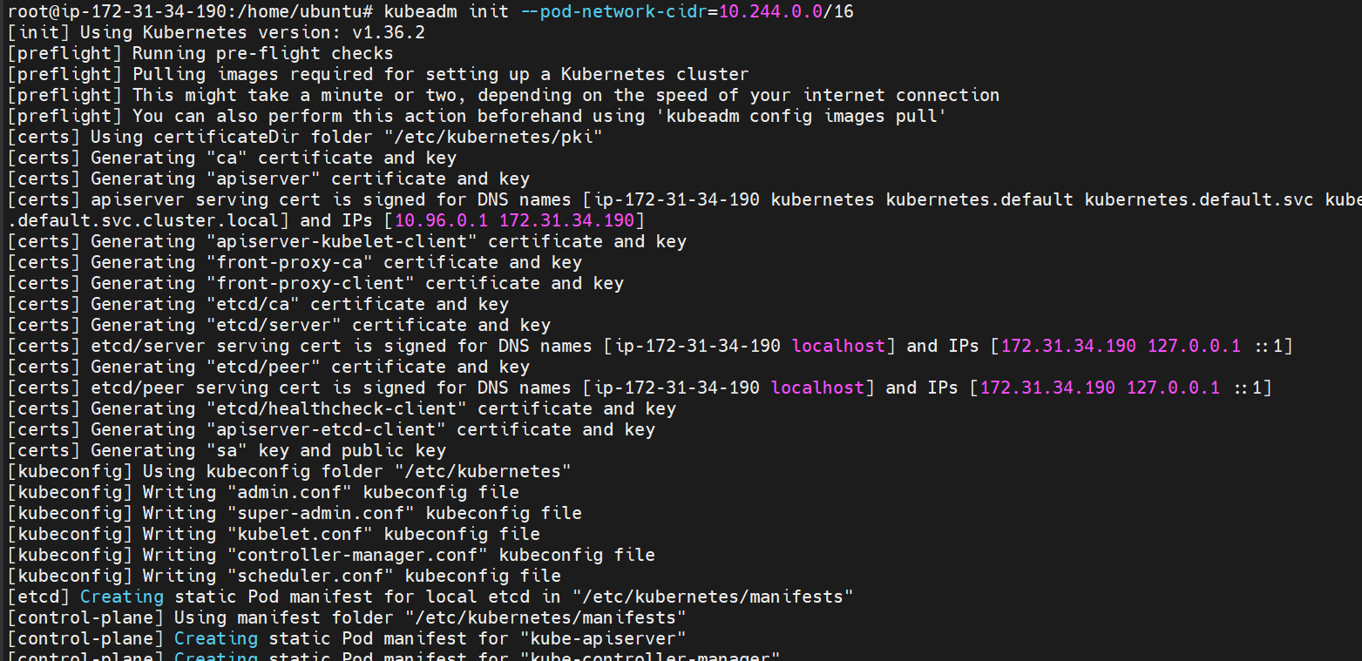

Lets now setup the other node
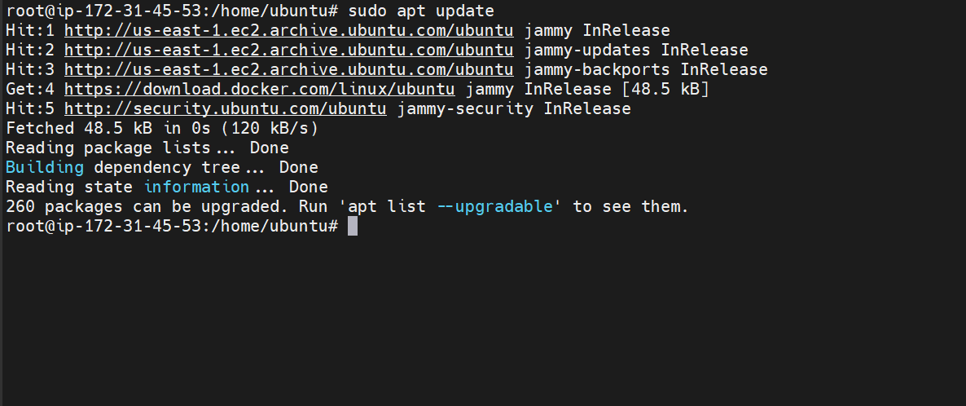
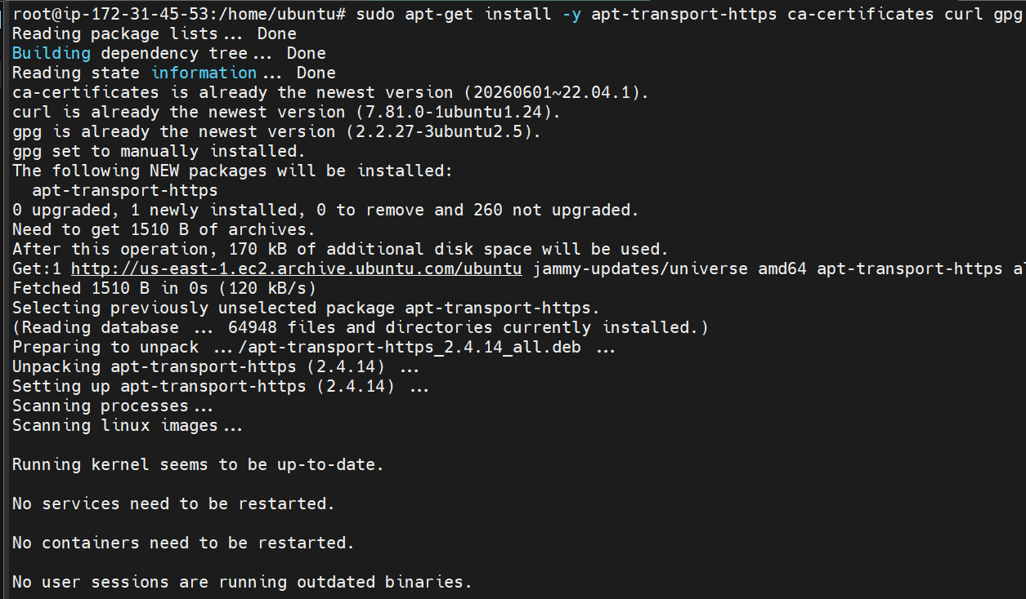

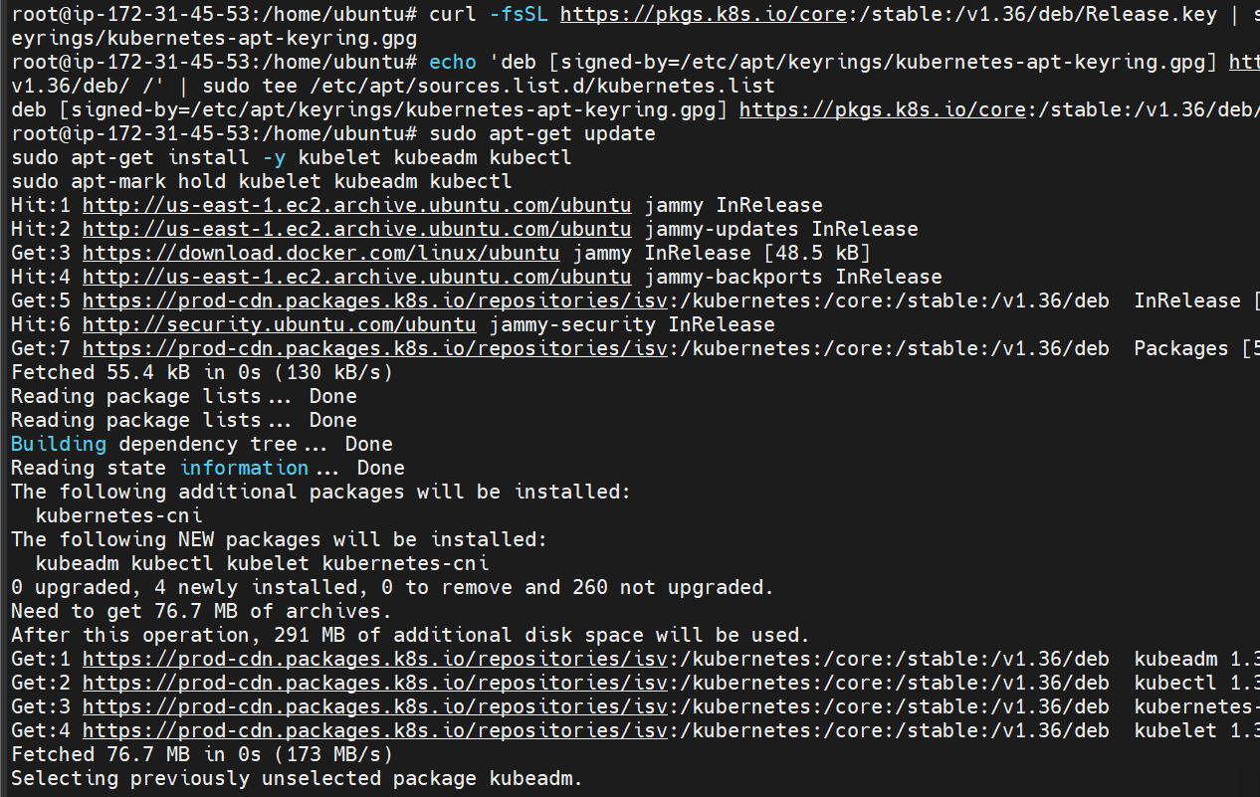
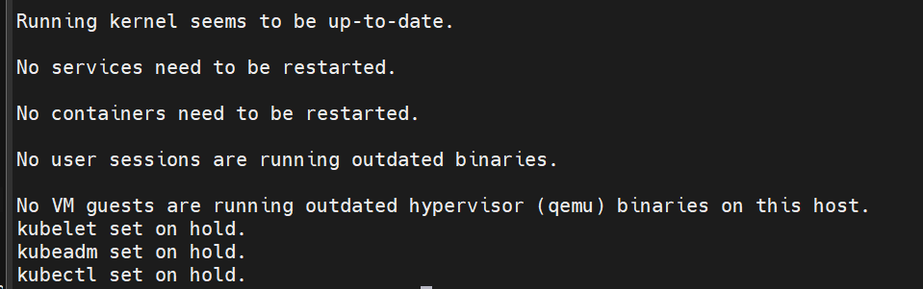
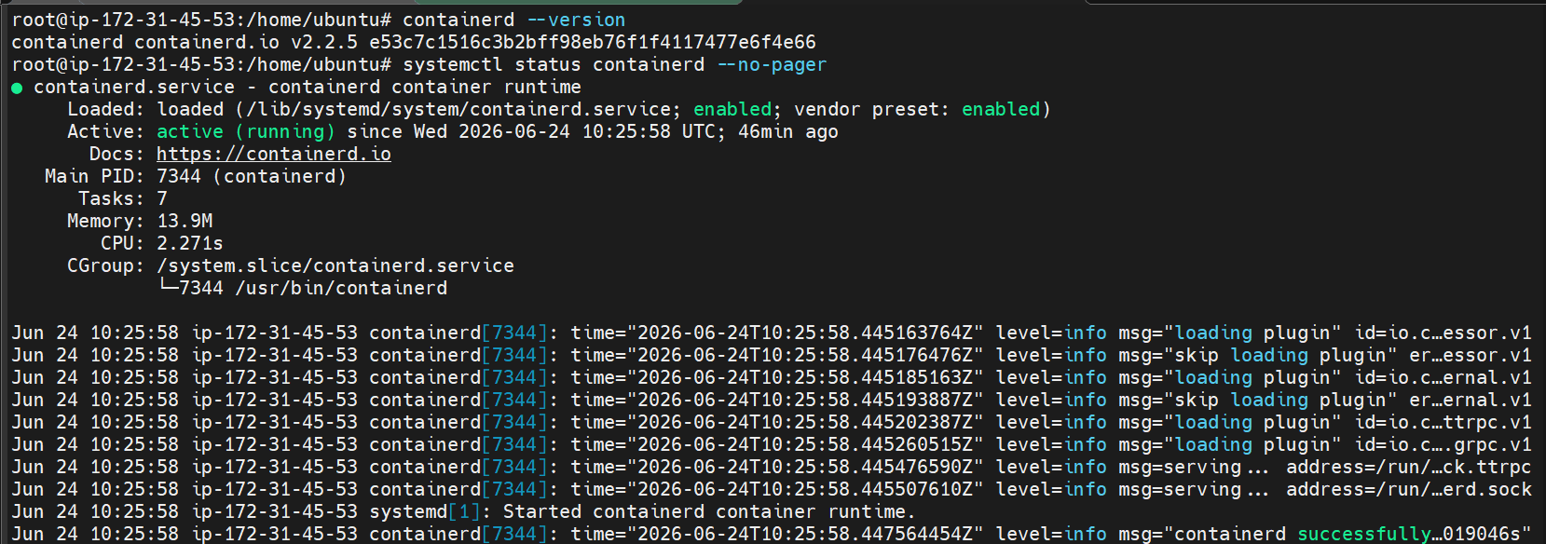
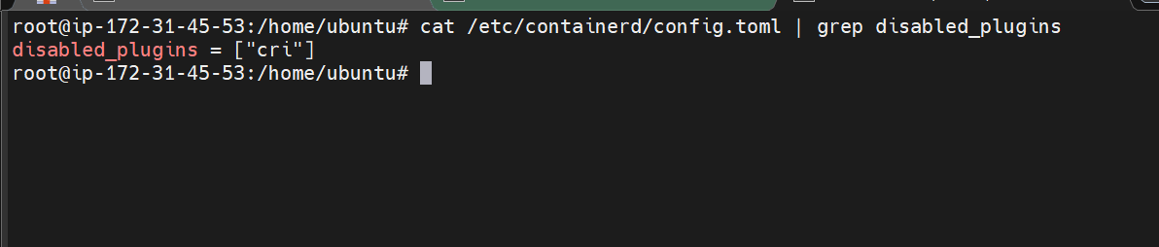

Kubeadm installation is done now
Lets connect both the nodes to master using kubeadm join command

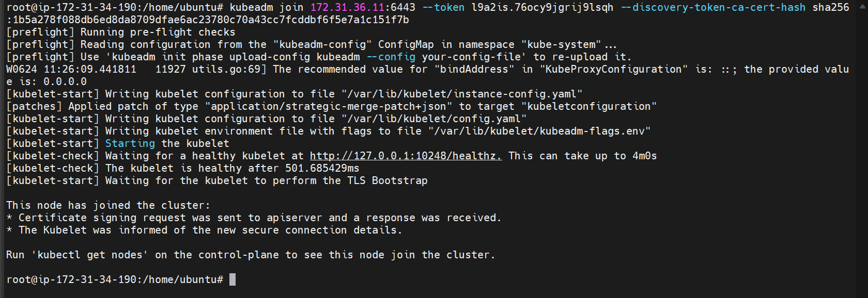
Joining the nodes to master
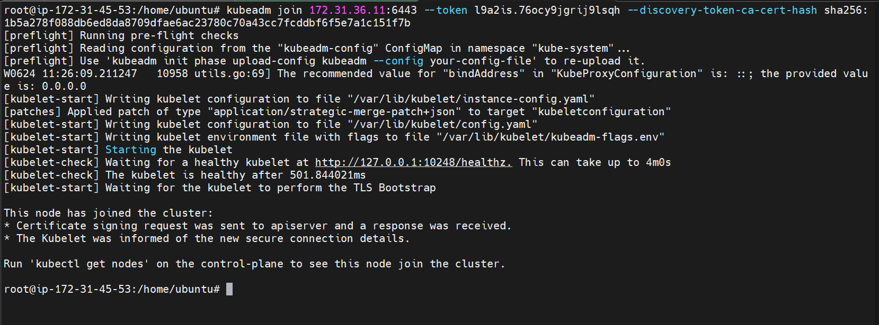

Install flannel to make sure that the nodes are connected
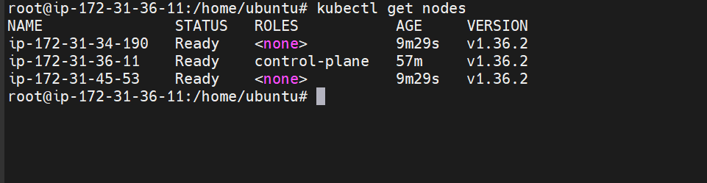

3 Run one nginx pod.
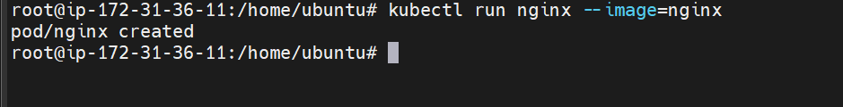
The pod is created with the help of kubectl run command
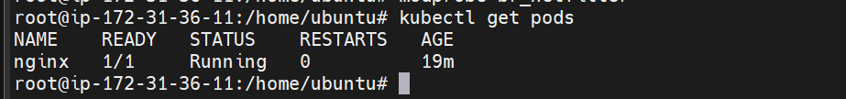
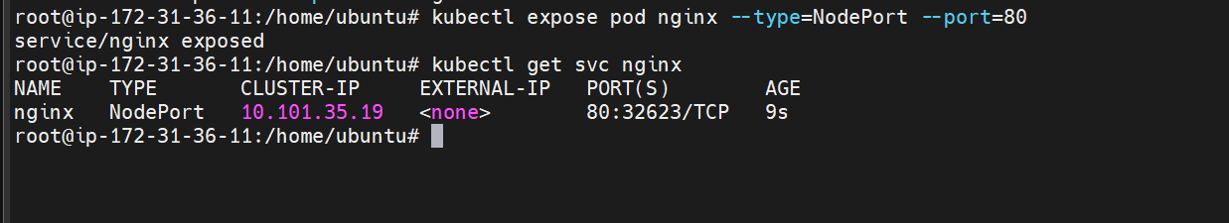
Exposing the nginx pod on 80
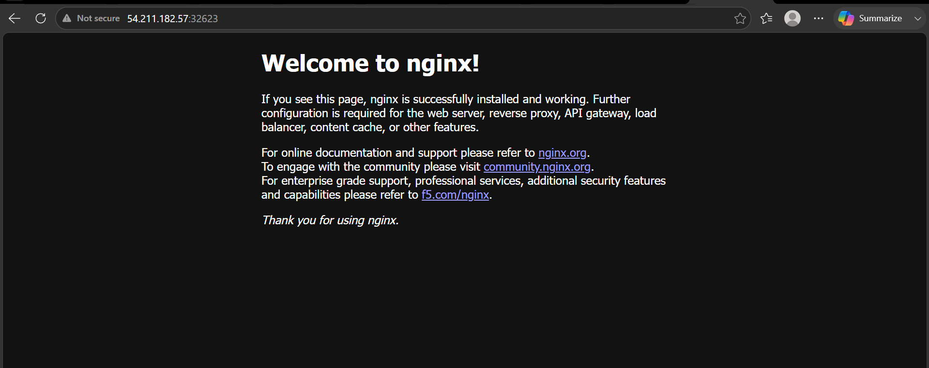
The nginx pod is now running

