- Create a Simple Pod Using YAML Task: Write a YAML file to create a Pod named firstpod with an nginx container. Verify the Pod creation using kubectl get pods and check the logs of the container using kubectl logs firstpod.

First create a yaml file
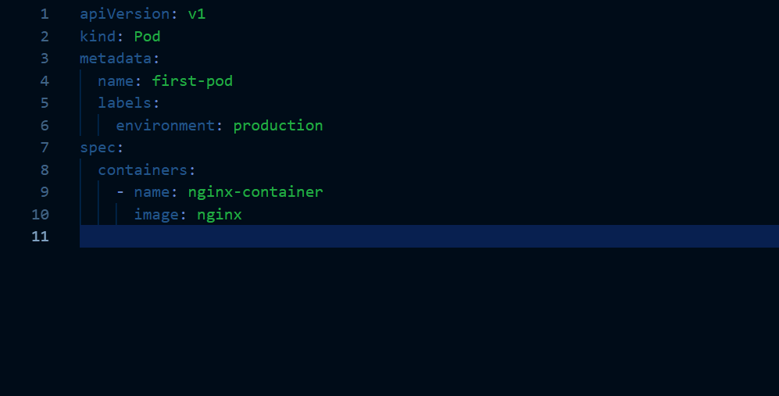
This is our first.yml file which creates a pod named first-pod
And container name is nginx-container and image is nginx
Lets now create the pod using the yaml file
Before that lets perform dry run
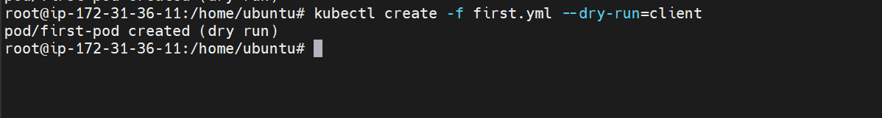
Now create a pod
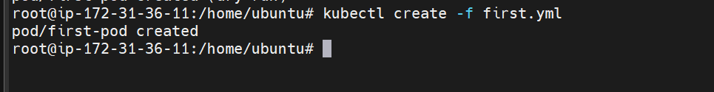
The pod is created
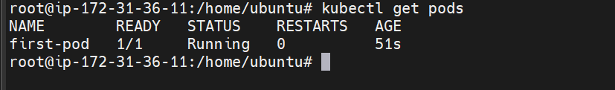
Let check logs
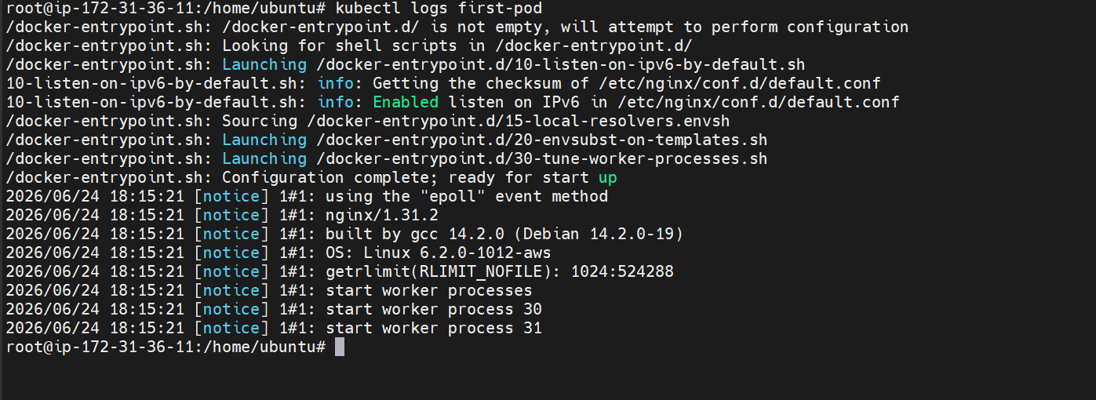

- Set Environment Variables in a Pod Task: Modify the YAML file to include environment variables myname: sabair and City: Hyderabad. Deploy the Pod and use kubectl exec <pod_name> -- env to check if the environment variables are set properly

first delete the existing pod
Modify the yaml file to add environment variables

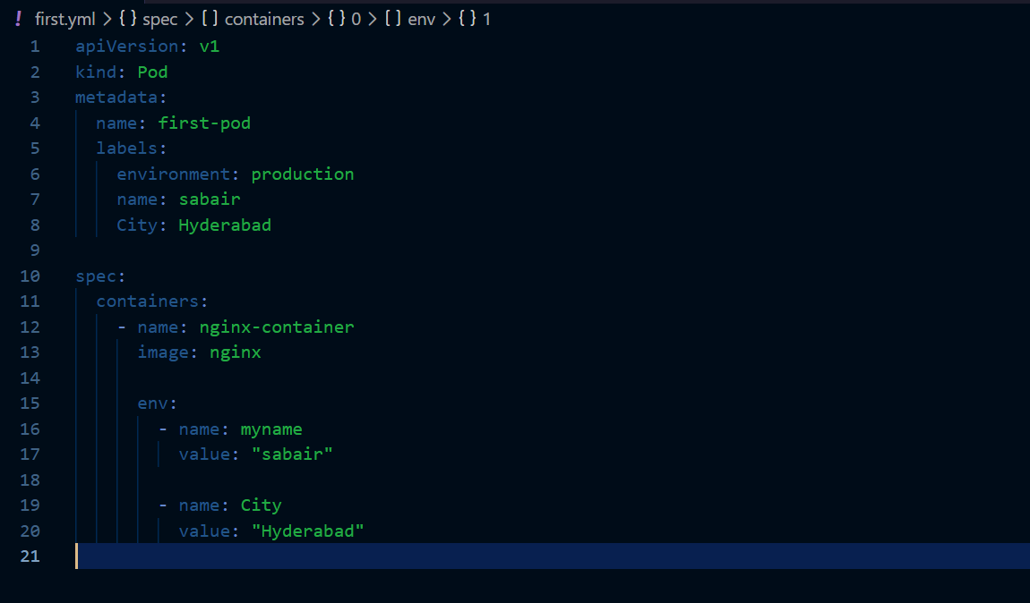

Here I have added environment variables name and City

Lets now create the pod with the modified version
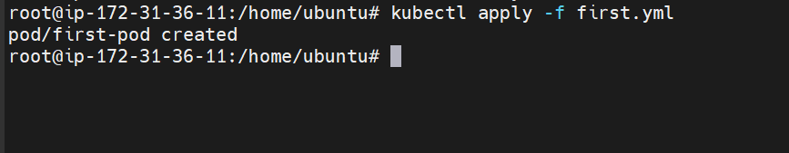
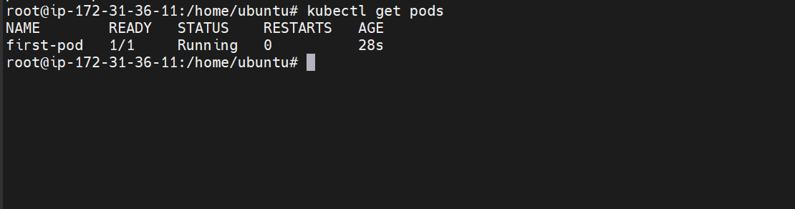

Validating with kubectl exec command whether the env variables are set properly or not
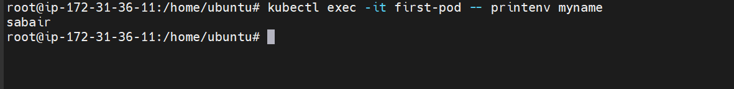
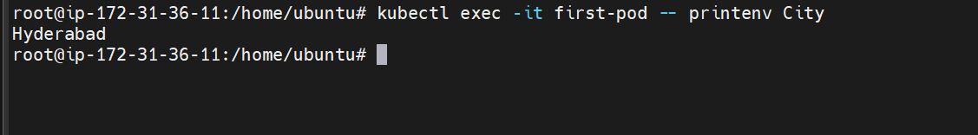
The environment variables are set properly
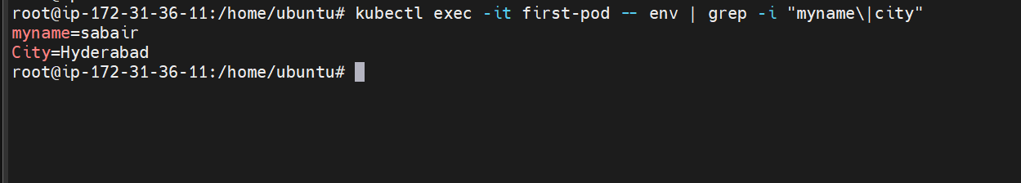

- Deploy a Pod with Commands (Args) in YAML Task: Modify the YAML file to add args that instruct the container to sleep for 50 seconds. Deploy the Pod and use kubectl describe pod to verify the args are correctly passed to the container.

Adding argument sleep 50 seconds
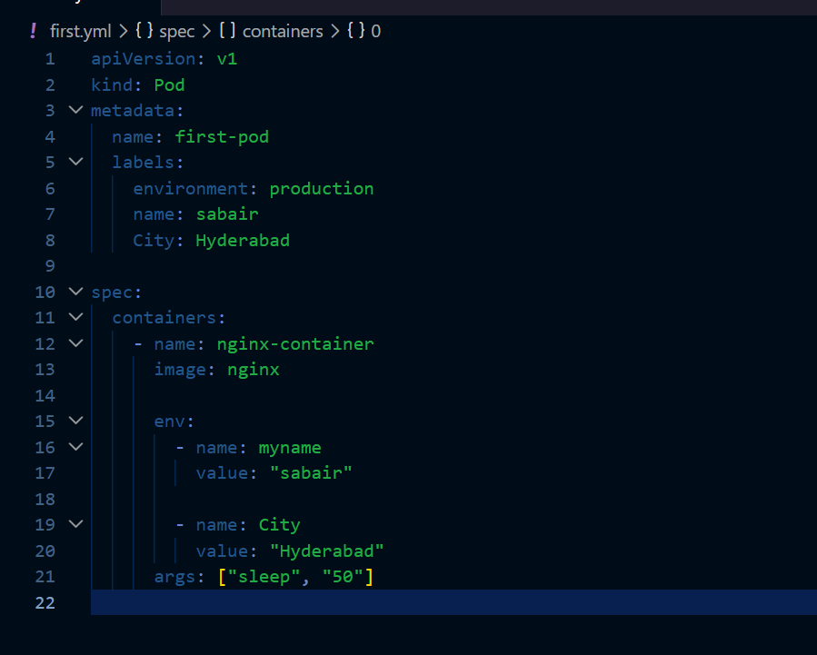

Creating a pod
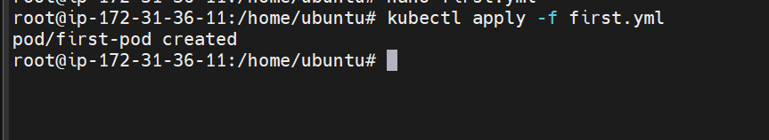
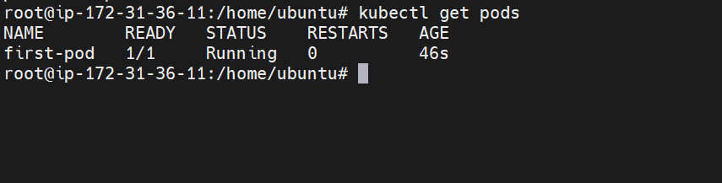
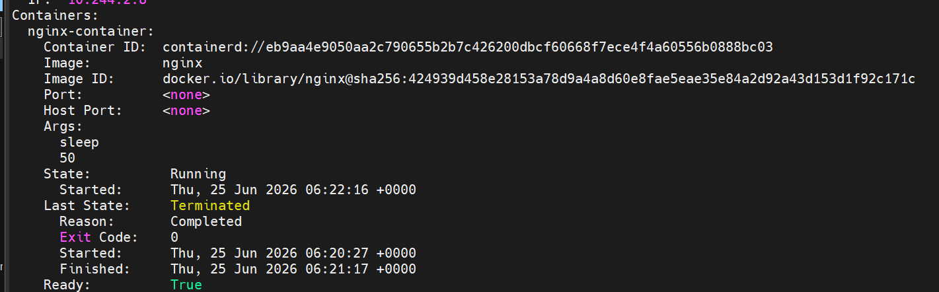
We can confirm that argument is passed correctly to the container

- Create a Pod with Two Containers Task: Create a YAML file to define a Pod with two nginx containers inside. Use kubectl exec to access both containers and verify that both containers can communicate through the same network (e.g., using telnet between them).

Lets just delete the existing pod and create new pod
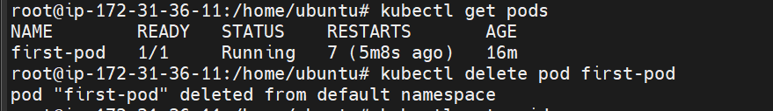
No pods present at the moment
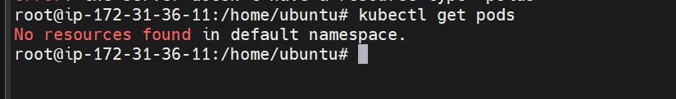
Now lets modify the yaml file
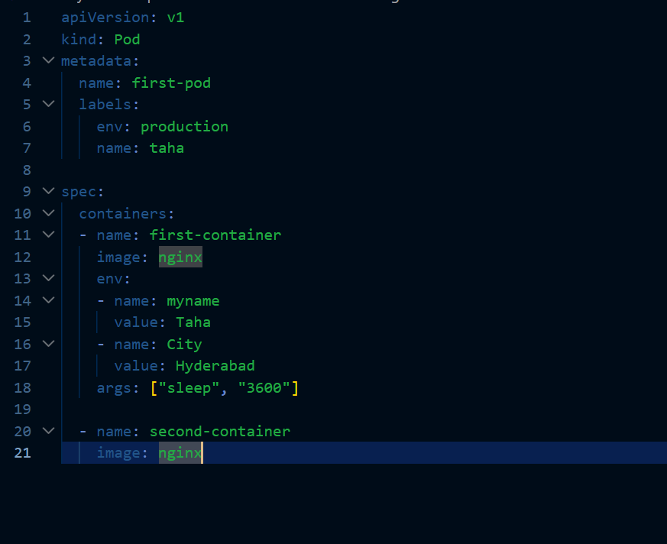
This the our yaml file now which creates two container in a single pod both of them use same nginx image
Lets now create the pod
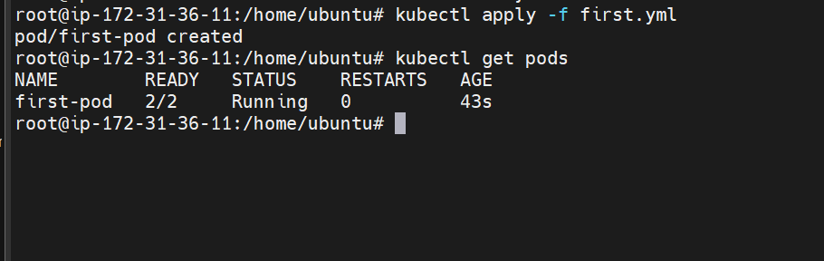
The pod is now created
We can see there are two containers running
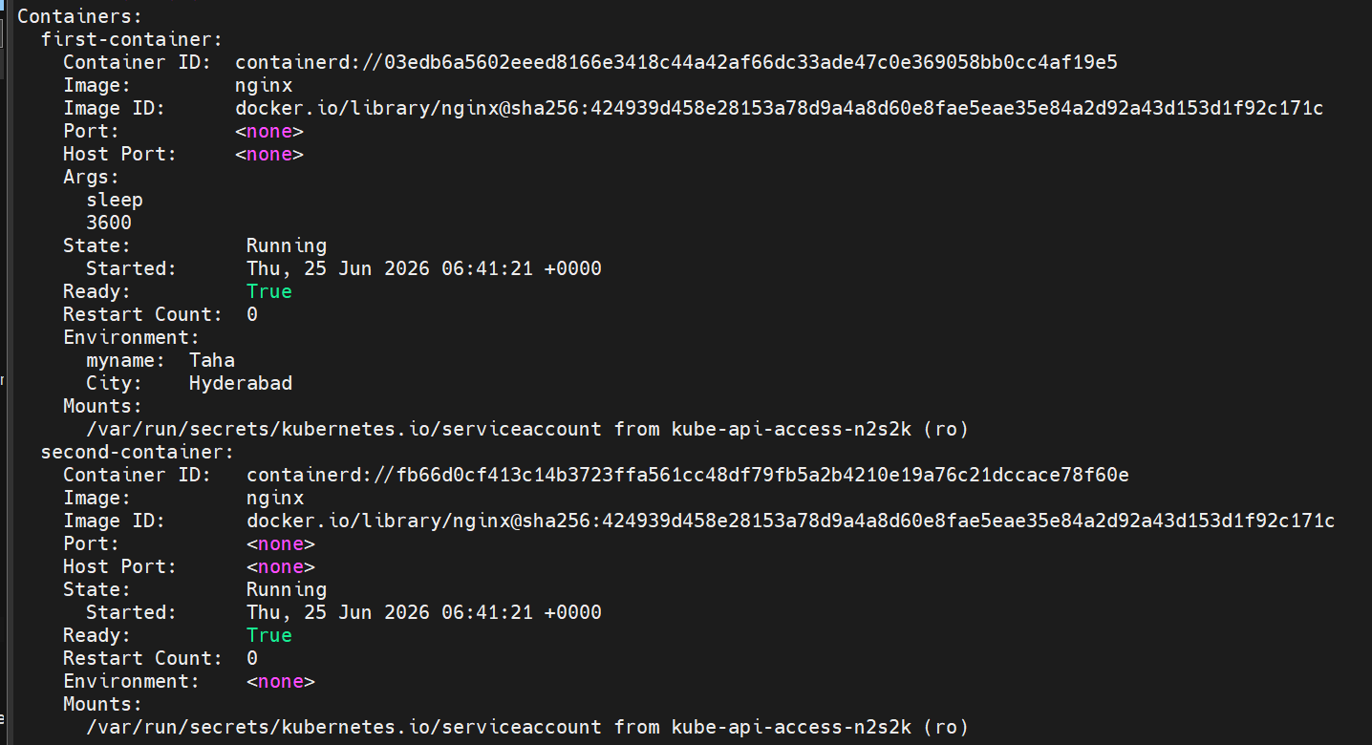
Lets get inside the container and telnet another
We are able to connect to other container in the pod
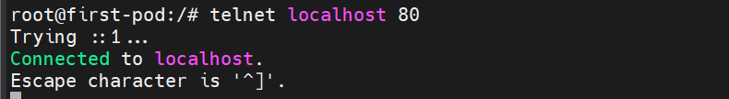
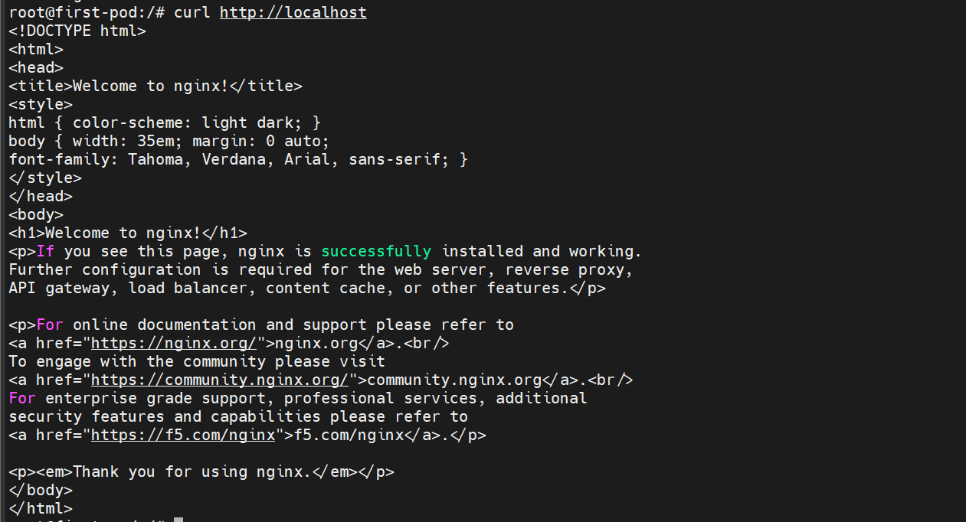

- Set Up an Init Container in a Pod Task: Modify the YAML to include an init container that sleeps for 30 seconds before the main containers start. Verify the init container's execution using kubectl describe pod and check the logs to confirm its completion.
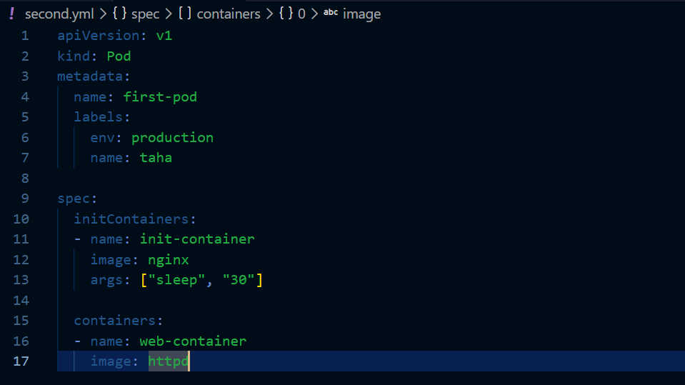

In this yaml file we are using two container one is init container and other is normal
Create the pod now
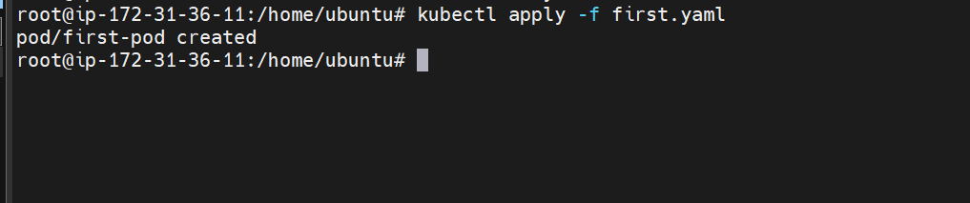

Lets now check the details
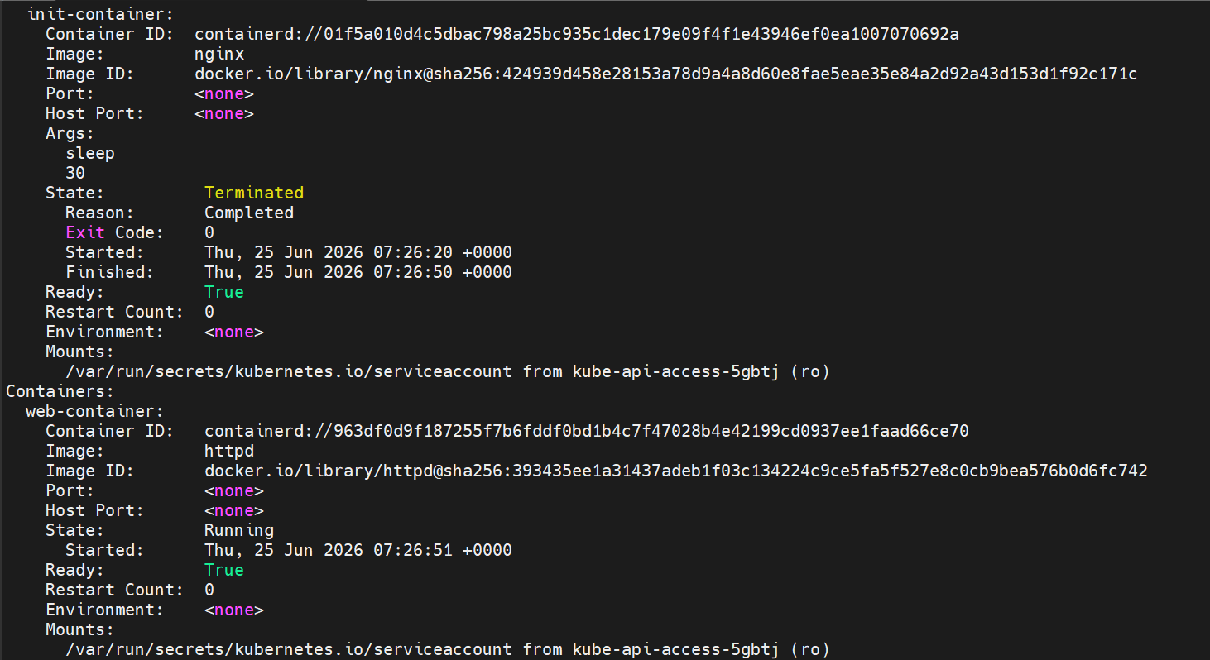
The two containers are now created
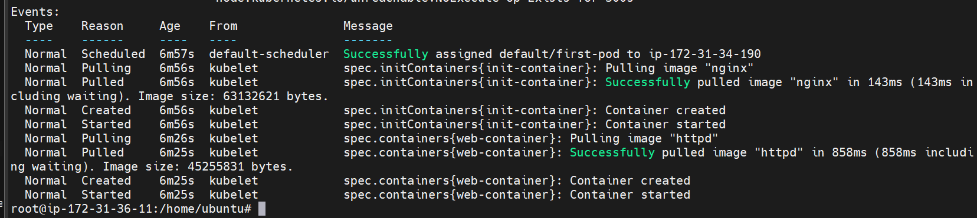
We can see their logs as well

- Run a Dry Run Command to Generate YAML Task: Use the kubectl run nginx --image=nginx --dry-run=client -o yaml command to generate a Pod YAML definition. Modify the generated YAML to suit specific requirements (e.g., labels or environment variables) and deploy it.
Lets first perform the dry run
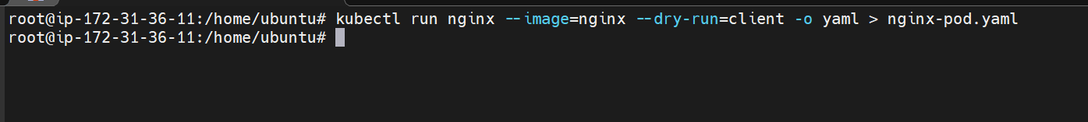
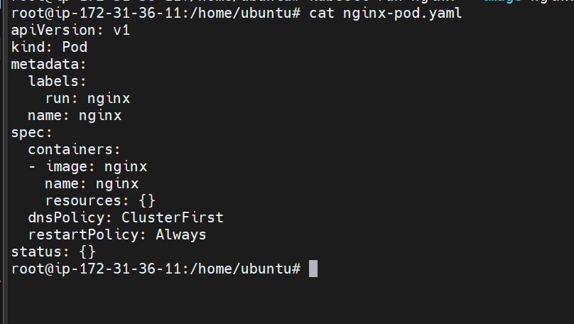

This is the generated yaml
Adding environment variables
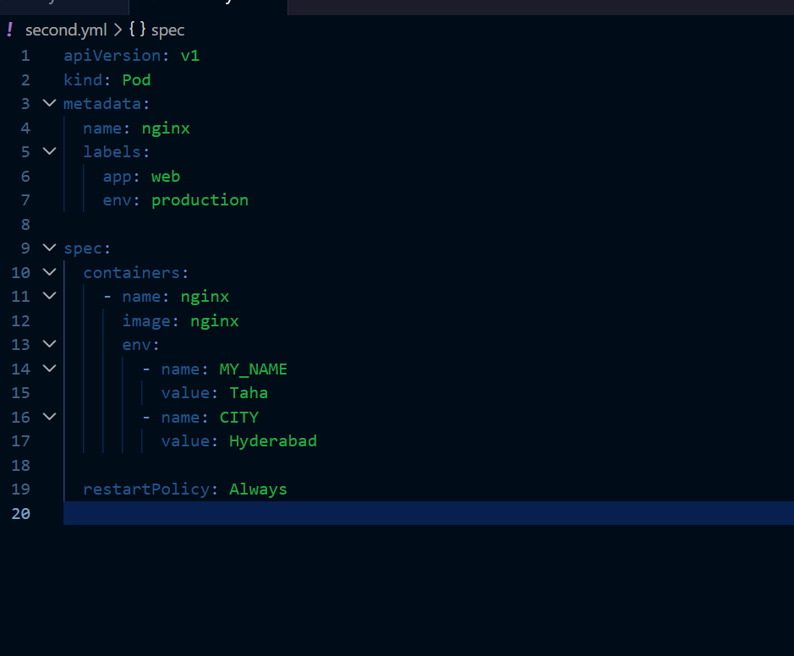
Lets create the pod now
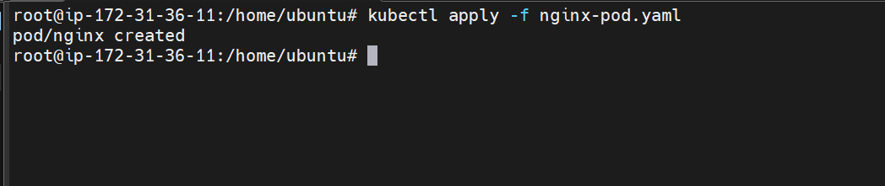

Pod is created
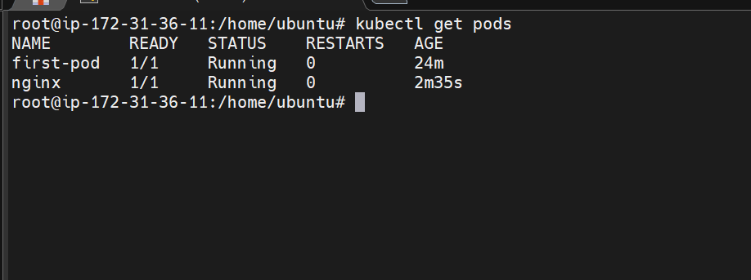

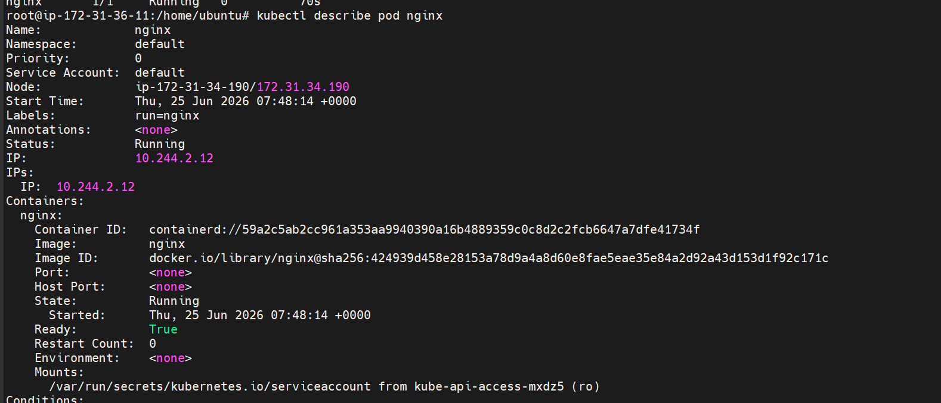

- Use kubectl apply vs kubectl create Task: Create a YAML file to define a Pod. First, deploy it using kubectl create -f <file_name>.yml and then modify the YAML (e.g., change the image version). Use kubectl apply to redeploy and verify the difference between both commands.

First lets create a yaml file
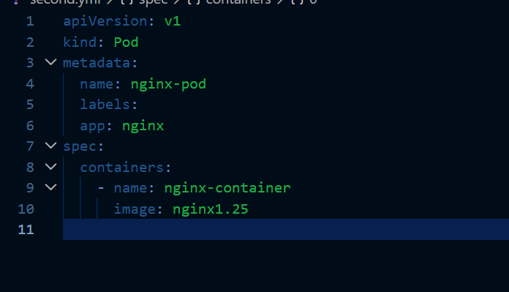
This is our yaml file
Lets now create pod using create command
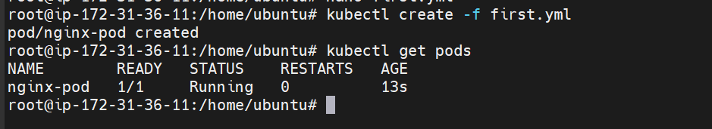
We have created the pod using create command
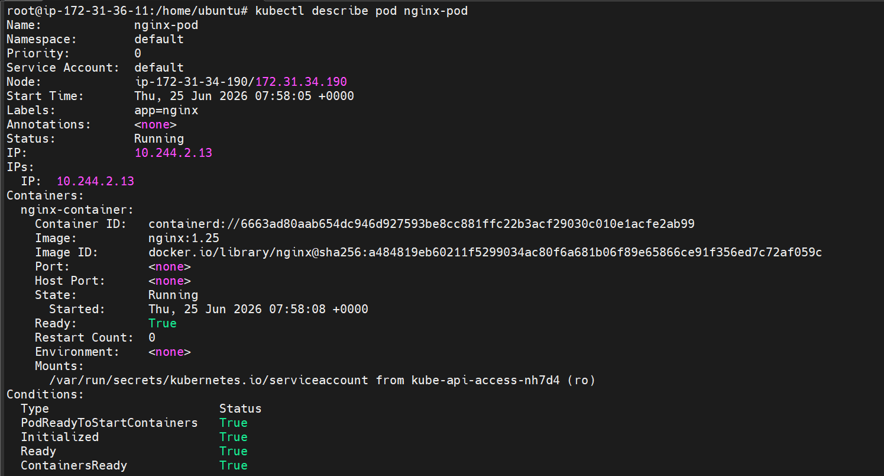
The image we have used is nginx1.25
Lets us now modify the yaml file with different image
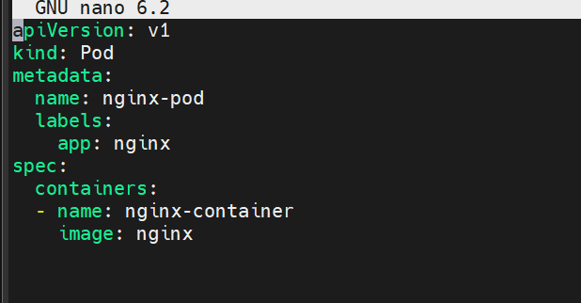

We have changed the image version now
lets try to update using kubectl create command
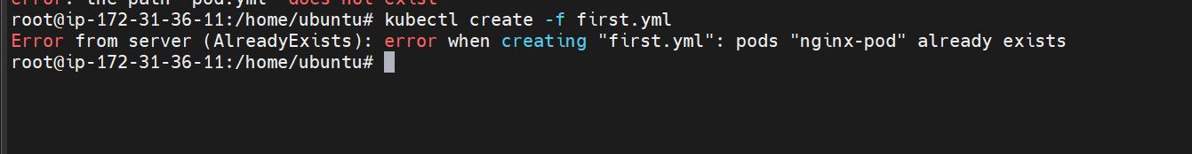
It is throwing an error because pod already exists
This shows that create command only creates new resources and does not update existing one
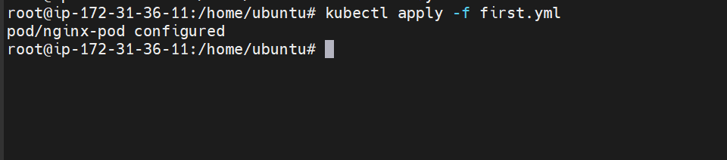
The apply command has created the pod with the different nginx version
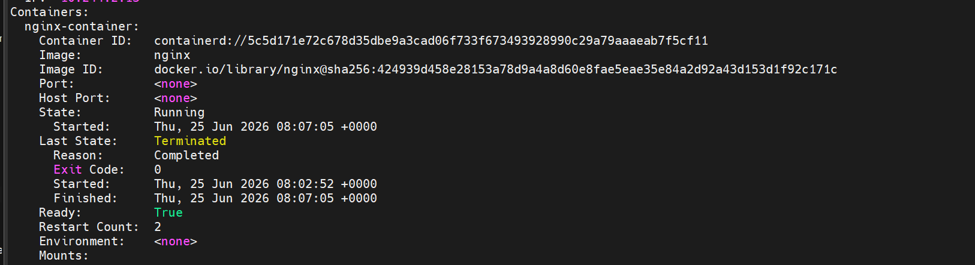

kubectl create creates a new Kubernetes resource and fails if the resource already exists.
kubectl apply creates the resource if it doesn't exist, or updates the existing resource to match the YAML configuration.

- Edit an Existing Pod Configuration Task: Use kubectl edit pod <pod_name> to modify the running Pod's environment variables or image. After making the changes, verify if they took effect by checking the container logs or environment variables using kubectl exec.

For this create a new pod
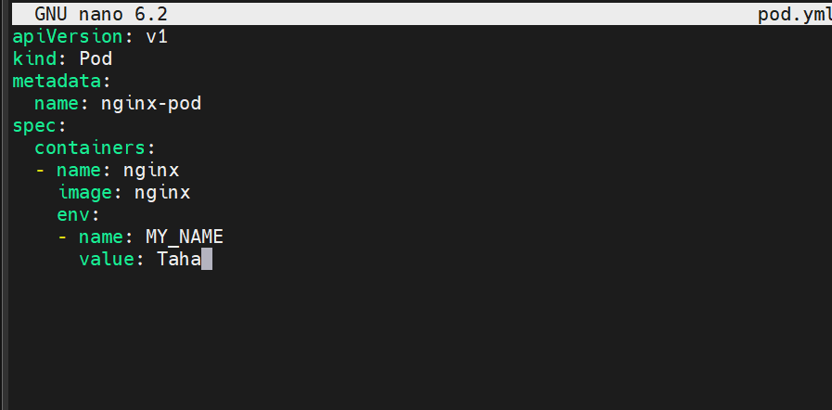
Here we have env variable MY_NAME and value Taha

Now create the pod
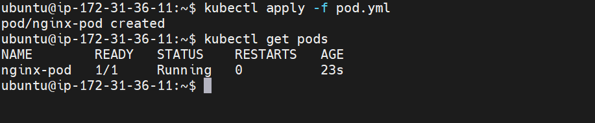
We have one pod that is running
lets check the details

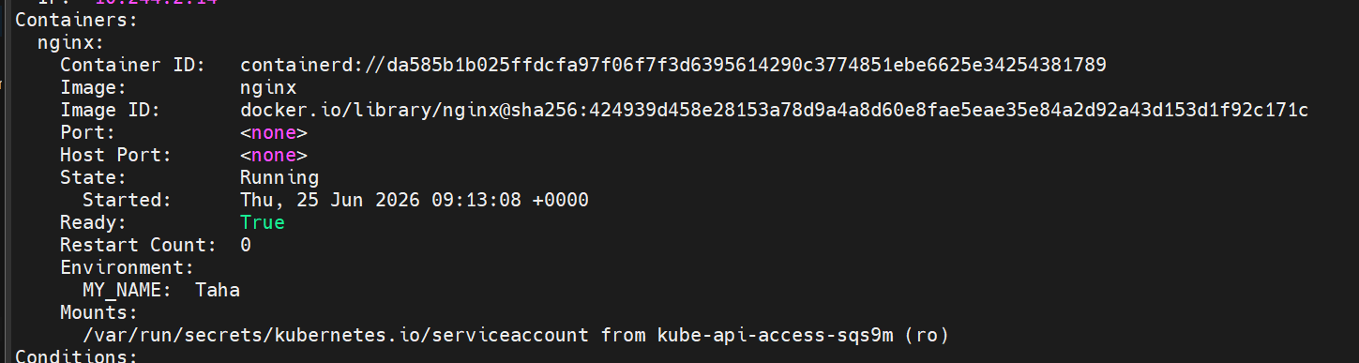

Now try to edit pod with the command:
kubectl edit pod nginx-pod
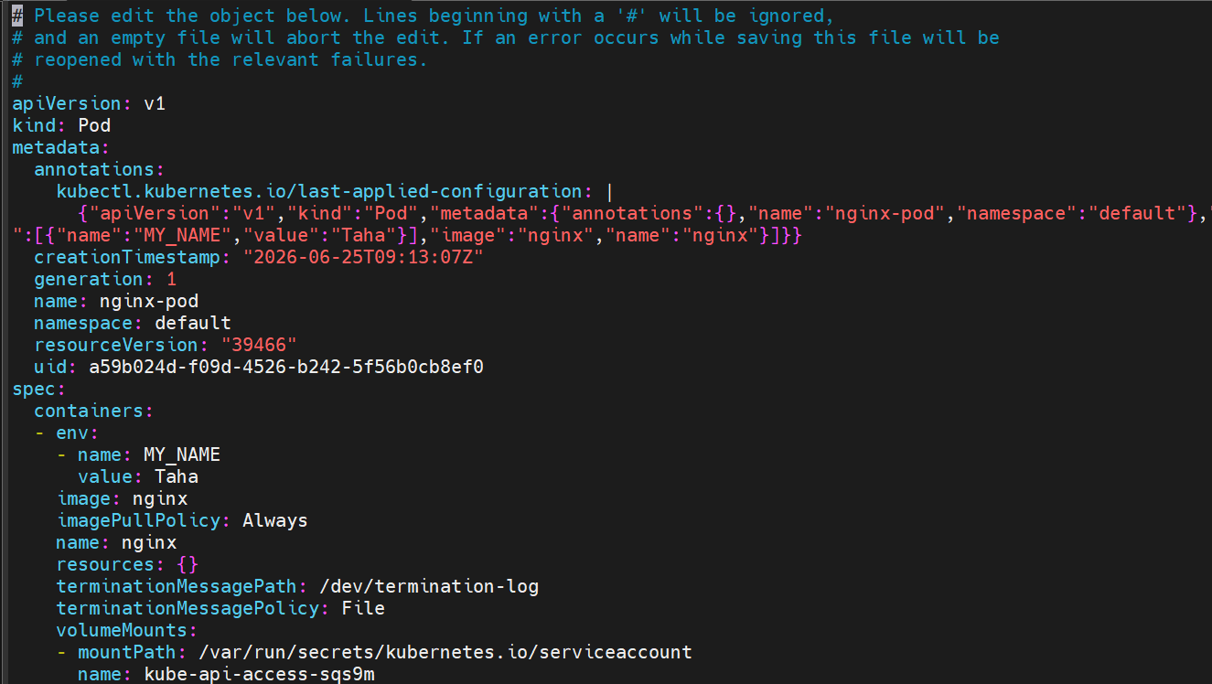



Now try to change the env variable value
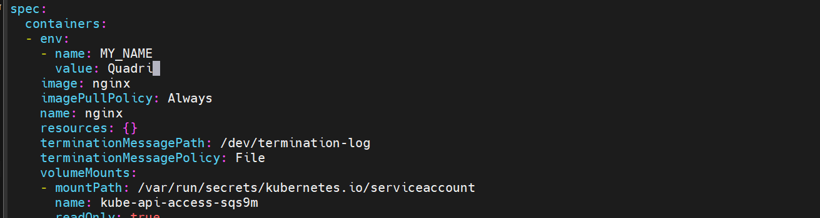

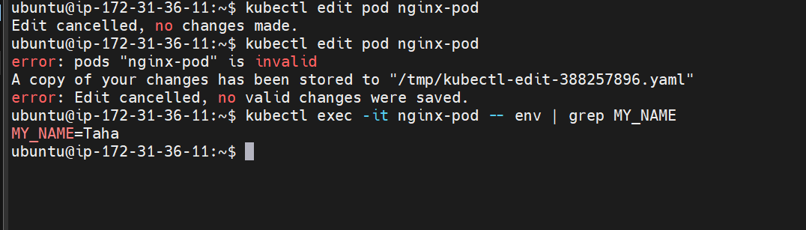
We are not able to change the existing pod
We need to create a deployment to edit.
Lets create a deployment now
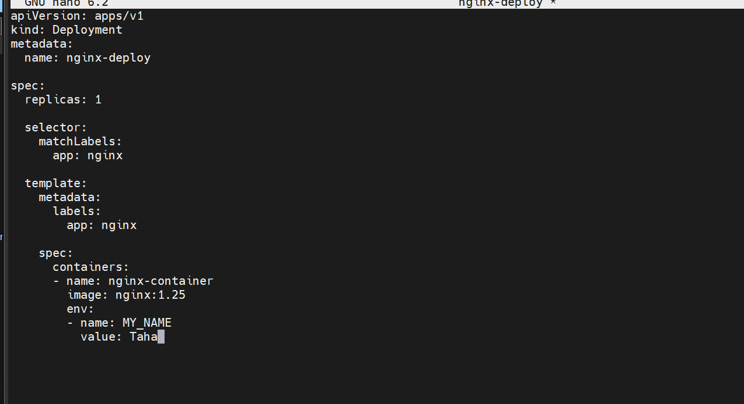
This is our deployment yaml file
Here we are creating a deployment with one replica
Lets now create it
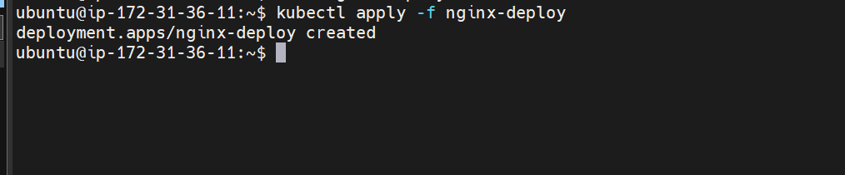

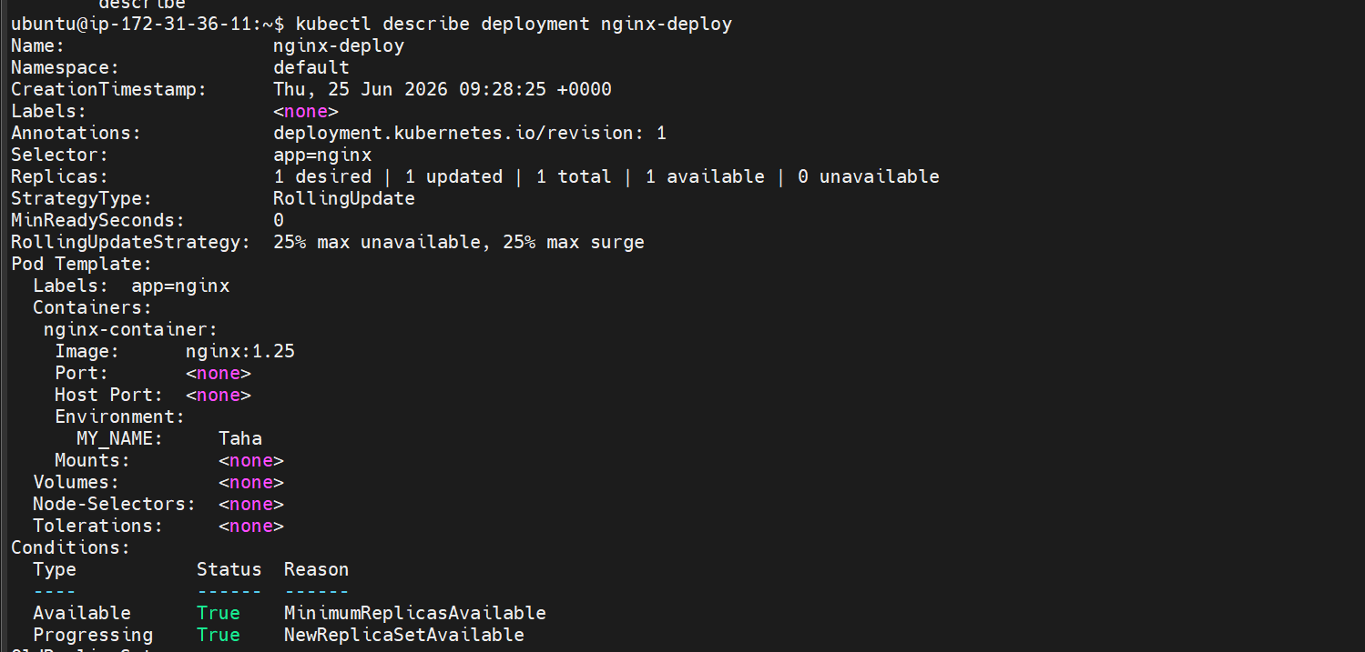

Lets now change the env variable value
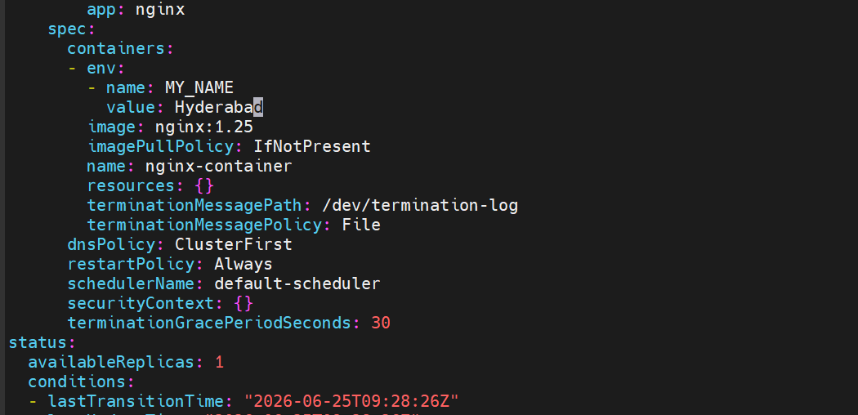

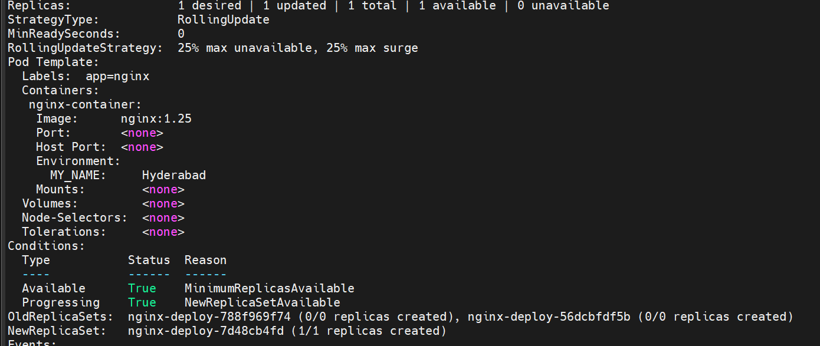
Now the env variable is changed to Hyderabad

- Expose a Pod Using a Service Task: Create a YAML file to expose your firstpod using a Service (ClusterIP). Ensure that your service is exposing the Pod on port 80 and verify it using kubectl get svc.
First lets create a new pod

This is our yaml file
Lets now create the pod
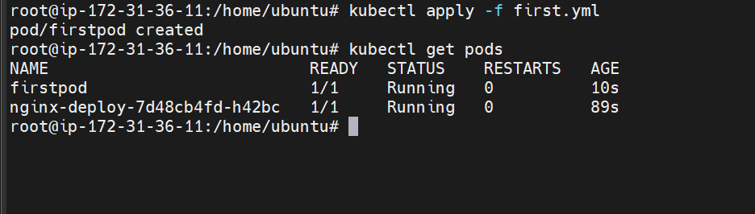
Lets now create a service.yml file to expose our app using service Ip
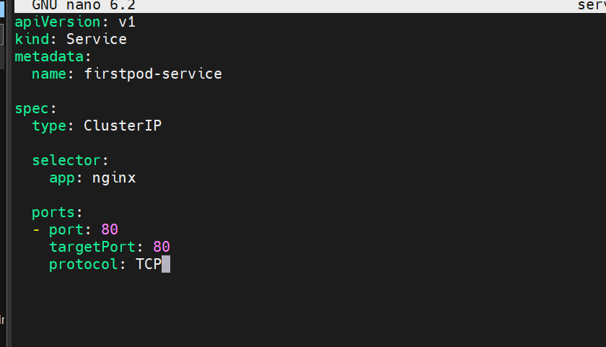
This is the service file

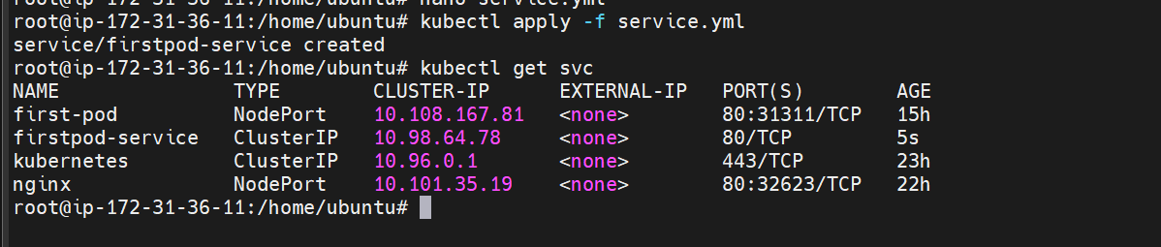
Creating service and validating it

- Pod with Resource Limits and Requests Task: Add resource requests and limits to the containers in your YAML file. Specify CPU and memory requests/limits for both containers and deploy the Pod. Use kubectl describe pod to verify if the resource configurations are correctly applied.

Creating yaml files with two containers and with resource limitations
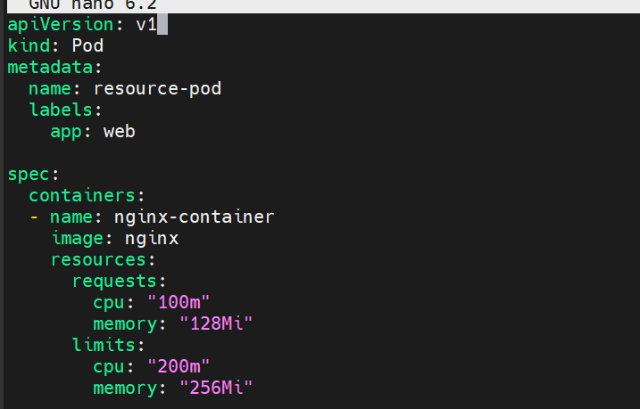

This yaml file creates a pod with two containers one nginx and one httpd
Also it changes the httpd port number to 8080
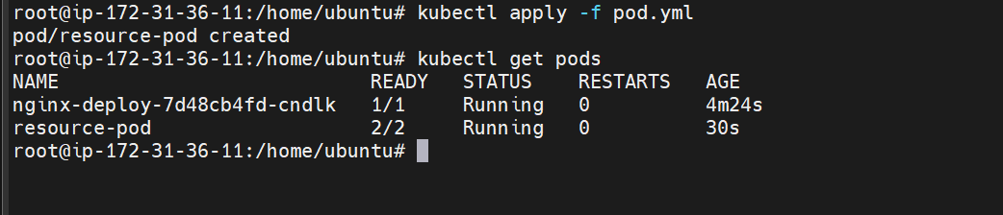
The pod is created with the resource limitations
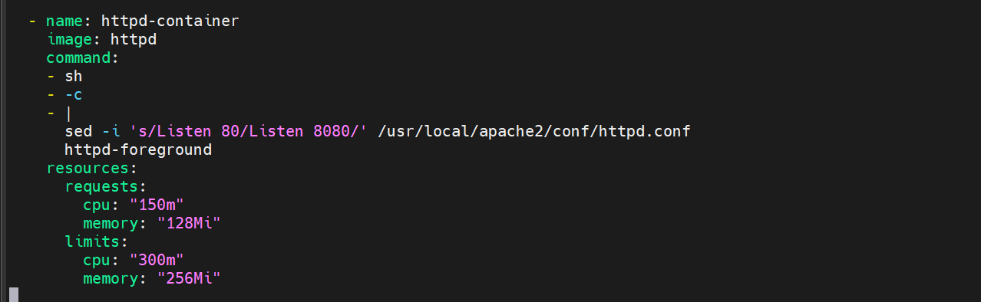
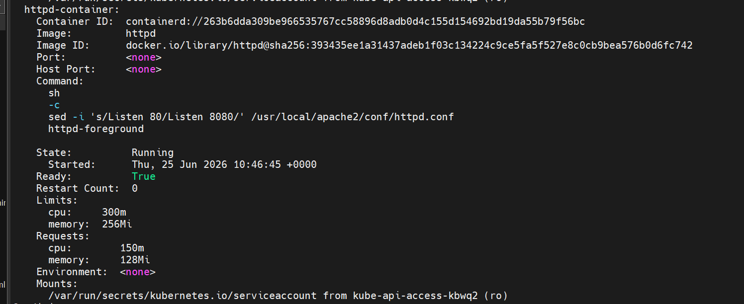
The pod is created with two containers and resource limitations

