Kubernetes-03

- Create a ClusterIP service for an Apache web server pod.

First lets create an Apache pod
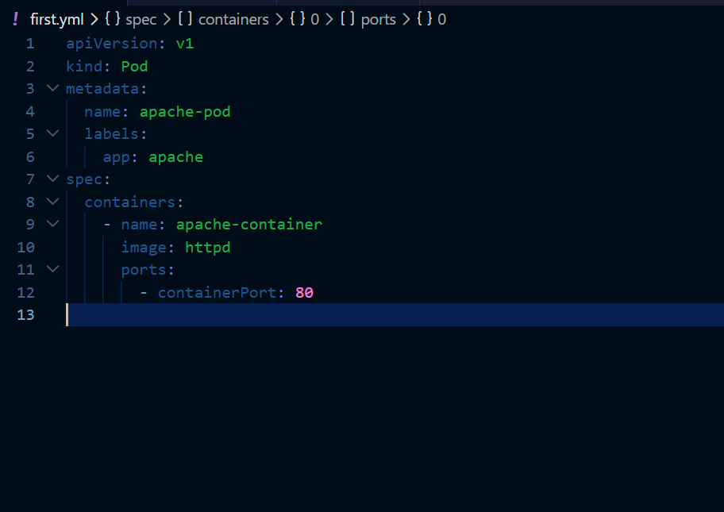
The above is the yaml file to create a pod
Lets now create a pod
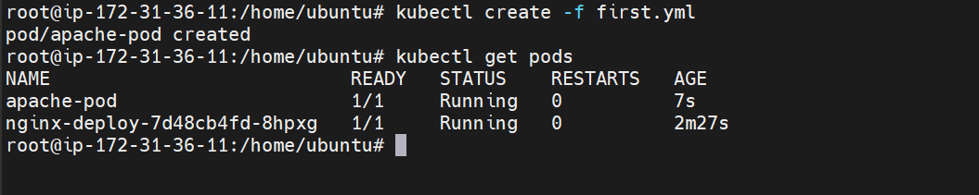
The pod has been created
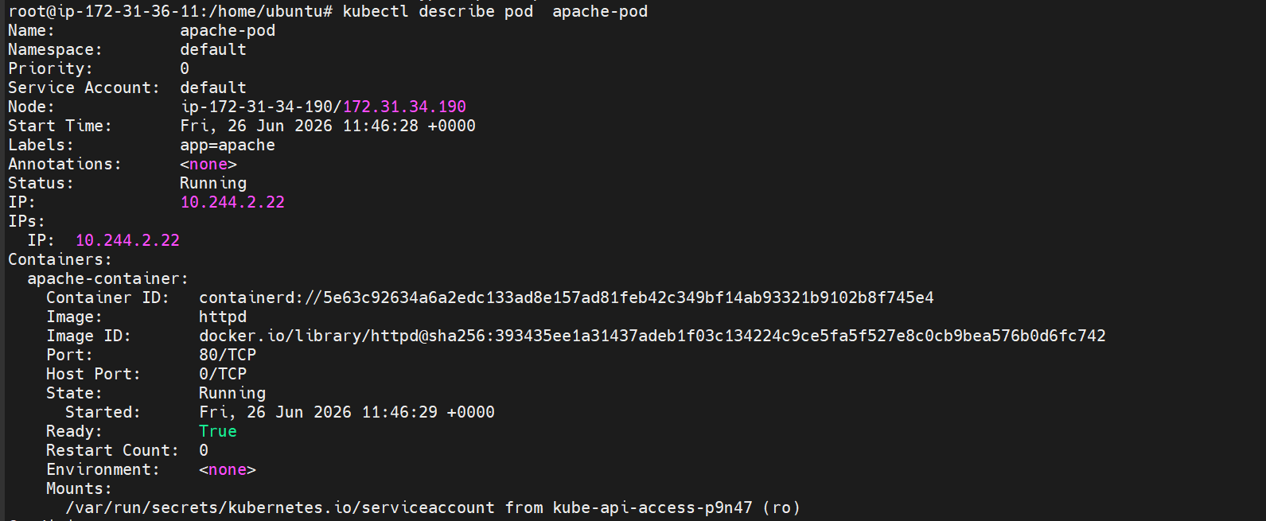

Lets now create a service.yml file
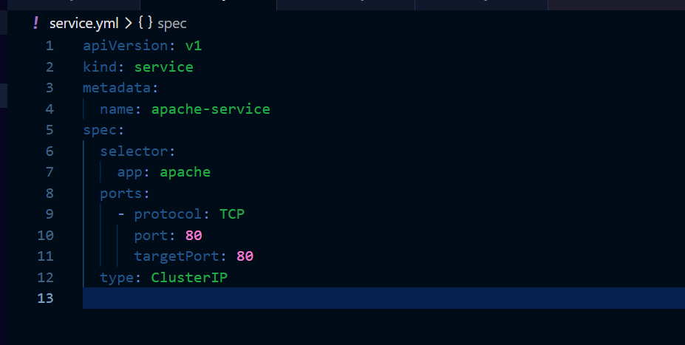
This is our service file which enables communication within the cluster
Lets now create it
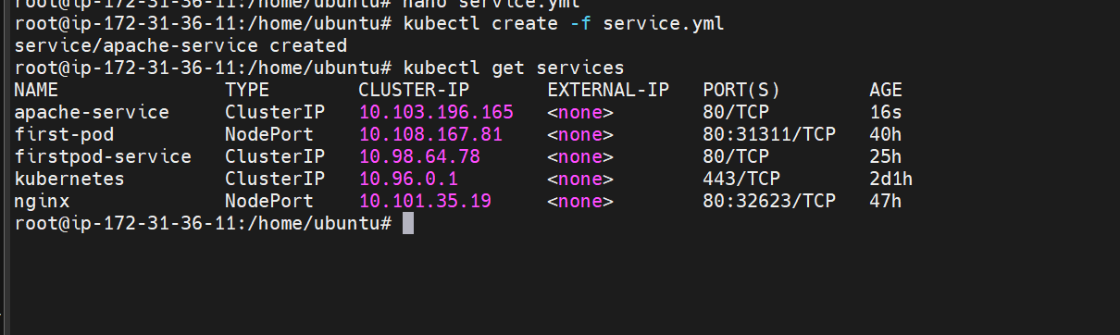
The service is now created with name apache-service
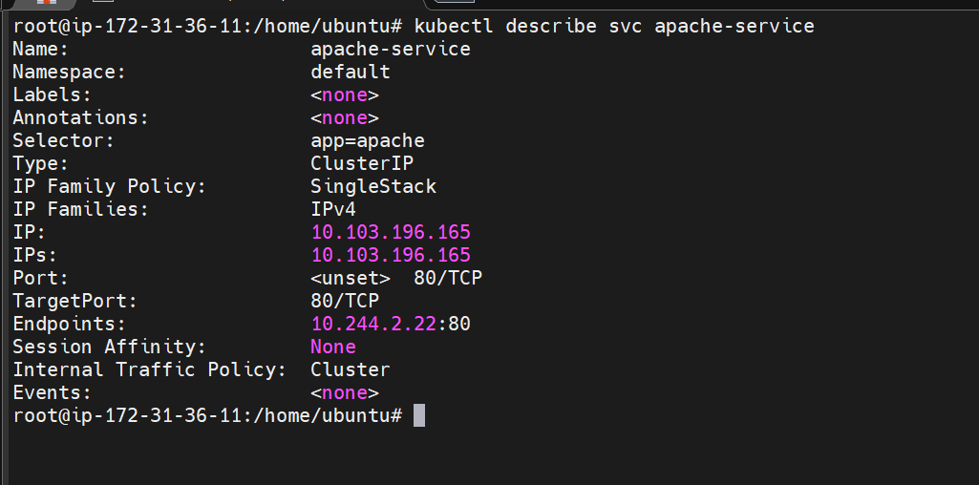
We can see the endpoint as well 10.244.2.22:80
Lets create one port pod to check the connectivity
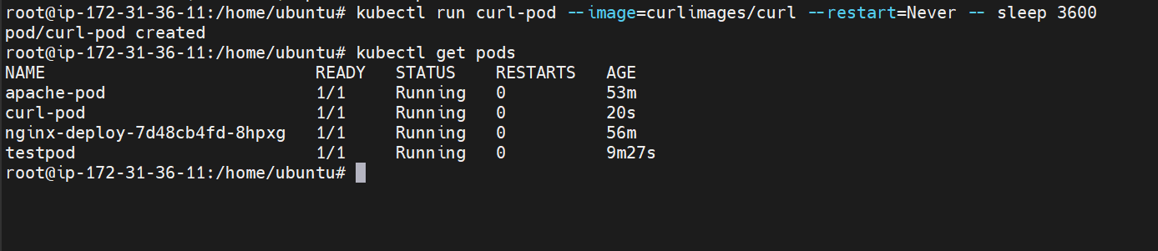
Get inside the pod and check if the pod is able to communicate with the other

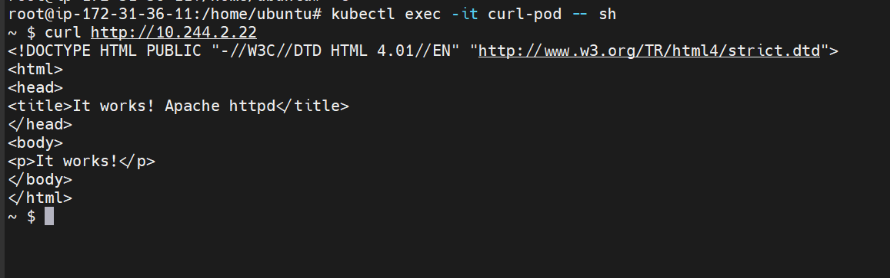

Our pods are now able to communicate with each other using clusterIP

- Expose an Nginx pod externally using a NodePort service.
First create a nginx pod
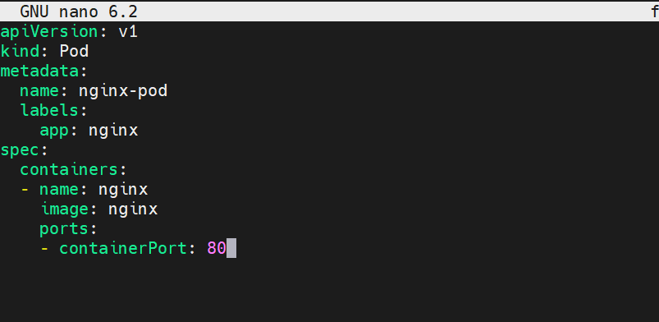
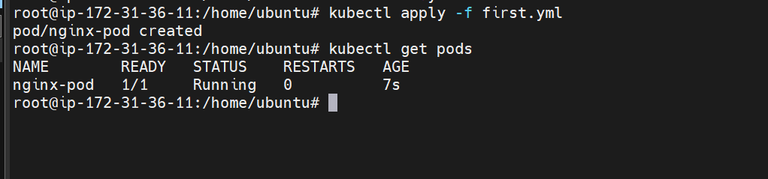
The pod is now created
Lets now create a nodeport service
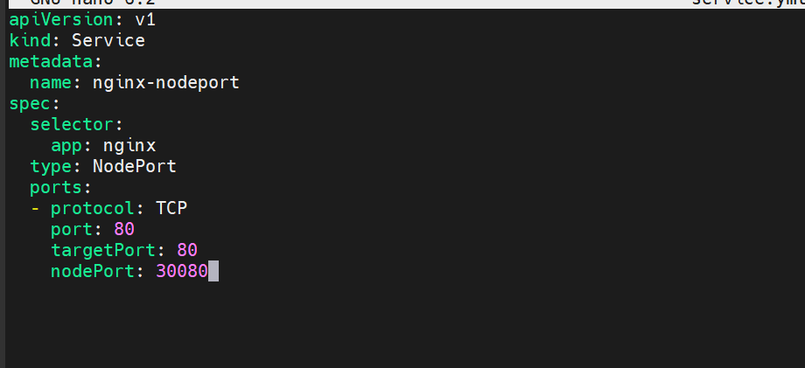
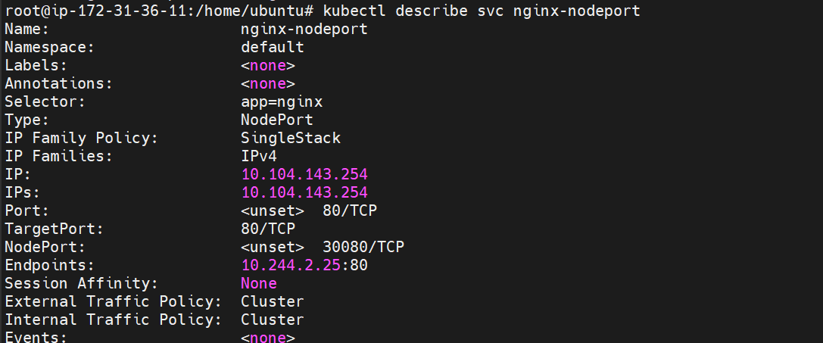
Service is now created

selector: Finds Pods with the label app: nginx.
port: 80: The Service port inside the cluster.
targetPort: 80: Forwards traffic to port 80 in the Pod.
nodePort: 30080: Opens port 30080 on every cluster node.
Lets now try to access it through internet
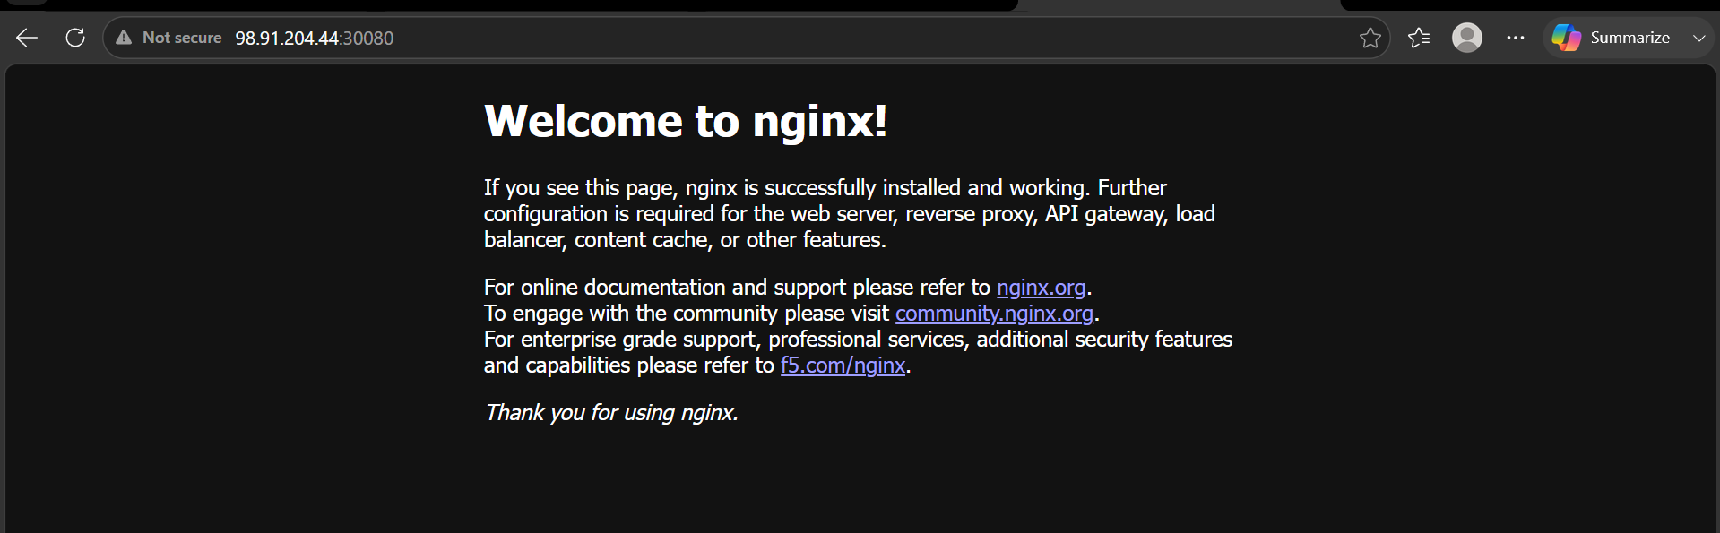
We are now able to access it through the hostip and nodeport

- Deploy a ReplicationController to maintain 3 replicas of an Nginx pod.

Lets now create a RC

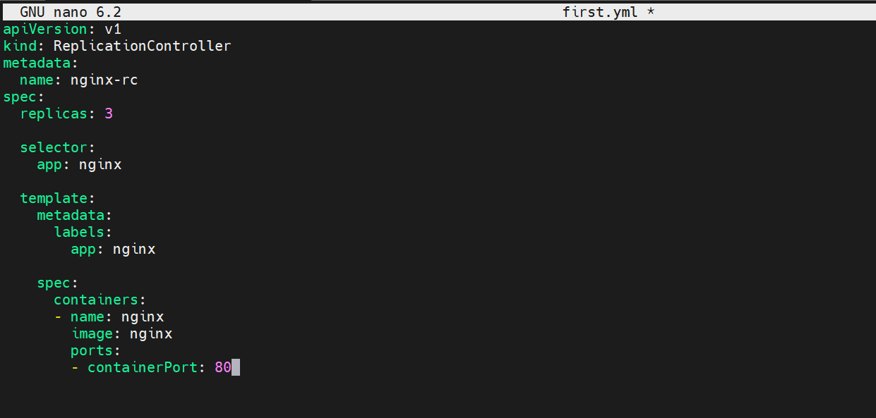

This is the RC which creates nginx pods with 3 replicas
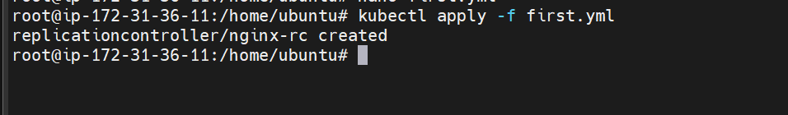
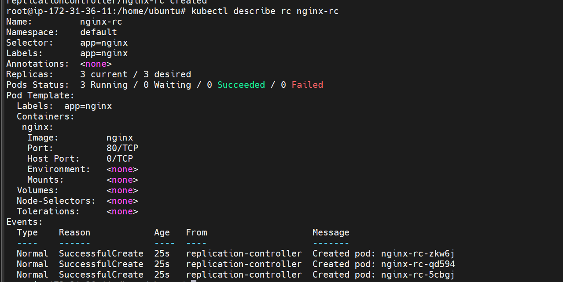

Three pods are created

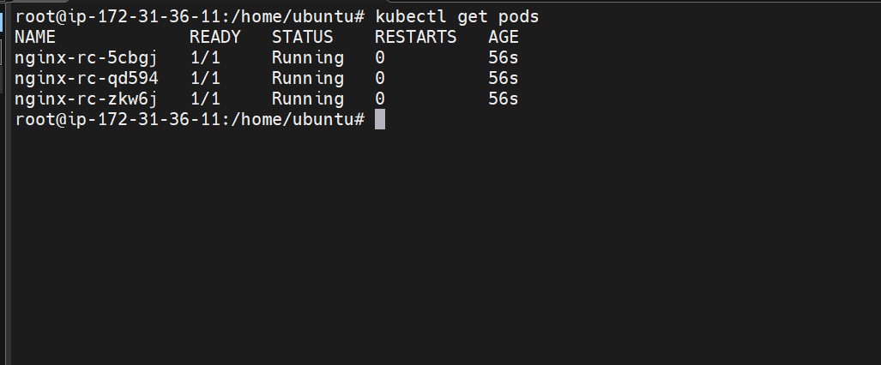

Lets now test self healing by deleting a pod manually

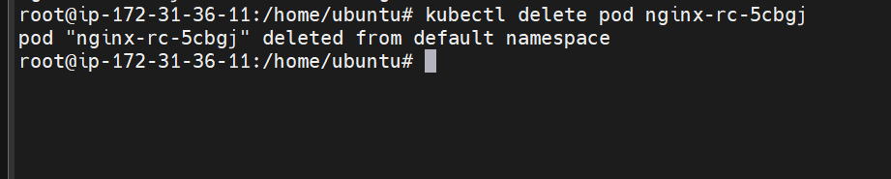

We have deleted a pod here

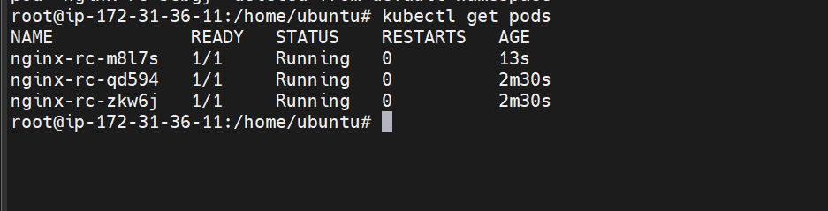

But still it can be seen that one more pod has started this is the nature of Replication controller it always maintains the count what we have mentioned.

- Scale the ReplicationController from 3 replicas to 5 replicas.

Method 1:
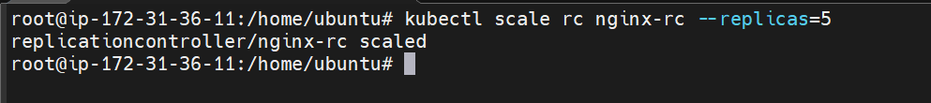
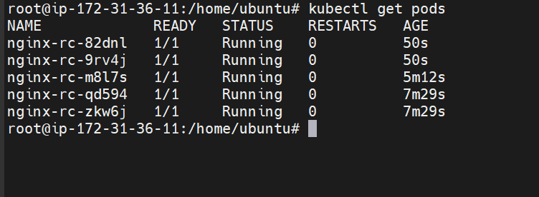

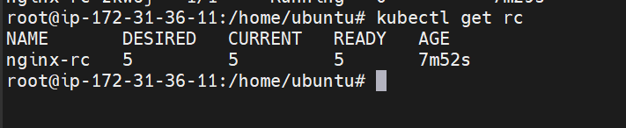

Scaling the resources without editing the yaml file
Lets now scale using the YAML file
Method 2:
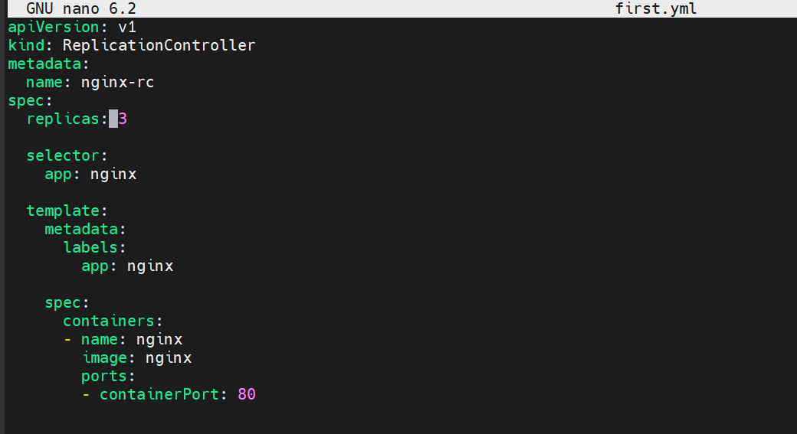
Updating the replicas from 3 to 5
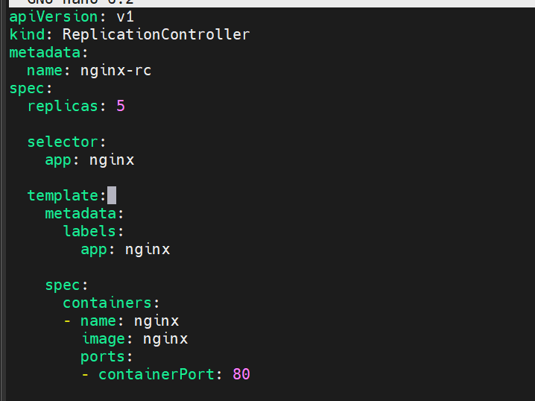
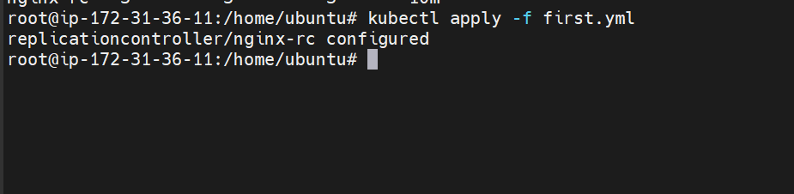
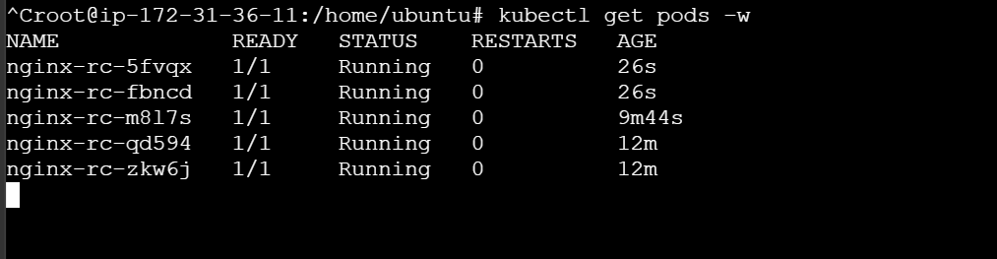
Scaling to 10
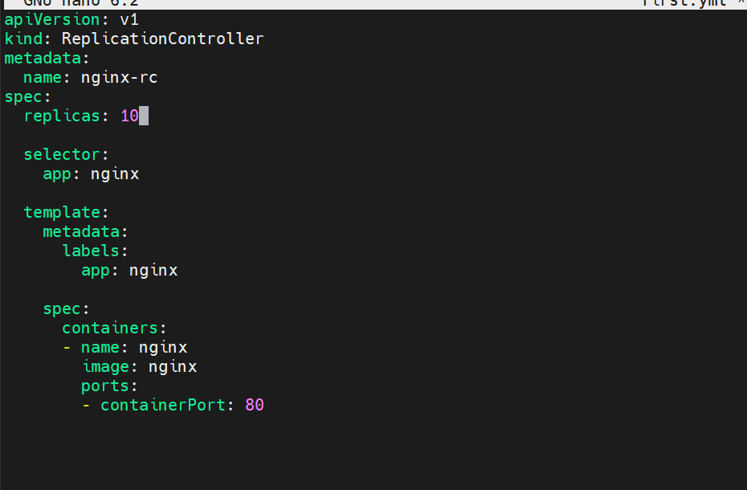
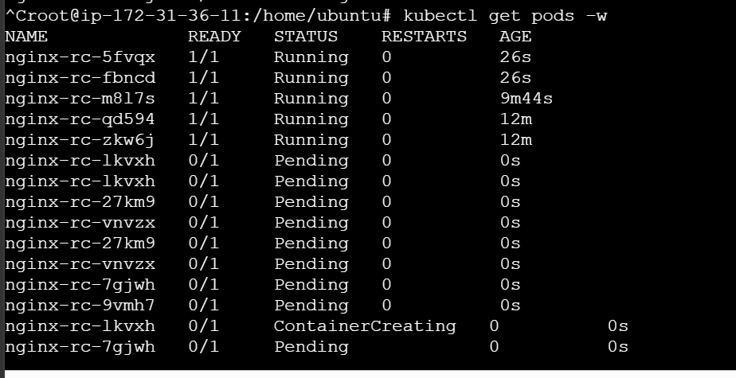
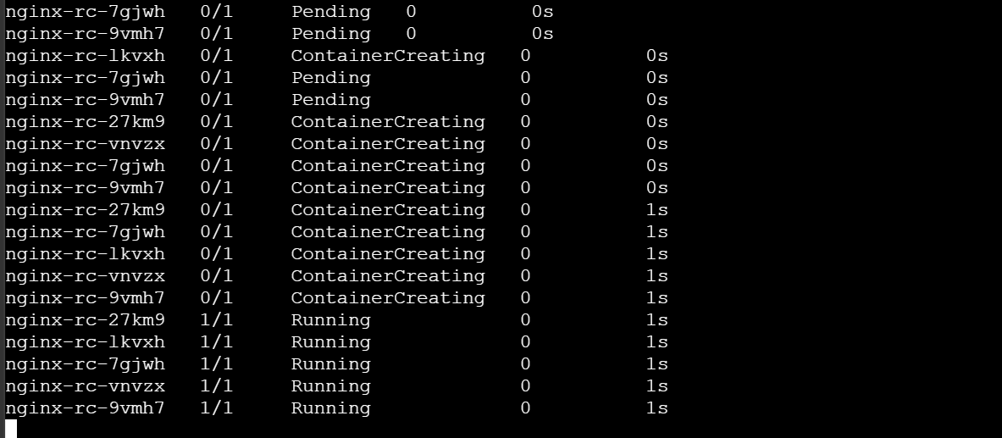
We can see the real time scaling
10 pods are running now
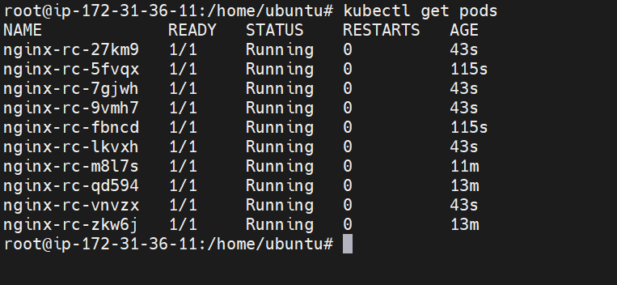
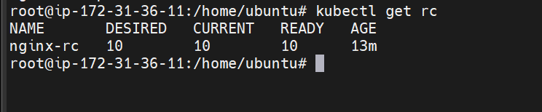

- Create a ReplicaSet to manage pods based on multiple labels (prod and test).

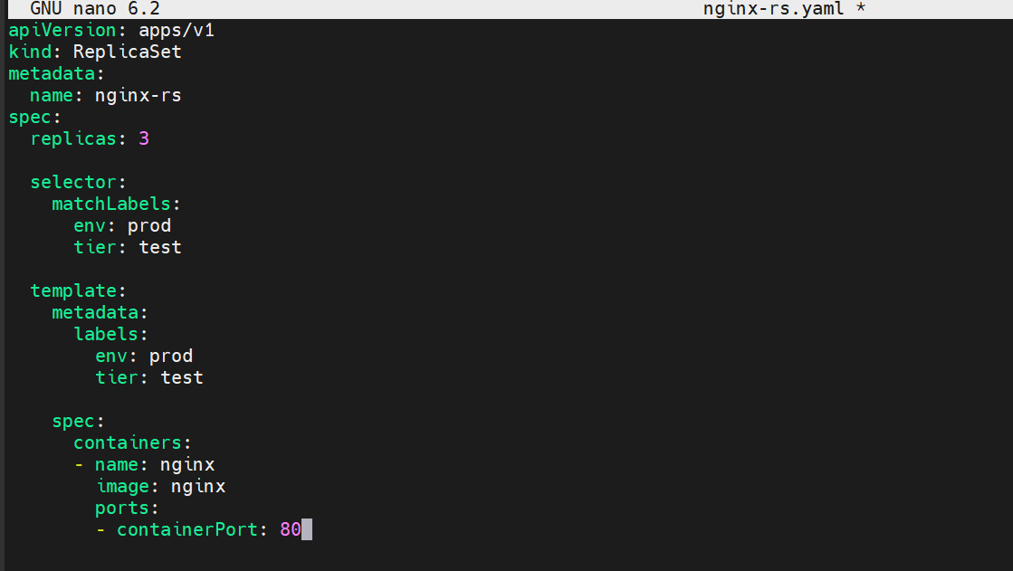
Every Pod created by this ReplicaSet gets these labels (prod,test)
The labels in the Pod template must match the selector, or Kubernetes will reject the ReplicaSet.

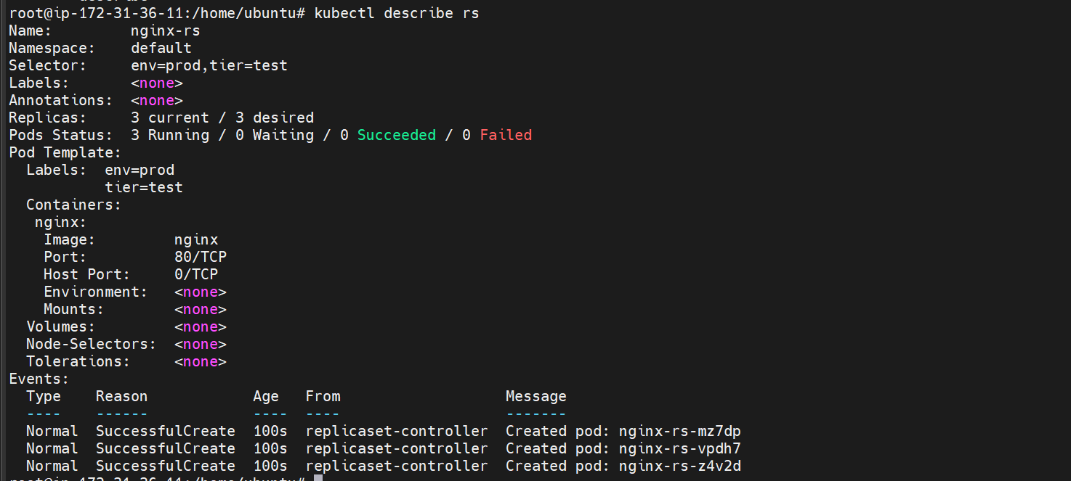

We can see that all the three pods have labels test, prod

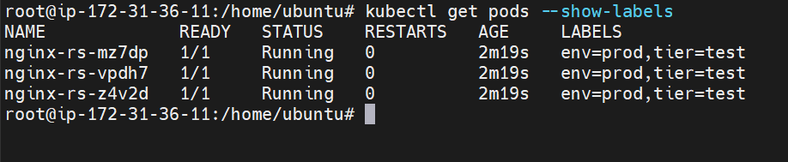

Lets test it by deleting a pod

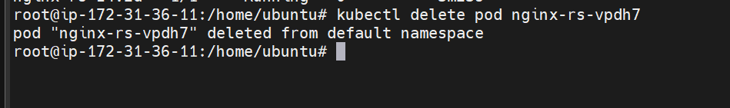

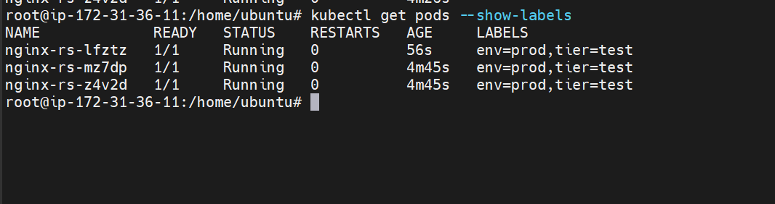

- Deploy a ReplicaSet that excludes pods with the label backend.

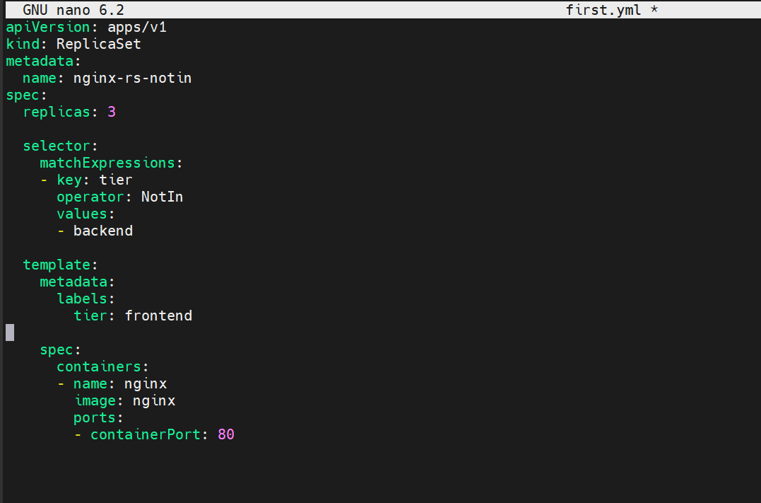
The above is the yaml file which creates replica set only when the label is frontend
And excludes backend label
Lets now create it

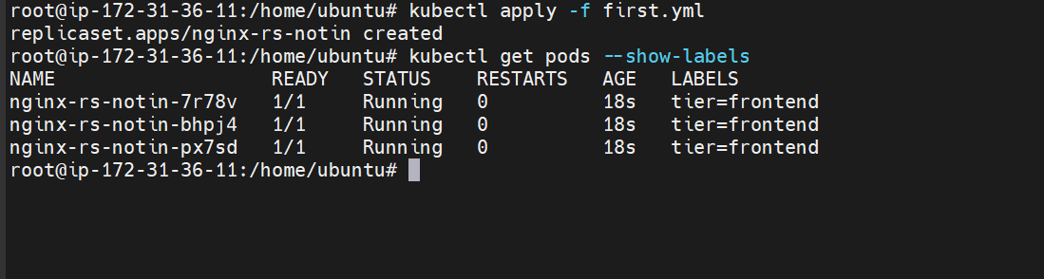
We can see the pods are created with only frontend label
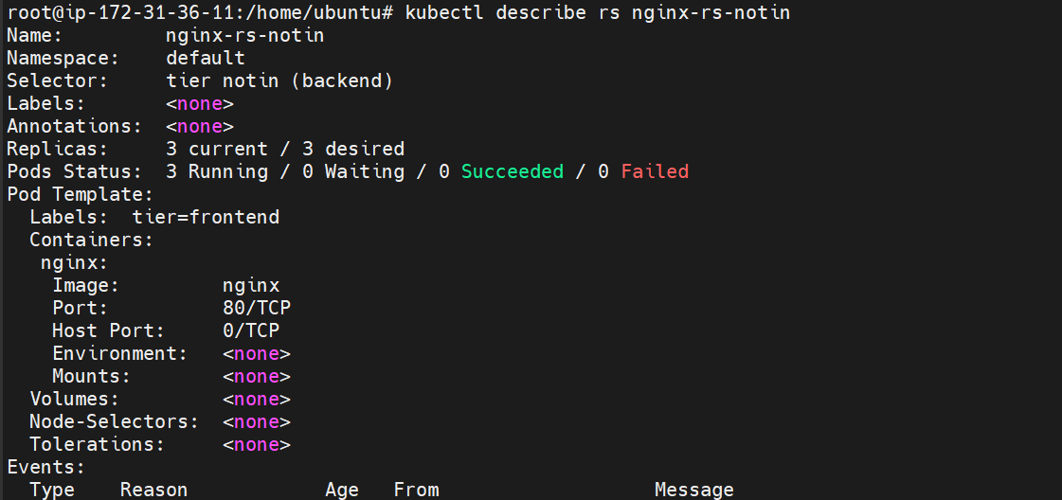

It excludes everything with label backend

- Test load balancing across multiple pods using a NodePort service.

First lets create two pods one nginx and one apache
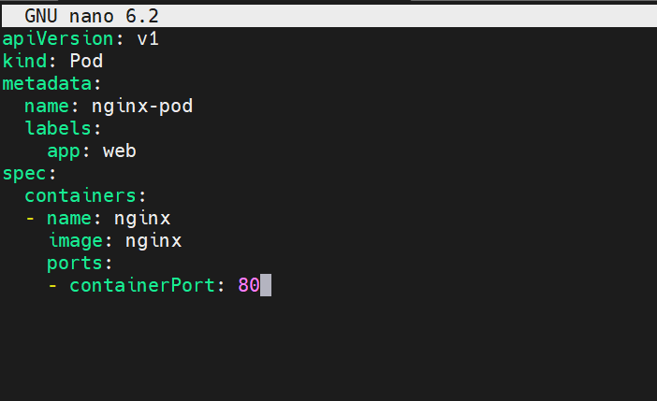
Lets create it
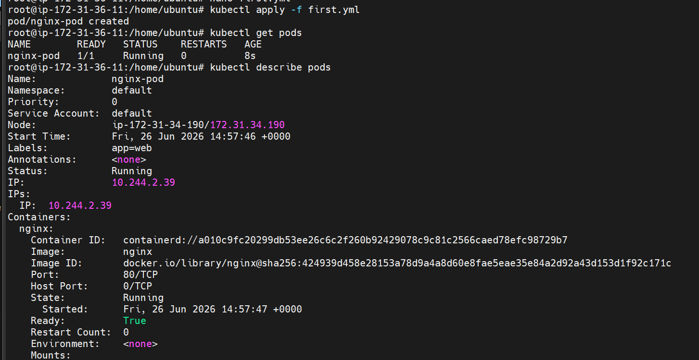
Nginx pod is now created

Lets now create apache one

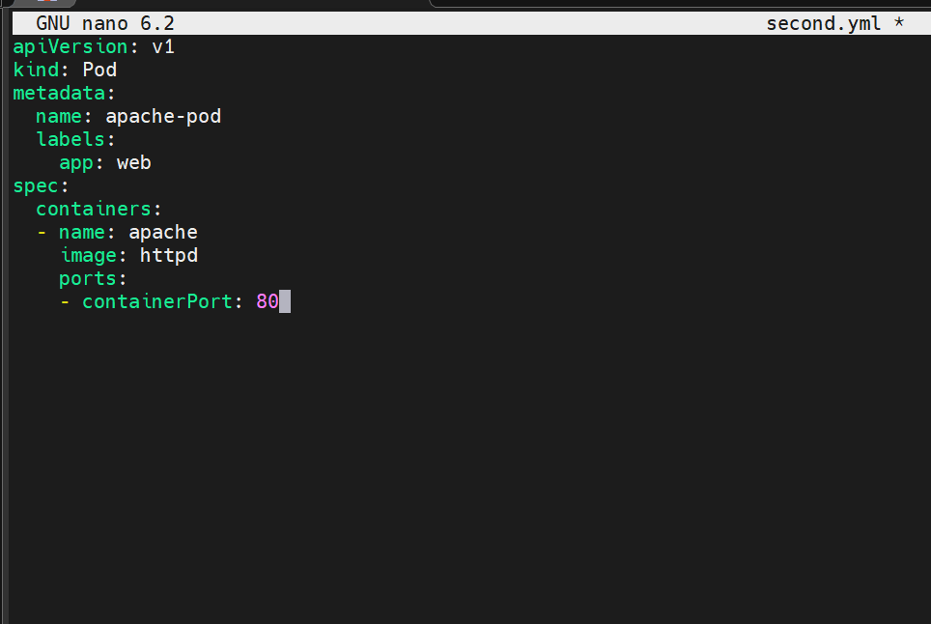

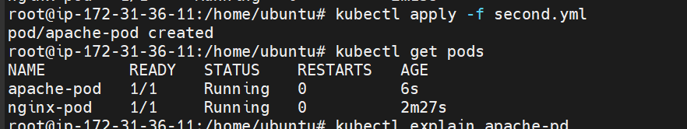
The apache pod also is created

Lets now create nodeport service file
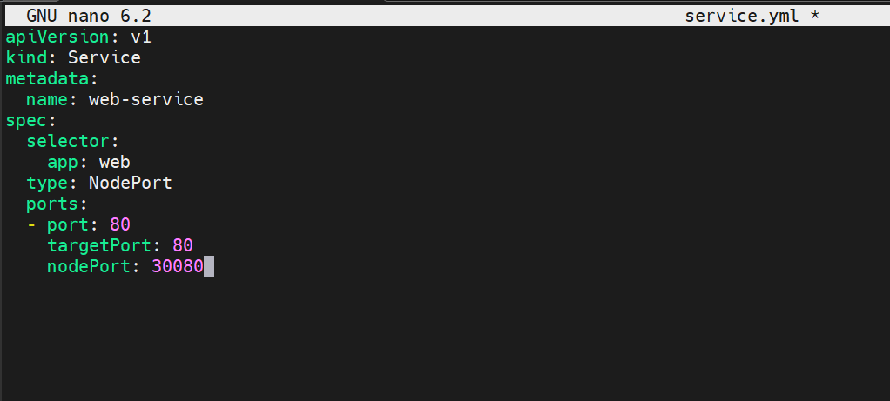
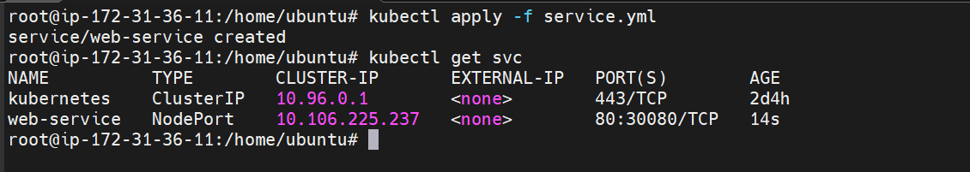
The service is now created
Lets verify load balancing now

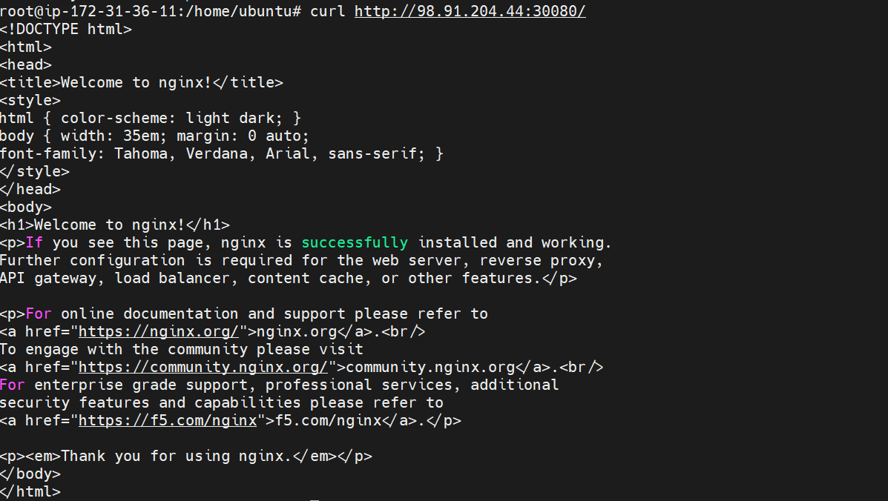
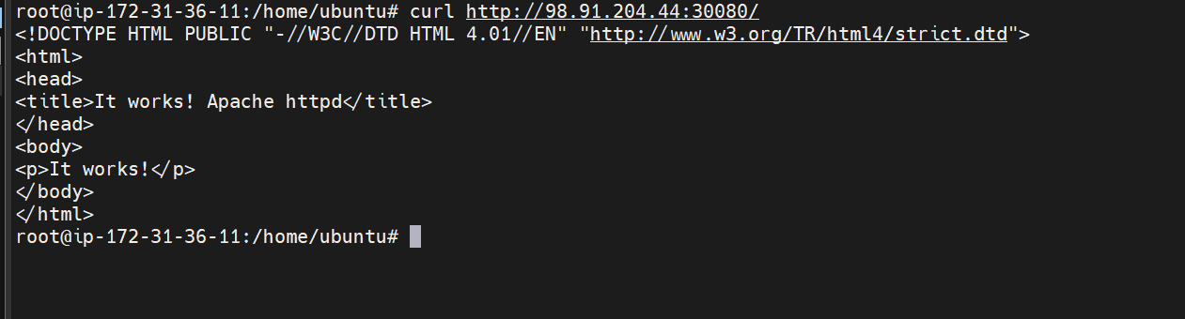

The load balancing is working properly now

- Delete a ReplicationController without affecting the running pods.

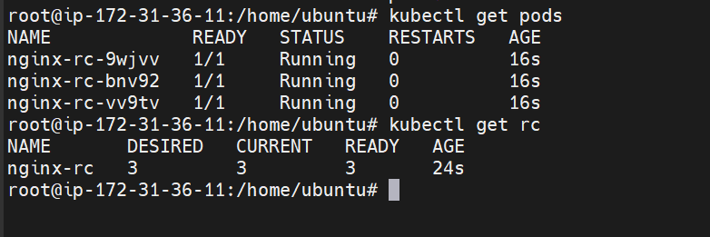

This is our replica controller

Lets delete the rc

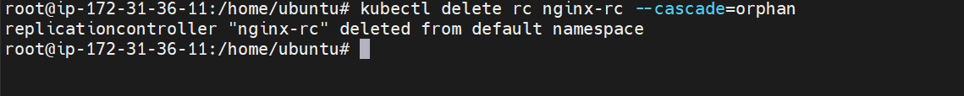
The rc is now deleted
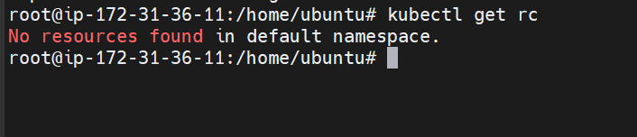

The pods are still running
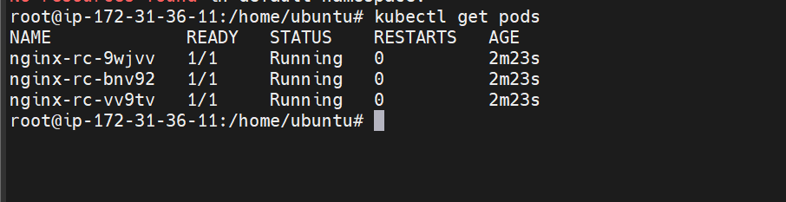

Lets delete the pod and check if another pod is getting created

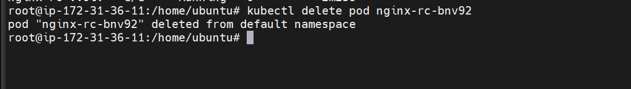

The new pode is not created because the replication controller isn’t managing the pods now
This is the key concept behind --cascade=orphan: the Pods continue running, but they are no longer managed by a controller

