- Deploy an application using a Deployment with 3 replicas and a rolling update strategy.
Let’s start with YAML file
A Deployment provides declarative management of Pods. It automatically maintains the desired number of replicas, supports self-healing, rolling updates, rollbacks, and scaling. If a Pod fails, the Deployment (through its ReplicaSet) creates a replacement automatically."

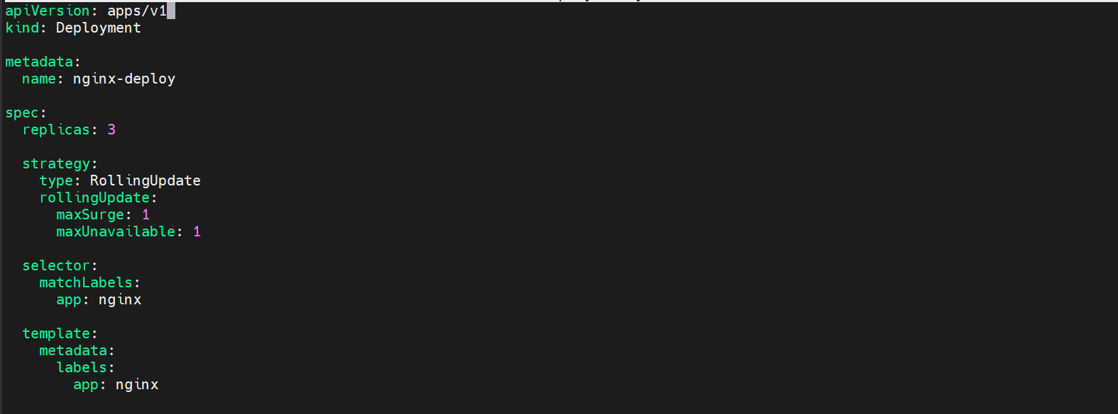
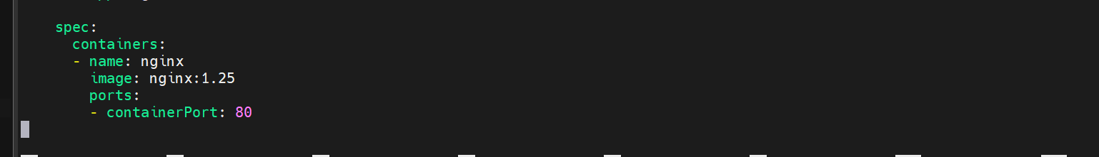

This is our deployment.yaml file
Which creates 3 replicas and has rolling update deployment strategy
Max surge specifies how many extra Pods Kubernetes can create during an update in our case it is 1.
Max Unavailable specifies how many Pods can be unavailable during the update.
In our case again it is 1.
Lets create the deployment
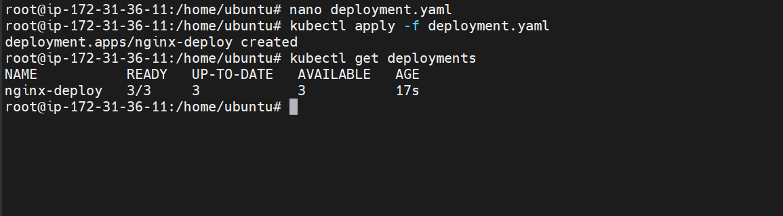
The deployment is now created
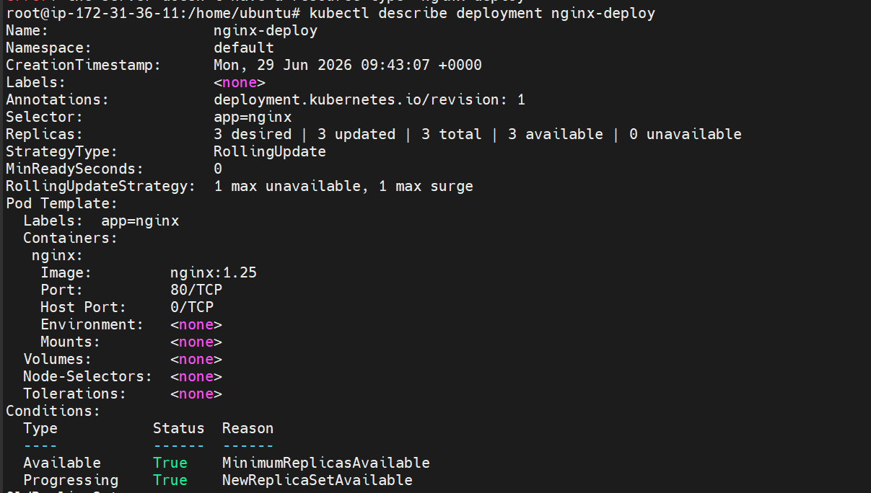
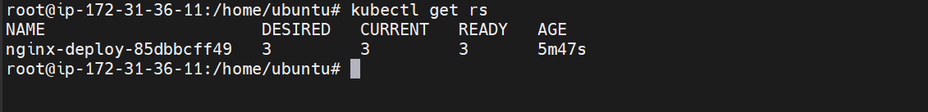
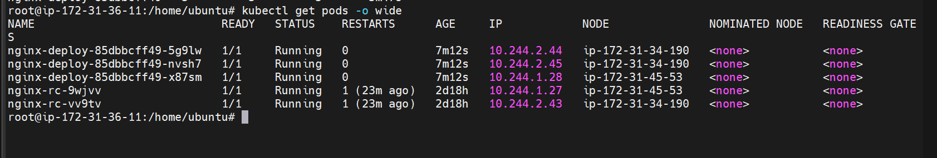
We have now deployed an application using a deployment with 3 replicas and rolling update strategy.

- Configure a Deployment with a Recreate strategy and observe the downtime.

This is our yaml file which creates a deployment with 3 replicas and uses recreate deployment strategy

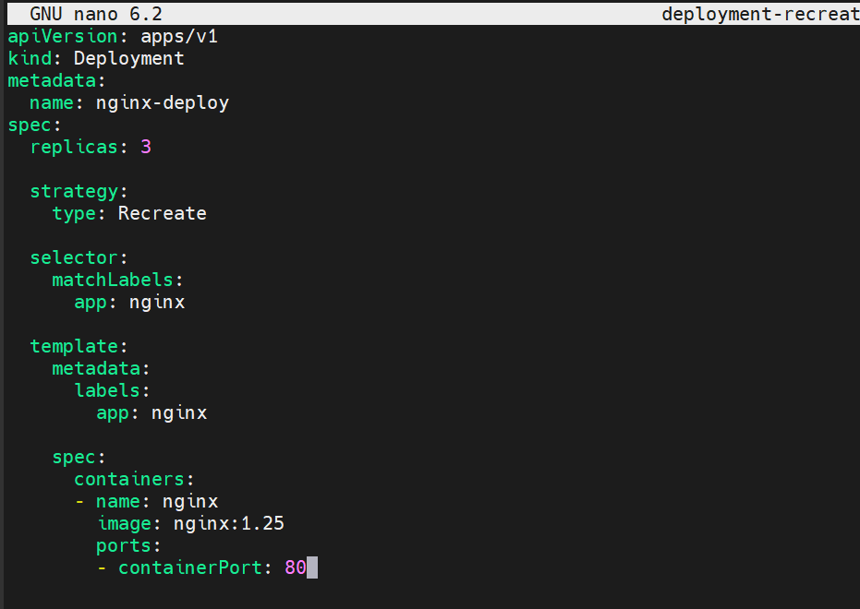
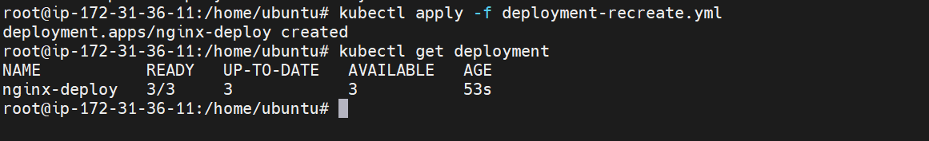
Deployment strategy is recreate
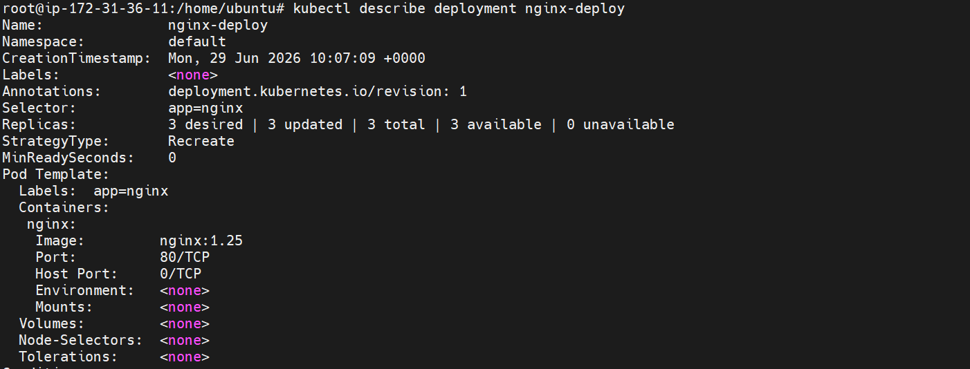
Lets now verify the downtime by updating the application

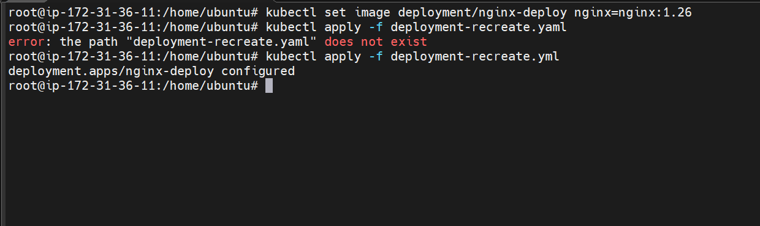
Here we have updated the nginx image

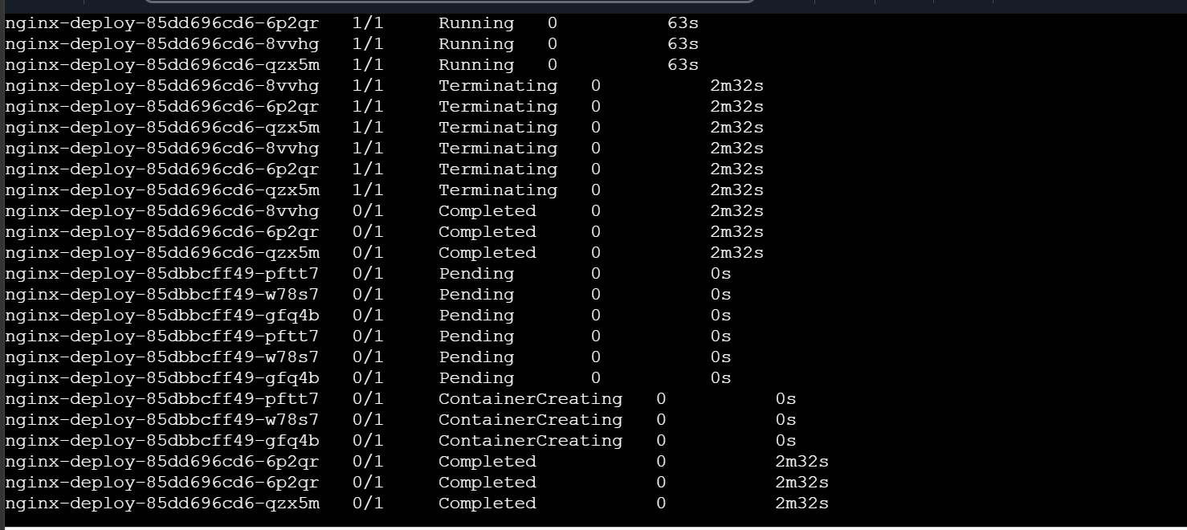
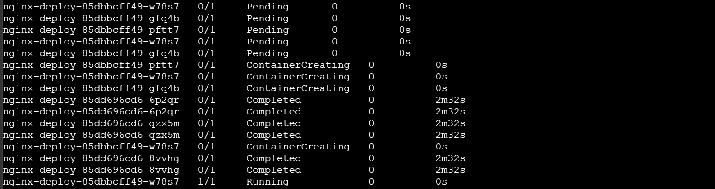
We can see there is some downtime while the pods are getting terminated and recreated
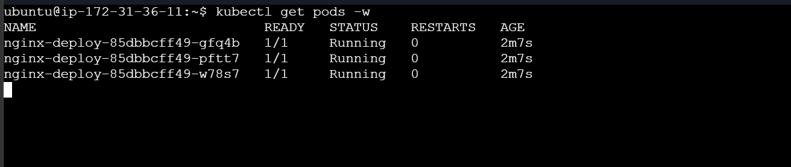
Finally all three pods are running
- Update an existing Deployment and perform a rollback to the previous version.

Lets now edit our deployment file
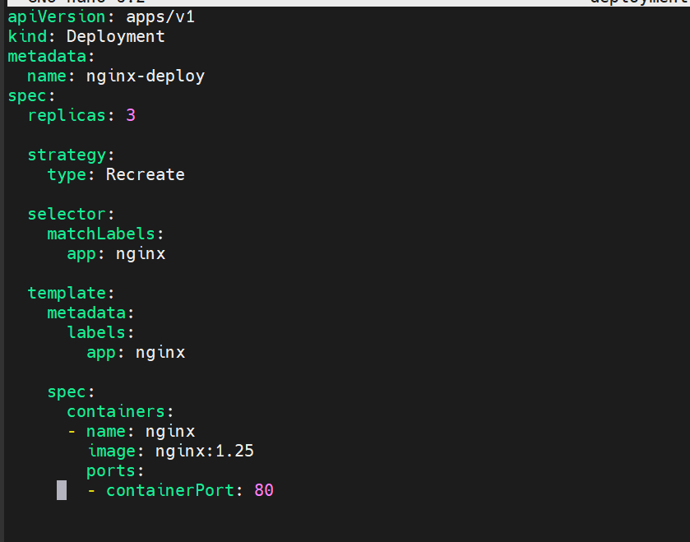
Here the nginx image is 1.25 lets update it to 1.26
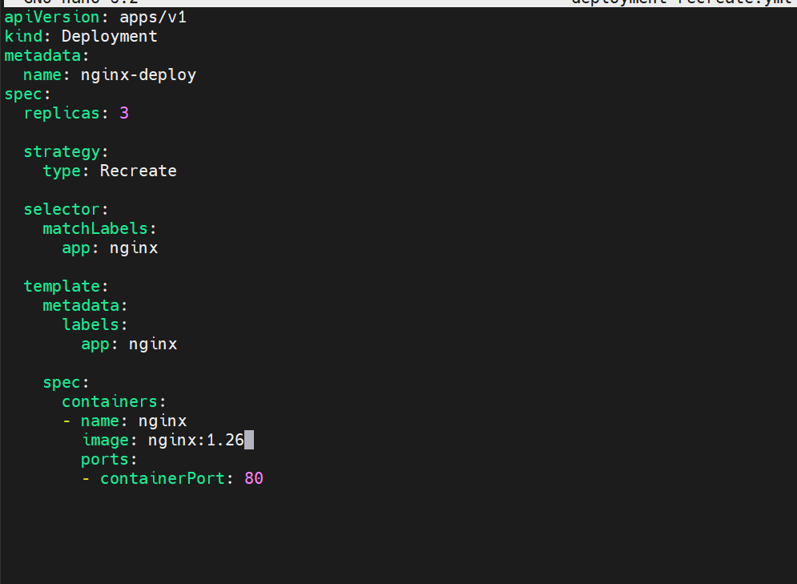
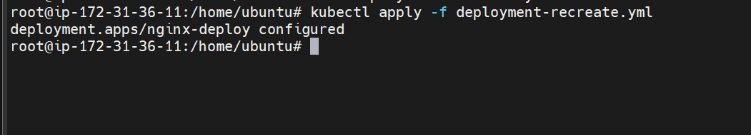

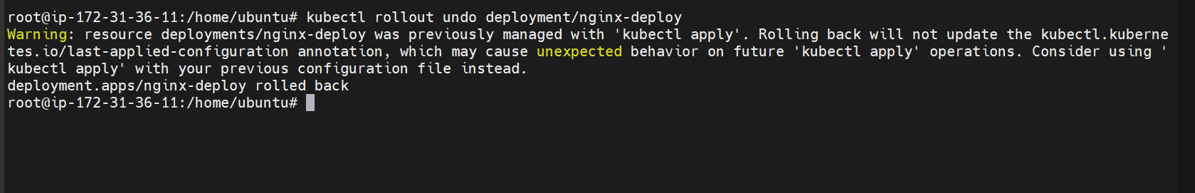

We have rolled back to the previous version here
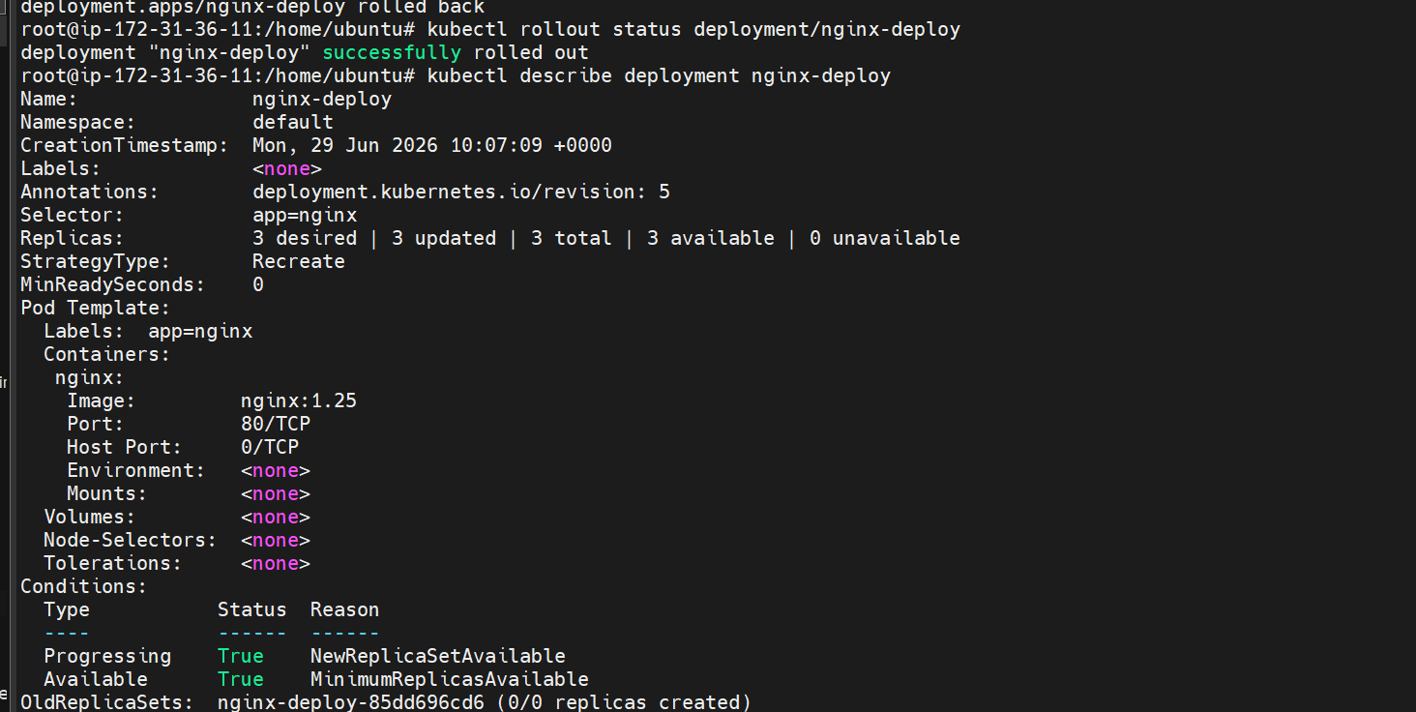
We can see that the nginx image is 1.25 again

- Modify a Deployment to add resource requests and limits for CPU and memory.
Lets modify the deployment file
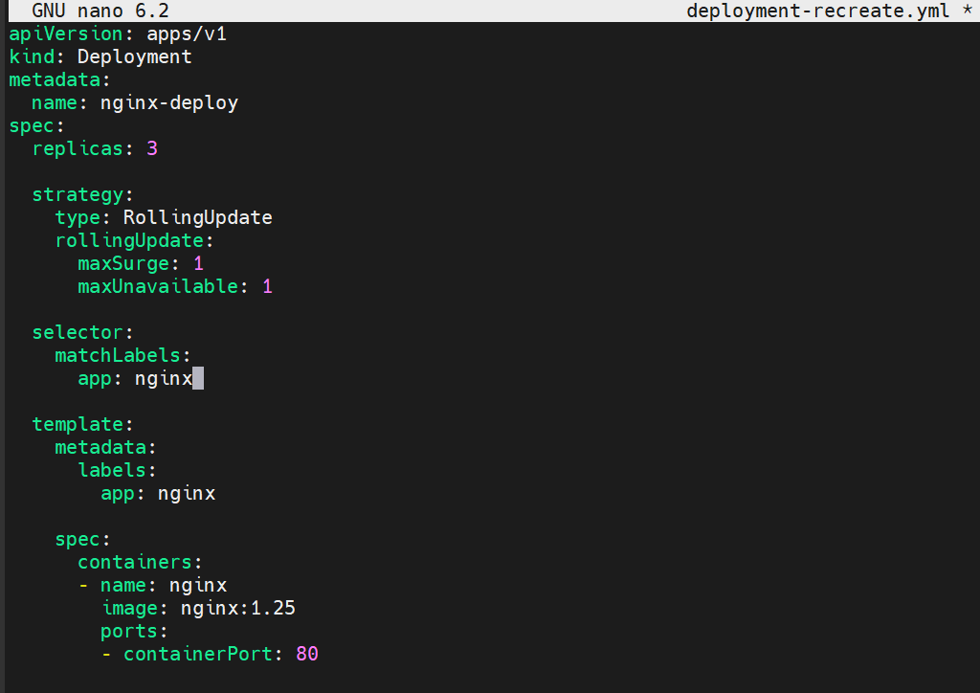
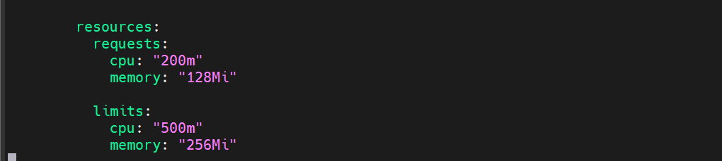
Here we have added resource and limits
A request is the minimum amount of CPU and memory that Kubernetes reserves for the container.
This tells Kubernetes:
"Schedule this Pod only on a node that has at least 200 millicores of CPU and 128Mi of memory available."
A limit is the maximum amount of CPU and memory the container can use.
This tells Kubernetes:
"Do not allow this container to use more than 500m CPU and 256Mi memory."
If the container:
- exceeds the CPU limit, it is throttled.
- exceeds the memory limit, it is usually OOMKilled (Out Of Memory).
Lets now create the deployment
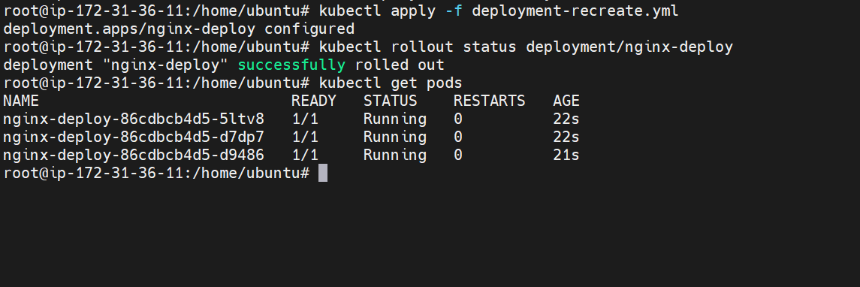
The deployment is now created
Lets check one of the pod
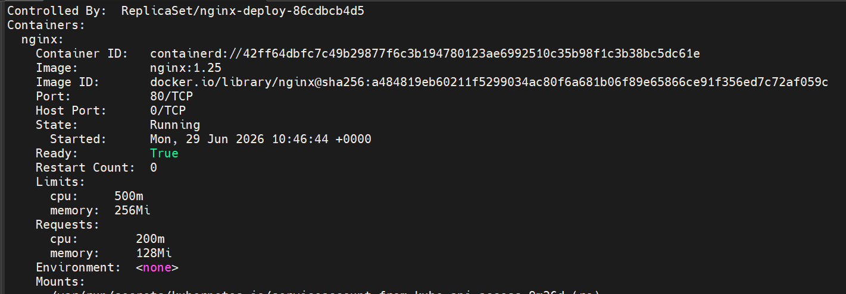
We can see that the particular pod has cpu and memory limitations and it requests for 200m cpu and 128 mib of memory

- Create a Deployment with MaxSurge and MaxUnavailable configurations.

MaxSurge: This specifies how many extra Pods Kubernetes can create during an update.

MaxUnavailable: This specifies how many Pods can be unavailable during the update.

Lets now create the deployment file
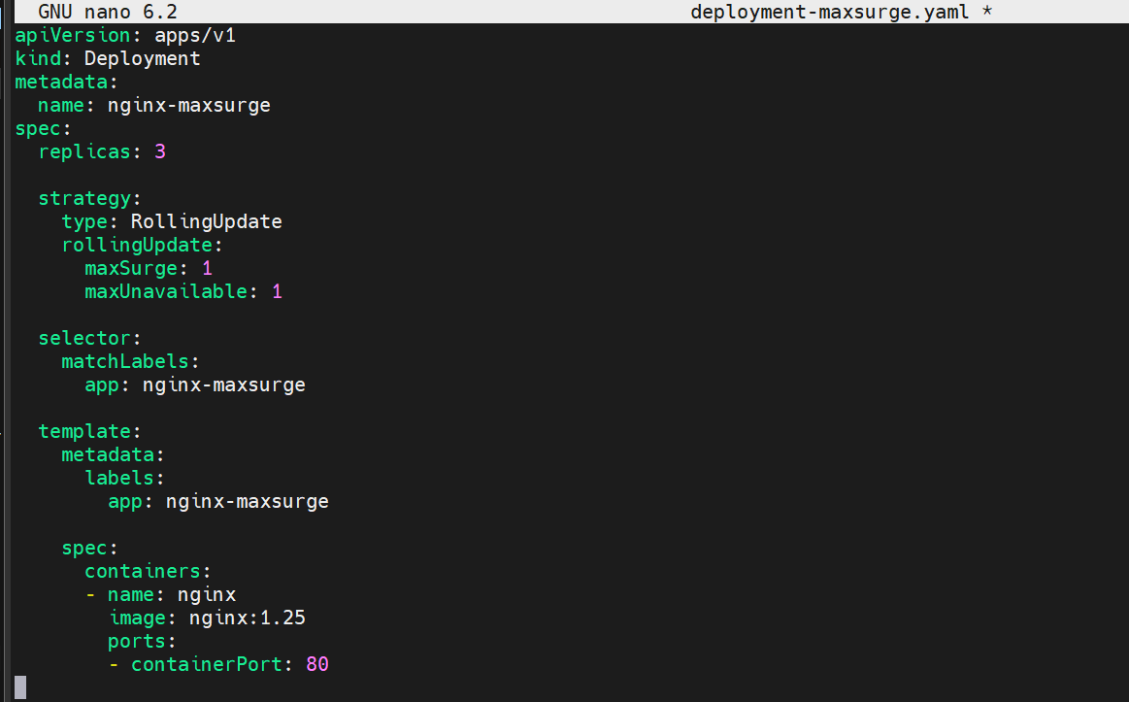
This is our deployment file
Here maxSurge Is set to 1 which means 1 extra pod will be created during an update
Also maxUnavailable is set to 1 too means 1 pod can be unavailable during an update
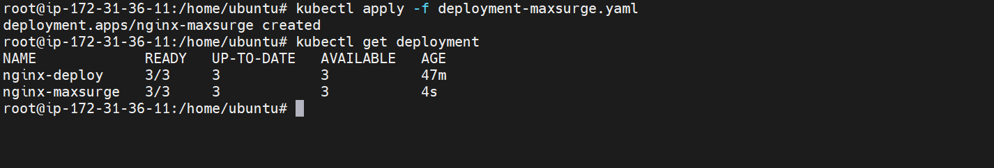

The deployment is created
Lets now perform an update
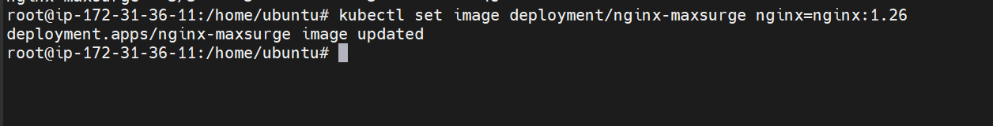
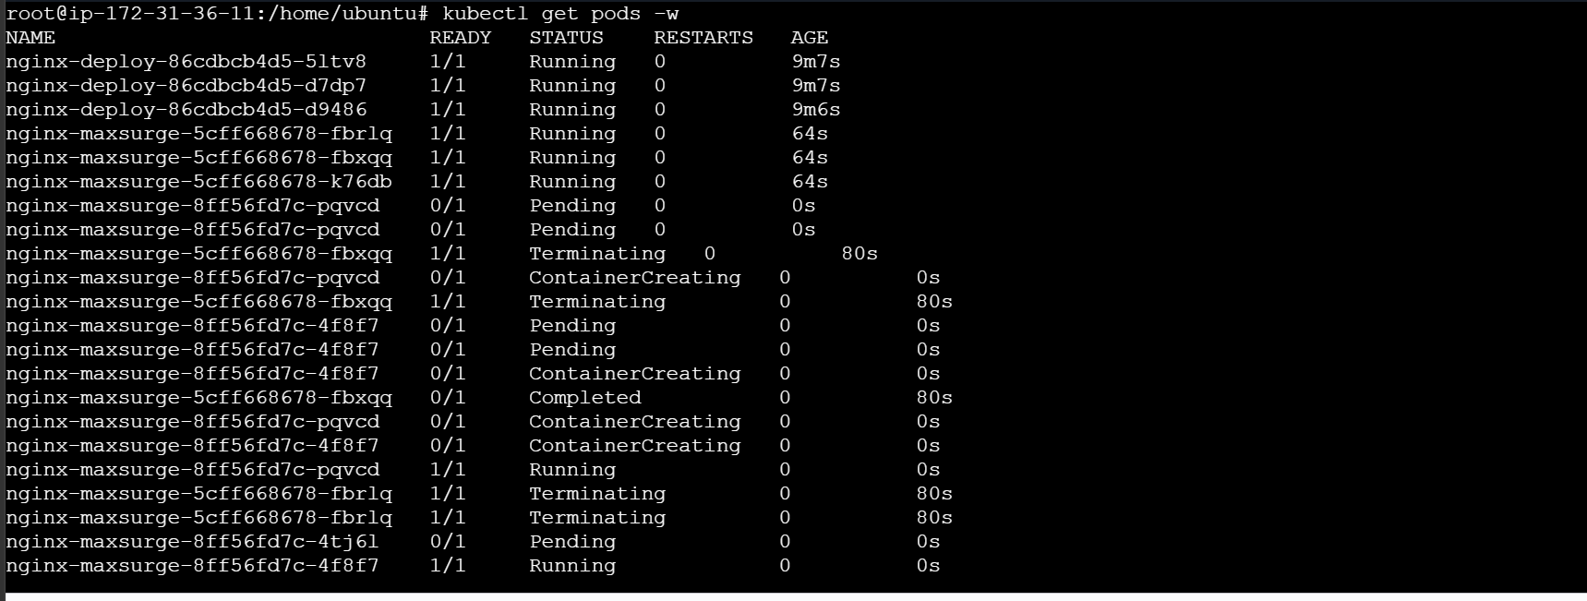

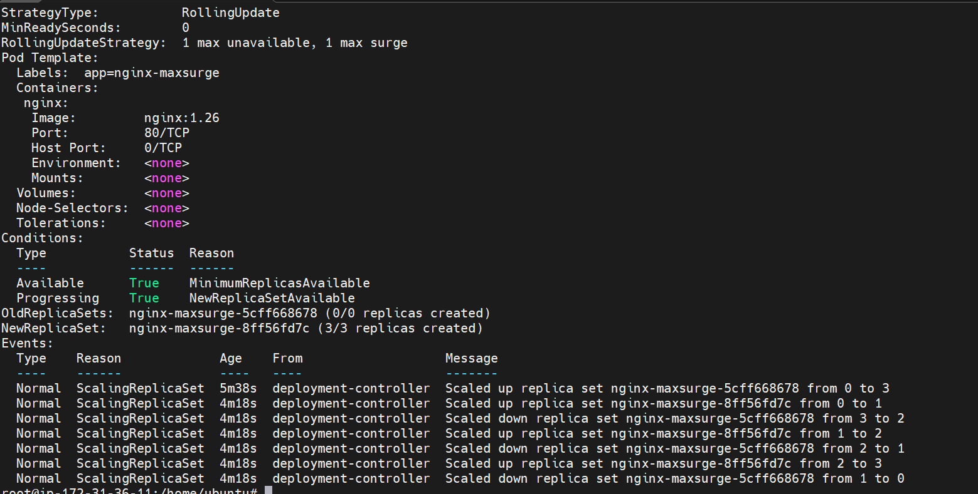
We can see the update strategy here 1 max unavailable and 1 max surge.

- Set up a Deployment with a custom revision history limit.

What is revisionHistoryLimit?
Every time you update a Deployment, Kubernetes creates a new ReplicaSet.
For example:
Revision 1 → ReplicaSet 1
│
Update
▼
Revision 2 → ReplicaSet 2
│
Update
▼
Revision 3 → ReplicaSet 3
│
Update
▼
Revision 4 → ReplicaSet 4
By default, Kubernetes keeps the old ReplicaSets so you can roll back if needed.
However, after many updates, you'll have many old ReplicaSets that are no longer used.
To control this, Kubernetes provides:
revisionHistoryLimit: 2
This tells Kubernetes:
"Keep only the latest 2 old ReplicaSets. Delete older ones automatically."

Lets now create a deployment
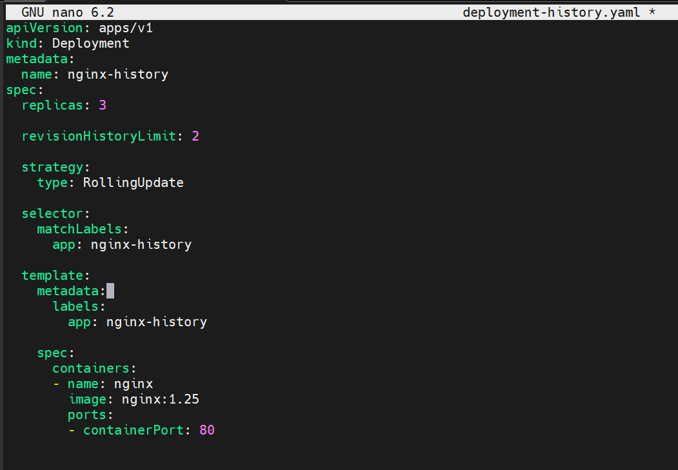

This is our deployment file
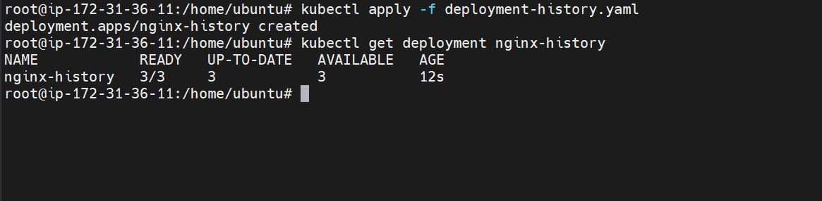
We have created the deployment
To verify the revision history lets perform multiple times
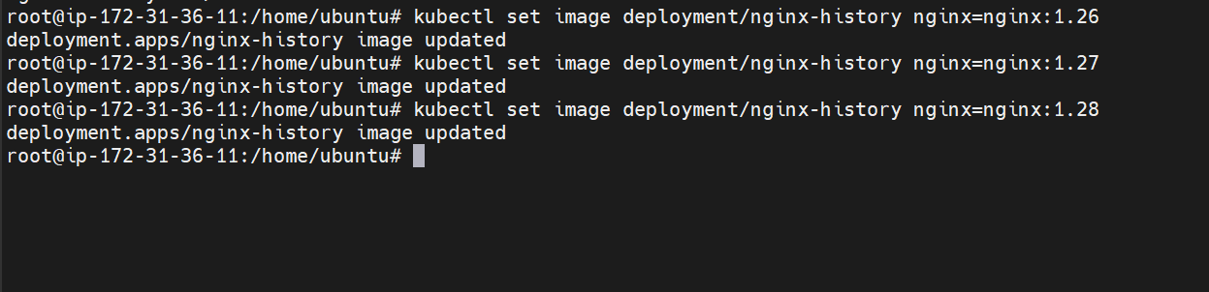
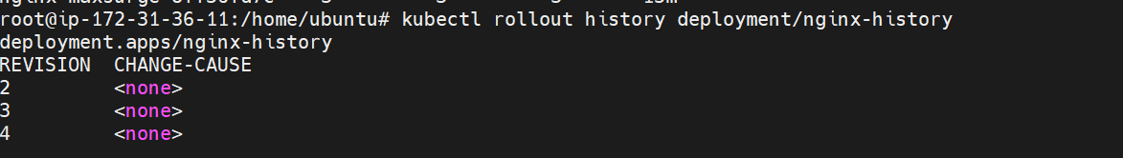

We can see here that only the last two revisions are kept

- Pause a Deployment during an update, and then resume it.
Lets create a new deployment first
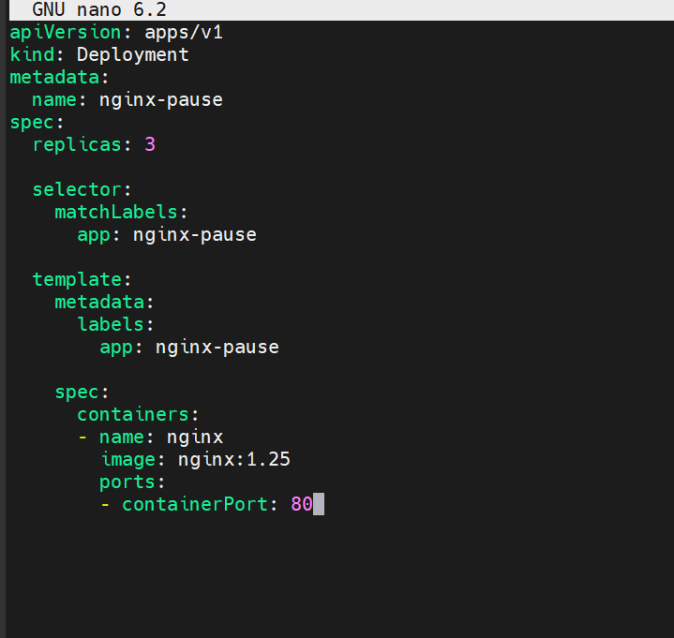
This is our new deployment which will create 3 replicas based on label nginx-pause
Lets now create it
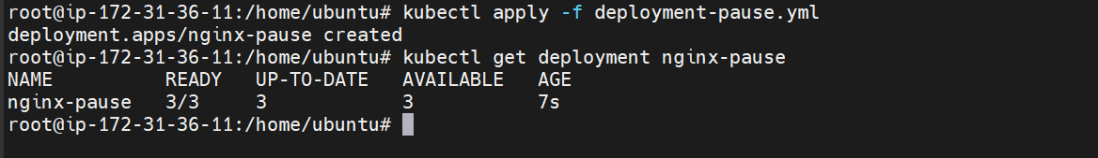
The deployment is now created
Now pause the deployment
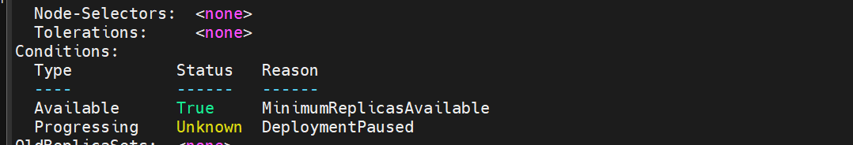
The deployment is paused
Modifying the deployment in paused state
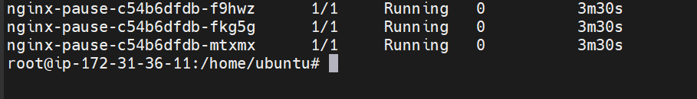
The existing pods are still running
Now resume the deployment
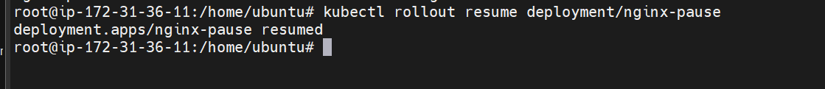
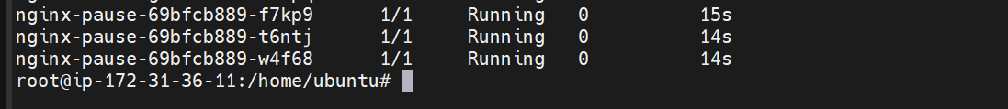
The deployment is now resumed
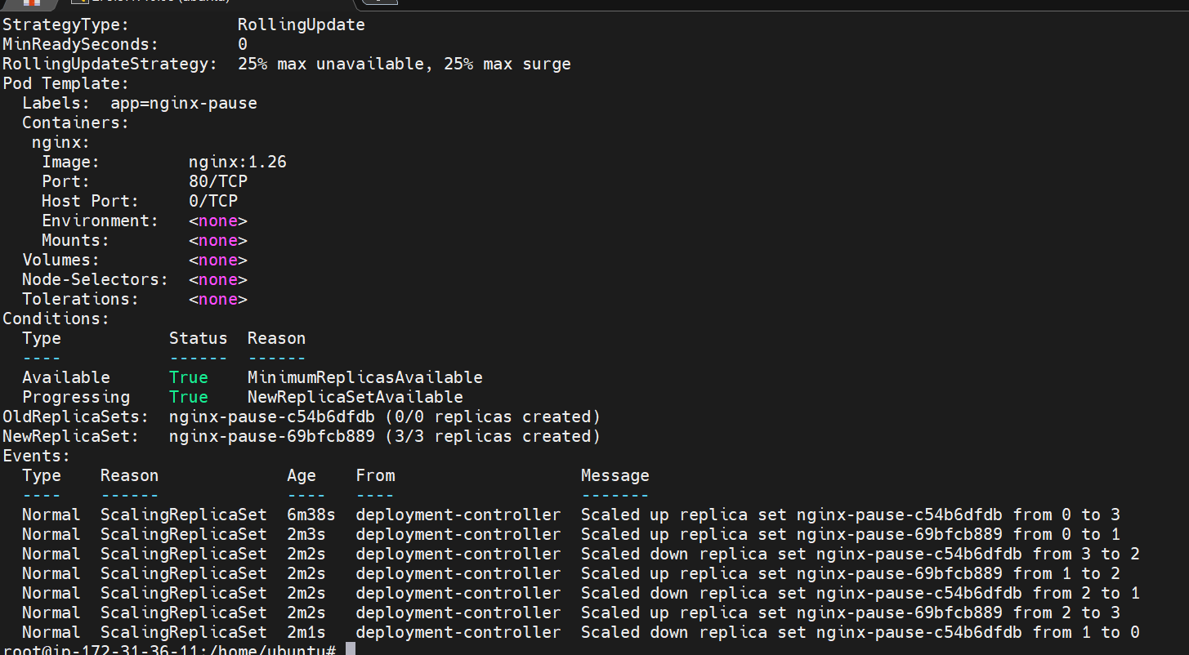
The image has been updated now.

- Create a pod using resource requests for memory and CPU, and observe how the scheduler assigns it to a node.

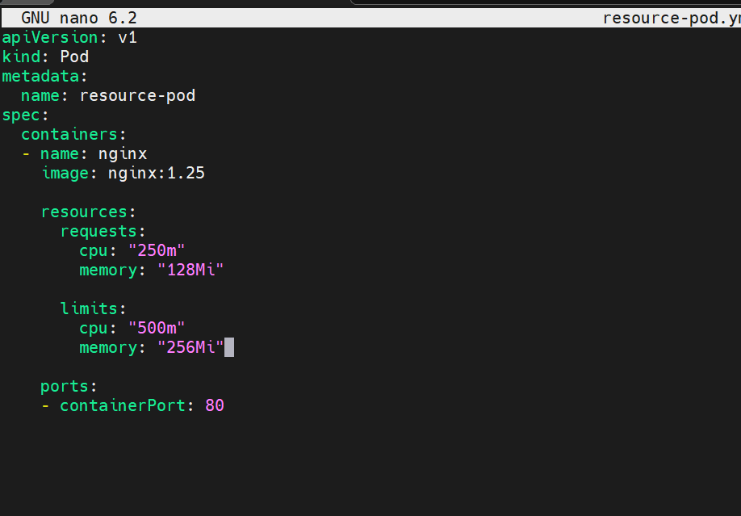

This is our yaml file which creates a pod with nginx application
The pod will be scheduled only on the node which has 250m cpu and
128 mib memory available
Also the maximum cpu for the pod should be 500m and memory should be 256 mib this is the limitation we have set
Creating the pod
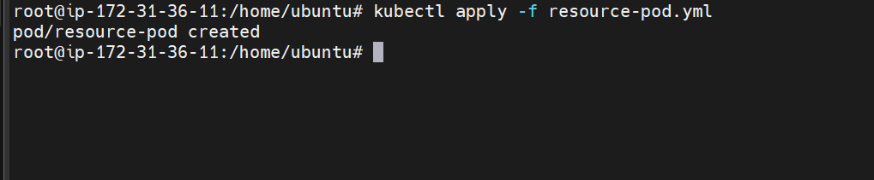
Verifying the pod
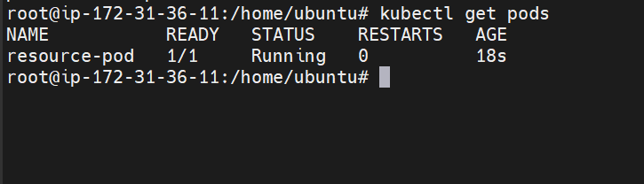

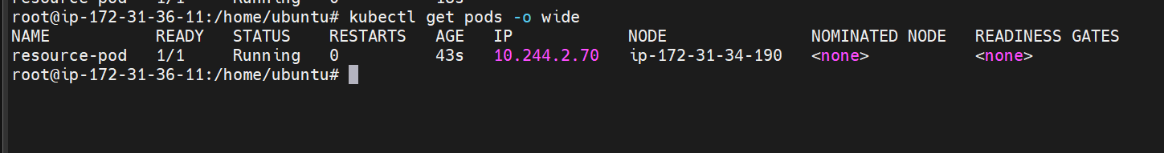
The pod is running on ip-172-31-34-190 node

We can see that the pod has been assigned to 172-31-34-190

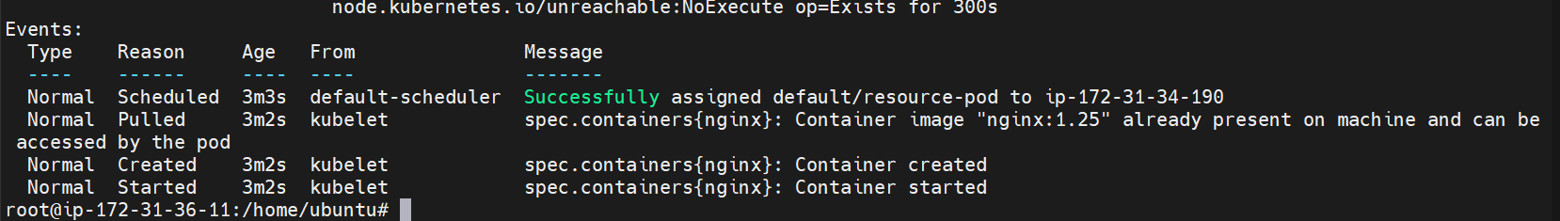
Lets now update the resource size

Here we are requesting the higher size than what we have

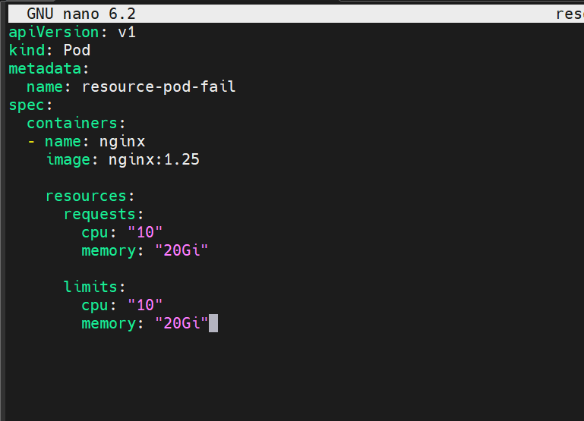
Apply changes now
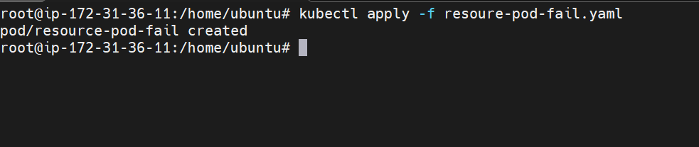

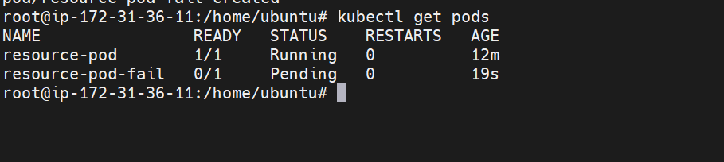

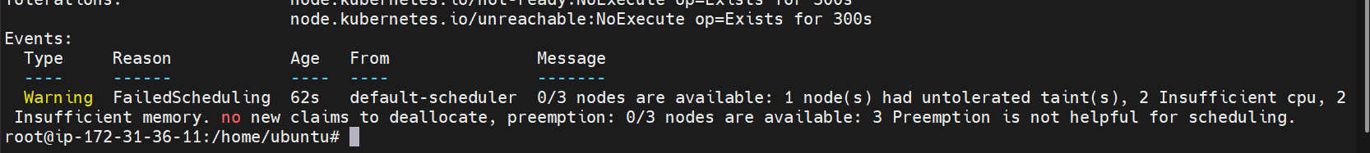
We can see that pod scheduling is failed due to insufficient memory and cpu.

