Terraform Challenge02

Goal of the Exercise
The goal of this exercise is to test your understanding of a Cloud Compute deployment with Terraform.
You are tasked with creating a codebase for a microservice deployment on a cloud environment, using Terraform. Since our focus is not the application itself, the service will be a simple web server that returns a static page.
Requirements
Service Details
- The service will be a simple web server that returns a static page.
- You can useapache2 or nginx to serve a simple HTML file.
- The service should be containerized and stored in a Docker registry.
- The service should be deployed on a single VM instance as a docker container.
- The image should be pulled from the registry specified earlier.
- The service should not be accessible from the internet but only through a Load Balancer, except for SSH access from specific IP addresses.
Deliverables
You are to provide the following as part of your solution:
- Dockerfile to build the image.
- Terraform codebase to deploy the following:
  - Docker registry
  - VPC and all required networking resources
  - EC2 instance
  - Load Balancer
Notes
- Since a CI/CD pipeline is not part of this exercise, we will work around that with the help of Terraform.
- To push the image to the Docker registry,build the image locally before running the Terraform code.
- Once the image registry is created, use Terraform topush the local image to the registry.
- Similarly, use Terraform to pull the image from the registry and run it on the VM instance once it is created.
- For SSH access:
  - Use a locally created key.
  - Add it to the cloud provider key storage.
  - Attach it to the instance.
- Use Terraform best practices for file structure and code organization.
  - Use variables, locals, modules, etc. when appropriate.
- Include all tfvars, scripts, and other helper files used to deploy the application.
- You may use any cloud provider of your choosing, although AWS is preferred.
- Use a free tier account or atrial account to deploy the resources.

First let’s start with the project folder creation
cloud-compute-terraform/
├── app/
└── scripts/
this is our structure so far
inside app folder create index.html file and add sample code
also create a Docker file as well
index.html:
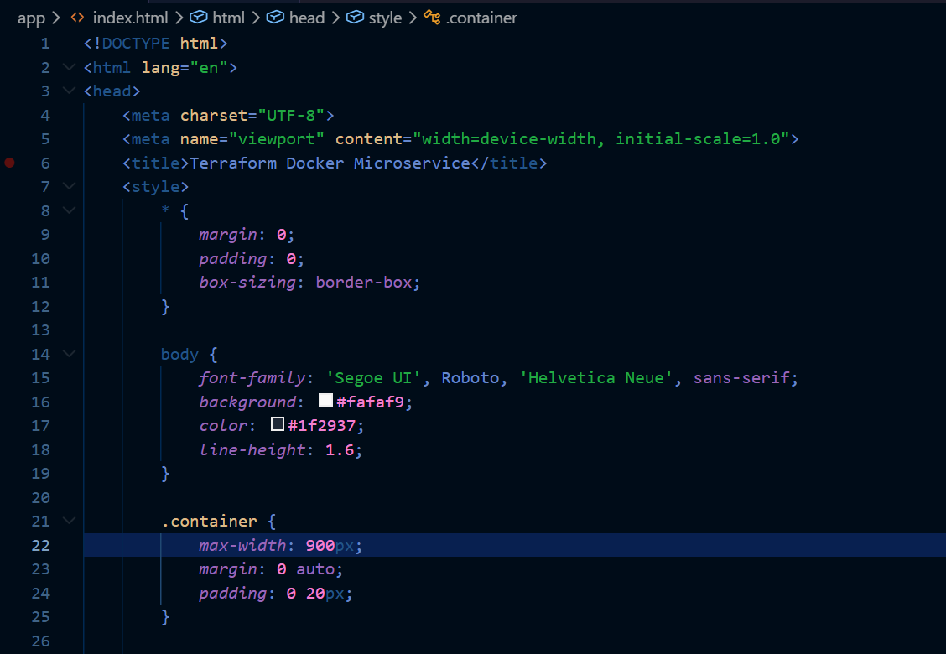
Dockerfile:
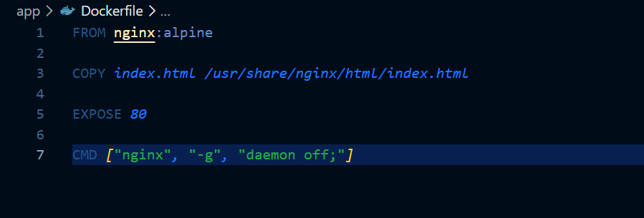
Let’s build the image locally now
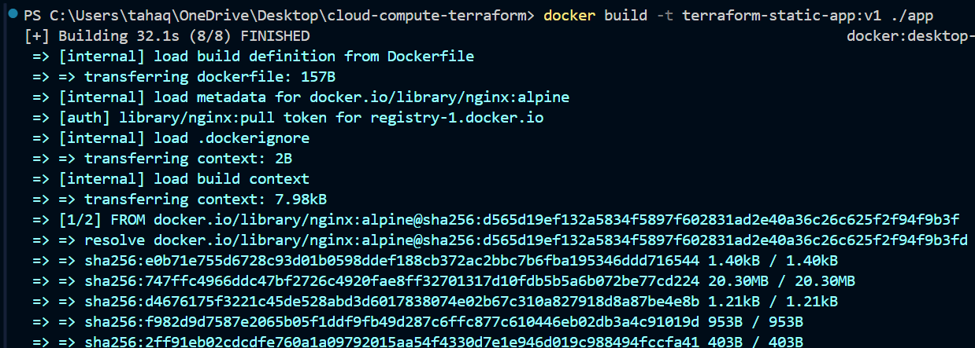
The image has been built
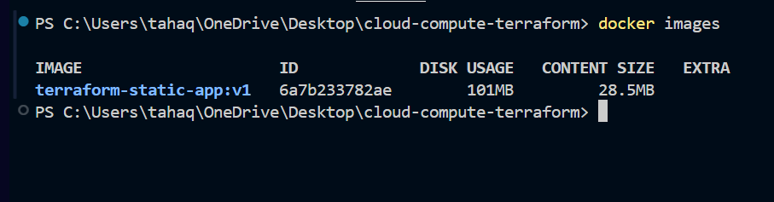
Let’s now make a container from the image
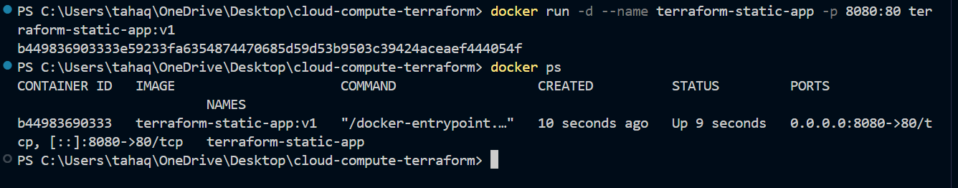
The container has been created
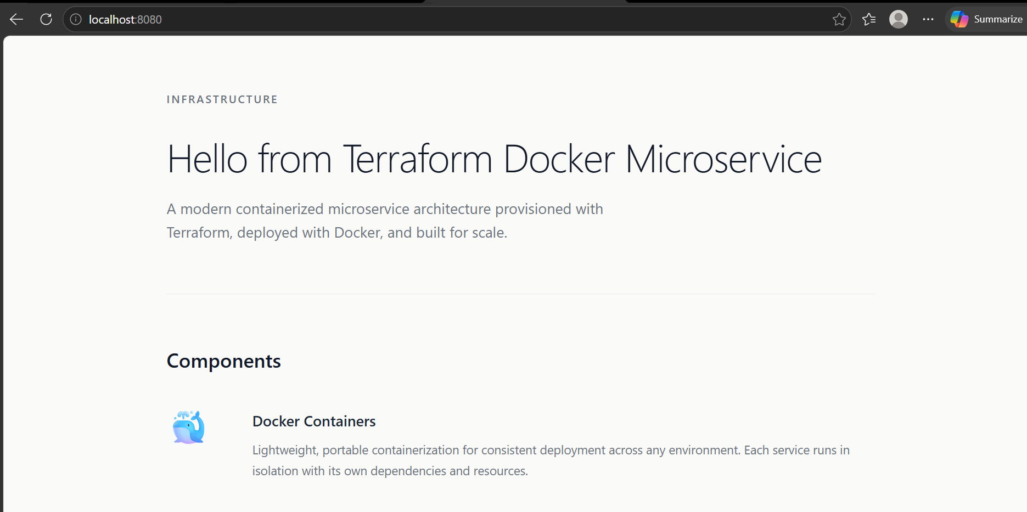
Our sample application is now deployed on local host port 8080
Let’s stop this container for now and move to another steps
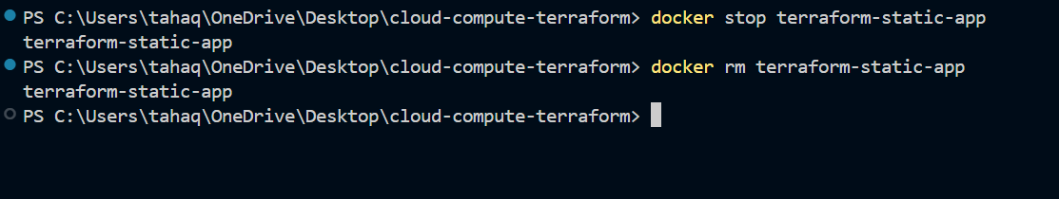

Let’s now create terraform files
Versions.tf
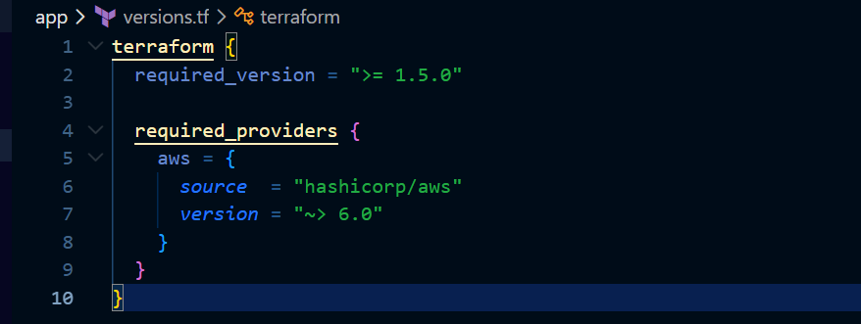
We are using terraform version greater than or equal to 1.5.0
And required aws provider is 6.0 or greater
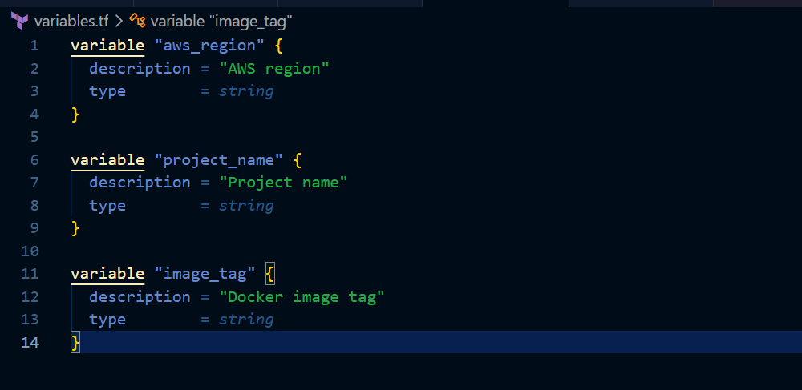
These are the variables we are using
This is the terraform.tfvars file
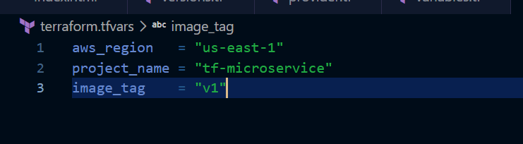
Instead of hardcoding in the variables.tf file we are using the .tfvars file
Now the main configuration file

main.tf
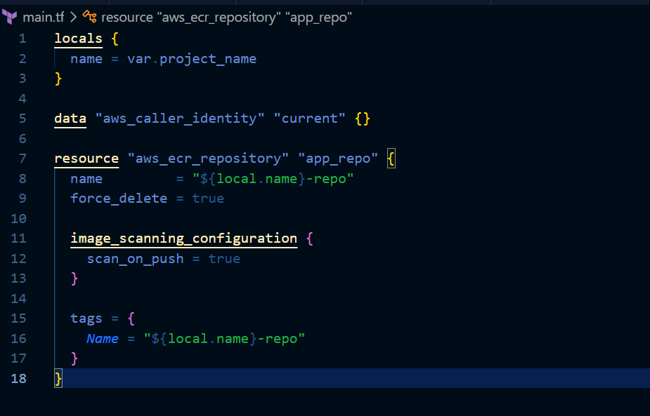
For now, we are just creating the ECR repository first after that we will go ahead with other steps
Let’s now create the ECR using terraform
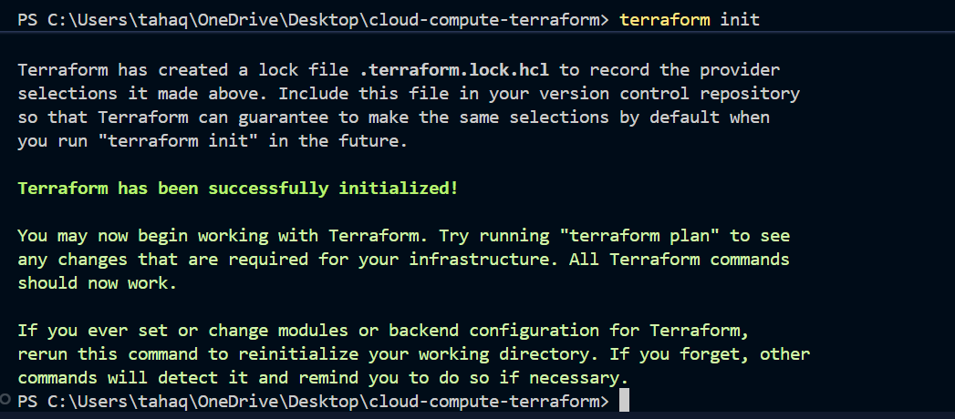
First initialize terraform
Let’s now validate and apply the changes
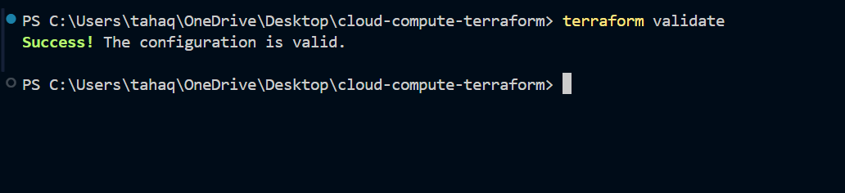
Terraform plan
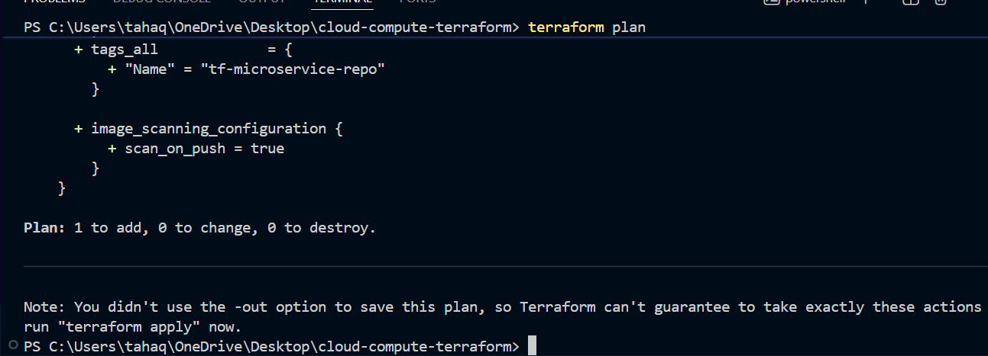
It shows one thing to add Let’s now apply changes
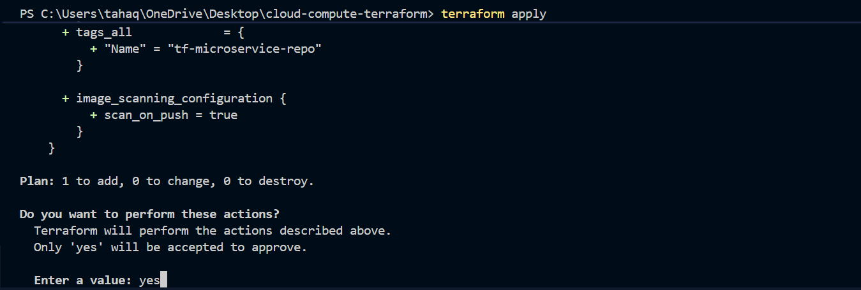
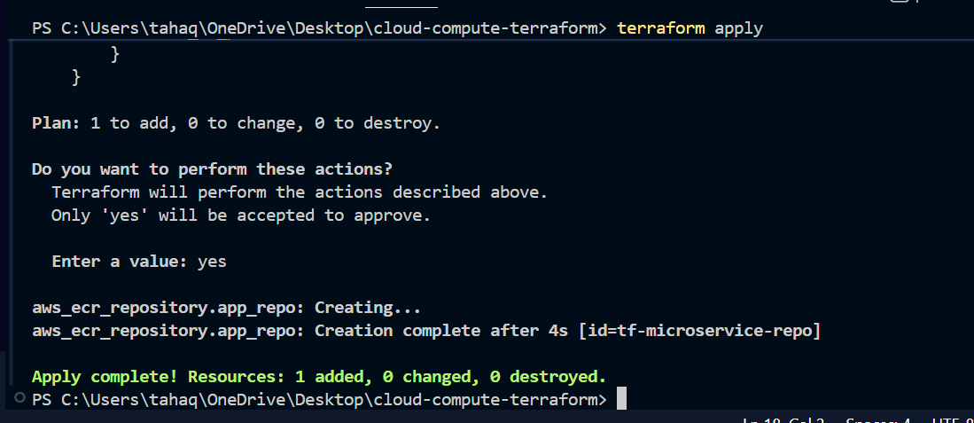
the registry is now created
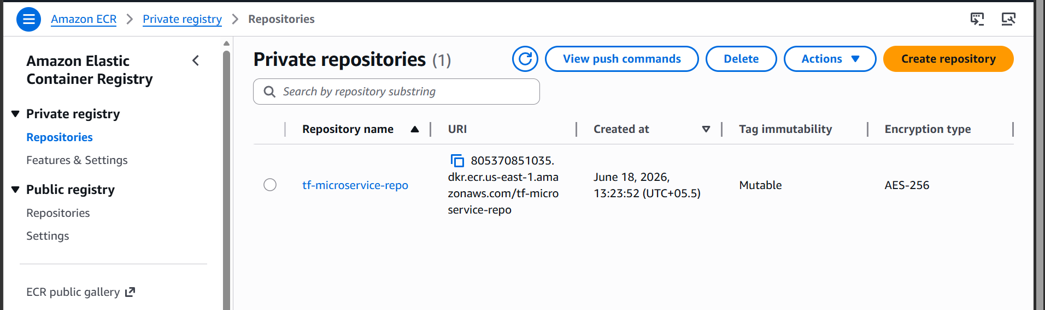
We can confirm it through the console as well
now push our local image to the ECR repository
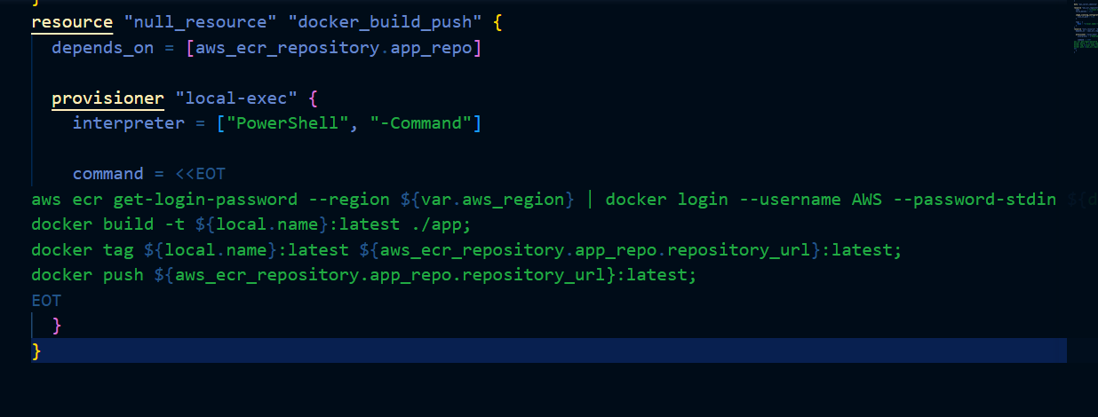
Here we are using a null resource because Terraform cannot directly execute Docker build and push operations. The null_resource acts as a wrapper that runs local commands on the machine where Terraform is executed. It is used to build the Docker image and push it to the ECR repository after the repository is successfully created.
now push the image to ECR
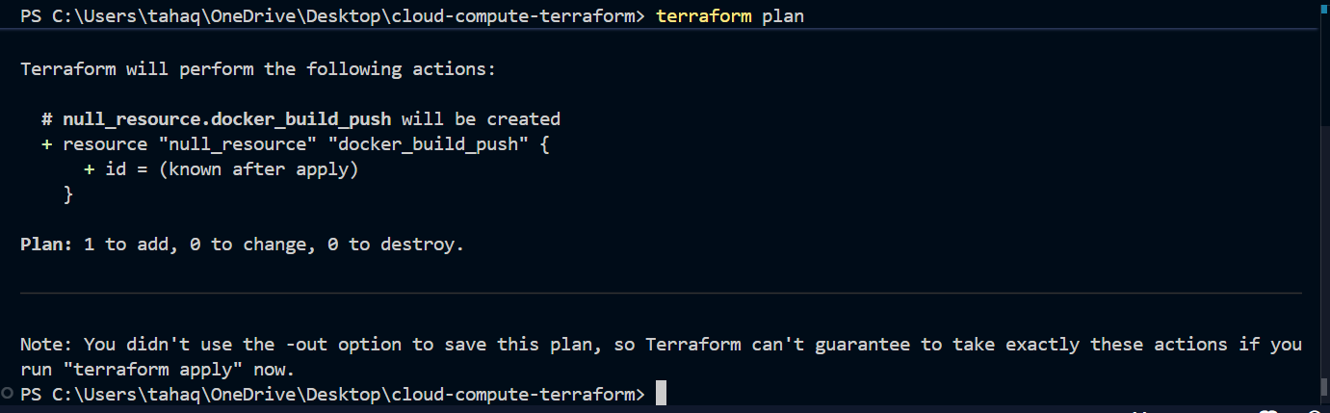
now apply
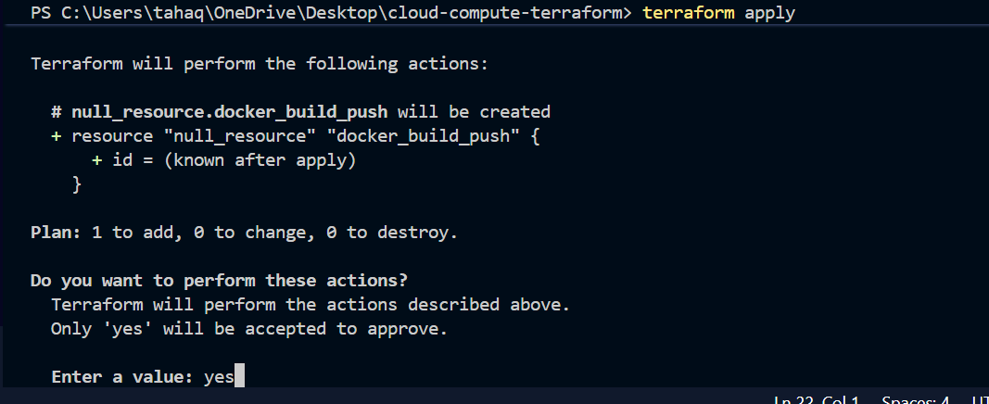
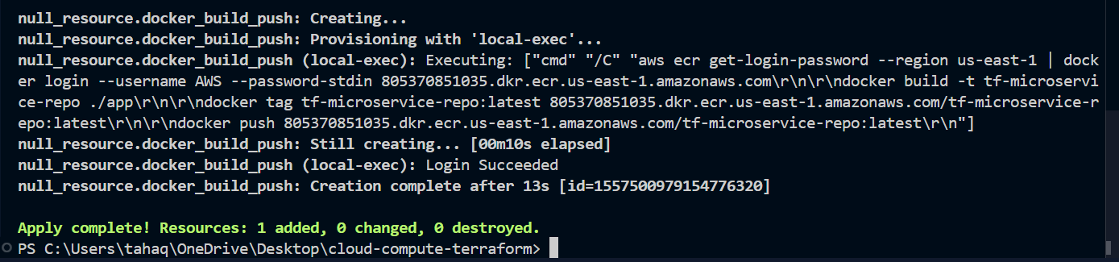
The creation is now complete Let’s verify now in ECR repository if the image is pushed
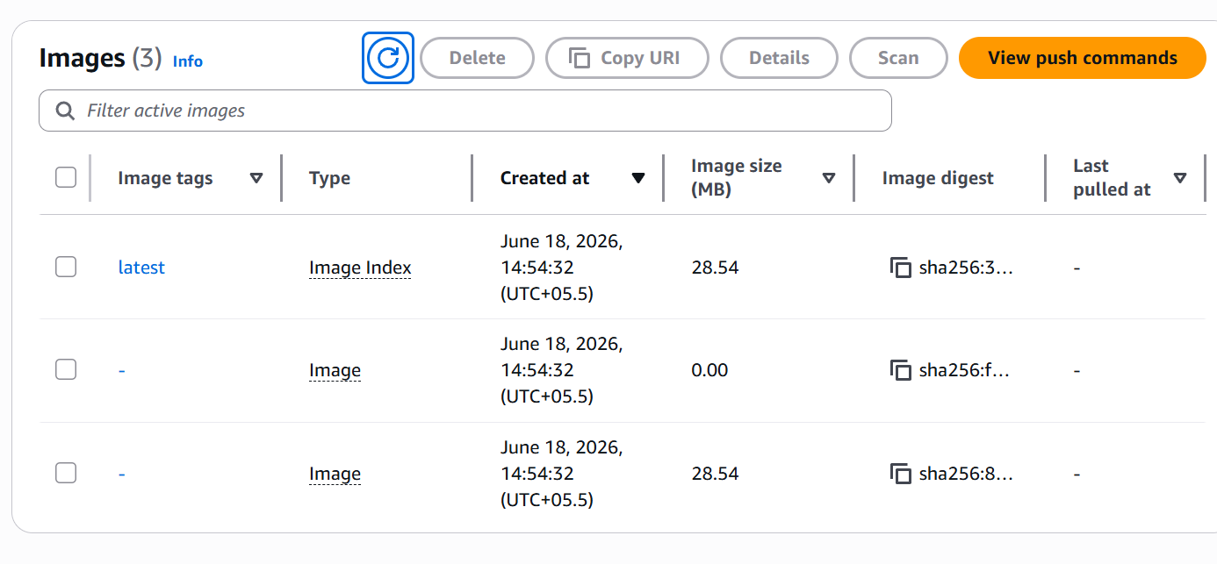
The image is pushed now
build the network now
We want our service not to be accessible from internet except through load balancer
add some more variables in variable file
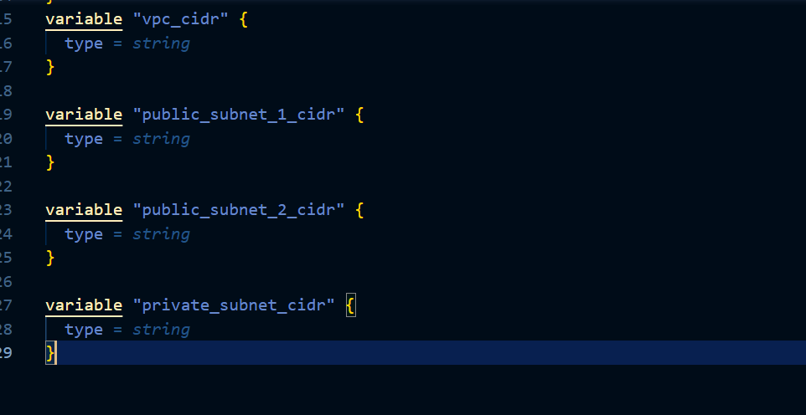
These are the new variables which we will use
Let’s now add their values in terraform.tfvars file
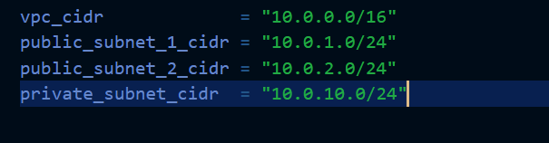
We need to add the availability zone for high availability so add this line data "aws_availability_zones" "available" {}
at the top of main.tf file
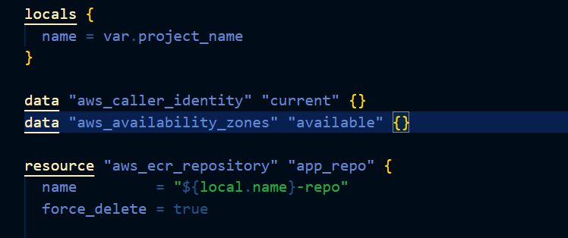

now create VPC
Below ECR section in main file add VPC creation code
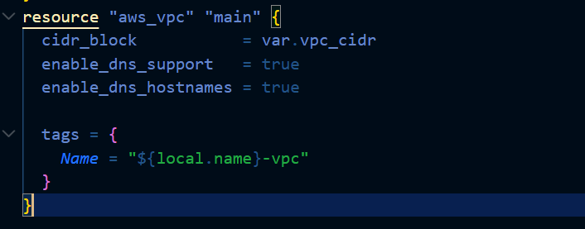
Also add internet gateway without it our VPC won’t have internet access
Now add public subnet
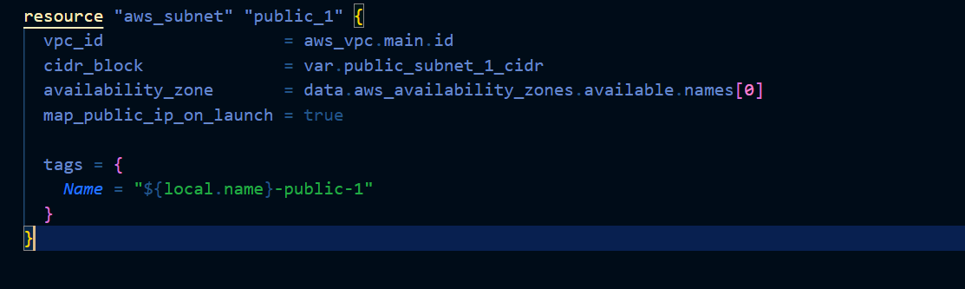
One more public subnet in another availability zone
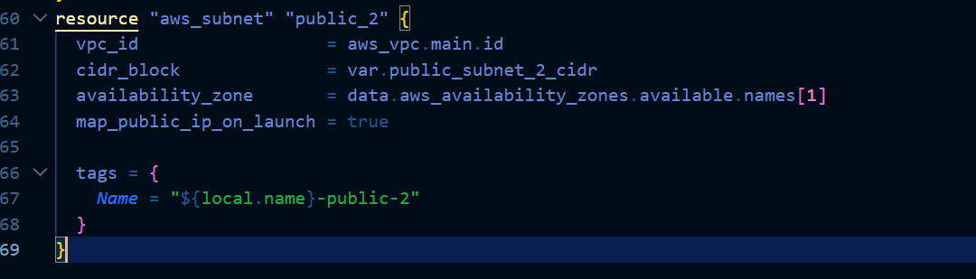

Now create a private subnet

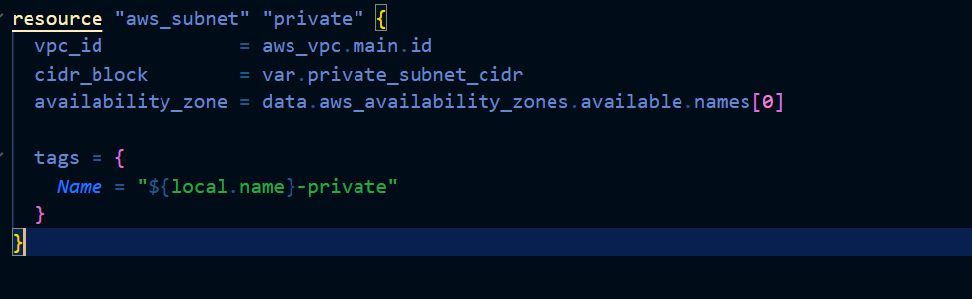
now go ahead and create the infra
first validate the configuration
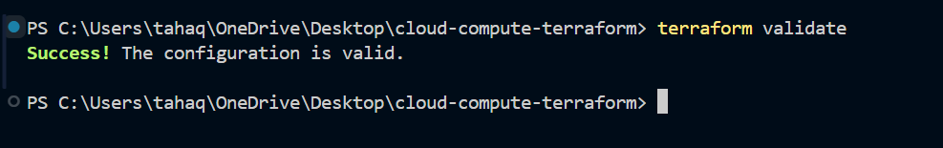
Terraform plan shows 5 things to add
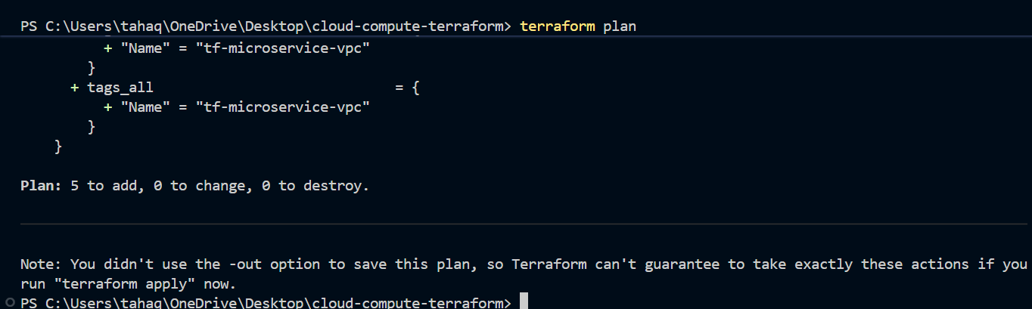
Let’s now create it
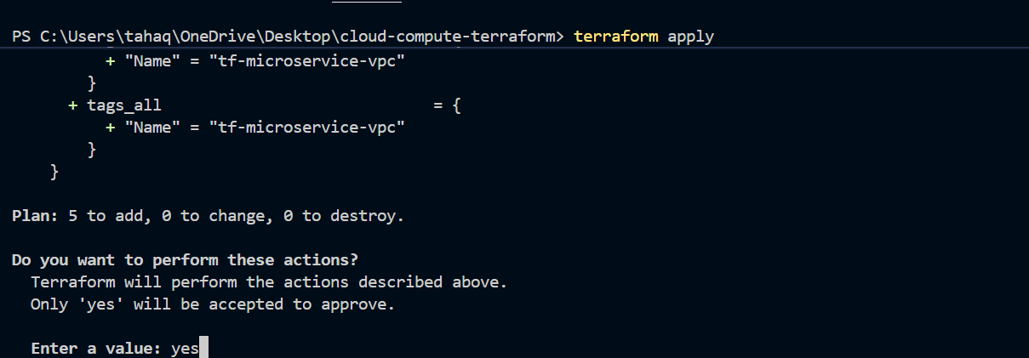
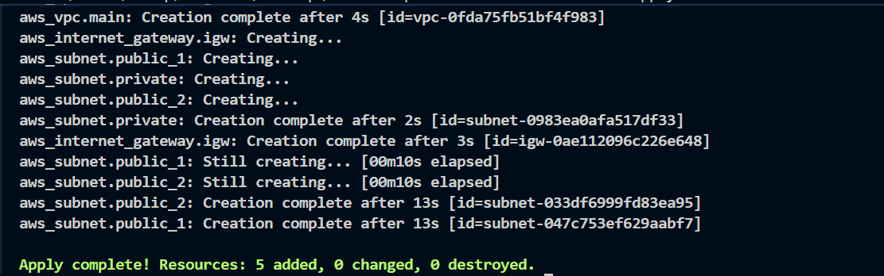
The resources have been created
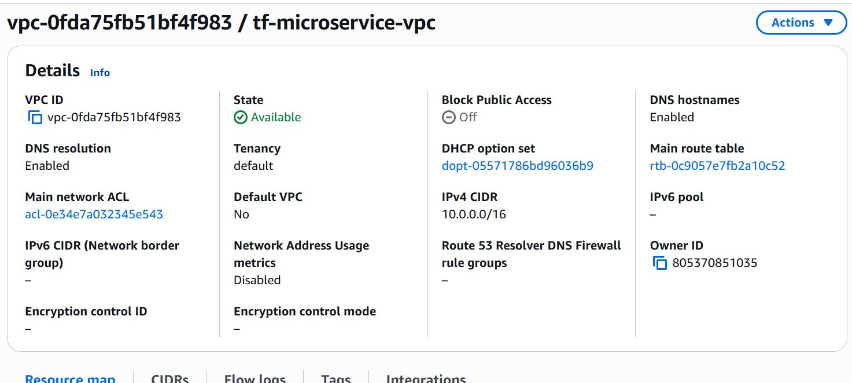

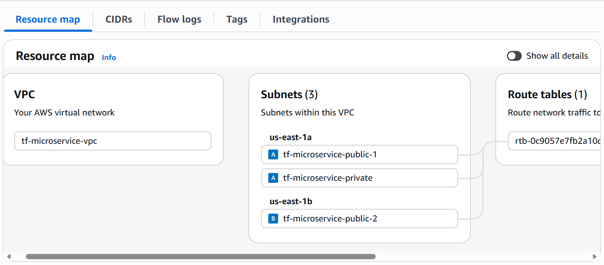
Let’s now add route tables
Go to main.tf and add
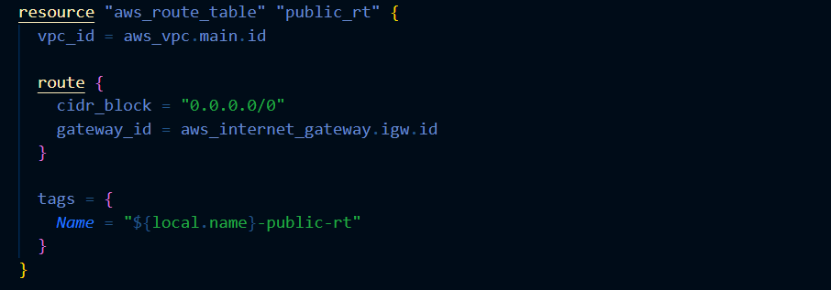
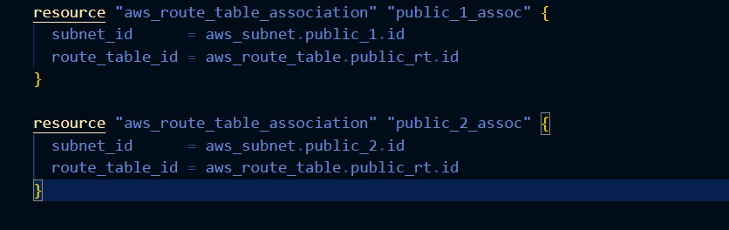
Here we are adding internet gateway to public subnet and associating public route tables with public subnet
now apply the changes
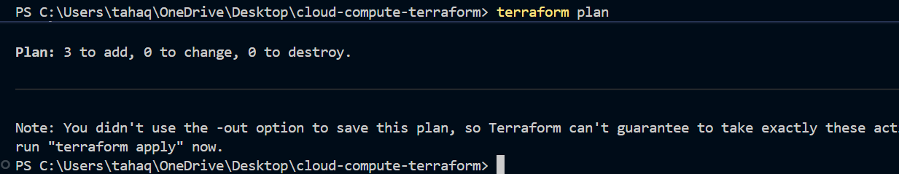

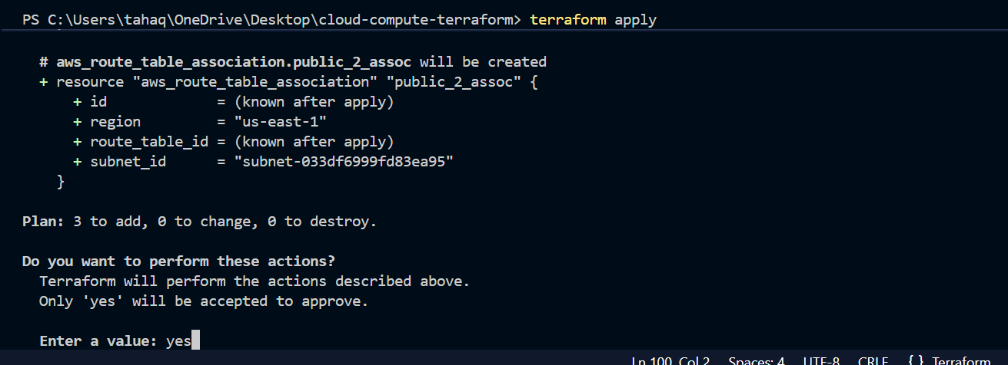
So the above infra is now created
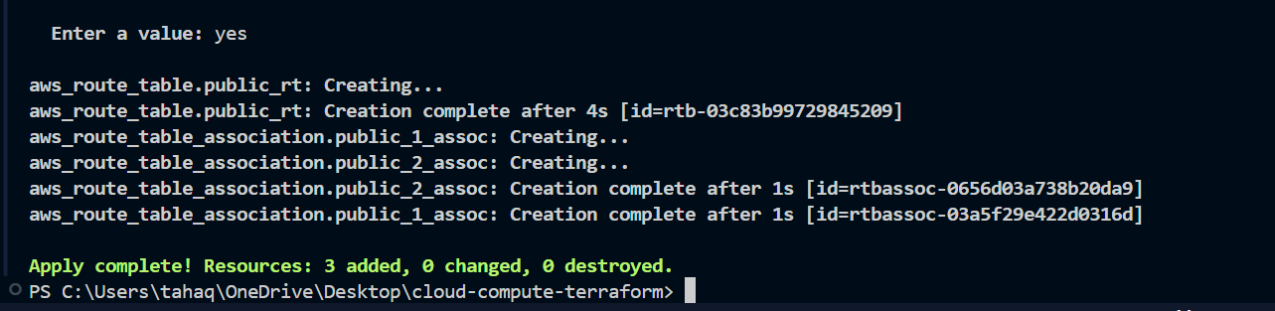
Let’s now create NAT gateway
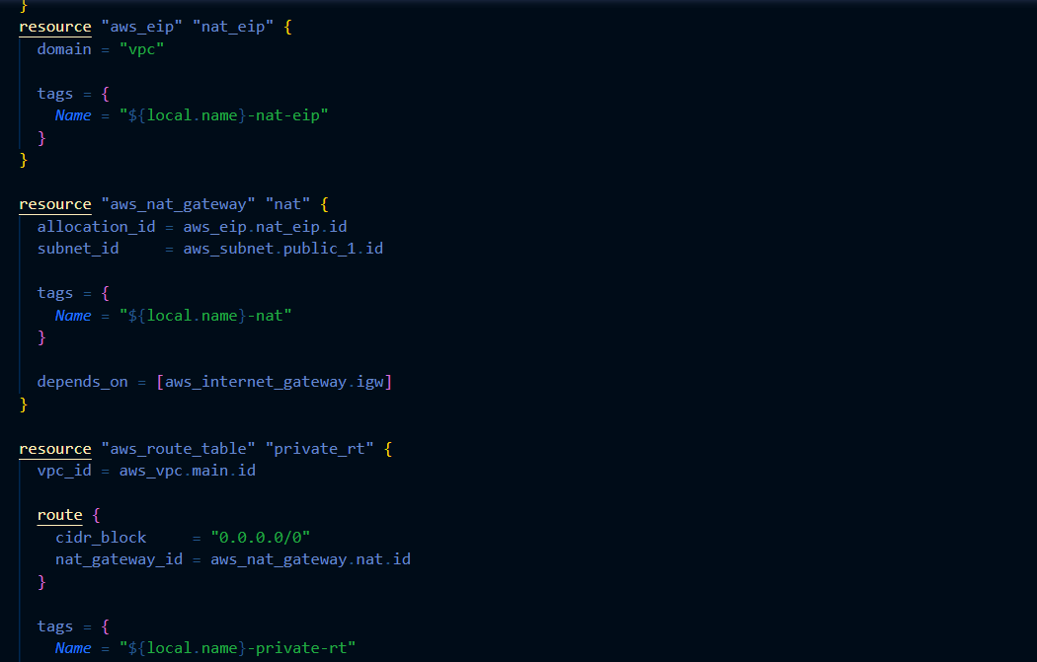
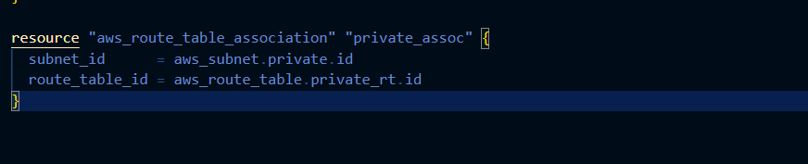
We are adding NAT gateway to make sure that our private instance has internet access(outbound)
Private EC2 needs internet access to:
Pull Docker image from ECR
Install Docker packages
Install AWS CLI
Let’s apply the changes
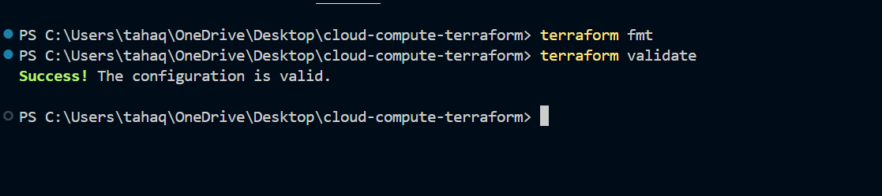
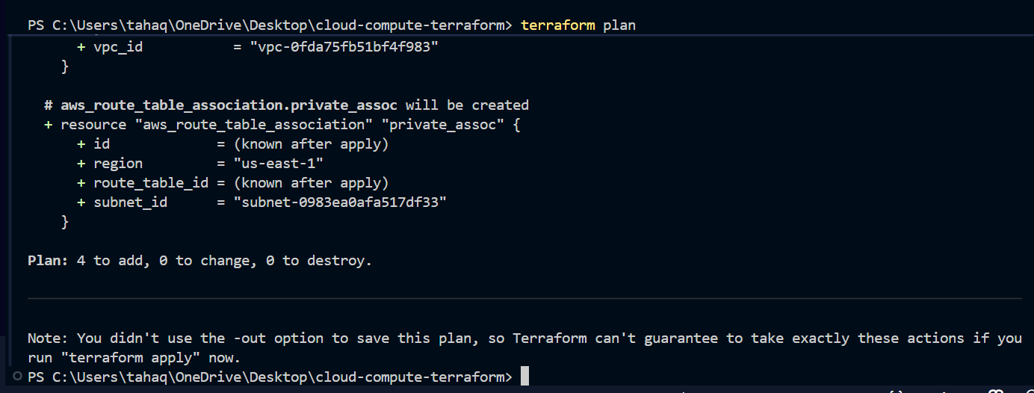
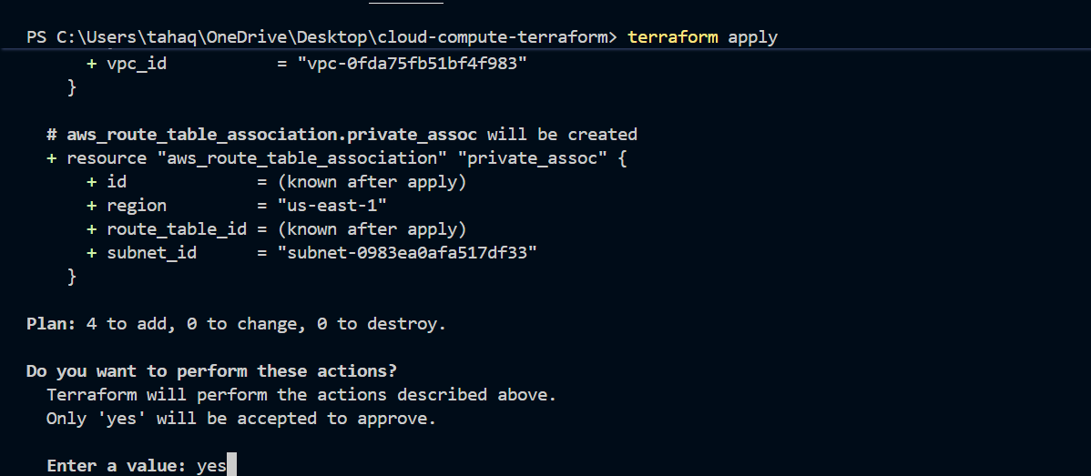
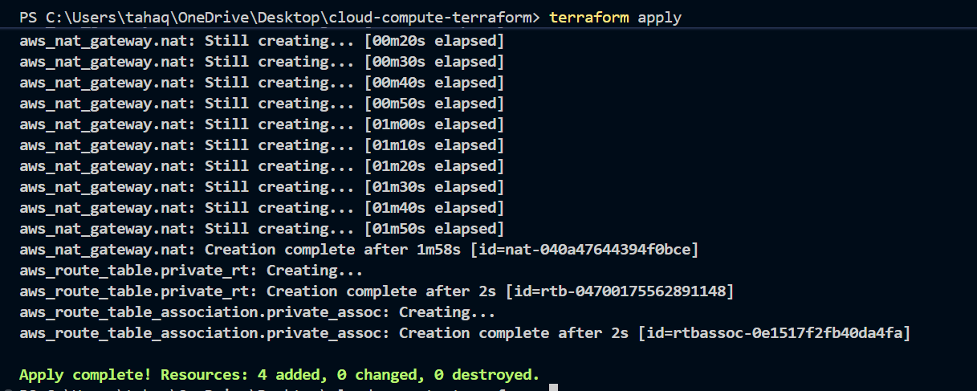
The NAT gateway is now created
now create security group
We need two security group one for EC2 and one for ALB
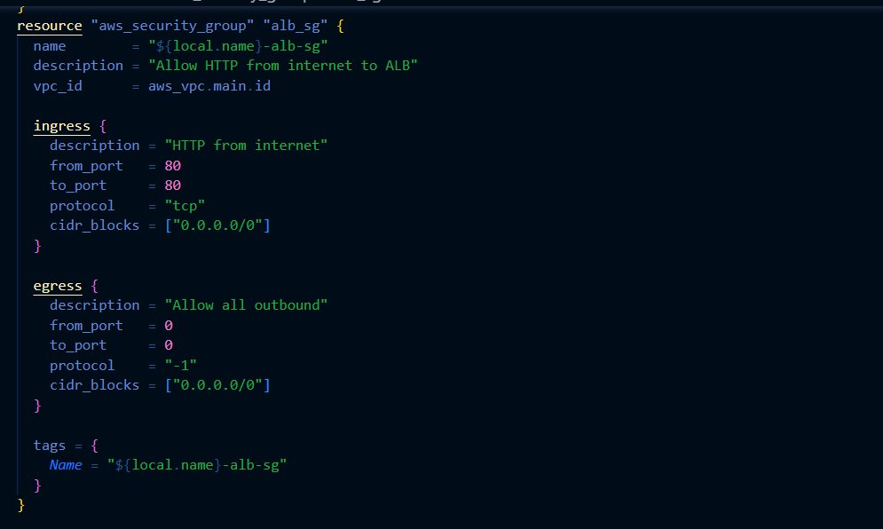
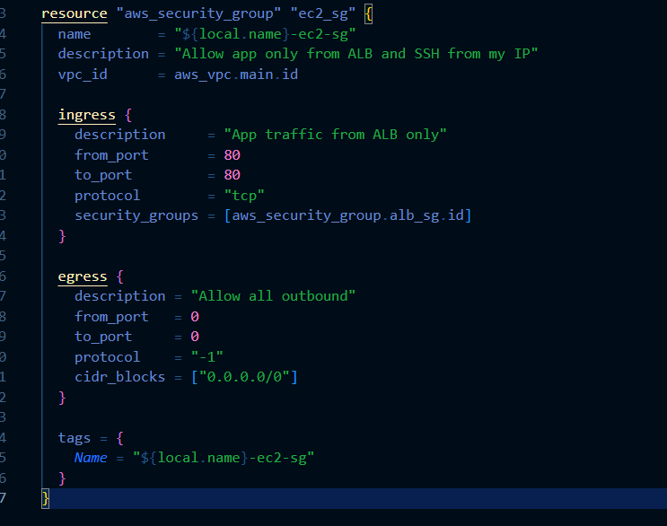
Let’s now create those
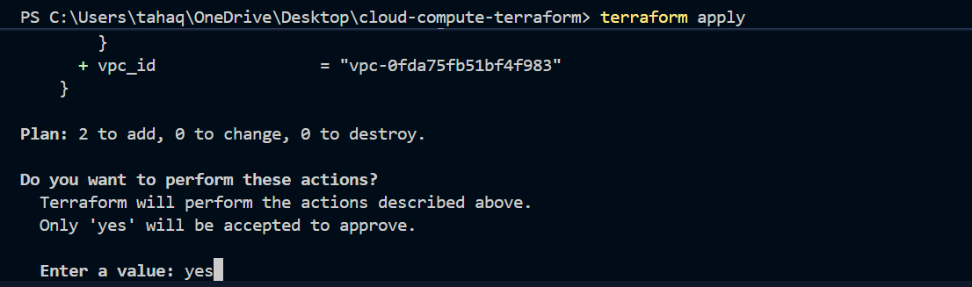
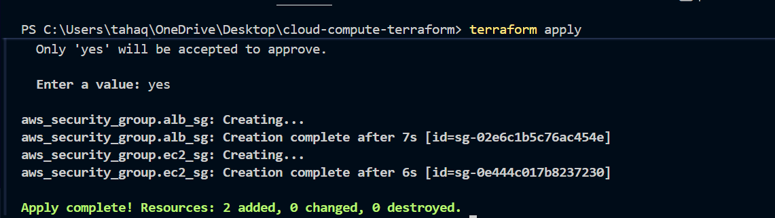
The security groups are created
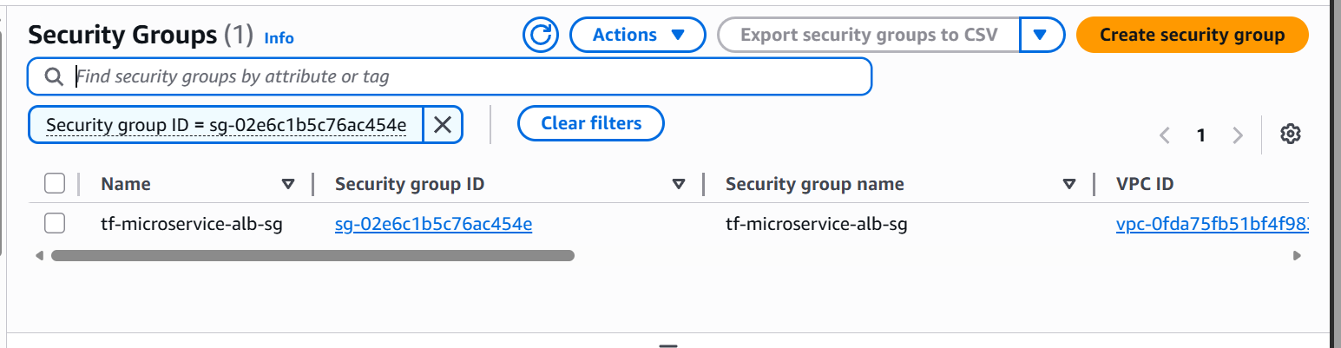
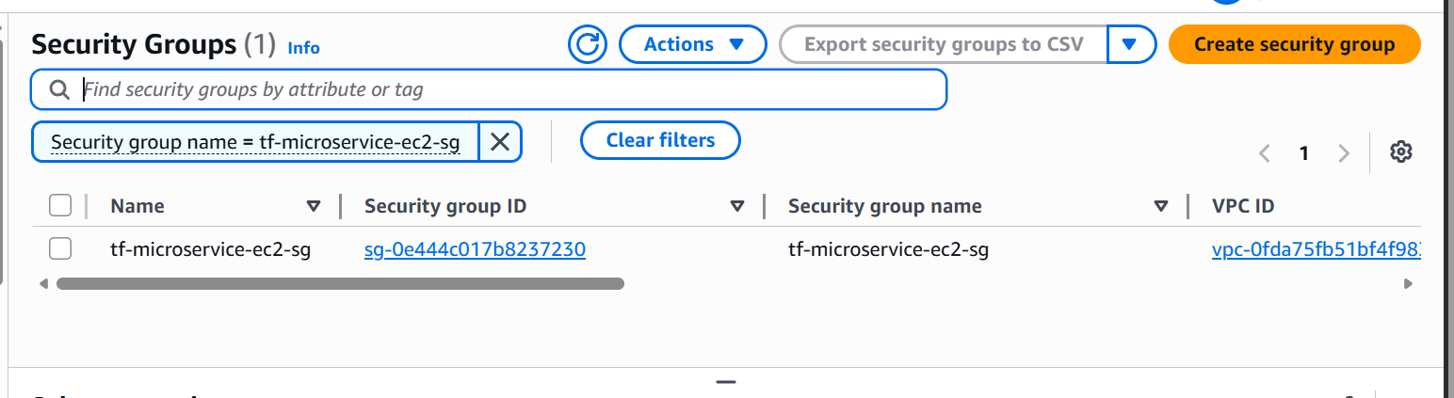
Now add key pair and ssh access
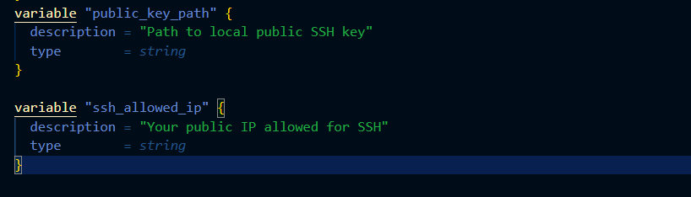
Add this in the variables files
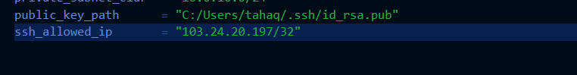
Add the keypath and ssh ip allowed which means your computer’s public ip address
Let’s now add this resource to main.tf
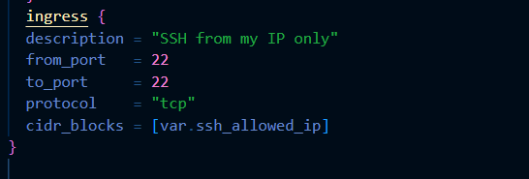
Also add this to ec2 security group
Now we have used local key
Upload to the AWS key storage
Restrict to specific IP
Let’s now apply changes
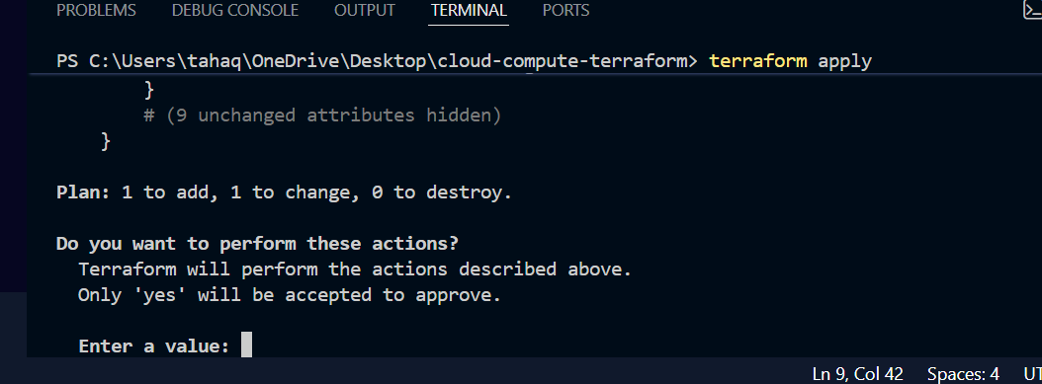
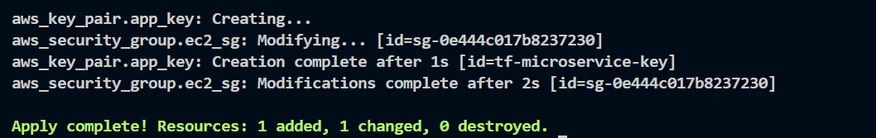
now create an IAM role so that our EC2 instance can access ECR securely
EC2 needs permission to pull the Docker image from ECR.
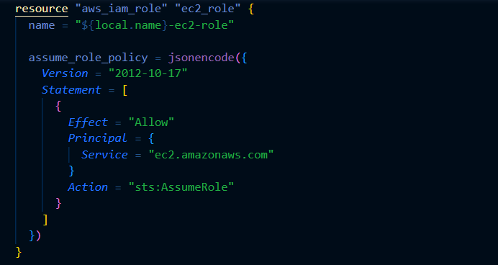
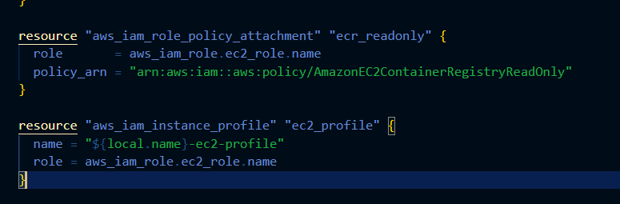
Because EC2 needs permission to pull images from the ECR so we are attaching only read only access policy
Let’s now apply the changes
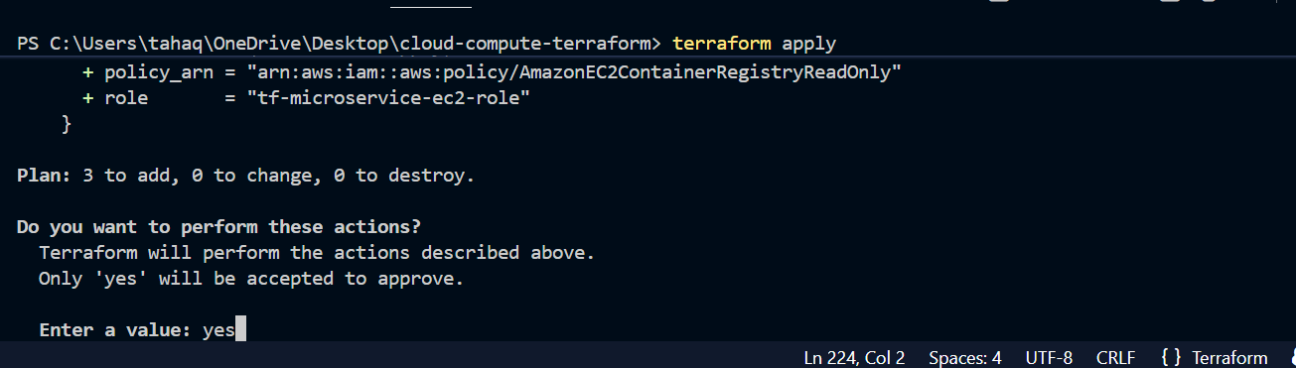

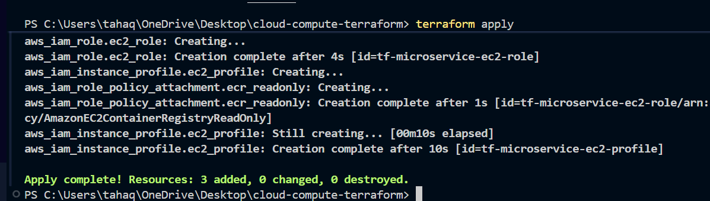

now create a user_data.sh file for boot strapping
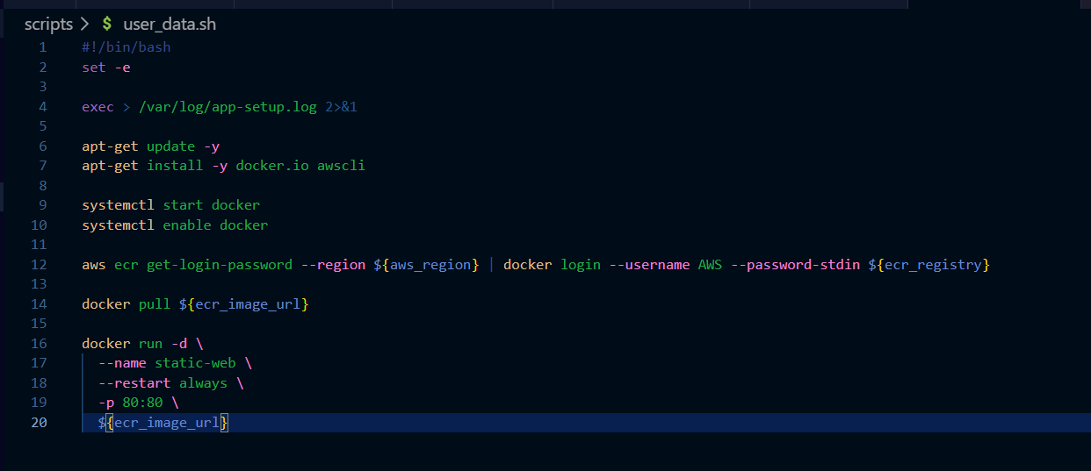
This script runs after the instance is created
This script updates the packages
Installs docker and AWS CLI
And then starts and enables the docker service
Logins to ECR
Pulls image from ECR
And then starts the container
Let’s now add EC2 code in the main.tf file
First update the locals block
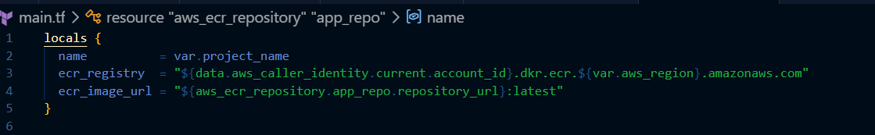
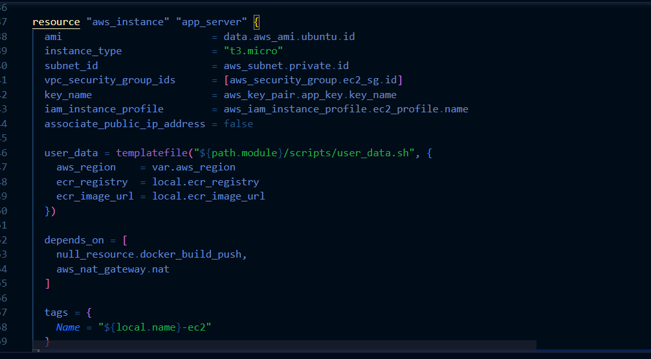
Ec2 creation code
now apply
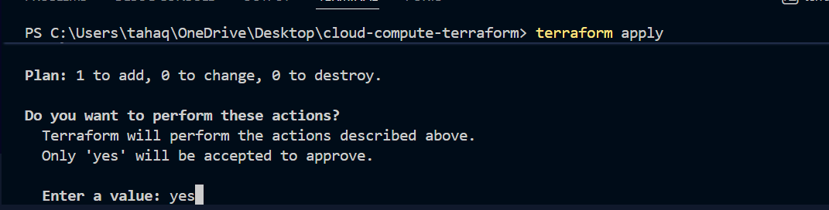
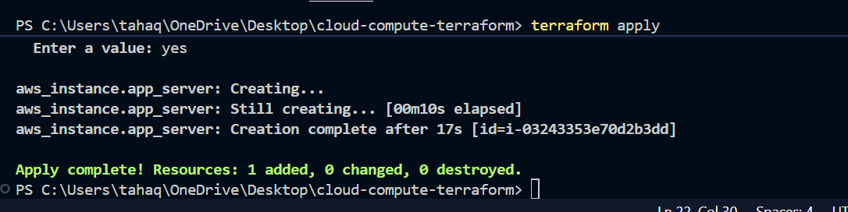
Instance is created
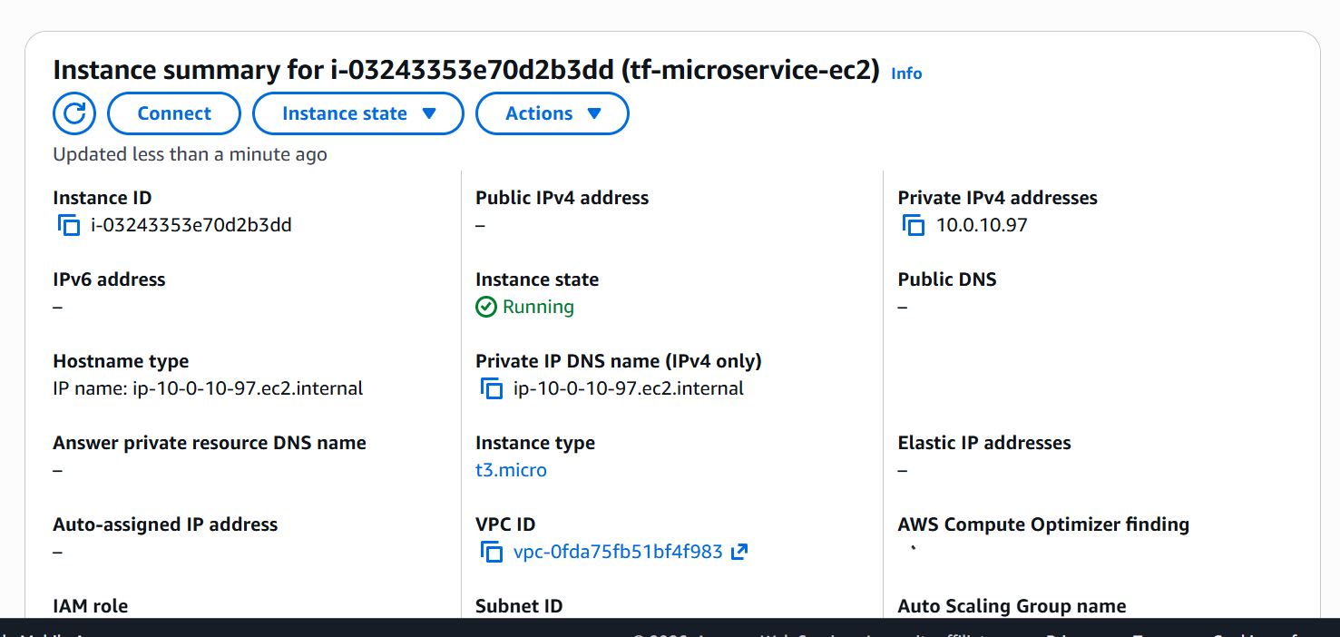
now add the loadbalancer code
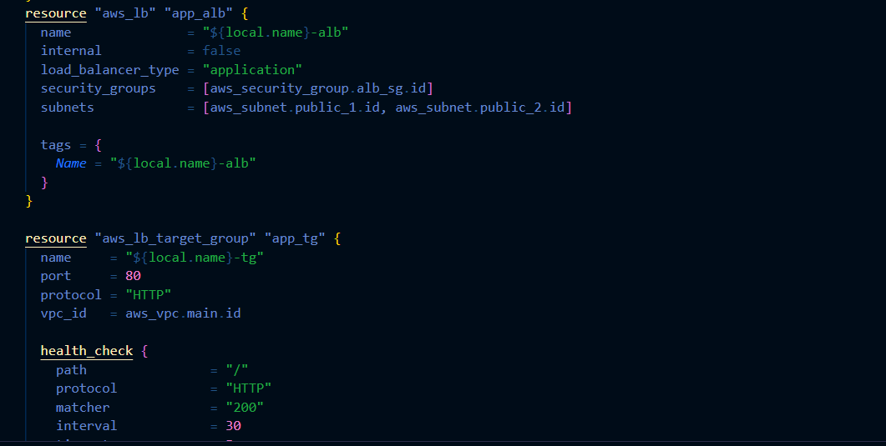
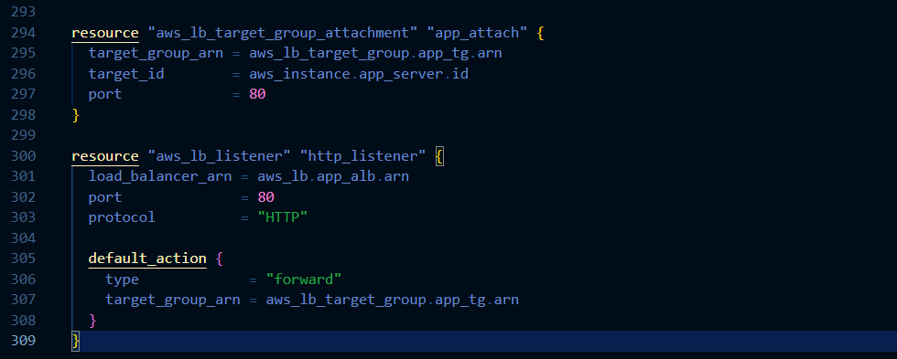

Create a outputs.tf file
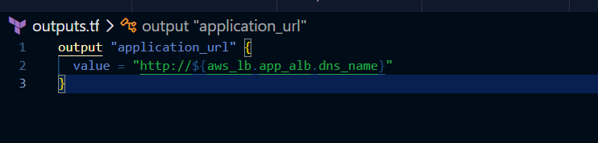
From here the load balancer dns will be printed at the output screen
now apply changes
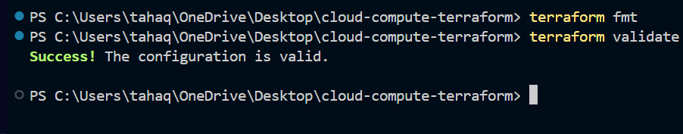
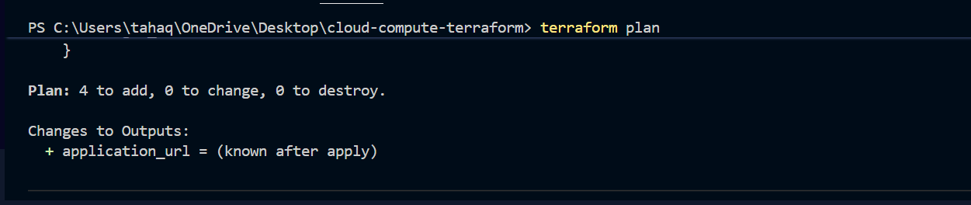
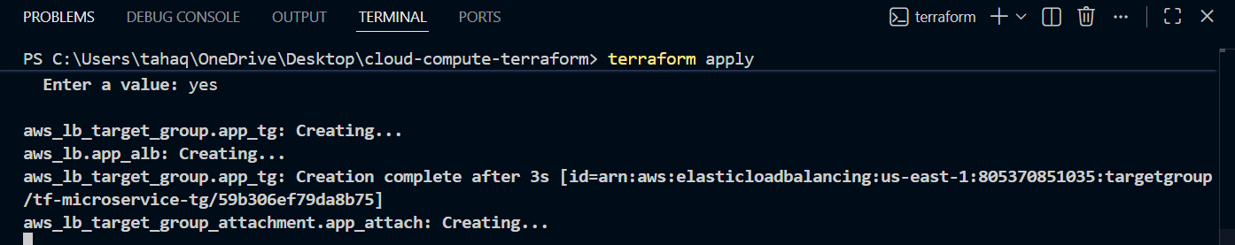
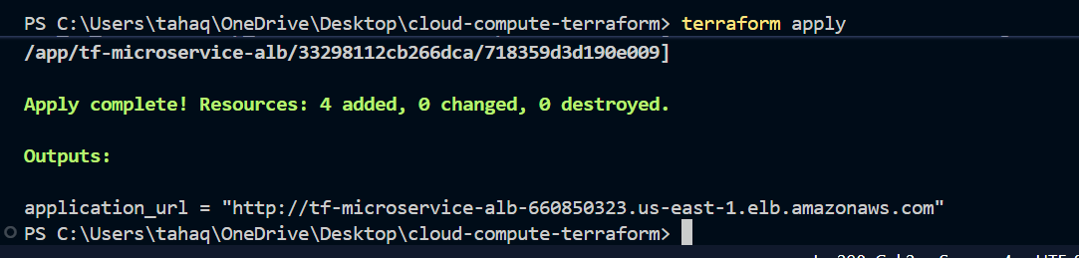
The load balancer has been created
Let’s now check if in the console
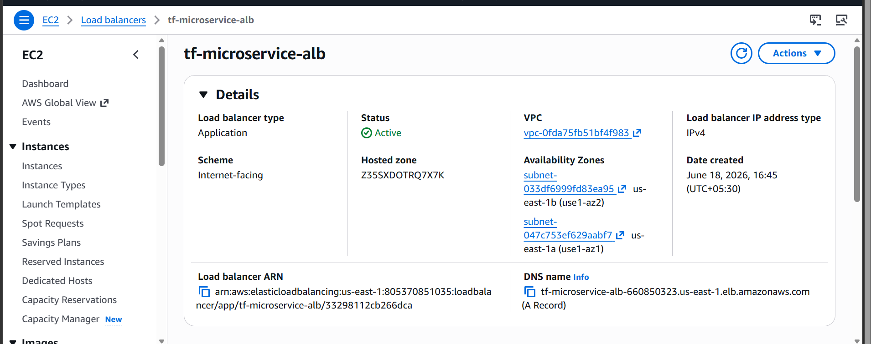
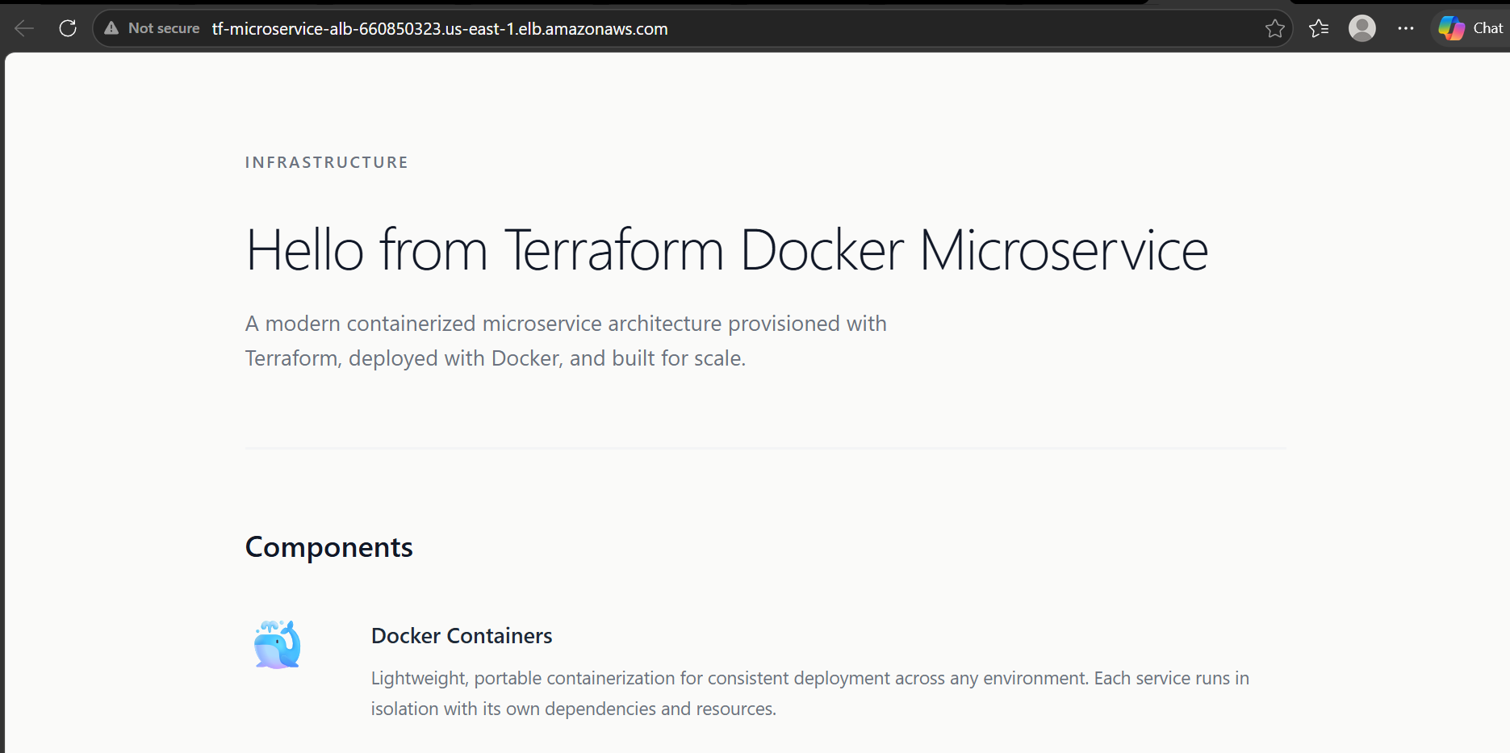
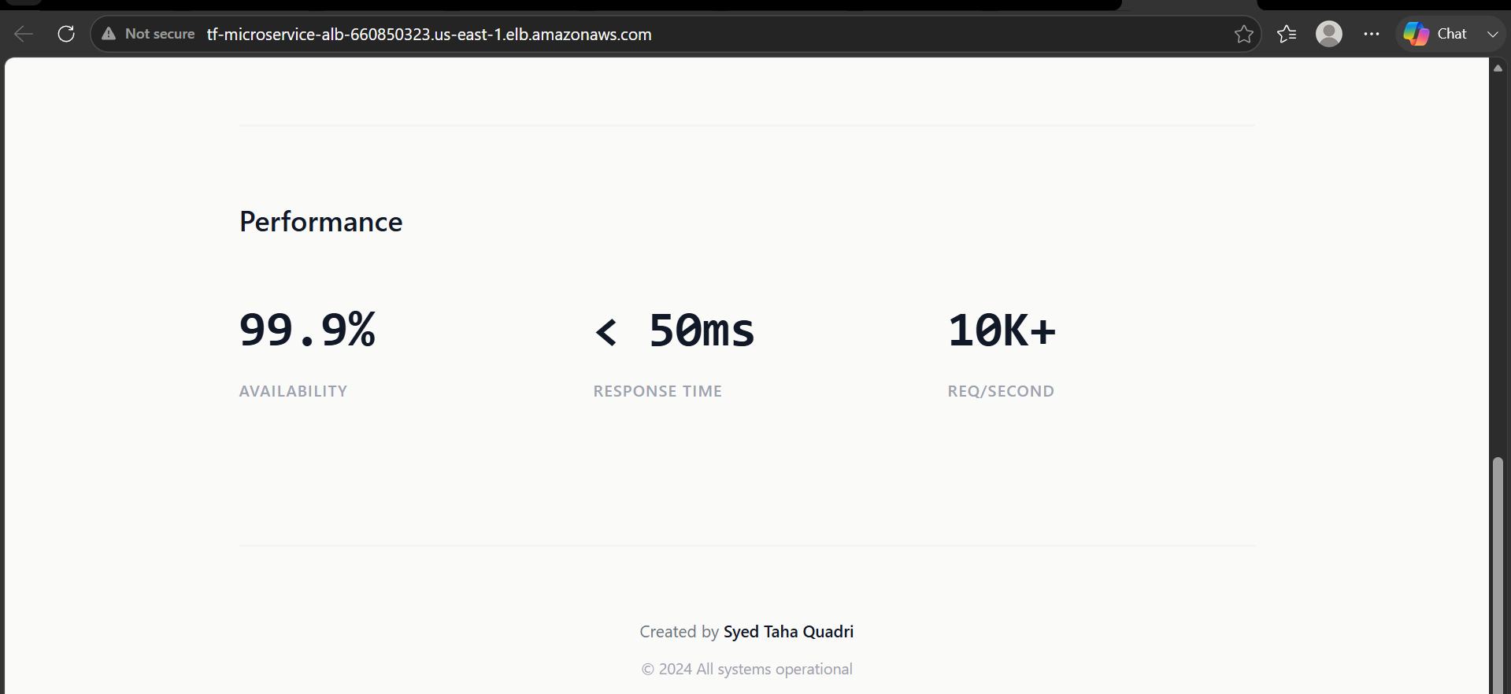
The application is now deployed and we are able to access it through load balancer DNS

So now we have
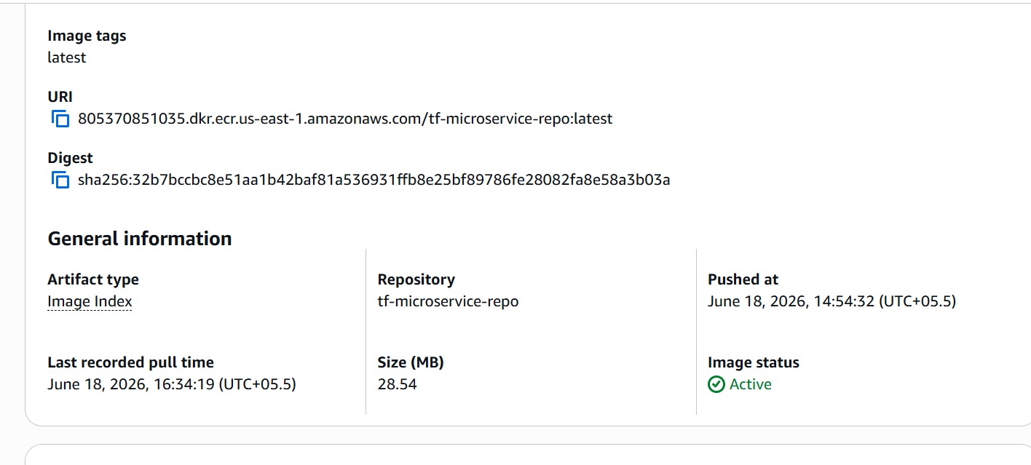
ECR repository created
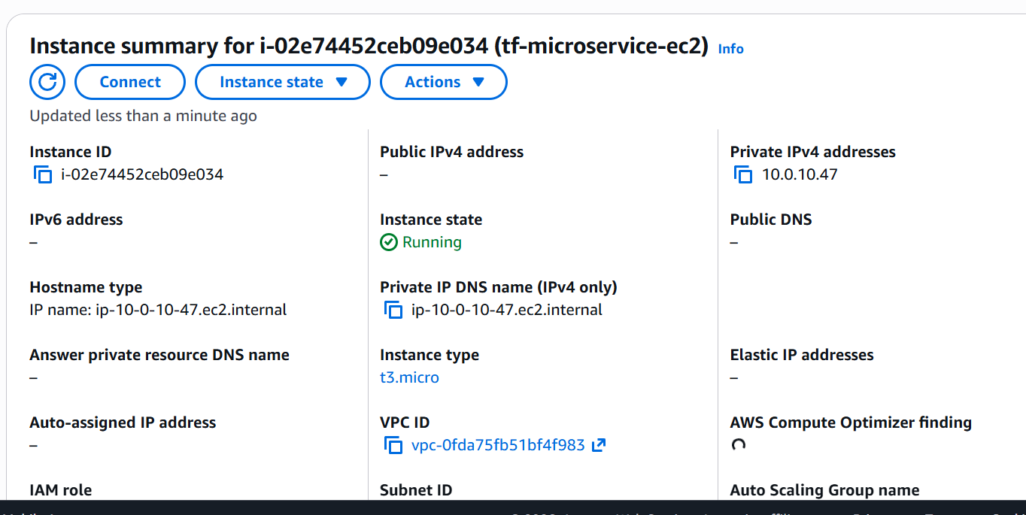
Instance only with only private IP
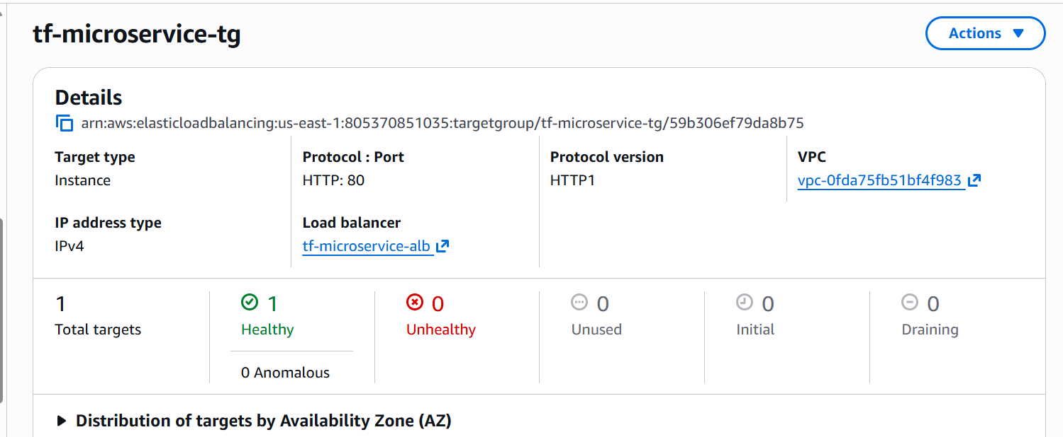
Healthy target group

Load balancer dns showing our static page

Conclusion
This project successfully demonstrated the deployment of a containerized microservice on AWS using Terraform. The application was containerized using Docker, stored in Amazon ECR, and deployed on a private EC2 instance. All infrastructure components, including networking, security groups, IAM roles, EC2, and the Application Load Balancer, were provisioned using Terraform.
The application is accessible only through the Load Balancer, while SSH access is restricted to a specific IP address, ensuring a secure architecture. This solution meets all the challenge requirements and highlights the benefits of Infrastructure as Code, automation, and cloud security best practices.

Key Learnings
- Dockerized and deployed a web application on AWS.
- Provisioned infrastructure using Terraform.
- Implemented a secure VPC with public and private subnets.
- Used Amazon ECR for container image storage.
- Automated application deployment using EC2 User Data.
- Configured an Application Load Balancer for secure access.

