Terraform Challenge
- Create an EC2 Instance on AWS Cloud using the below-mentioned ubuntu AMI and instance_type. Or, (You can use of your choice as well) ami = "ami-0461b1436c9b3c1a3" instance_type = "t2.micro"

First lets create a folder
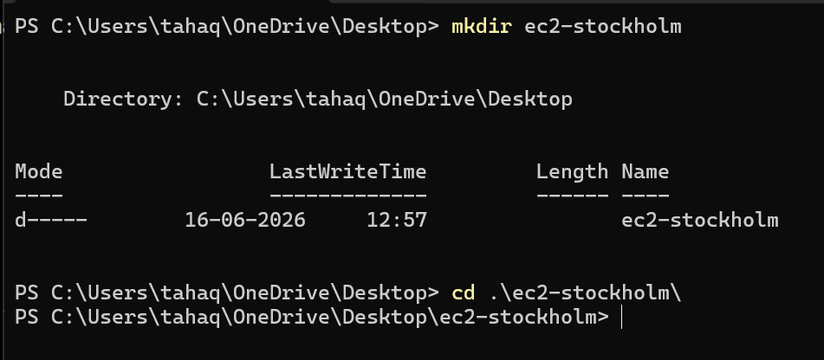
Open in vs code
Lets create providers file first
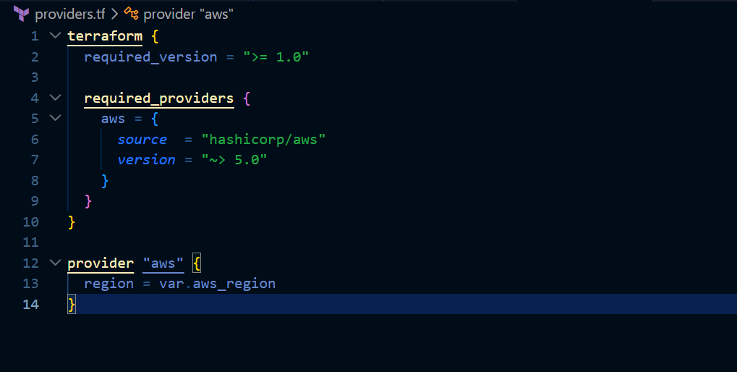
The provider and terraform version

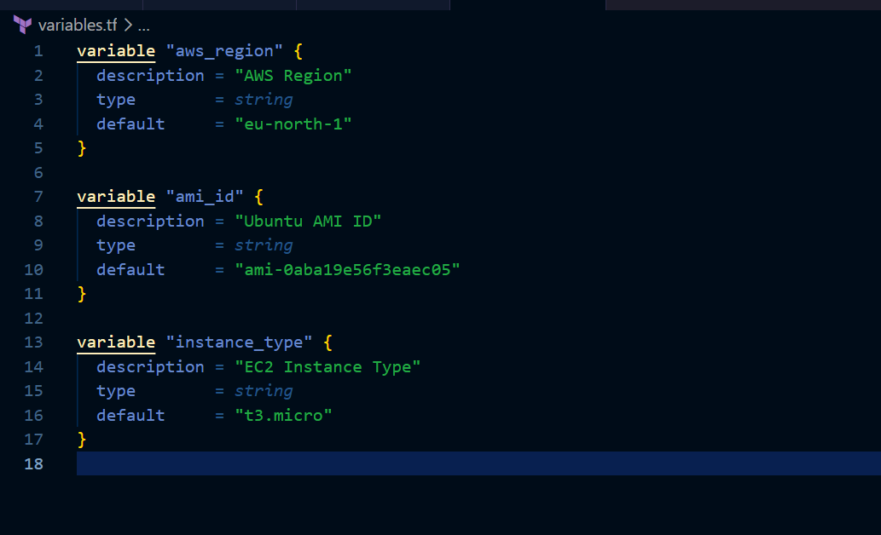
Here we have the variables defined

Now create the main.tf file
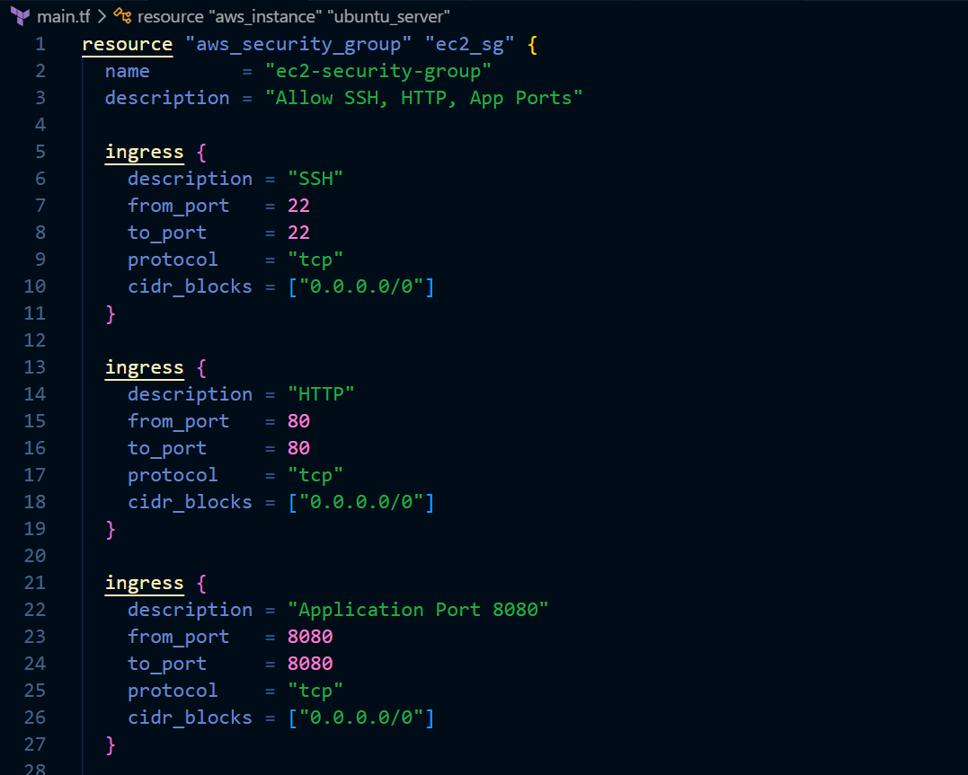
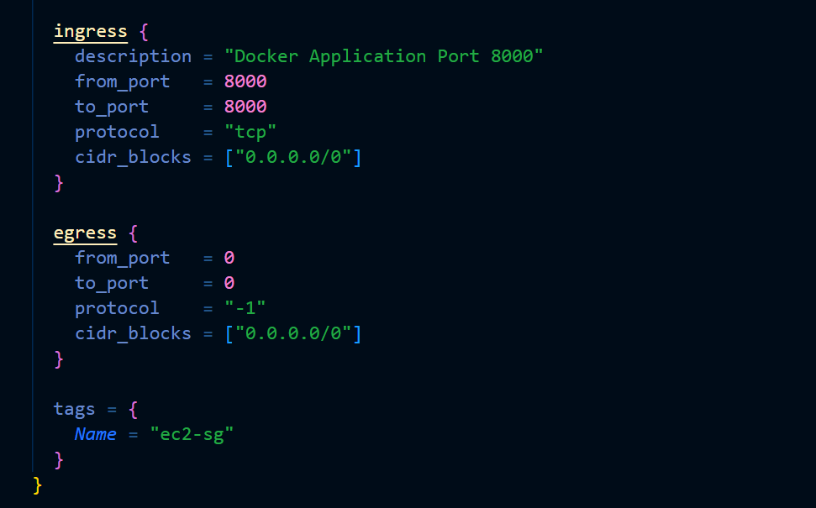
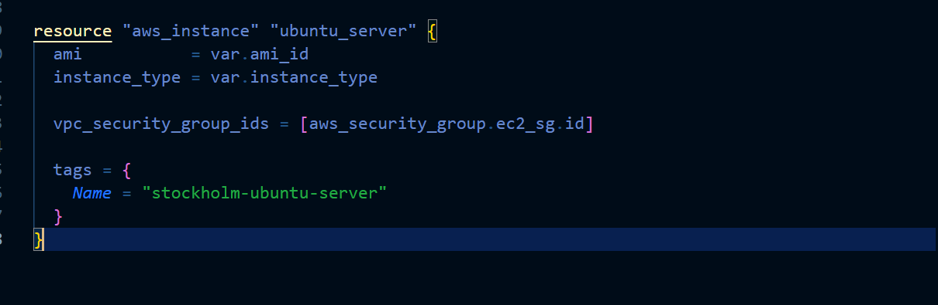
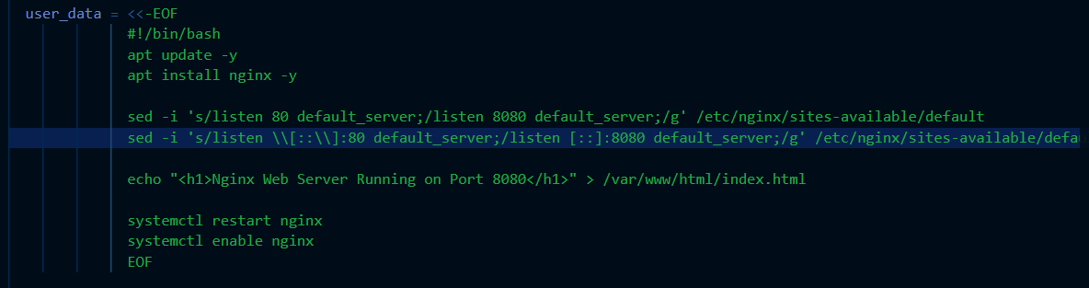
Here we are creating the aws instance as well a security group which allows inbound ports 80,8080,8000 and all outbound and also we are installing nginx on the instance using userdata and changing the port from default to 8080
the configuration is fetching the values ami and instance_type from the variables file

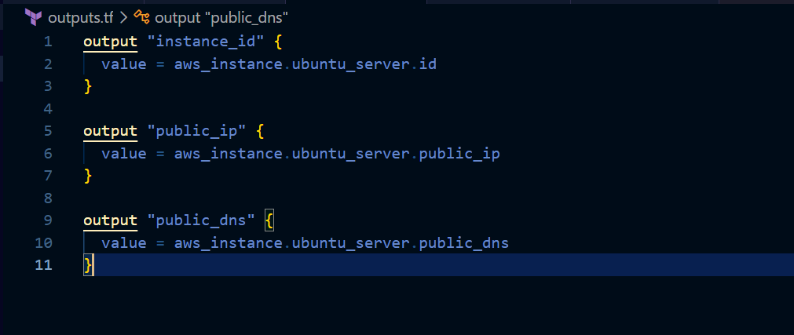
This is the outputs file this will save the output and displays it after the infra is created
Lets now create the infrastructure

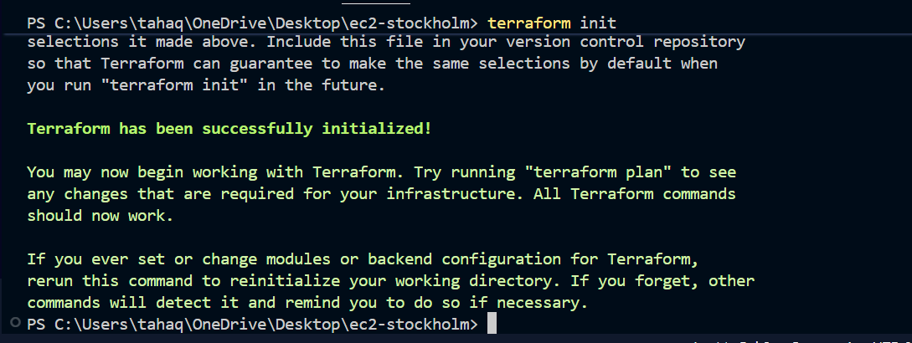
Syntax validation
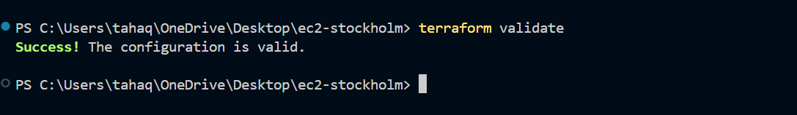
Lets now go ahead and apply the changes
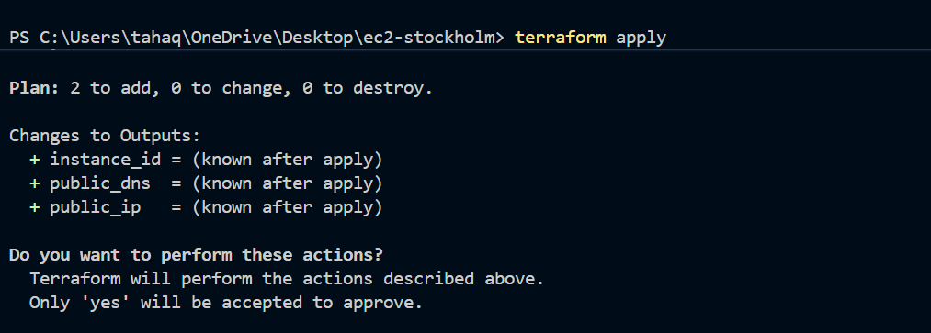
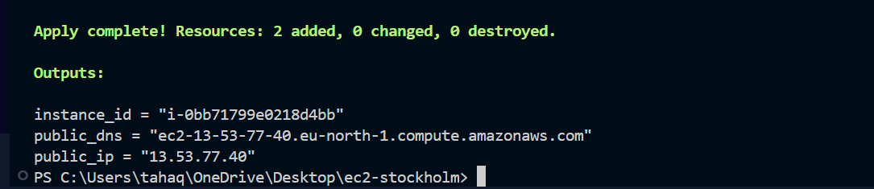
The ec2 instance has been created
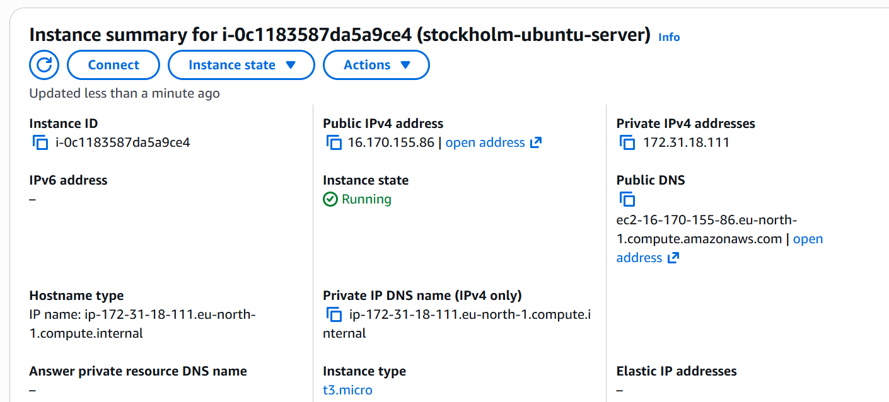
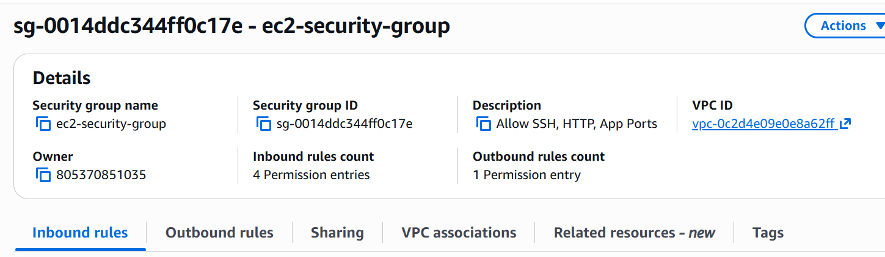
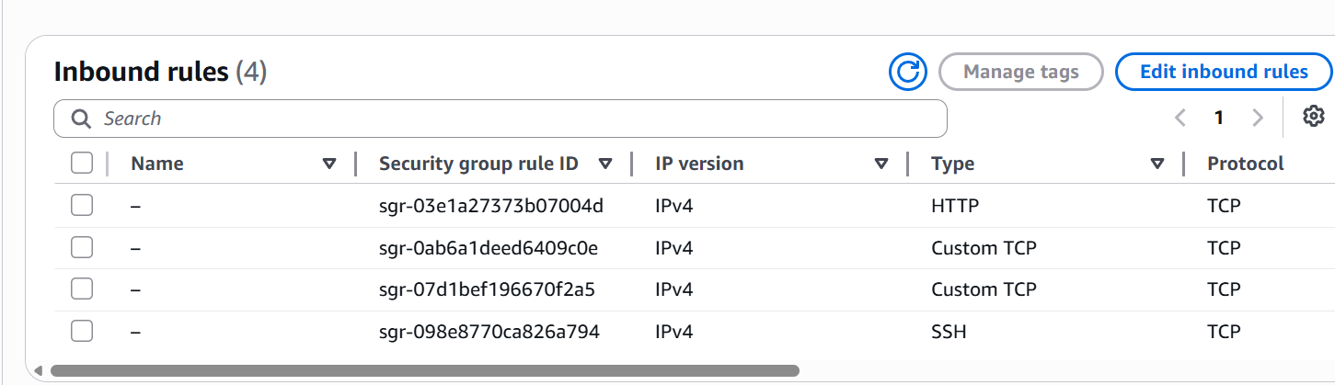
The security group has been created with the ports 80,22,8080,8000

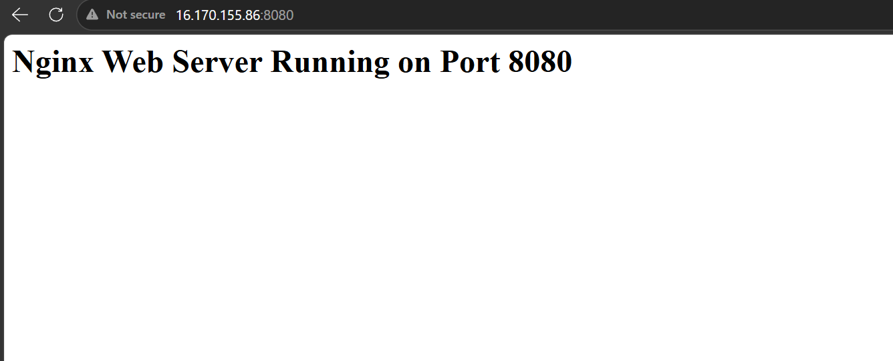
The nginx server is also deployed and it is running on port 8080

Create a Docker-compose file for the project:https://github.com/betawins/cricbuzz-docker-hello-world.git and point it to port 8000.
Lets now install docker and docker compose using user data

