- Execute the script shown in the video.
This is our main.tf tf file which reads the values from variables.tf file

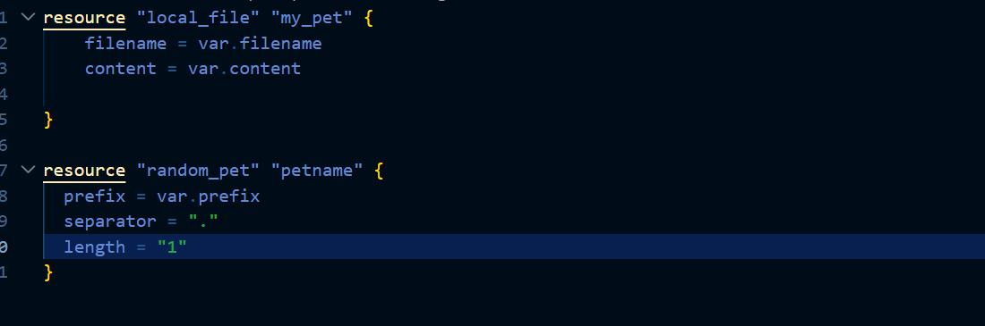
This is our variables.tf file
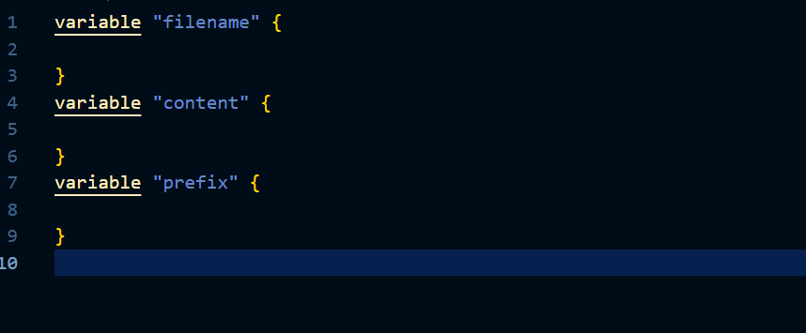

Here we have not given values to the variables so lets use environment variables to pass values to them
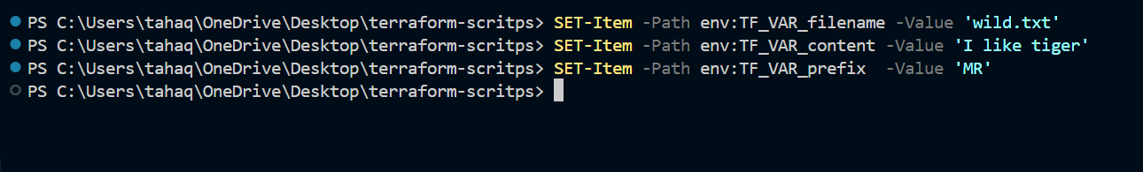
We have set the environment variables
Lets now apply the changes
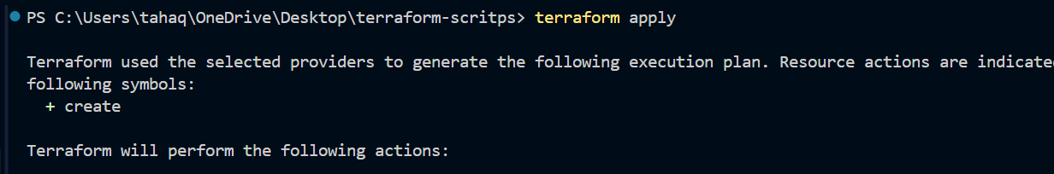
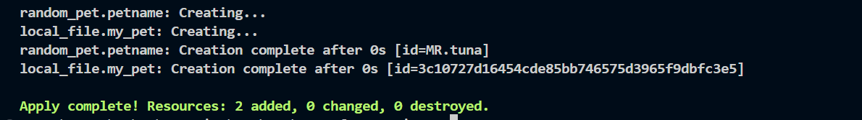
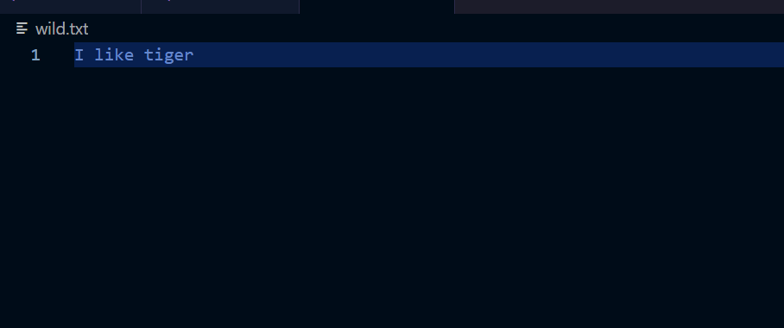

Lets now see the resource dependency.
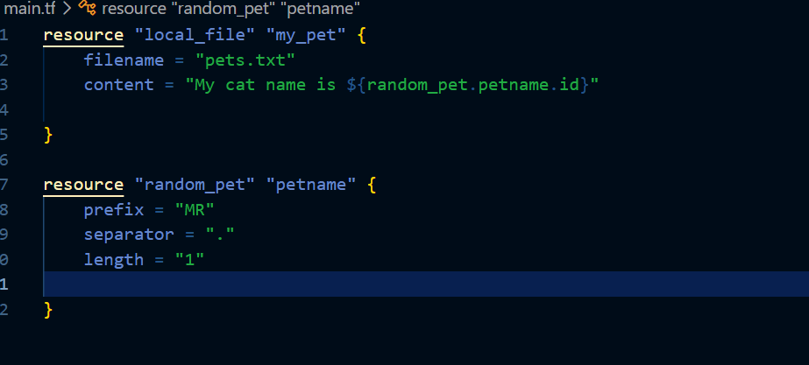
This is our main configuration file
Here we are using the resource random
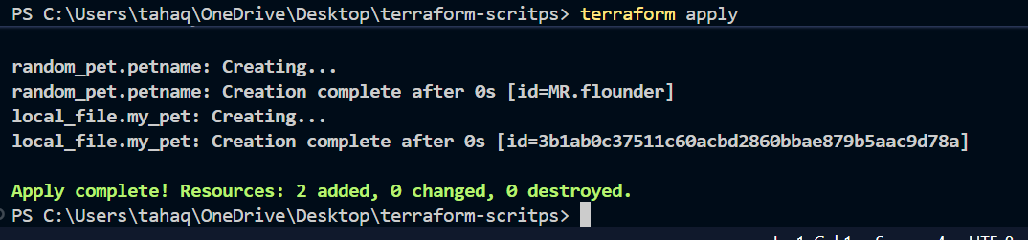
After applying the changes we can see that it has used value from the random resource block
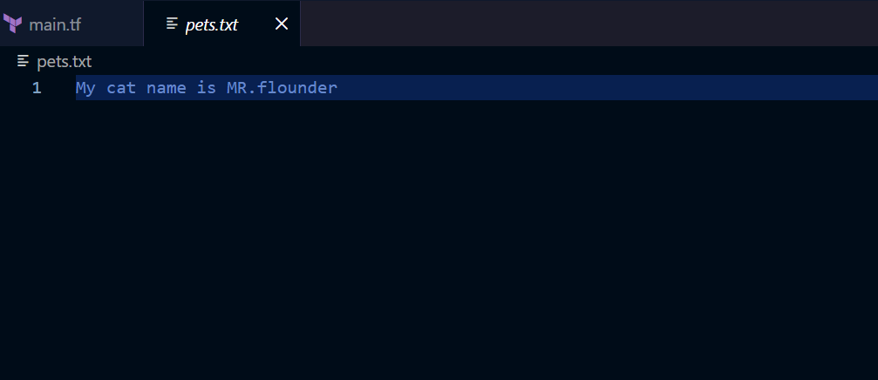

Using output variables
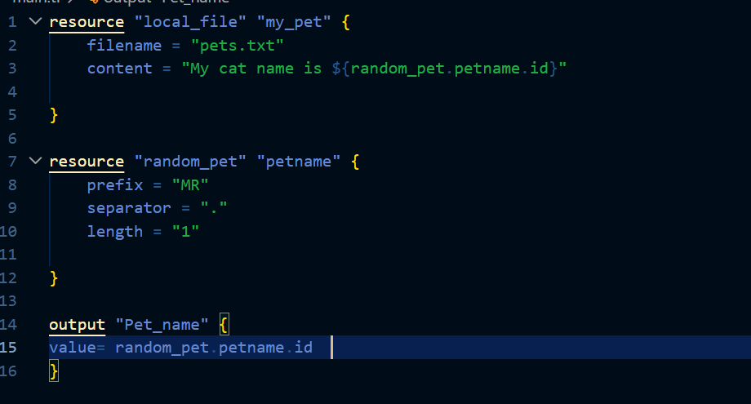

Using this we can print the value at the output screen
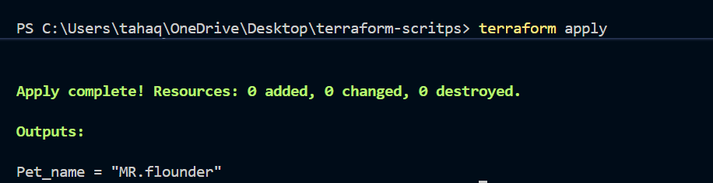
Here we can see that the output is displayed
Terraform output command also shows the output
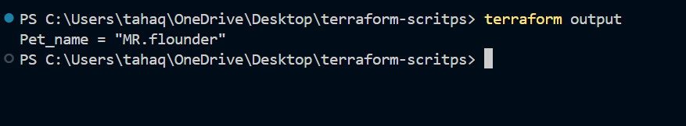

terraform show: this command displays the content of the state file
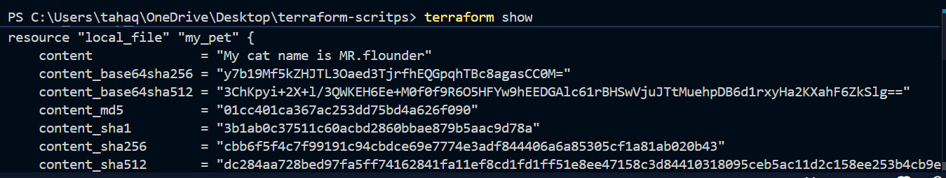
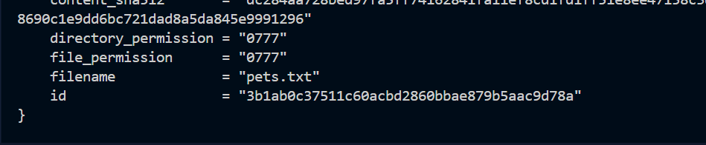
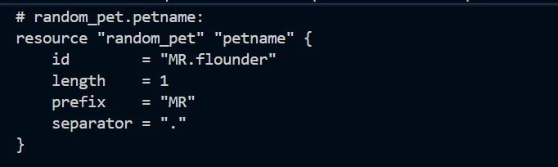

- Integrate Terraform in Jenkins using the Terraform plugin.
Lets go to our Jenkins server and install terraform plugin
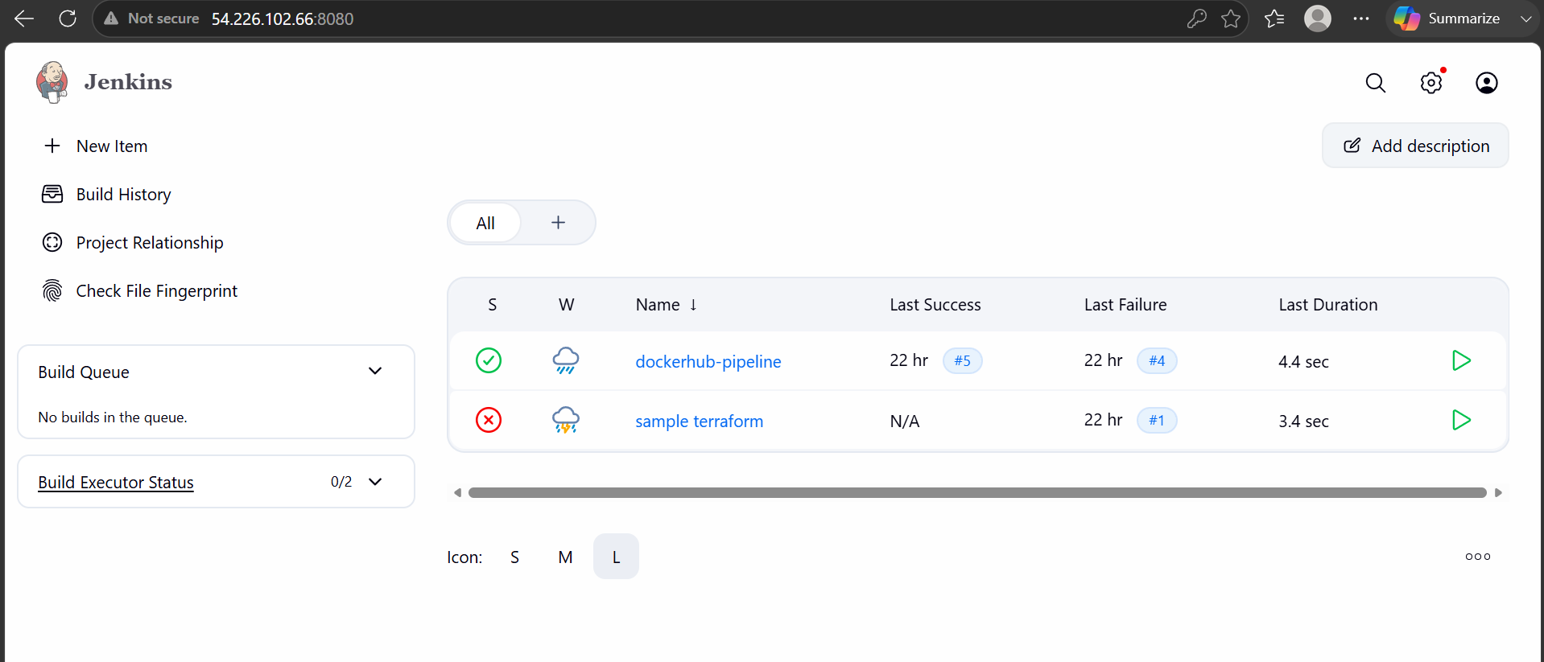

We are now logged in to Jenkins server lets install the terraform plugin
Go to manage Jenkins and plugins
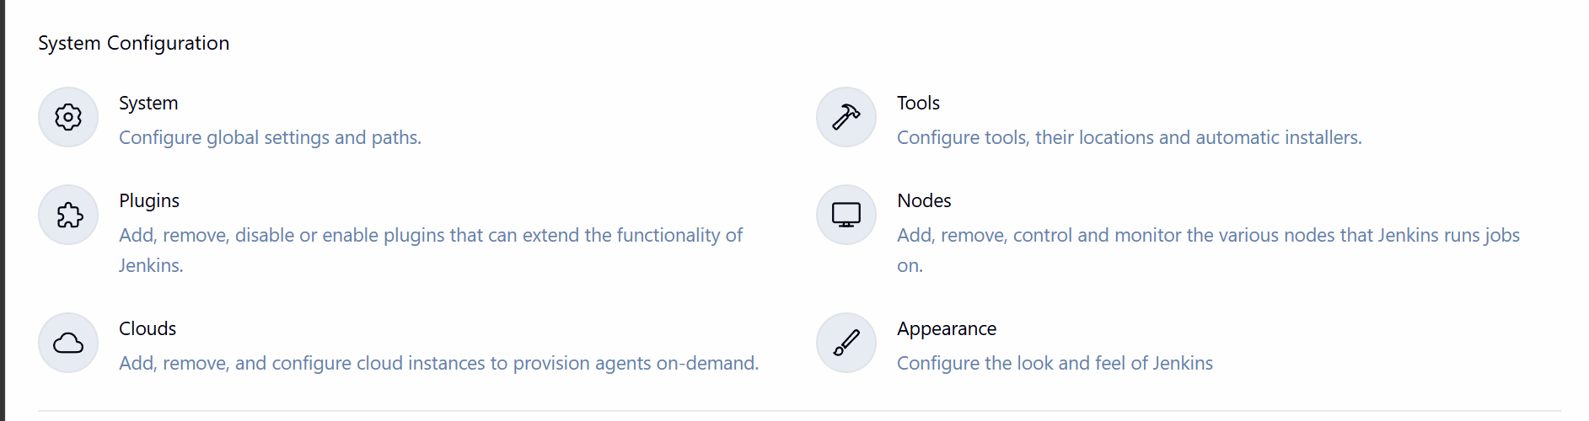
In available plugins search for terraform
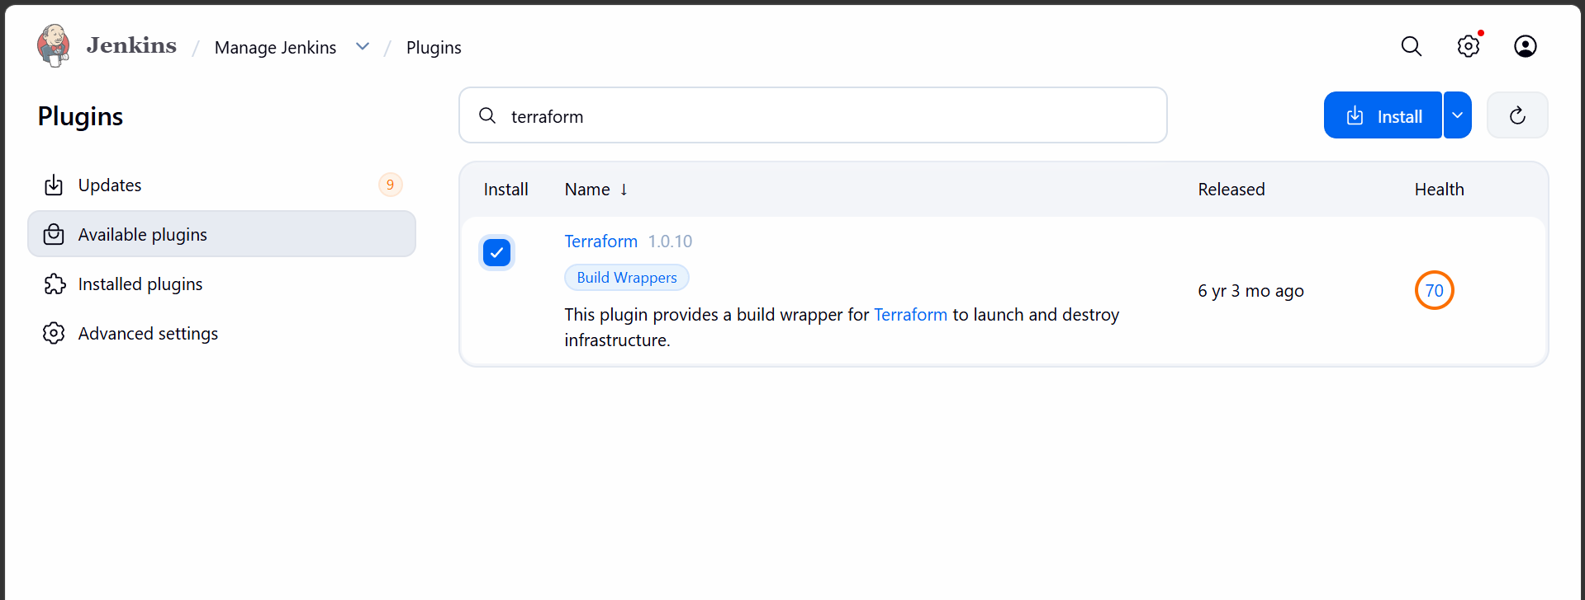
Add terraform installer in tools
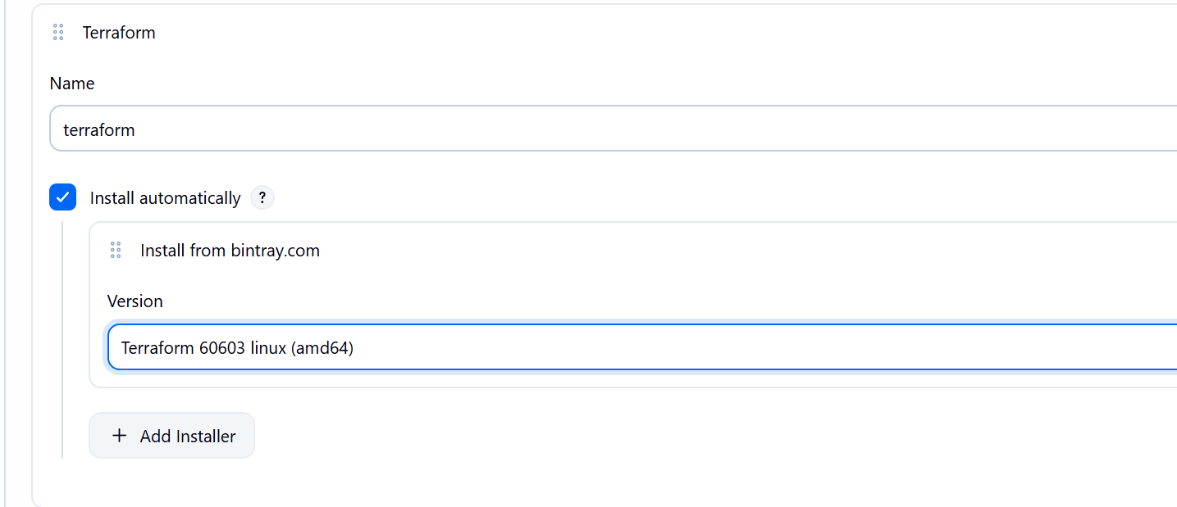

Create a pipeline job
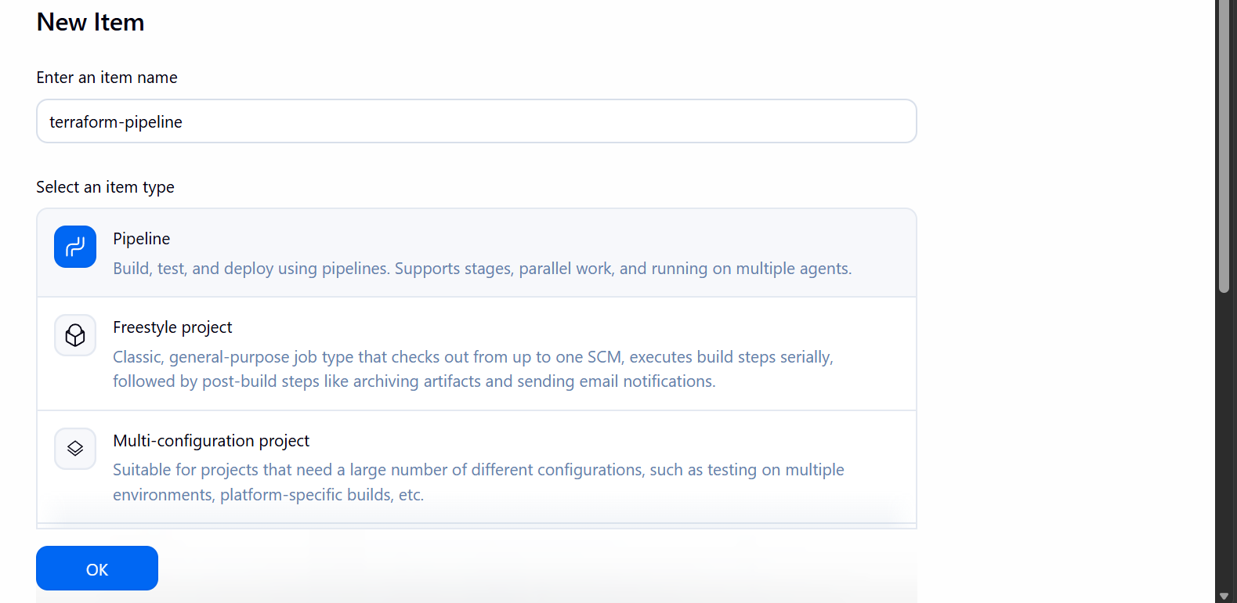
This is our main.tf file
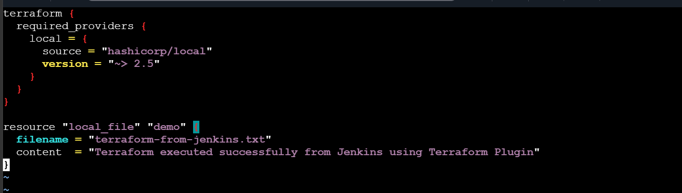
We have to keep it in the Jenkins workspace folder

Lets now run the pipeline script
pipeline {
agent any

tools {
terraform 'terraform'
}

stages {

stage('Terraform Version') {
steps {
sh 'terraform version'
}
}

stage('Terraform Init') {
steps {
sh 'terraform init'
}
}

stage('Terraform Plan') {
steps {
sh 'terraform plan'
}
}

stage('Terraform Apply') {
steps {
sh 'terraform apply -auto-approve'
}
}
}
}

The pipeline ran successfully
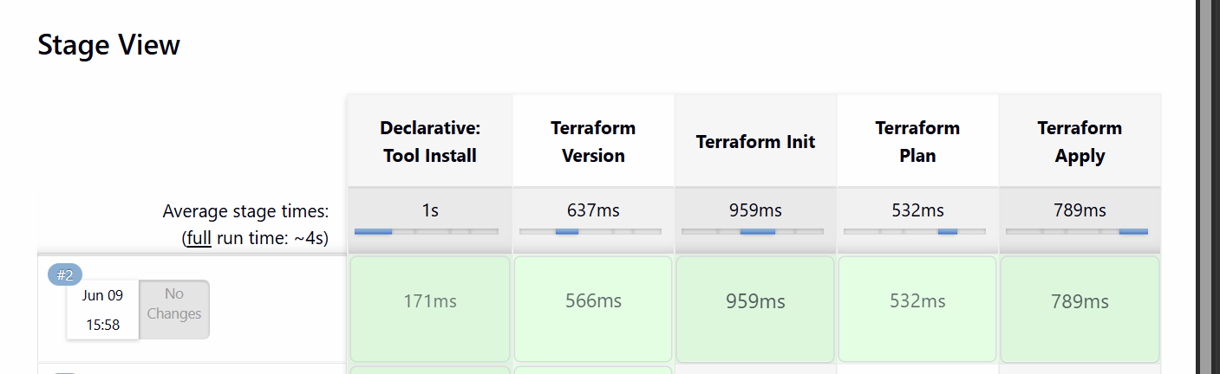

- Create one Jenkins job using Maven Project for the code below with two stages:
Stage 1:Git clone
Stage 2:Maven CompilationCode:https://github.com/betawins/java-Working-app.git

Lets install the maven integration plugin
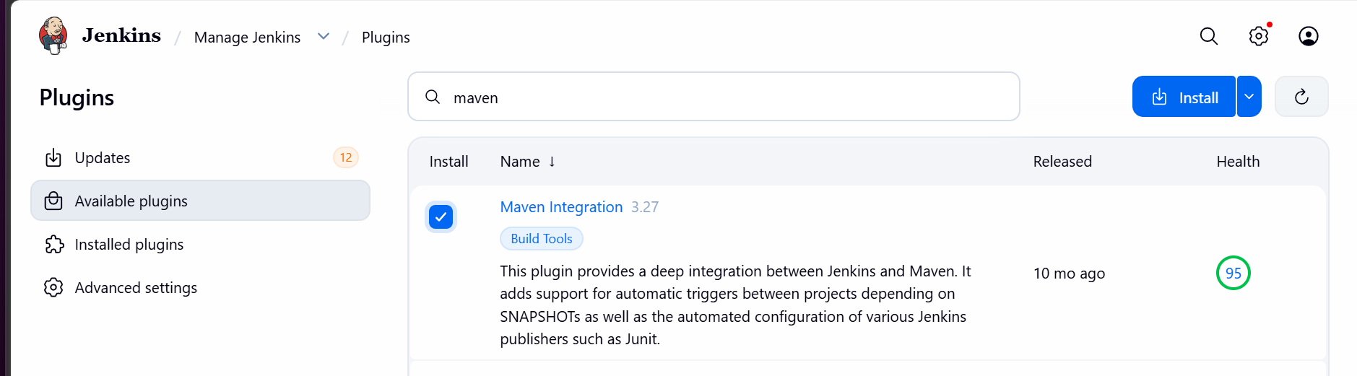
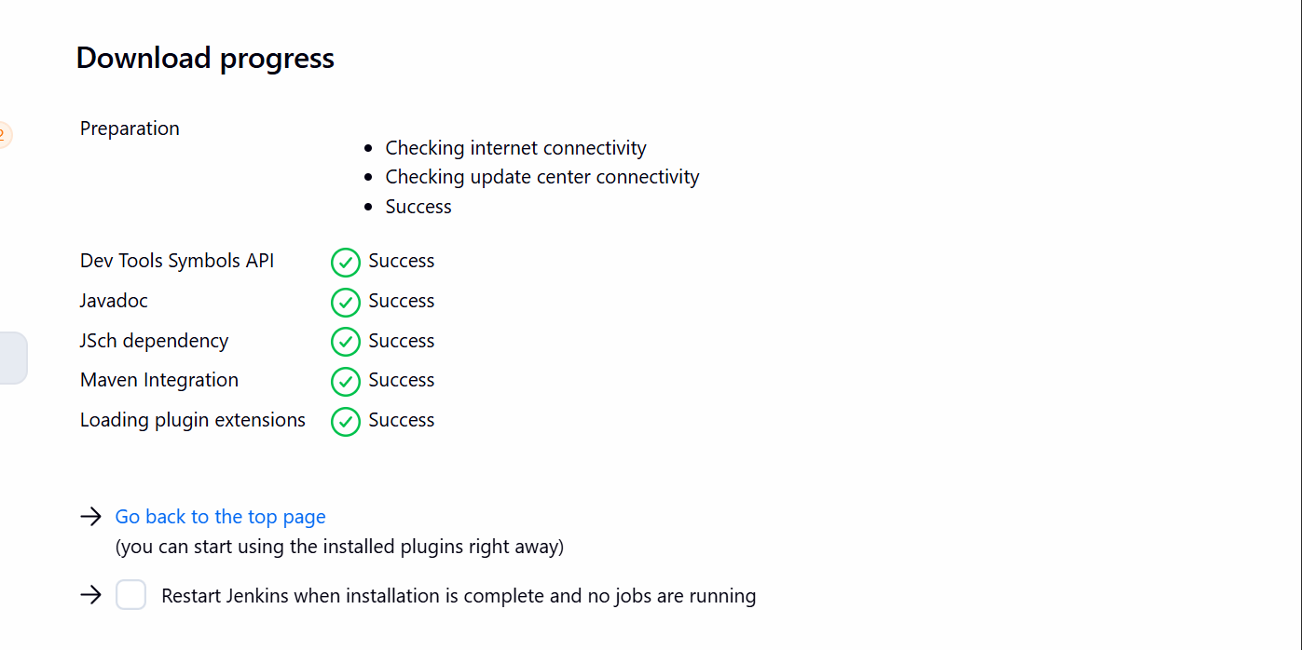
Add maven installer in tools
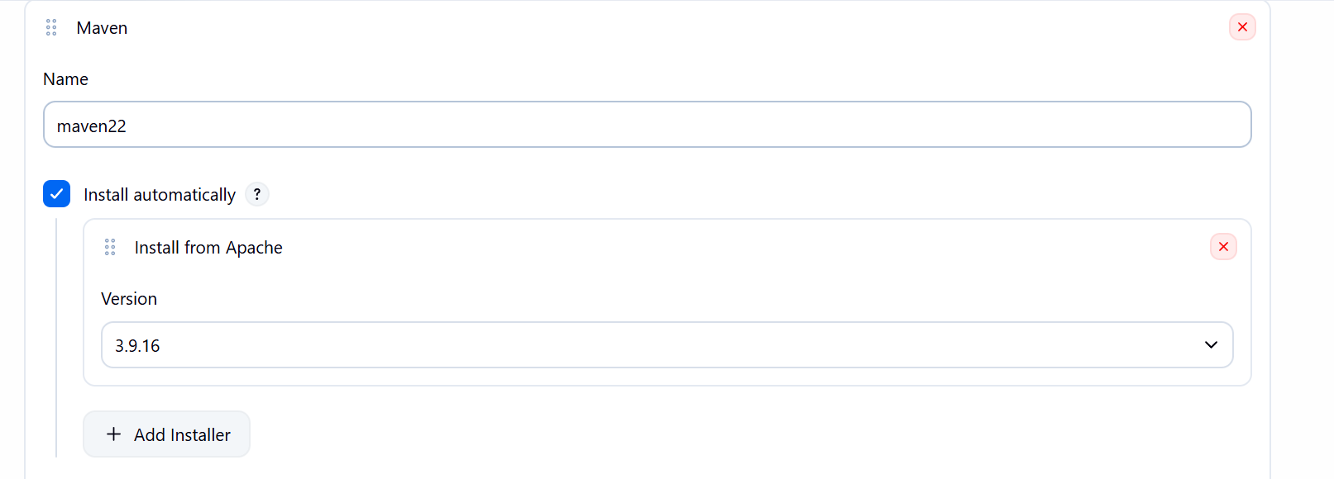

Create a new job
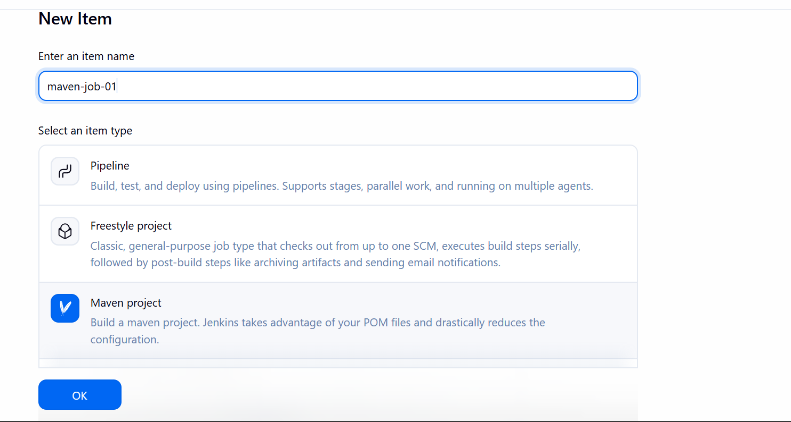

Add the git repository URL
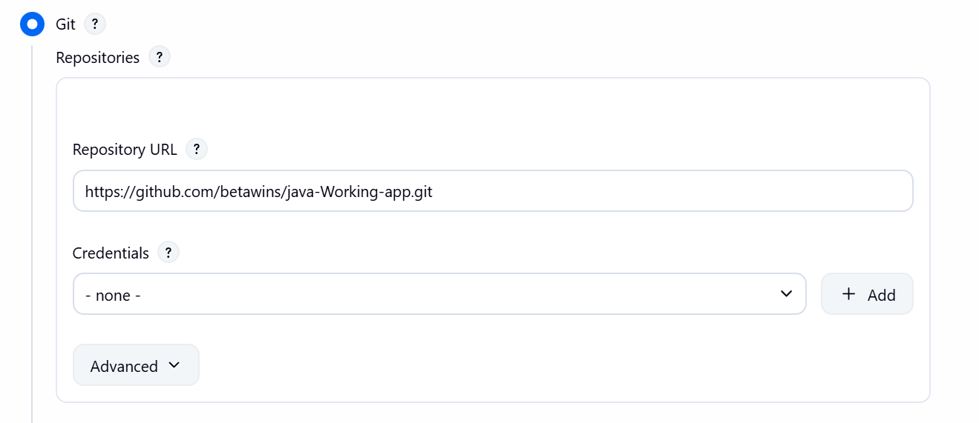

Save the build now and run the job
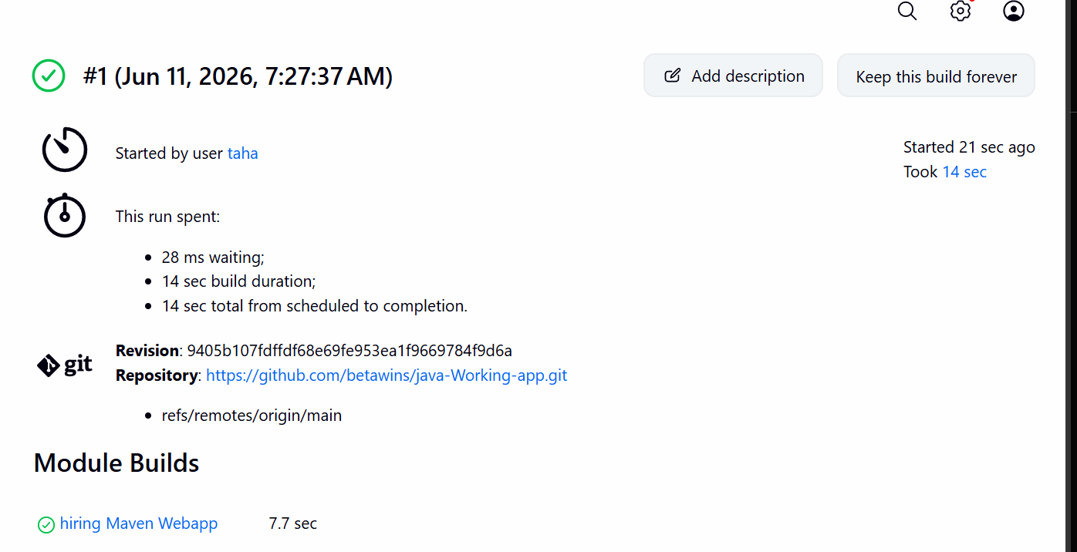
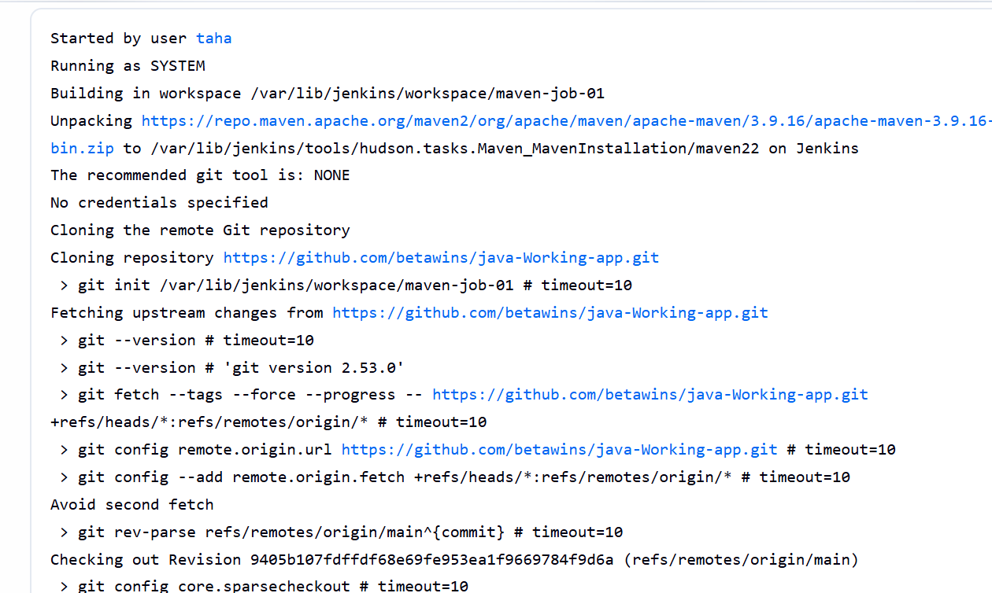
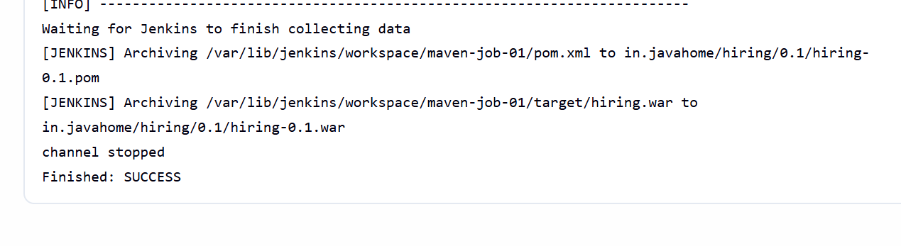

War file is created
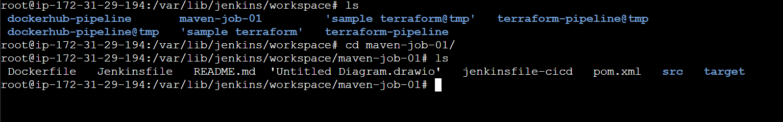

- Use the same code and create a parameterized job in Jenkins with:
- Stage 1:Git clone
- Stage 2:Maven CompilationCode:https://github.com/betawins/java-Working-app.git

Lets create a new job
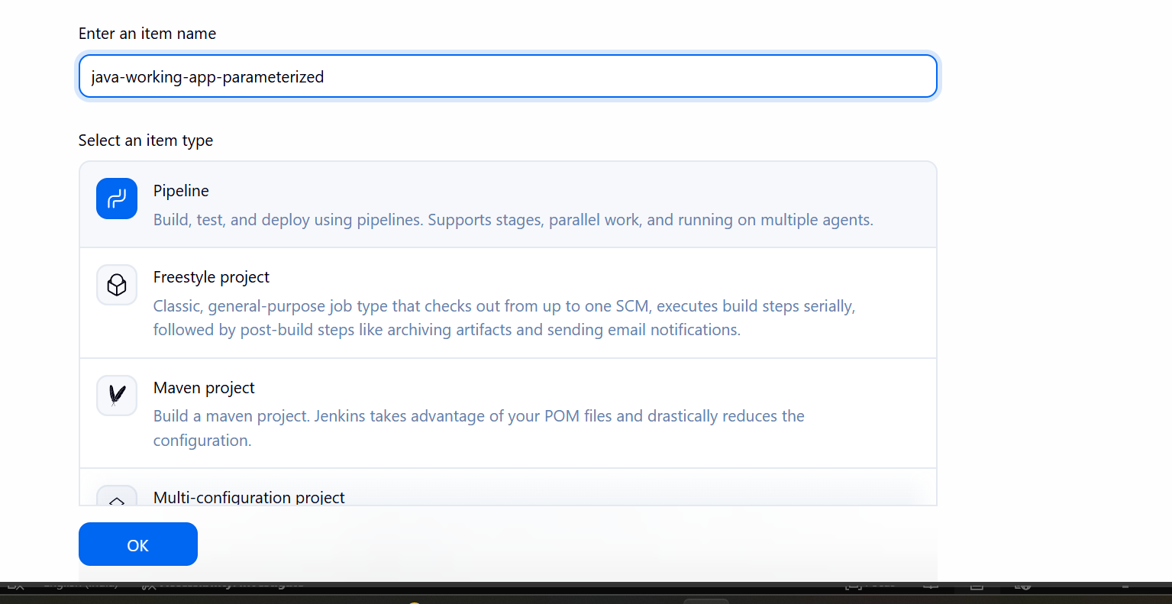
Select the option this project is parameterized
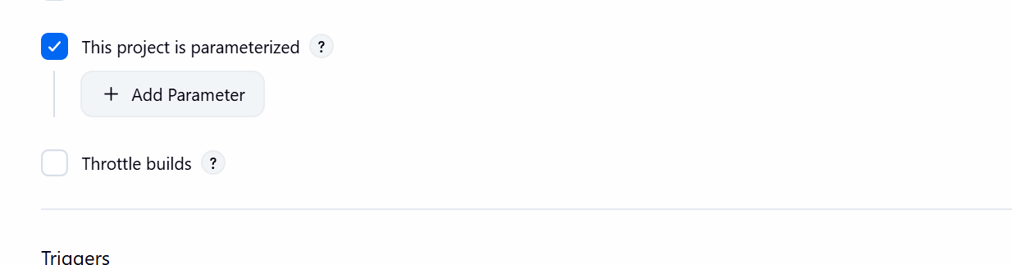

Add a string parameter
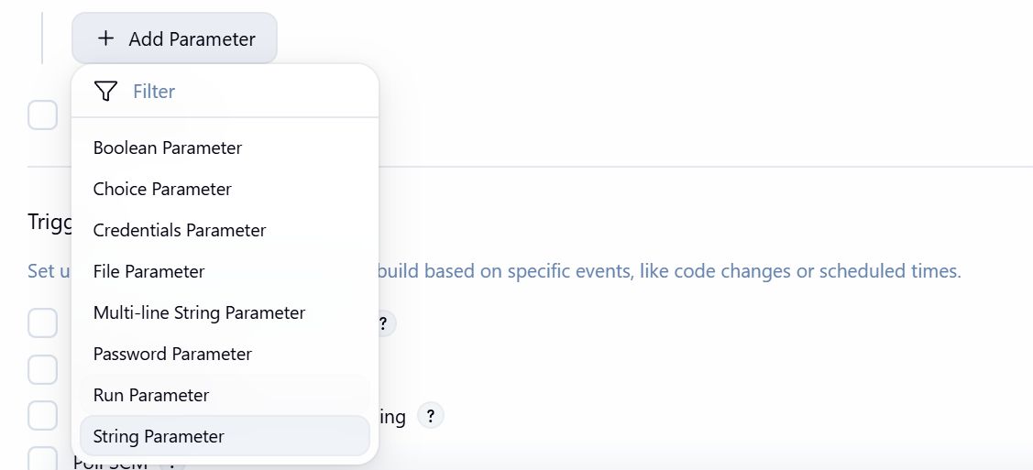

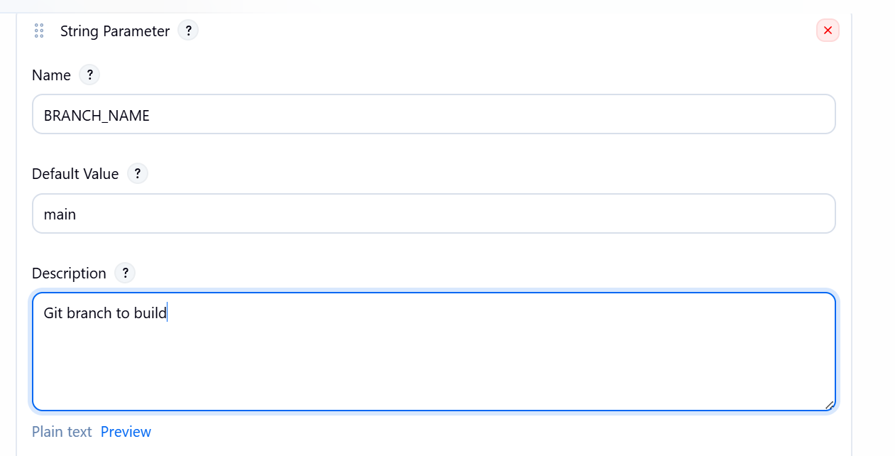

Lets now write the pipeline script
pipeline {
agent any

tools {
maven 'maven22'
}

parameters {
string(
name: 'BRANCH_NAME',
defaultValue: 'main',
description: 'Git branch to build'
)
}

stages {

stage('Git Clone') {
steps {
git branch: "${params.BRANCH_NAME}",
url: 'https://github.com/betawins/java-Working-app.git'
}
}

stage('Maven Compilation') {
steps {
sh 'mvn clean compile'
}
}
}

post {
success {
echo 'Build completed successfully'
}

failure {
echo 'Build failed'
}
}
}

Lets save this script and run the pipeline job
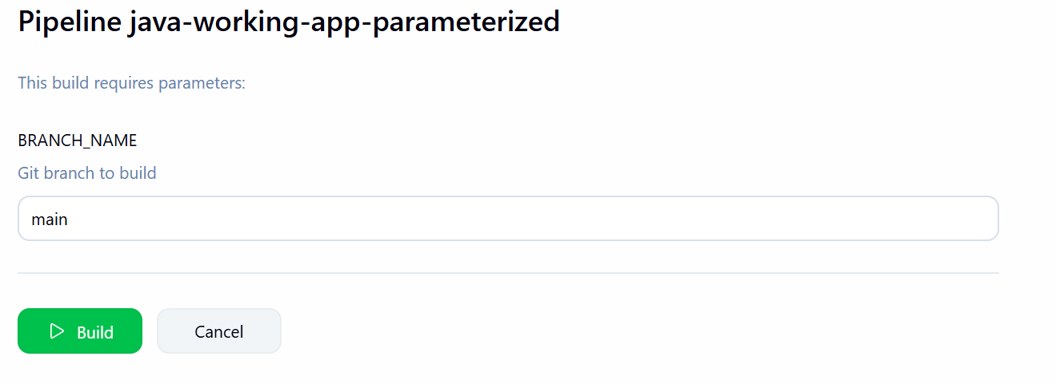
While running the job it will ask for the branch to build
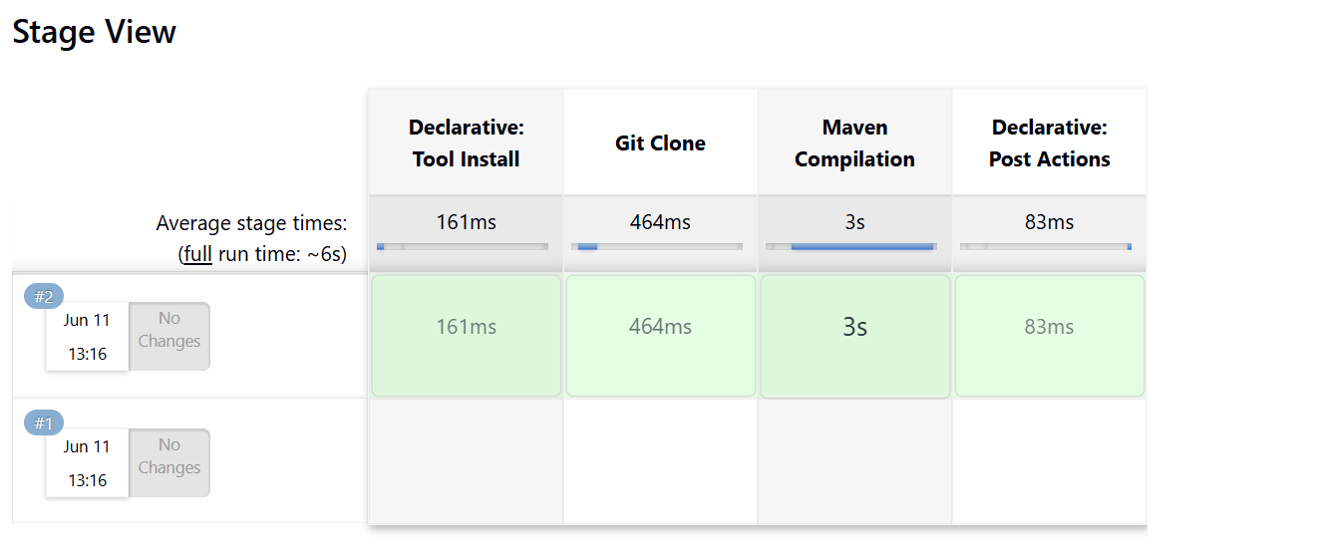

This pipeline uses the parameters we are configured it will ask us while running the job which branch you want to run. First it will clone the branch and compiles the source code using maven.

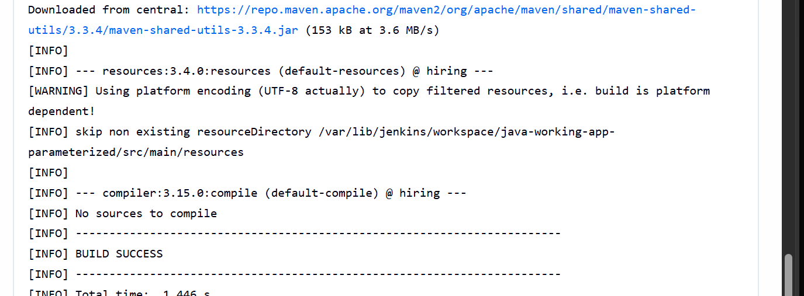

The pipeline ran successfully

- What are the global variables in Jenkins?

Jenkins Global Variables
What are Global Variables in Jenkins?
Global variables are predefined variables provided by Jenkins that can be used anywhere in a pipeline job. They contain useful information about the current build, job, workspace, Git repository, and Jenkins environment.
These variables help us avoid hardcoding values in scripts and make our pipelines more flexible and reusable.

Commonly Used Global Variables
Variable | Description
BUILD_NUMBER | Current build number
BUILD_ID | Unique identifier of the build
JOB_NAME | Name of the Jenkins job
BUILD_URL | URL of the current build
WORKSPACE | Path of the Jenkins workspace
JENKINS_URL | URL of the Jenkins server
NODE_NAME | Name of the Jenkins agent/node
GIT_BRANCH | Git branch being built
GIT_COMMIT | Commit ID of the source code
GIT_URL | Git repository URL

Why Do We Use Global Variables?
- To get build information dynamically.
- To avoid hardcoding values.
- To make pipelines reusable.
- To access job, Git, and workspace details during execution.

Example Pipeline
pipeline {
agent any
stages {
stage('Display Variables') {
steps {
echo "Job Name: ${env.JOB_NAME}"
echo "Build Number: ${env.BUILD_NUMBER}"
echo "Workspace: ${env.WORKSPACE}"
echo "Build URL: ${env.BUILD_URL}"
}
}
}
}

