Terraform Task 04

- Execute the script shown in the video.

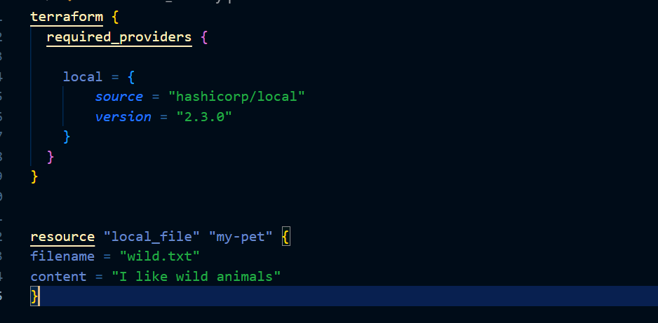

Here we are using the specific provider 2.3.0 when we do terraform init this specific provider will be downloaded

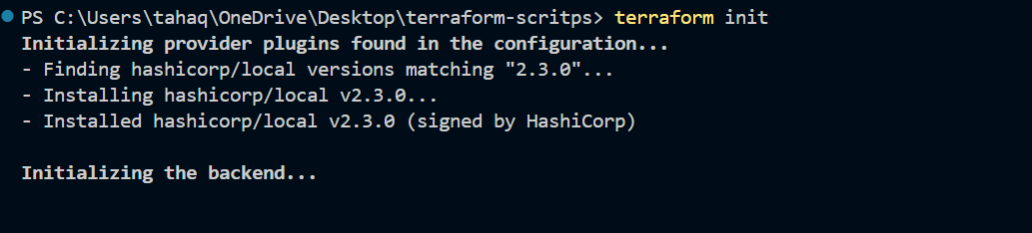
Lets apply the changes

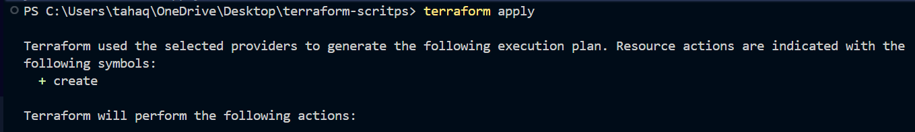

A file named wild.txt is created with the content which we passed
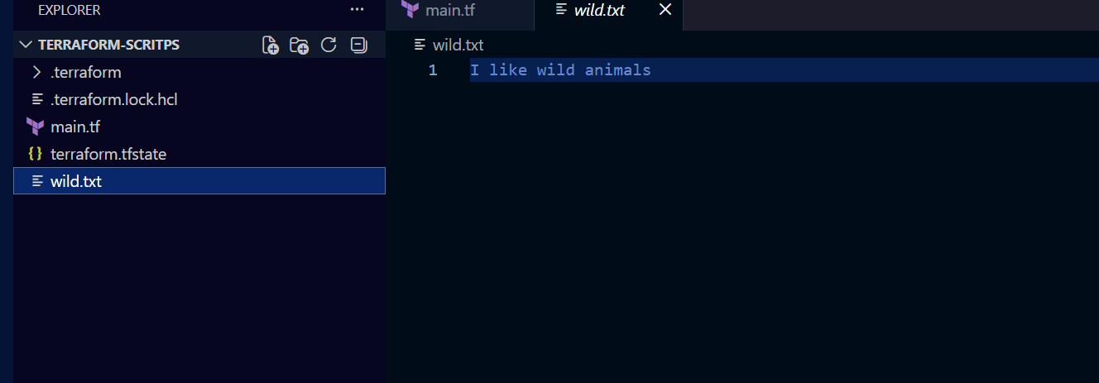

Lets use the different provider versions

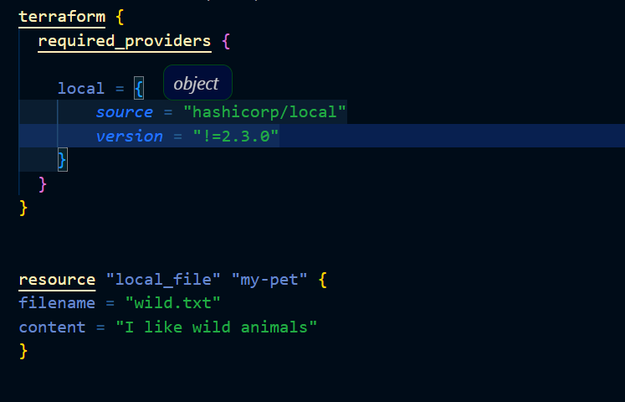

Here I have passed the version as not equal to 2.3.0
Also we have to use terraform init upgrade to upgrade the provider

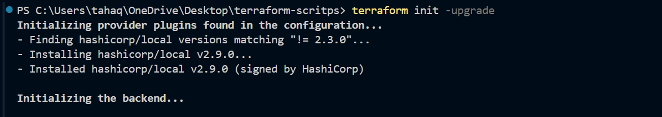

Another way
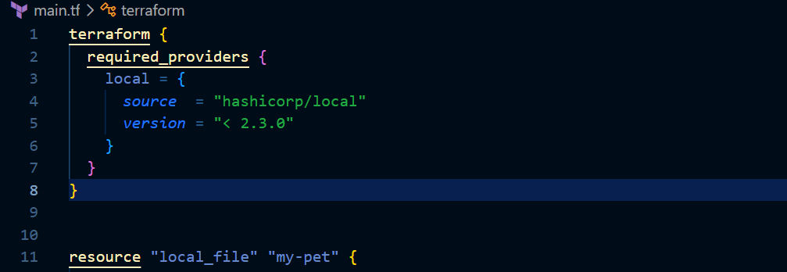

Here we are saying that we need version lesser than 2.3.0
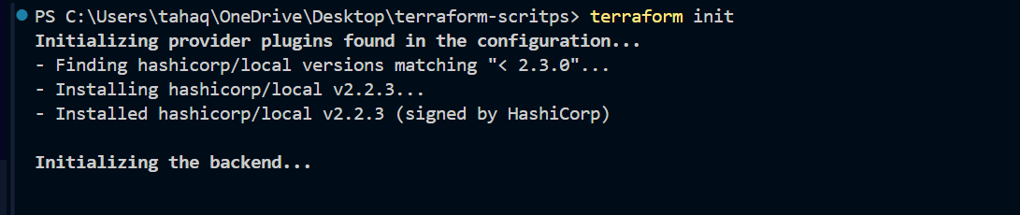

Lets now use the version greater than 2.3.0
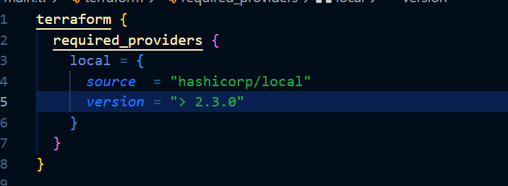

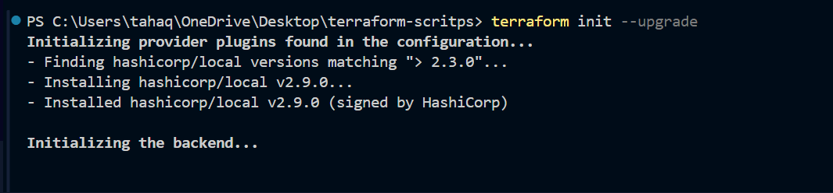

Using provider lesser than 2.5.0 and greater than 2.3.0

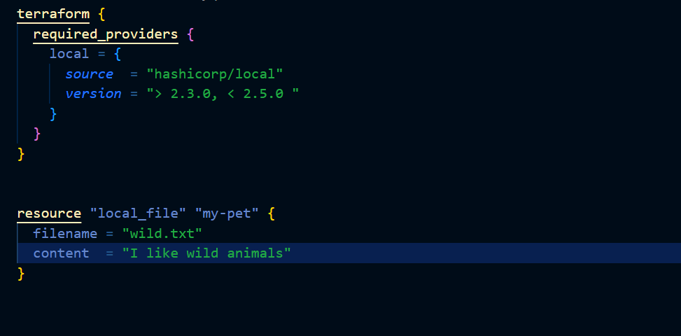

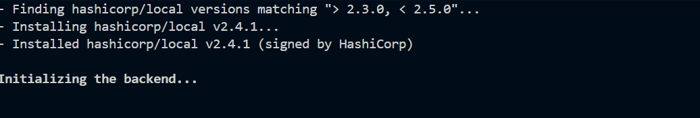

Specific version or version

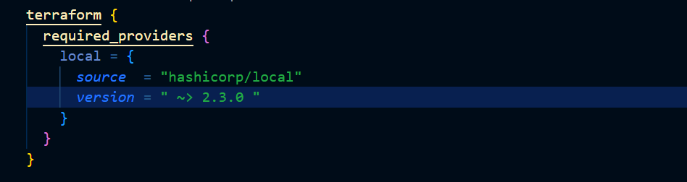

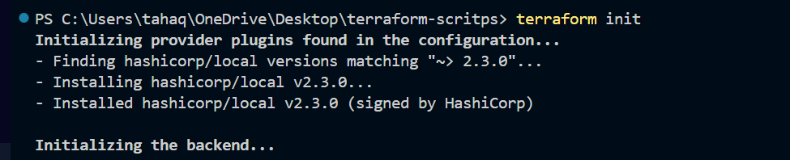

Terraform data block
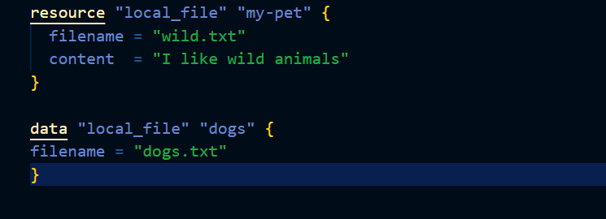

Here we are using the data block which only reads the content of another file.

When we apply the changes the terraform state file will have the dogs.txt too
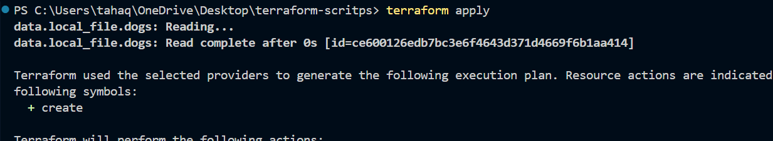
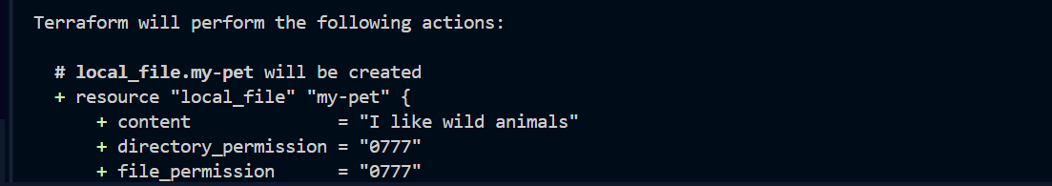

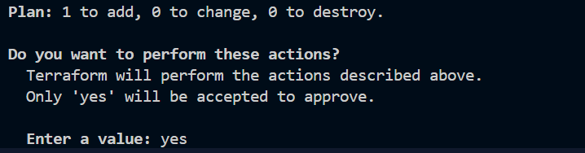
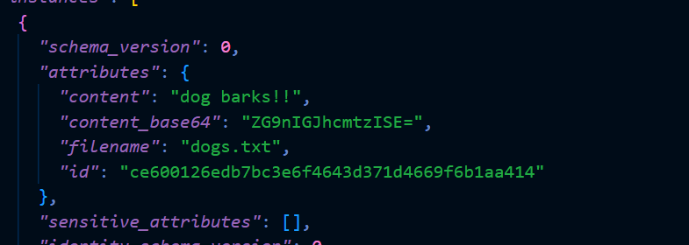

Meta Arguments :
Using count meta argument

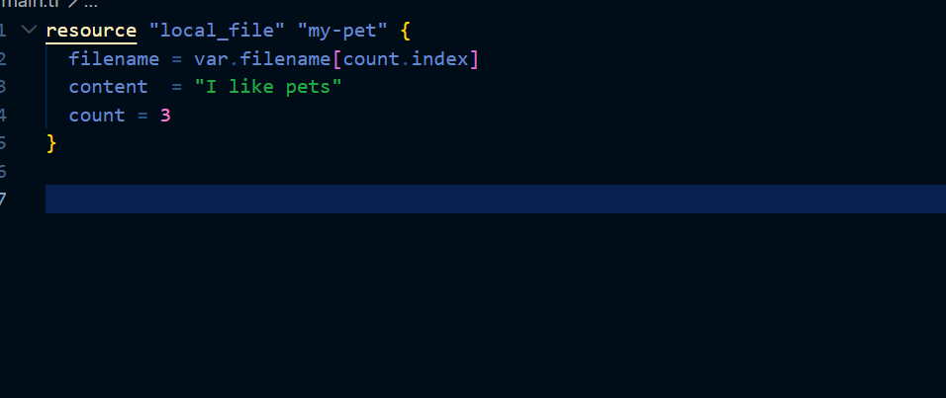
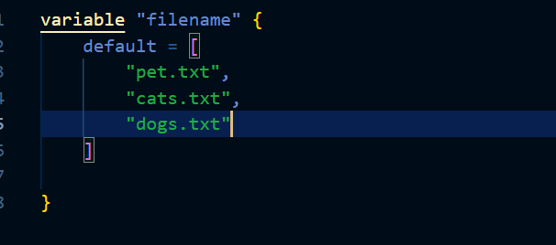
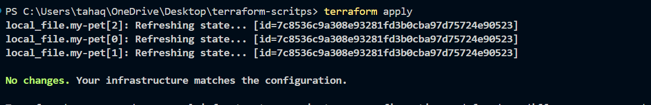

Another way of using count meta argument

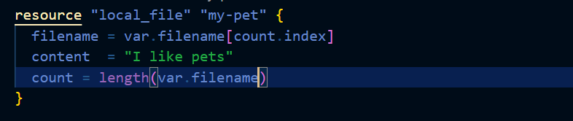
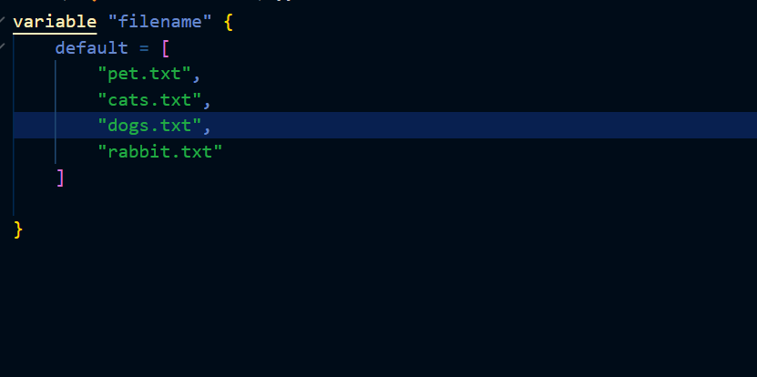

Lets apply the changes

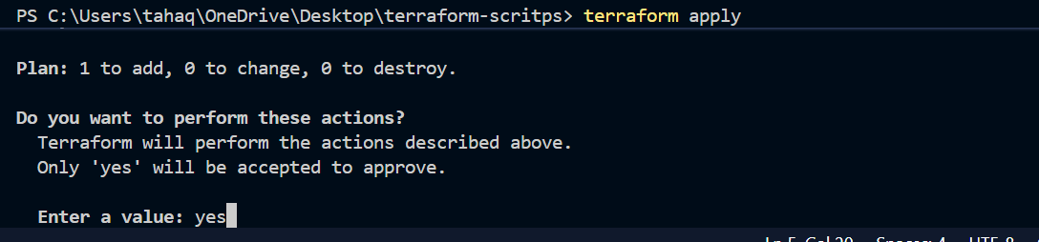
You can see that one more file named rabbit.txt is added

We have created three different files without writing 3 resource block

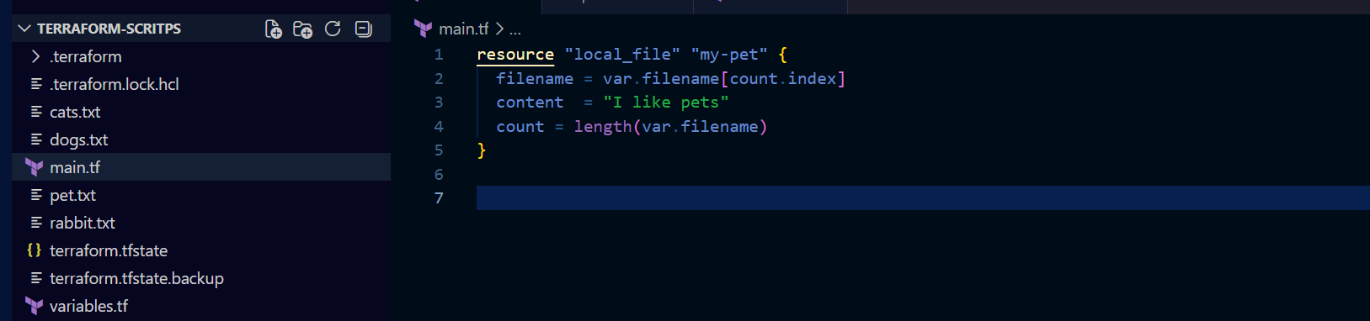

Using for_each meta argument
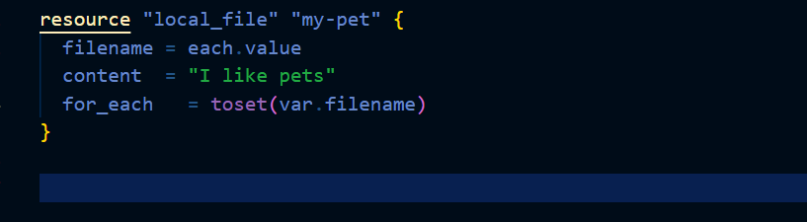

Here in our main.tf file we are using for_each meta argument

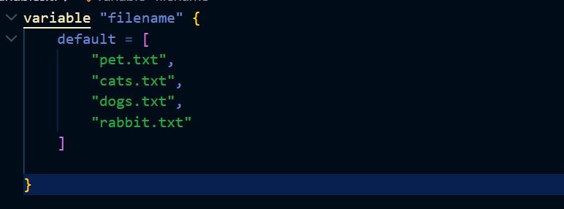

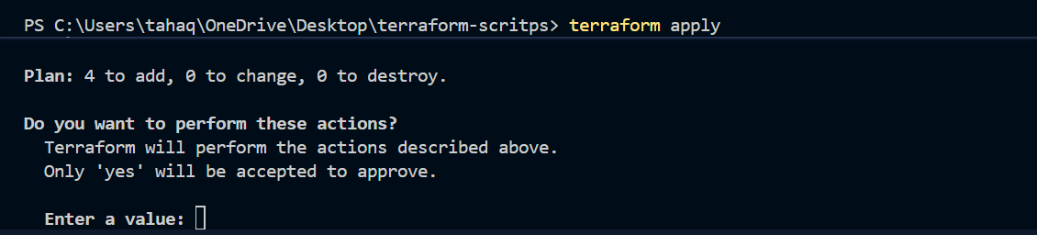

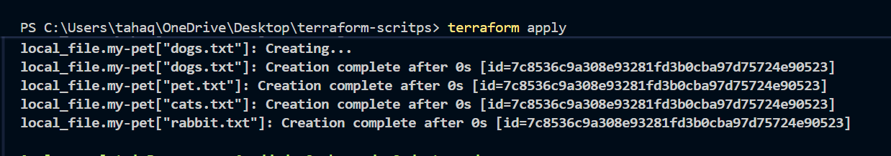

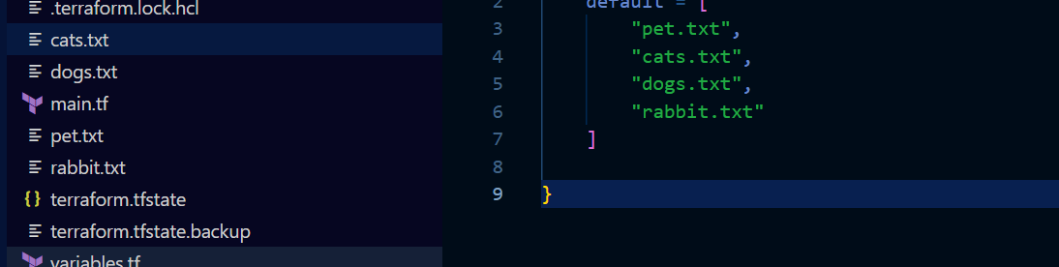

Creating a user using terraform and assigning custom policy

Initializing the backend
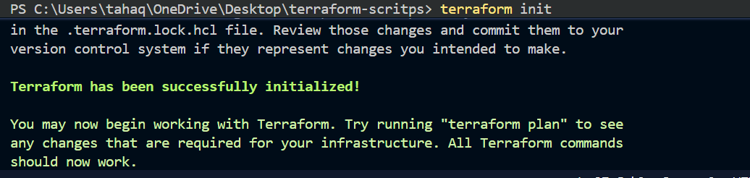

Terraform plan
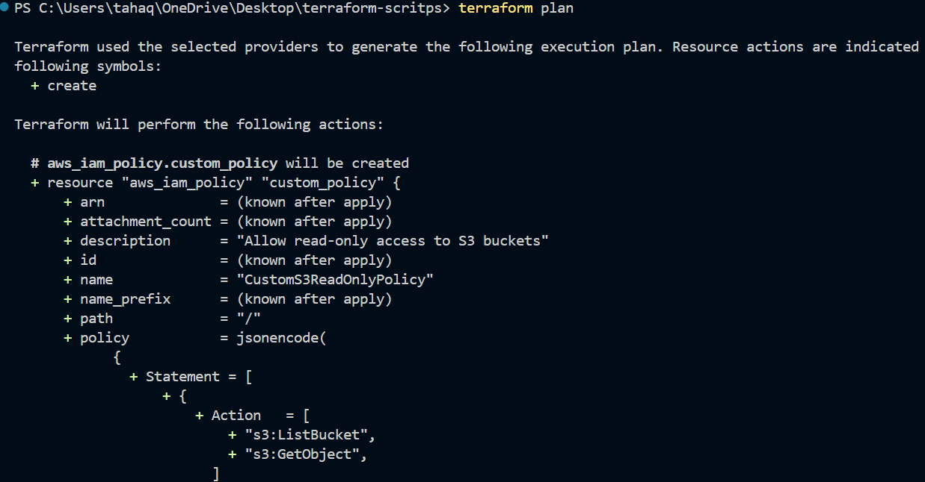
It shows 3 things to add
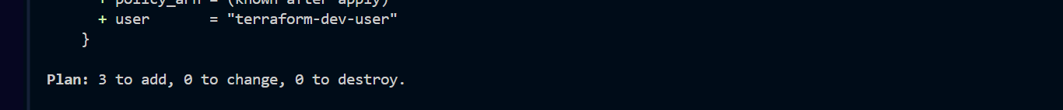

User will be created a custom policy will be created and the policy will be attached to that user

Lets apply the changes now
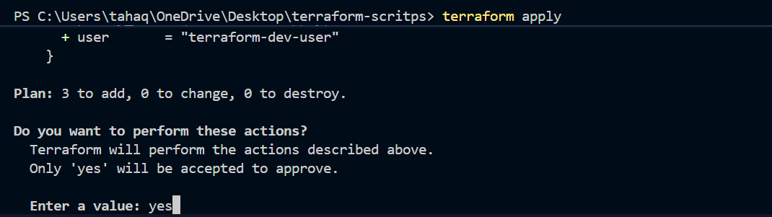

The user has been created
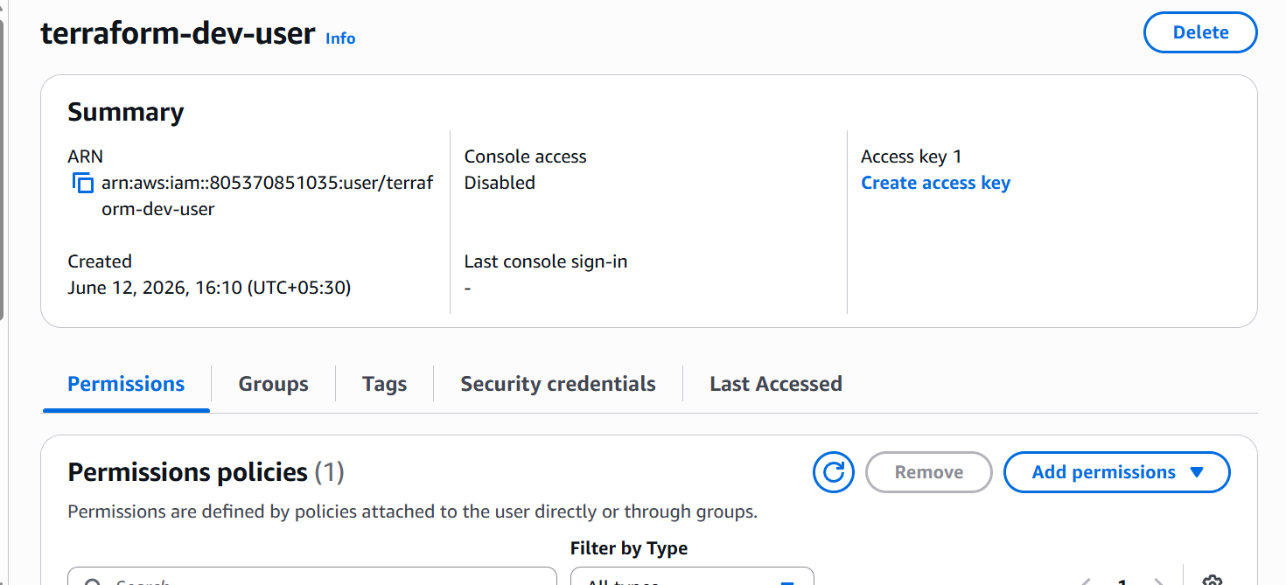

We have attached the s3 read policy

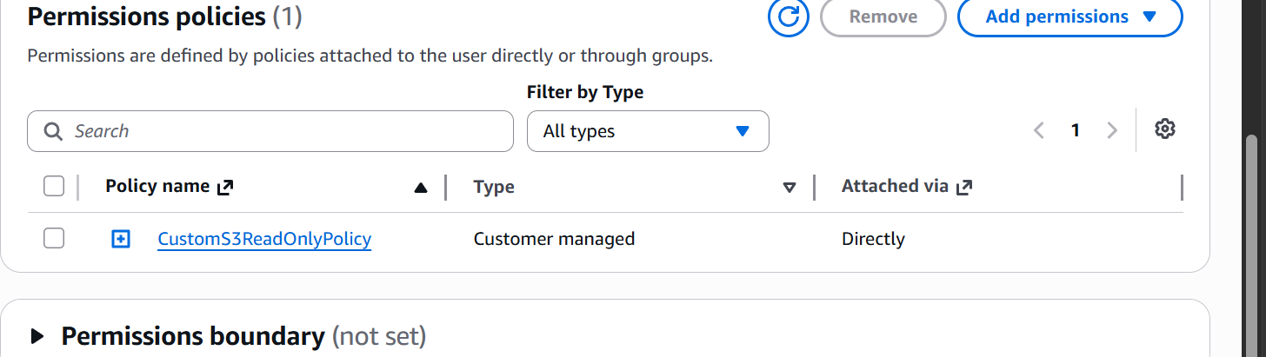

- Integrate Terraform in Jenkins using the Terraform plugin.

Lets go to our Jenkins server and install terraform plugin
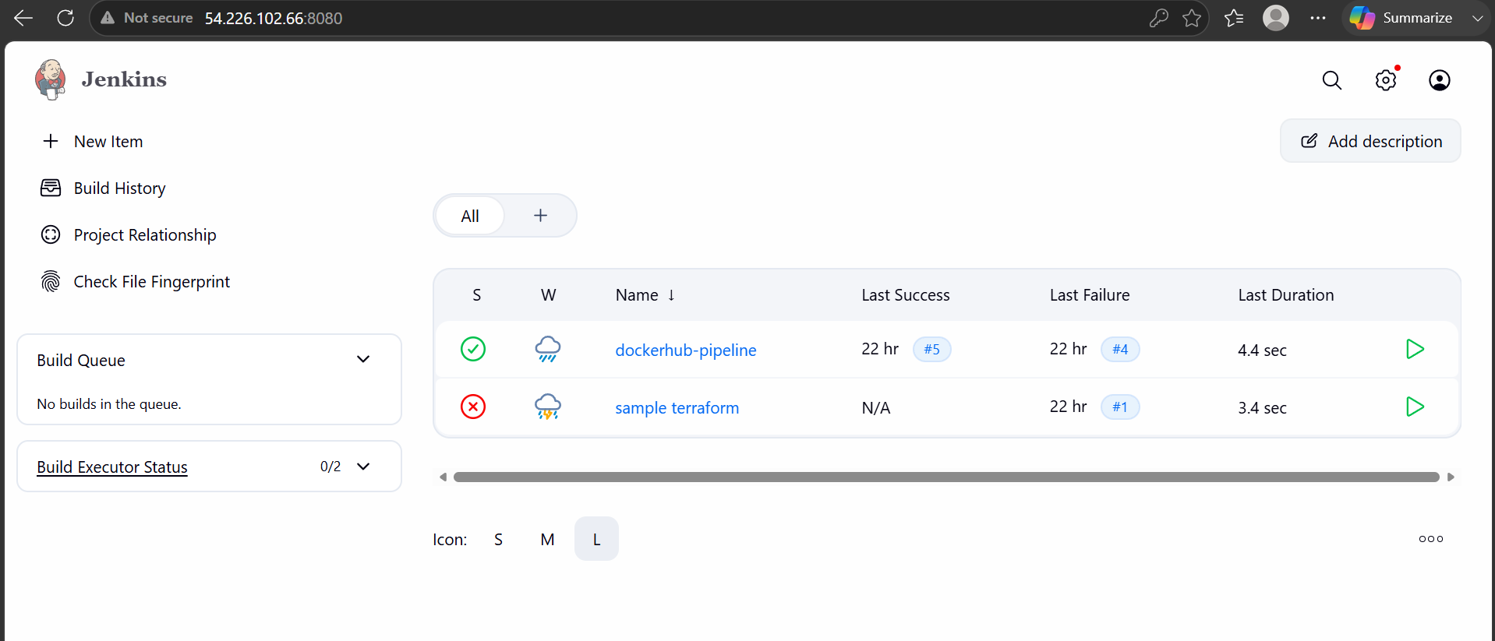

We are now logged in to Jenkins server lets install the terraform plugin
Go to manage Jenkins and plugins
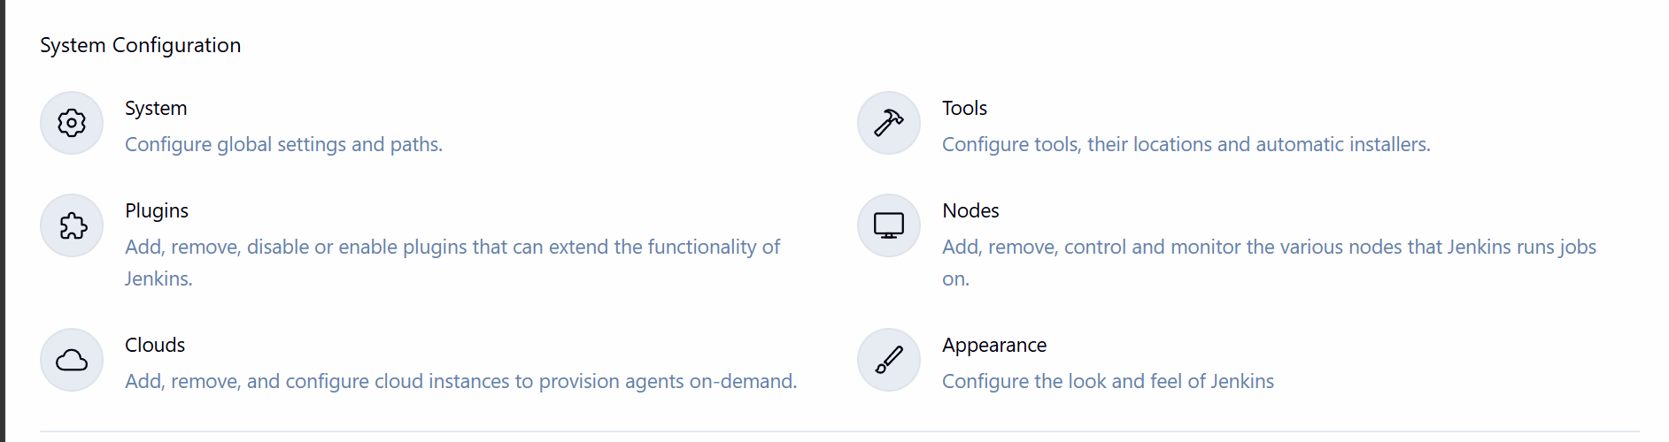
In available plugins search for terraform
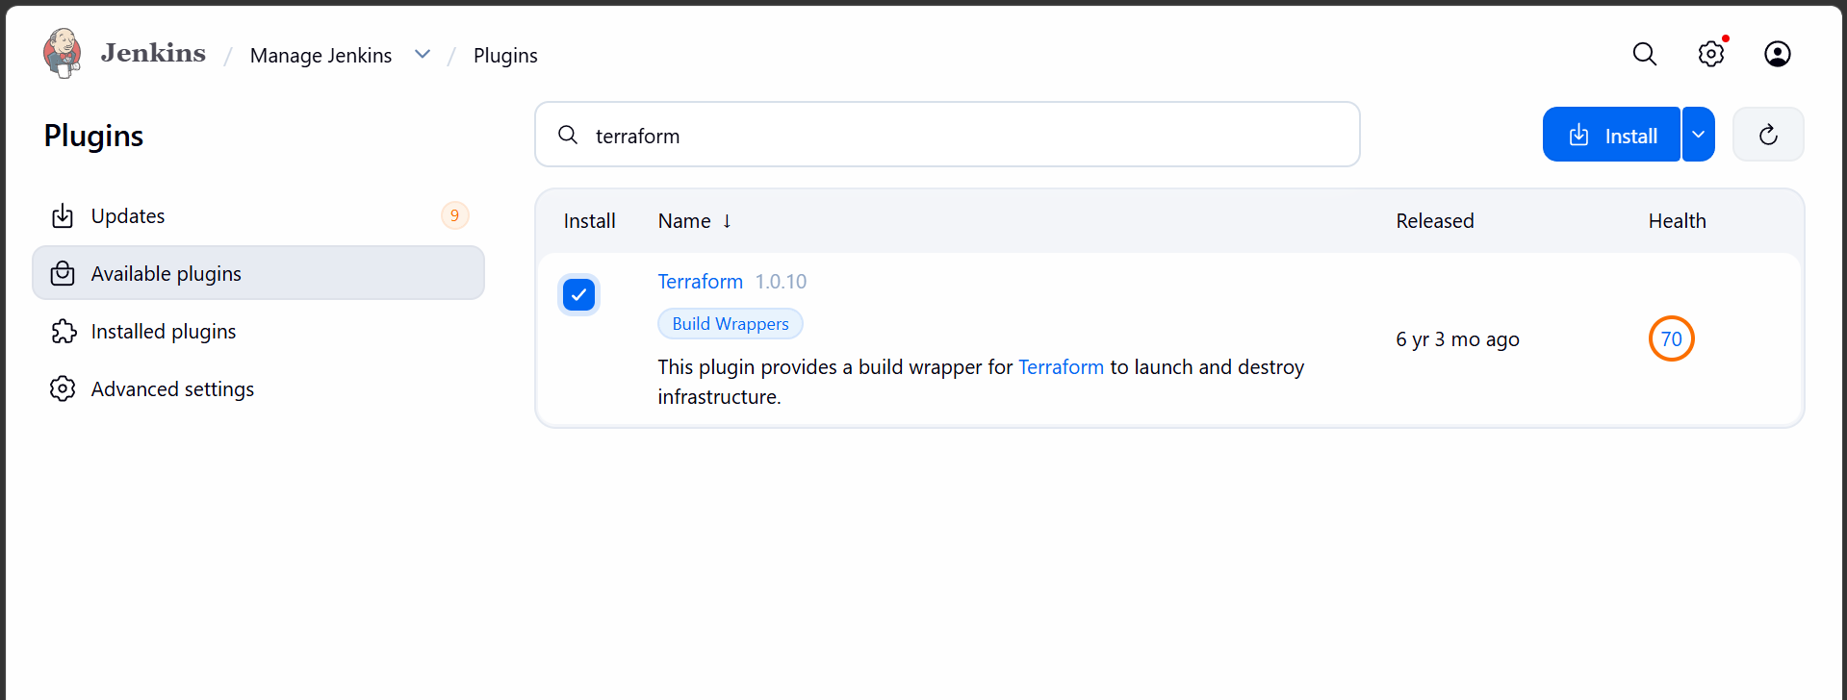
Add terraform installer in tools
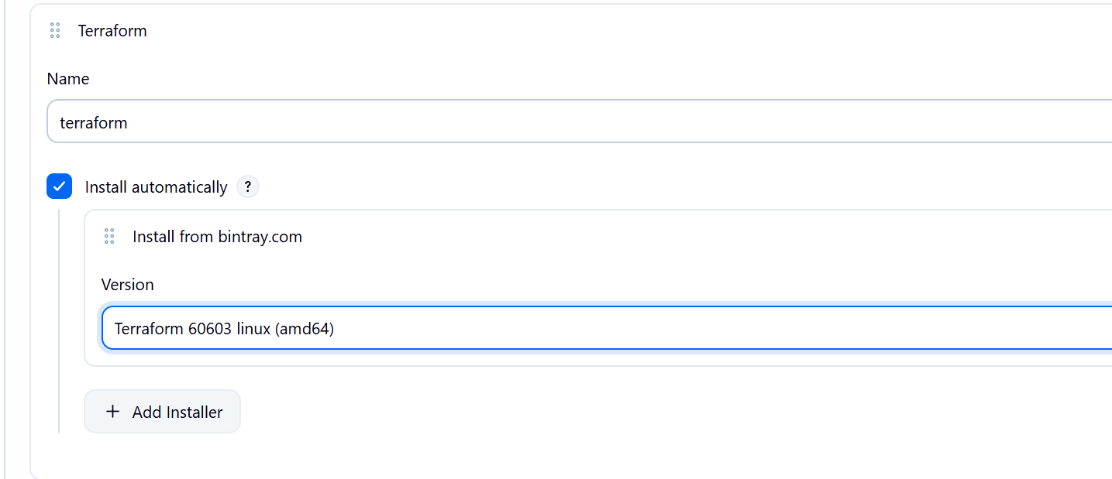

Create a pipeline job
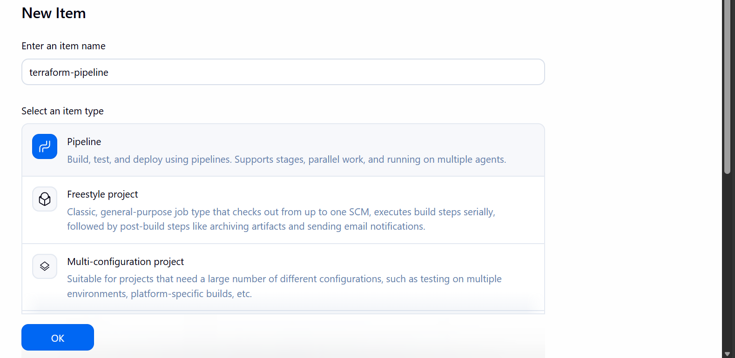
This is our main.tf file
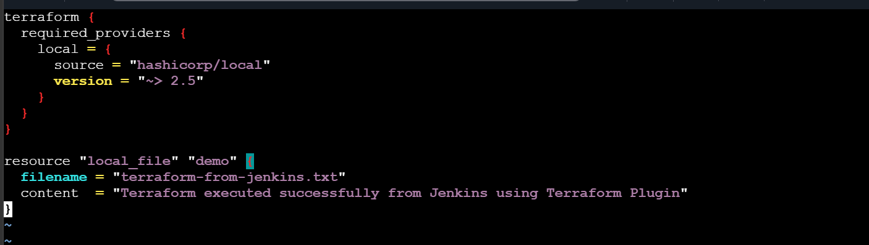
We have to keep it in the Jenkins workspace folder

Lets now run the pipeline script
pipeline {
agent any

tools {
terraform 'terraform'
}

stages {

stage('Terraform Version') {
steps {
sh 'terraform version'
}
}

stage('Terraform Init') {
steps {
sh 'terraform init'
}
}

stage('Terraform Plan') {
steps {
sh 'terraform plan'
}
}

stage('Terraform Apply') {
steps {
sh 'terraform apply -auto-approve'
}
}
}
}

The pipeline ran successfully
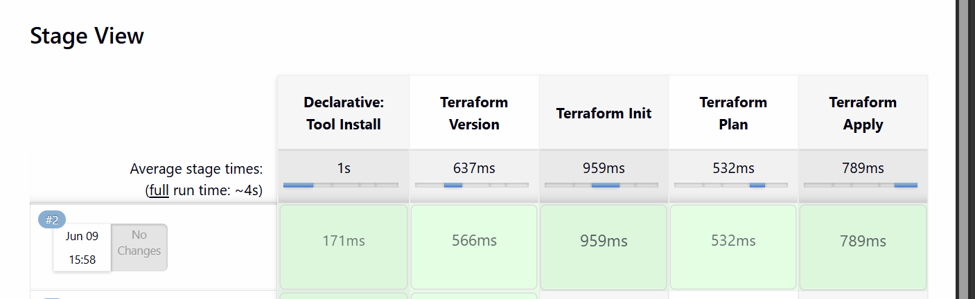

3). Create a CI/CD pipeline for a Nodejs Application: https://github.com/betawins/Trading-UI.git

First lets install node js and npm in Jenkins server
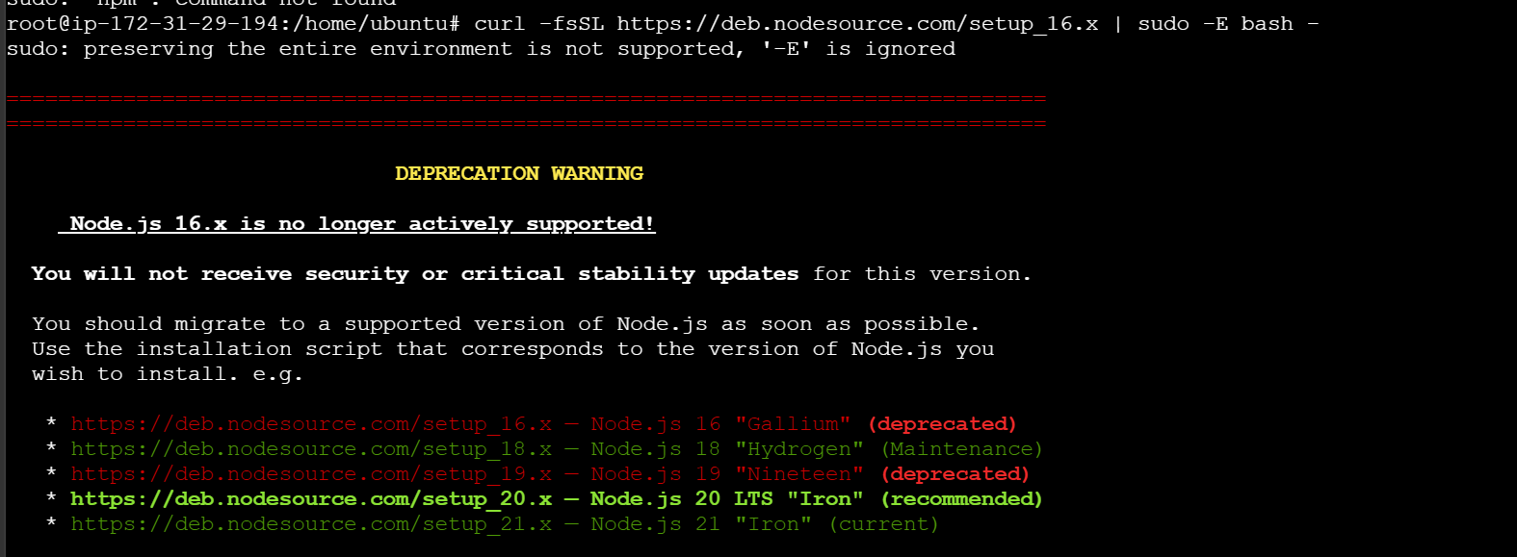
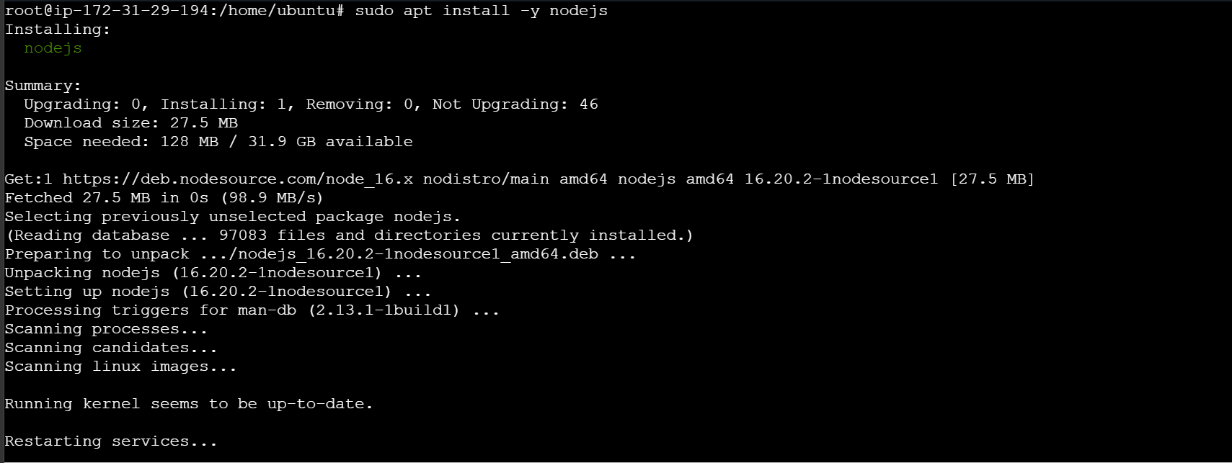

Lets now login to Jenkins server
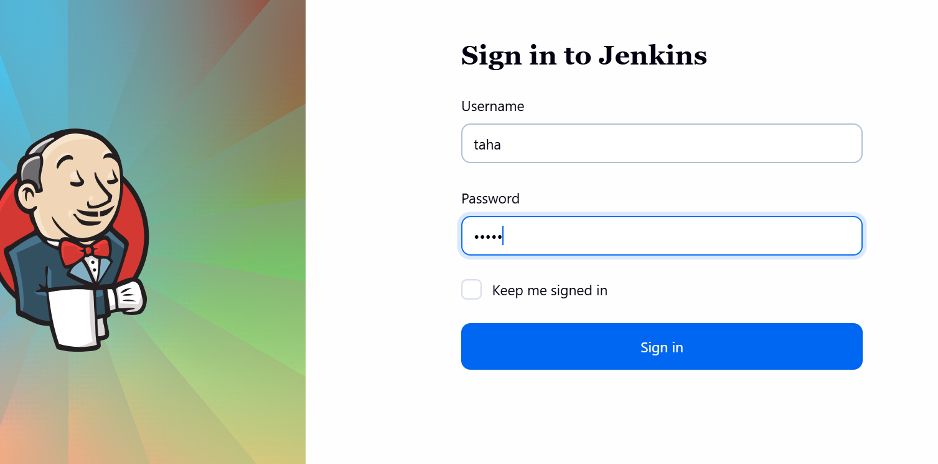
Now create a new job
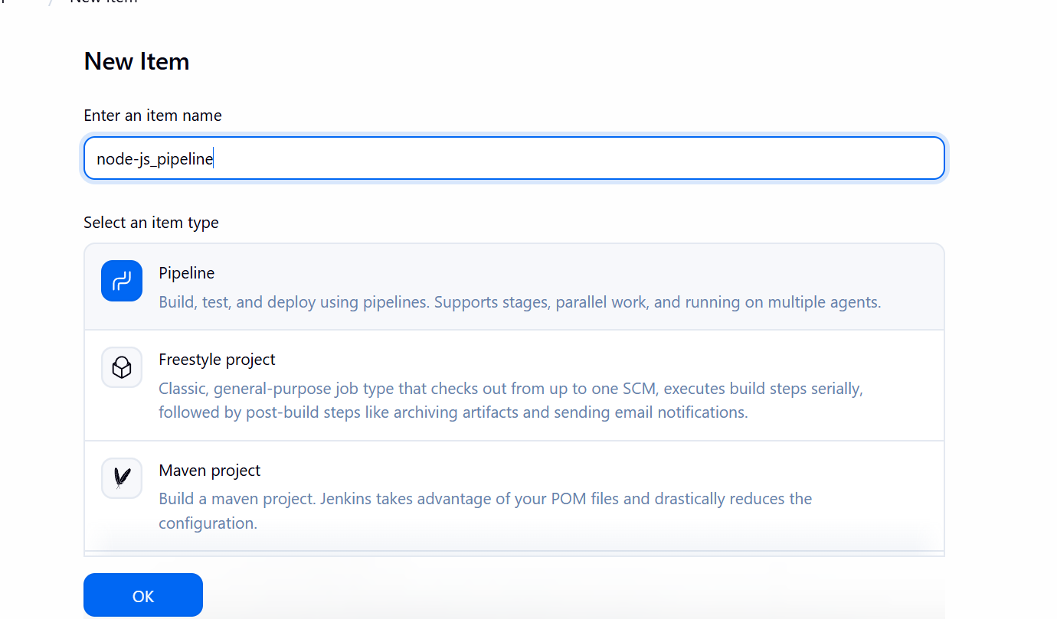
Write the pipeline script
pipeline {
agent any

environment {
CI = 'false'
}

stages {
stage('Git Clone') {
steps {
git branch: 'master',
url: 'https://github.com/betawins/Trading-UI.git'
}
}

stage('Install Dependencies') {
steps {
sh 'npm install'
}
}

stage('Build NodeJS App') {
steps {
sh 'npm run build'
}
}
}
}

This pipeline will clone the Node.js application, install dependencies, and build the project.
Lets now save and run the job

Pipeline ran successfully
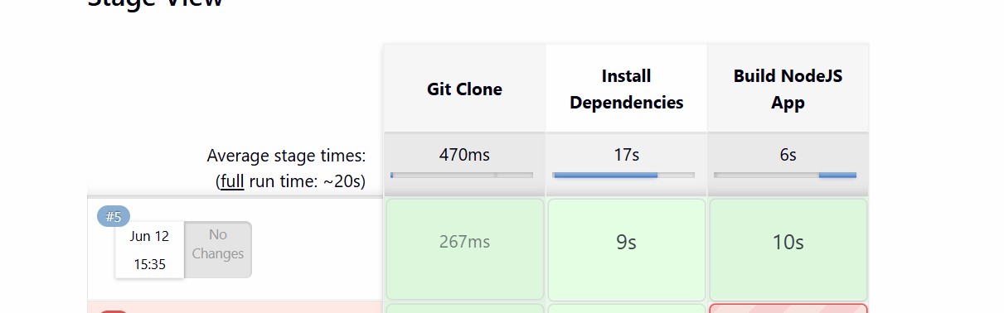
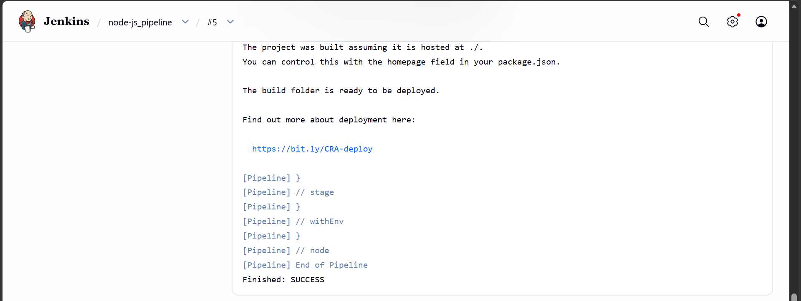
The package has been created as well.
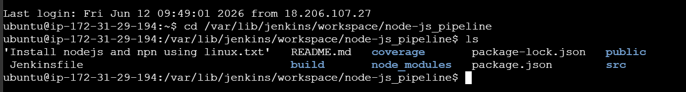

4). Explain 10 Maven commands.
Command | Purpose
mvn validate | Checks if the project structure and pom.xml are correct.
mvn compile | Compiles the source code (src/main/java).
mvn test | Runs unit test cases without creating a package.
mvn package | Creates a deployable file like .jar or .war.
mvn verify | Runs additional checks to verify package quality.
mvn install | Installs the package into the local Maven repository (~/.m2).
mvn deploy | Uploads the package to a remote repository like Nexus Repository Manager.
mvn clean | Deletes the target directory and old build files.
mvn dependency: tree | Shows all project dependencies in a tree structure.
mvn site | Generates project documentation and reports.

