Creating s3 bucket using terraform
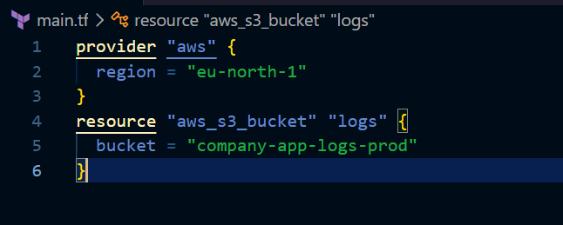

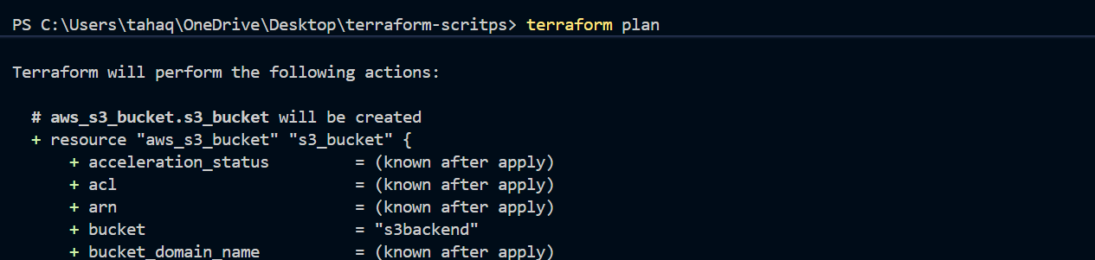

Lets now do terraform apply and create s3 bucket
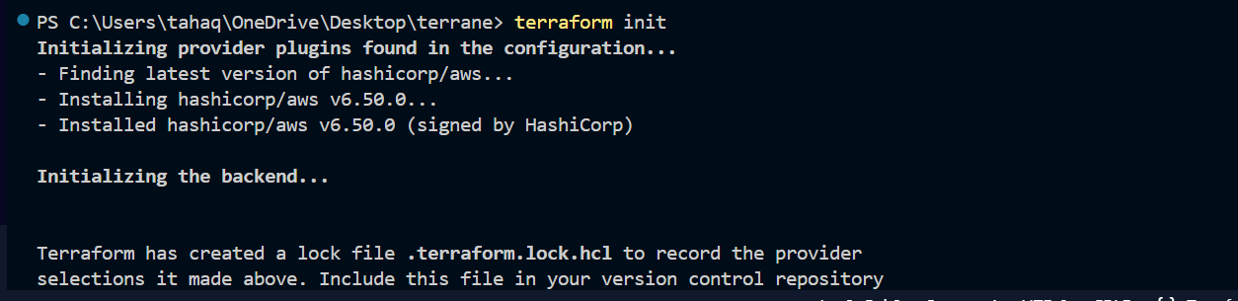
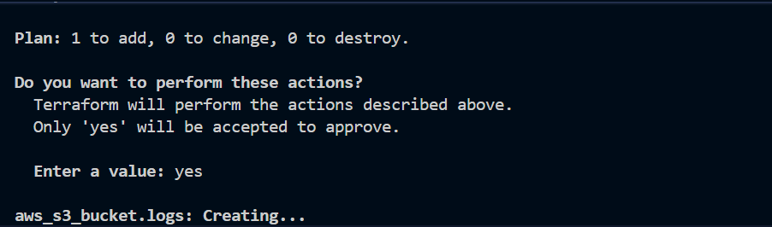

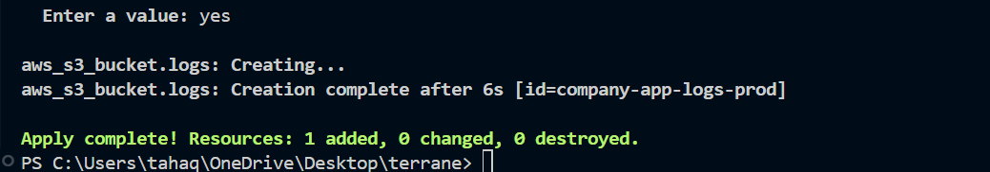
The bucket has been created
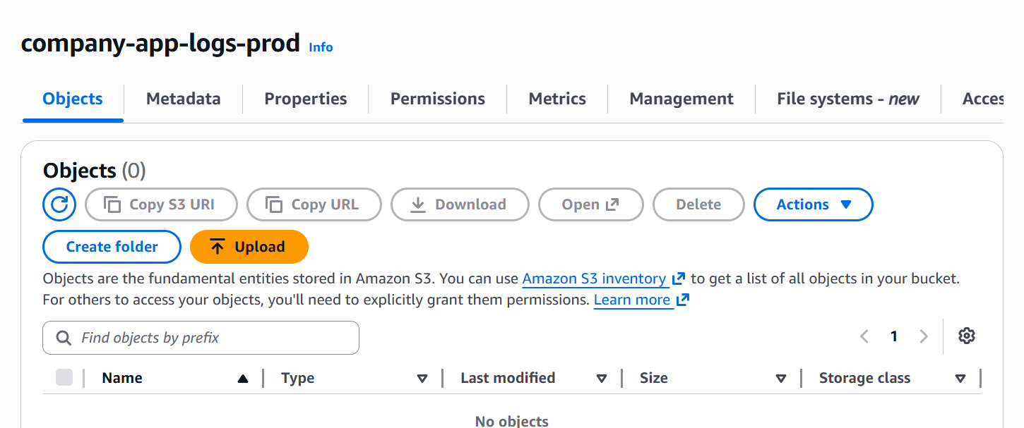

2. create an ec2 instance with httpd installed
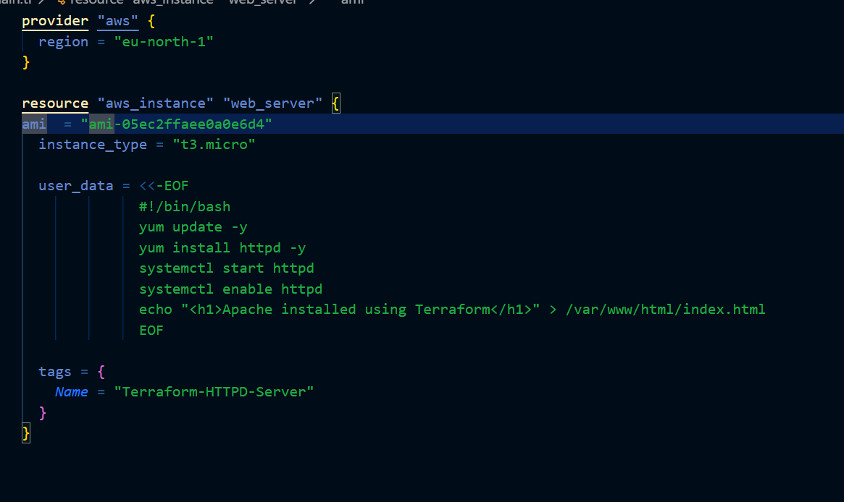
This is our terraform script with user data
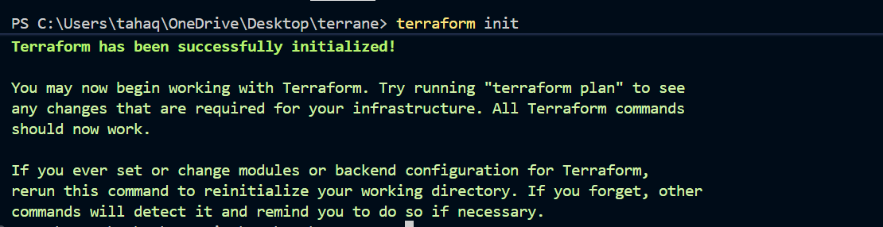
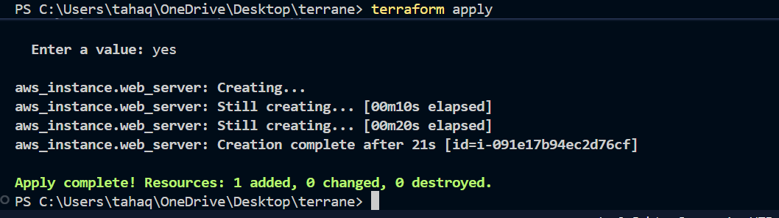

The instance is now created
Lets verify the httpd installation
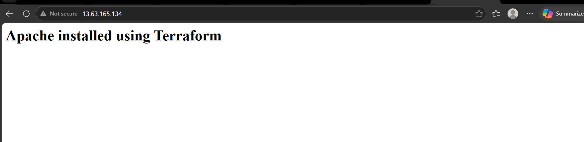

3). Set up S3 as backend
Lets create another folder
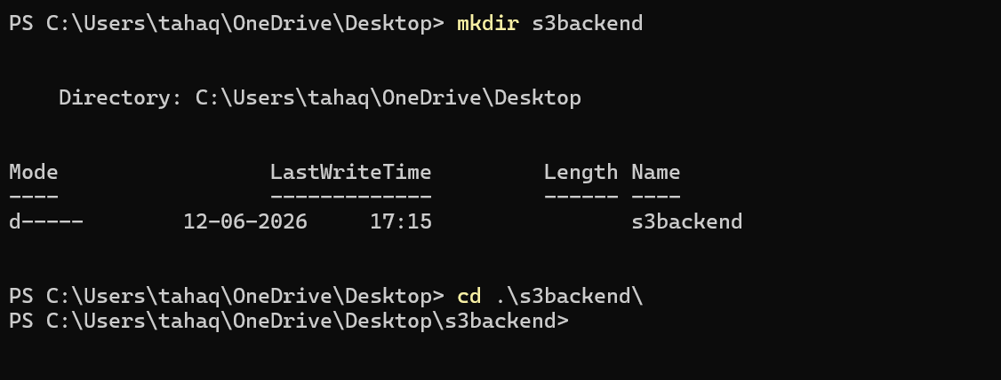
Lets now create an s3 bucket
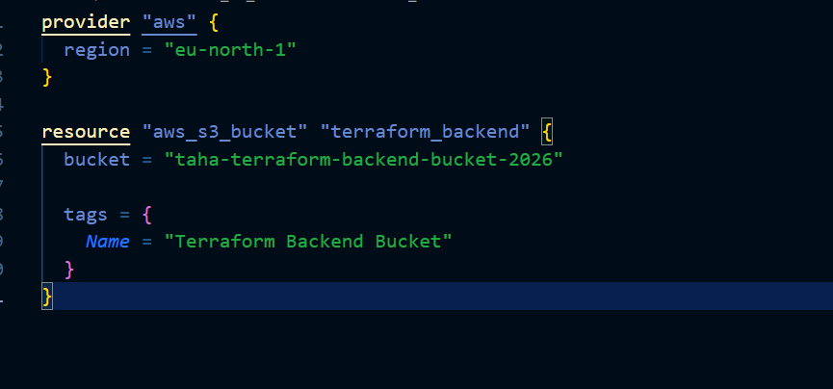
Initialize terraform backend
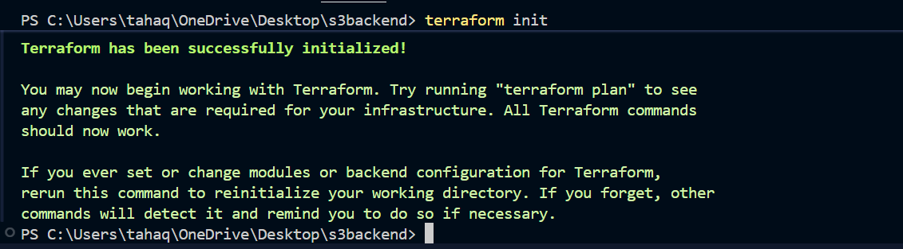
Lets apply the changes
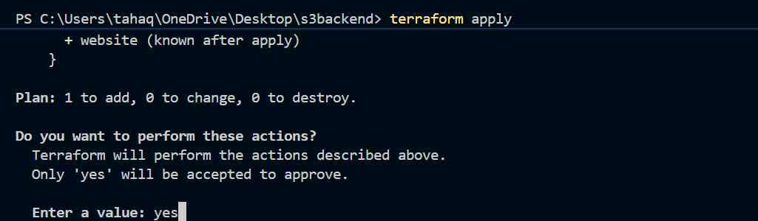
S3 bucket is created
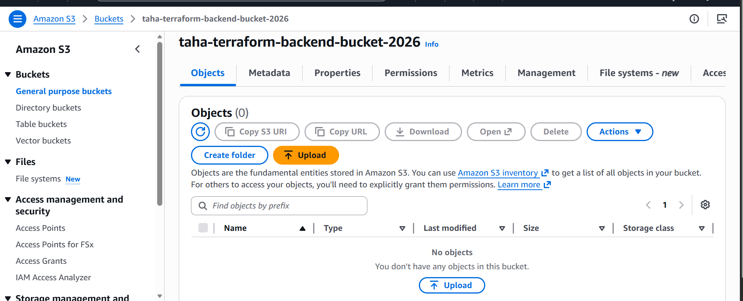

Now configuring this bucket as back up for our aws httpd instance

For that create backend.tf file and configure the s3 bucket as backend
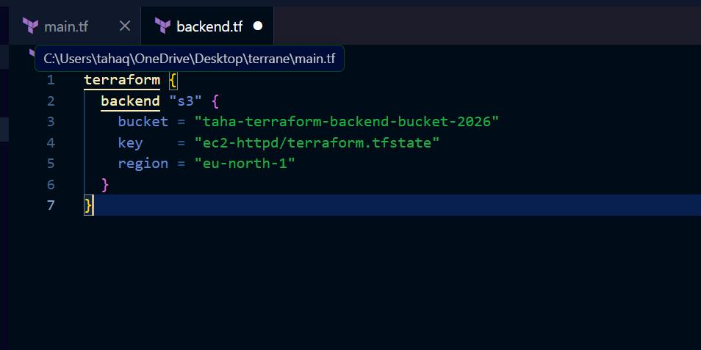
Lets now apply changes
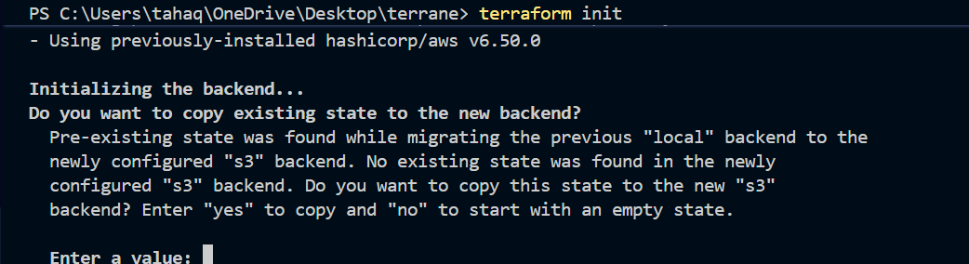
Enter yes
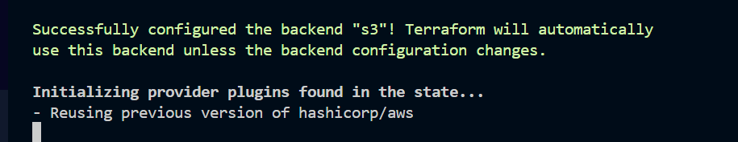
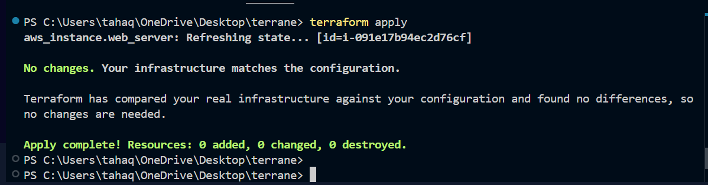
We can see that the state file is stored in the s3 bucket
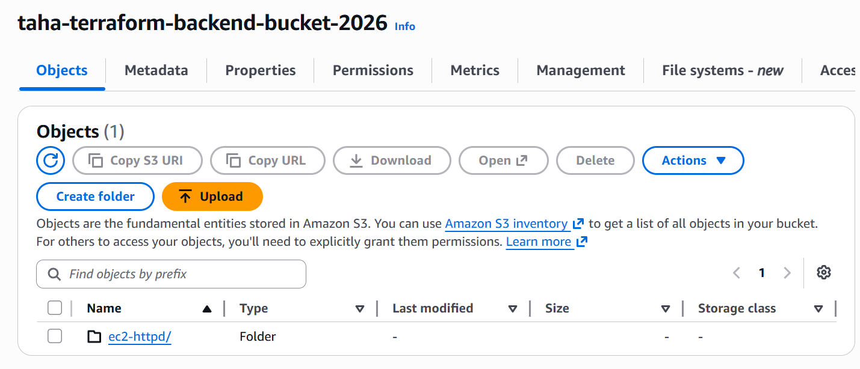
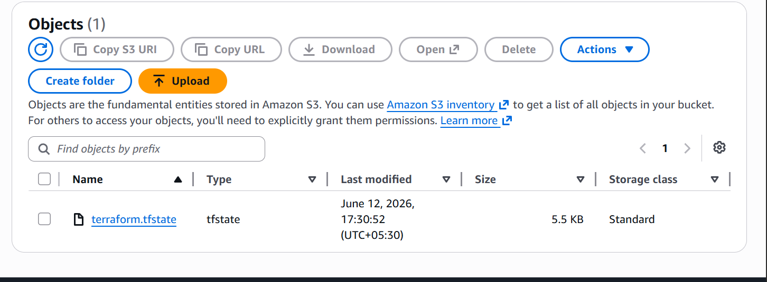

Set up DynamoDB locking .
Lets now setup DynamoDB locking
First go to another folder and create a DynamoDB table
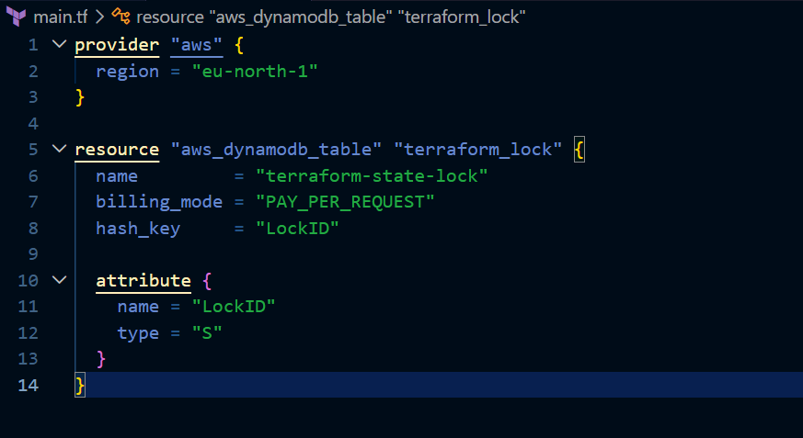
This will create a dynamo db table
Lets apply changes
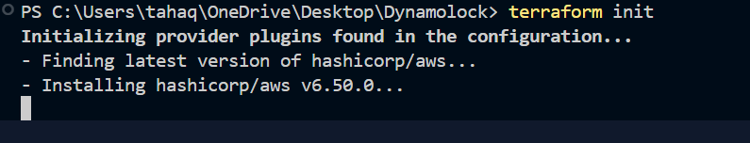
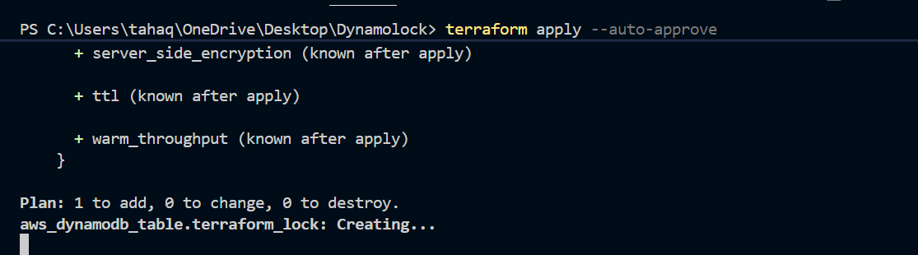
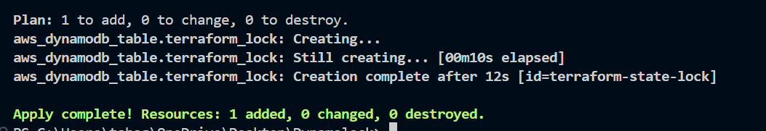
The table is now created lets verify it
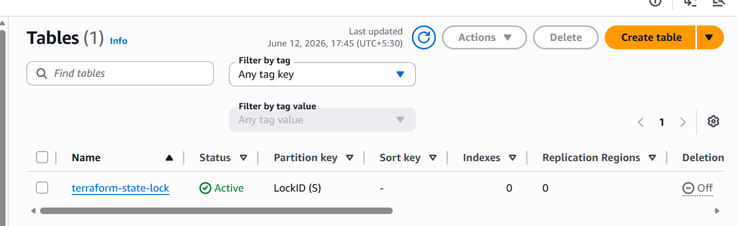
Lets now configure it for our ec2 instance
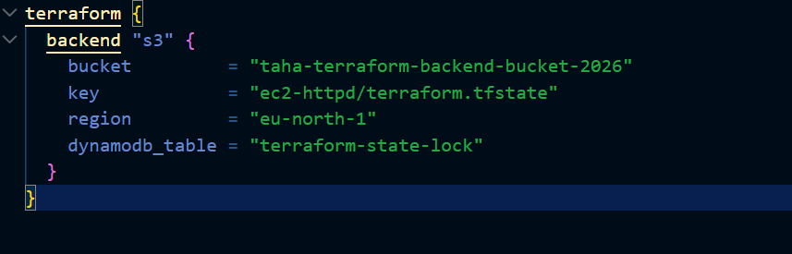
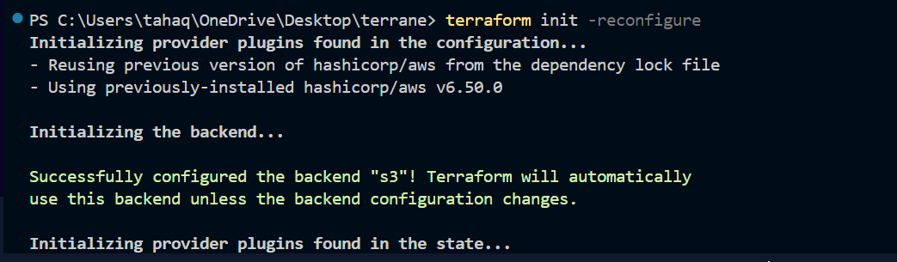
Now Terraform state is stored in S3 and locking is handled by DynamoDB.
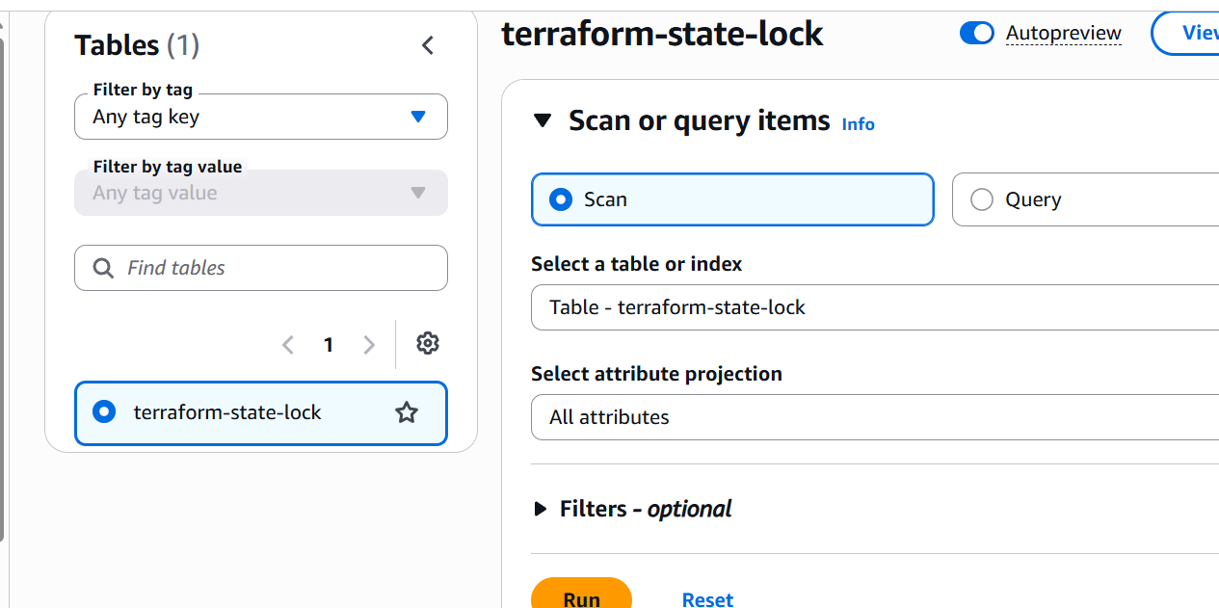
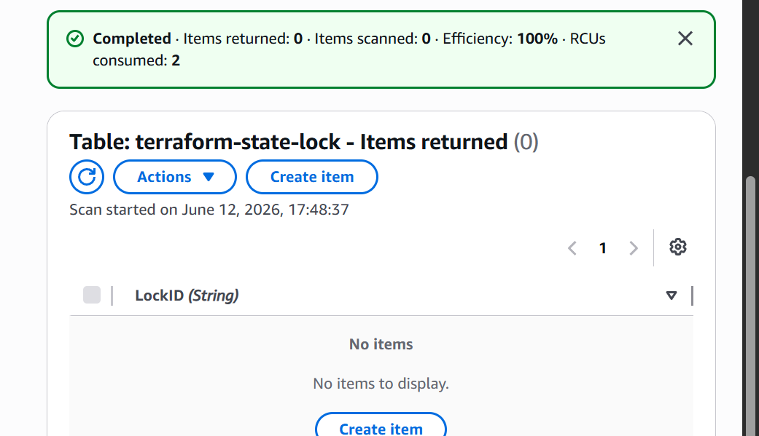

using local terraform provisioner
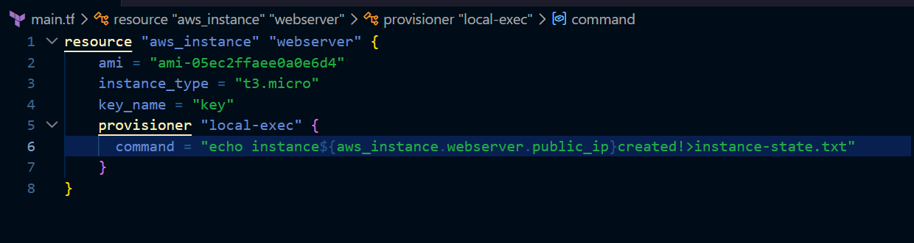
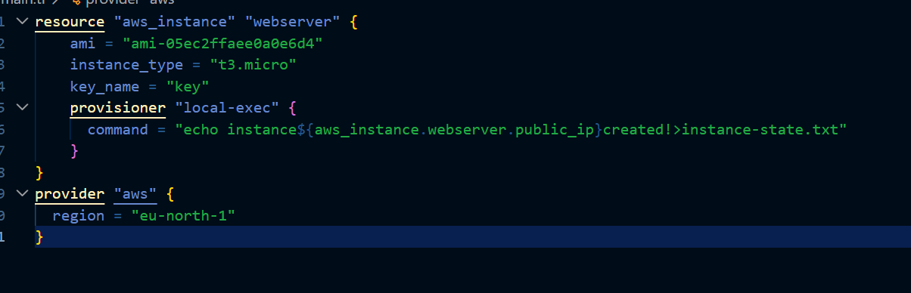
The instance has been created and the message is redirected to instance-state.txt file
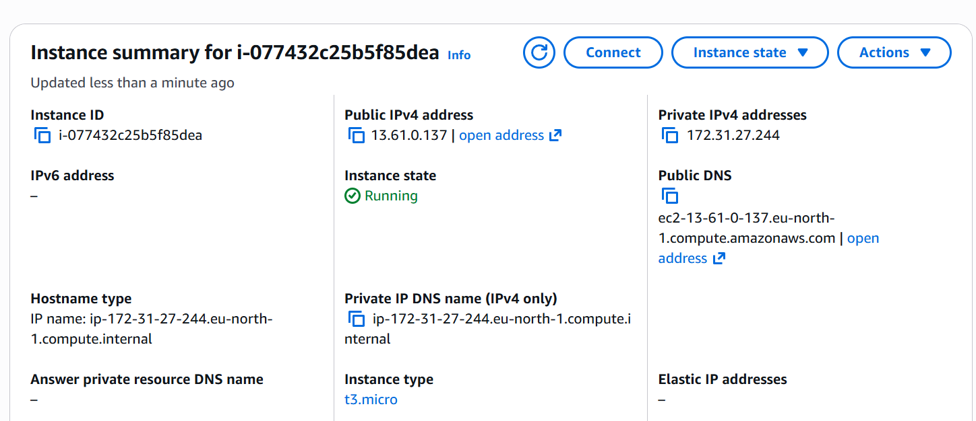

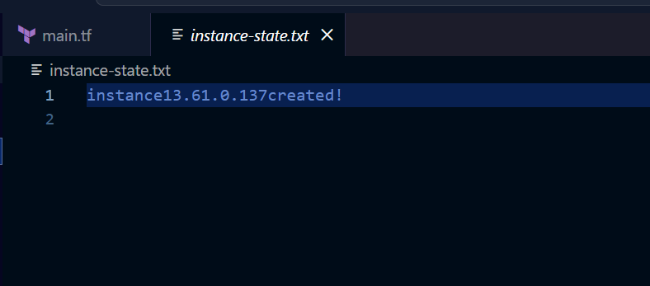

New way for S3 lock
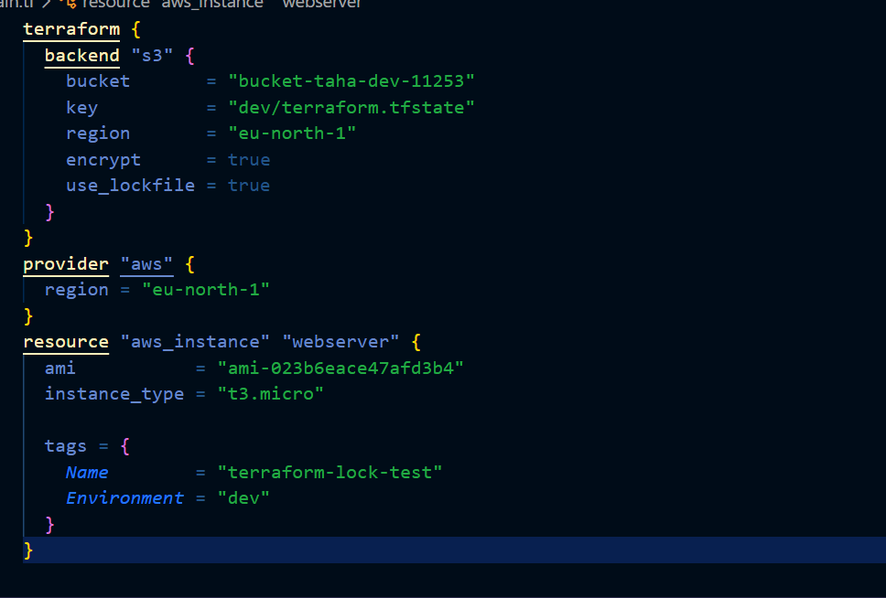
Using the lock feature from the s3 backend itself
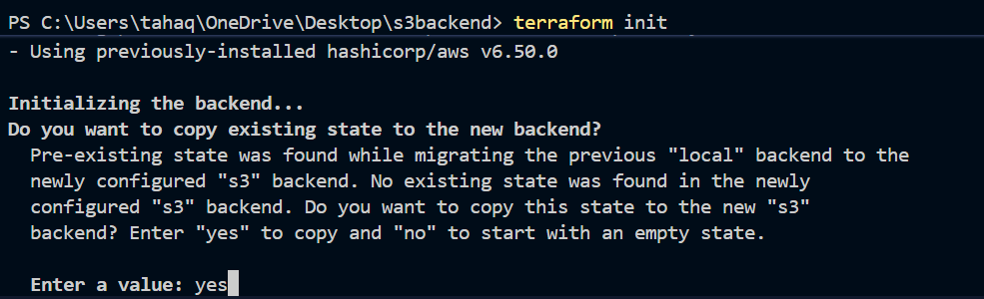

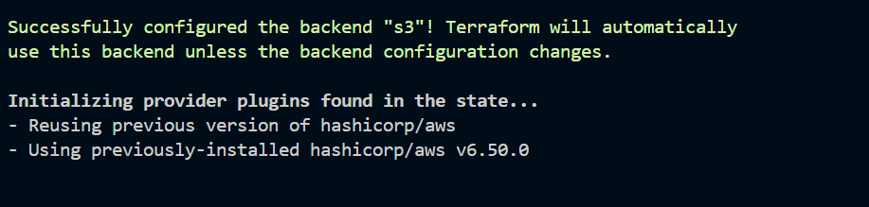
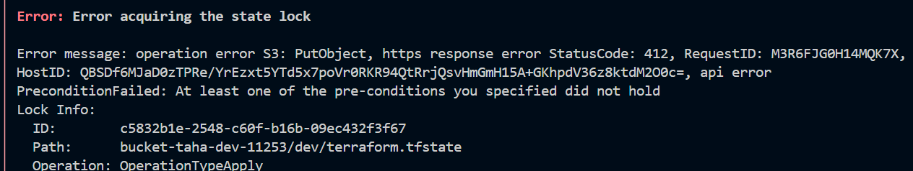
When I try to run terraform apply command from two terminals the lock does not allow me to do it
So we have used “use_lockfile “ command to achieve state lock

