- Execute scripts from the video
First lets create a folder named terraform project
Inside that create a folder aws_instance
Create a main.tf and variables.tf file inside aws_instance folder
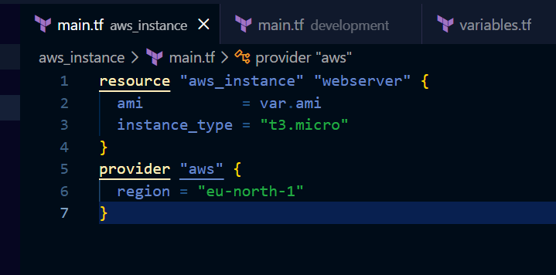
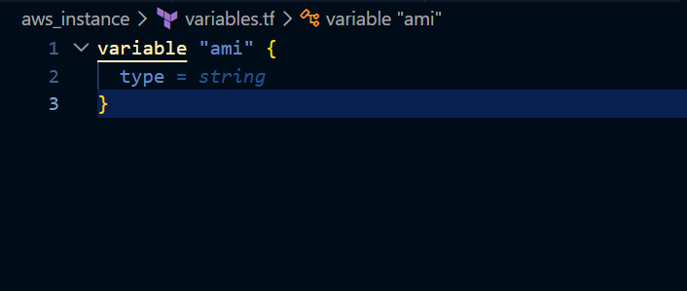

Create a folder named development and create a main.tf file inside it
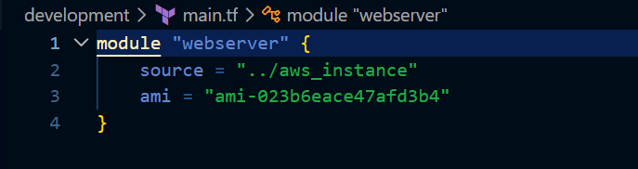
Here we are using a module and calling the module
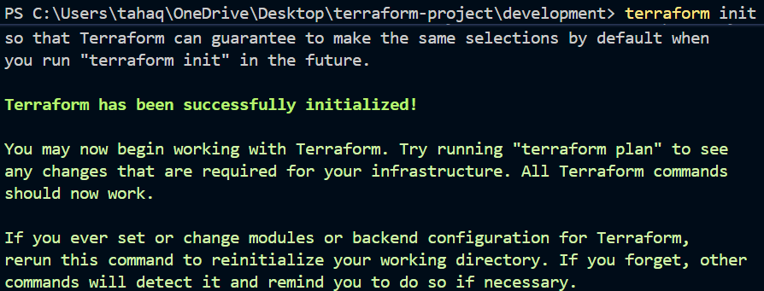
Initializing the backend
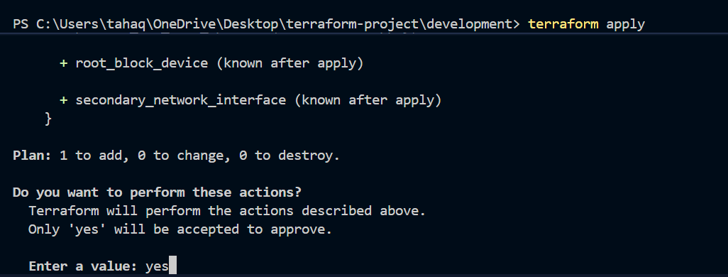
One change that is aws instance to be created
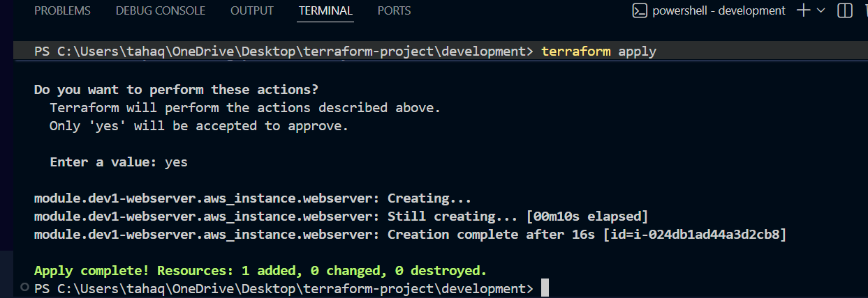

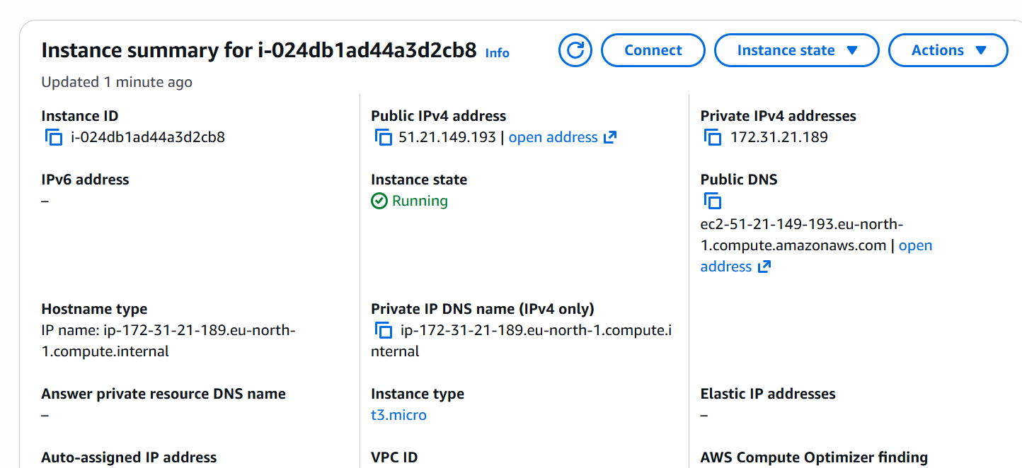

The instance is now created

2. Terraform Workspace
Terraform workspaces allow multiple state files to exist within the same Terraform configuration. This helps manage different environments such as:
- Development (Dev)
- Testing (QA)
- Staging
- Production (Prod)
Each workspace maintains its own Terraform state, ensuring that infrastructure changes in one environment do not affect another.
àLets create a project inside root
- terraform workspace new projectB
- terraform workspace list
- terraform workspace select default
- terraform workspace select projectB

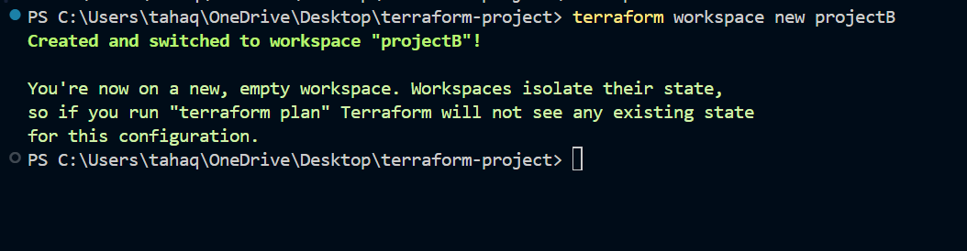
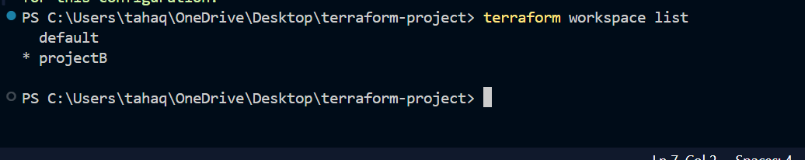
Switching to workspace
Lets now apply changes again
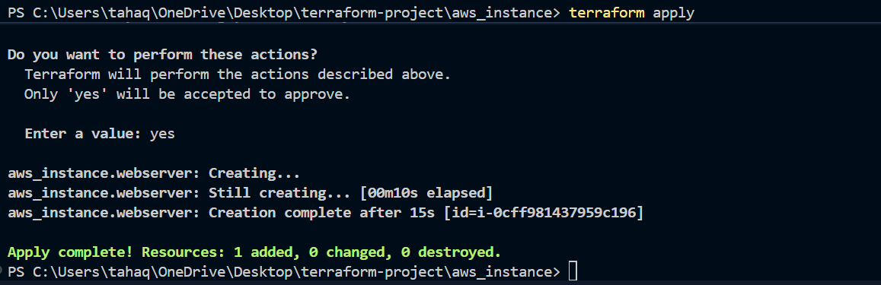
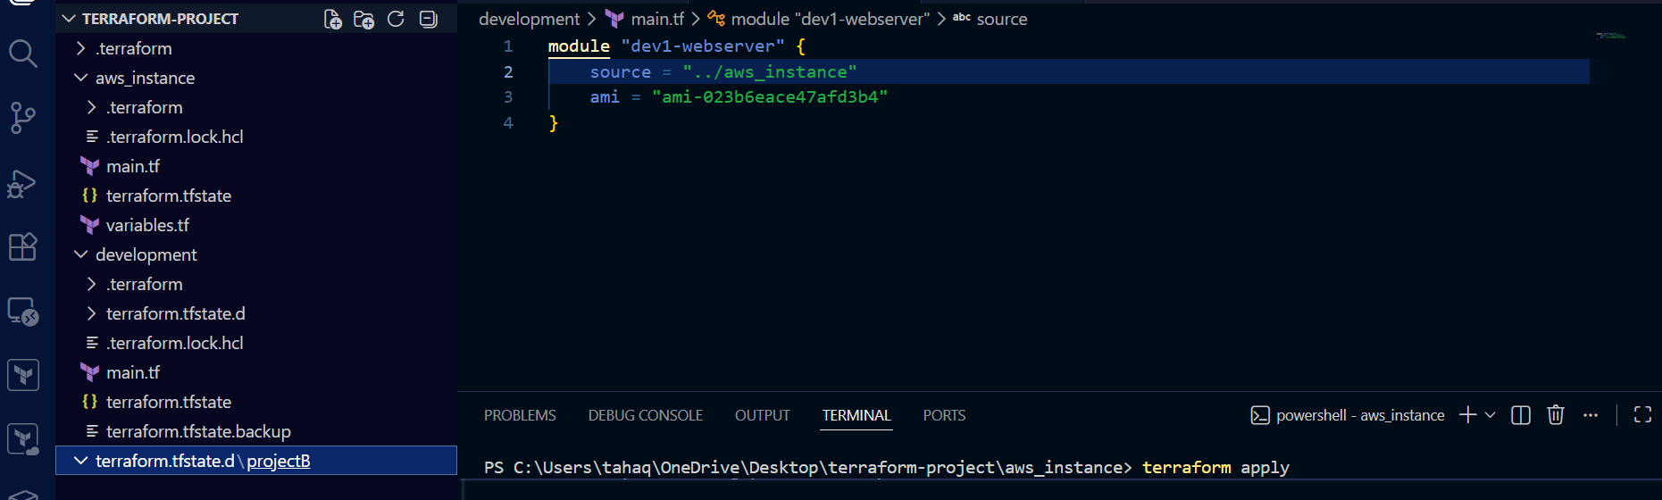

terraform.tfstate.d folder confirms that workspace is managing separate state file

2). Provision EC2, S3, and VPC using Terraform modules.
First create a project folder
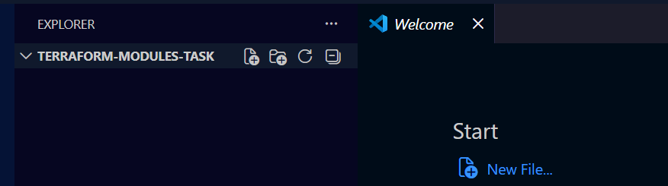
Inside it create
main.tf
providers.tf
variables.tf
outputs.tf files.
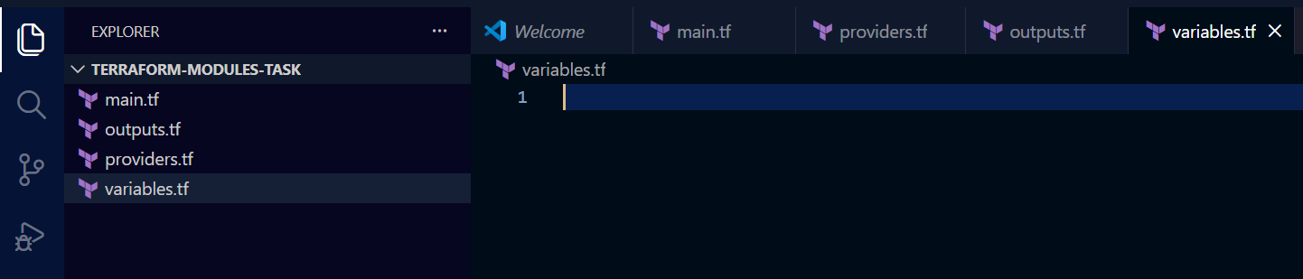
Also create a module directory as well inside the root directory
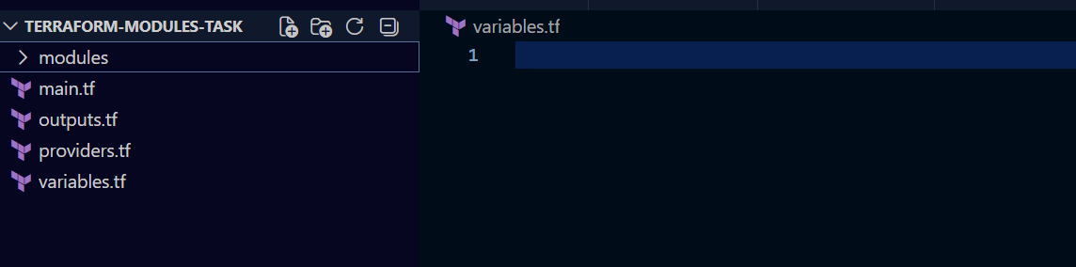

Now lets create the infrastructure
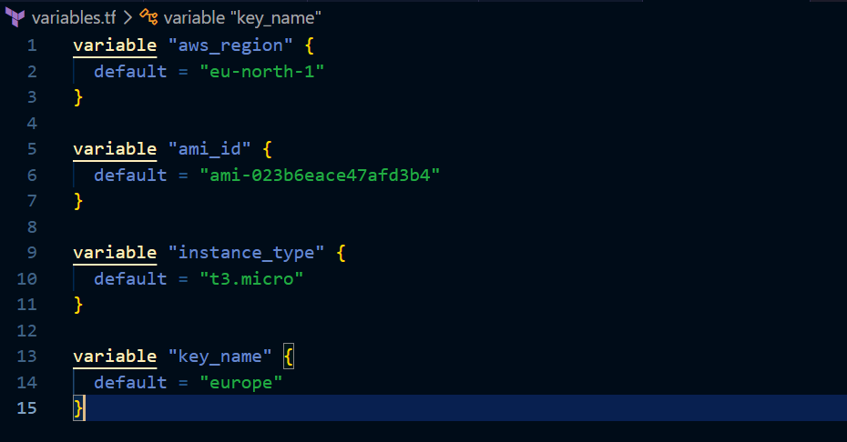
These are the variables in our configuration
Required providers
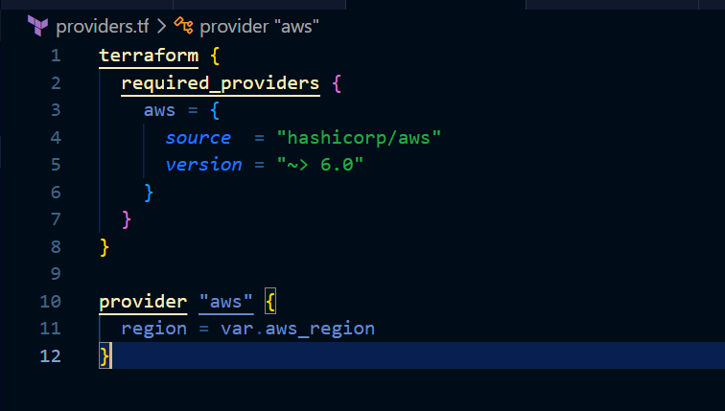
Here we are using the region value from the variables.tf file
Now the main.tf file
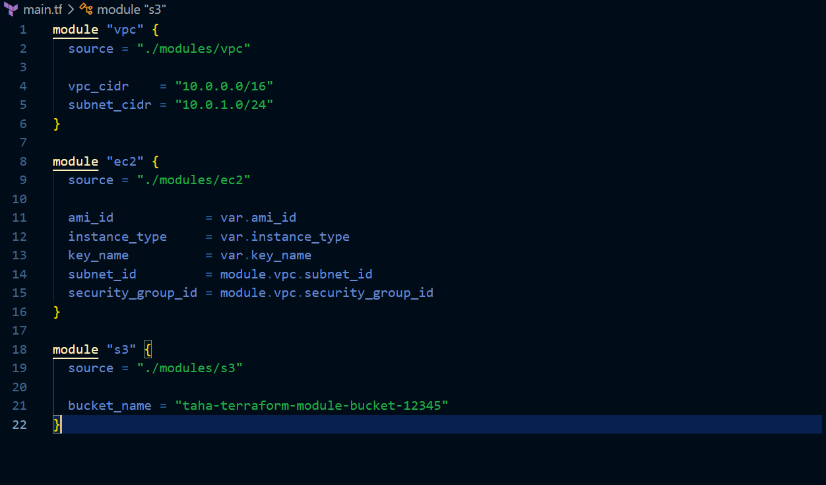

Here we are referring to the modules for each service which we will create inside the modules directory now
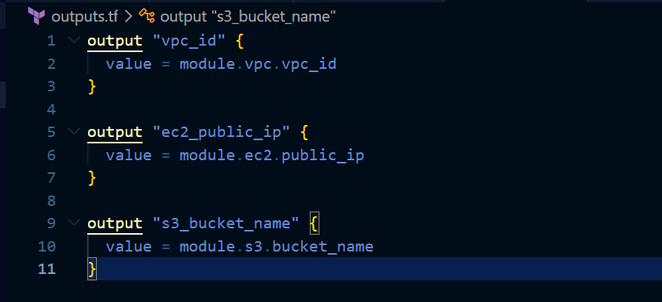
This is our outputs.tf file which will store the output values like vpc id, s3 bucket name and public ip address of our ec2 instance
Now lets create 3 modules for the respective services
First under the module directory create a directory for vpc
Inside vpc directory create a variables.tf file
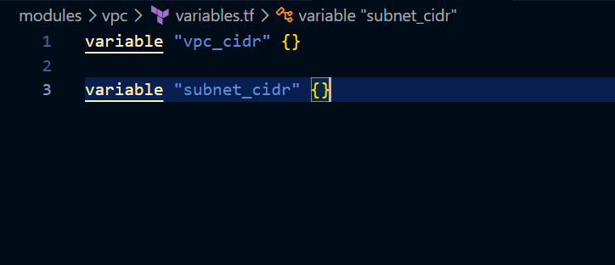
Declaring the variables not defining any value
Now create a main.tf file inside the vpc directory
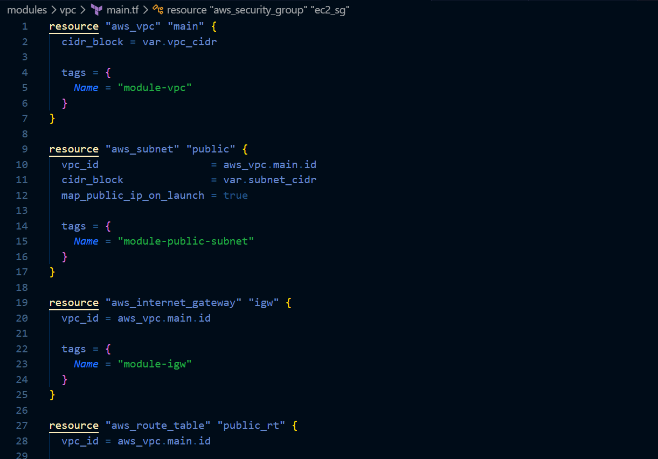
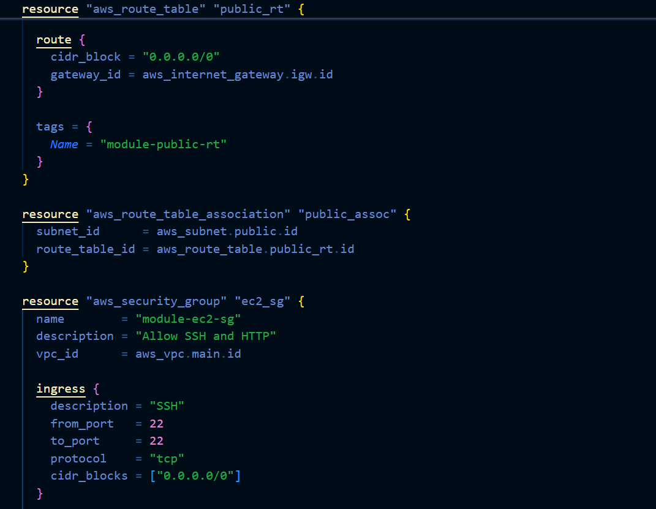
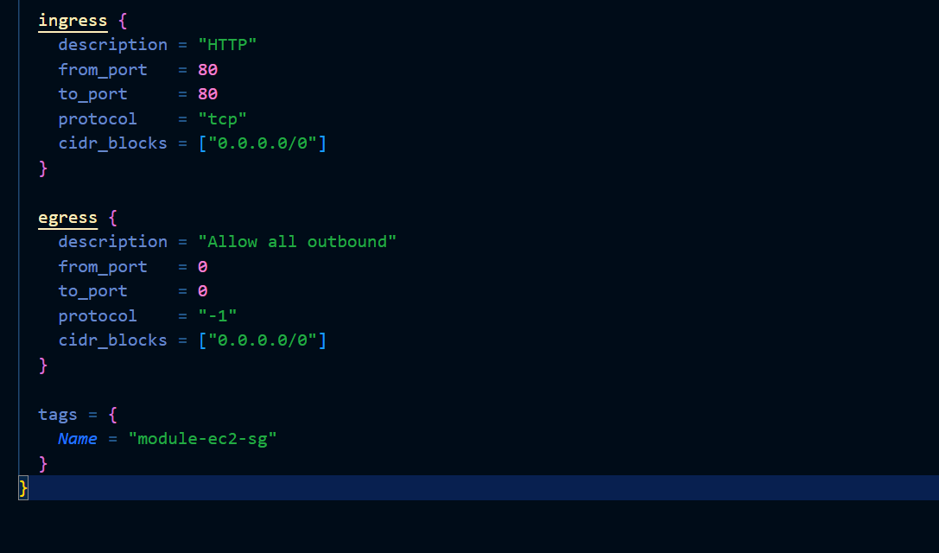
Here we are creating a vpc, public subnet , internet gateway , public route table , security groups with inbound 22 and 80 and outbound all access also we are associating the subnet to the route table
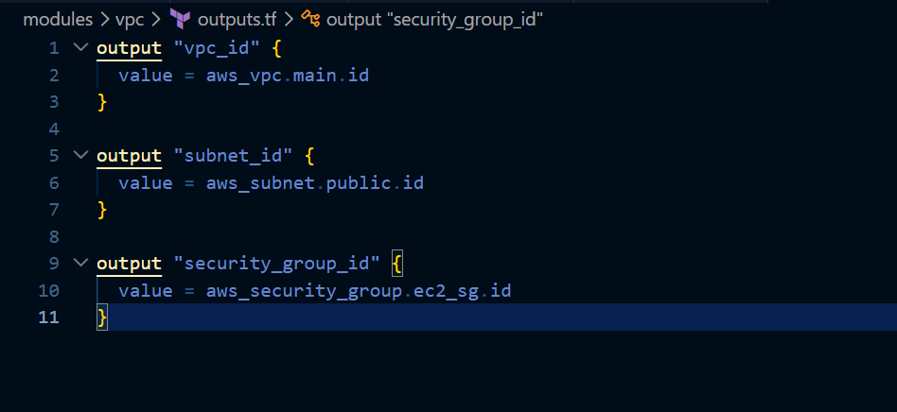
outputs.tf for vpc module
here we will have the output of vpc id subnet id and security group id.

Lets now get to the creation of ec2 module
Inside root directory create ec2 directory
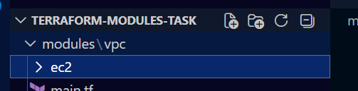
Now lets create a variables.tf file inside ec2 directory
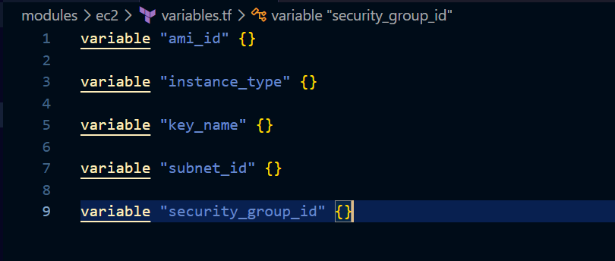
Here we are declaring variables but not defining them

main.tf file for ec2 instance
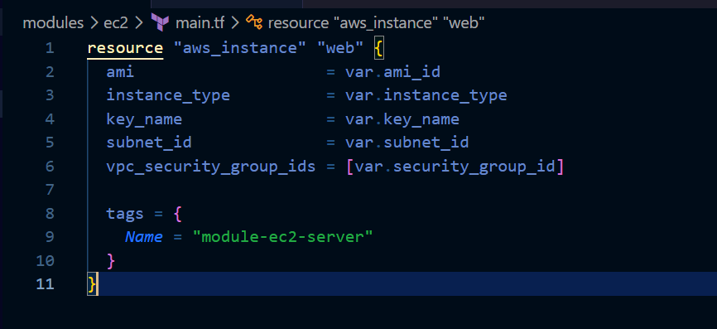

outputs.tf file for ec2 here we are storing public ip and and instance id
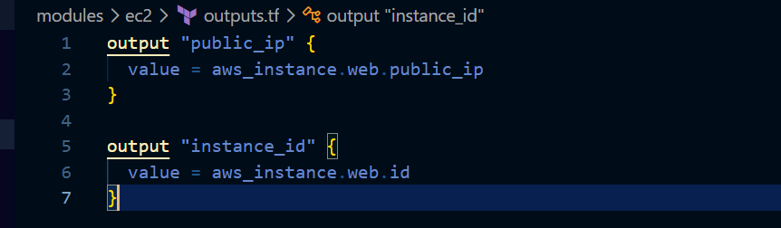

Lets now create the s3 module

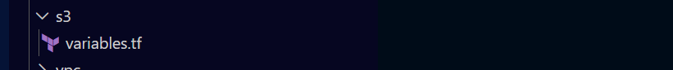
Now create a variables.tf file
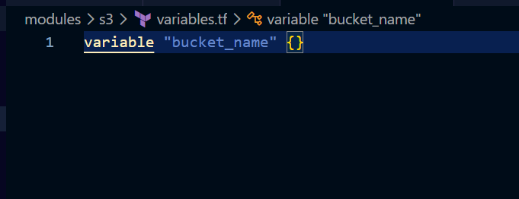
This is the main.tf file we are using the variable bucket name from variables.tf file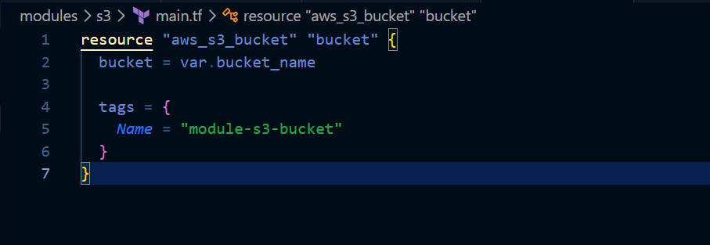
This is outputs.tf here we are storing the bucket name
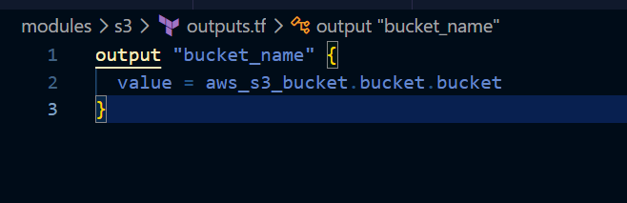

Lets now initialize our project
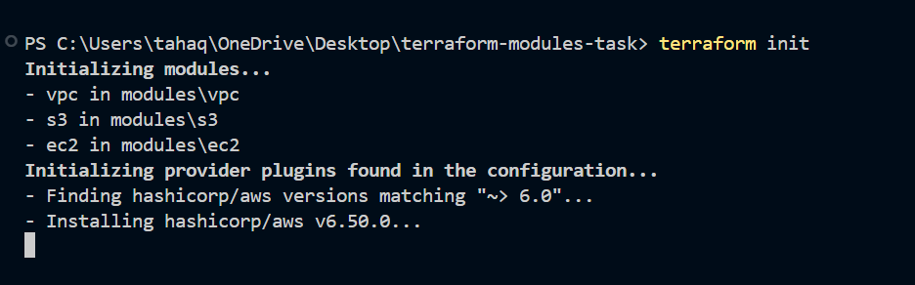
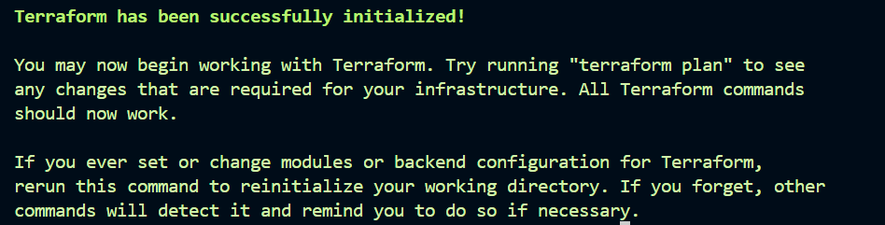
Terraform validate to check if the configuration is correct
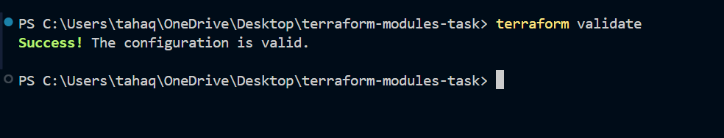
Lets now do terraform plan
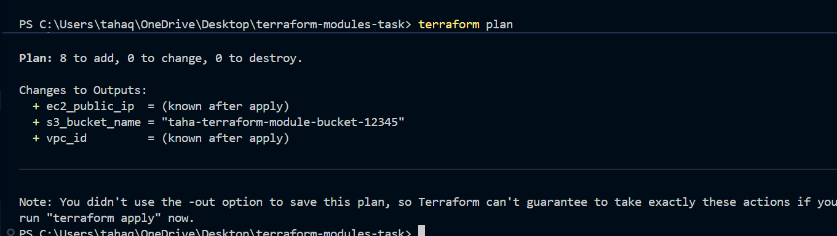
It shows 8 to add
Lets now create the infrastructure by applying the changes
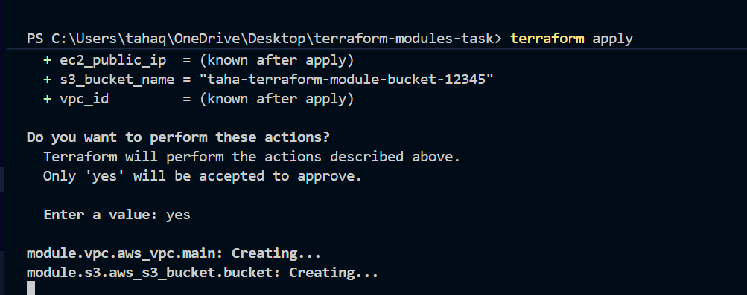
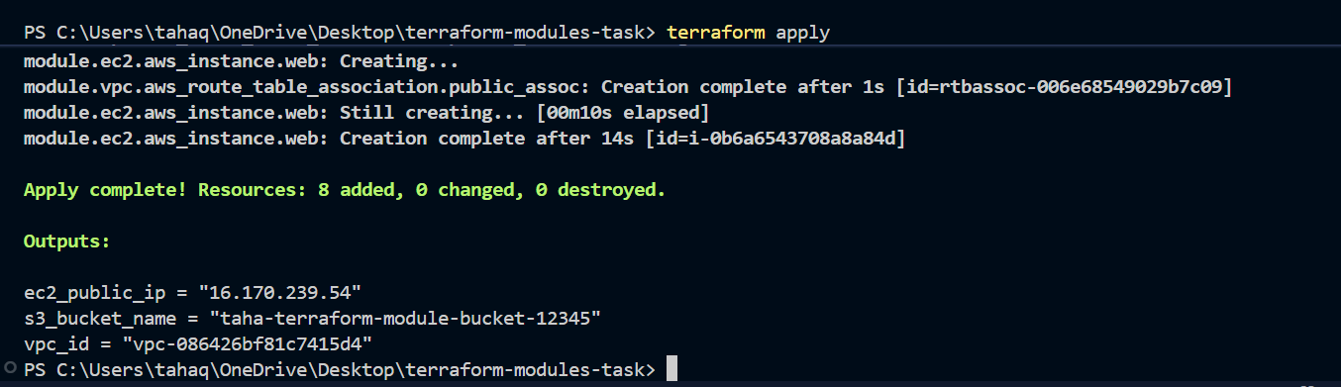
The infrastructure is now created
Lets confirm in the console as well
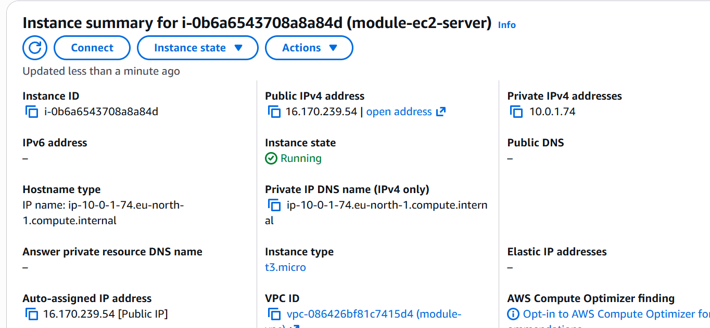
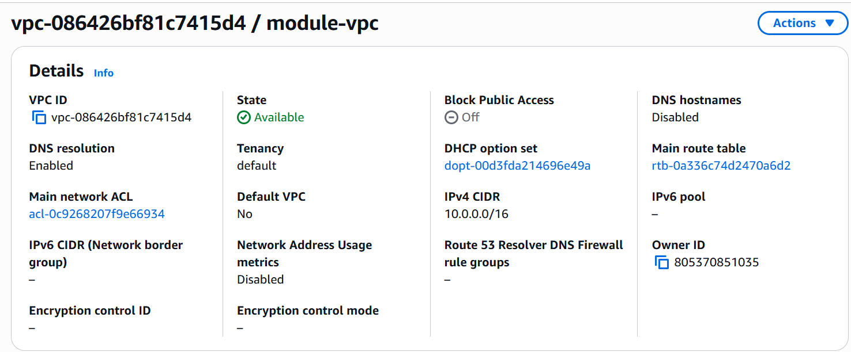
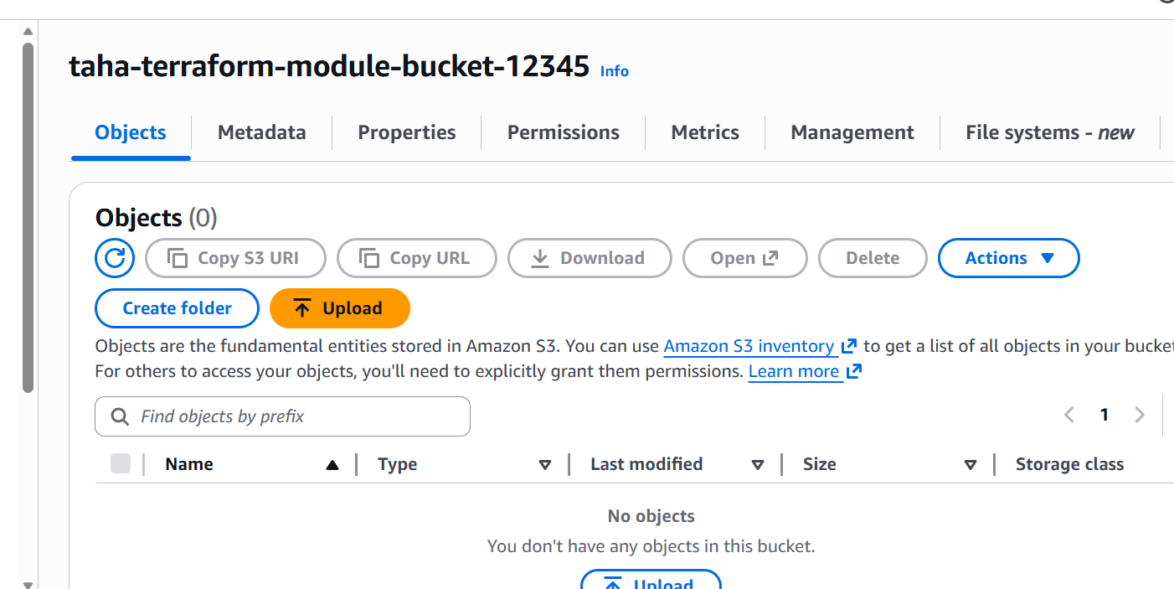

We can see that vpc ec2 and s3 are created

03). Provision EC2 for 3 different environments (Dev, Staging, and Prod) using Terraform workspaces.
Lets now create instances using workspaces
First lets create a folder and add
providers.tf
main.tf
outputs.tf
variables.tf
variables.tf:
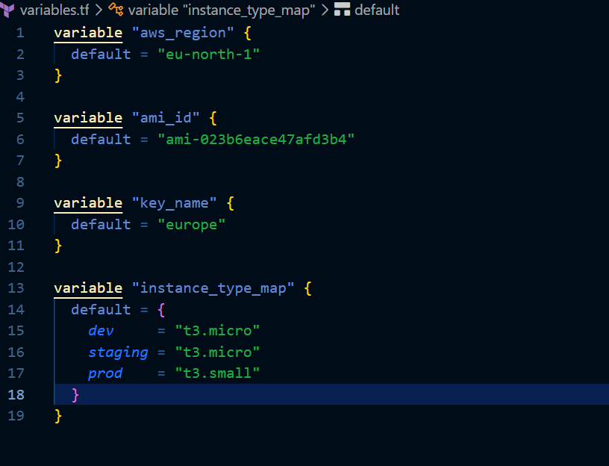
These are the variables used

Providers.tf
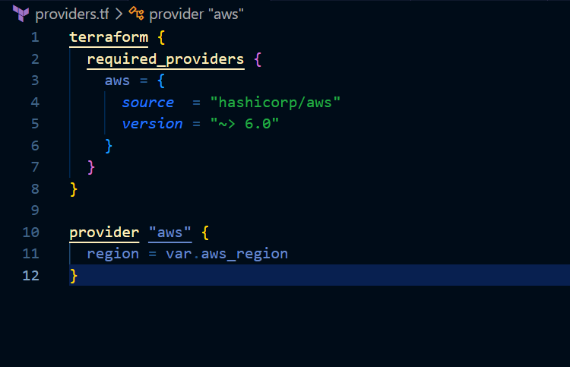
These are the providers region we are fetching from the variables.tf file
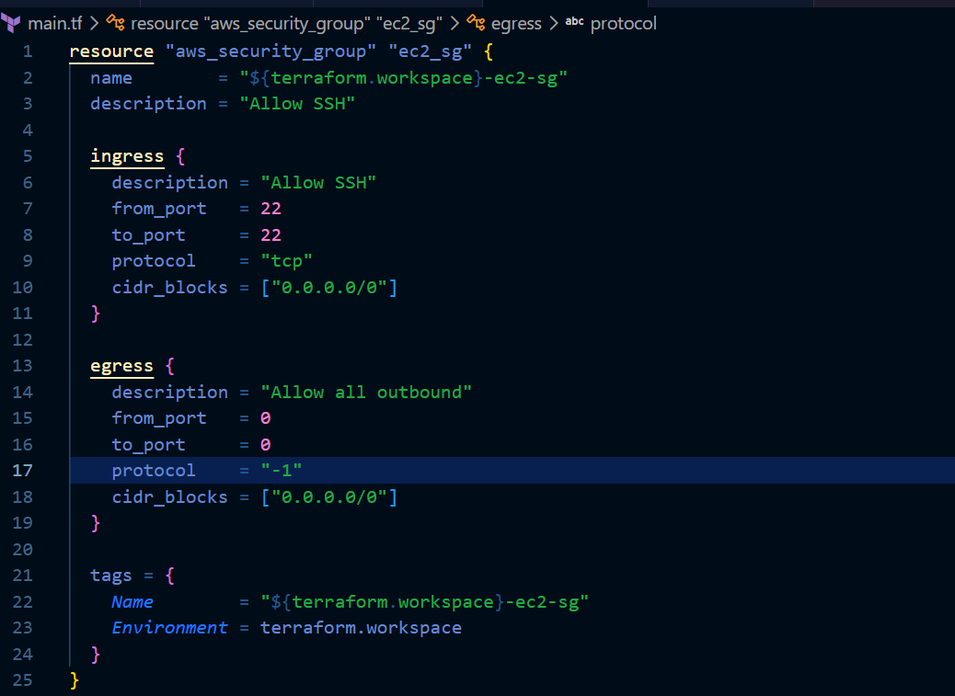
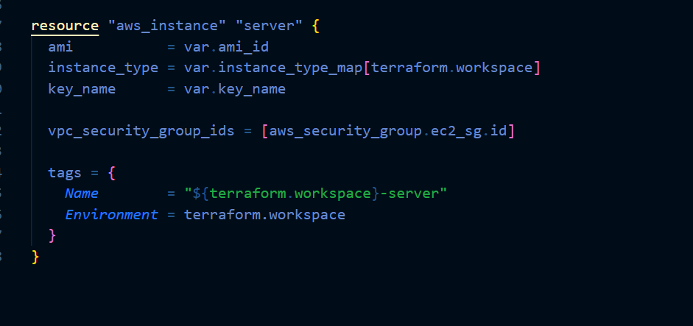
Lets now create the infrastructure
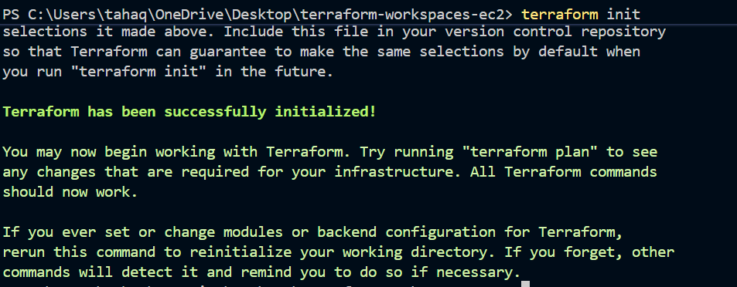
Now lets create a workspace
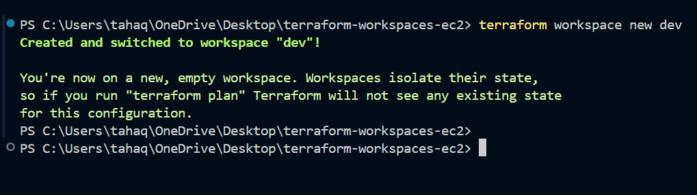
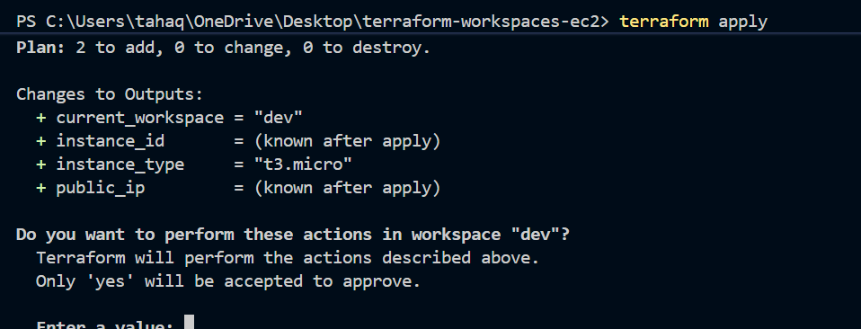
Based on our workspace terraform will create the instance
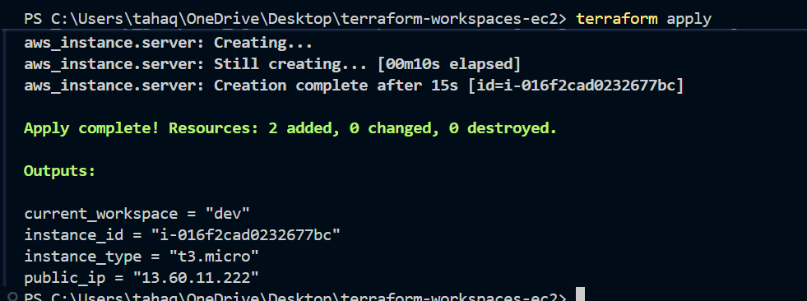
The instance is now created let’s now verify it in the console
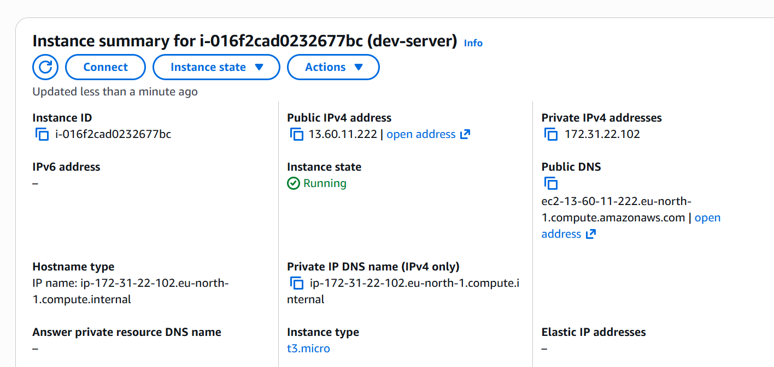
We can verify that the instance is created .
Lets now create for the production
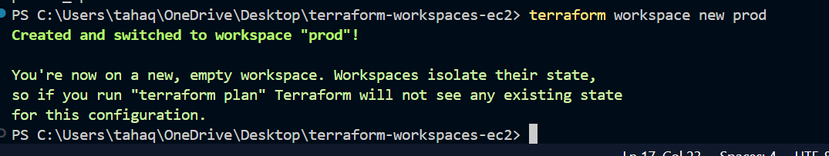
Apply the changes
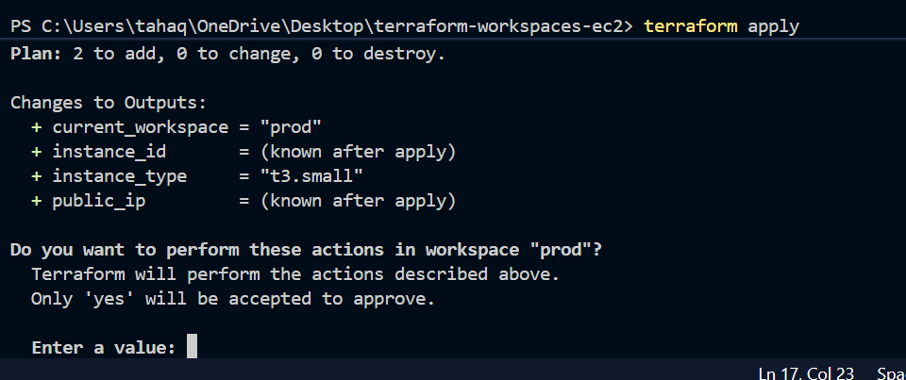
We can see that it is going to create a t3.small instance for production

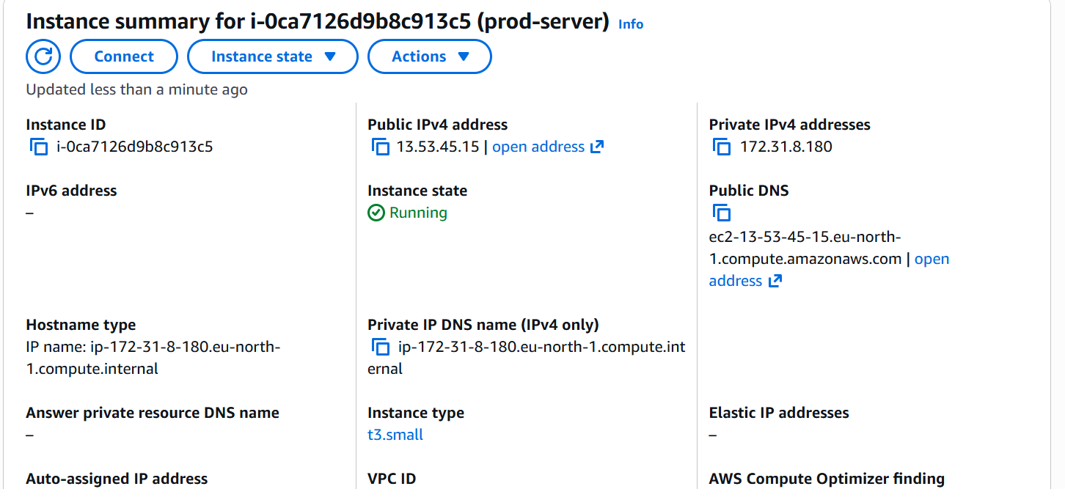
The instance has been created.
The main.tf file contains the AWS resources required for the project. In this task, it creates a Security Group and an EC2 instance. Terraform workspaces are used to manage multiple environments such as Dev, Staging, and Production using the same codebase. The terraform.workspace variable dynamically identifies the active environment and is used to assign resource names, tags, and instance types. This approach avoids code duplication and allows separate Terraform state files for each environment while maintaining a single Terraform configuration

