- Create a tomcat container on 8080 and deploy sample application in tomcat.

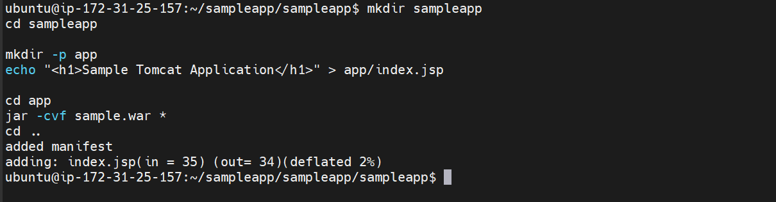

Creating and adding a sample deployment file

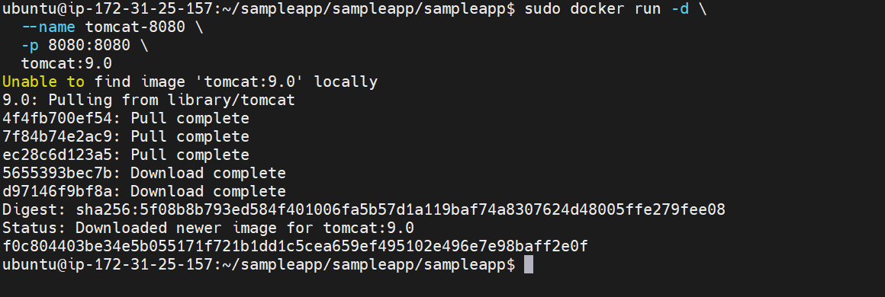

Created a new tomcat container with tomcat 9.0 image

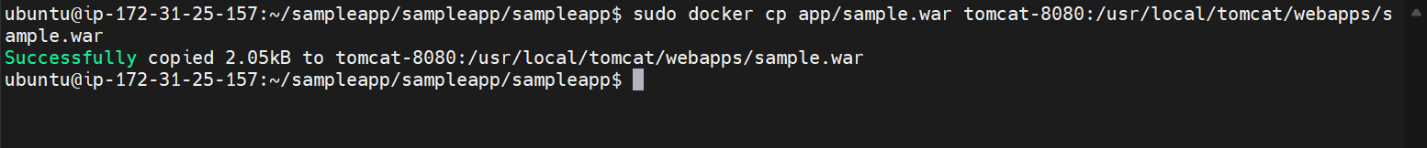

Copied the sample file from docker host to docker container

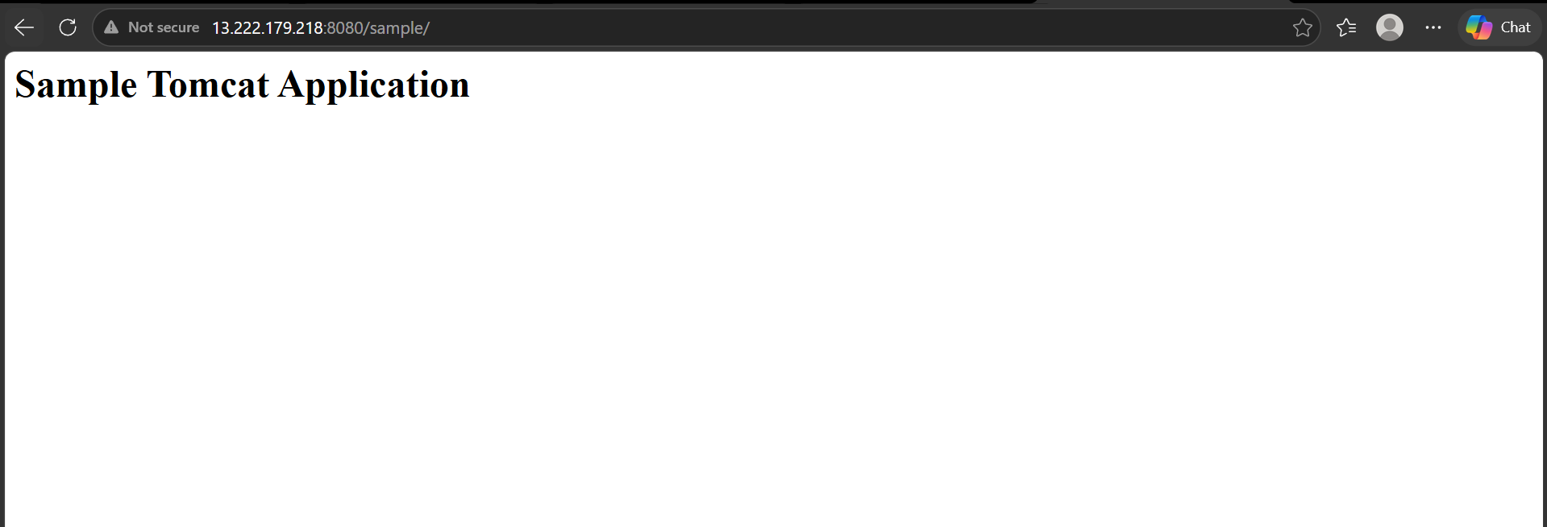

We have now deployed a sample file on tomcat container.

- Create volume and deploy tomcat container on port 8081.

Lets now create a volume

Volume is created

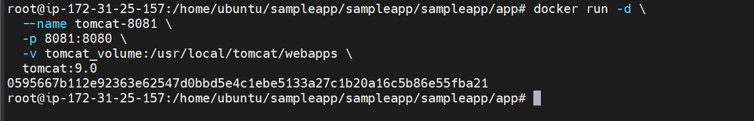

Now we have created a new container also we have used the created volume for persistent storage

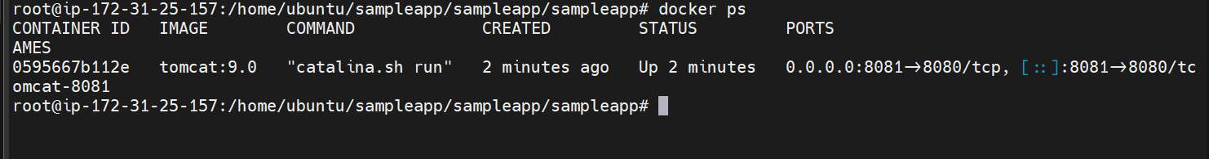

Copying the sample file to the new container

The tomcat container is now running on 8081

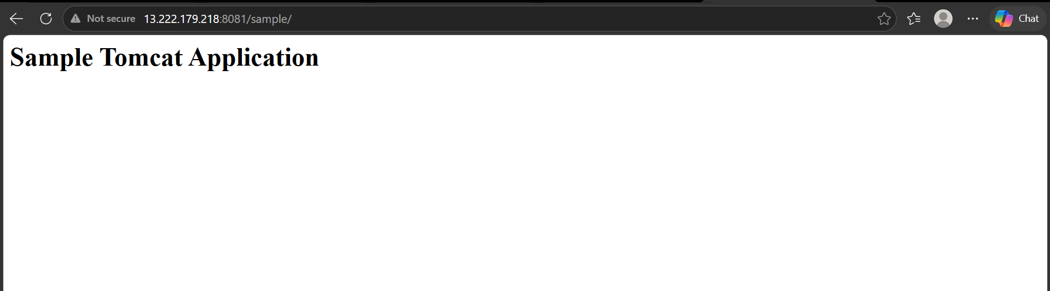

- Limit the nginx container to 500 MB.

Lets now create a nginx container with memory limit of 500 mb

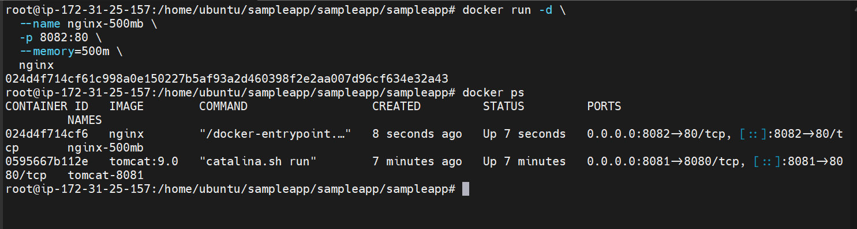
The container has been created
We can see that the container is limited to only 500 mib
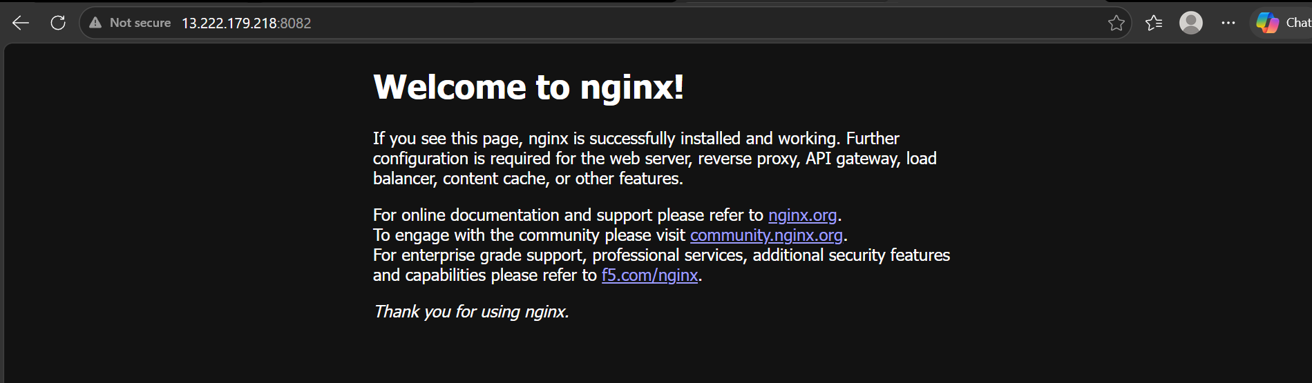
container is running on 8082

- Create a sample docker file using below instructions.
Base module as amazonlinux:latest
Maintainer you name
Install nginx
COPY one index.html file to image
Expose on port 80
Command to start the nginx container

Lets create a index.html file
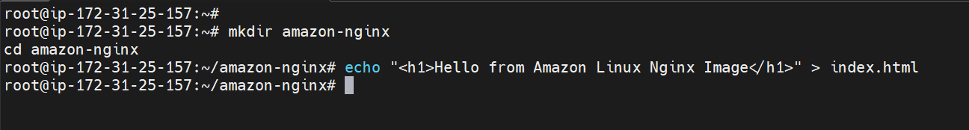

Now lets create a Dockerfile

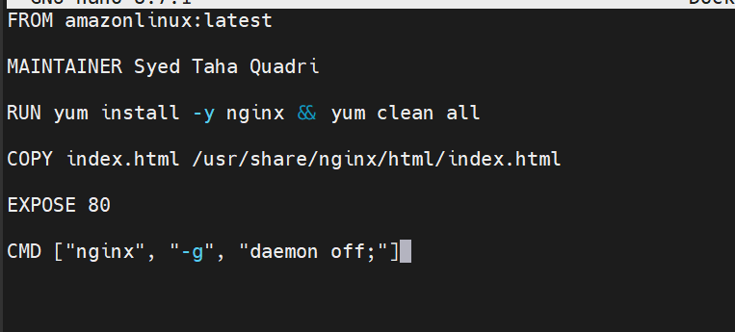

This Dockerfile creates a custom Nginx image using Amazon Linux as the base image, installs Nginx, copies a custom web page (index.html), exposes port 80, and starts the Nginx web server when the container runs.

Lets now build this image
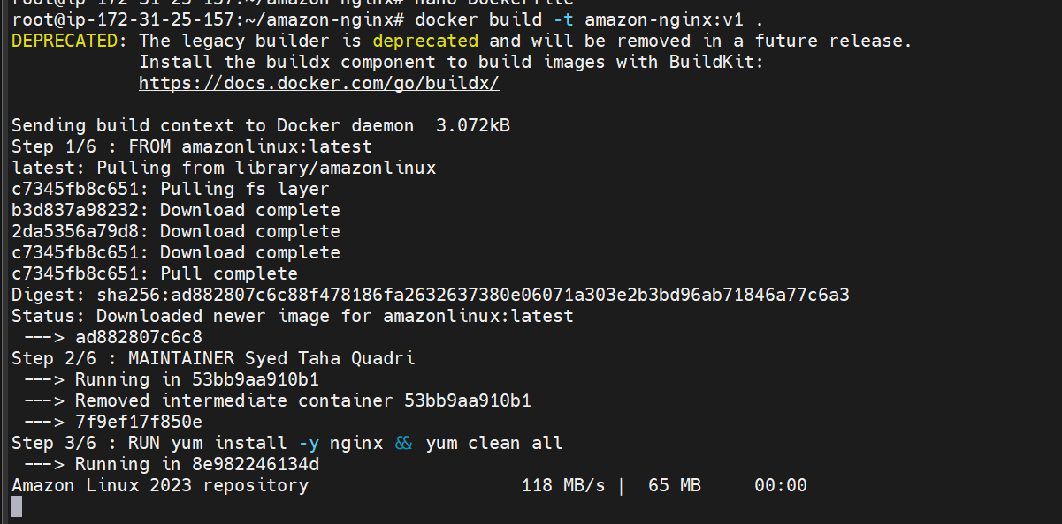
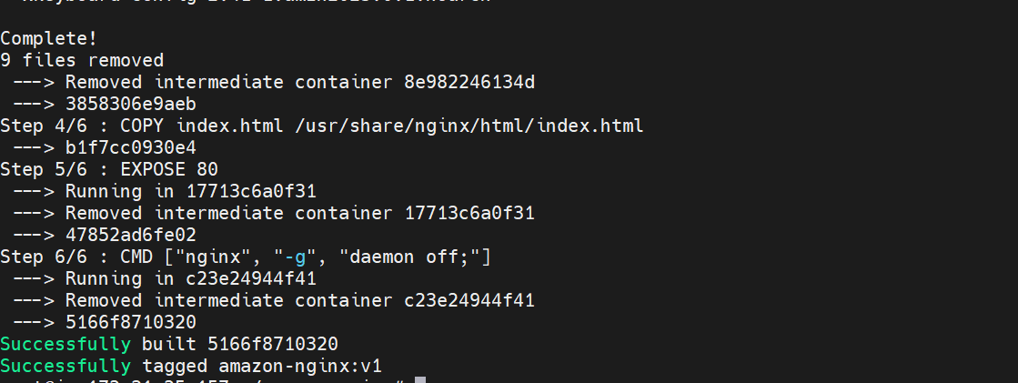
The image has been built

Lets now run the container

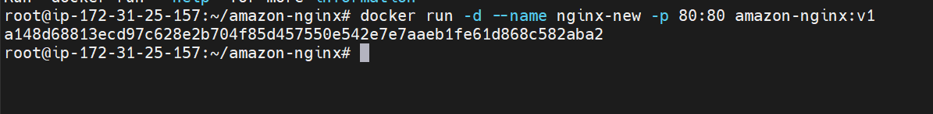
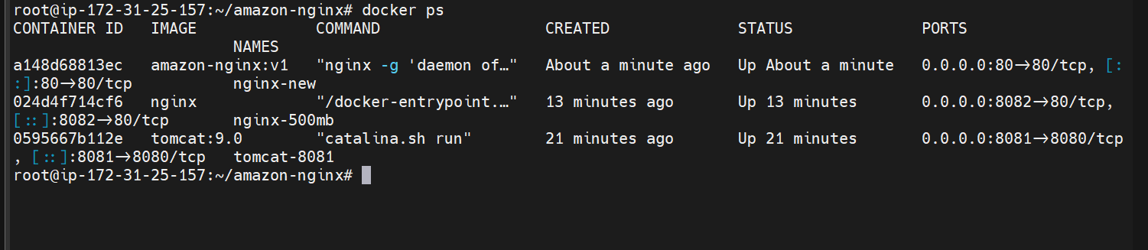

We can see the container is now launched on port 80
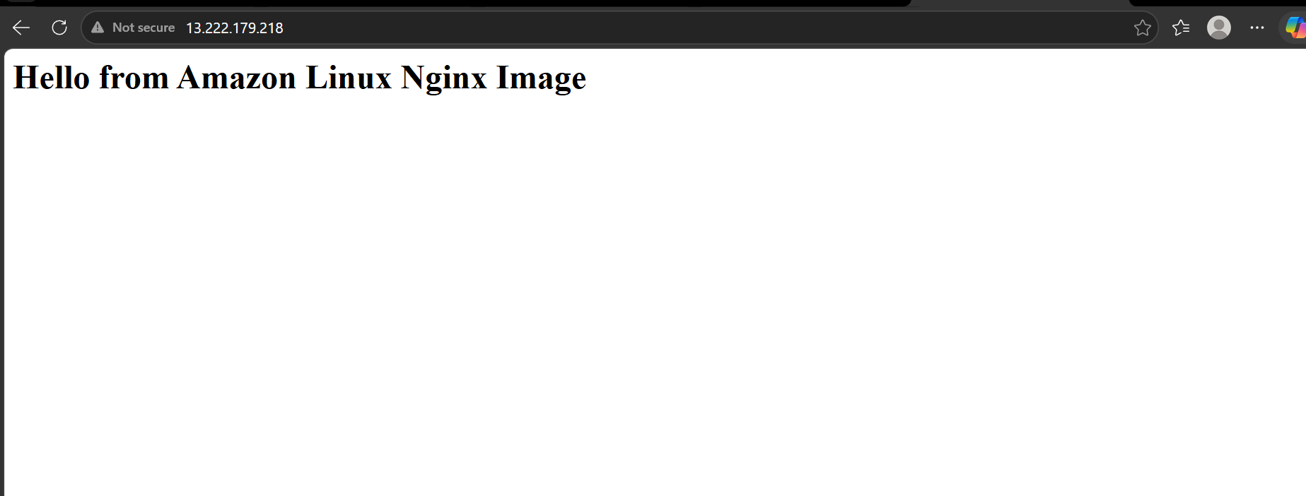

- Lets now push the image to docker hub
We have now logged in to our docker hub account
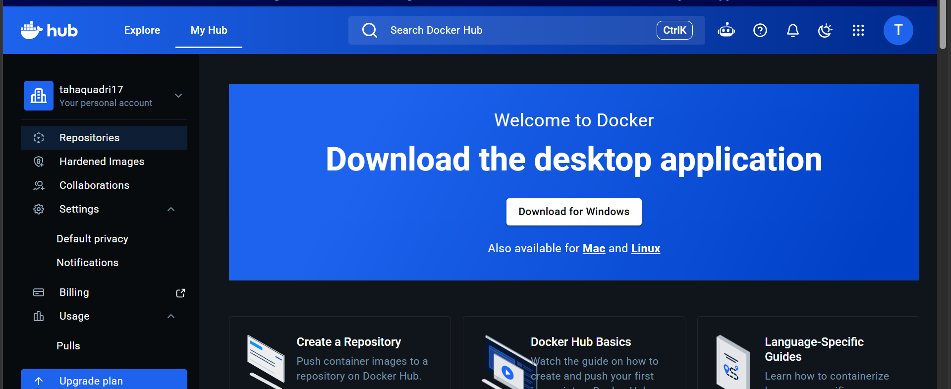

Lets create a new repo
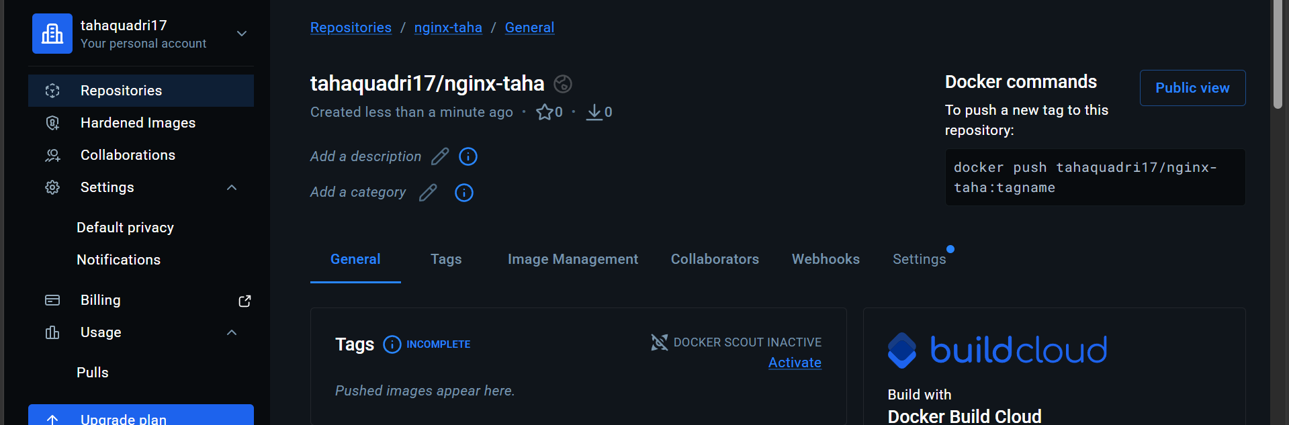
We have now created a new repo

Logging to docker hub through cli

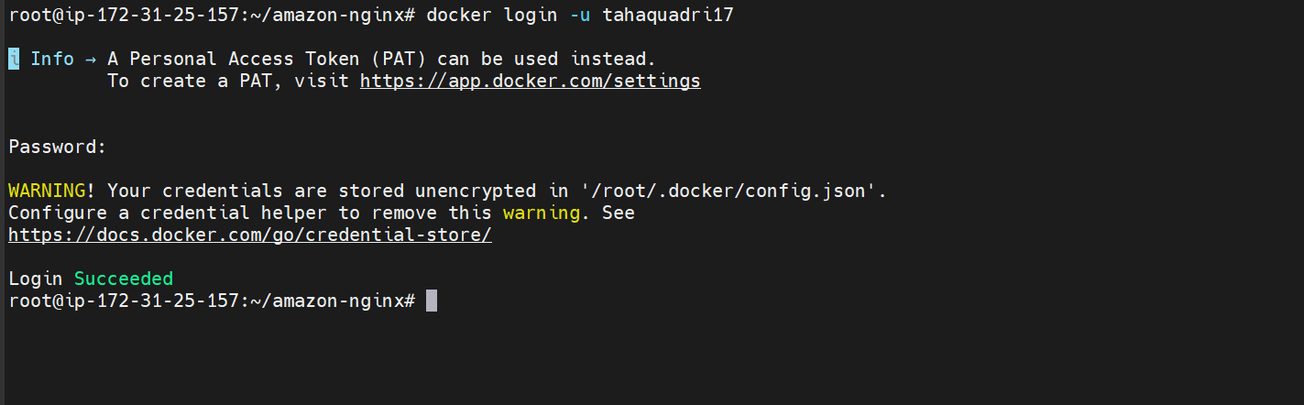

Giving a name to the image according to repo on docker registry

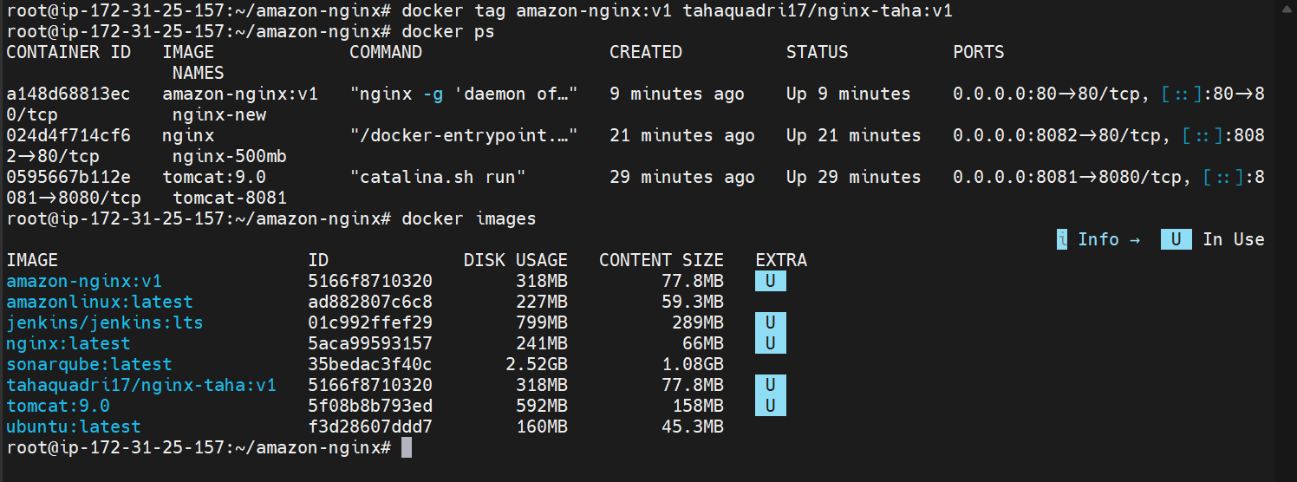
Image has been pushed to docker hub

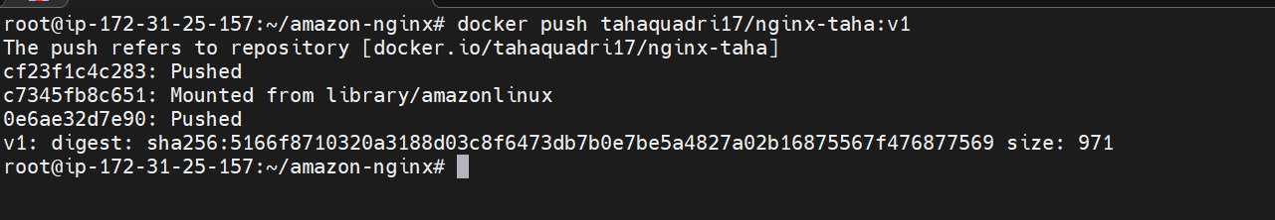
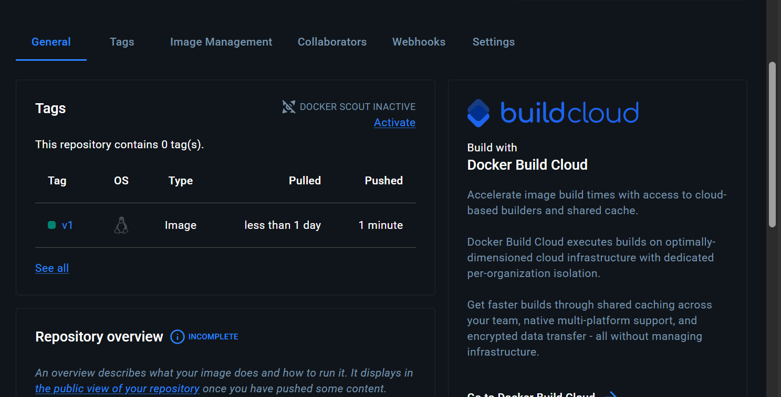

- Push image to AWS ECR

lets now first create a repo in aws ECR

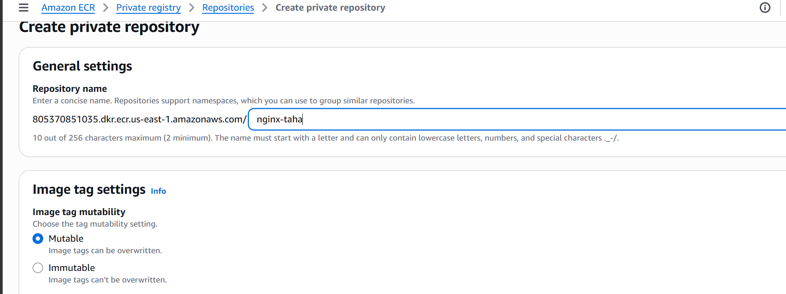

We have now created a repo in aws ECR
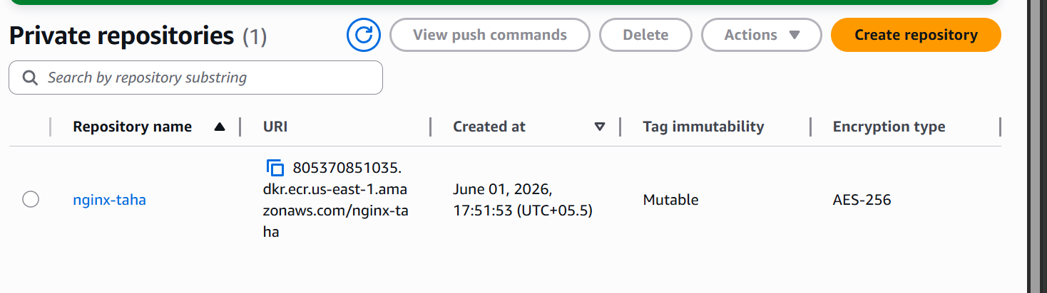

Go inside repo and click on view push commands

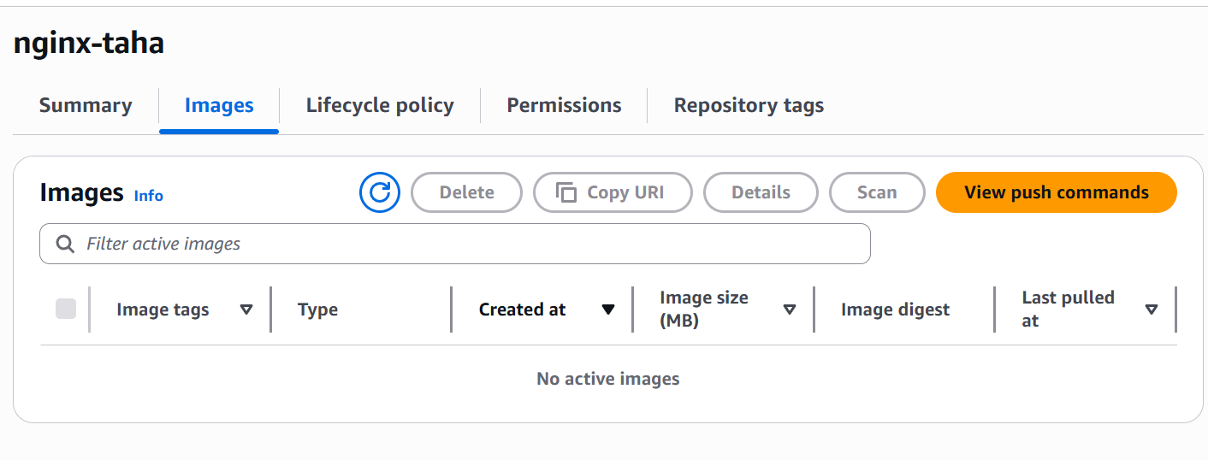

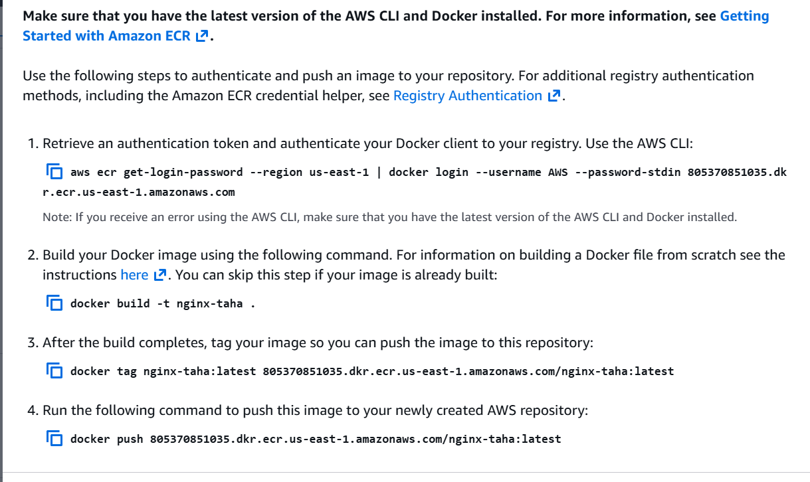

Lets use these commands to authenticate and to push our image to ECR using aws cli
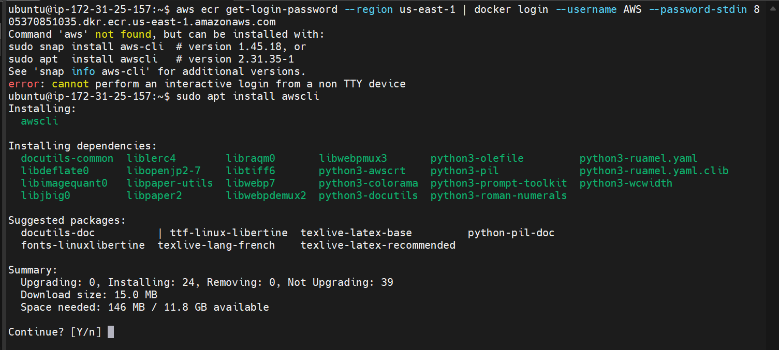

First lets install aws cli in our aws instance

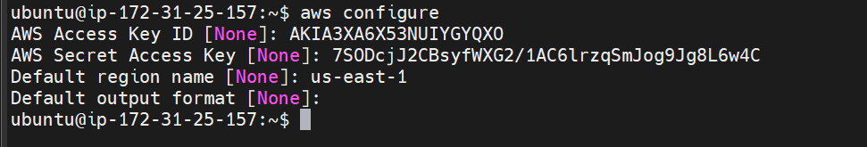

We have successfully logged in to ecr

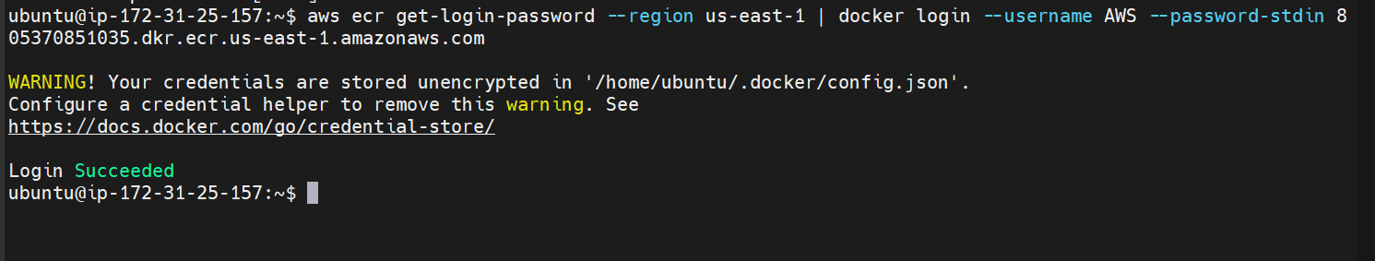

Creating a new image with a tag amazon-nginx:v1

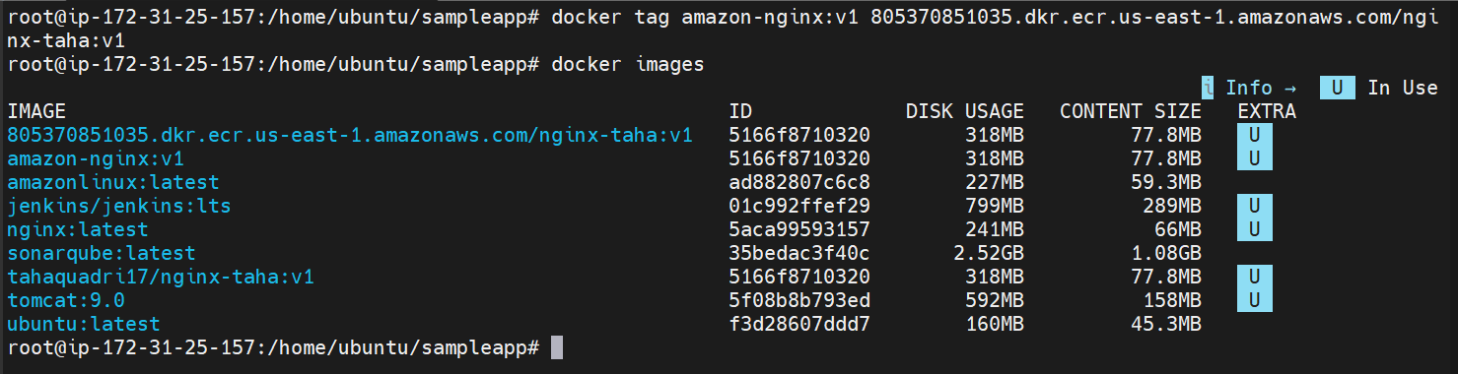

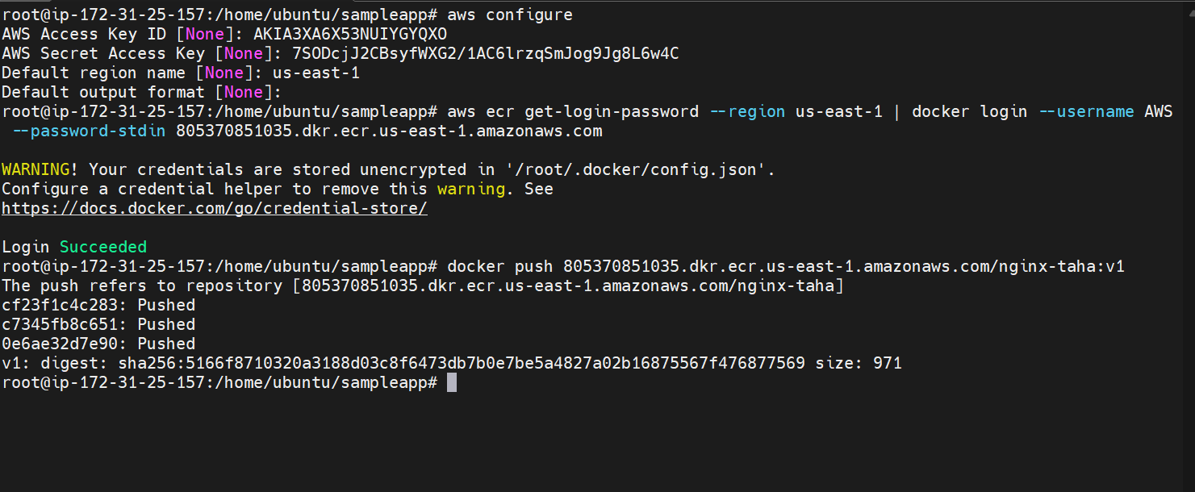

Logged in again as root user and pushed the image to ECR

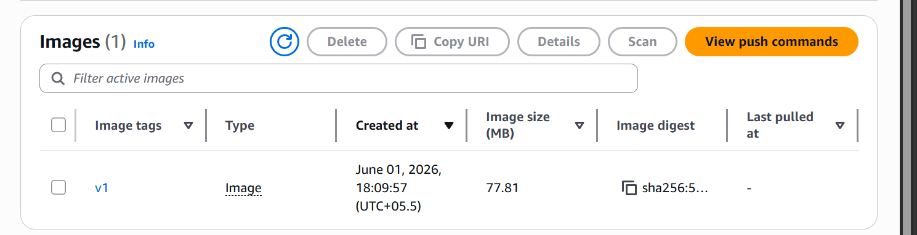

We can see the image is pushed to ECR

