Docker Task:
- Setup a virtual machine using Ubuntu image.
Go to aws console
Give vm a name and select Ubuntu machine
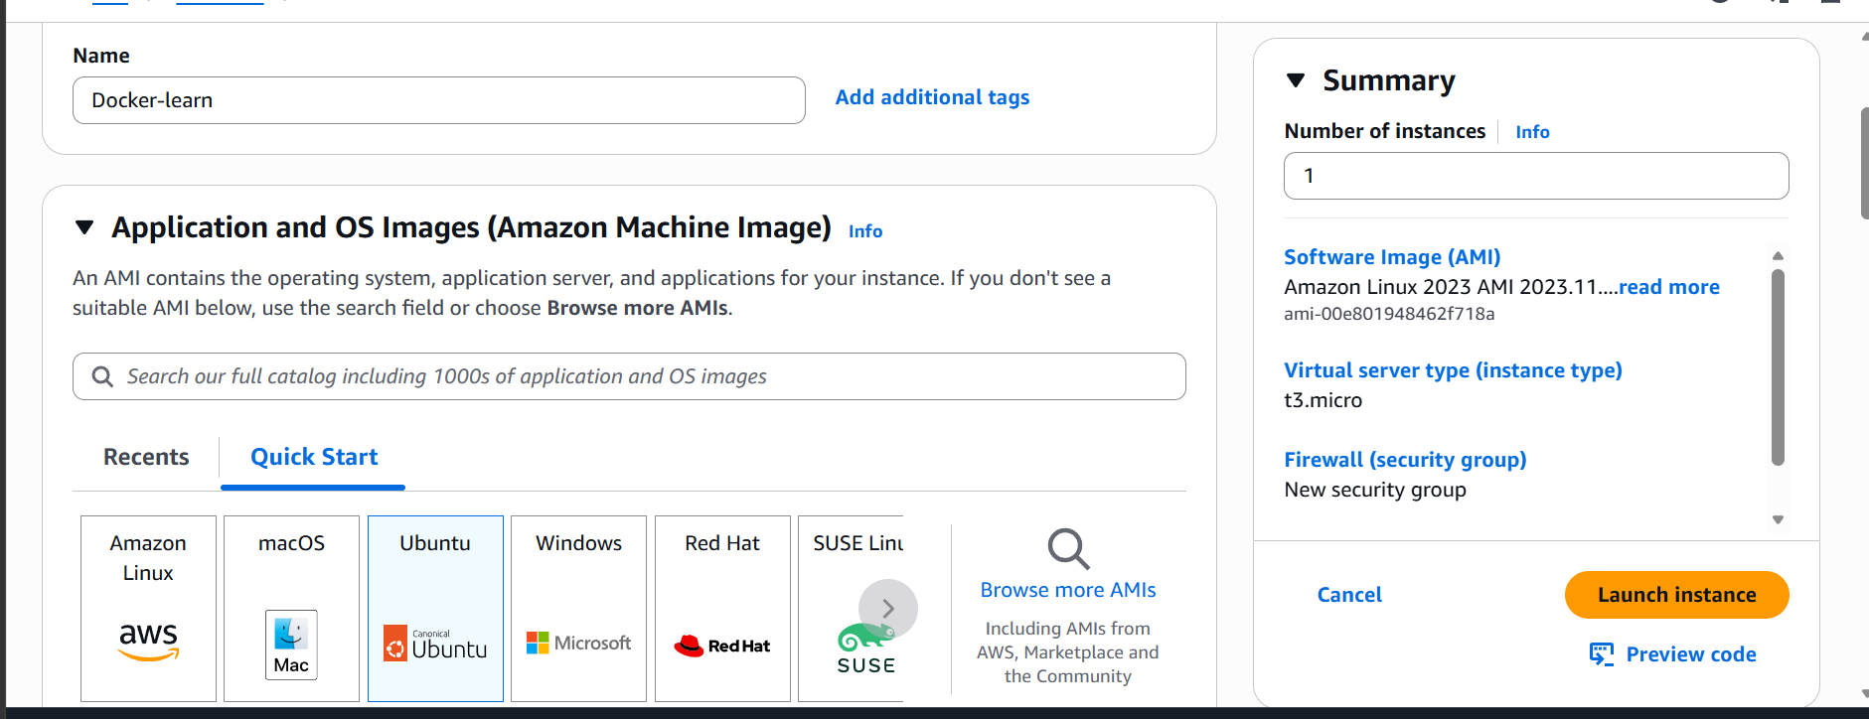
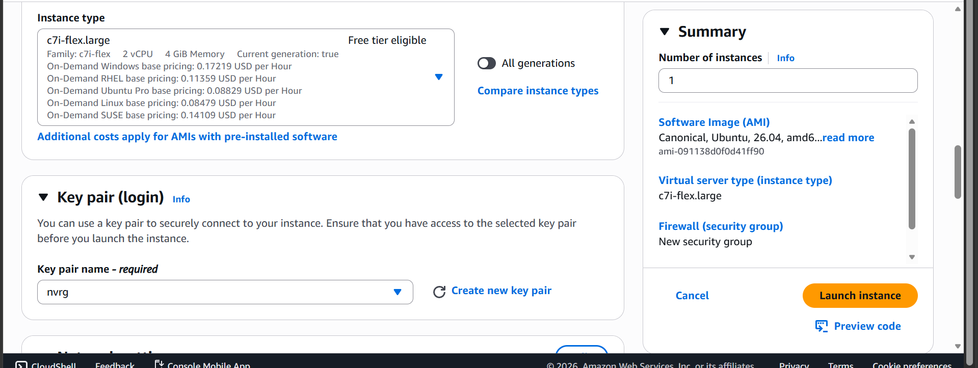

Ubuntu based vm is launched
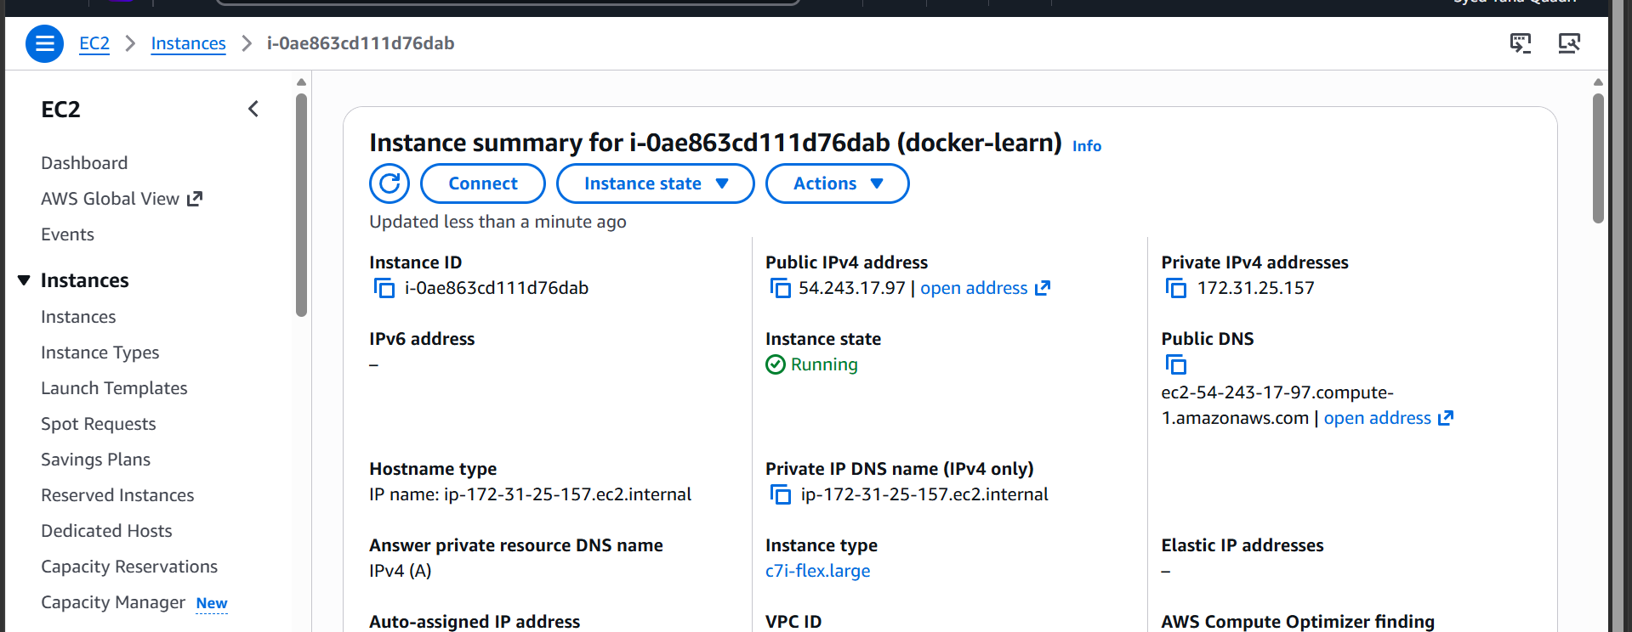

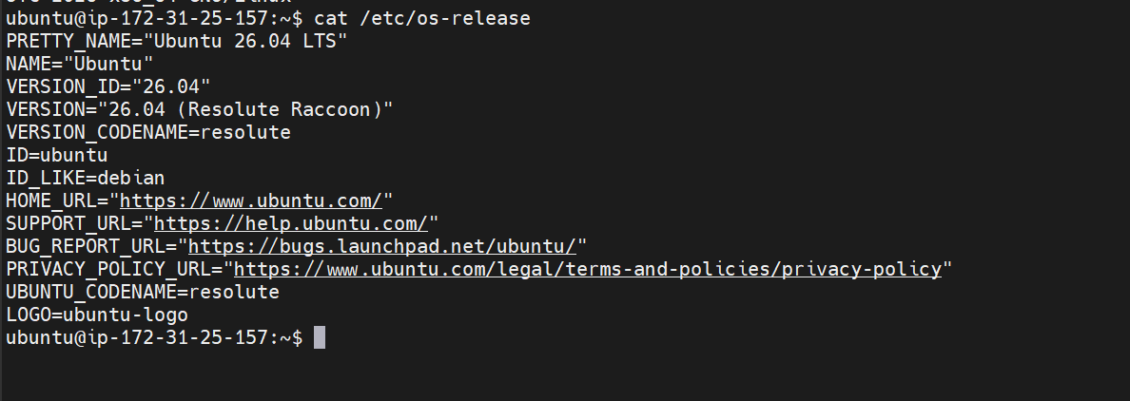

- Install docker on ec2.

First lets update the packages
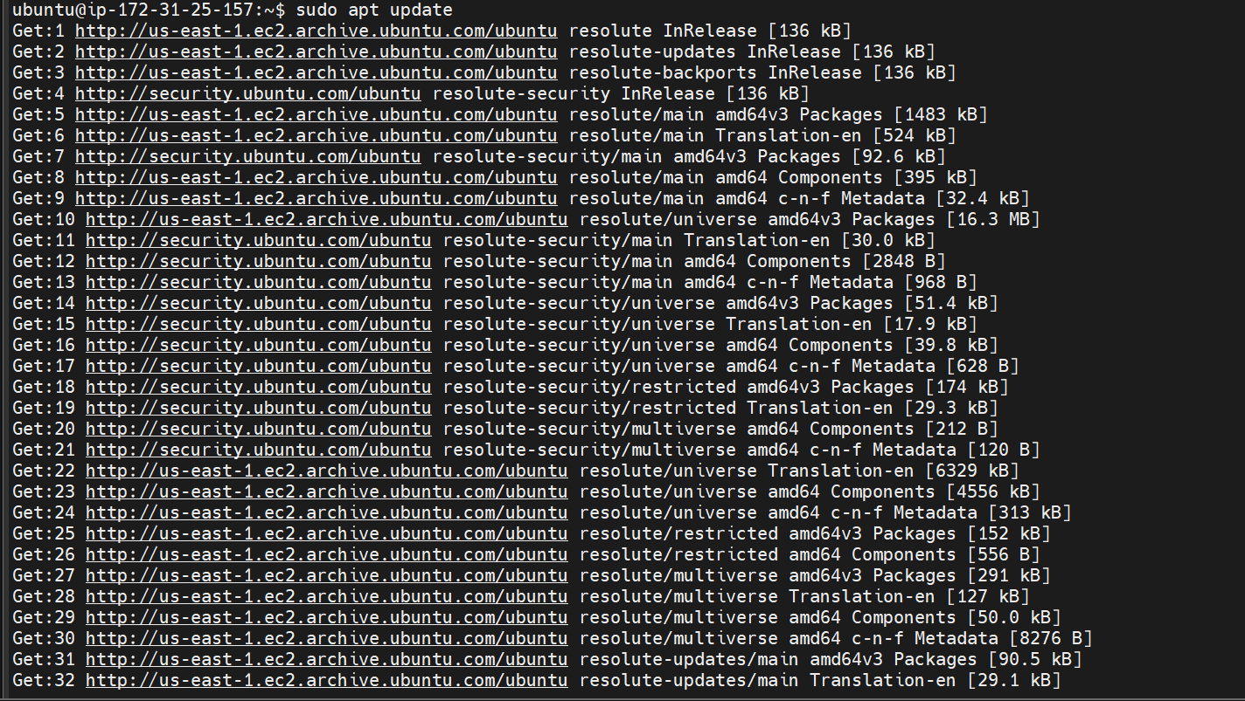

Now lets install docker
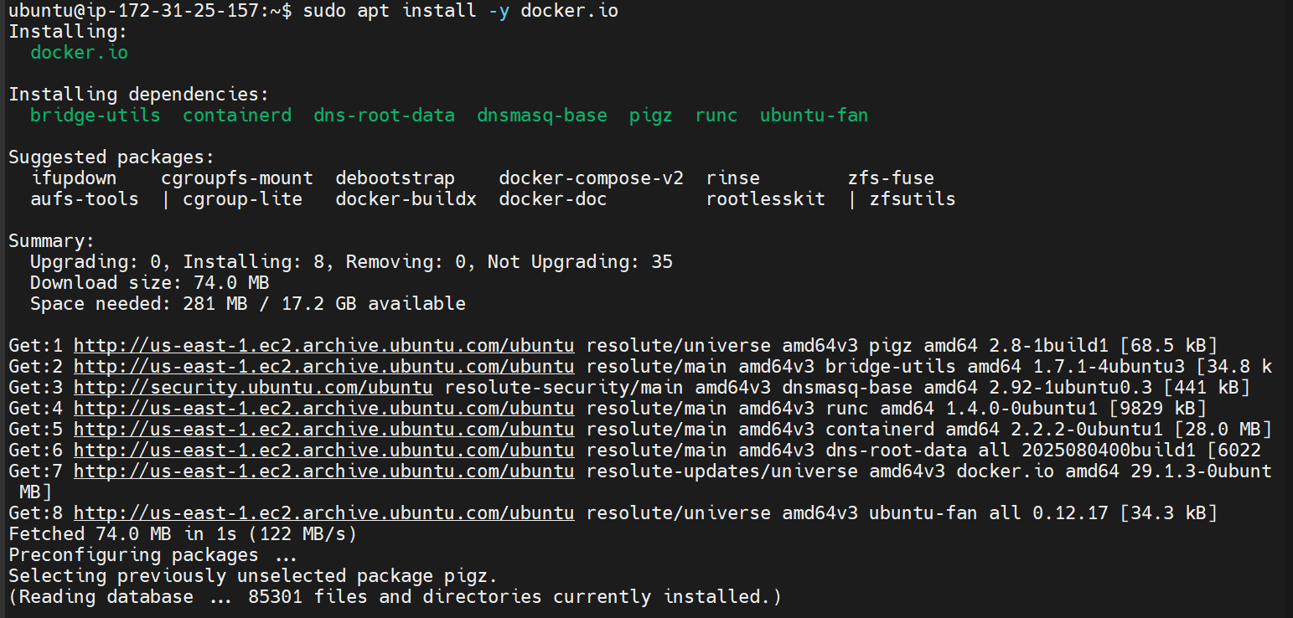
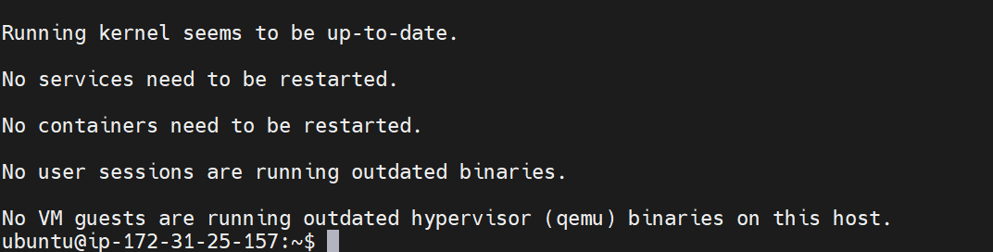
Docker is installed
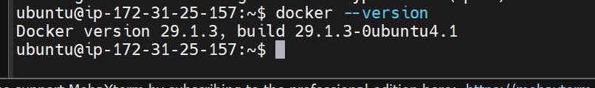

- Pull 5 docker images. (nginx, Apache tomcat, ubuntu, Jenkins, SonarQube)

lets pull all the images one by one
Nginx
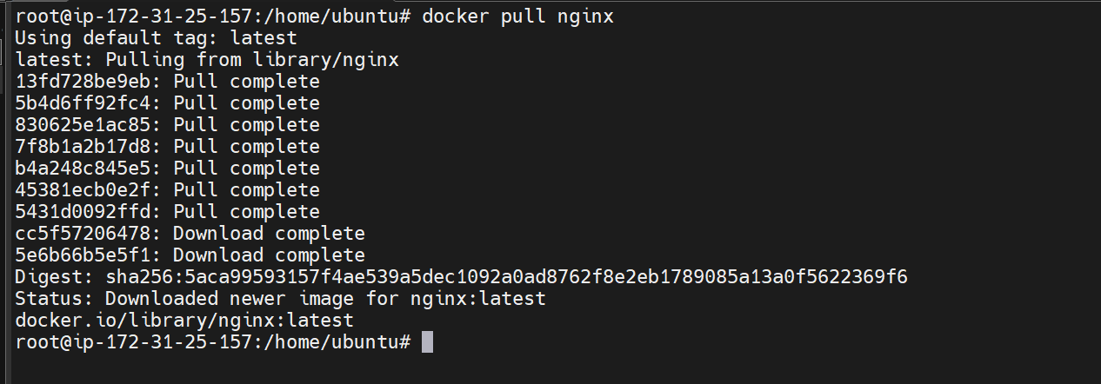

Apache tomcat

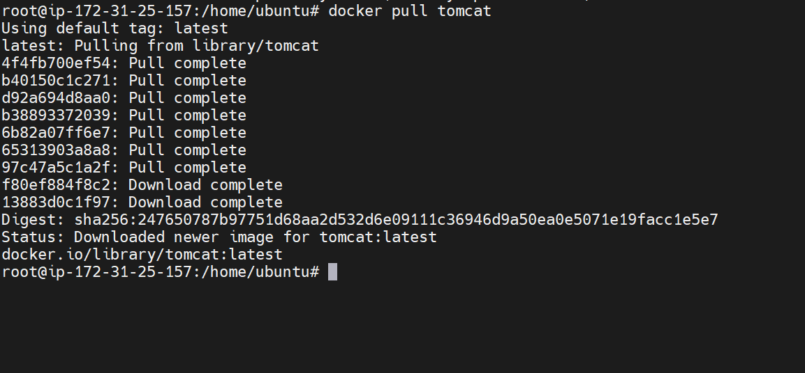

Ubuntu
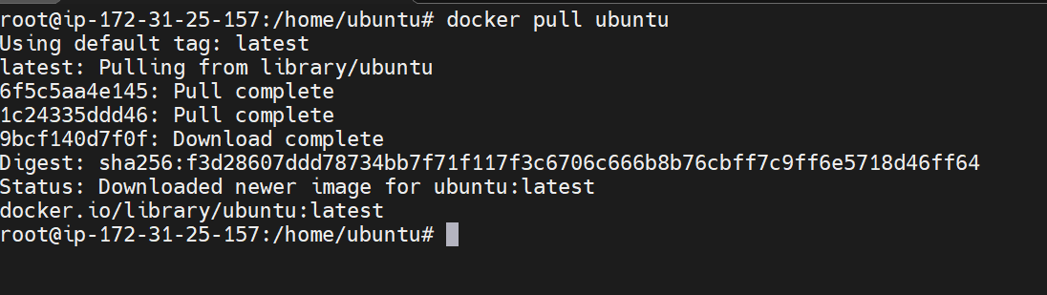
Jenkins
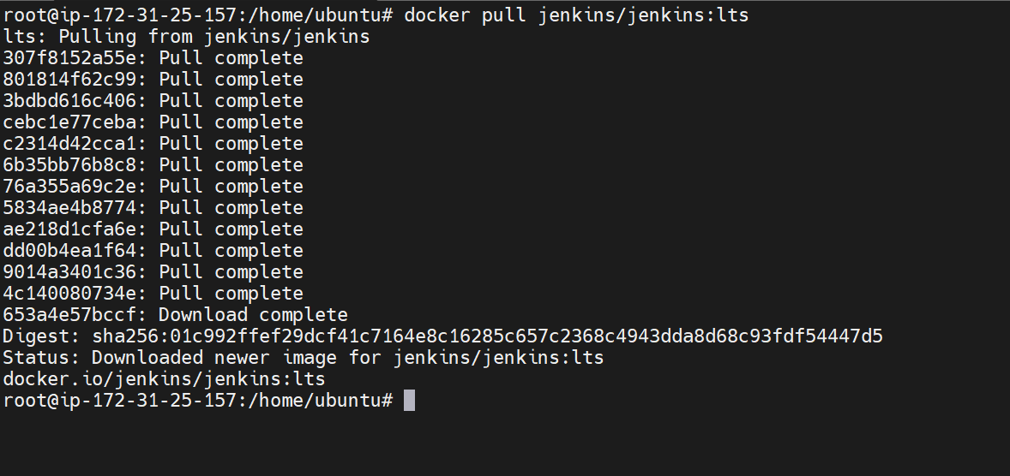

Sonarqube
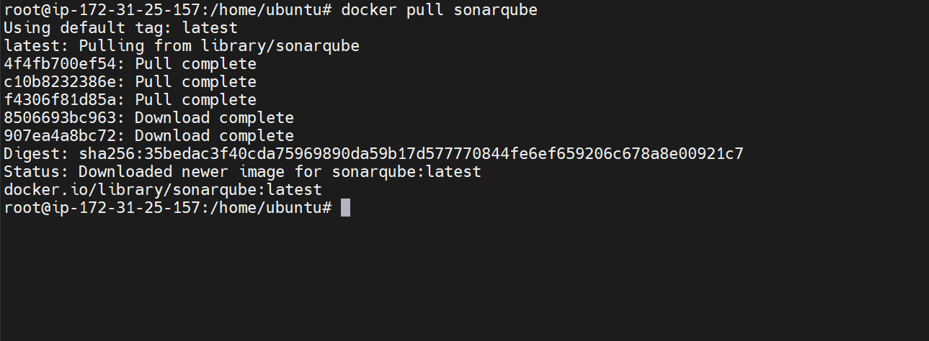

- Run nginx container and expose on port 81.
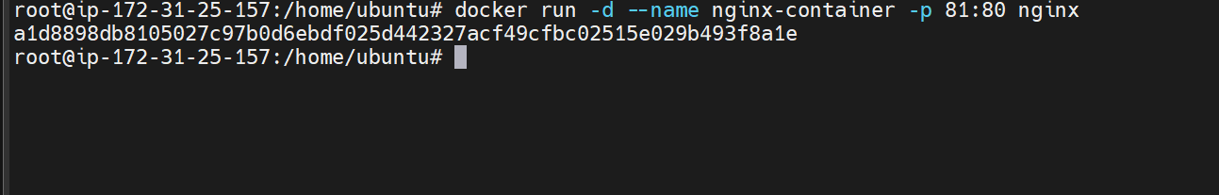
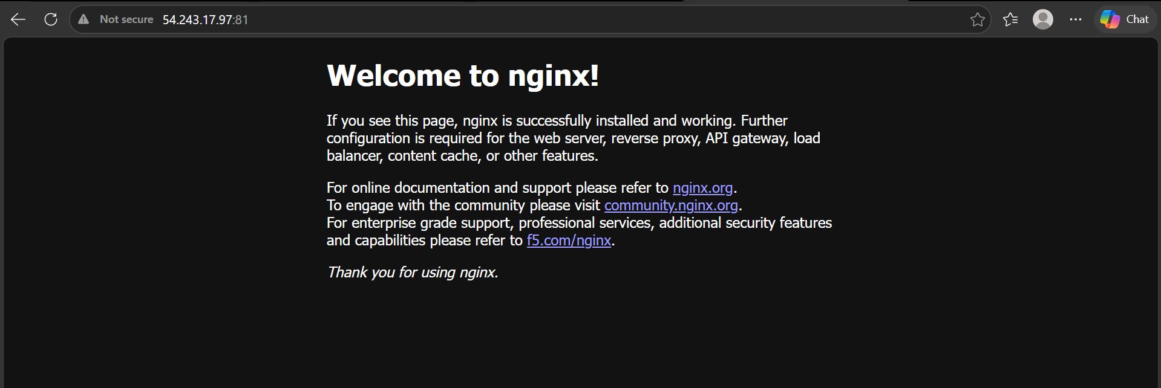
Nginx is now running on 81

- Delete the Apache tomcat image from local.

Lets now delete the tomcat image

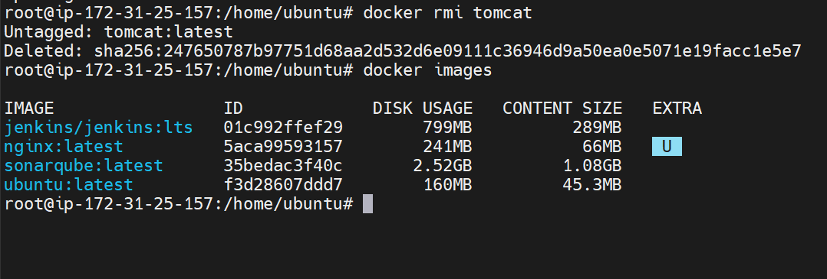

The tomcat image is deleted

- Inspect the Jenkins image, SonarQube image.
Inspecting the Jenkins image

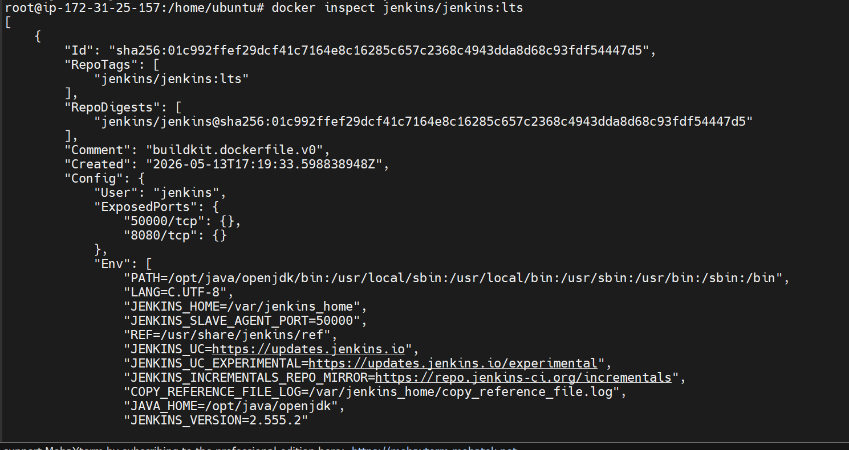
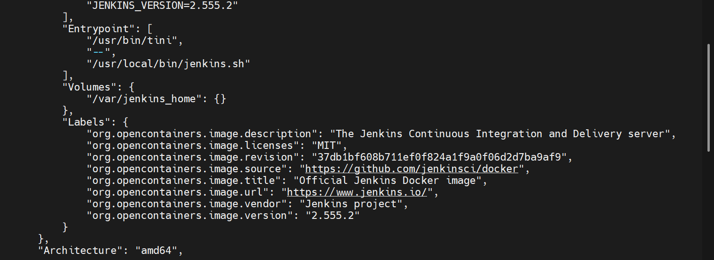

- Run Jenkins container and run one sample job

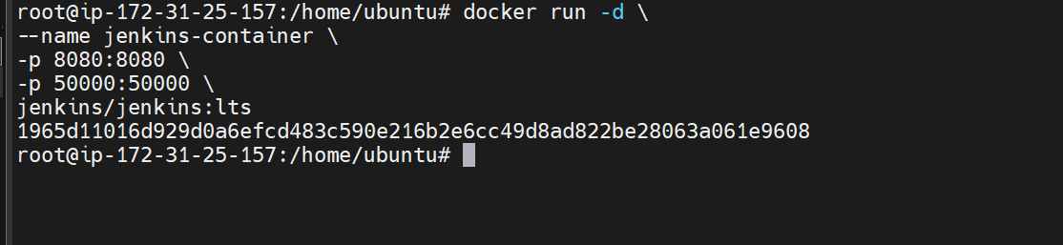
Jenkins container is now running
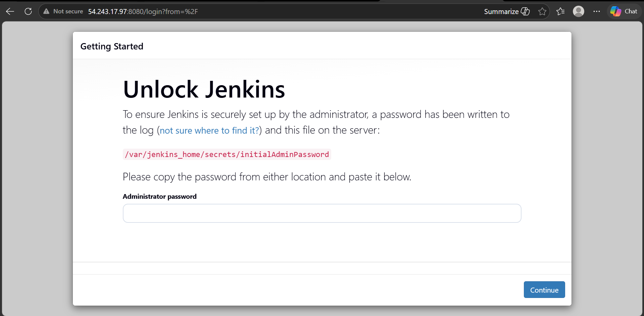
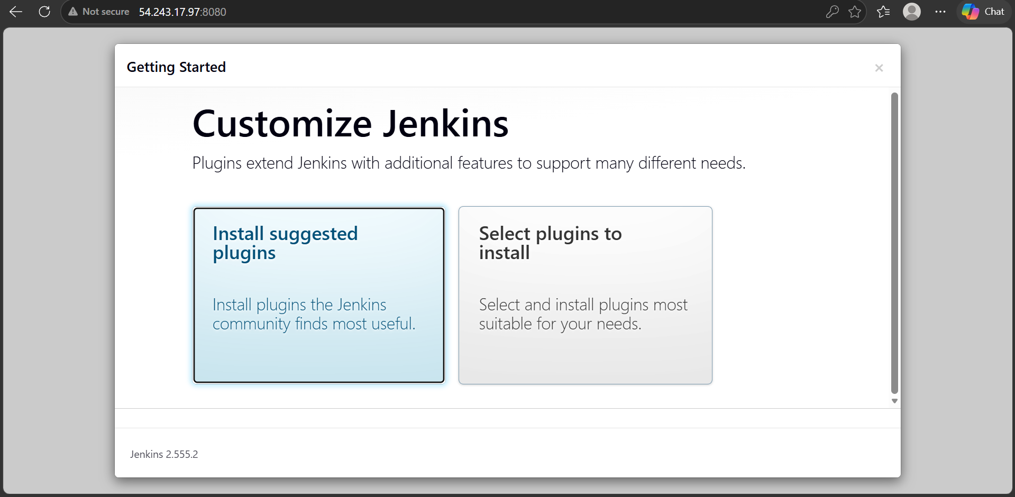
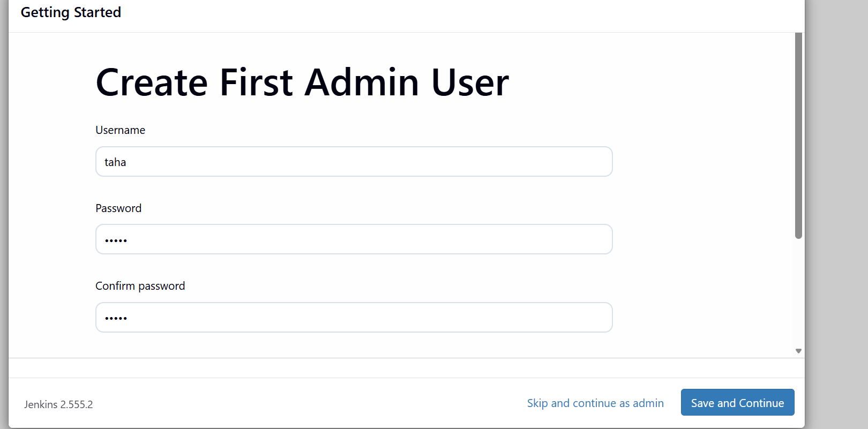
Now creating a sample job
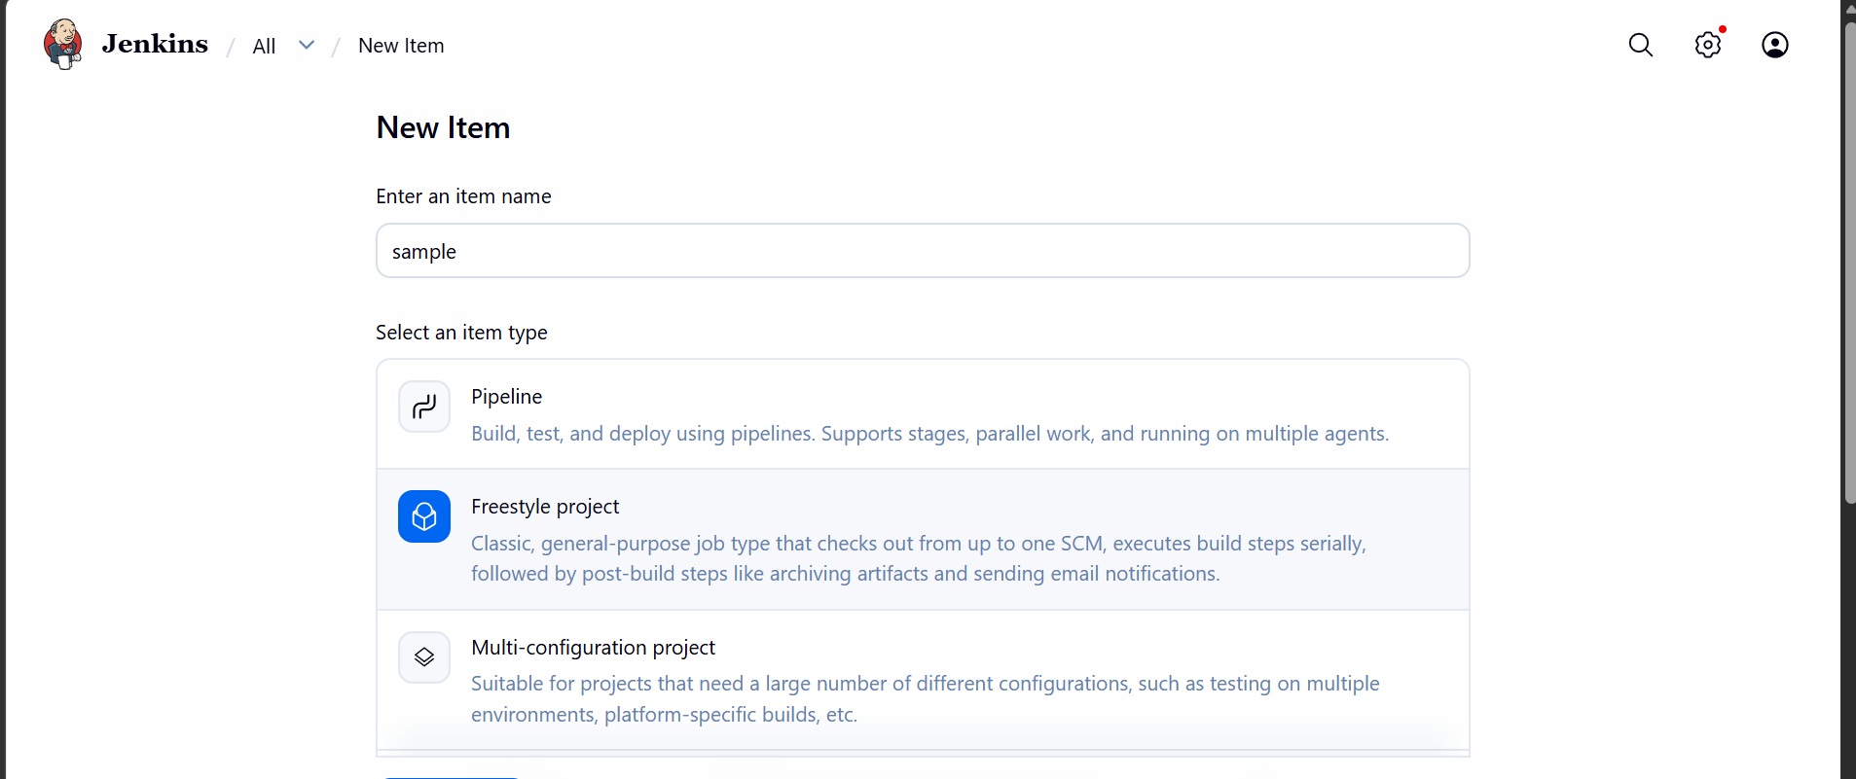

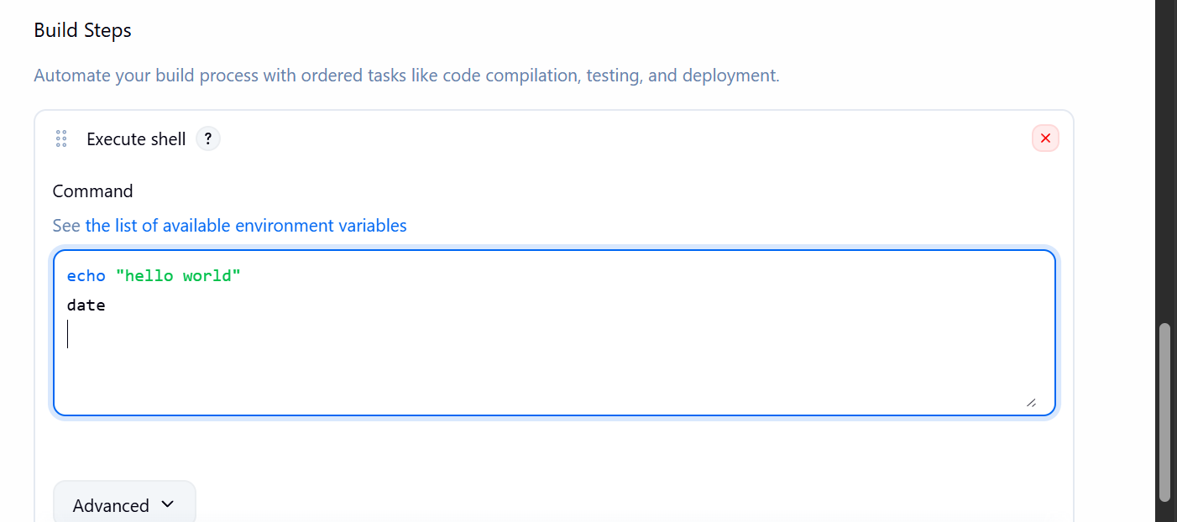
Now lets build the job
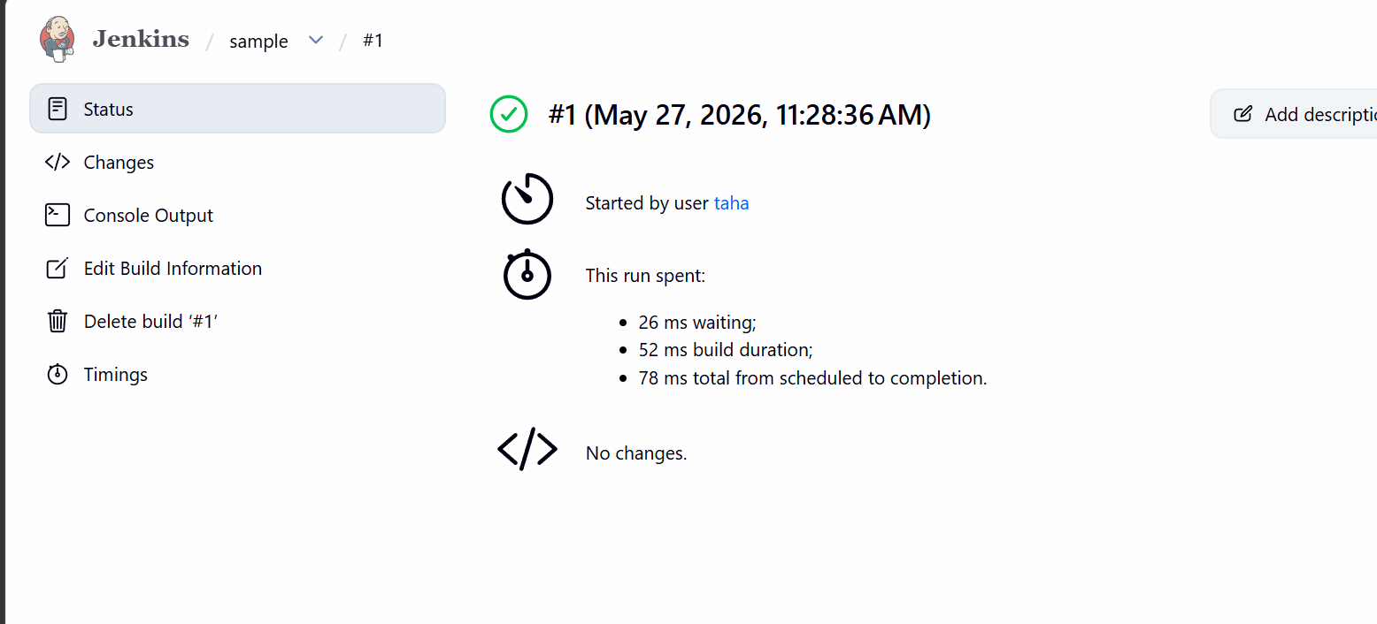
The job ran successfully
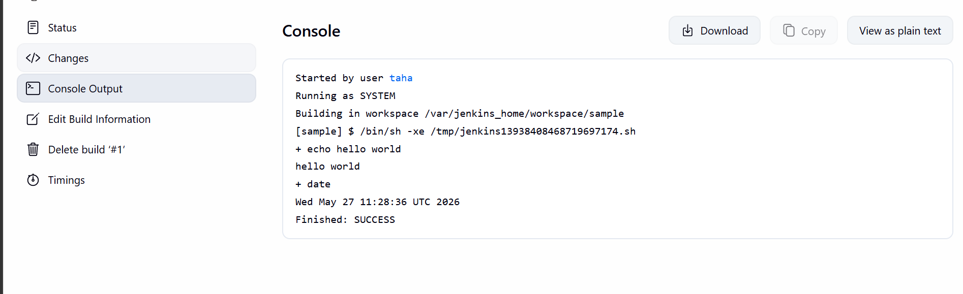

Inspecting sonarqube

