Jenkins CI/CD pipeline
1) Setup Jenkins CICD pipeline using freestyle job using Docker containers using below code.
Source Code: https://github.com/betawins/hiring-app.git
Stages:
- Git Clone
- SonarQube Integration
- Maven Compilation
- Nexus Artifactory
- Slack Notification
- Deploy On tomcat

first lets setup Jenkins using docker container
we have logged in to an ec2-instance
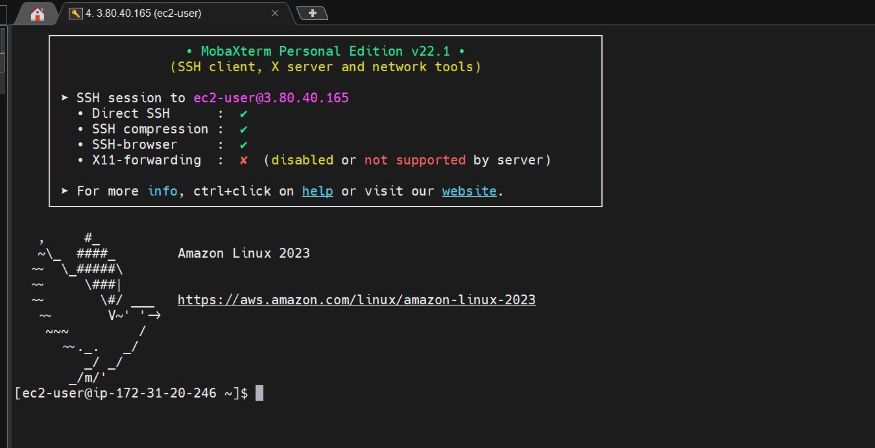
Updating packages and installing docker
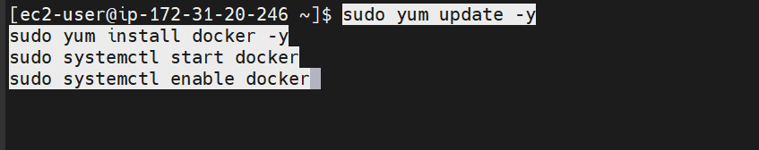
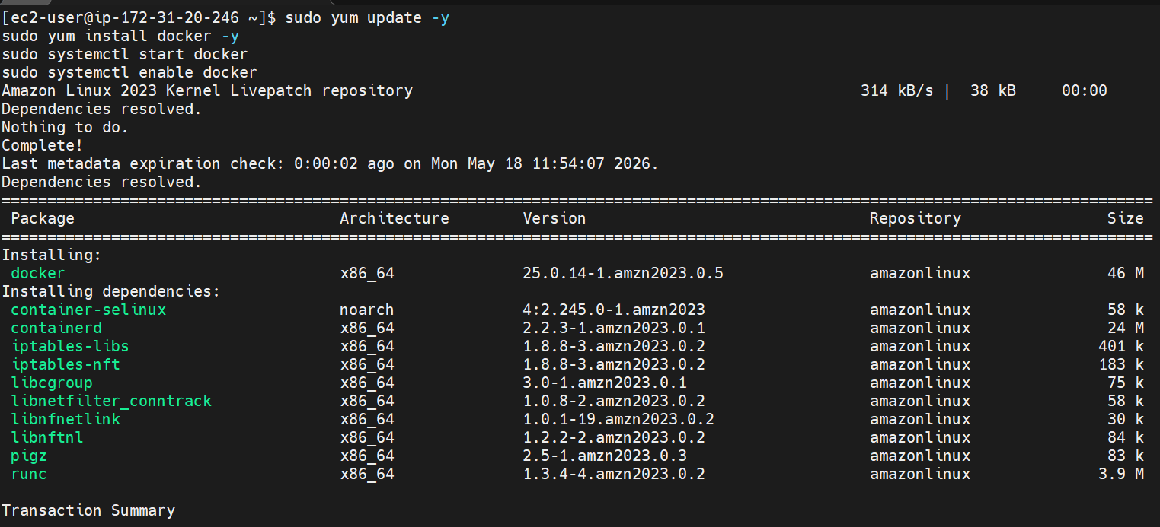
Docker is now installed
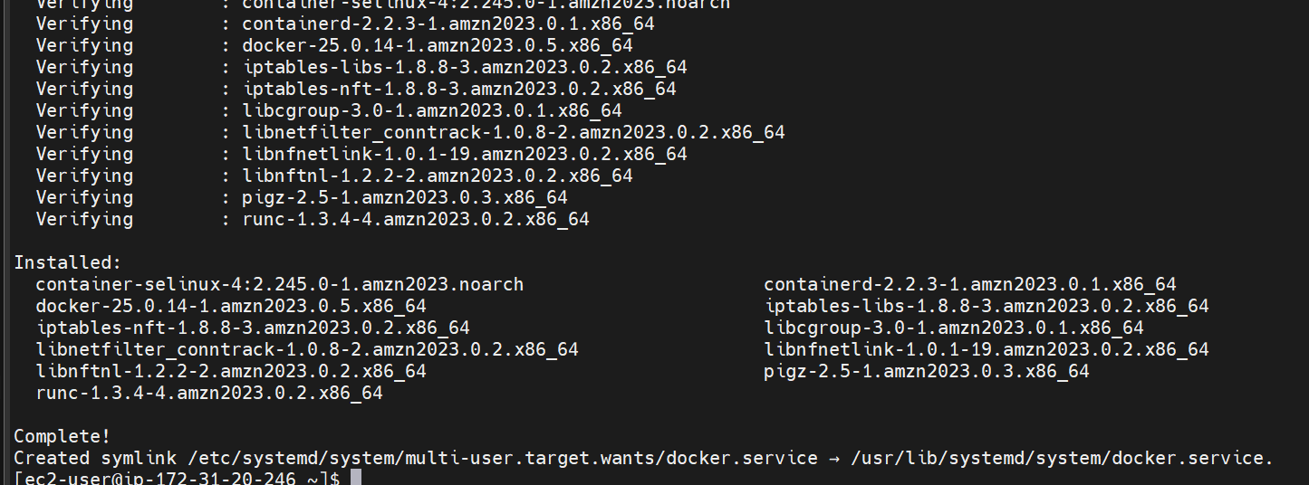
Adding ec2-user to docker group to avoid permission issues
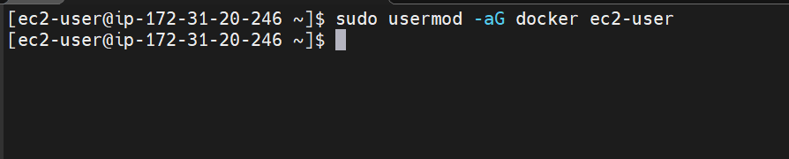
Verify if docker is running
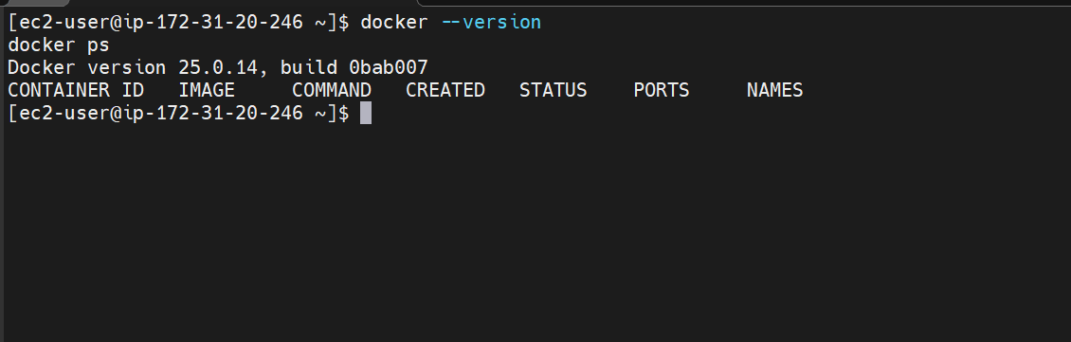
Lets now run Jenkins as container

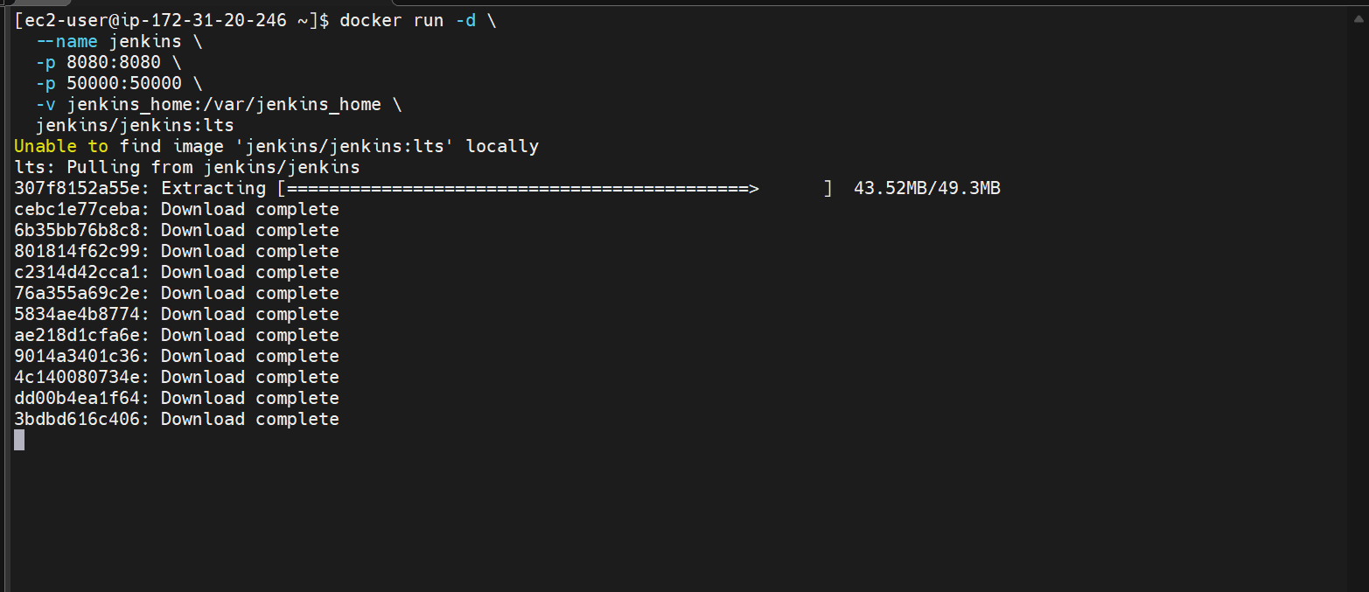
Here Jenkins image was not present locally so it pulled from the internet
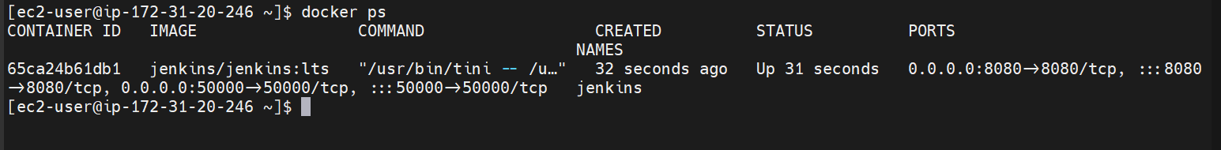
We can see that Jenkins container is up and running
What each flag does:
- -d — run in the background
- --name jenkins — gives the container a name so you can refer to it easily
- -p 8080:8080 — maps EC2 port 8080 to Jenkins port 8080 (the UI)
- -p 50000:50000 — for Jenkins agent connections
- -v jenkins_home:/var/jenkins_home — important: this creates a persistent volume so your Jenkins data (jobs, config, plugins) survives if the container restart
Now lets get the initial admin password for jenkins
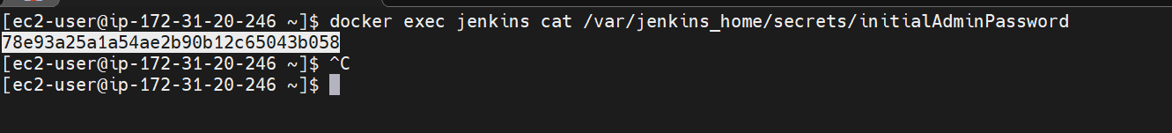
The exec flag helps us to run linux commands inside the container
Lets go to the browser now
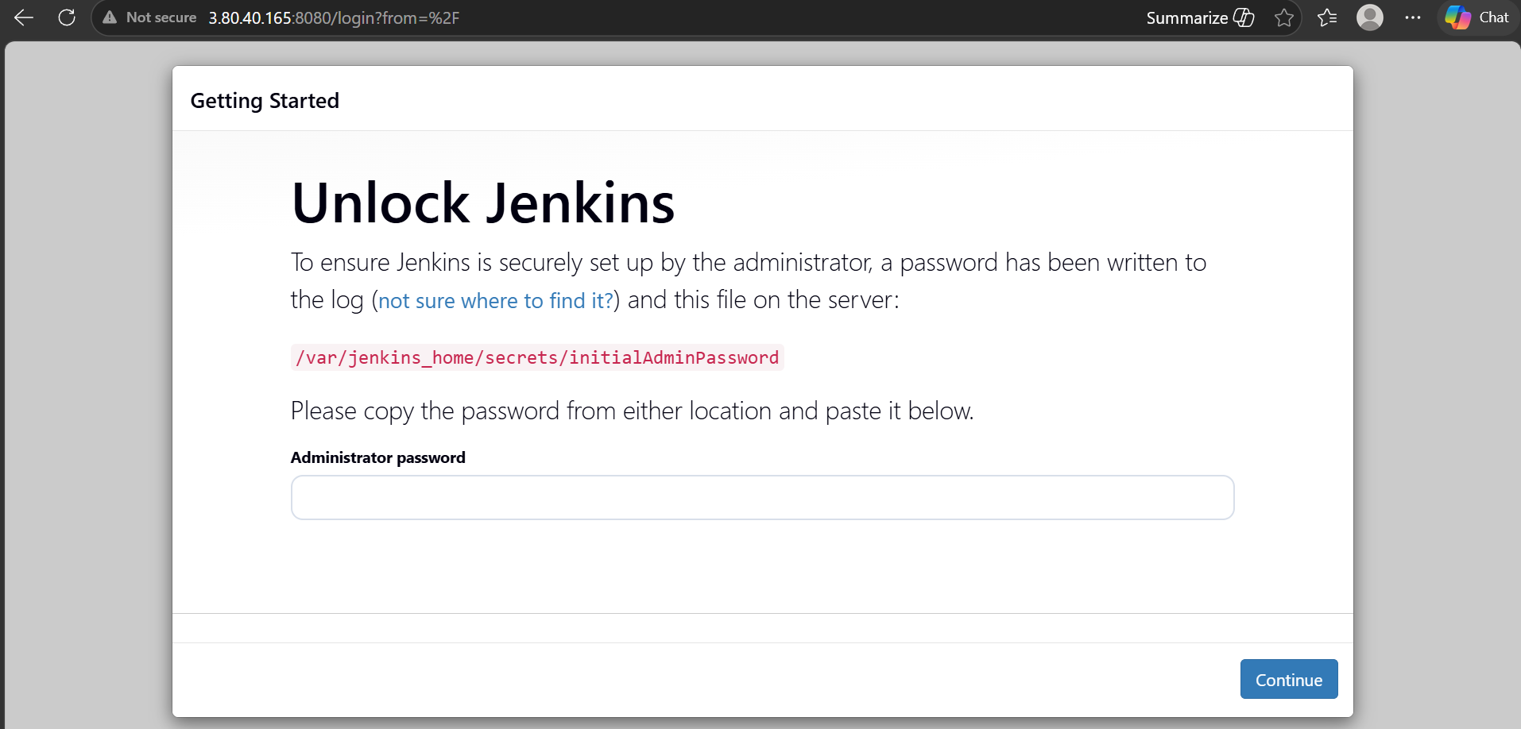
Jenkins is now up and running
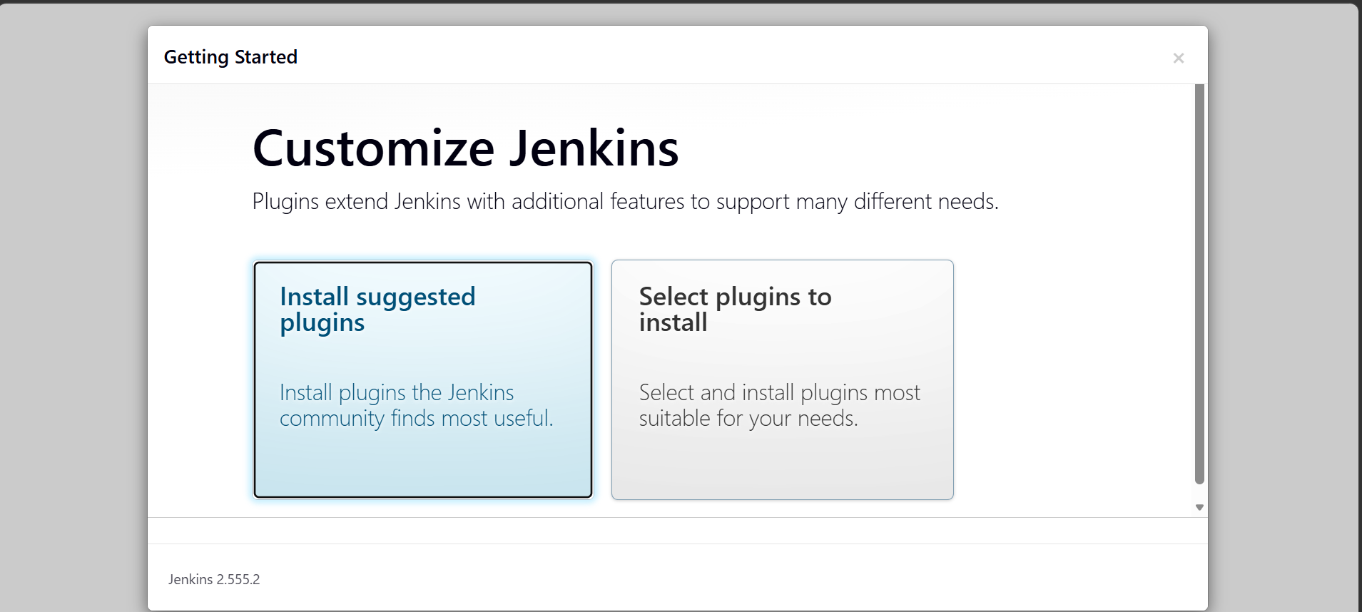

Install recommended plugins
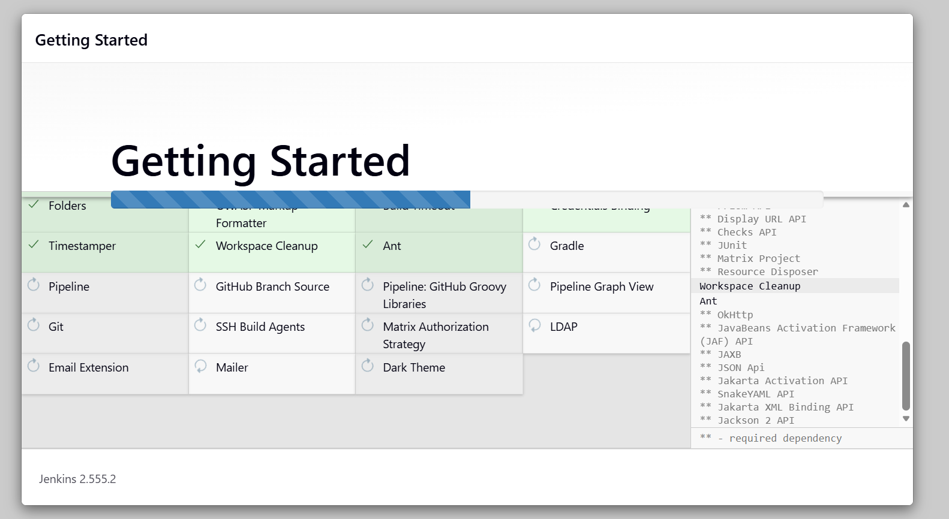
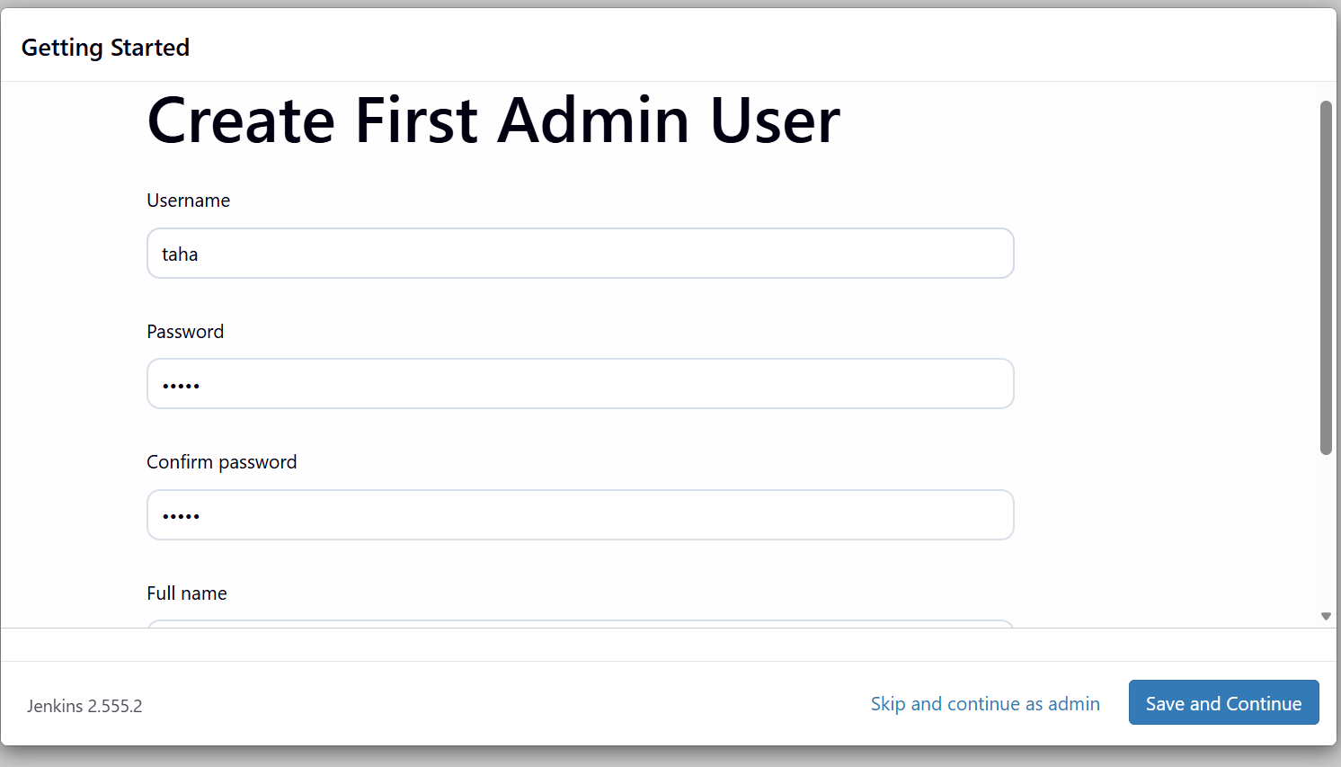

Lets create a freestyle job
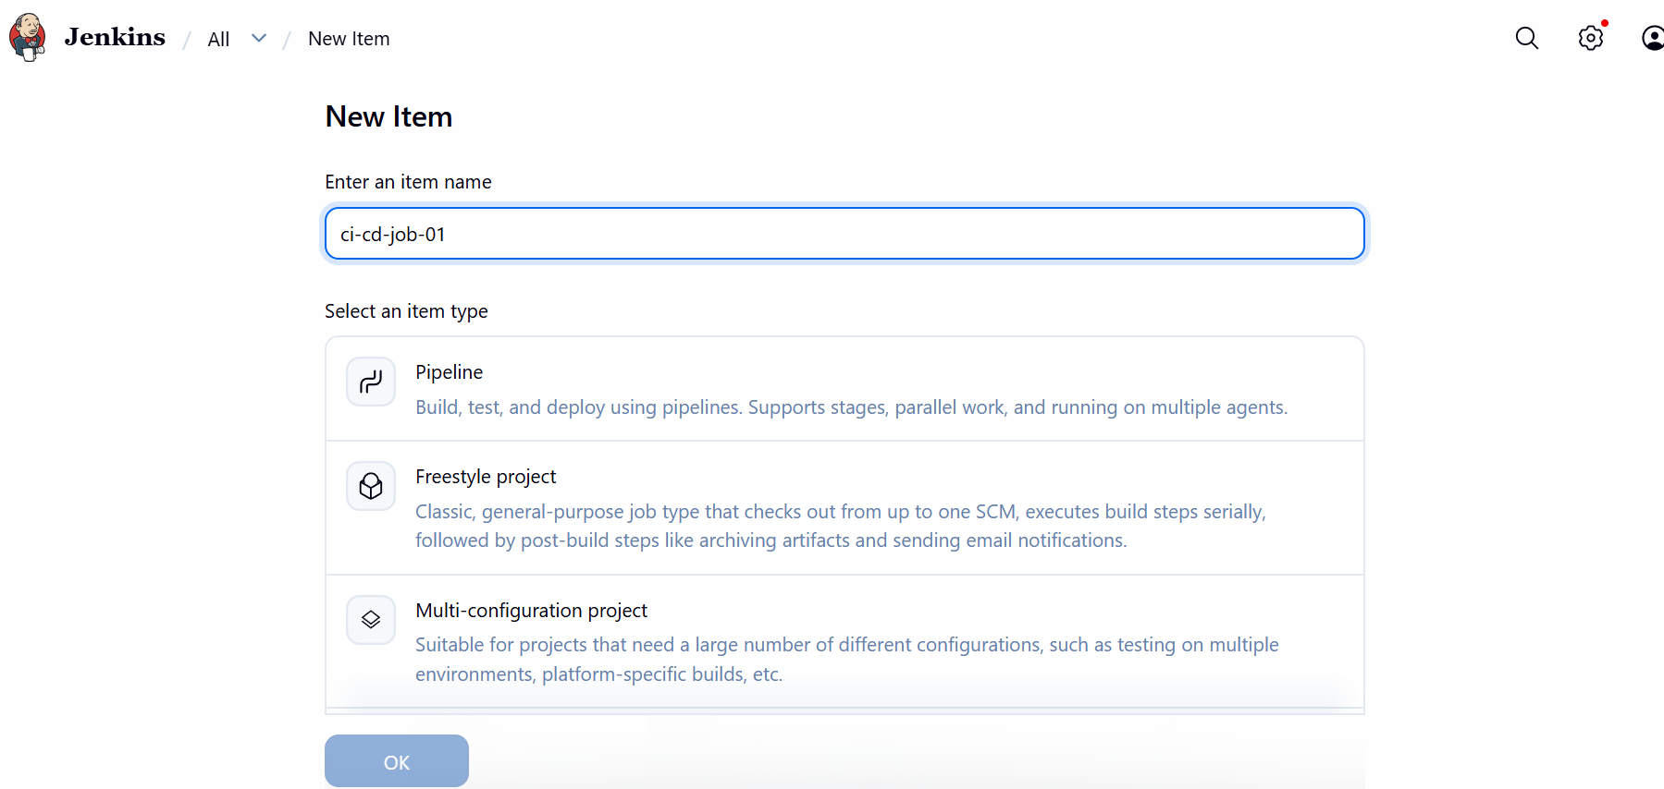
Clone the source code repo now
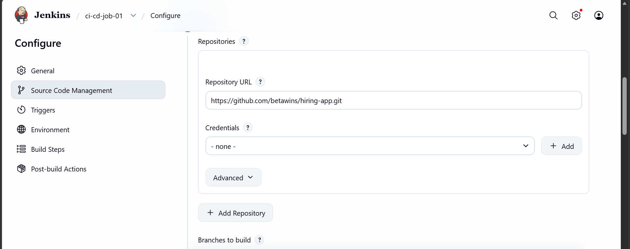
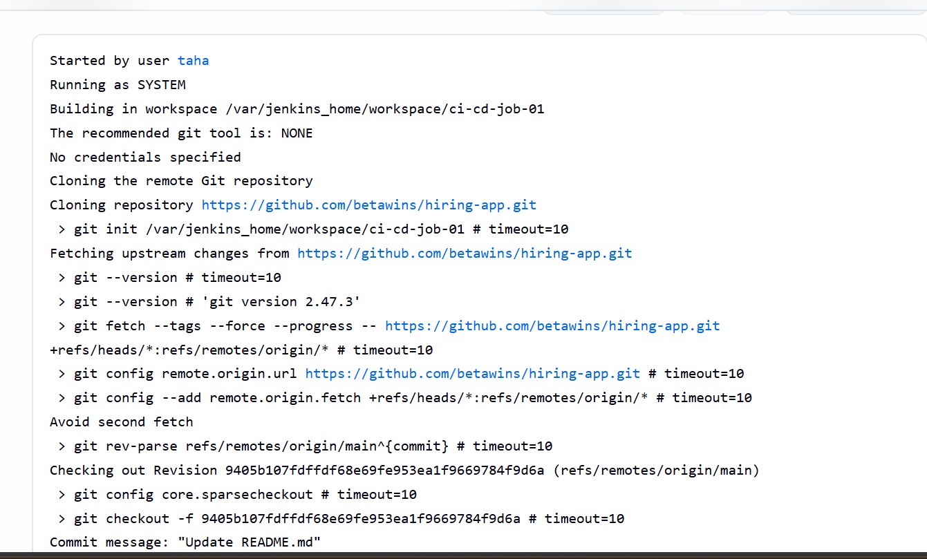

The job is build now the code is cloned
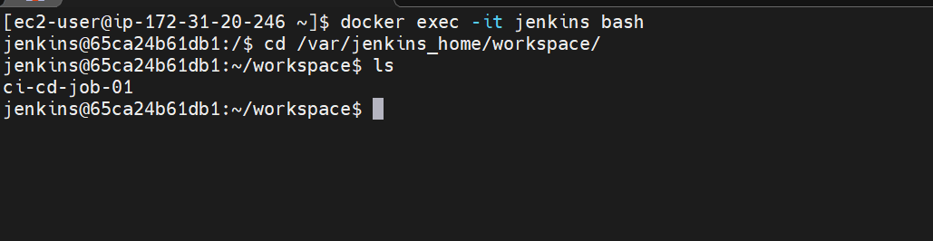
We can see the code is built
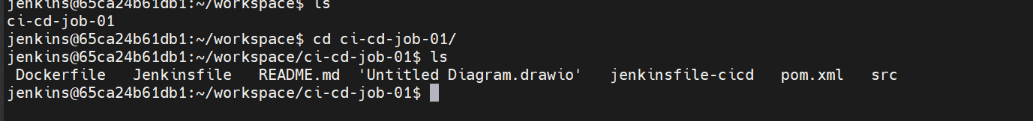
Now lets do the sonarqube setup
Installing java 1.8
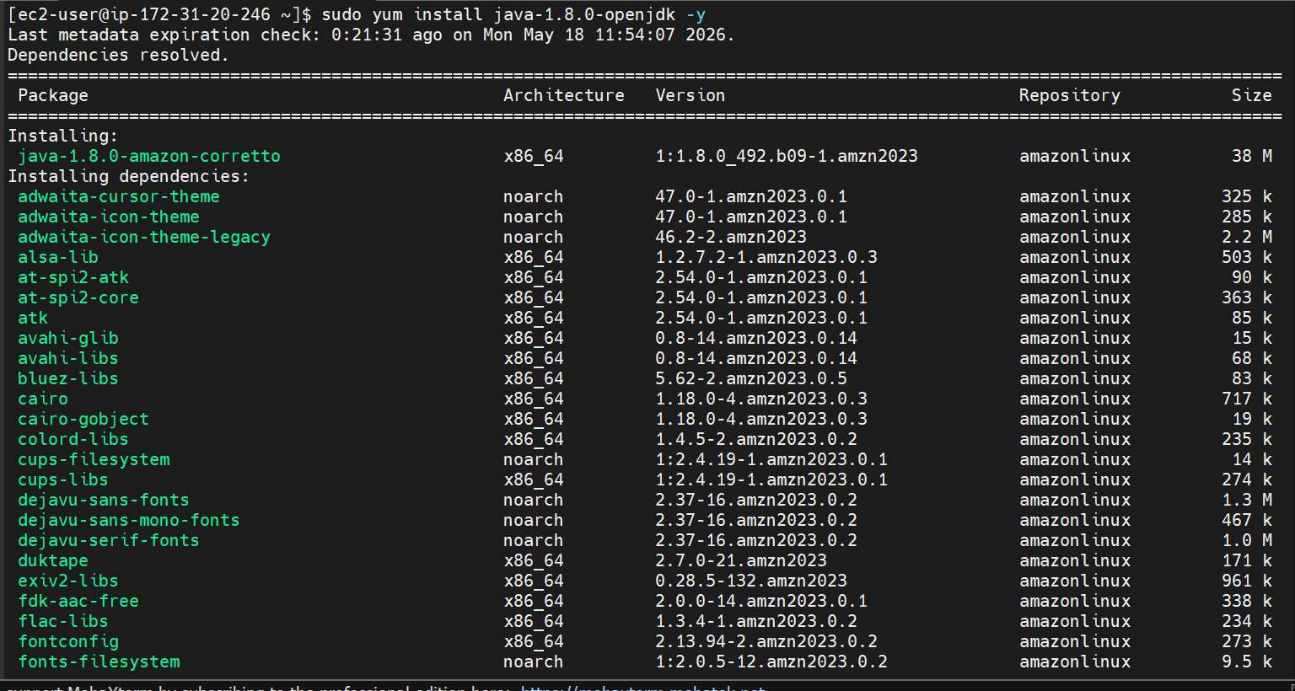
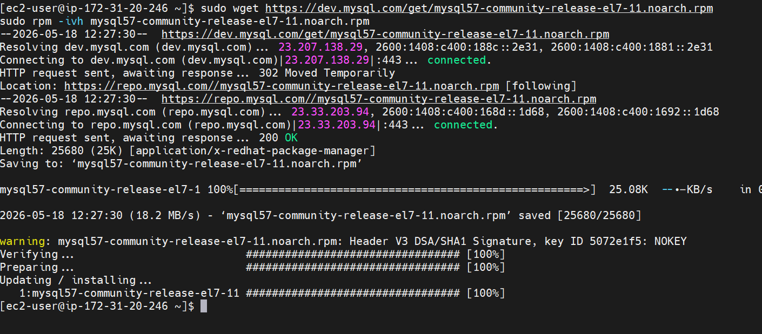
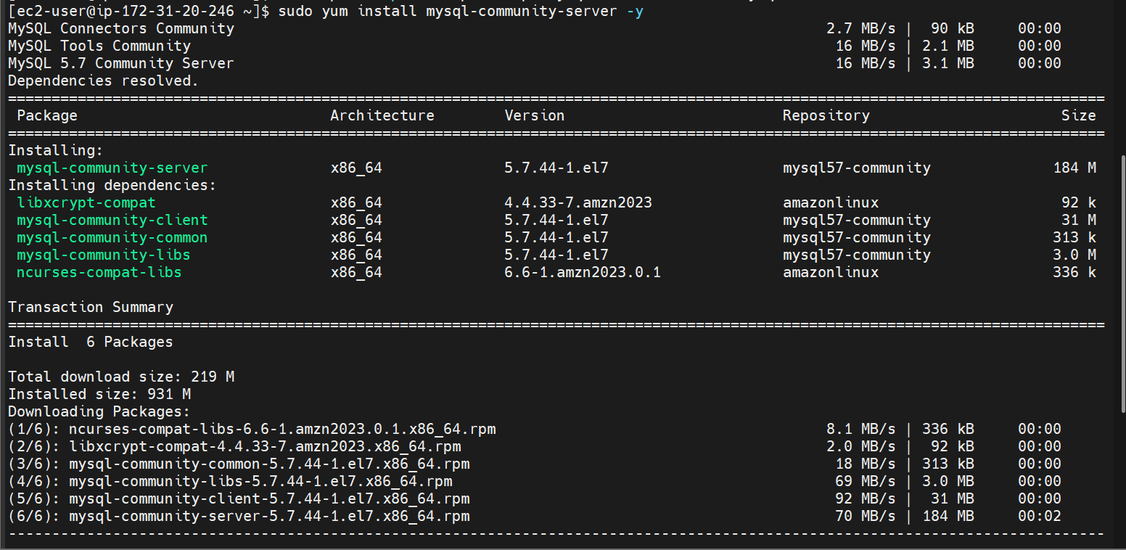
Now lets install sonarqube server
Installing it using the docker compose
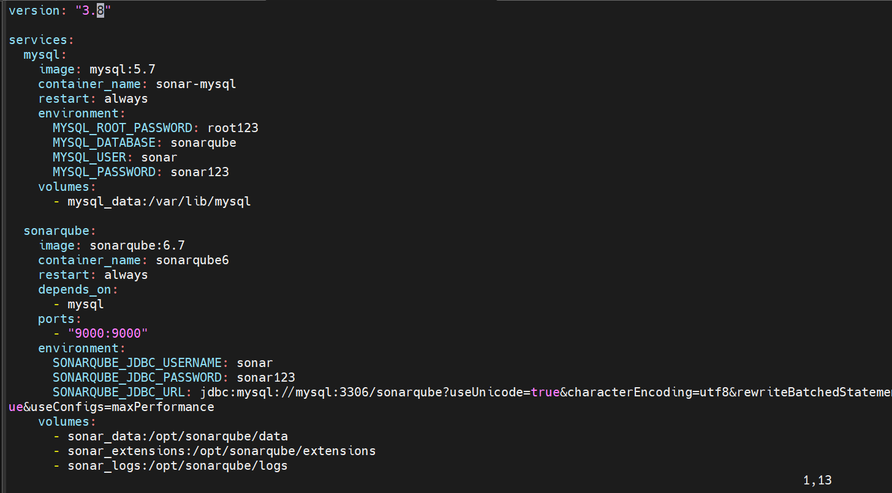
Docker is not installed so installing docker
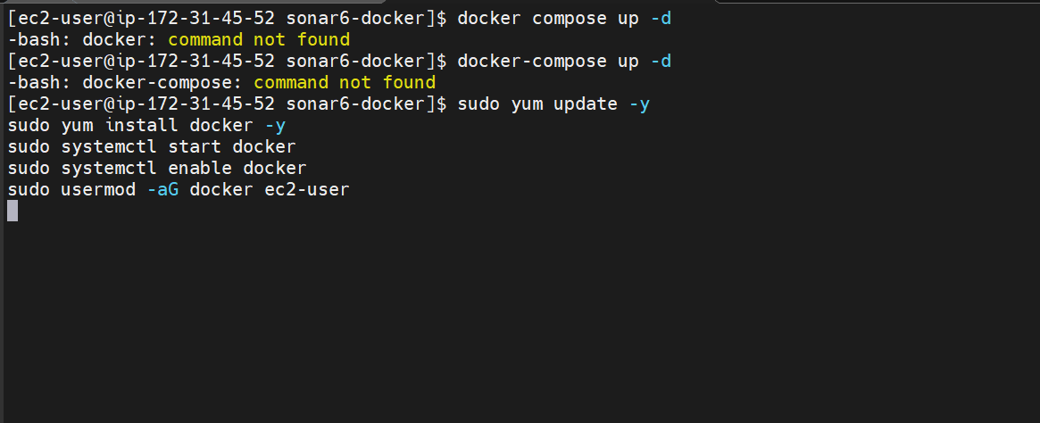
Installing docker compose plugin
Running the docker compose file
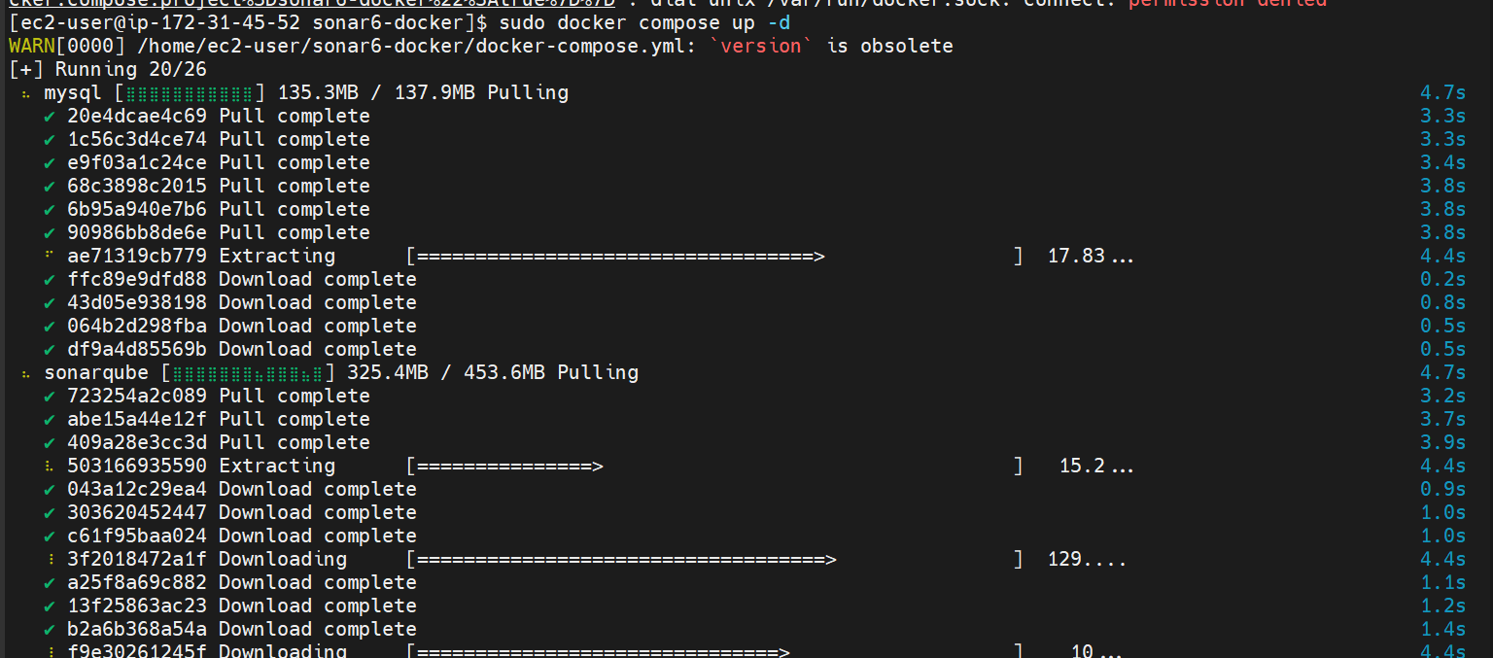
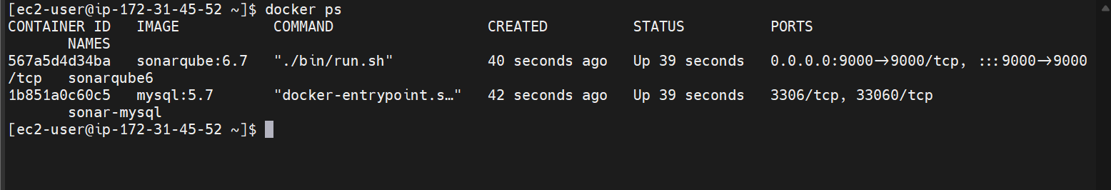
Sonarqube and mysql are now installed
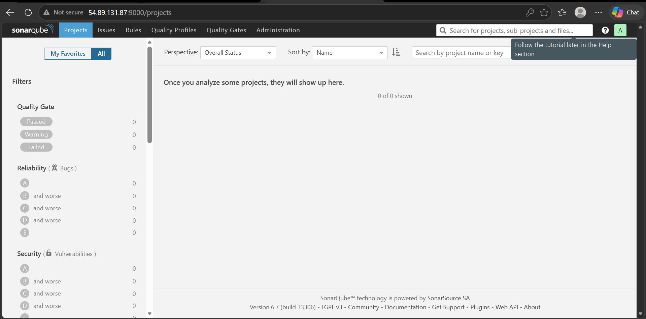
We are now able to login to sonarqube

