Load Balancers

- Configure Classic Load balancer.

Lets create two instances first
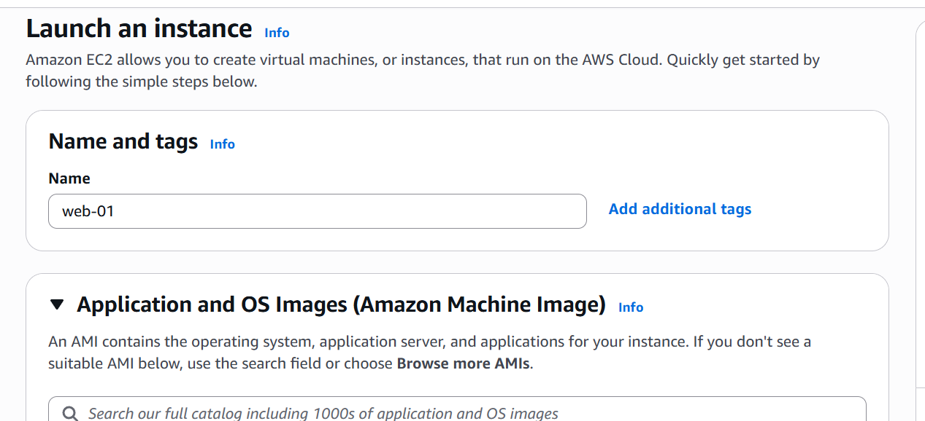

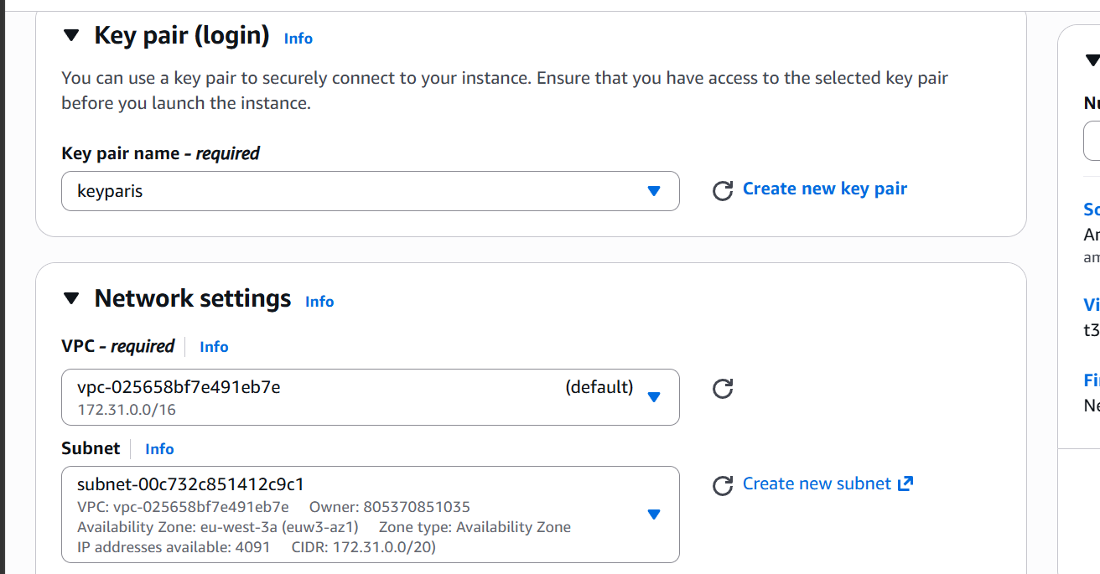
Instance in AZ-1

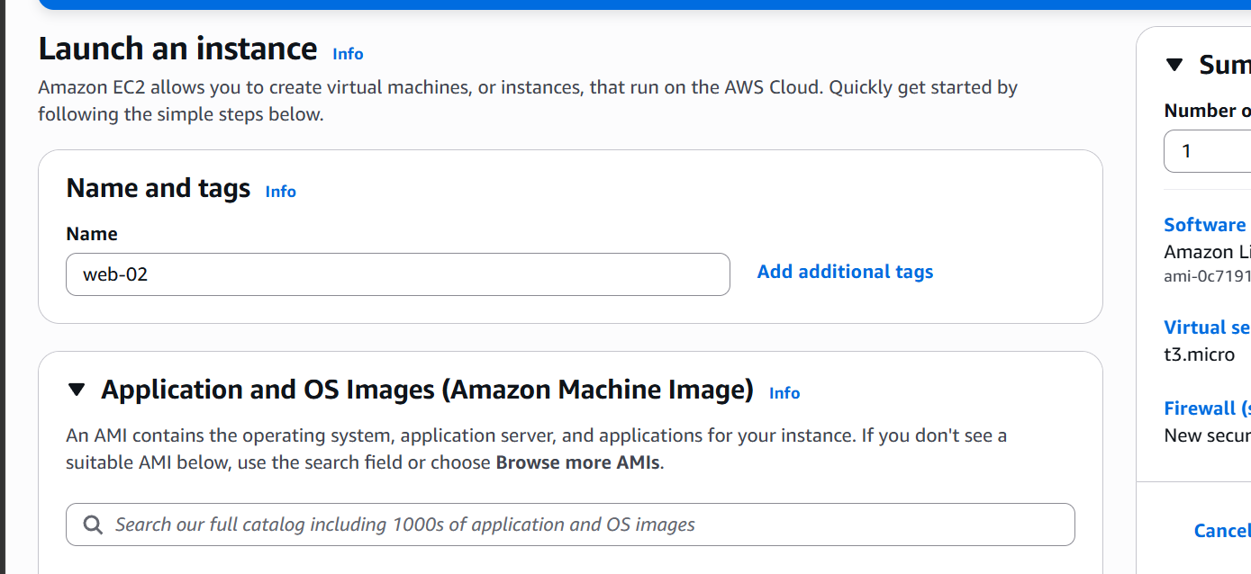

Second instance
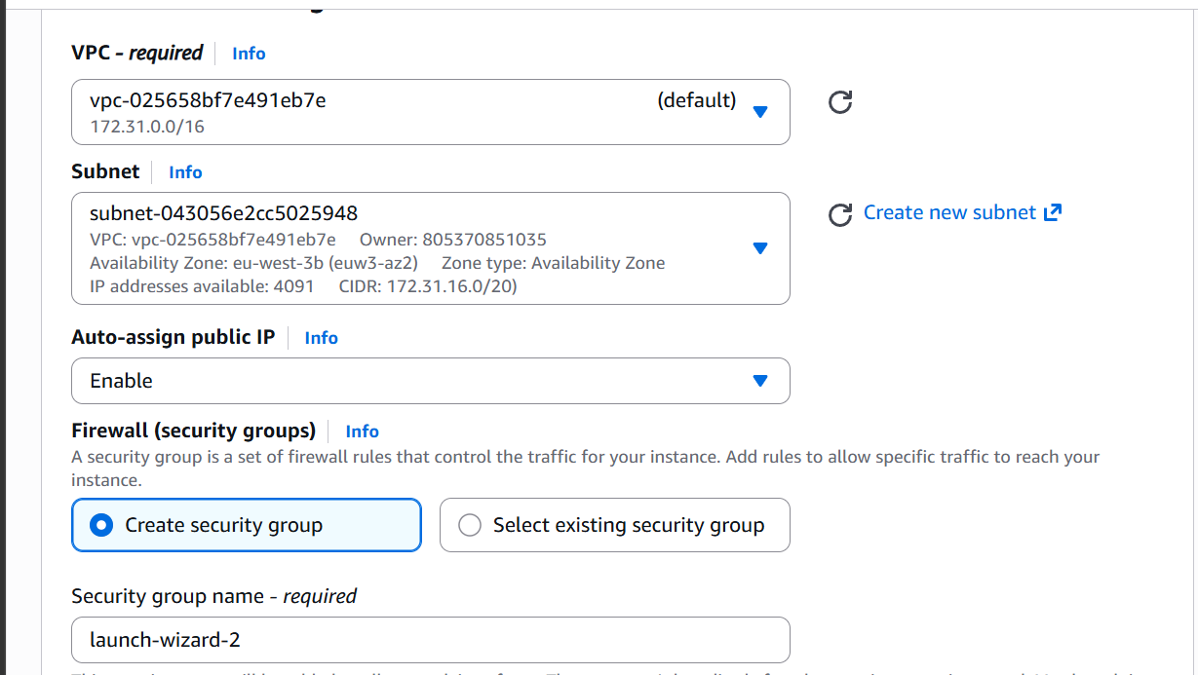

This in AZ-2
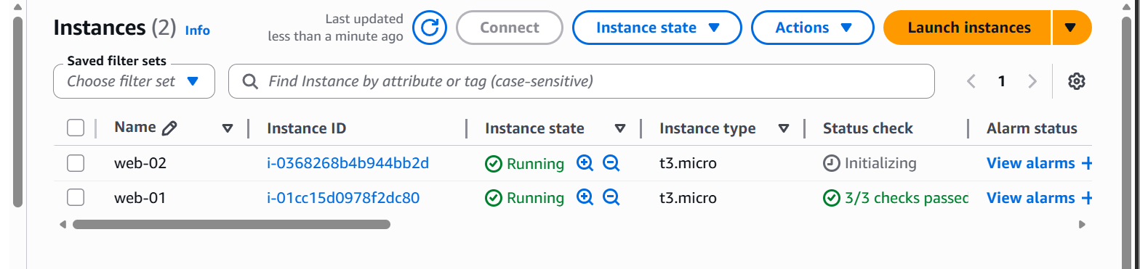

These are our two instanes in different subnets
Let us now ssh into them and install web server
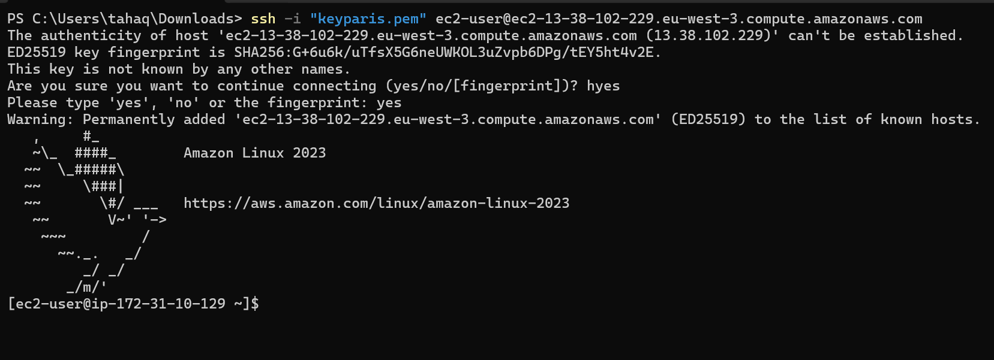
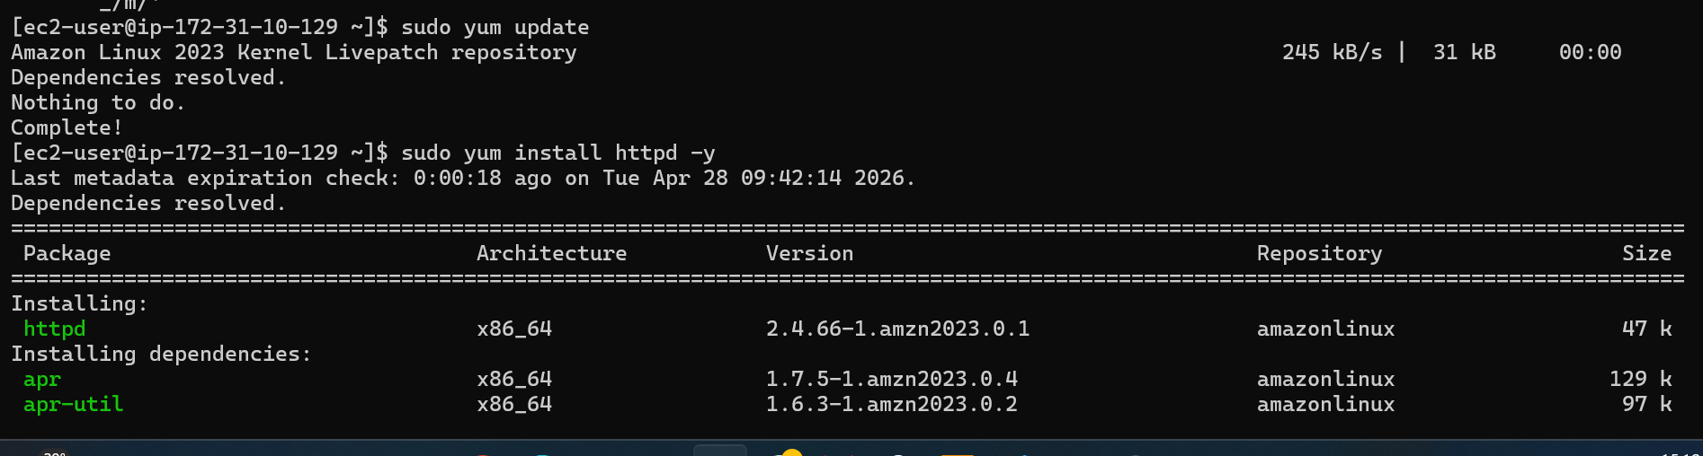
Lets go to the deployment location and add our content
Let us check on browser
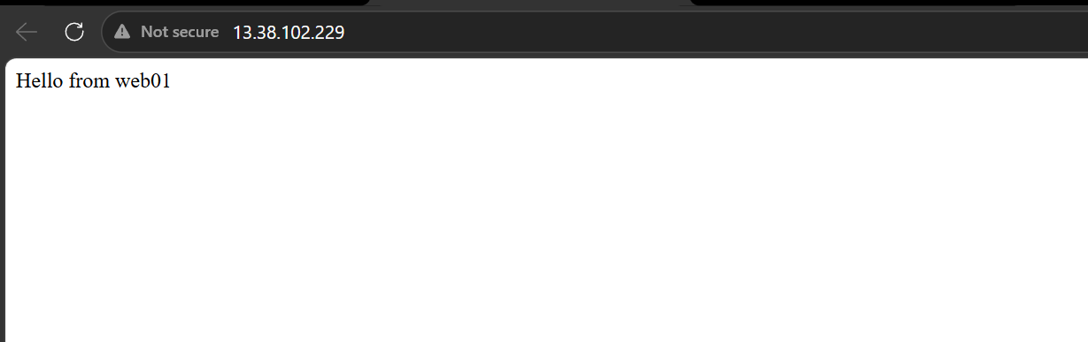
We are able to access our webserver from web01 instance
Let us do the same in web02 as well
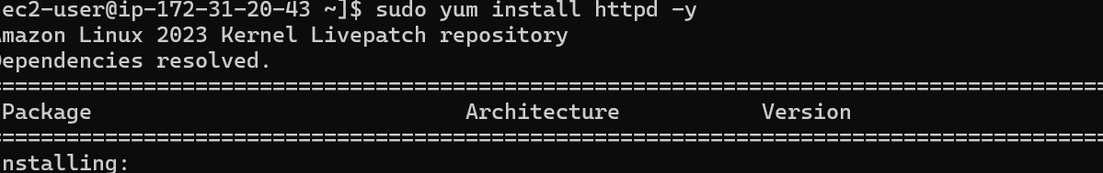

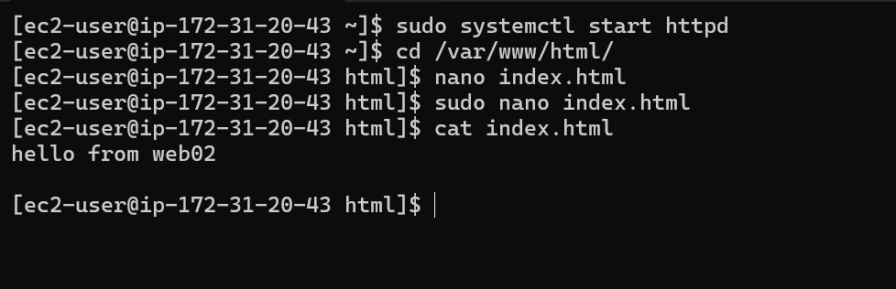

Let us check on browser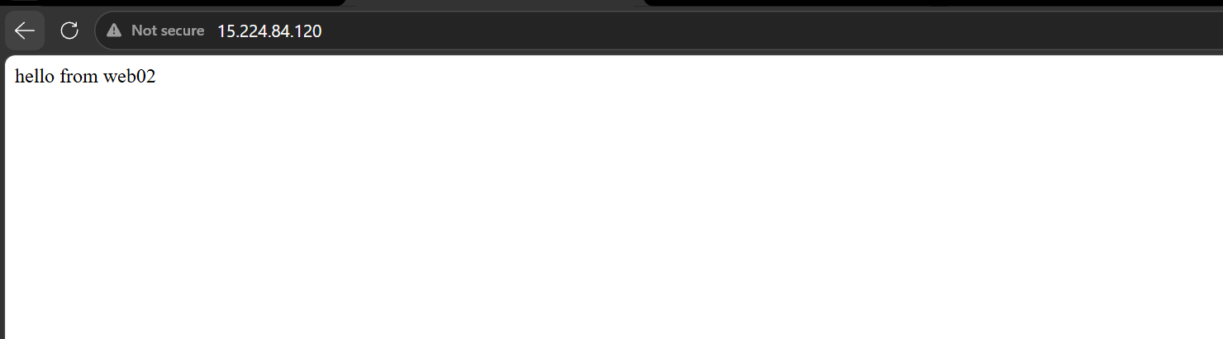
This is working as well
Now lets configure our classic load balancer
Under EC2 options go to load balancing and load balancers
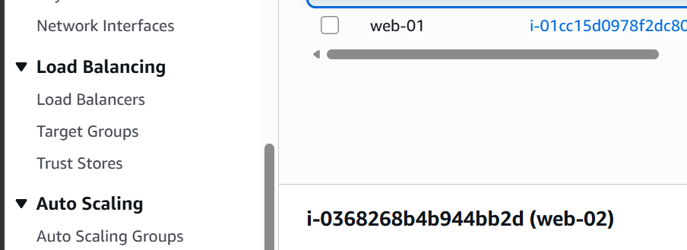
Click on create load balancer
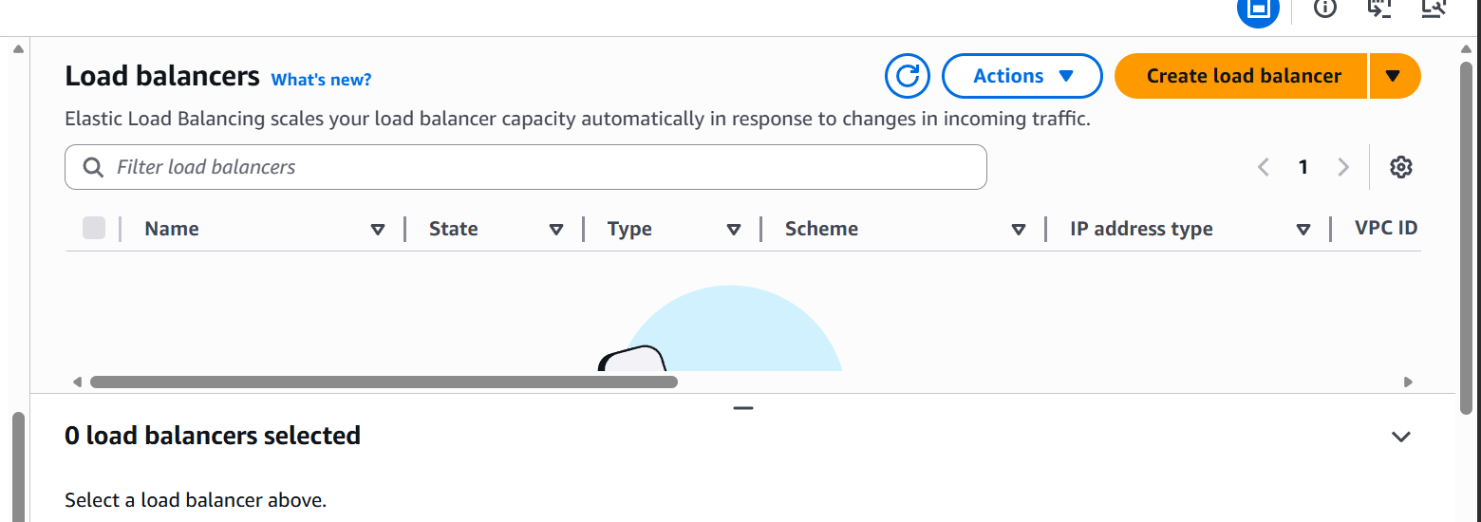

Select classic load balancer
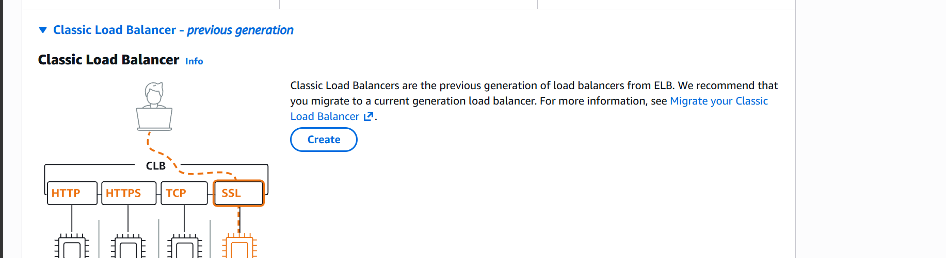

Give a name
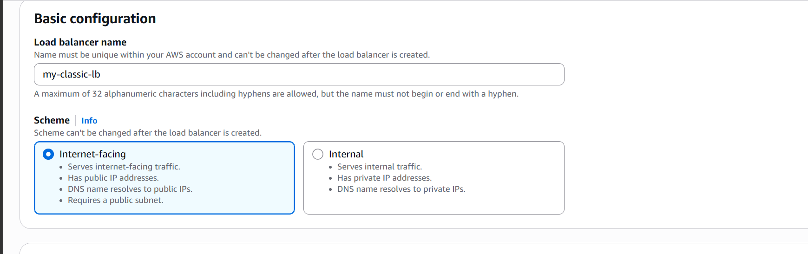
Select VPC and subnets
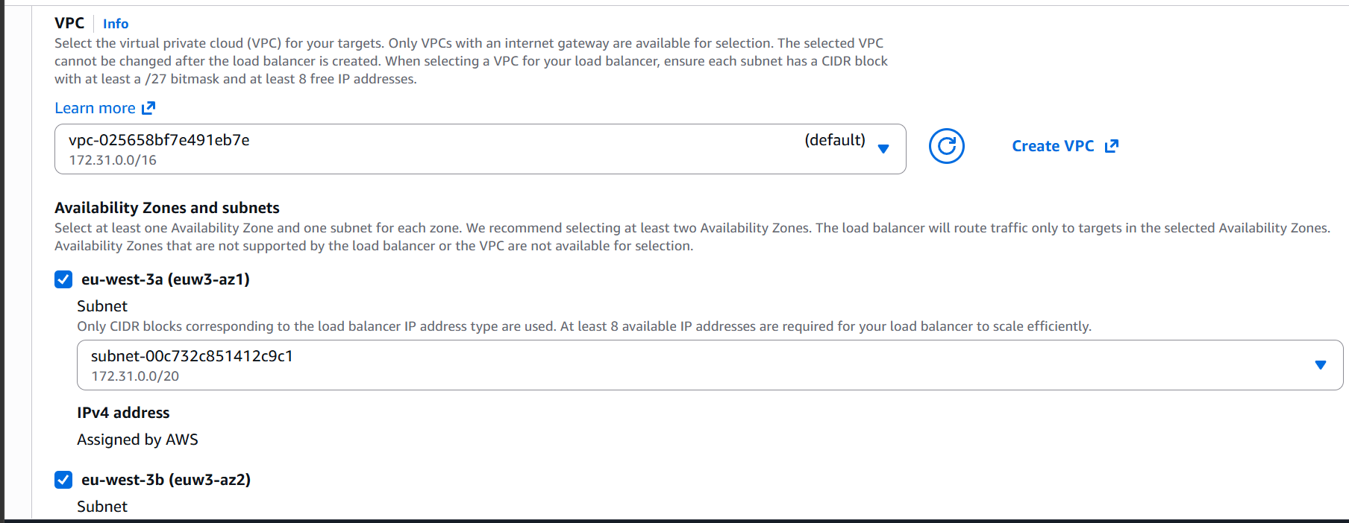
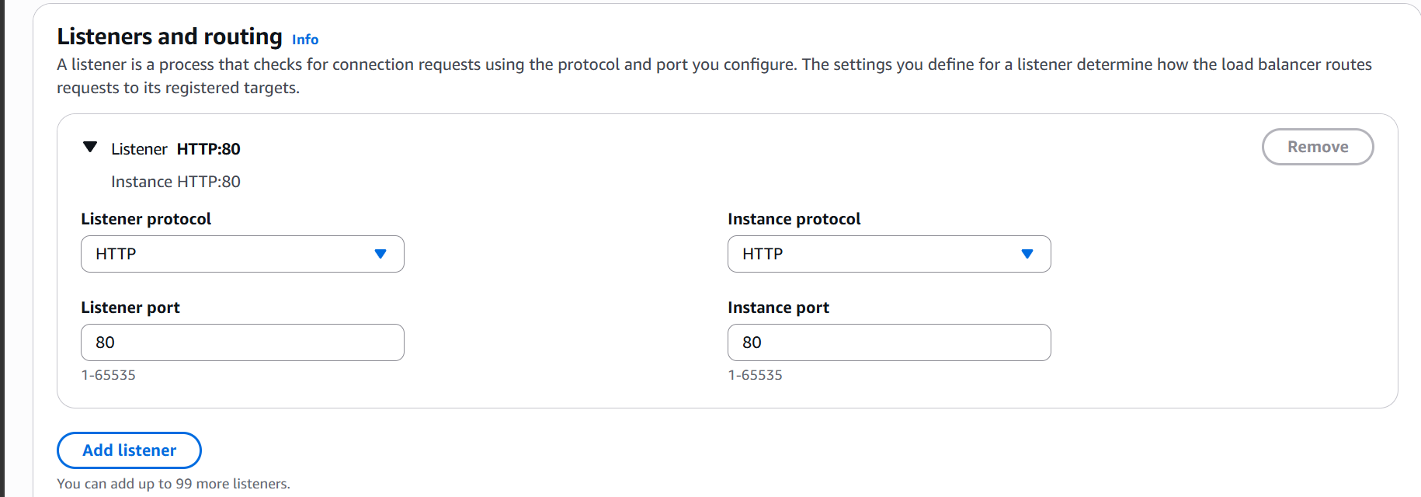

Listeners and routing
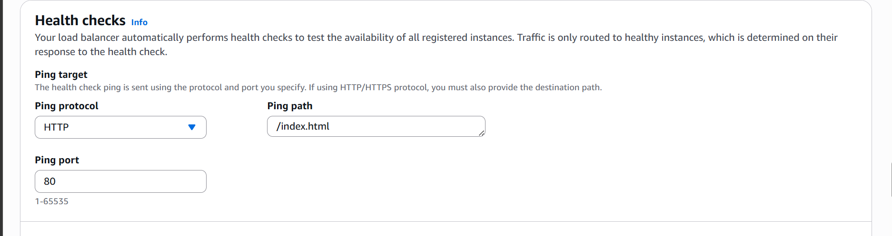

Health check: this will check if httpd is alive or not

Select Instances
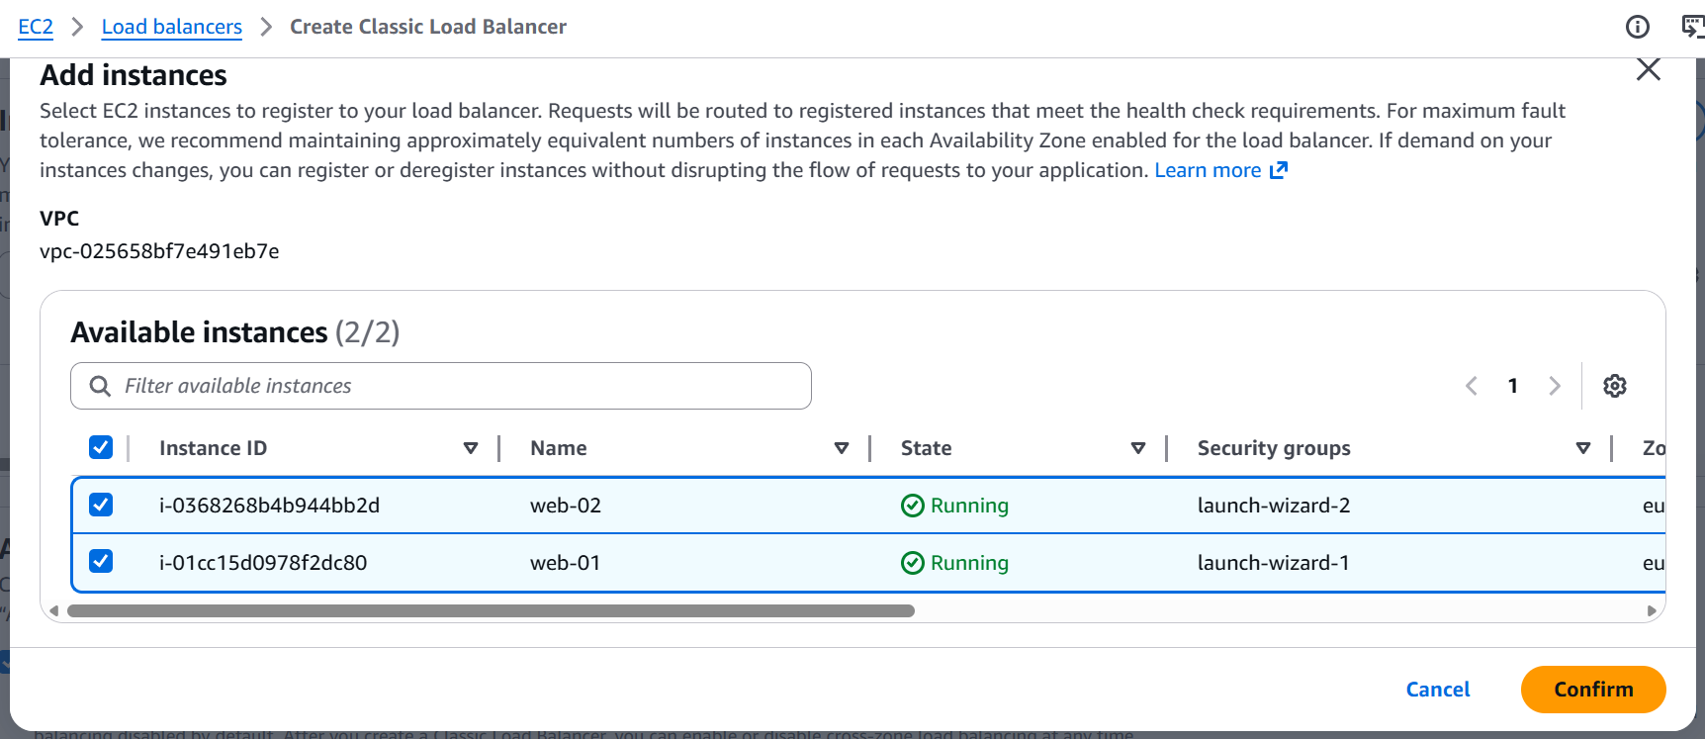

Now click on create loadbalancer

Our Classic Load balancer is now configured
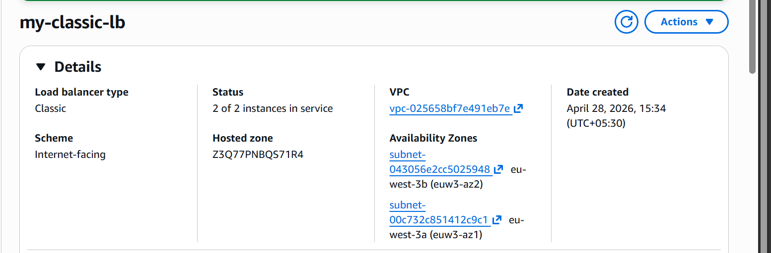
2 of 2 instances are in service now
Lets now check with the load balancer DNS
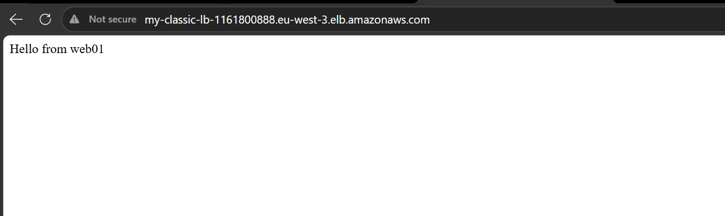
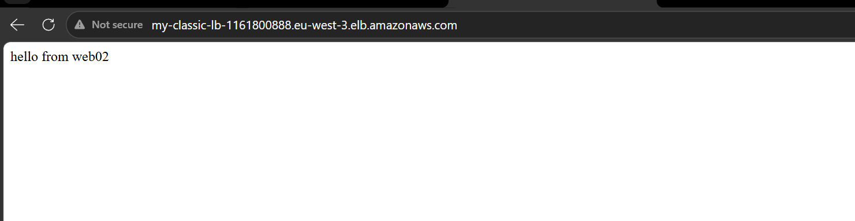

The load balancing is working perfectly fine.

- Configure Application Load Balancer

Click on create load balancer
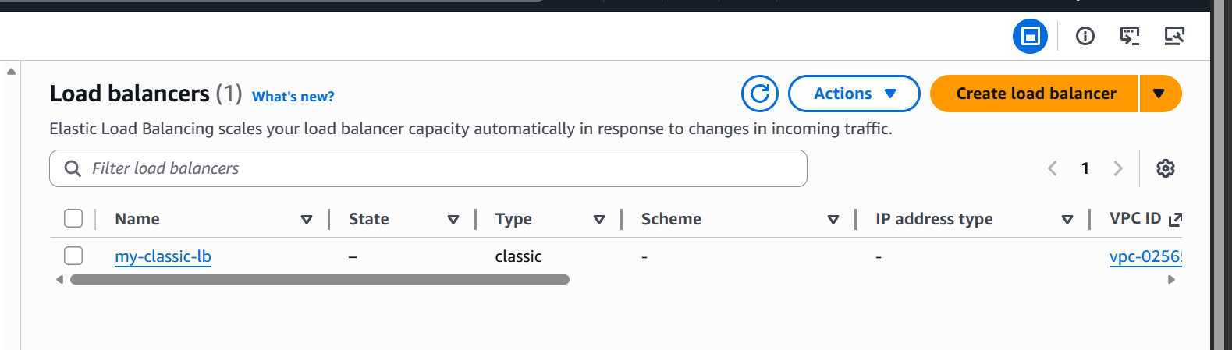

Select Application load balancer
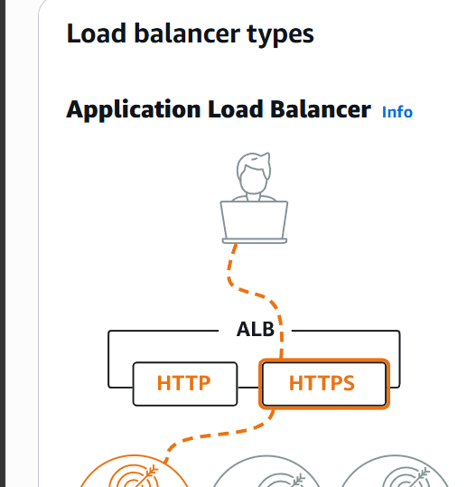

Click on create
Give a name and select internet facing scheme
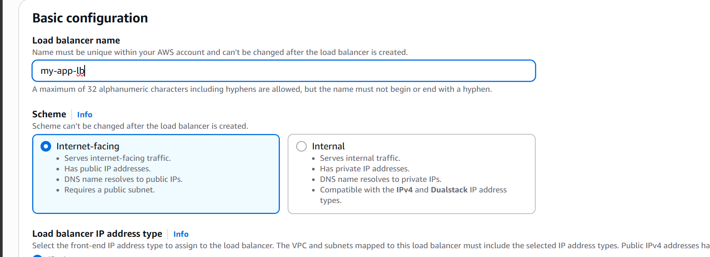

Select VPC and subnets
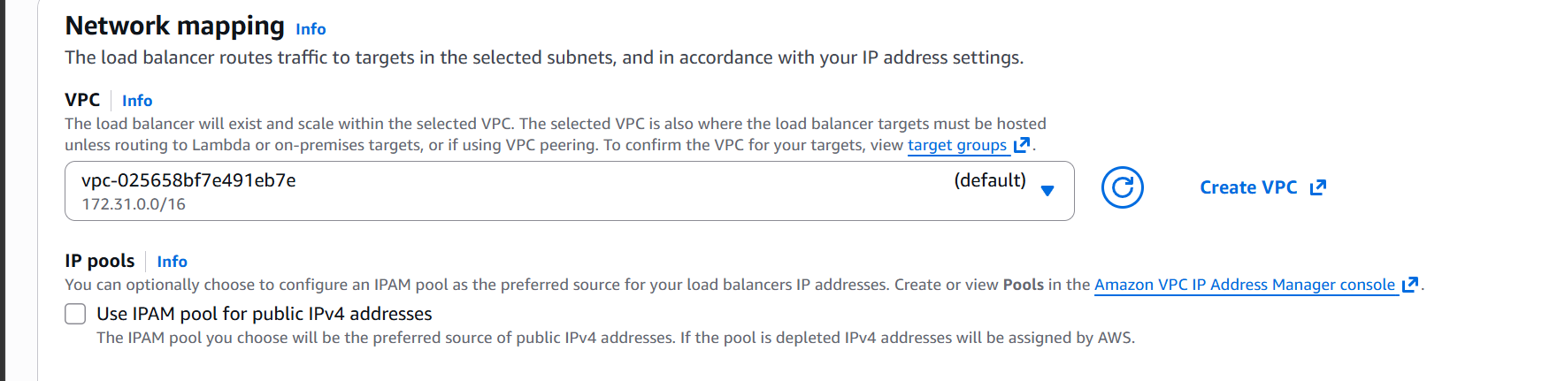
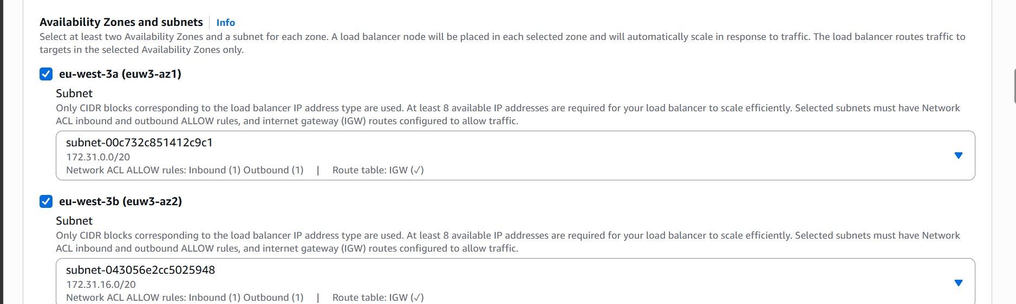

Create a security group with http and httpd ports
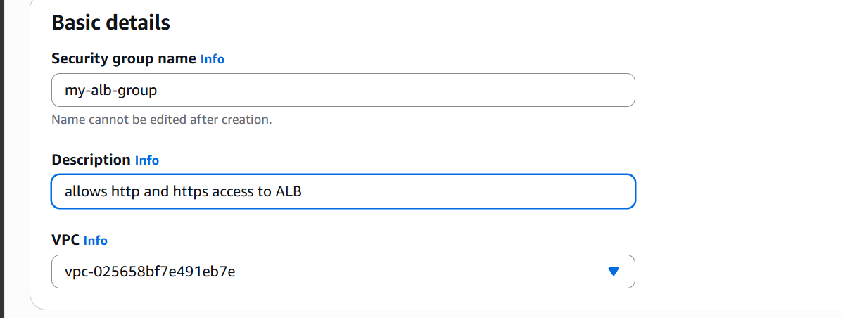

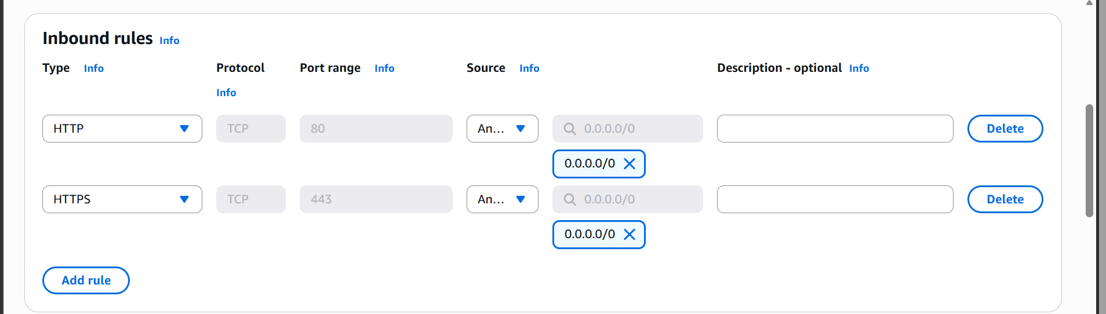

Selecting the new security group

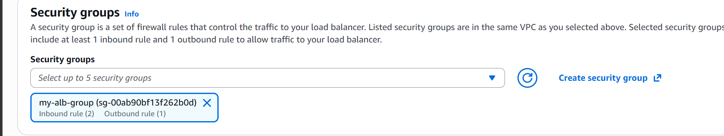

Create a target group

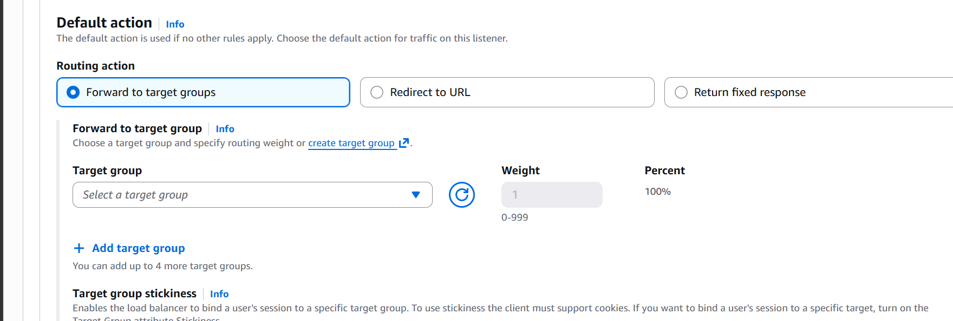

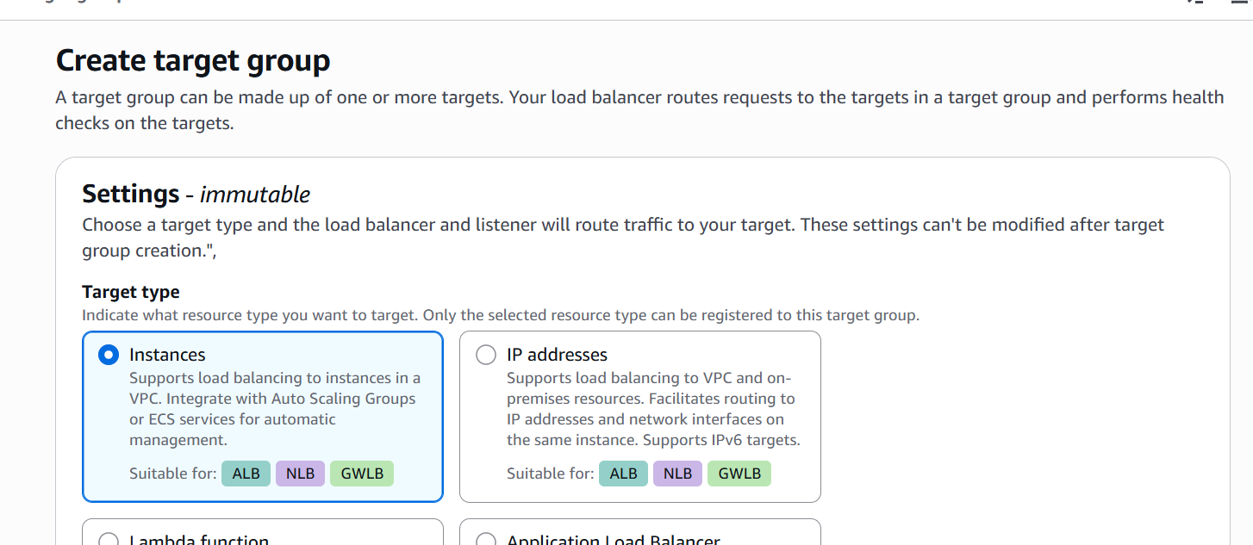
Select instances as target type
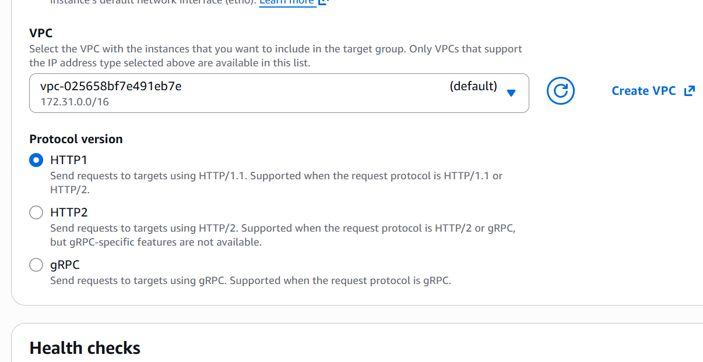

Select vpc for target group
Health check path and protocal
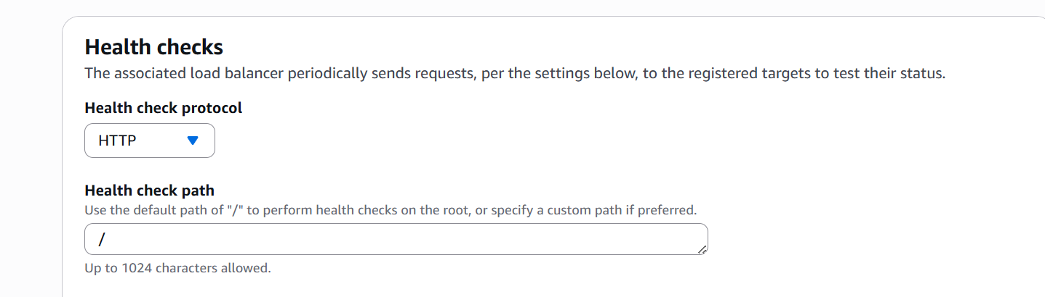

Select the target instances
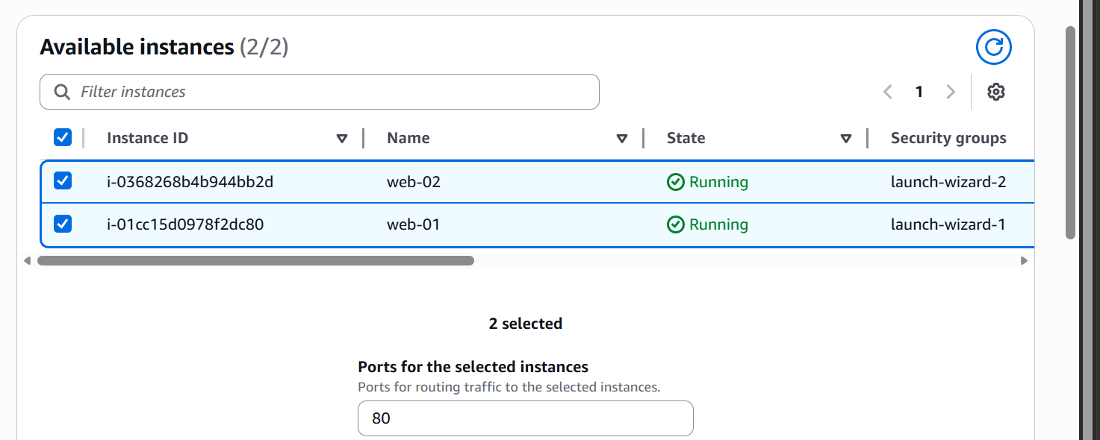

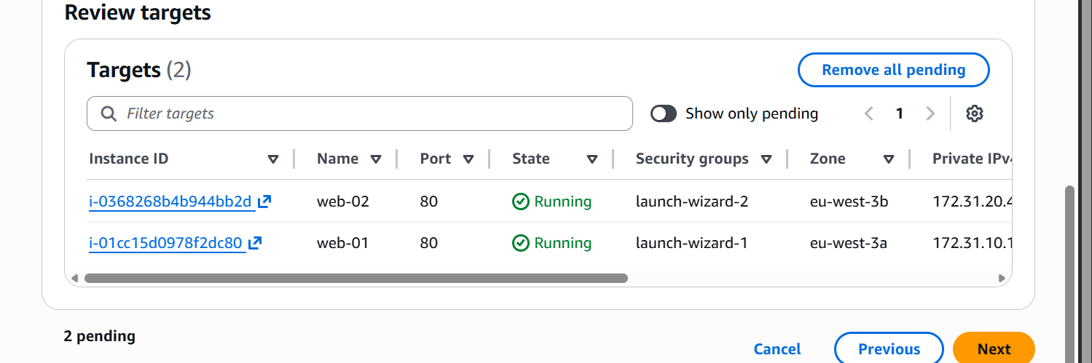

Now click on create target group
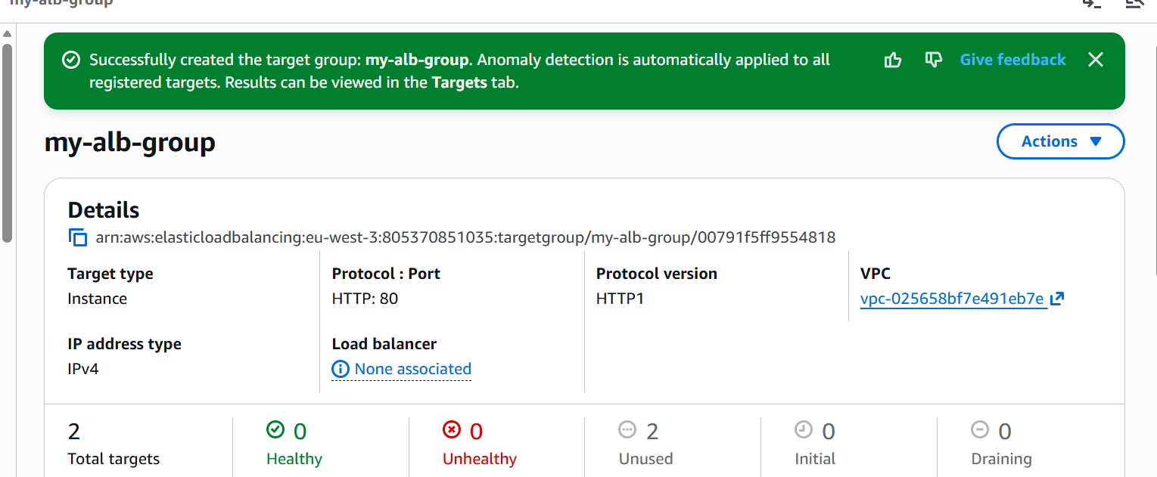
Target group is now created
Lets us now select the same target group and create our Application Load Balancer
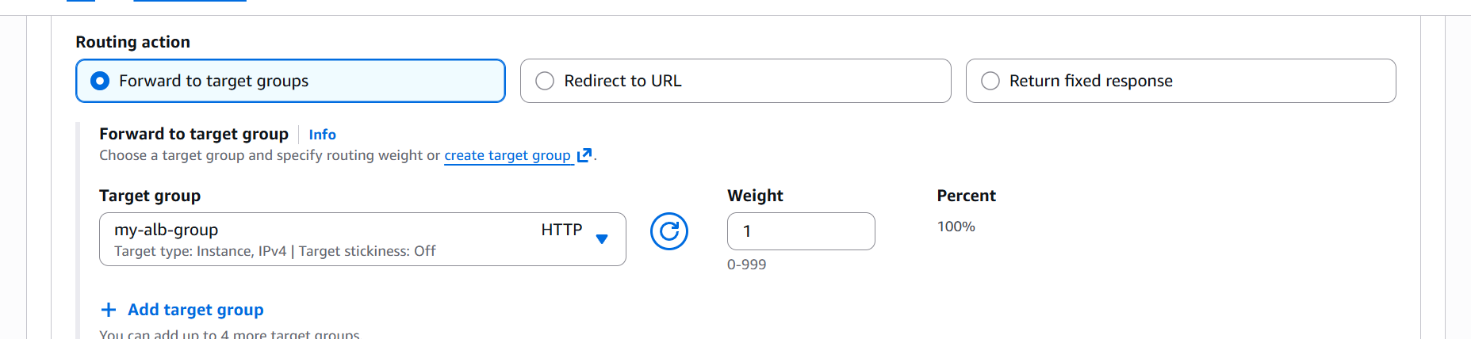

Now click on create Load Balancer
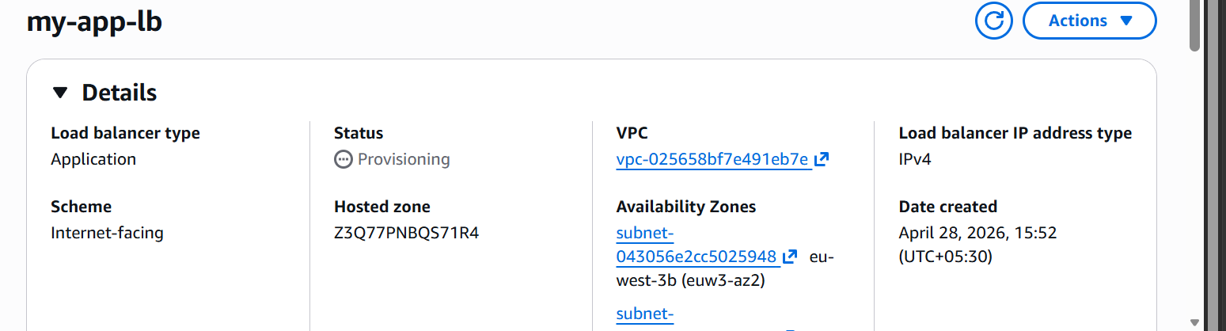
Load balancer is created
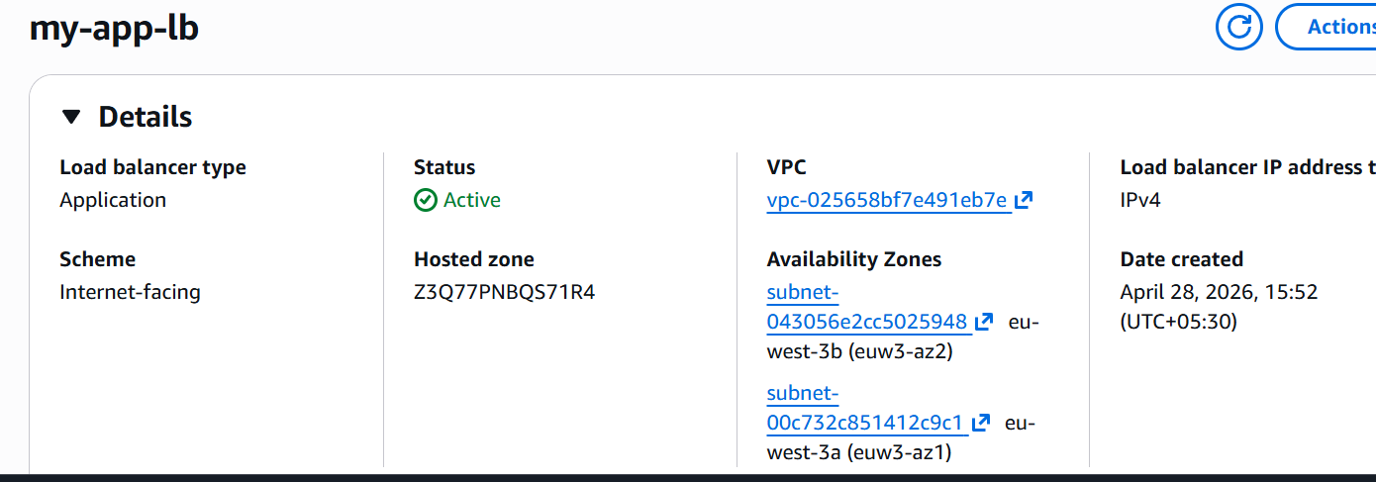
The load balancer is now active let us now test with its dns name
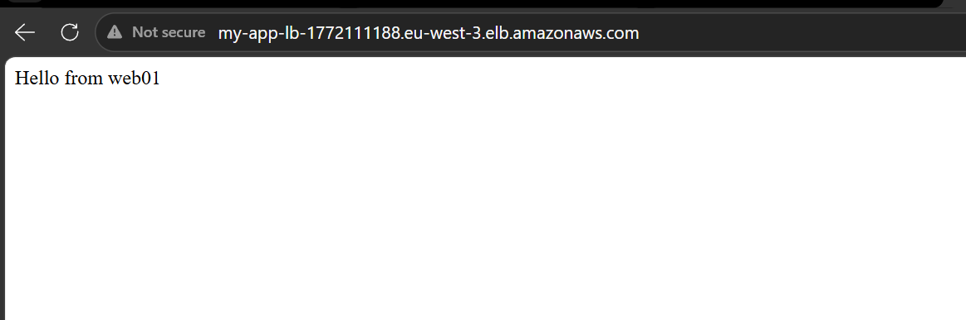

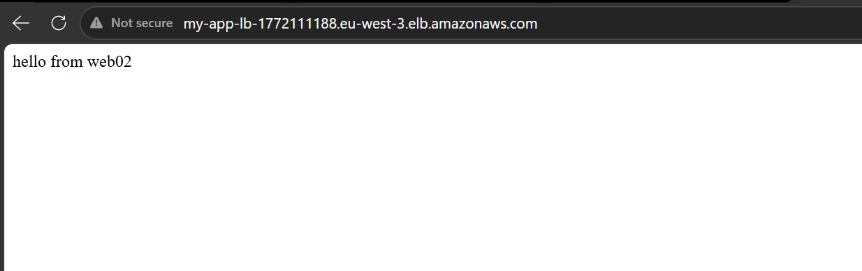

This is working fine now
Let us now do path based routing as it is a feature of the application load balancer
Let us ssh to our web01 instance
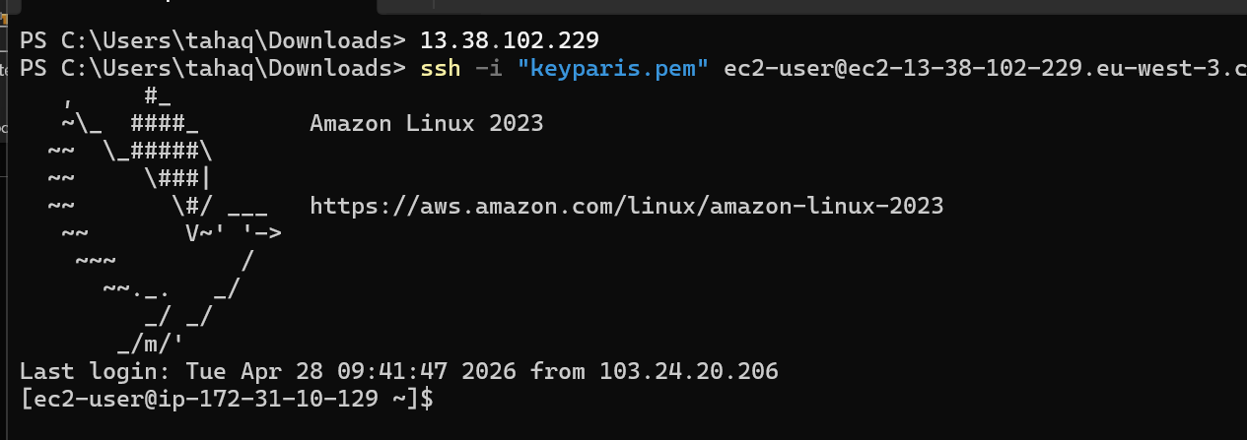
Lets now add a file in alb1 folder
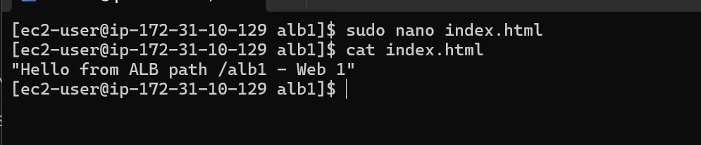
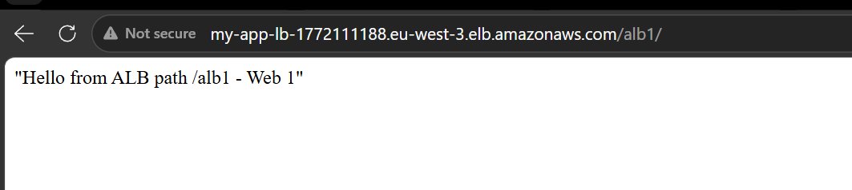
Lets do the same in web02 instance
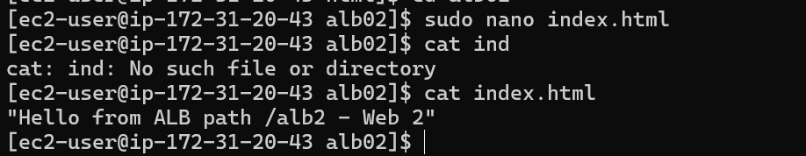
The file’s been updated let us check with the dns
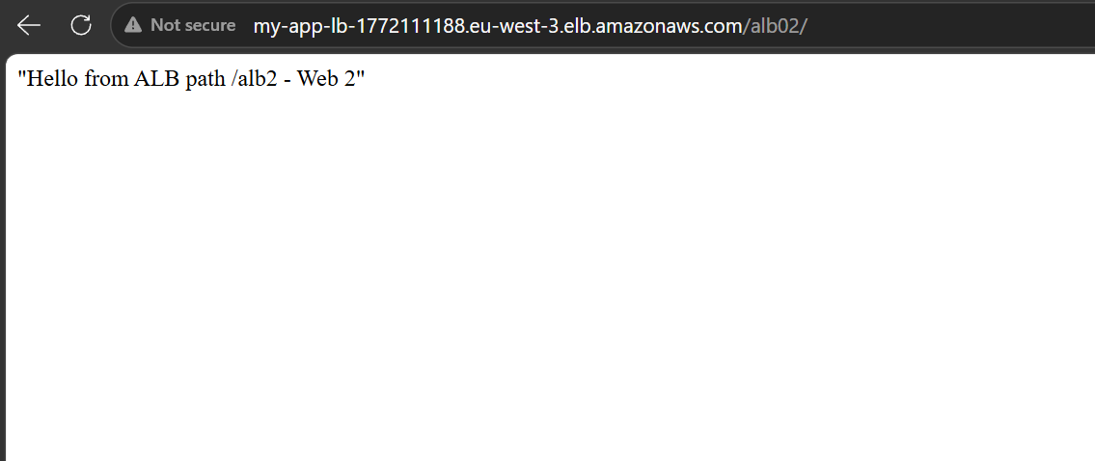

This is accessible too

Let us now create the target group
Go to instances and under that target group
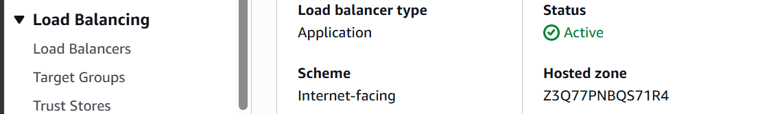
Now click on create a target group
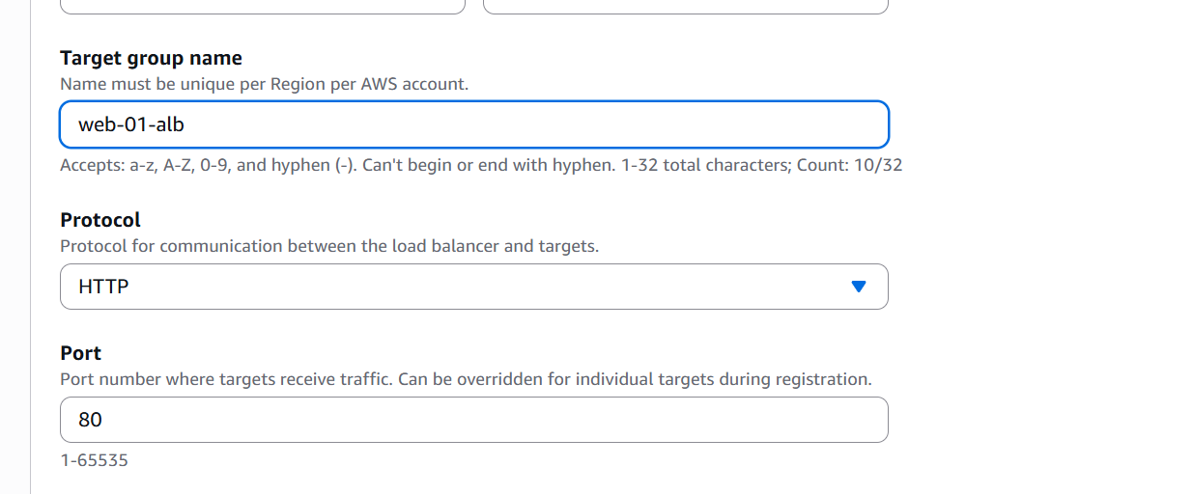
Give it a name

Select vpc and http version
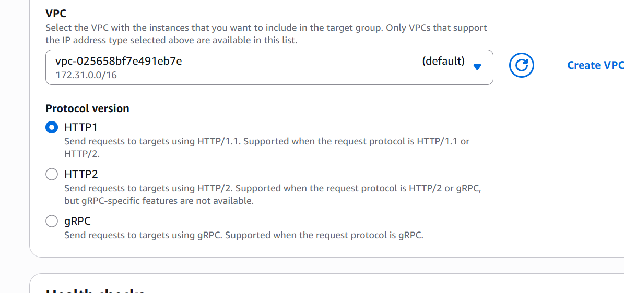
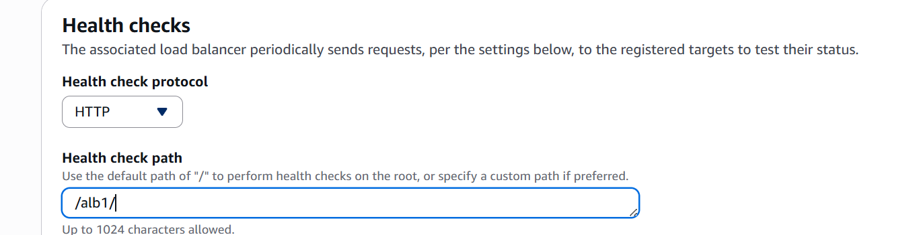

Give the health check path
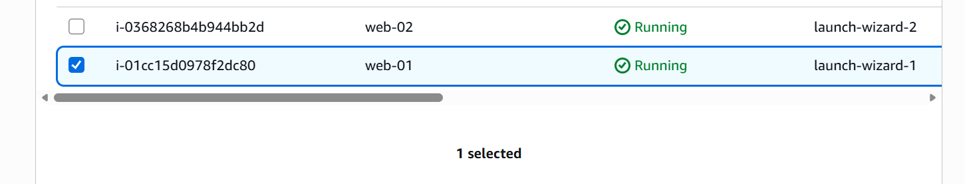

Select an instance
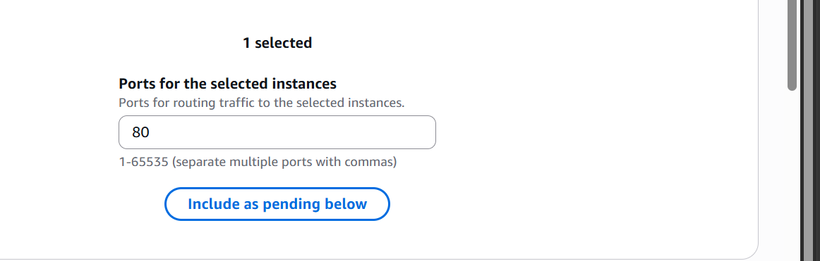
Include as pending below
Now create the target group
Create one more target group for our web-02 instance
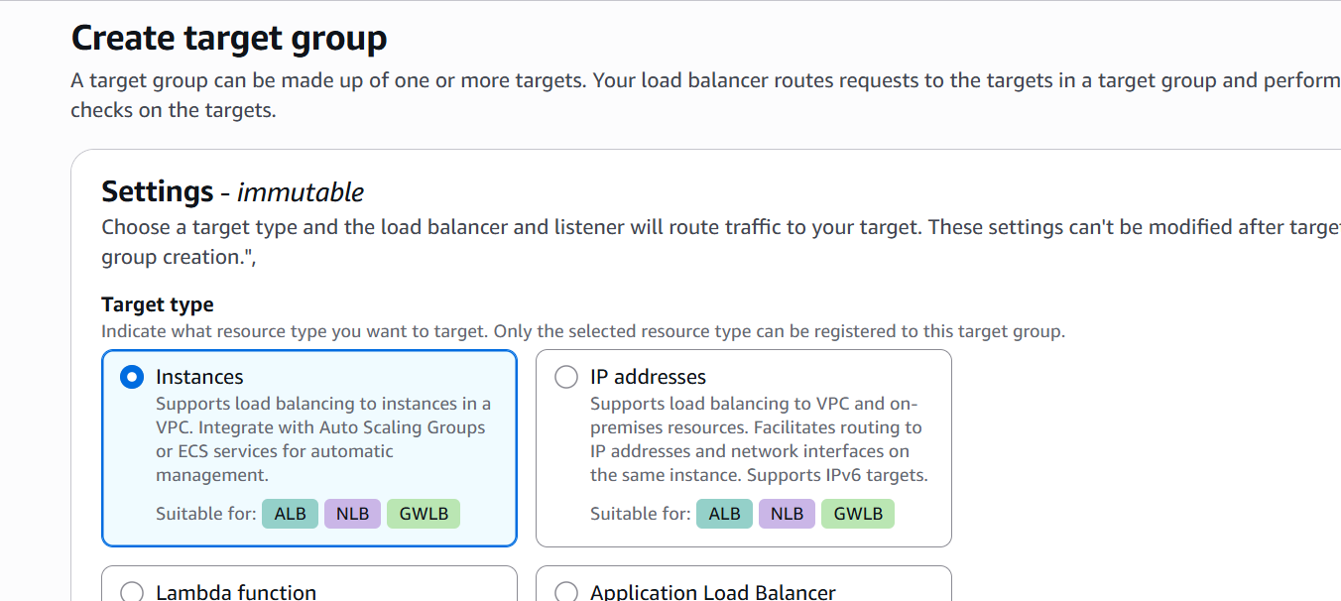
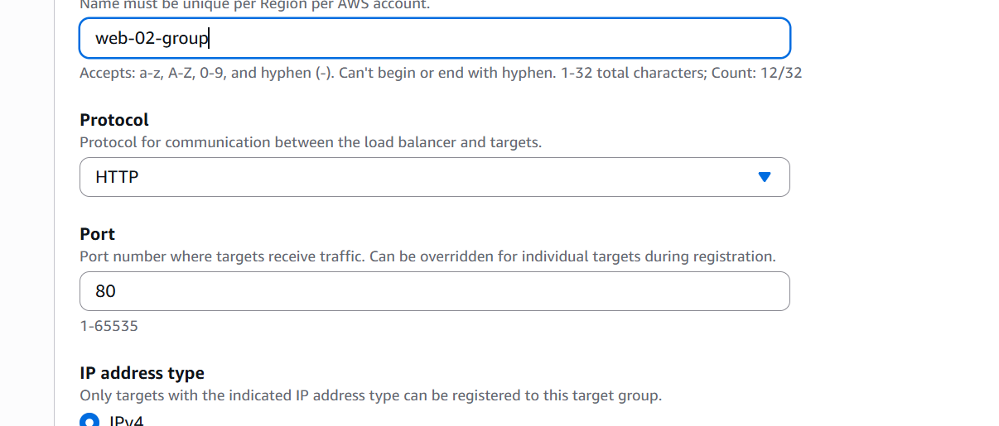
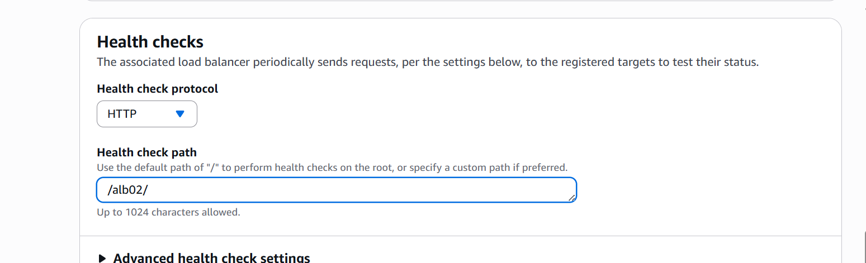
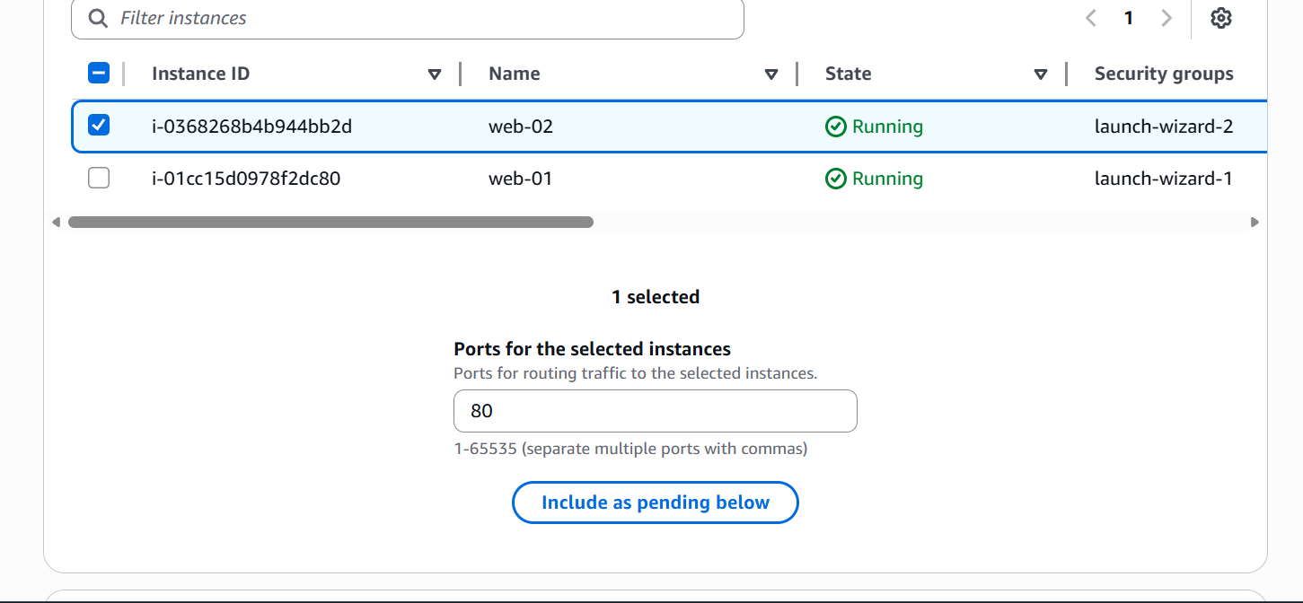
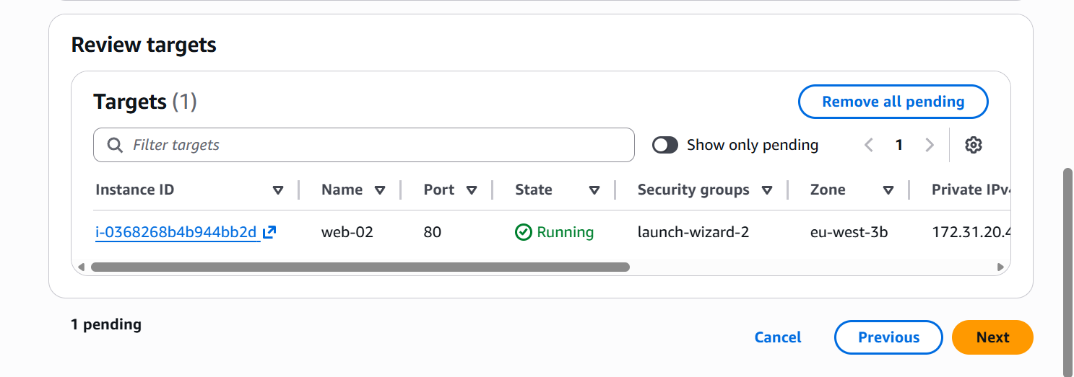

Let us now change the load balancer listener rules
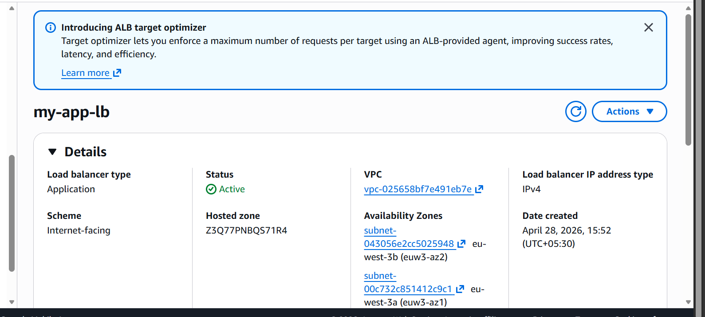

Go to listener rules and edit
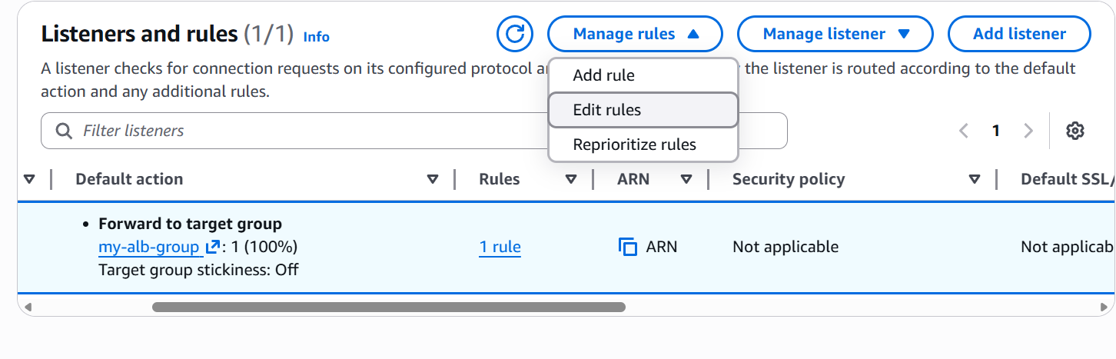
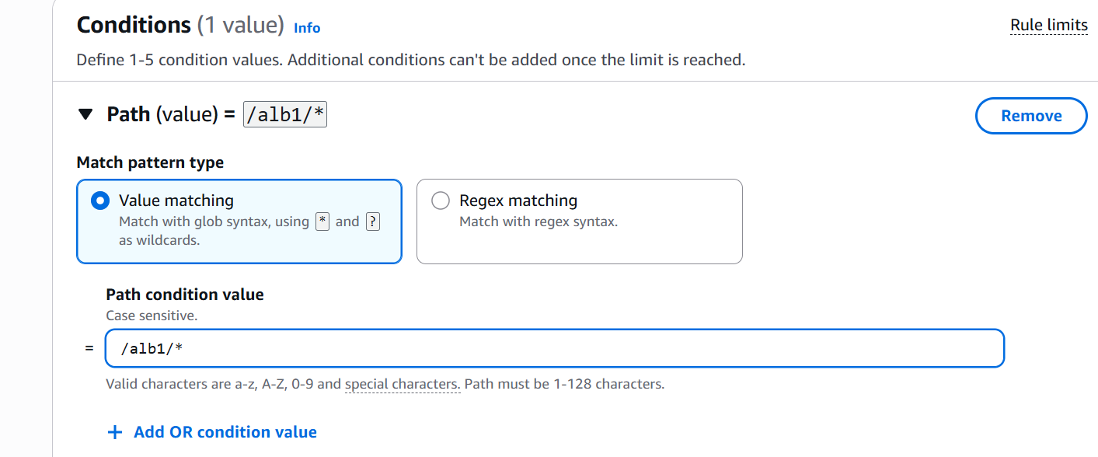

Set the condition if value is /alb1/ then request should go to web01 target group
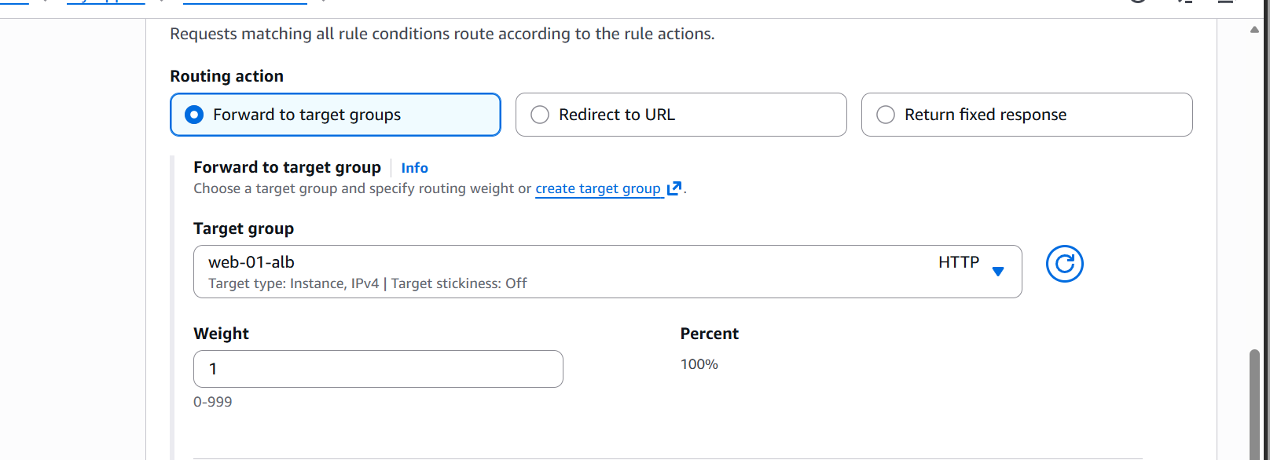
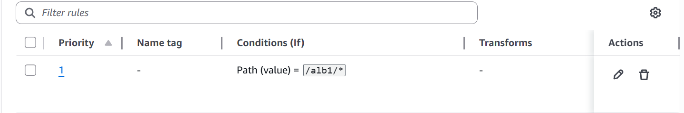
Priority set to 01
Lets now add another rule
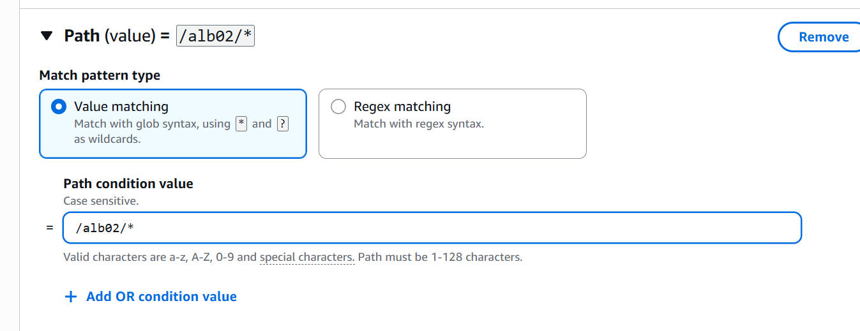
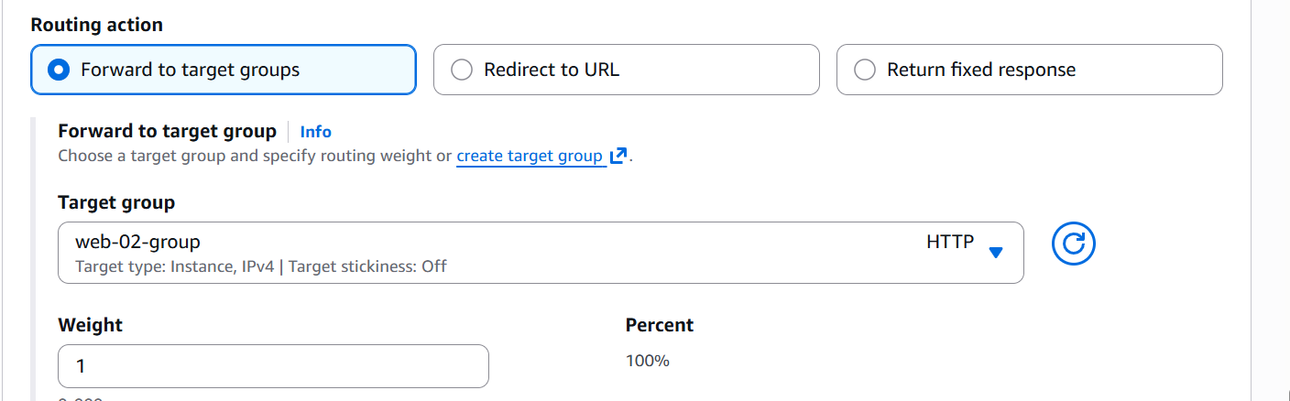
Priority set to 2

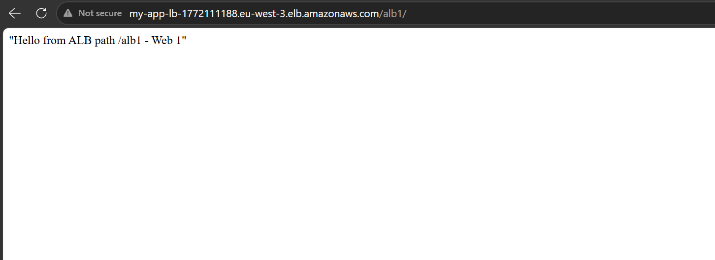

Now we are able to access based on the path
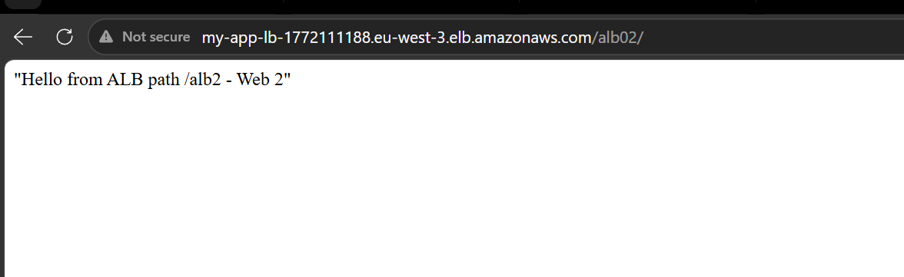

So we are able to access our load balancer using different path

- Configure Network Load Balancer

Let us create a target group
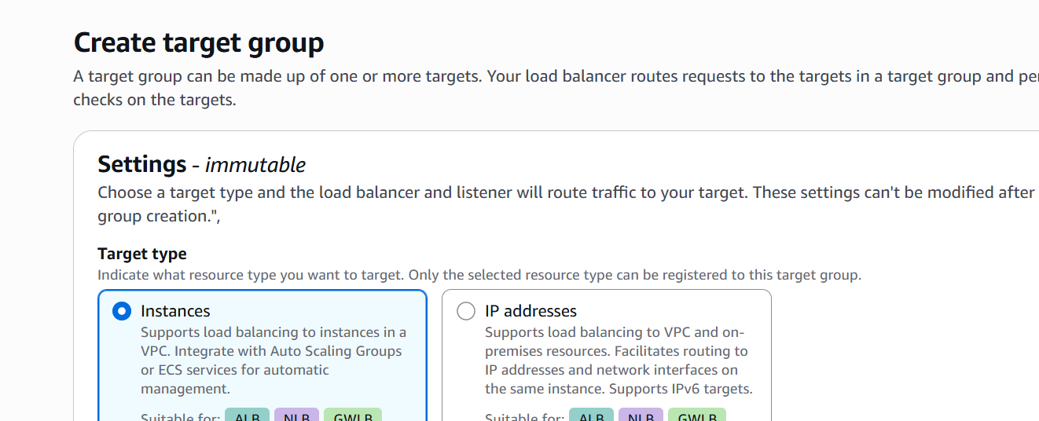

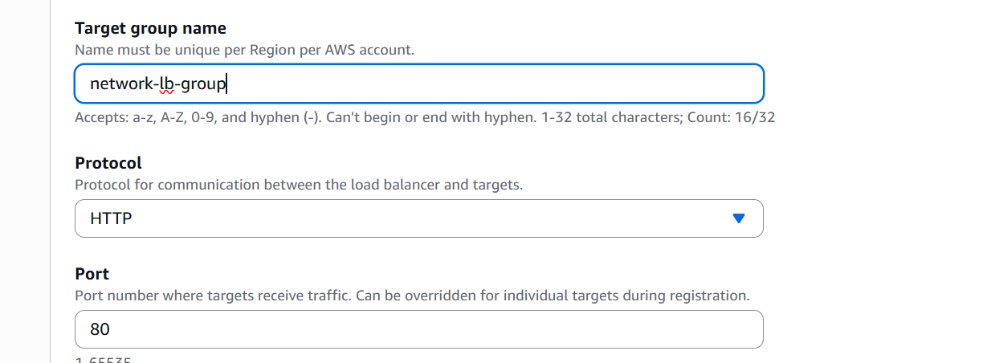
Select VPC

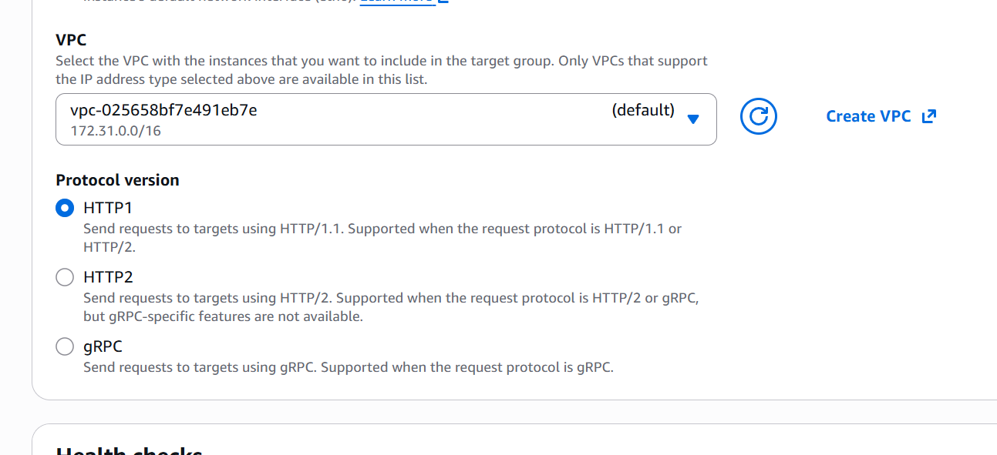

Select health check path
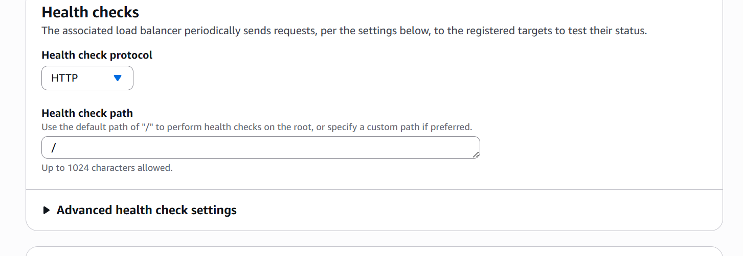

Selected the Target instances
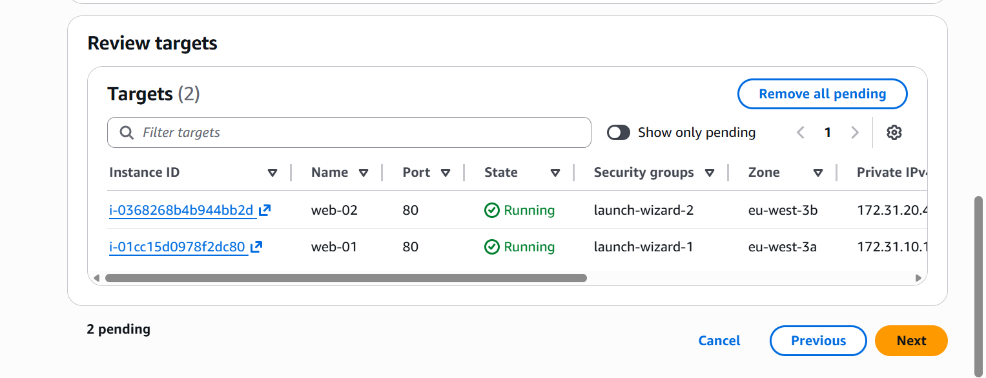

Let us now create the network load balancer
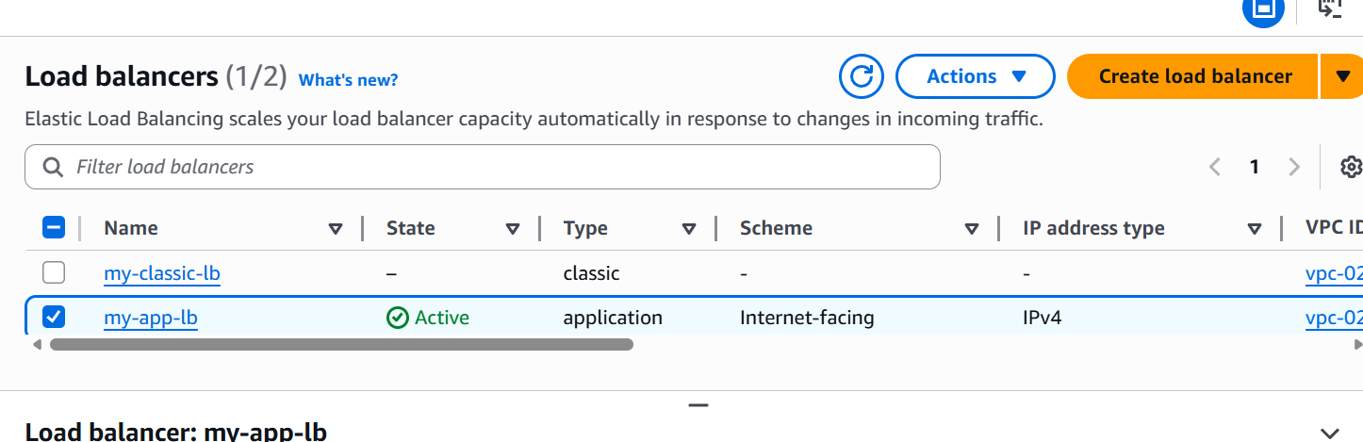

Click on create load balancer
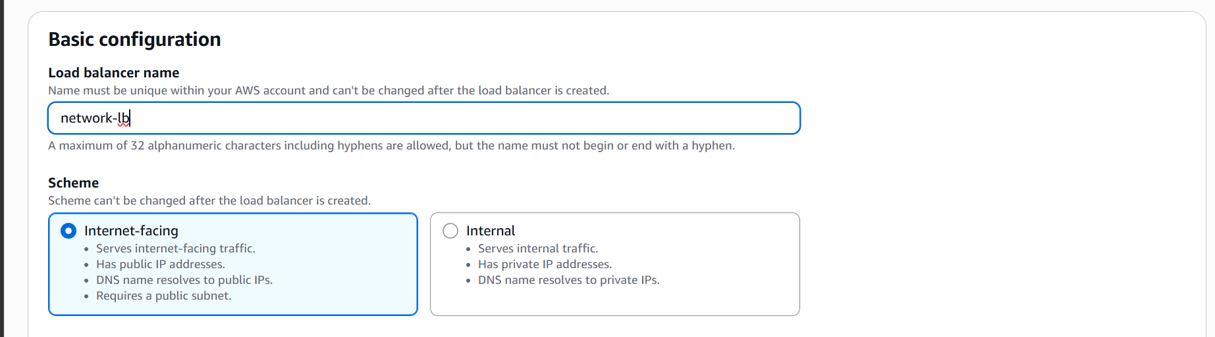

Select VPC and subnet

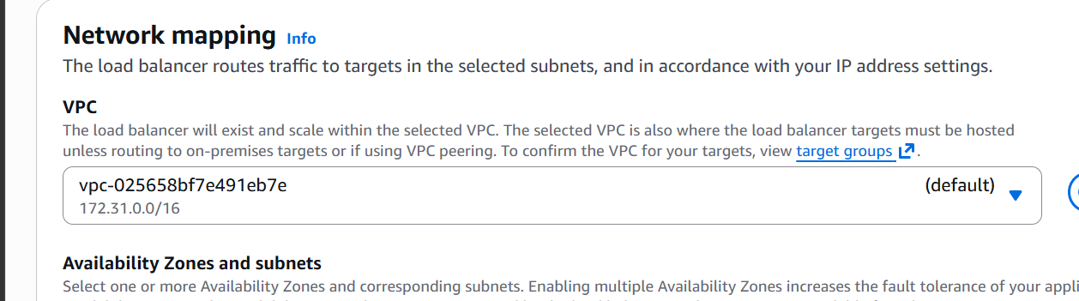

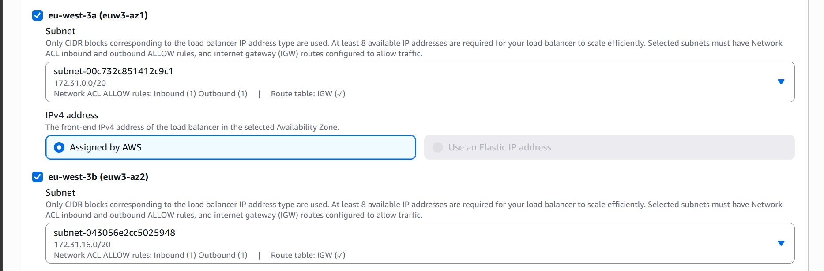

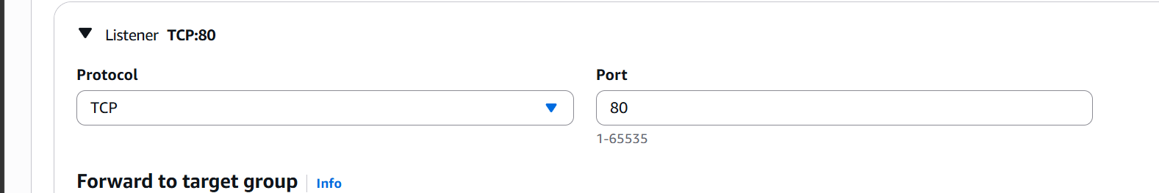

Listener on TCP:80

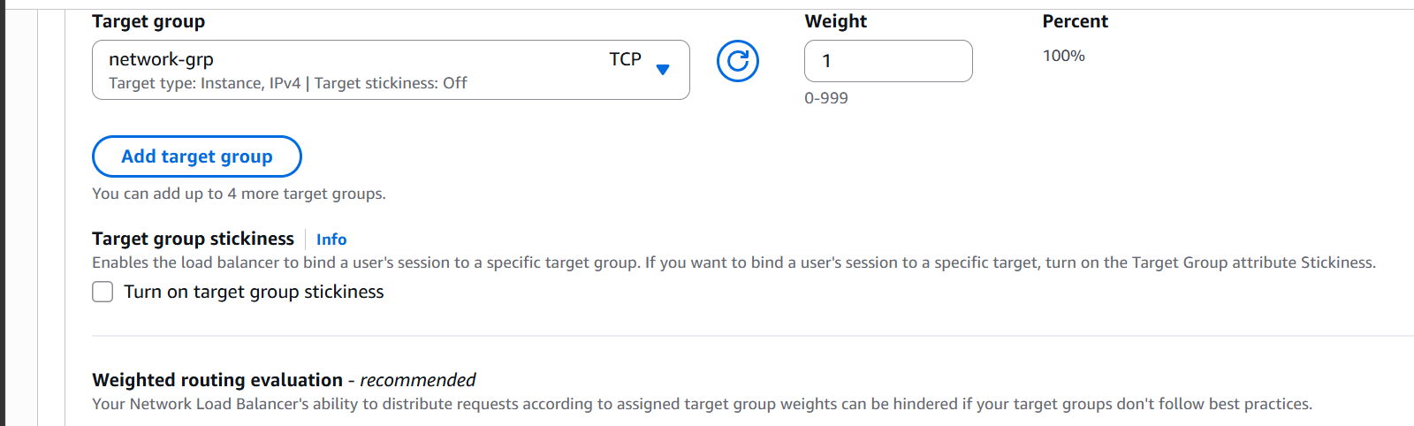

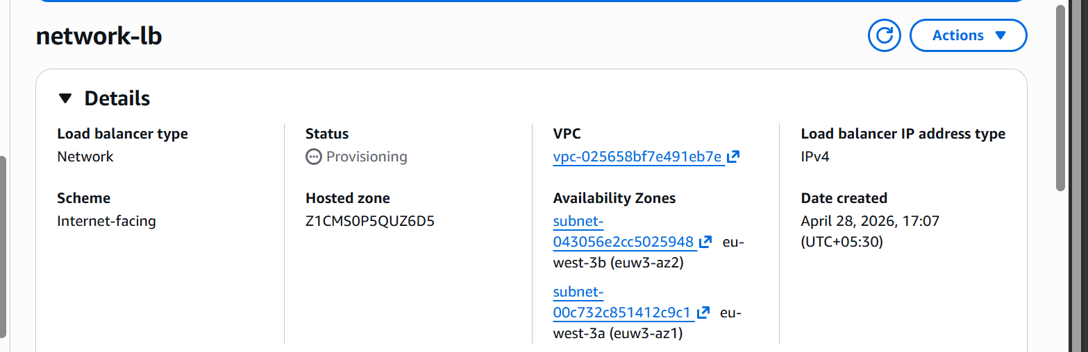
Network load balancer is now created

Our network balancer is working properly
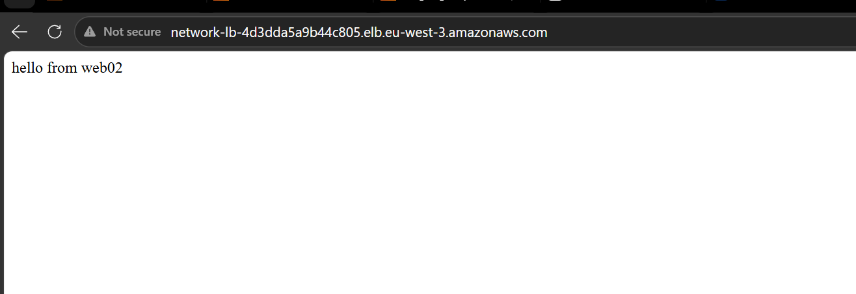

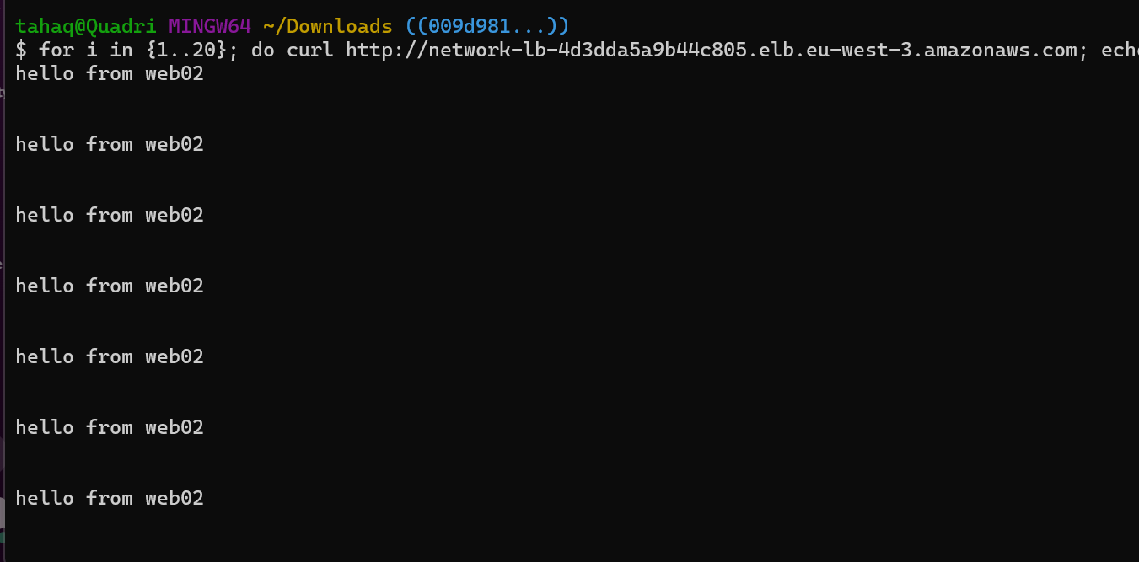
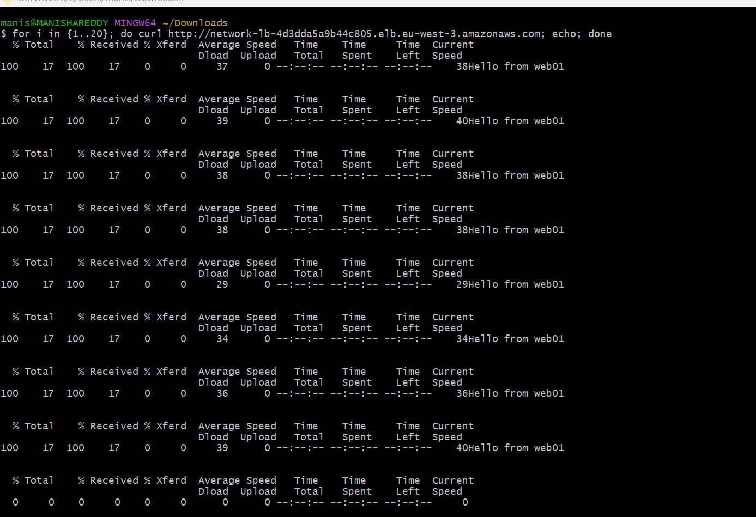

When I tried to curl from another source the traffic goes to web 01

- Attach SSL for application load balancer.

Go to certificate manager and request for a certificate
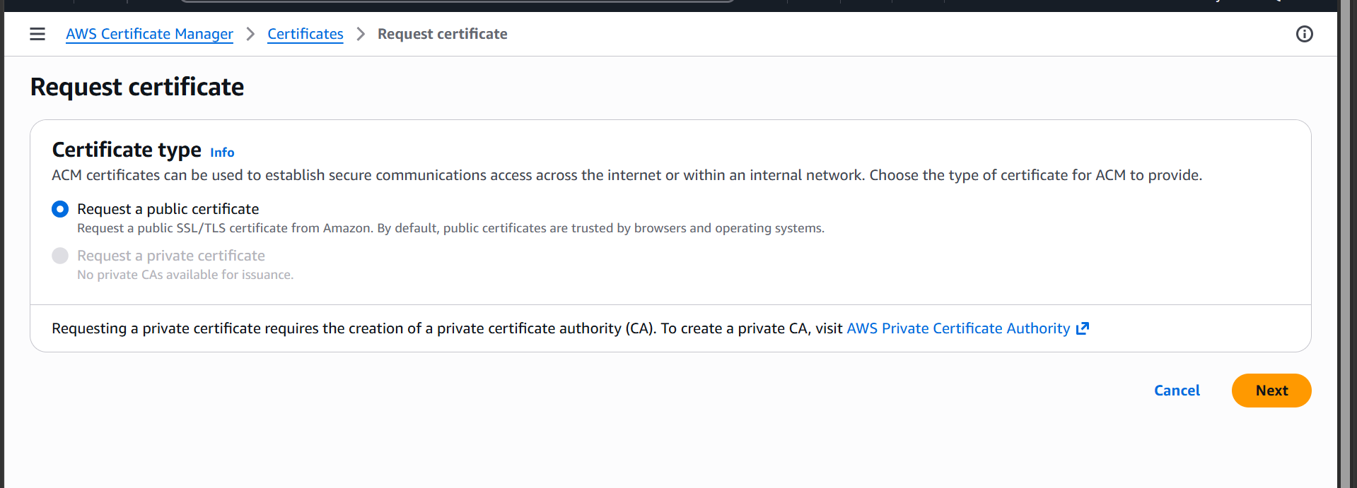
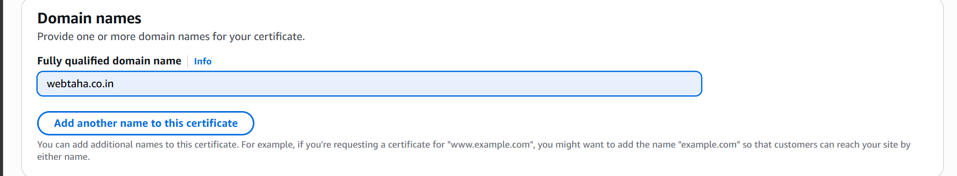
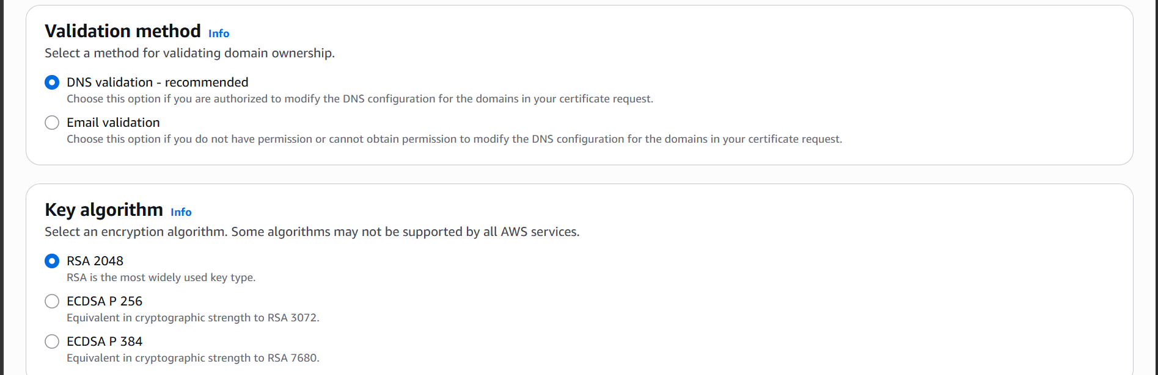
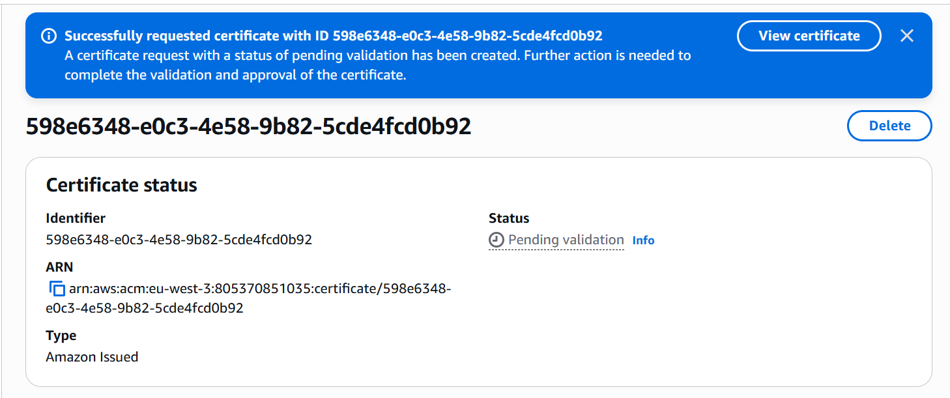
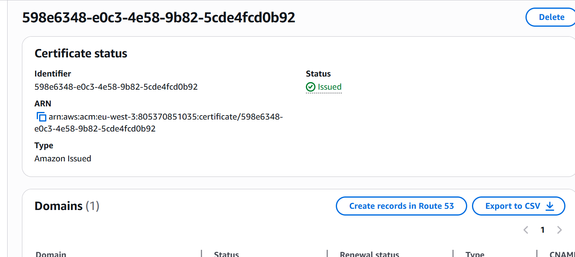

Certificate is now issued

Now let us add HTTPS listener to our ALB
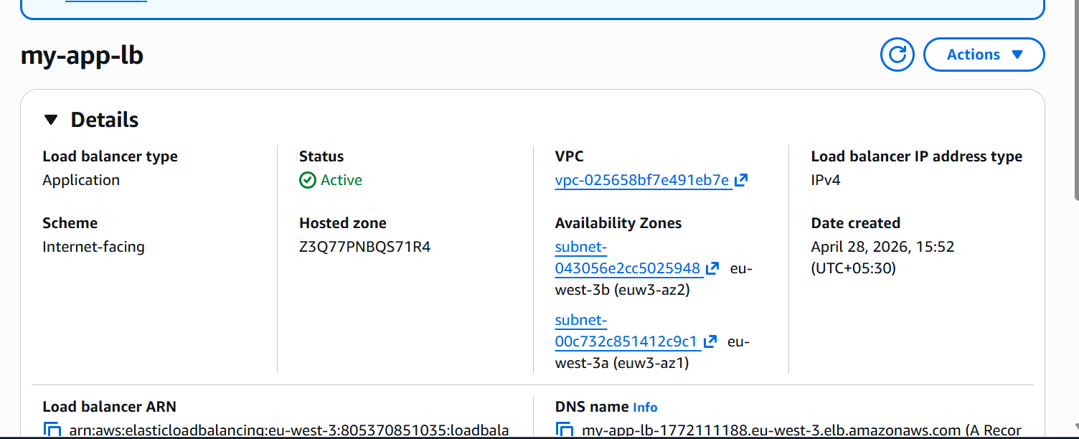
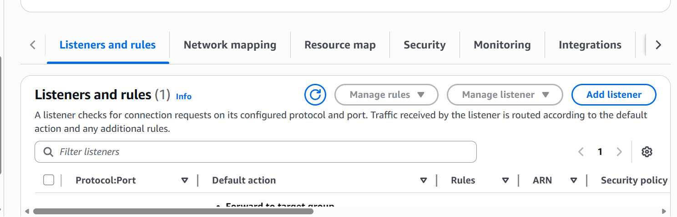

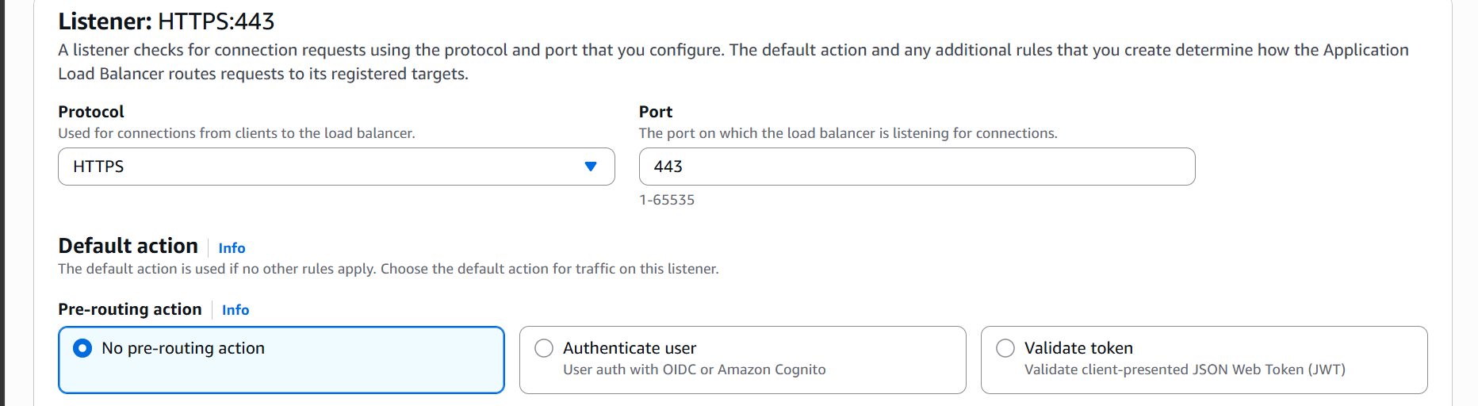
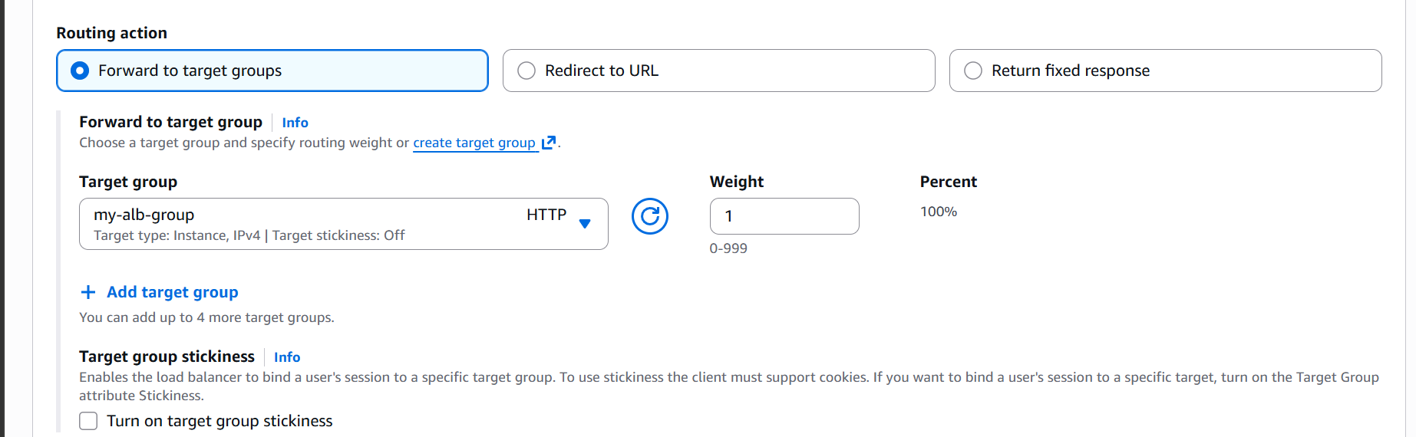
Select the certificate
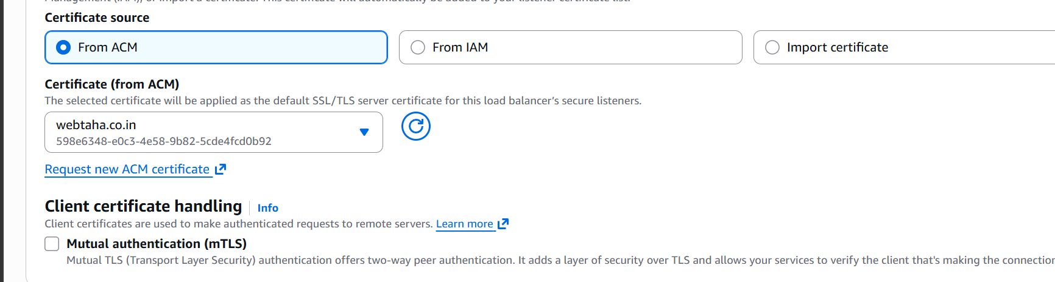
Now click on add listener
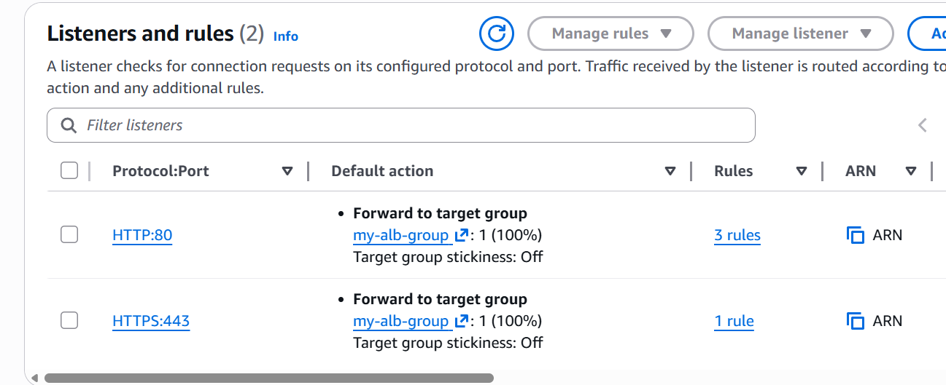

We have now added one more listener : HTTPS
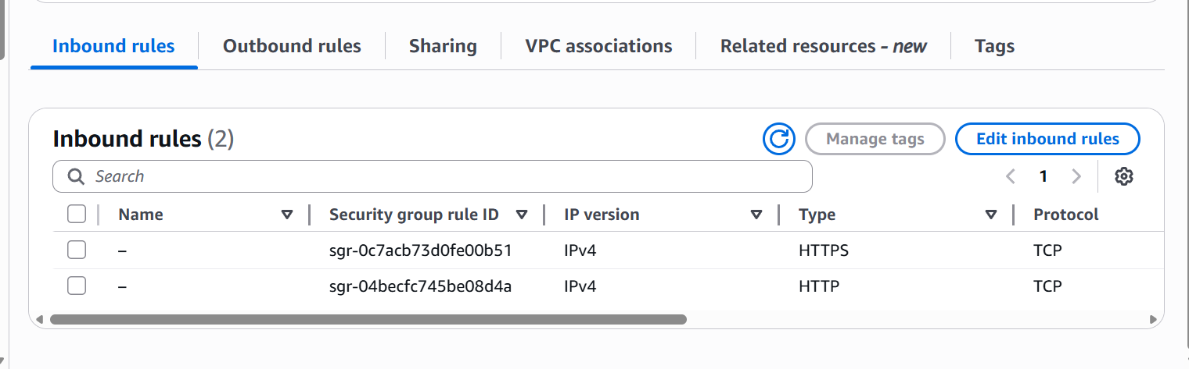
We already have both HTTP and HTTPS allowed in our ALB

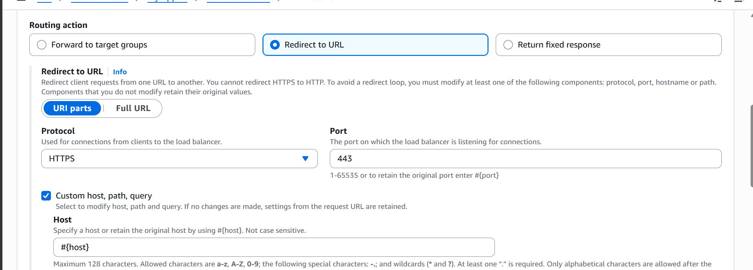
Redirecting the traffic to HTTPS

The SSL certificate is now attached to our Application load balancer

- Map Application Load Balancer to R53
Go to Route 53 and create a hosted zone
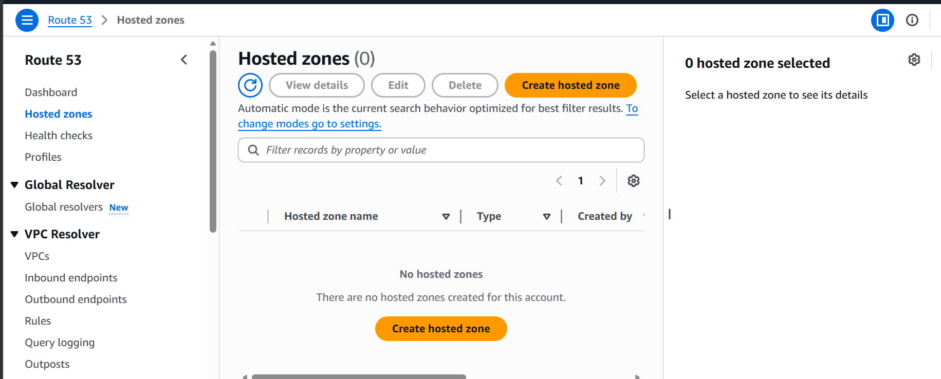

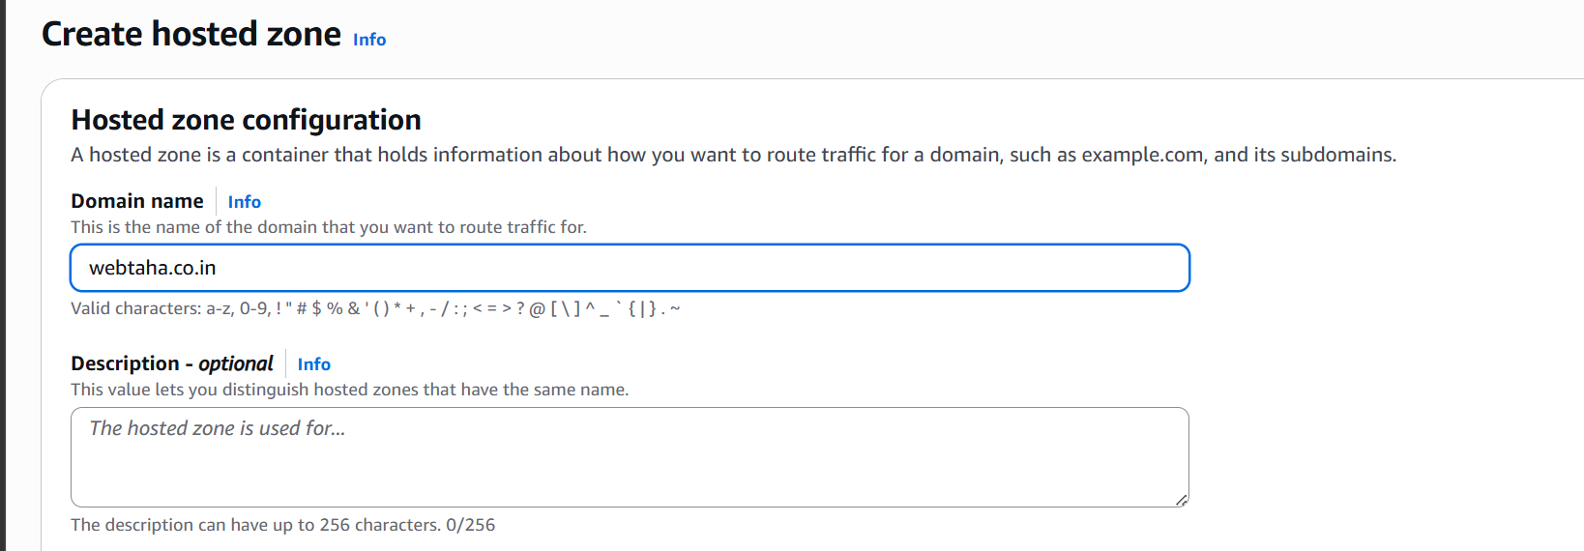

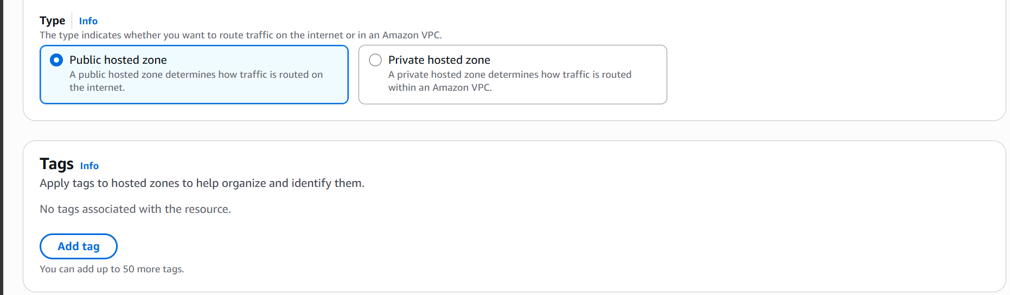

Hosted zone is created
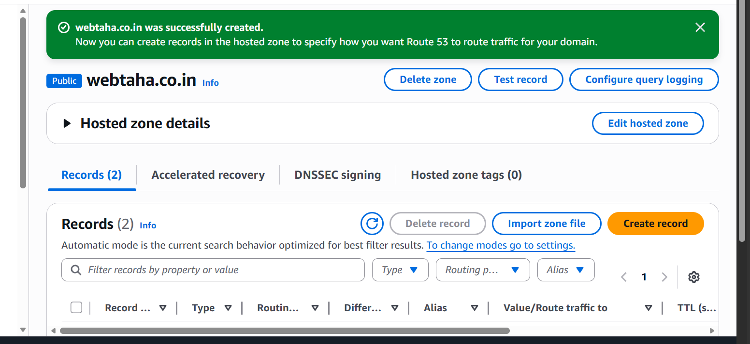
Lets add the records in our domain providers nameserver

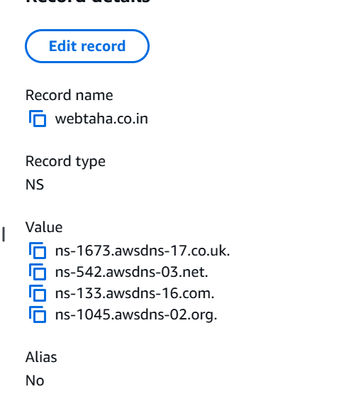

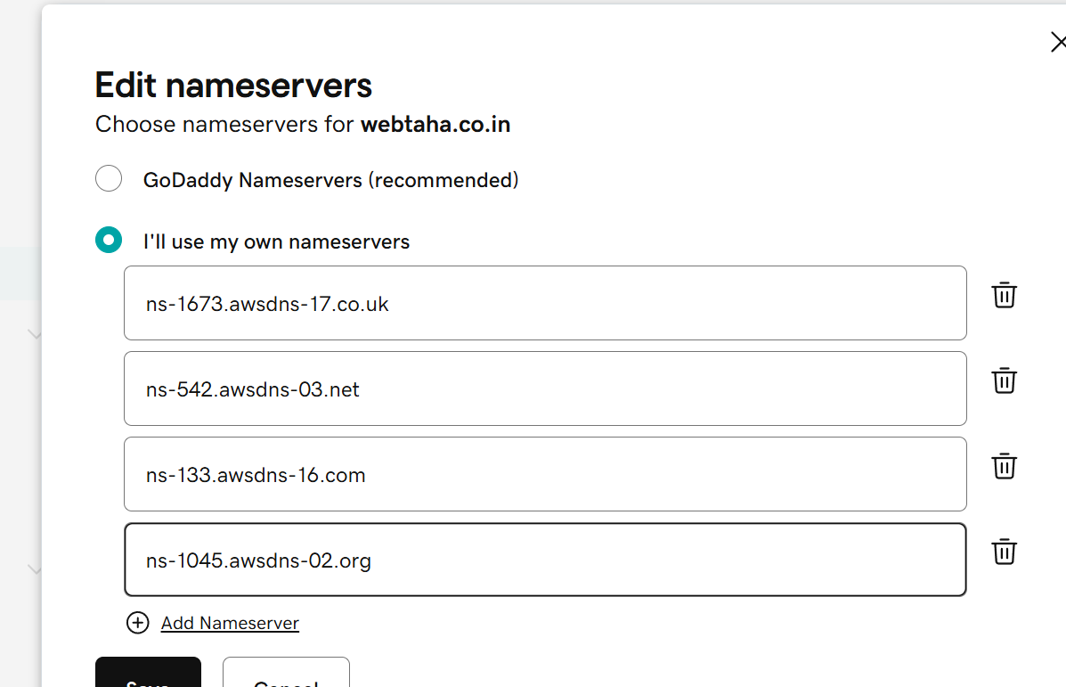

Adding records in route 53
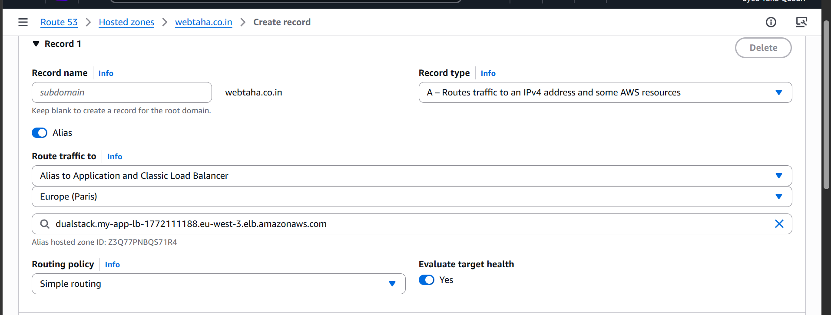

Create another record
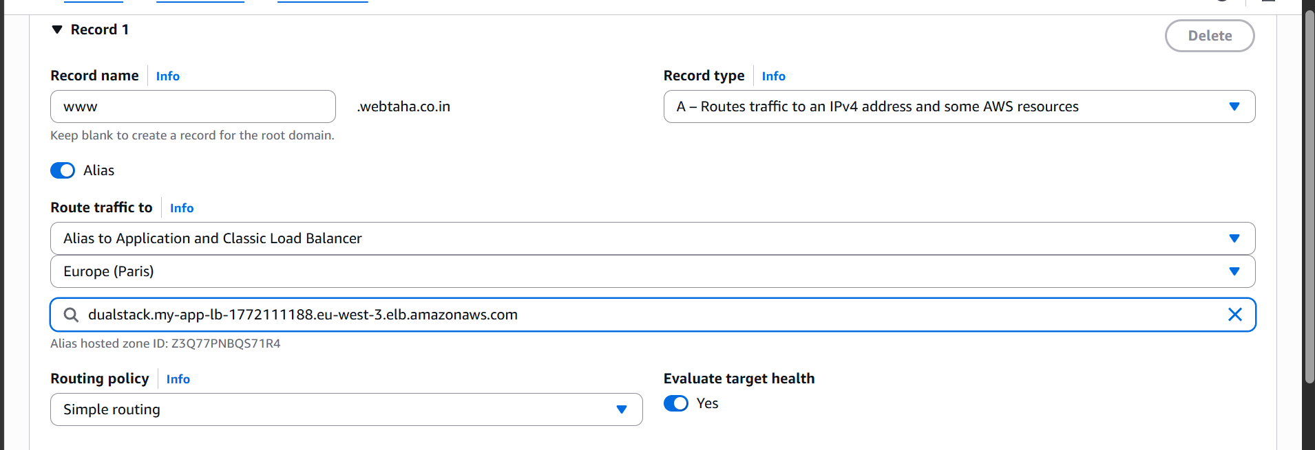

Lets check our URL now

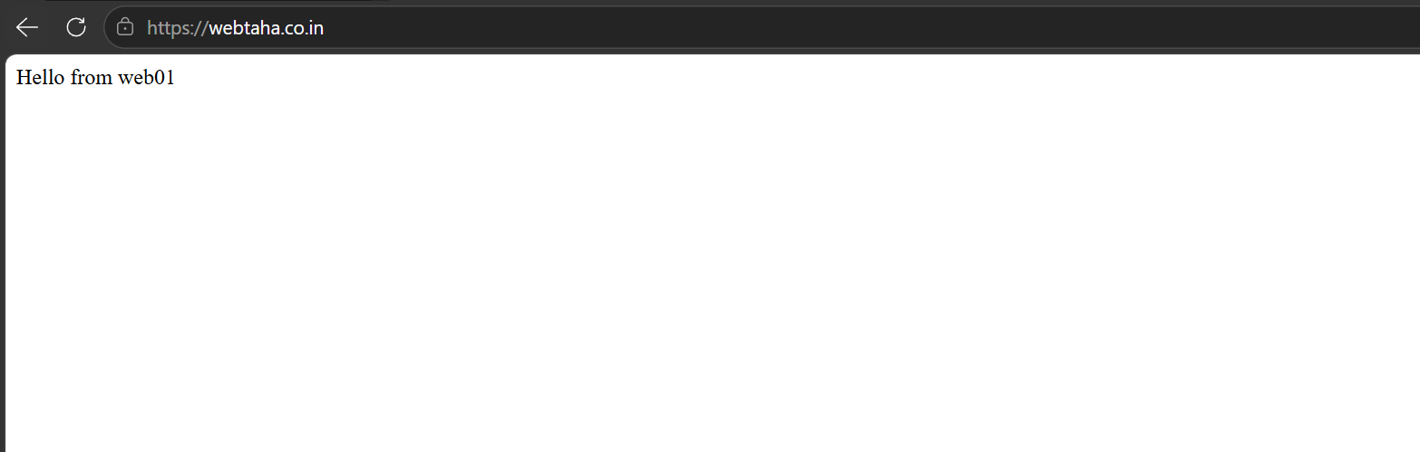

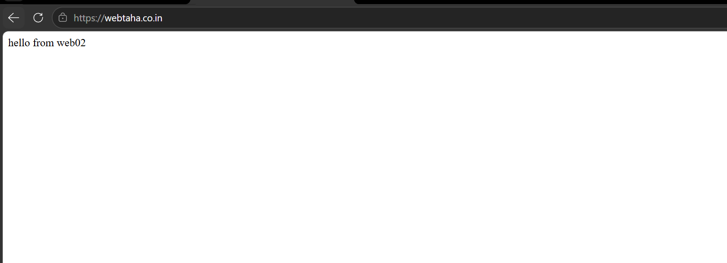

Its working now
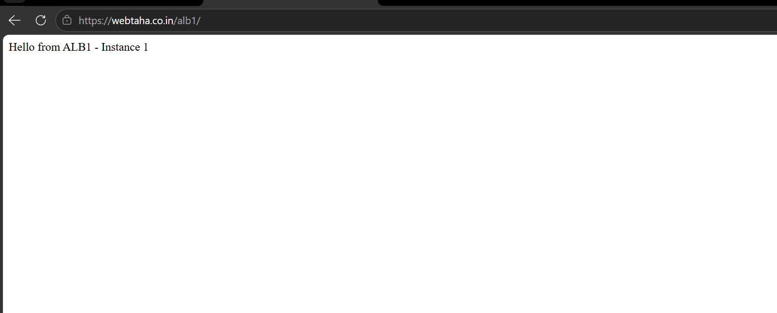

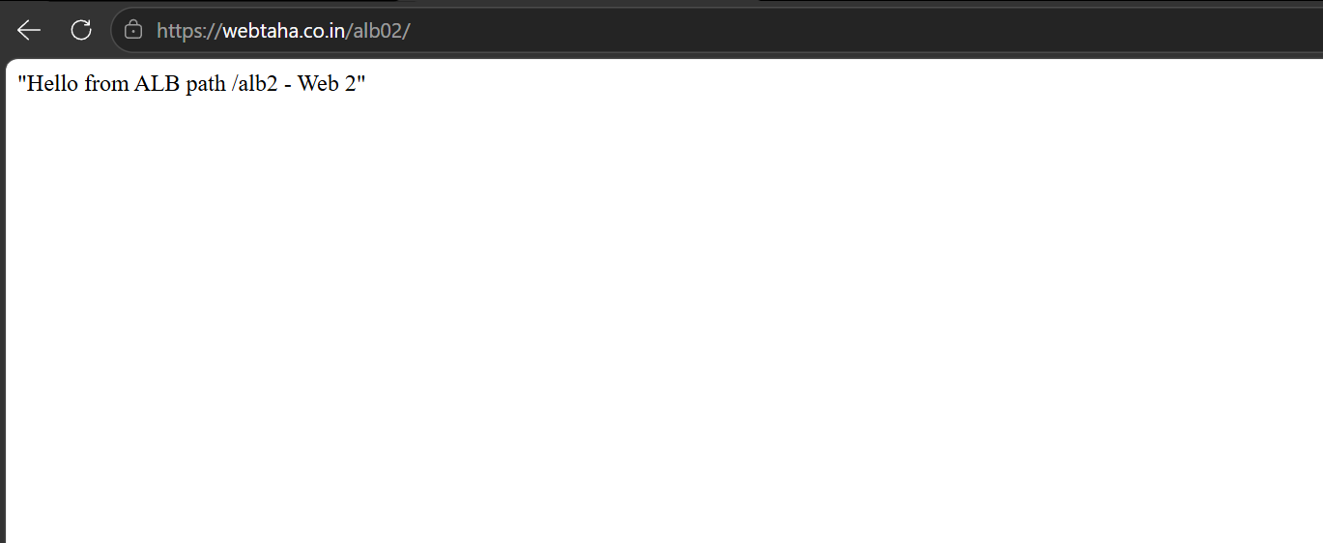

So now we have mapped our application load balancer to our route53!!

- Push the Application logs to S3
First lets create a S3 bucket

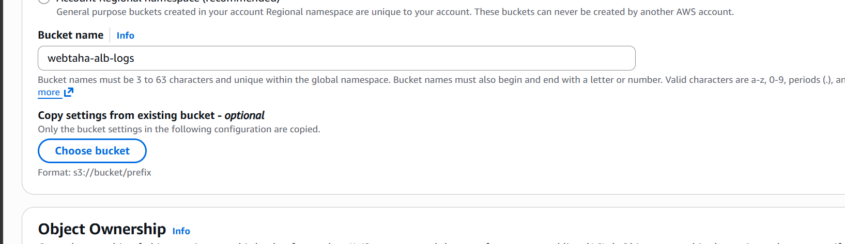

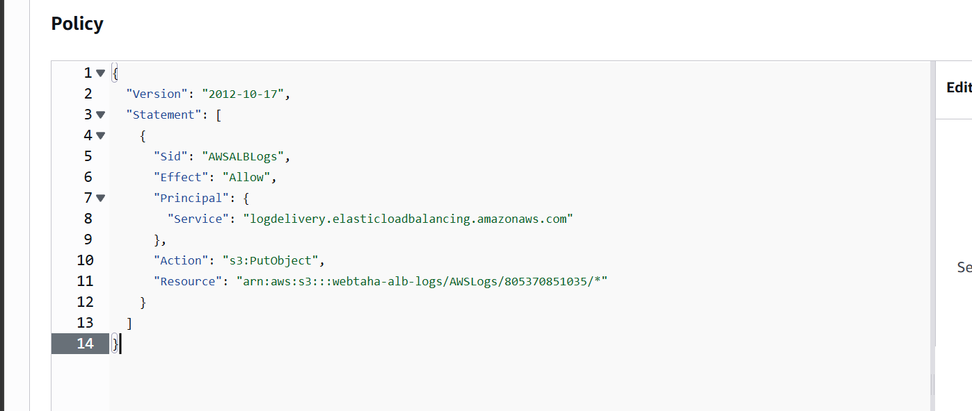

Now let us enable access logs
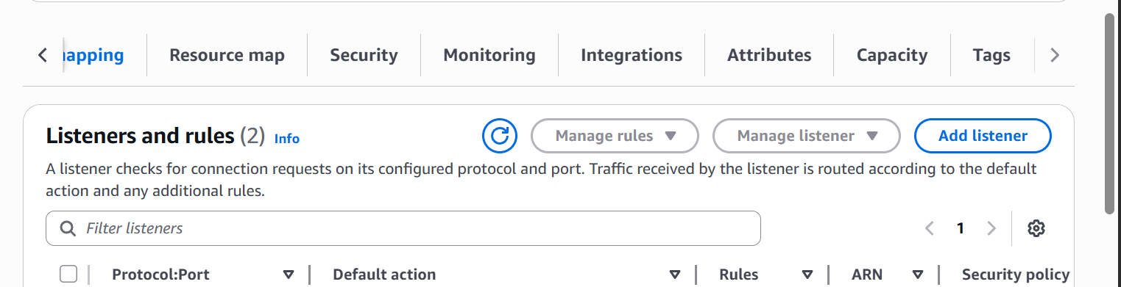

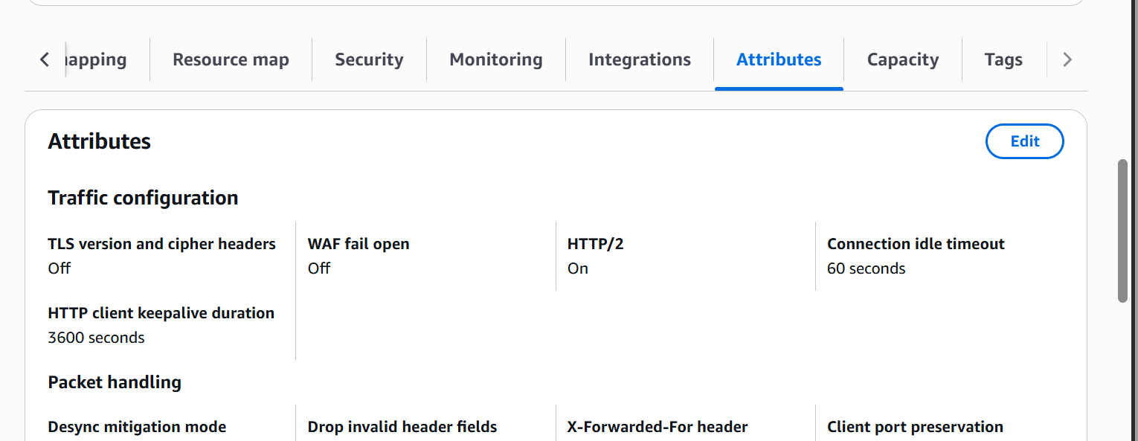

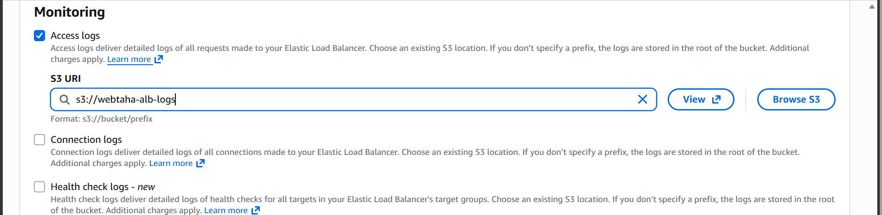

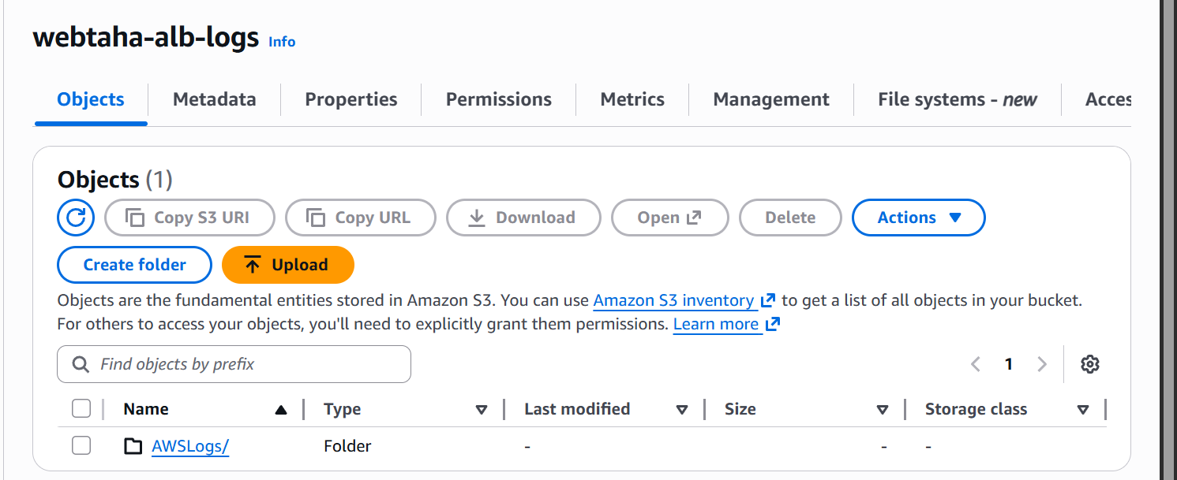
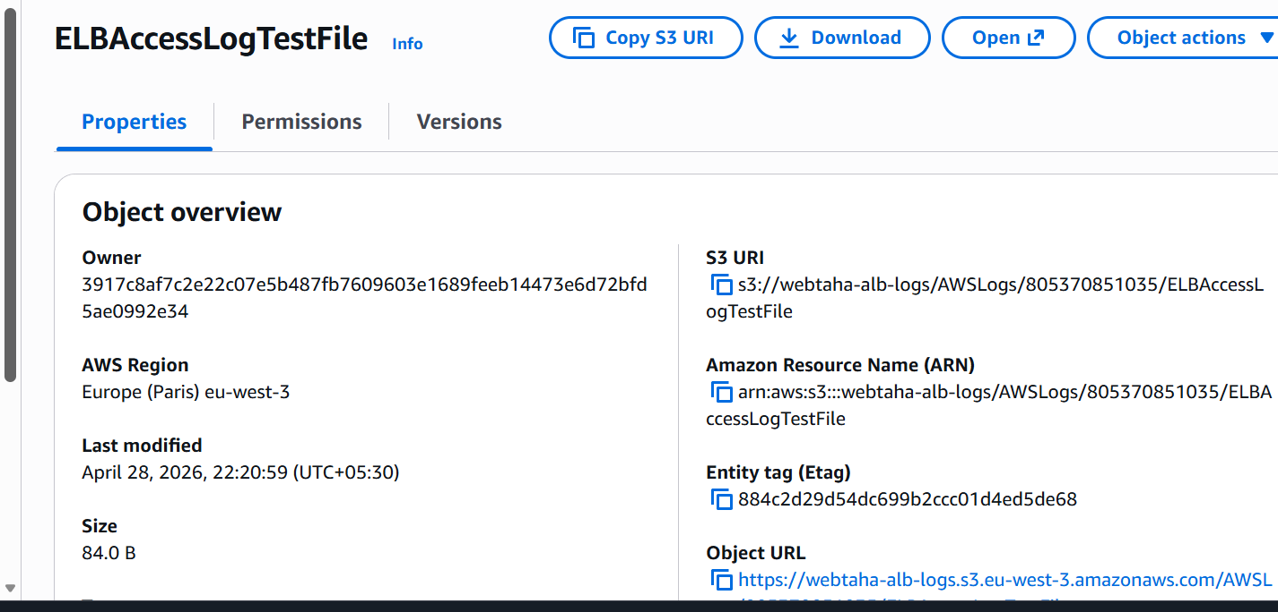

We can now see that logs are generated
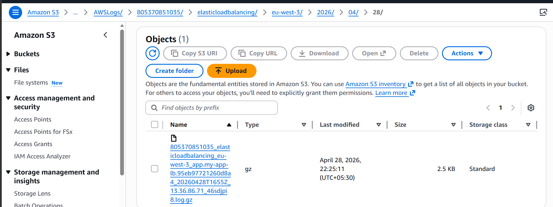

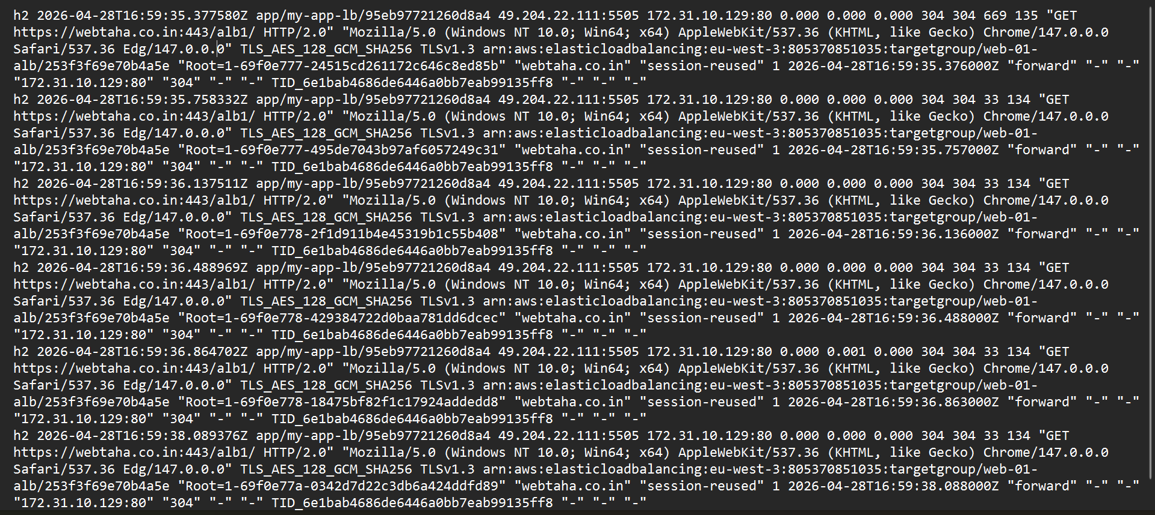

We are now able to access our ALB’s logs in S3 bucket.

