- 3) Setup a Jenkins CICD pipeline using Scripted pipeline using feature-1.1 branch.
Source Code: https://github.com/betawins/sabear_simplecutomerapp/tree/feature-1.1
stages:
- Git Clone
- SonarQube Integration
- Maven Compilation
- Nexus Artifactory
- Deploy On tomcat

Creating a new job
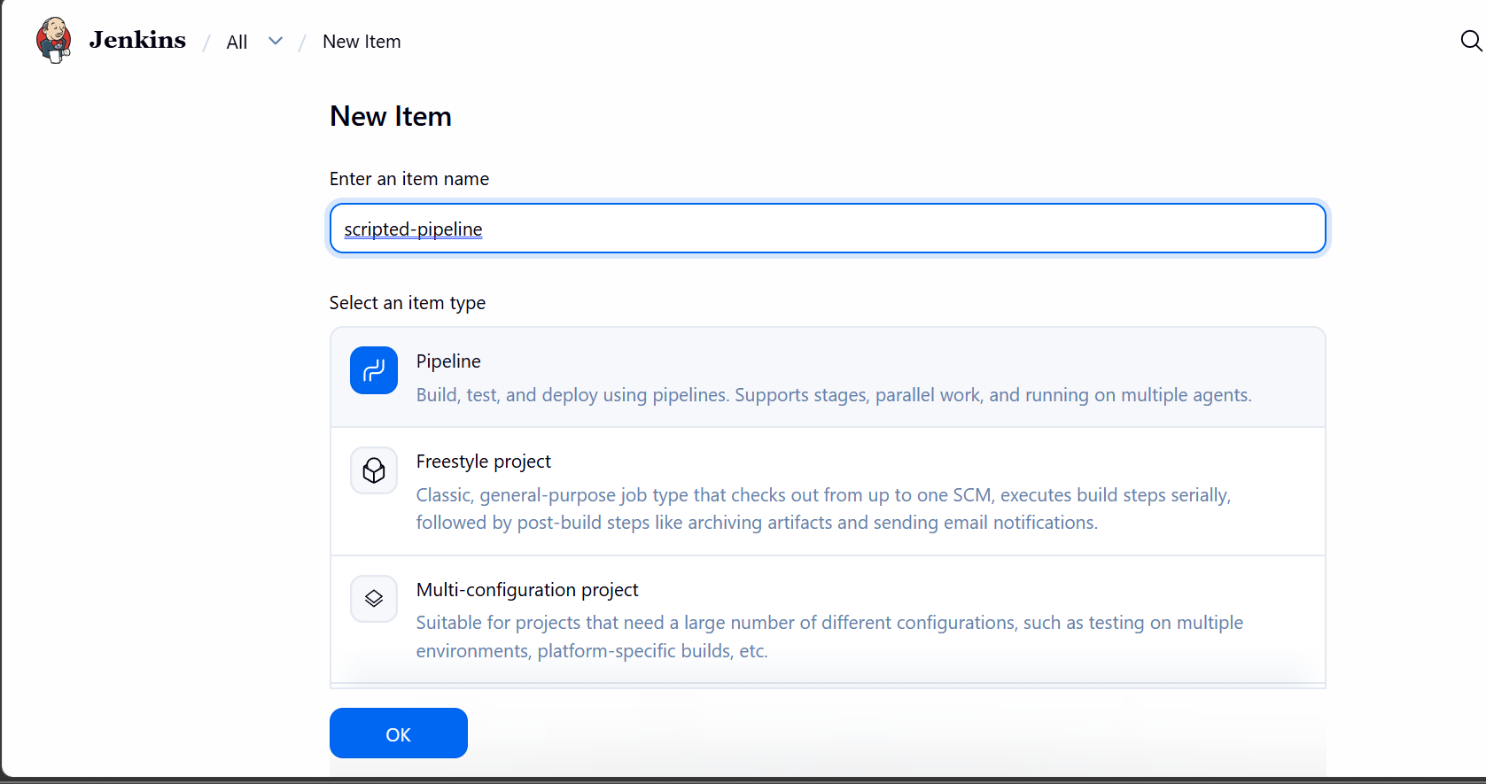

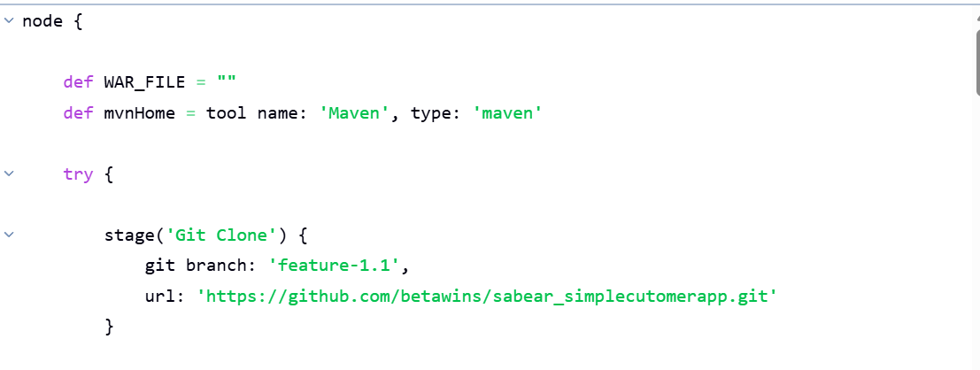
Cloning the repo
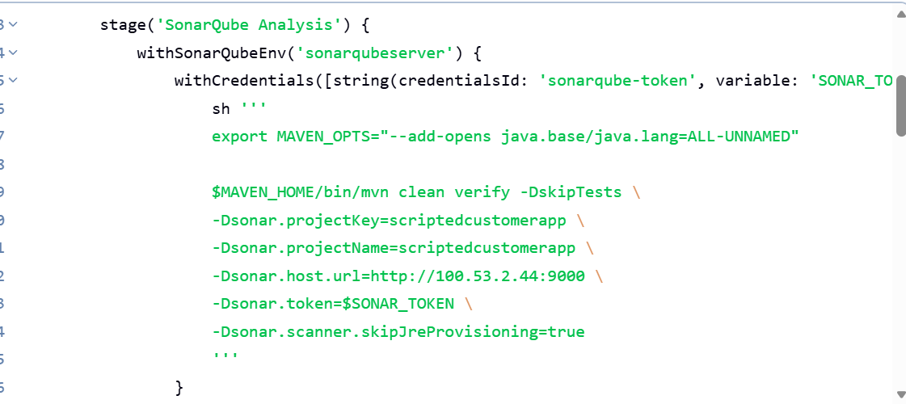

Sonarqube analysis
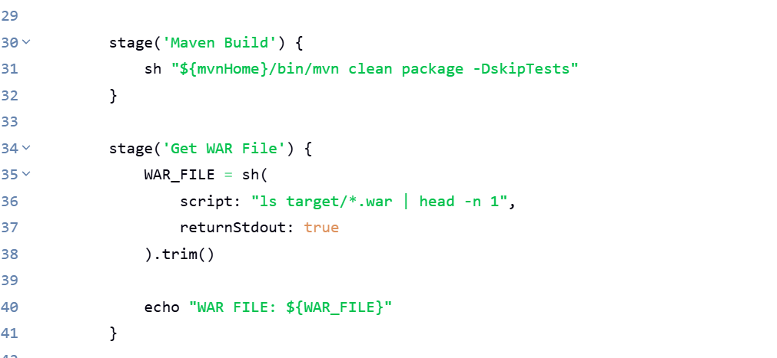
Building the code

Maven build
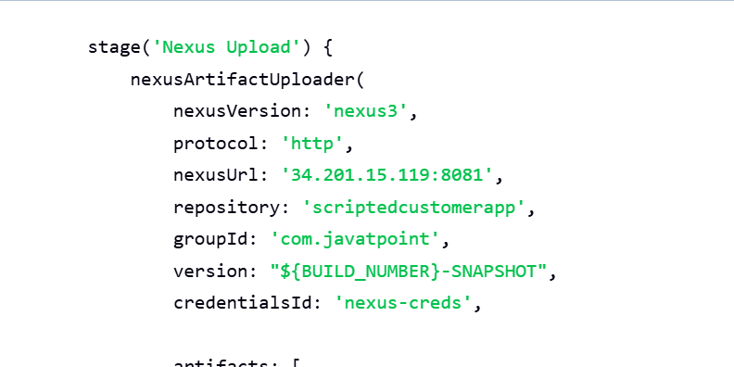
uploading the artifact to nexus
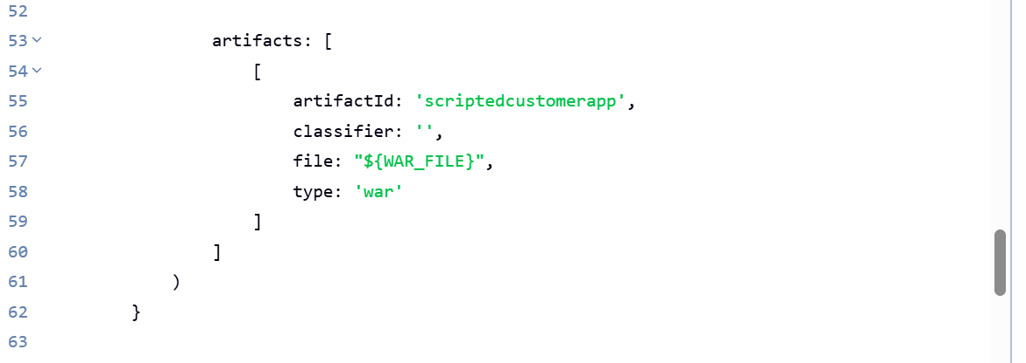

Tomcat deployment
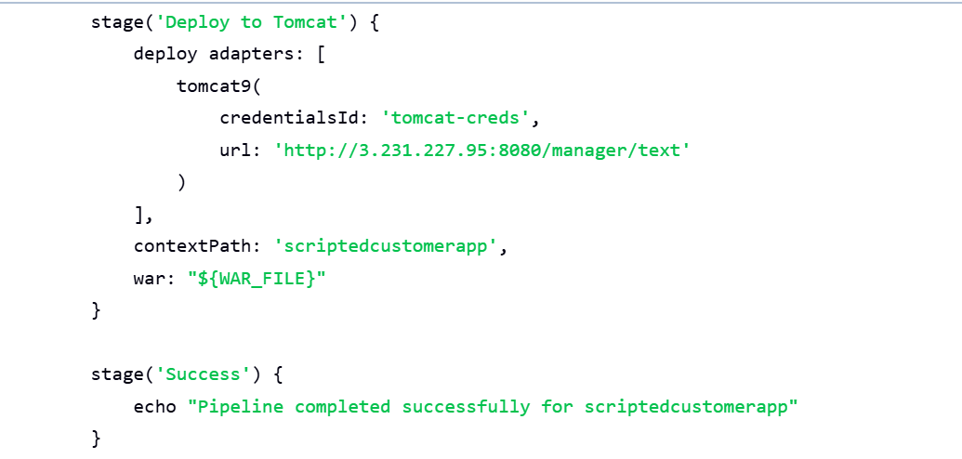

Artifact uploaded to nexus repo scriptedcustomerapp
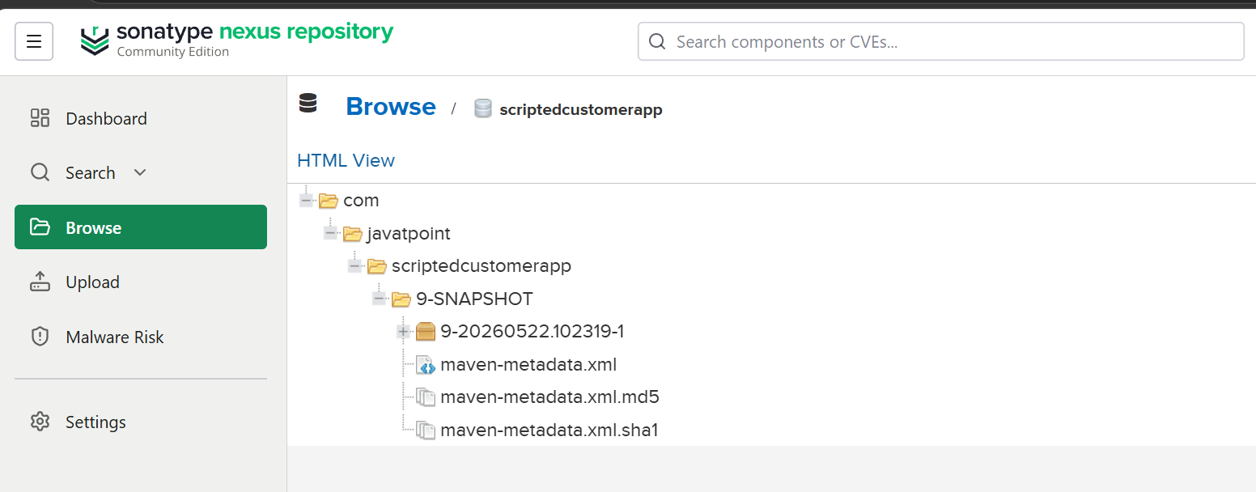

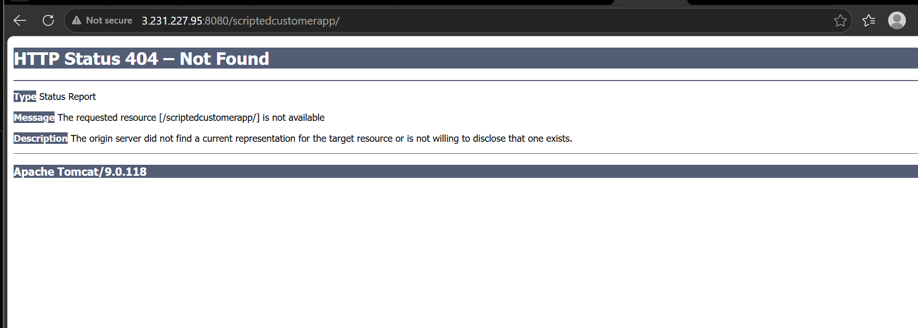

4) Write sample skeleton of pipelines.

pipeline {
agent any

tools {
maven 'Maven'
}

stages {

stage('Git Clone') {
steps {
git branch: 'feature-1.1',
url: 'https://github.com/betawins/sabear_simplecutomerapp.git'
}
}

stage('SonarQube Integration') {
steps {
echo 'SonarQube analysis will run here'
}
}

stage('Maven Build') {
steps {
sh 'mvn clean package'
}
}

stage('Nexus Upload') {
steps {
echo 'Artifact upload to Nexus will happen here'
}
}

stage('Deploy to Tomcat') {
steps {
echo 'WAR deployment to Tomcat will happen here'
}
}
}
}

5) Create a parameterized job in Jenkins.

Go to Jenkins
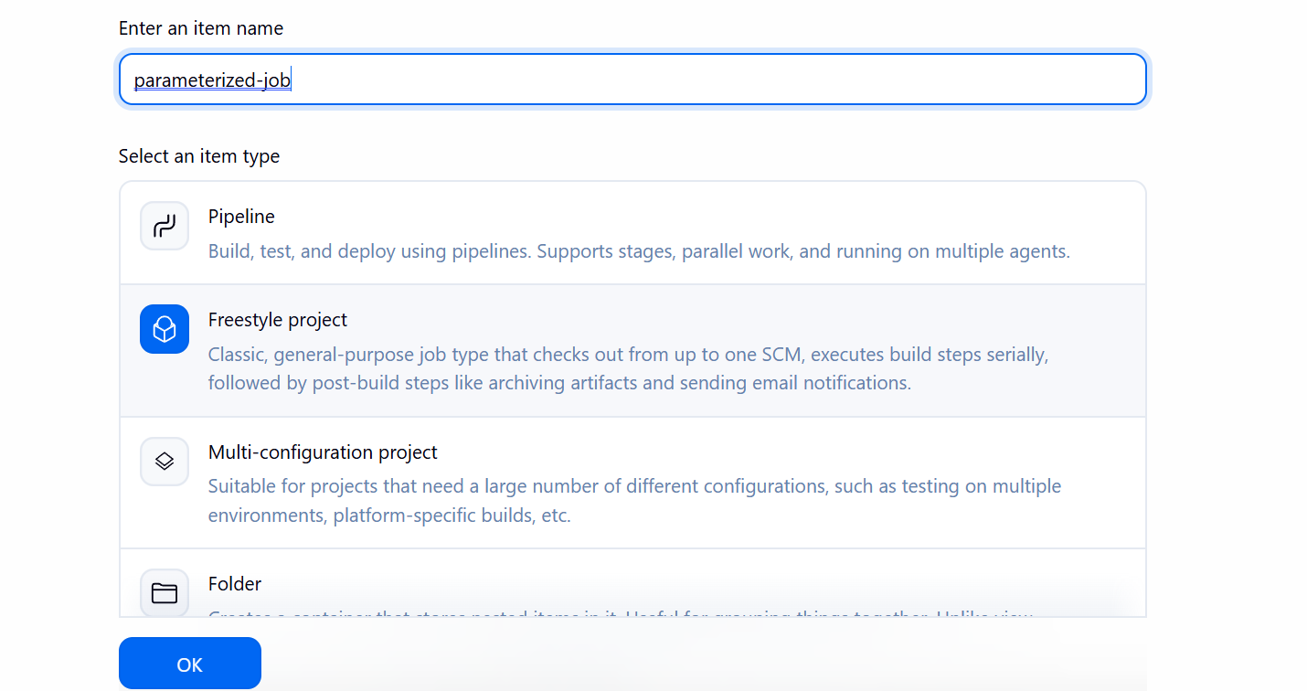
Go to all and create new item

Under configure select this is parameterized job
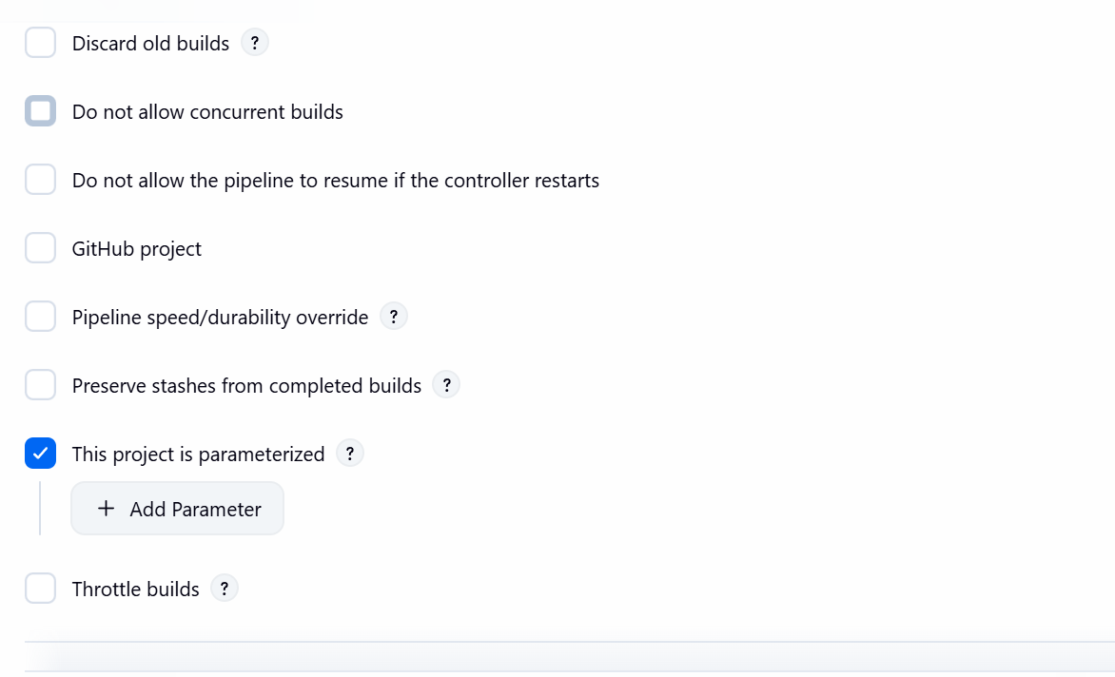
String parameter:
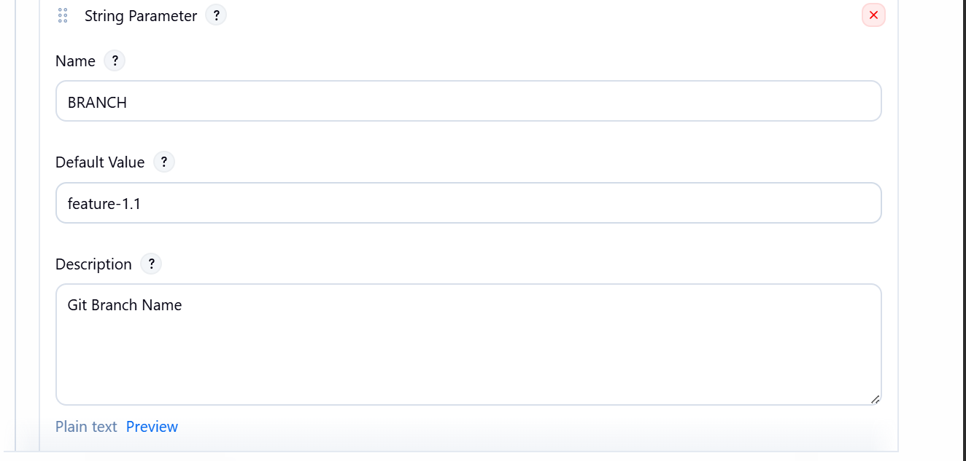

Choice parameter:

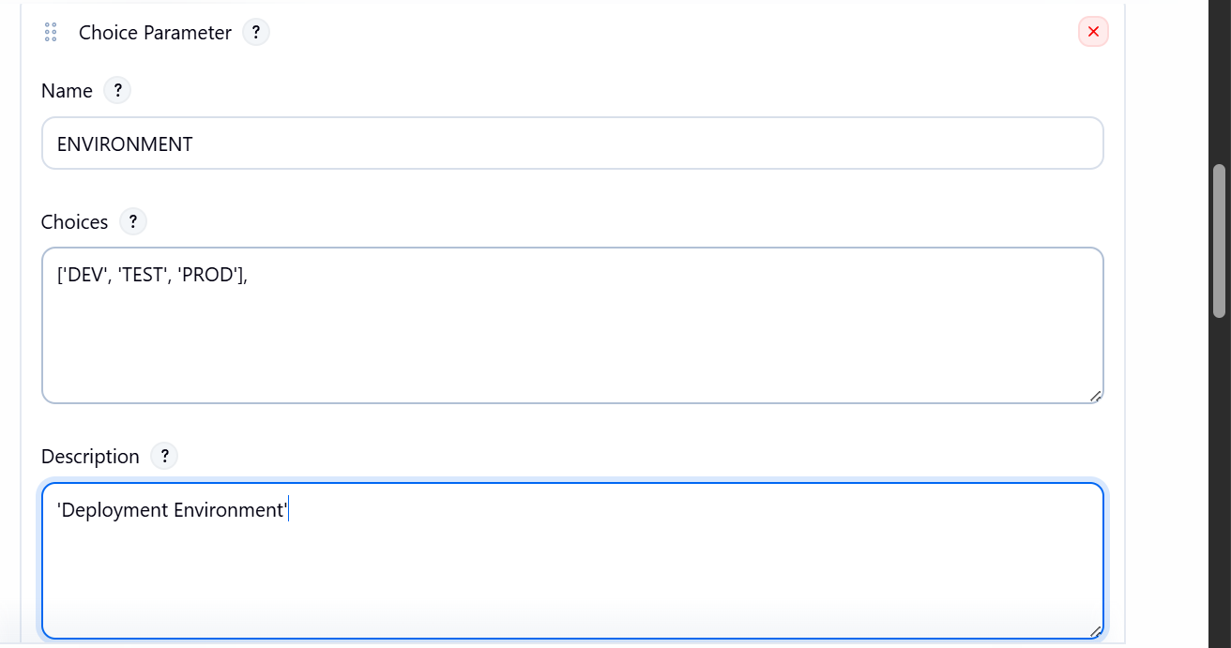

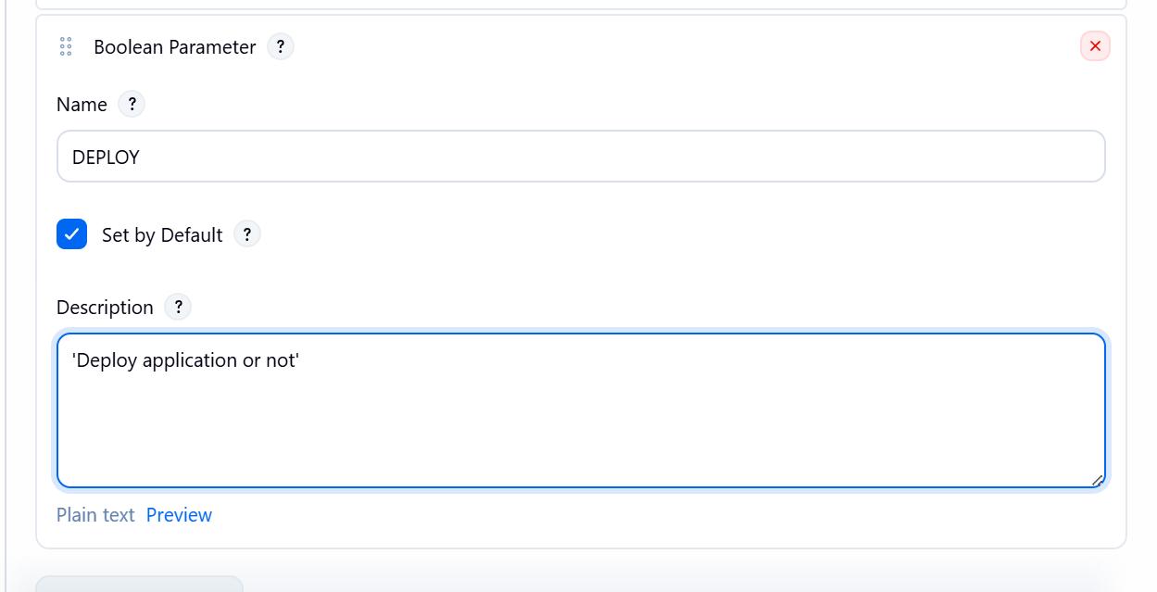

Using branch parameter
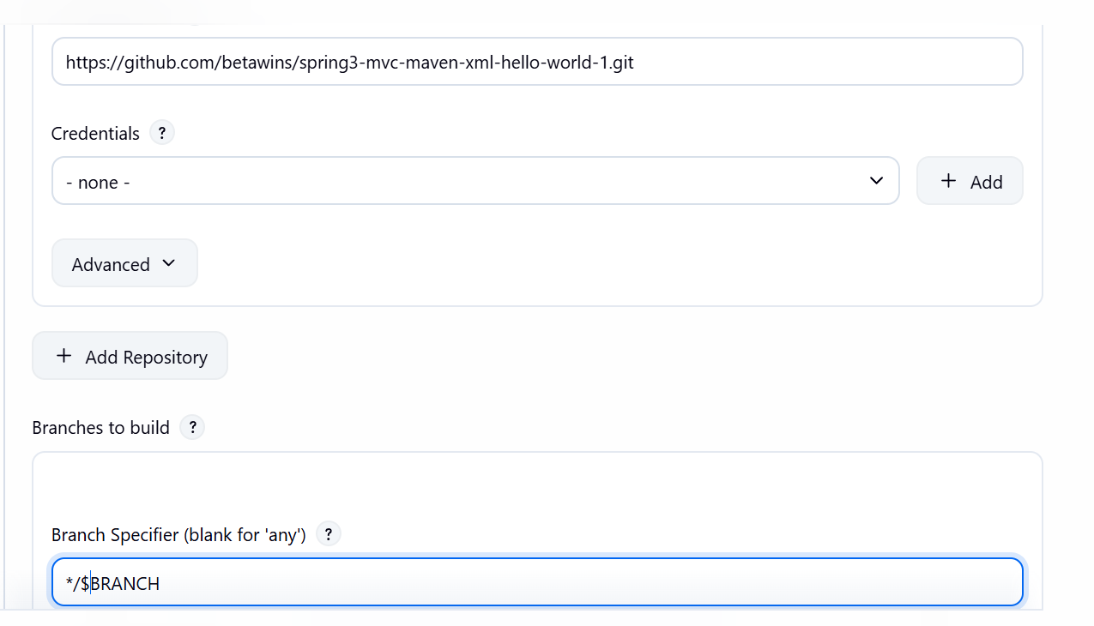

Build version parameter

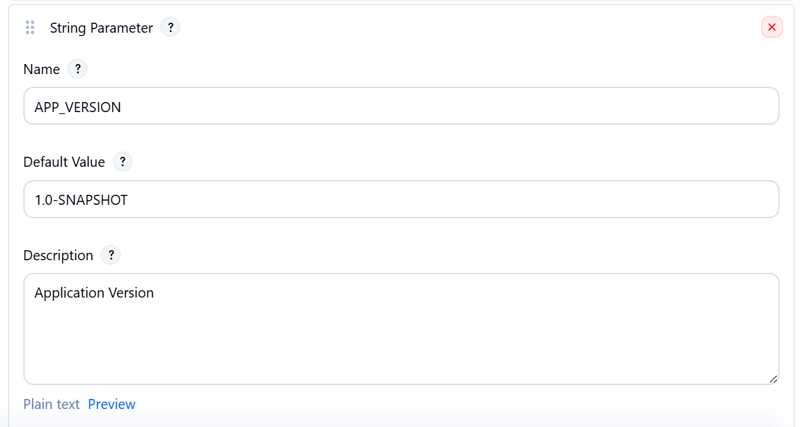

Building with parameters
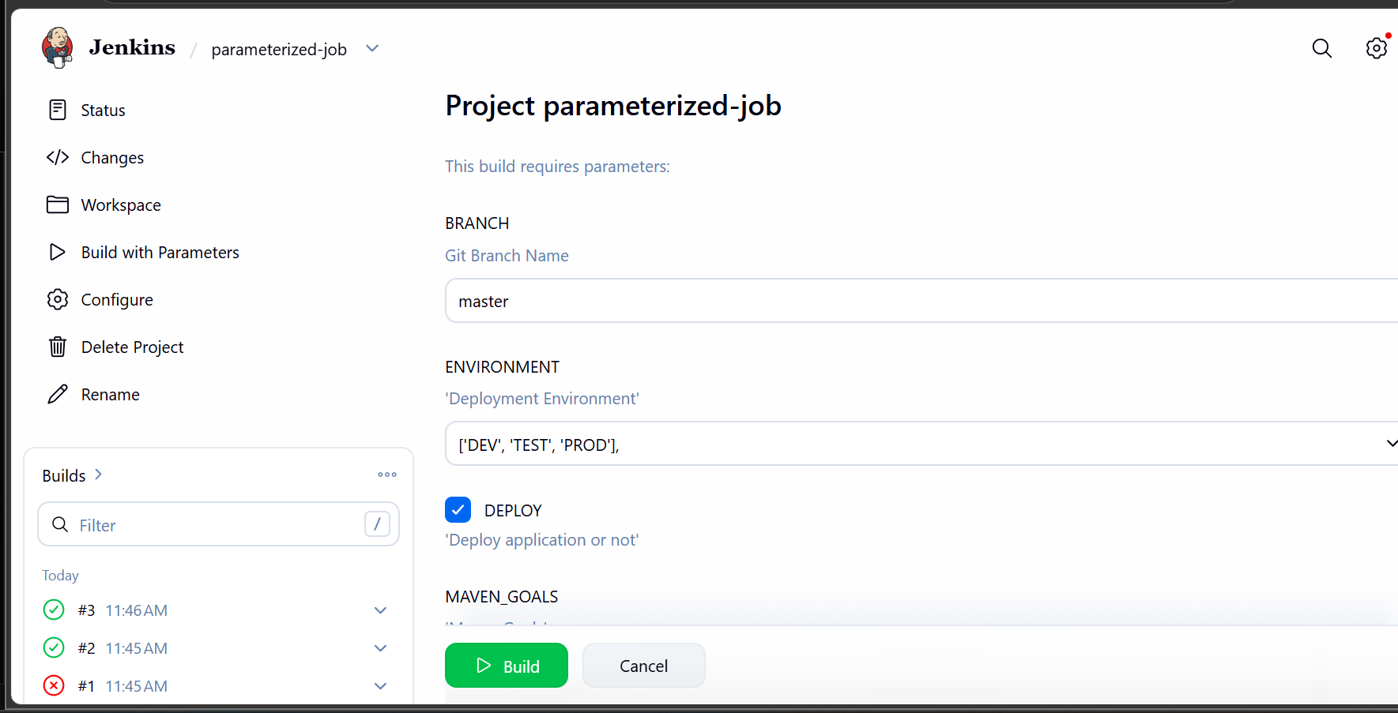

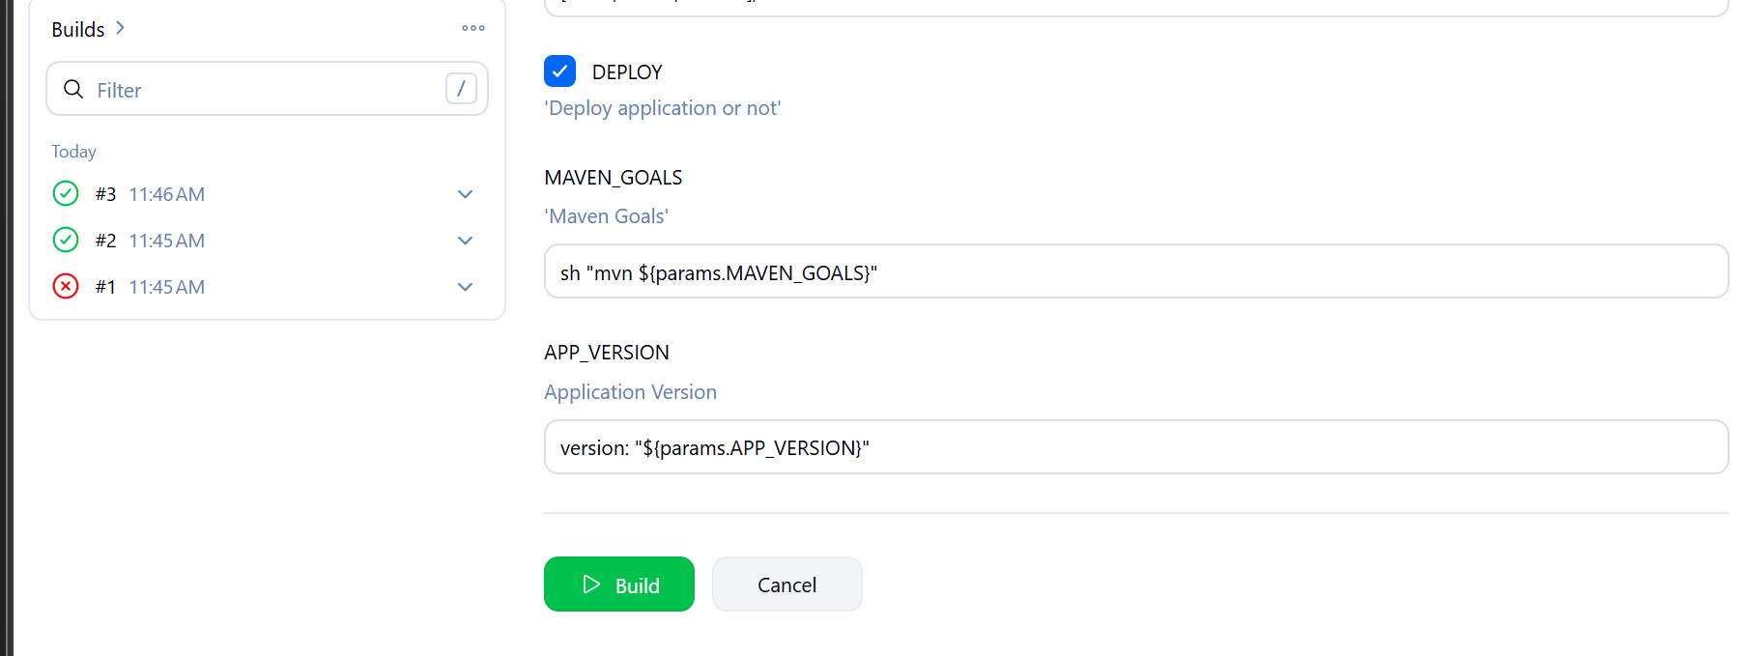
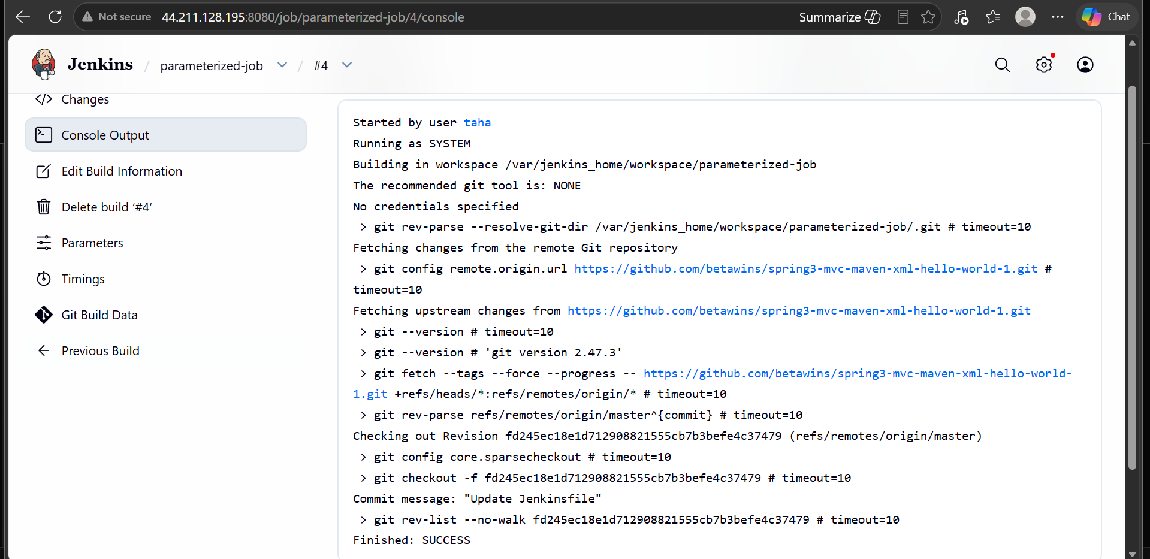

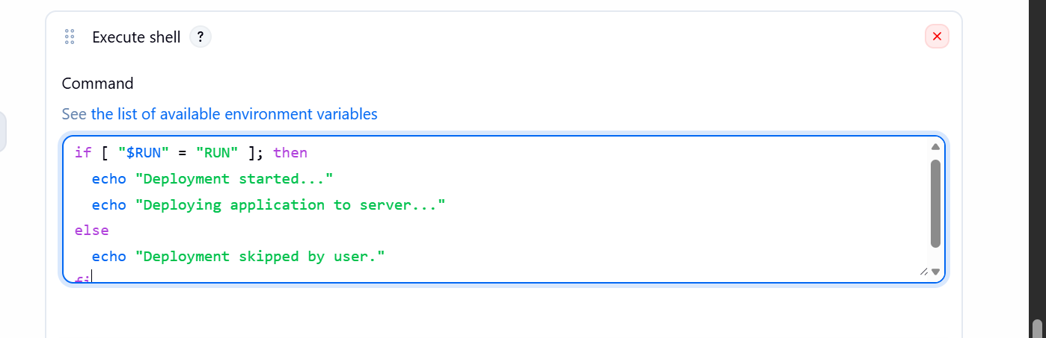
Adding shell command in build section

Job ran successfully

6) Setup one slave machine for Jenkins
Now lets launch one more instance
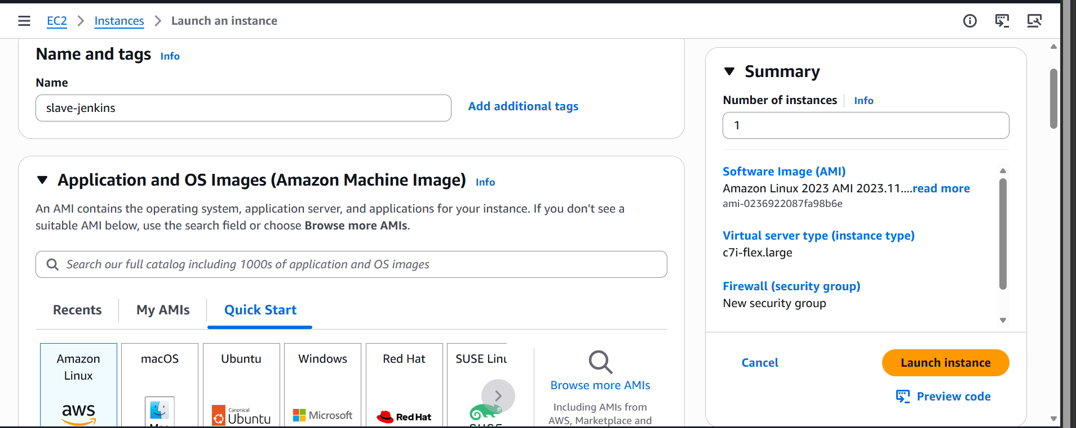
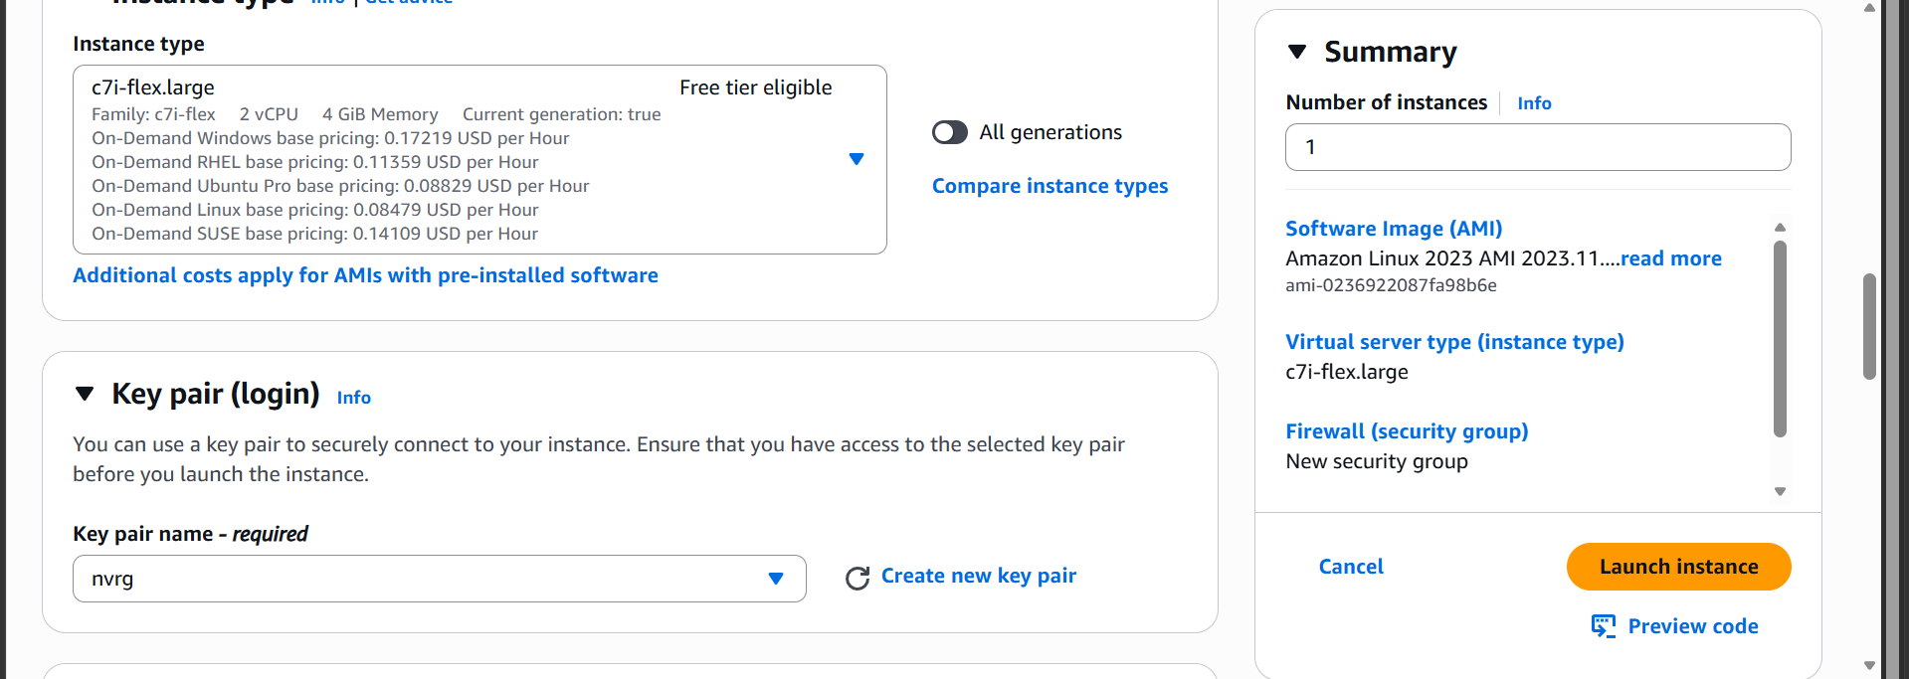
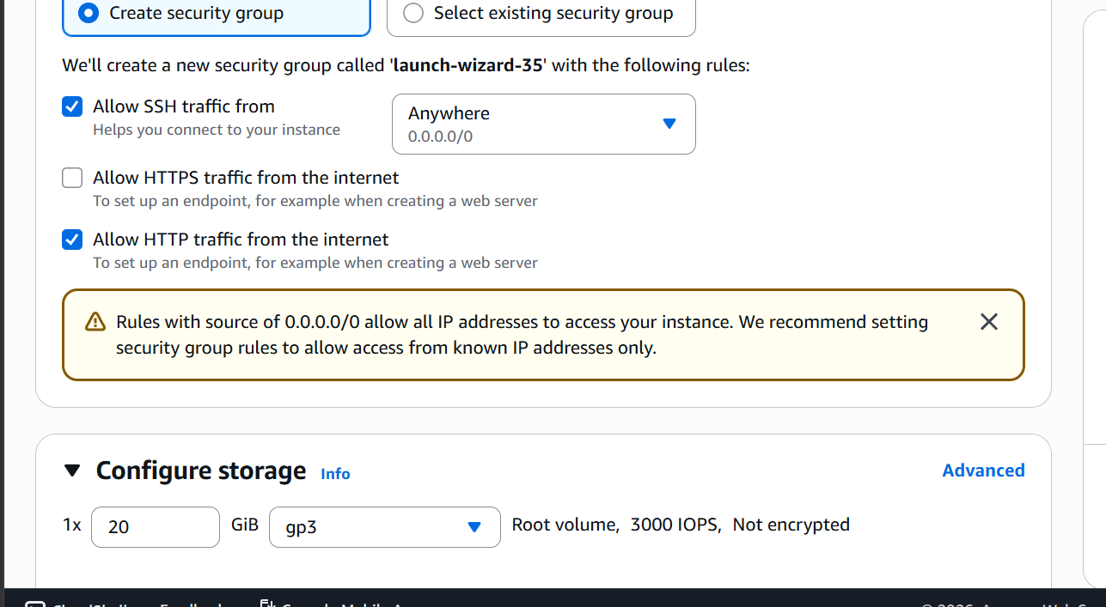

Ssh into the slave machine and
Installing java
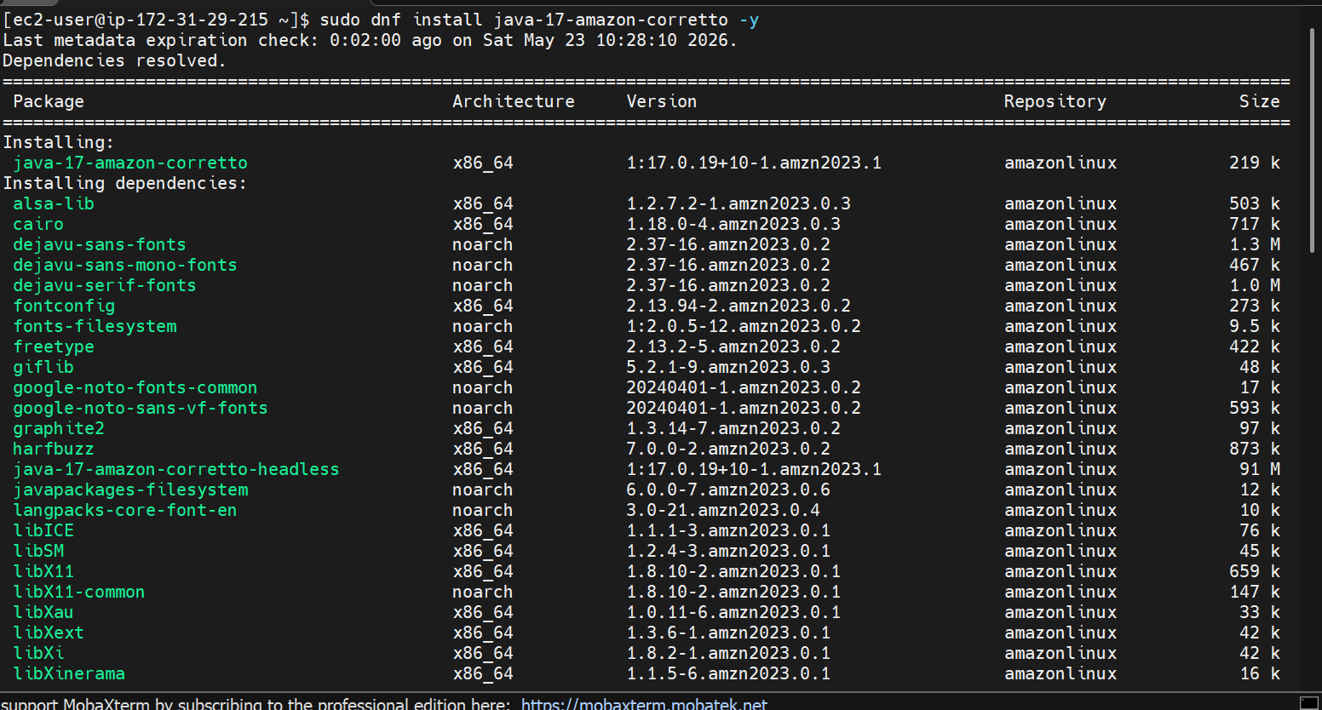
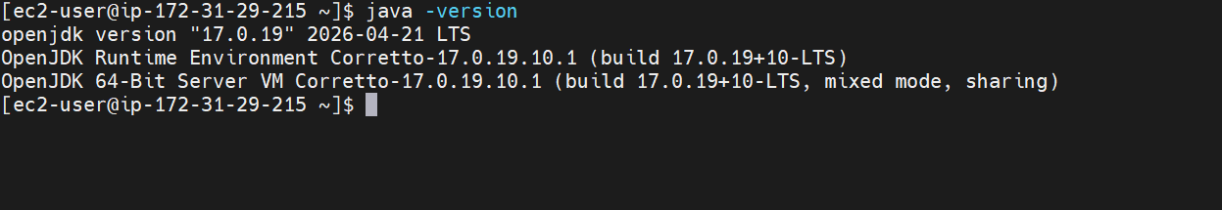
Create a Jenkins user
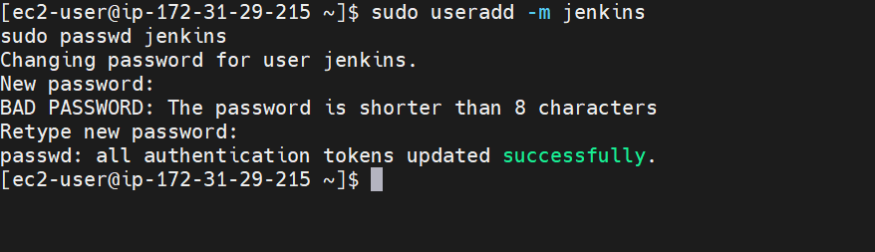
Creating Jenkins agent directory
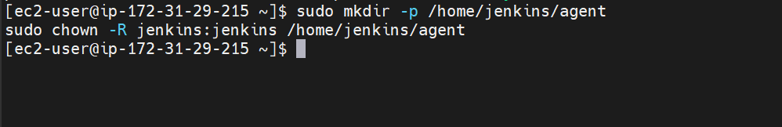
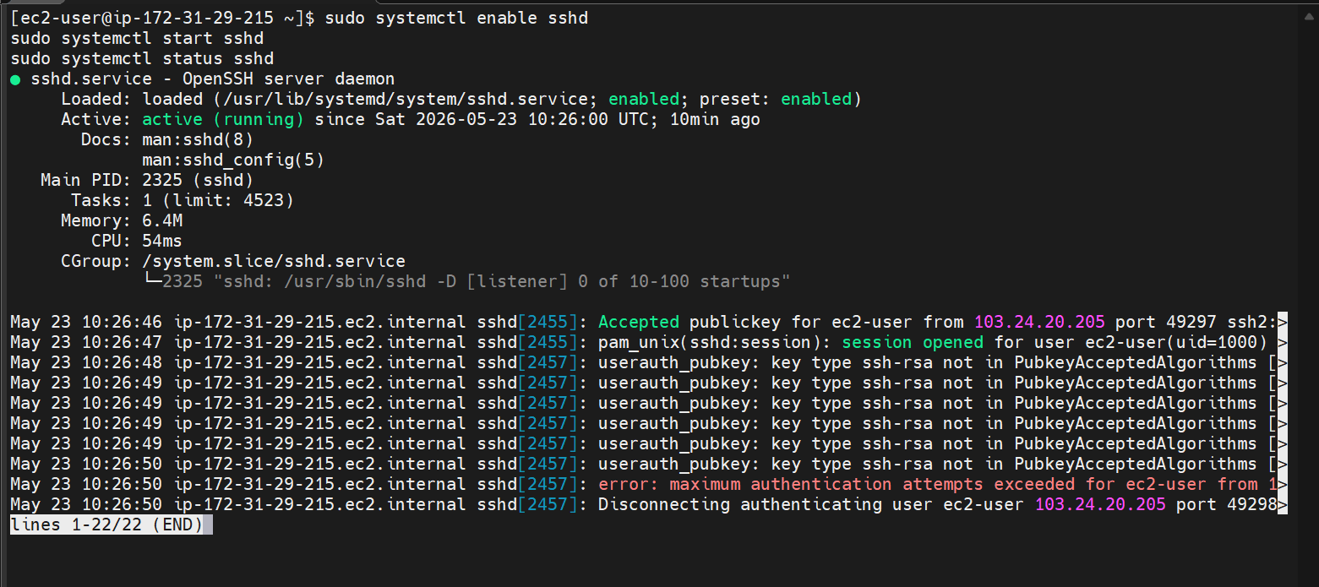
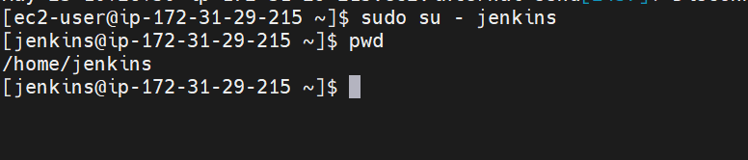

Switch to Jenkins user

Now login to Jenkins master
Generate ssh key
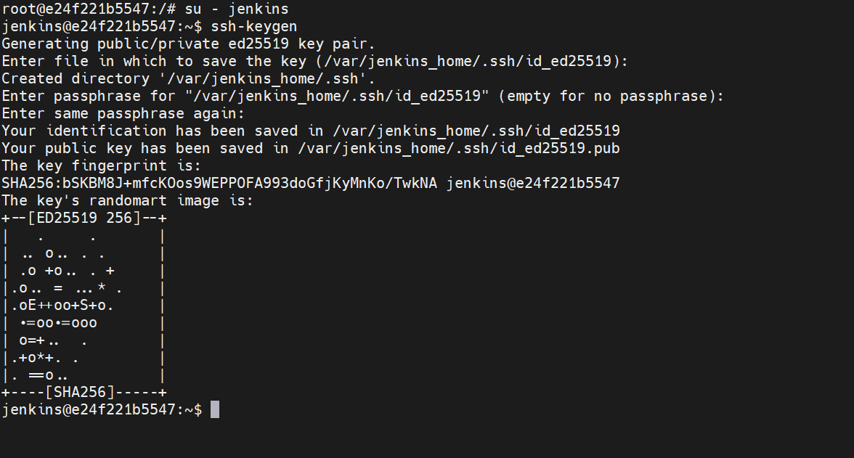
Copy publickey from Jenkins master to slave and ssh to slave
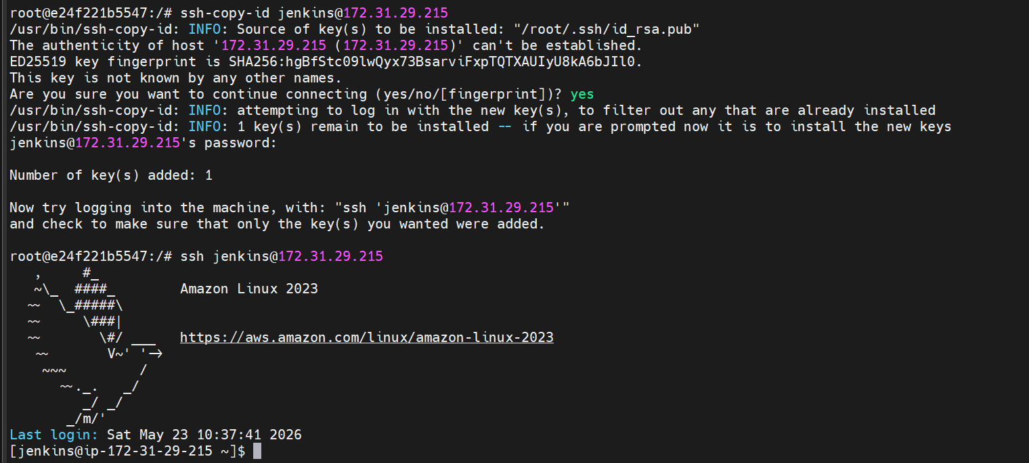
Now go to Jenkins server
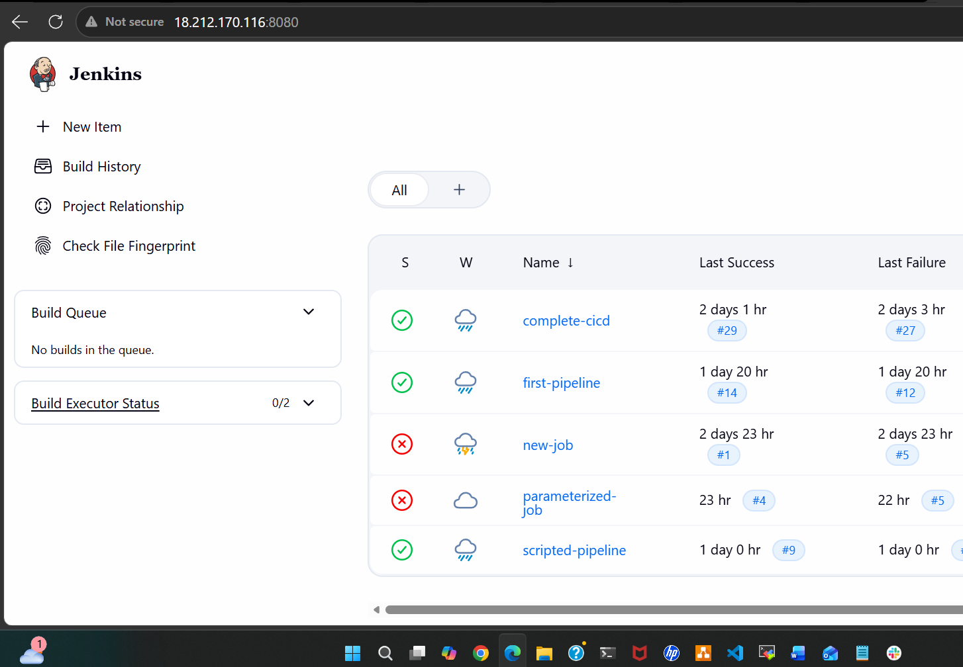
Go to manage Jenkins add nodes
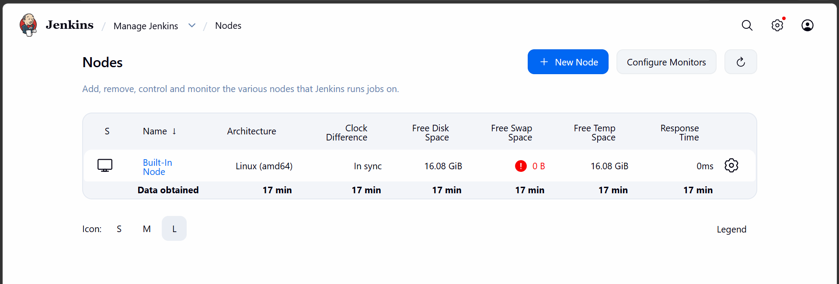
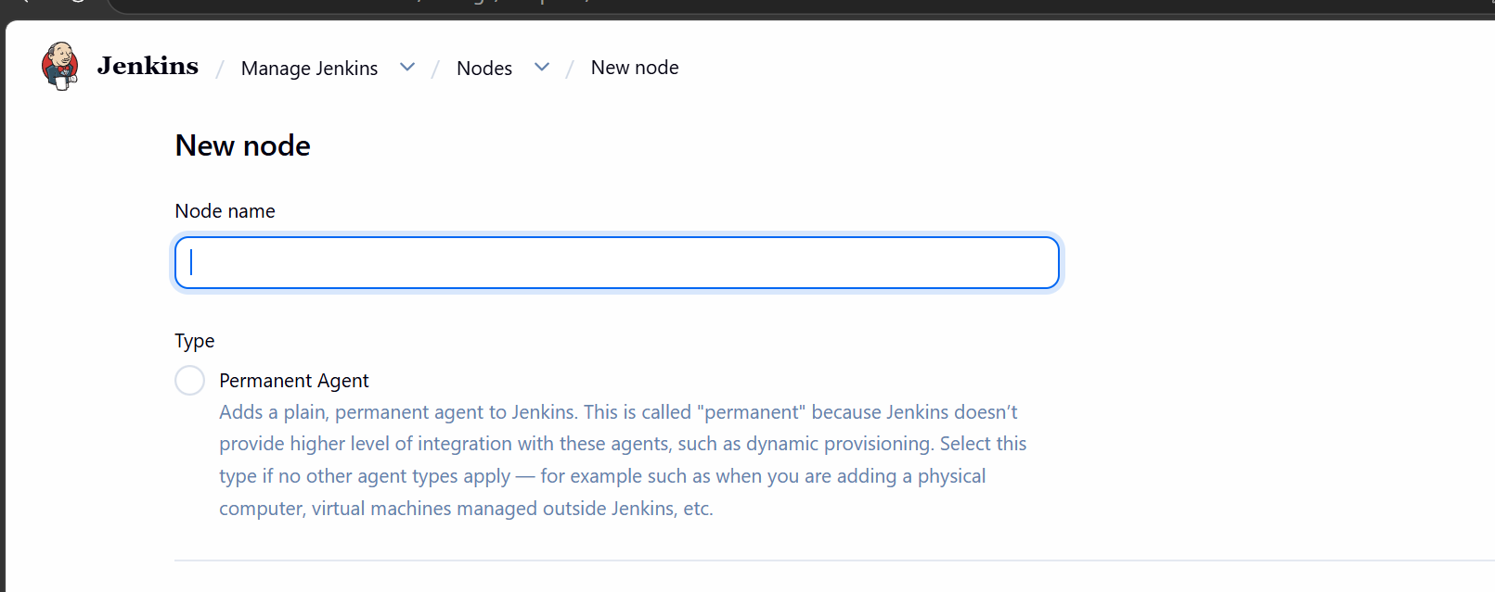
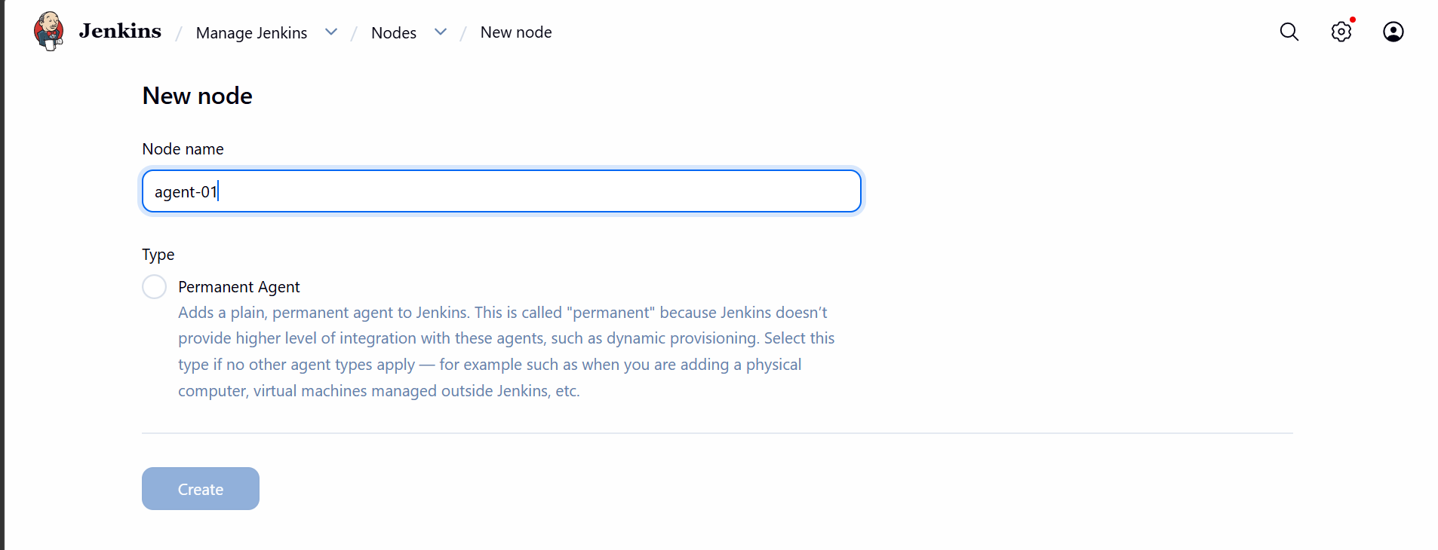
Add credentials
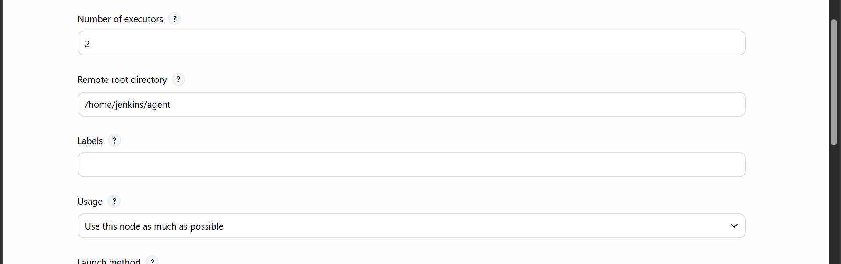
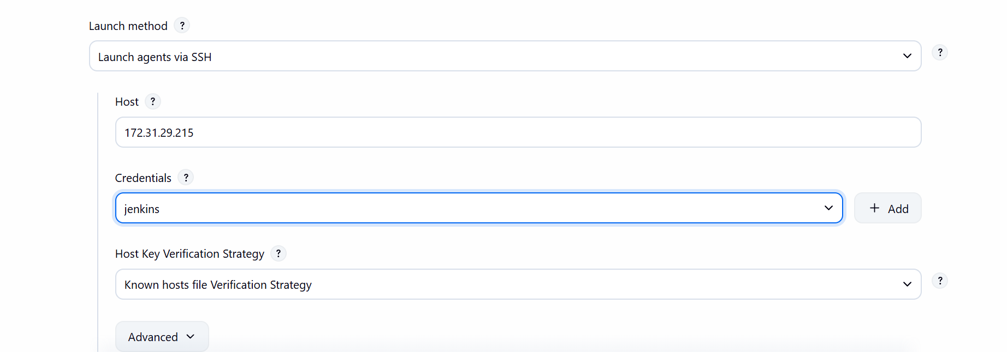

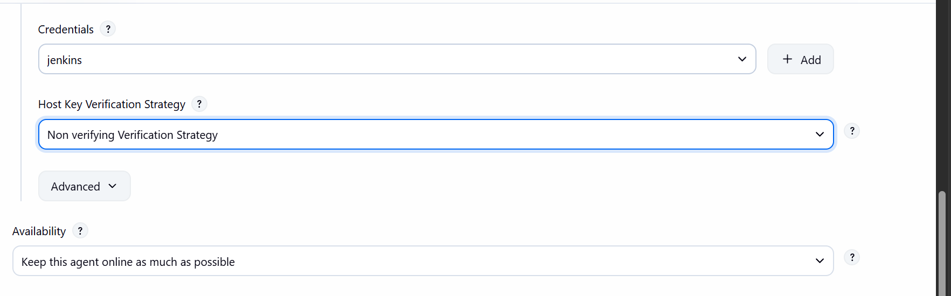

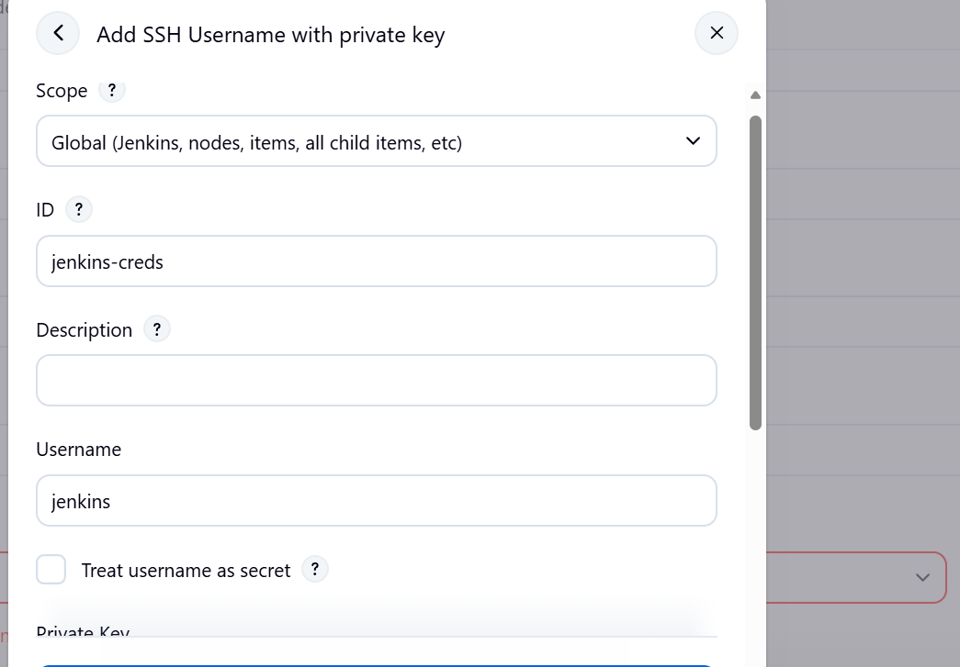

Now save
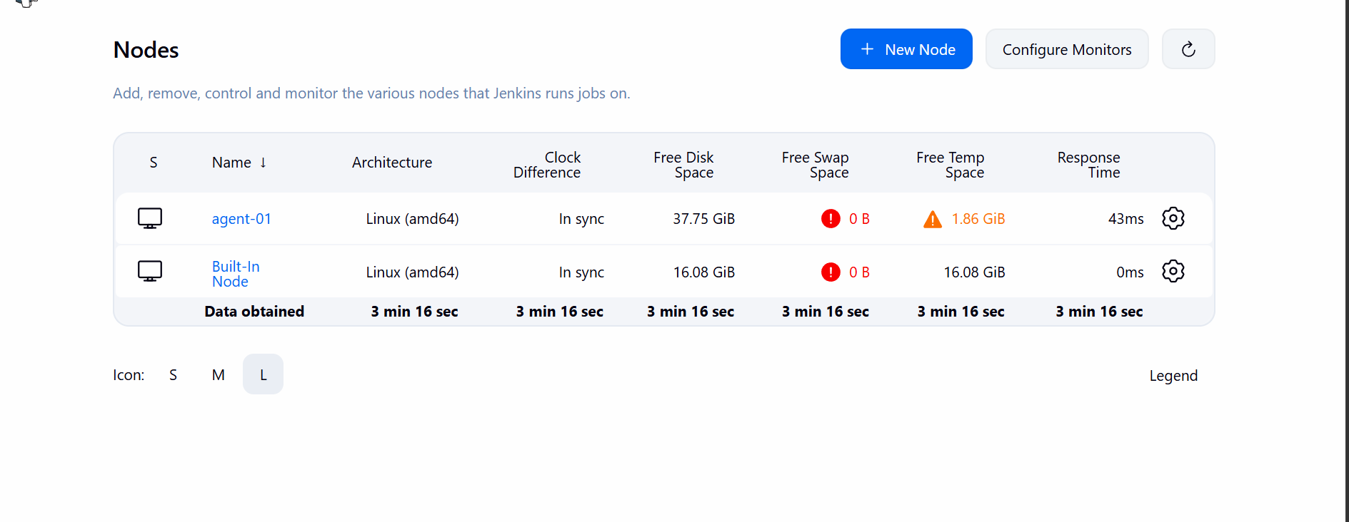
Our agent machine is launched now
Now lets build a pipeline on it
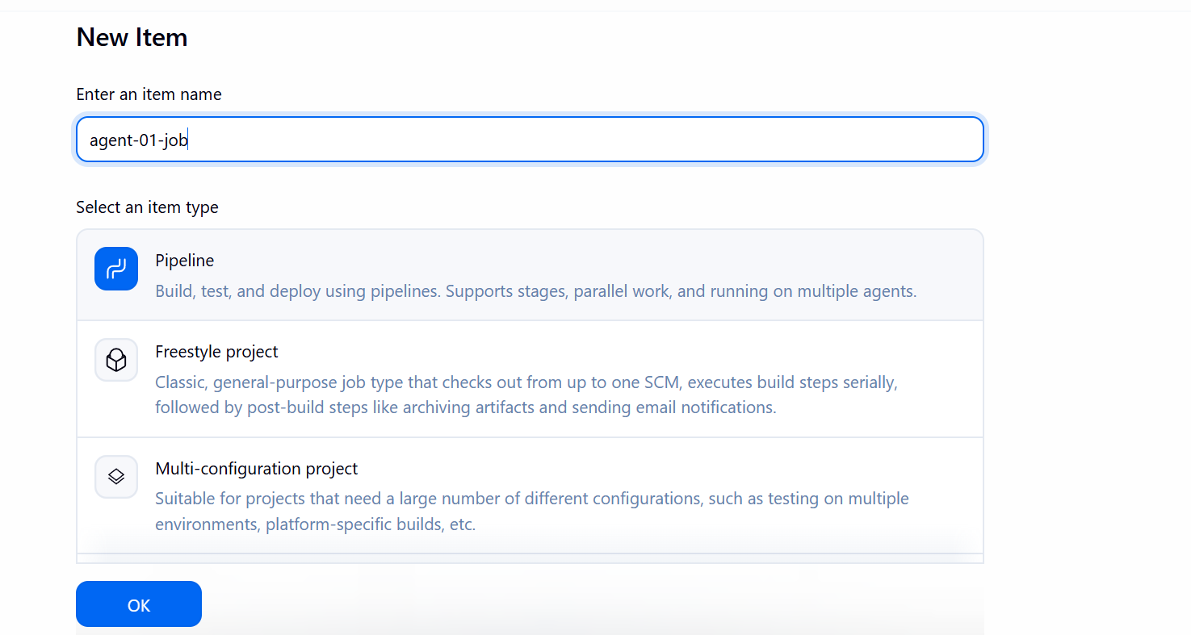

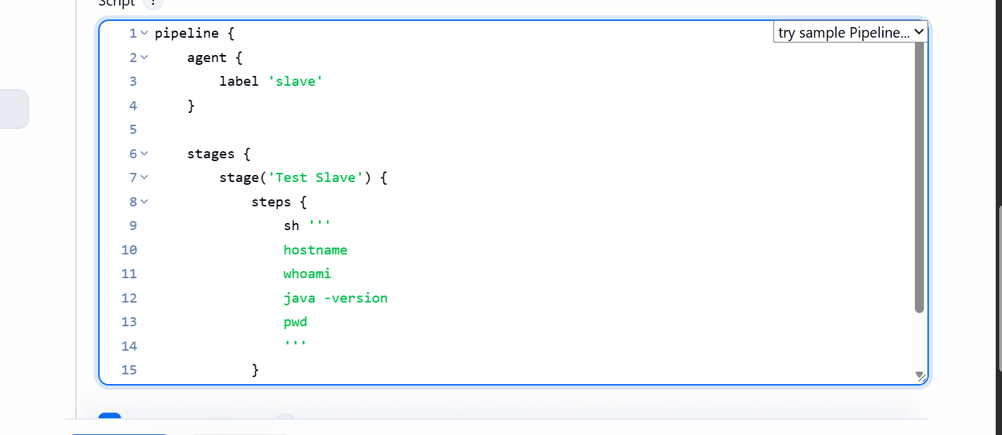

This is basic pipeline which executes some shell commands
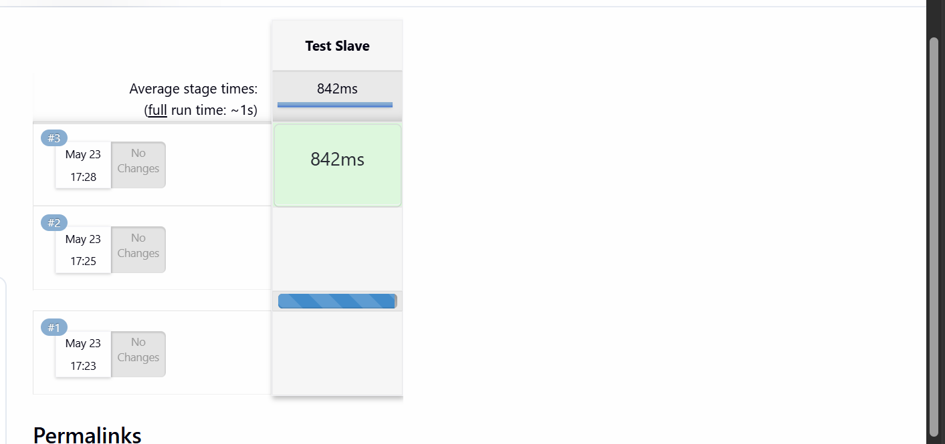
The job ran on agent-01 succesfully
