Date command: This command displays the current date.
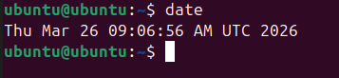

echo $0: This command displays the shell which we are using. 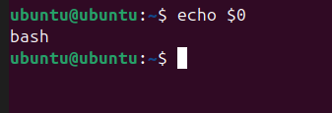

ls command: this command displays the content of a directory.
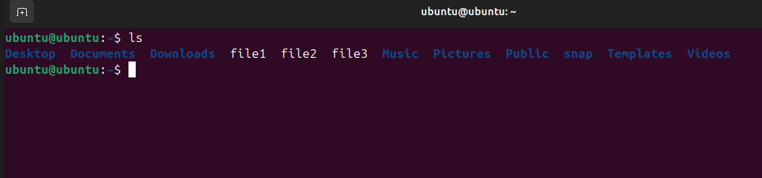

ls -a command: this command displays the hidden files.
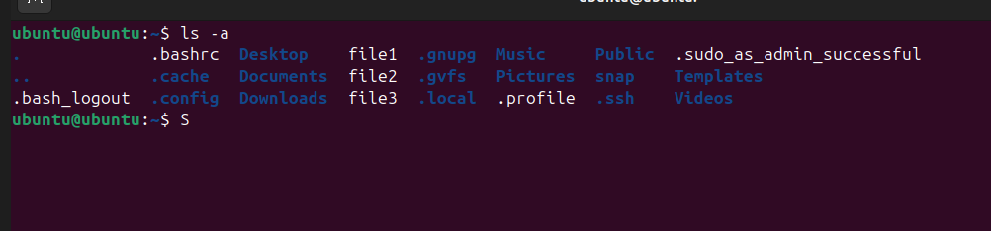

ls -ll command: this command displays all the files along with the timestamp
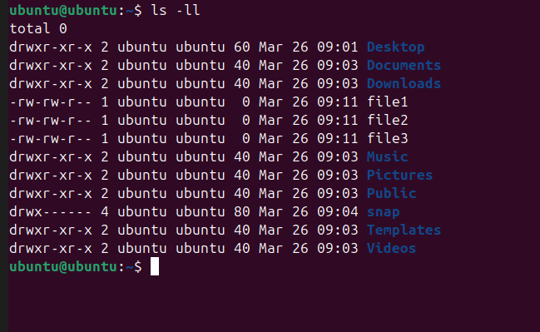
ls -ltr command: this command is similar to the ls -ll command but it keeps oldest file at the top and most recent at the bottom
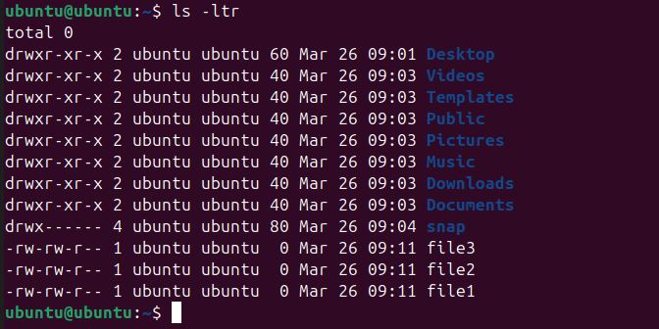

pwd command: This command displays the present working directory.
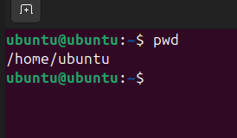
cd command: this command is used to switch between directories.
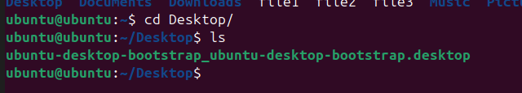
‘/’ Represents the root directory:
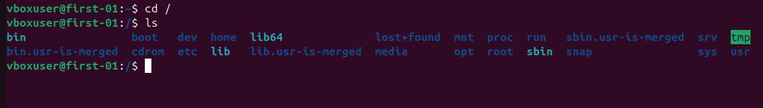

‘~’ Represents the home directory of the current user:
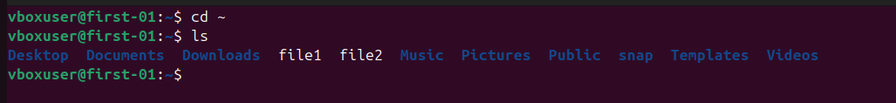

mkdir command: this command creates a directory
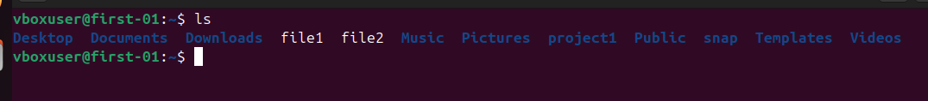
mkdir . command: this command creates a hidden directory
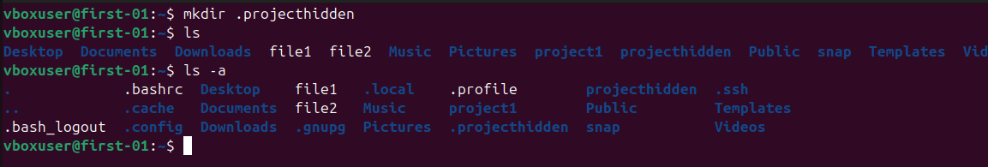
mv command: this command can be used for two different things one is to rename a file and the other to move a file from one directory to other.
Example of renaming a file:
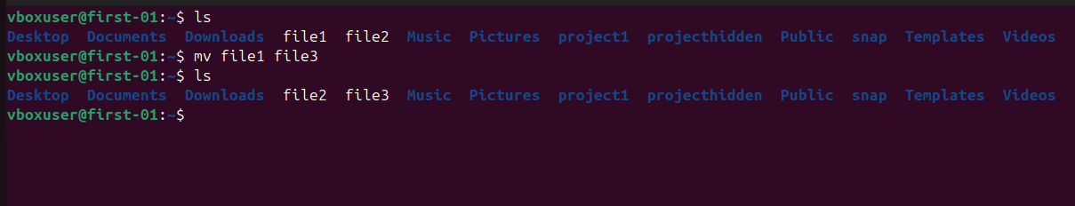

Example of moving a file:

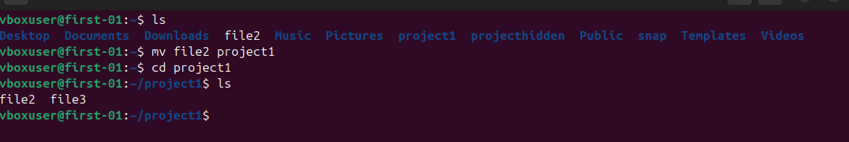

clear command: This command clears the screen.
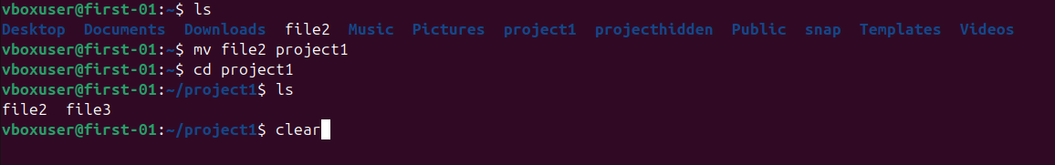
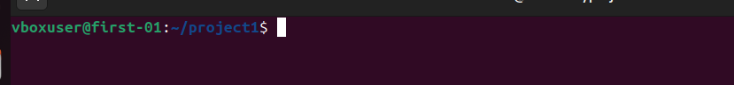

rm command: this command deletes the file or a directory.
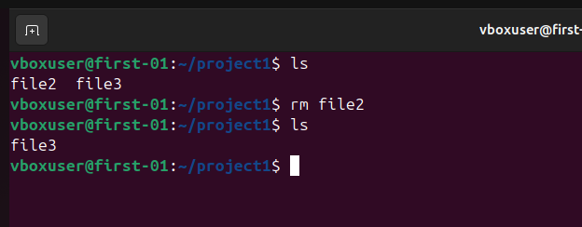

we need to use rm -r to delete a directory recursively
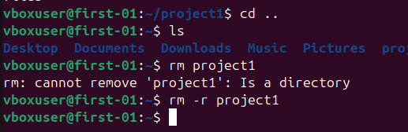
Or we can use rmdir command.

touch command: this command is used to create an empty file.

cp command: this command is used to copy a file and directories.
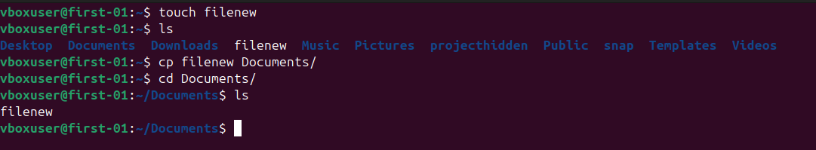

vi editor: editors allow us to write text into a file
there are three editors in Linux vi , vim , nano
vi editor: when we open a file with vi editor it will be in command mode we need to enter ‘i’ to get into insert mode and we can then start writing
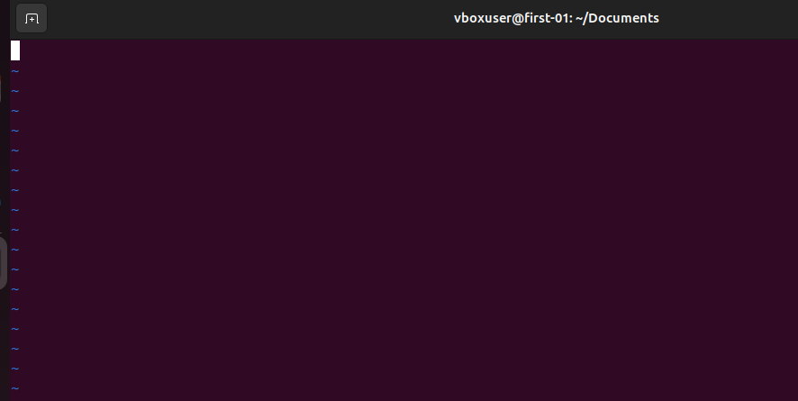
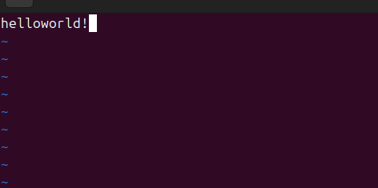
to save the content and file we need to press escape key and enter :wq!
w: write
q: quit
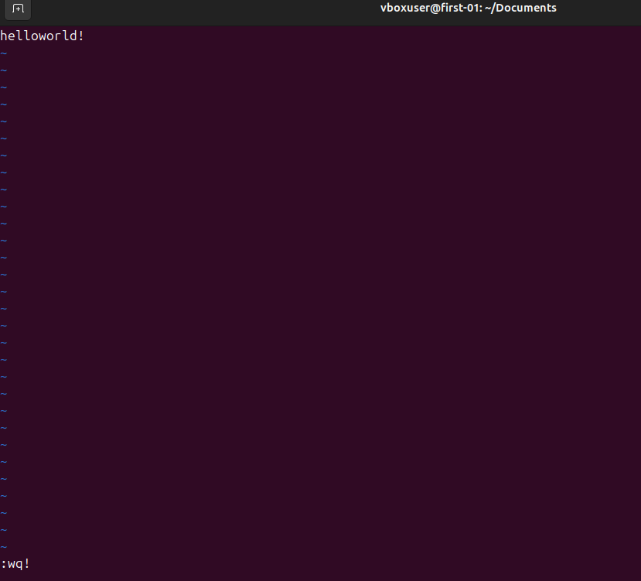

cat command: this command allow us to read the content of a file
