- Create a namespace dev-environment and apply a resource-based quota that restricts the number of pods to 3 and services to 2.

Lets login to our master node and create a namespace

In Kubernetes, namespaces provide a mechanism for isolating groups of resources within a single cluster. Names of resources need to be unique within a namespace, but not across namespaces. Namespace-based scoping is applicable only for namespaced objects (e.g. Deployments, Services, etc.) and not for cluster-wide objects (e.g. StorageClass, Nodes, PersistentVolumes, etc.).

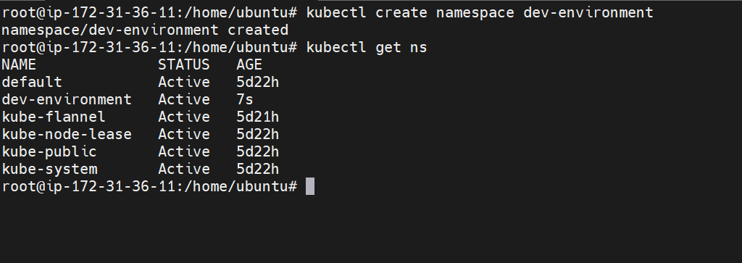

We have created a namespace named dev-environment
Lets now create a resource quota yaml file
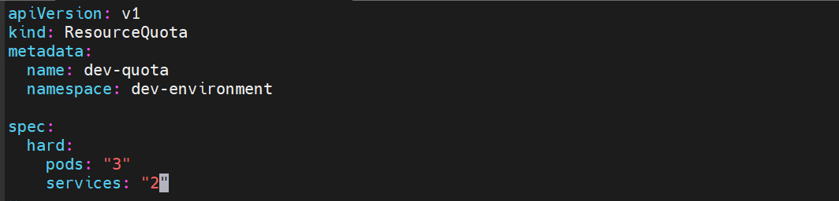

This is the resource quota file which restricts pods to 3 and services to 2 in dev-environment namespace

Lets create it now
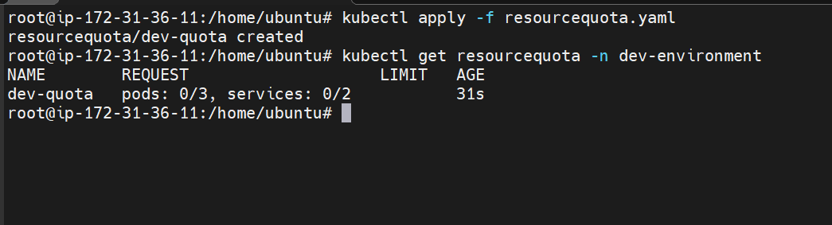
The resource quota is now created for namespace dev-environment
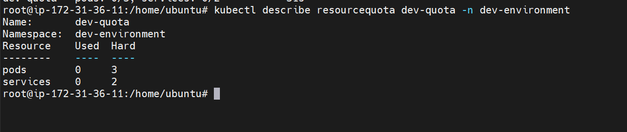
Lets now test it by creating pods
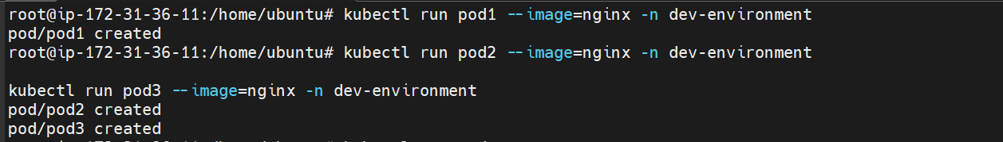
We have created 3 pods in the dev-environment namespace
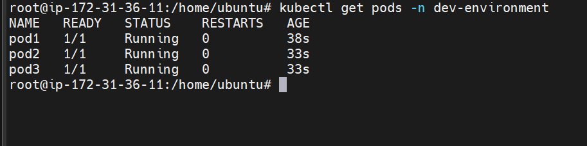

Now when we try to create another pod it will throw an error
Lets test services as well
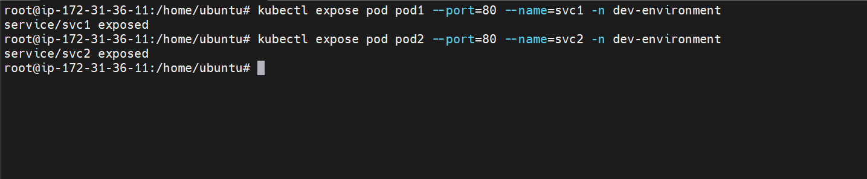
We have created two services
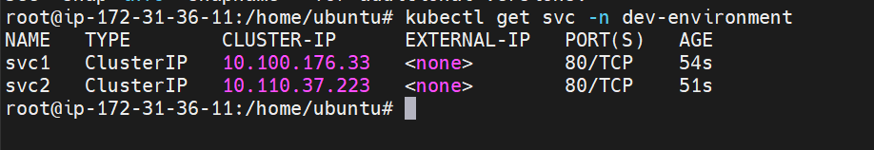
We can’t create the third service due to resource quota restriction
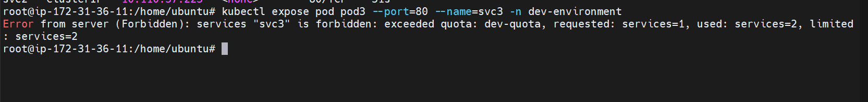

- Create a pod in the prod-environment namespace with 0.2 CPU and 200Mi memory requests, and 0.5 CPU and 500Mi memory limits.
First lets create a new namespace
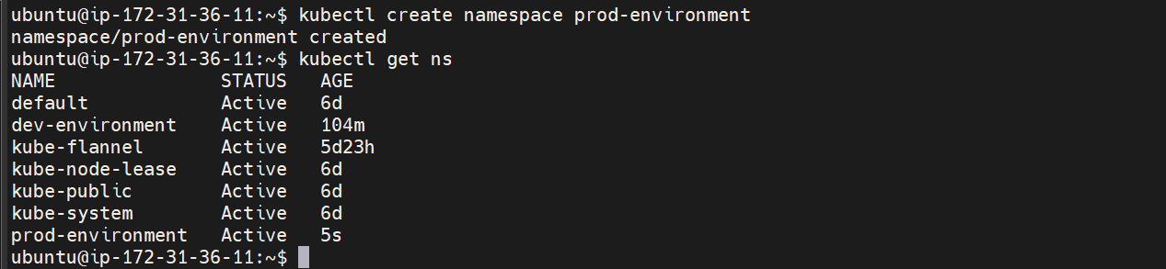
We have now created a namespace named prod-environment
Now create a pod with resource and limits
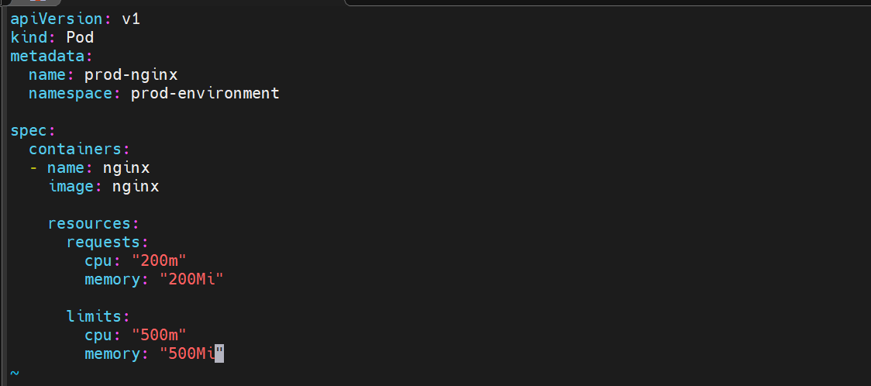
Here we are requesting for 0.3 cpu and 200Mi memory
Also the maximum memory and cpu limit for the pod is 500Mi and 500m
On prod-environment namespace
Create the pod now
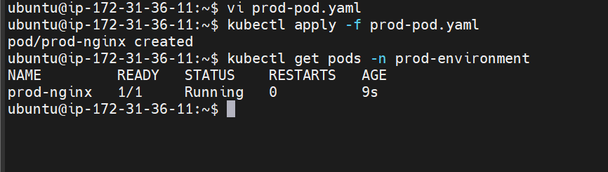
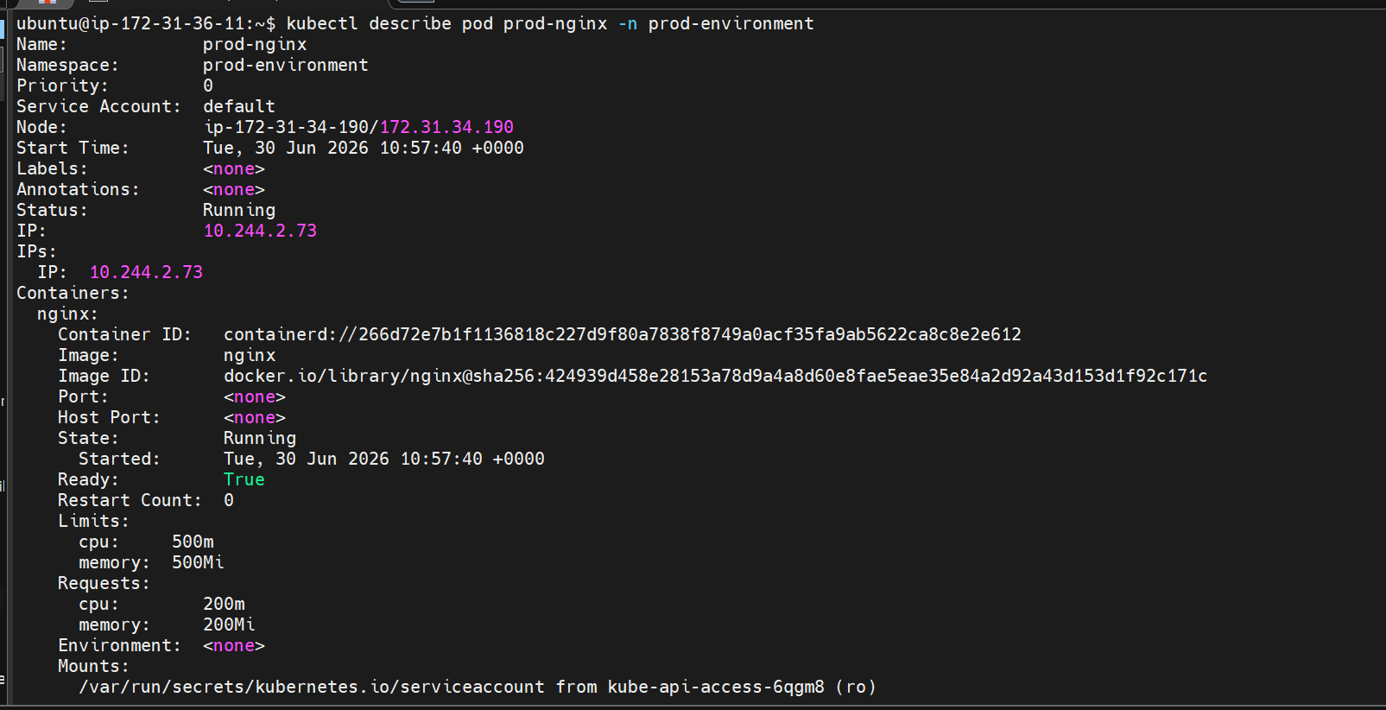
Here it can be seen that the pod has been created with the specified configuration for resource and limits
Q1: What is the difference between Requests and Limits?
Answer:
- Requests are the minimum resources Kubernetes reserves for scheduling a pod.
- Limits are the maximum resources a container can consume.

- In the staging-environment namespace, set a LimitRange that assigns default CPU and memory limits (300m CPU, 600Mi memory) and applies a minimum and maximum CPU.

First create a namespace for staging environment

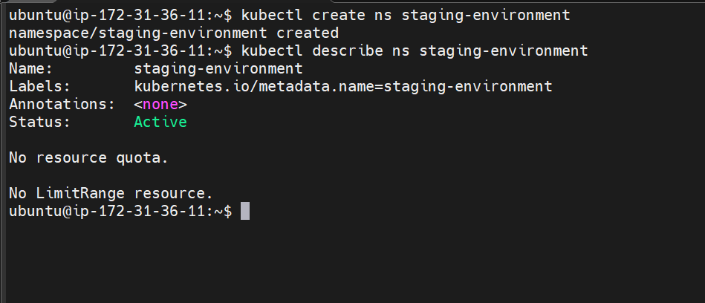

Now we have a namespace for staging environment

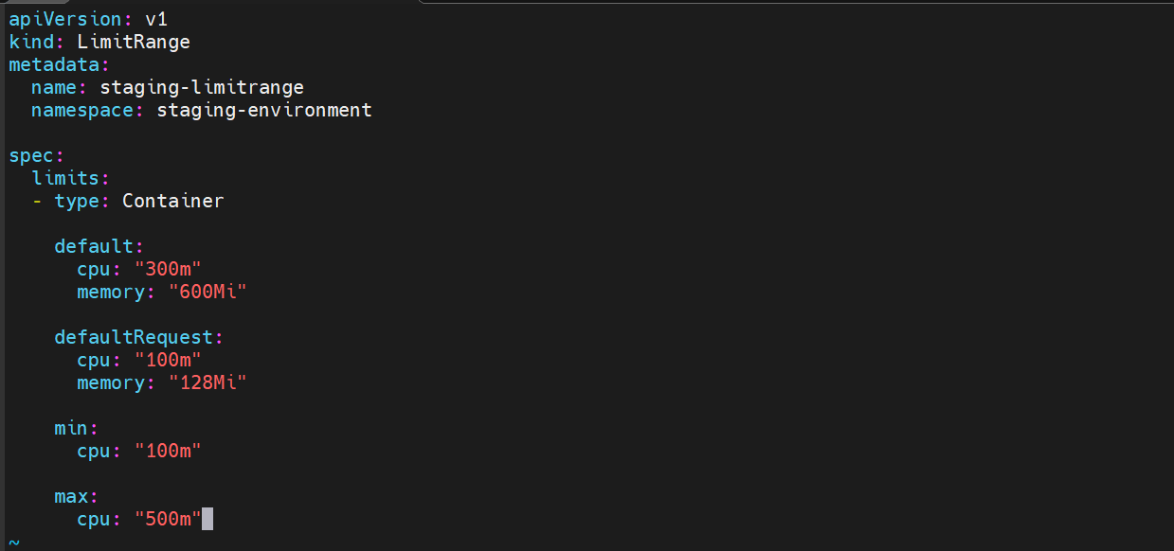

Here we are creating a limit range in the namespace staging-environment

We have default limits cpu: 300m and memory: 600Mi

Then we have default request if requests are omitted, Kubernetes automatically assigns these values.
Then we have min cpu 100 m a container cannot request or limit CPU below 100m.

Max cpu we have 500 a container cannot have a CPU request or limit greater than 500m.

Let us now create the object
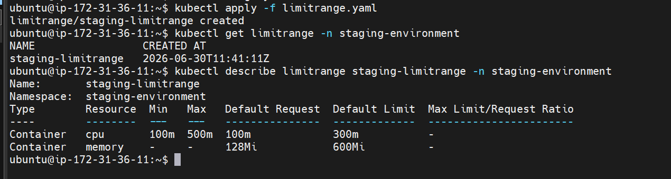
We have created the limit range

Lets now test it by creating a pod
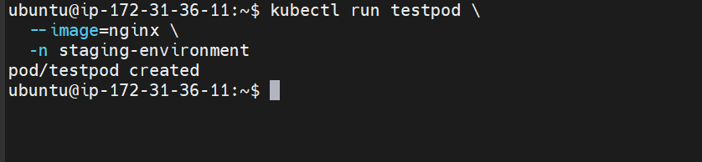

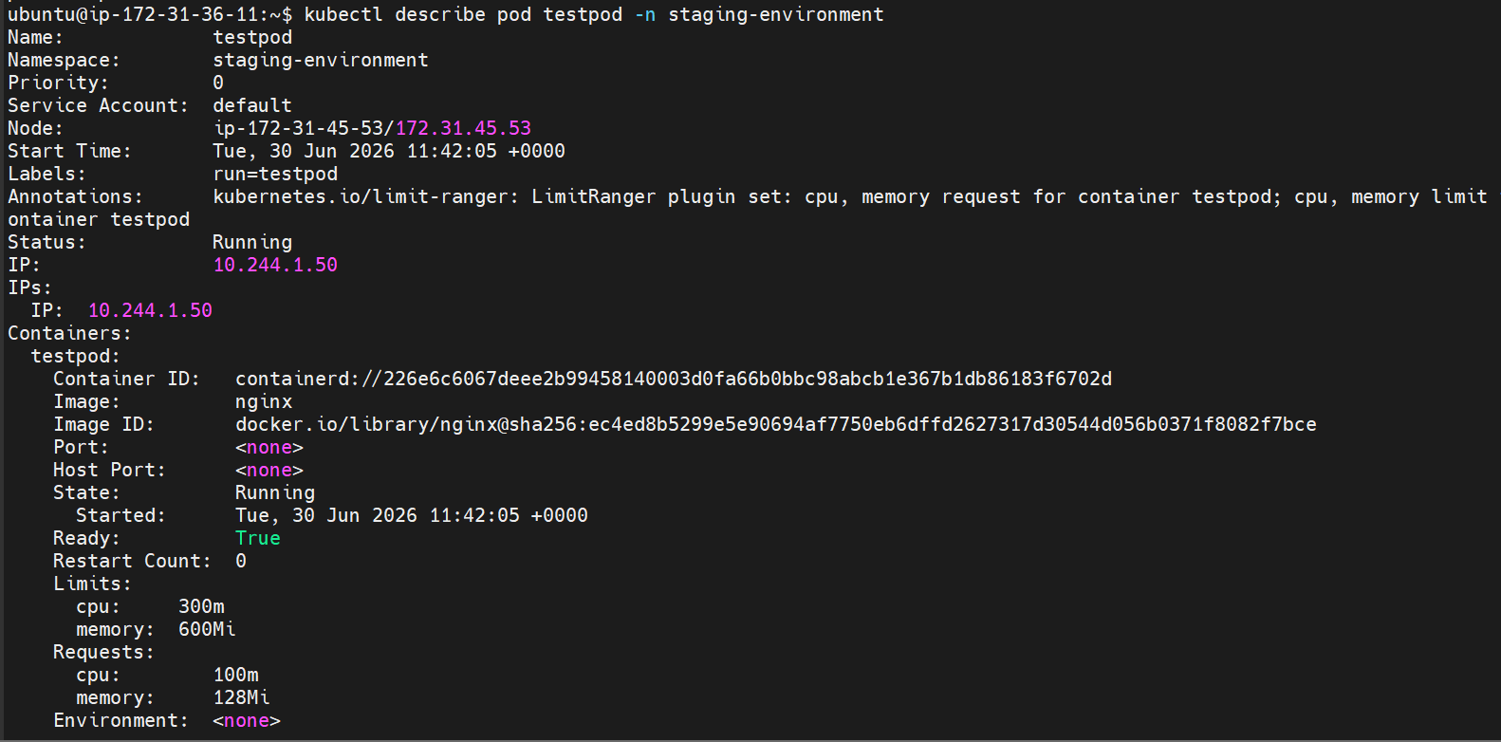
Here the specifications can be seen

Lets now create a pod with less cpu then mentioned

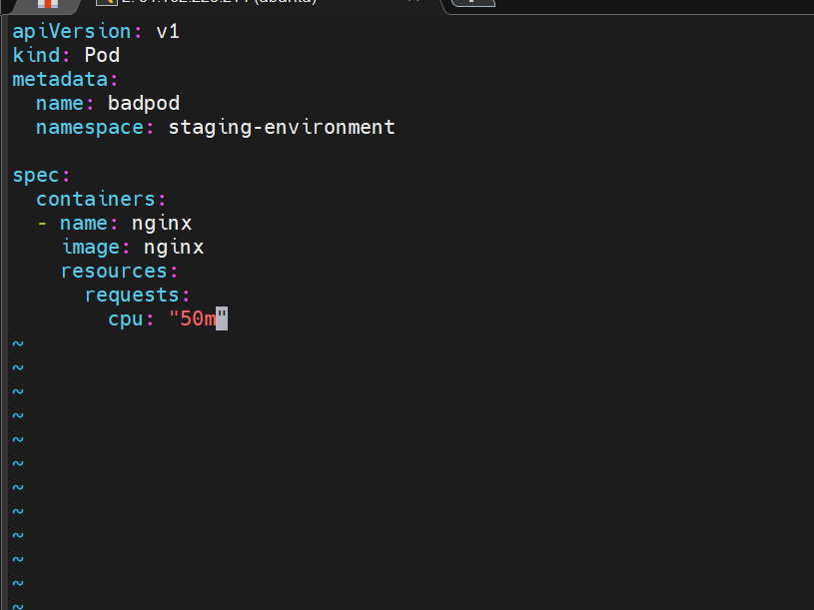

This is the yaml file to create a pod with 50 m cpu

Lets try creating it
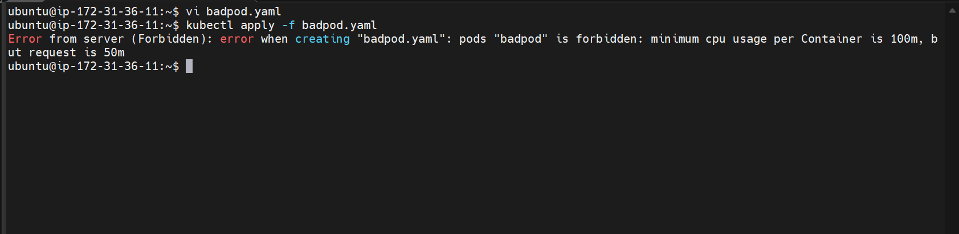

Here we can see that we are not able to create a pod with cpu less than 100m

Lets now modify and check for the higher cpu as well
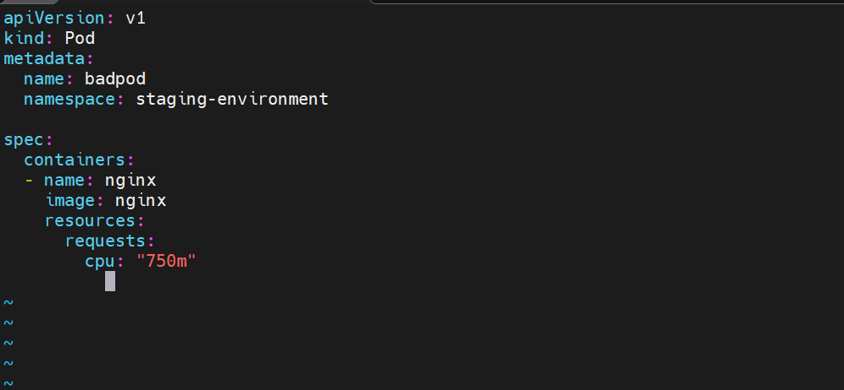
Trying to create a pod with 750m cpu

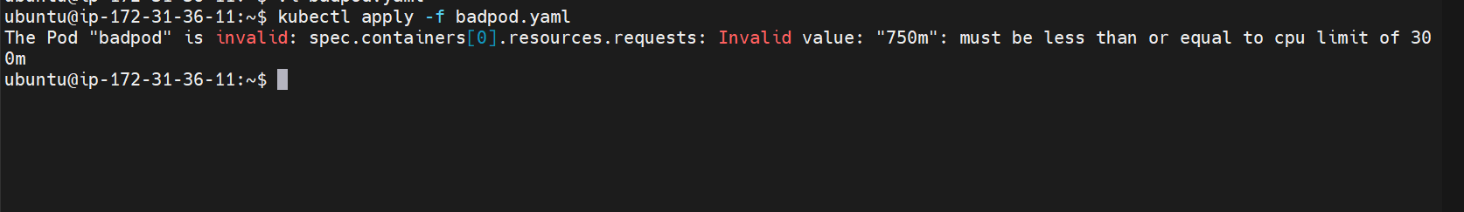

Again the error we can’t exceed the limit

- Create a pod and a NodePort service in the default namespace, then create another pod in the test namespace and communicate between them using Service DNS.
First lets create a nginx pod
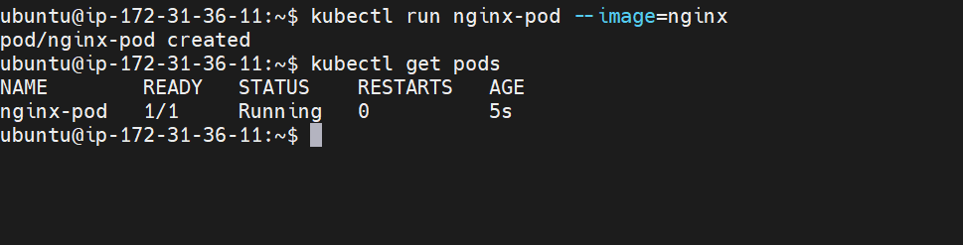
Pod has been created
Lets expose it using a nodeport service
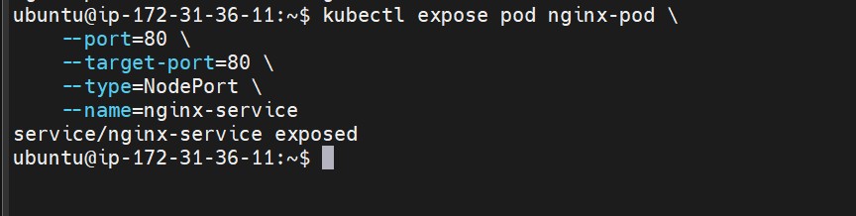
The pod is now exposed to internet on port 80

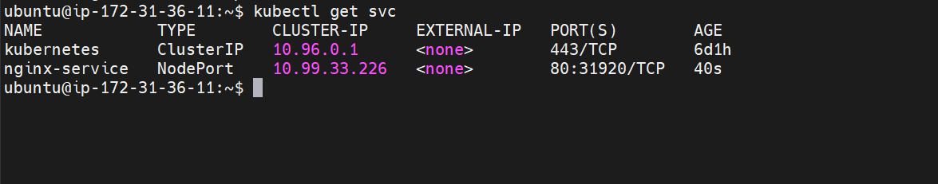
Lets now create a test namespace
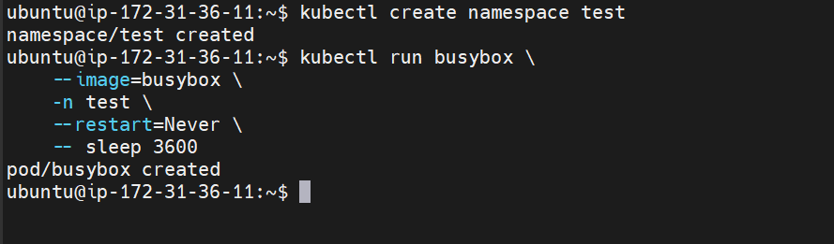
Also we have created a pod inside the test namespace
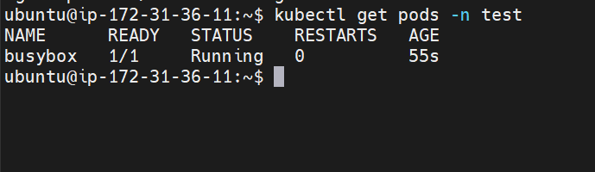

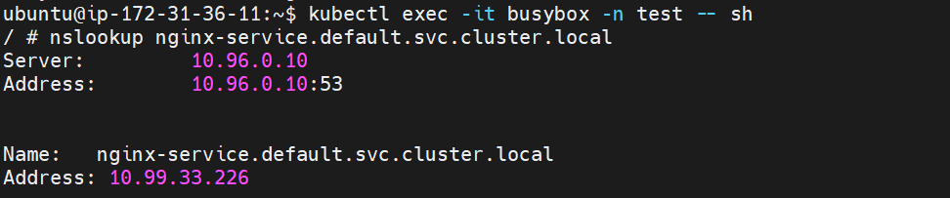
Getting inside the container and checking the dns
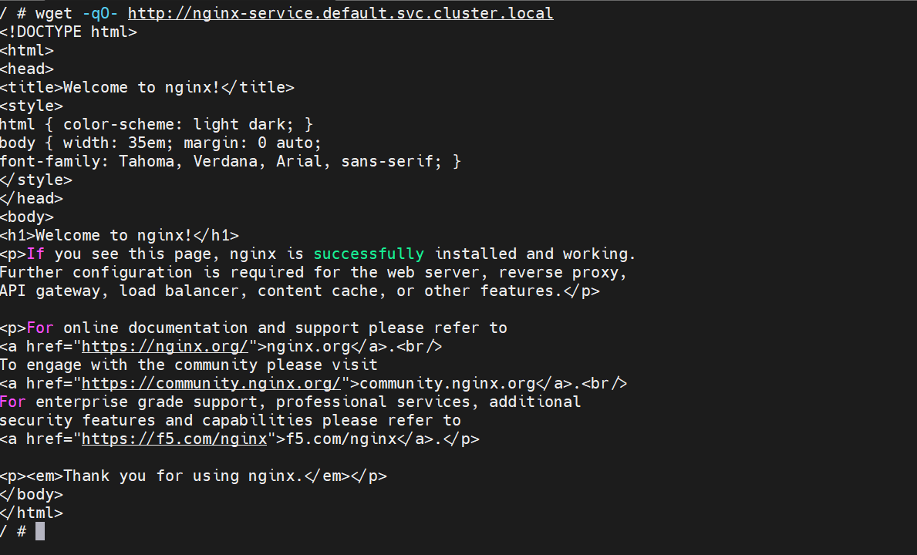
We are able to connect to the nginx-pod using the service dns
So the connectivity is successful

- Apply a LimitRange with a max limit/request ratio of 2 for memory in the performance-environment namespace, and test by creating a pod with mismatched resource requests and limits.

Create a namespace first
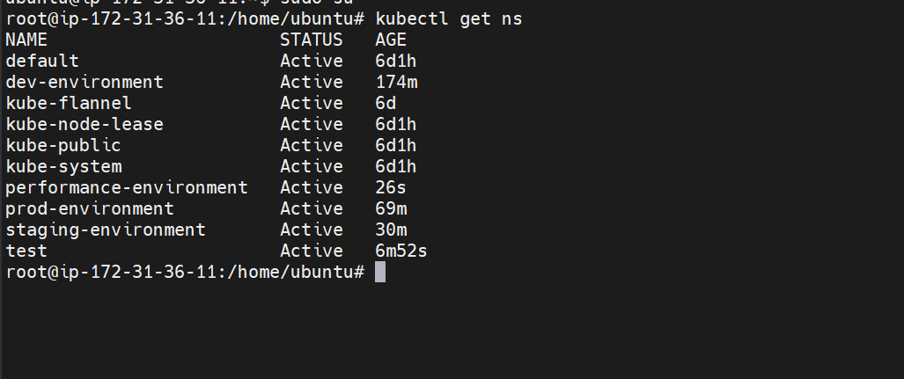

The namespace has been created

Now create the limit range
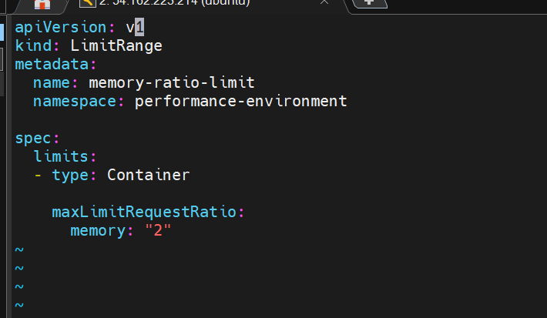

The max limit ratio is set to 2
Create it
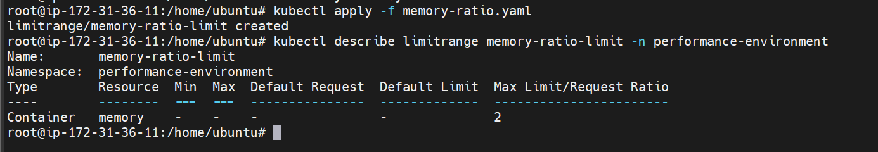

Now create a pod that violates the rule to test it
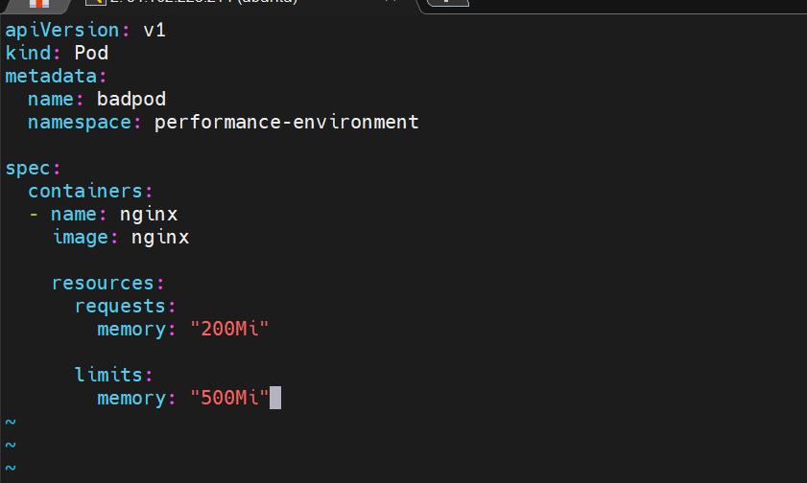

Here we are creating the pod which exceeds the cpu ratio

Lets create it

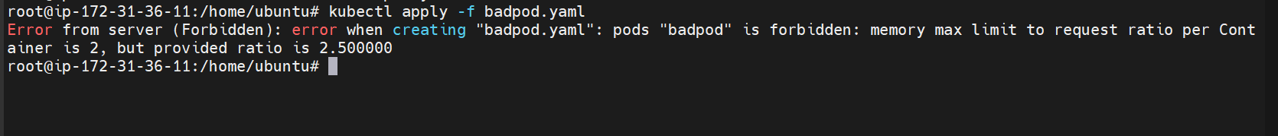

We are unable to created because the ratio is exceeded

Lets now create a valid pod
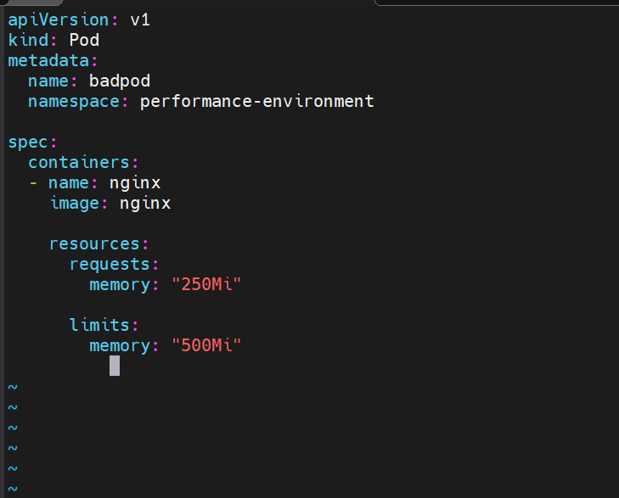

Lets create it now
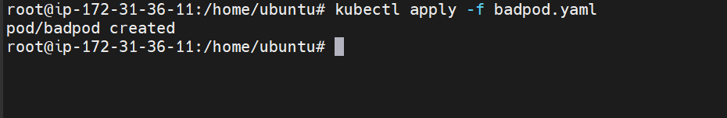
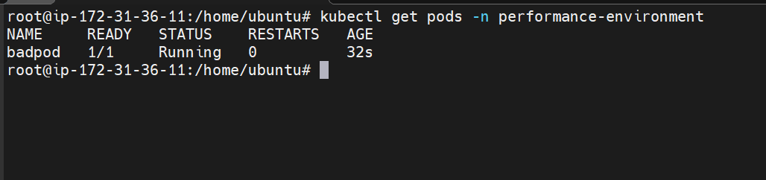
Now the pod is created

Why is This Useful?
Without this rule, someone could define:
Request = 100Mi
Limit = 2Gi
The scheduler would reserve only 100Mi, but the application could later consume up to 2Gi, potentially causing resource contention on the node.
The ratio helps keep requests and limits reasonably aligned.

