MERCURY
Robust and Transferable Mental-Health Label Classification
from Social-Media Text through Ensemble Distillation
Submission-oriented research paper draft
Manuscript field | Value
Authors | [Author 1], [Author 2] — replace before submission
Affiliation | [Department, University, City, Country] — replace before submission
Corresponding author | [Name and email] — replace before submission
Provisional target | IEEE Access — Applied Research / Research Article
Version | Draft 1.1 audited • 2 September 2026

Important scope statement
MERCURY classifies inherited dataset labels. It is not a diagnostic system and must not be represented as one.

Abstract
Automatic classification of mental-health-related categories in social-media text is often evaluated on datasets with uncertain provenance, severe class imbalance, and explicit label terms. These conditions can inflate natural-test performance and make improvements difficult to interpret. This study introduces MERCURY, a RAMHA-compatible training framework that combines variance-reduced probability teachers, confidence- and disagreement-aware knowledge distillation, and diagnostic-term masking consistency while retaining a single deployable RoBERTa-Large–adapter–BiLSTM–attention checkpoint. We reproduce the RAMHA backbone on an audited public Depression/Anxiety/Stress (DAS) subset containing 20,917 cleaned unique texts and compare both systems under five identical seeds. MERCURY improves mean natural-test macro-F1 from 92.738% to 92.998% (mean paired difference +0.260 percentage points; exact two-sided sign-flip p=0.0625) and mean condition-masked macro-F1 from 87.851% to 88.567% (+0.716 points; p=0.0625). Balanced-test macro-F1 is effectively tied (92.509% versus 92.506%; p=0.875). A three-model probability ensemble attains 94.112% natural macro-F1 in the earlier ablation but requires three inference passes and is treated as a teacher rather than the final model. A separate matched GoEmotions proxy experiment favors MERCURY by 0.290 macro-F1 points, while RAMHA retains higher macro precision. With only five paired seeds, the minimum attainable two-sided sign-flip p-value is 0.0625; the evidence therefore supports consistent natural and masked point-estimate gains, not statistical superiority at alpha=0.05 or clinical validity.
Keywords—mental-health text classification; social media; RoBERTa; adapters; BiLSTM; attention; knowledge distillation; ensemble learning; robustness; GoEmotions; reproducibility.

1. Introduction
Social-media text offers a large but ethically sensitive record of how people discuss distress, emotions, and mental-health conditions. Automatic text classifiers can support aggregate research, data triage, or corpus exploration, yet labels in public datasets rarely correspond to clinical assessment. Performance can also be overstated by duplicate leakage, source artifacts, class imbalance, and direct mentions such as “depression” or “anxiety.” A credible study must therefore separate dataset-category prediction from diagnosis and test whether gains persist when obvious shortcuts are removed.
RAMHA [1] is an appropriate architectural base because it combines contextual RoBERTa representations [2], parameter-efficient adapters [3], a bidirectional LSTM, token attention, and focal loss [4] for Depression/Anxiety/Stress classification. However, exact reproduction is constrained by incomplete implementation details and unavailable code or immutable splits. We therefore treat our audited implementation as a reproduced RAMHA baseline rather than claiming bit-for-bit equivalence to the paper’s reported experiment.
MERCURY—Mental-health Emotion Recognition through Uncertainty-aware Consistency and RobustitY—asks whether ensemble variance reduction can be transferred into one deployment-sized model while explicitly protecting performance against diagnostic-term masking and domain change. The method preserves RAMHA’s inference architecture; its novelty lies in the integrated teacher, distillation, robustness-selection, and matched-evaluation protocol.

1.1 Research problem
Existing mental-health text classifiers may achieve high scores without demonstrating that they learned robust linguistic evidence. The research problem is to improve a reproducible RAMHA-style classifier under class imbalance and shortcut exposure while avoiding the computational cost of an ensemble at inference and evaluating whether the improvement transfers to a separately curated emotion corpus.

1.2 Research questions
- RQ1. Across five identical seeds, how does MERCURY compare with the reproduced RAMHA baseline on natural, class-balanced, and condition-masked DAS tests?
- RQ2. What do probability ensembling, distillation, and masking consistency contribute, and what robustness–accuracy trade-offs do they create?
- RQ3. Under identical data, seed, optimization, and stopping rules, does MERCURY initialization improve a three-class mapped GoEmotions branch over RAMHA initialization?
- RQ4. Which classes and error directions remain difficult, and how strongly do paired statistical tests support the observed score differences?

1.3 Objectives and contributions
- Audit and deterministically split a public DAS corpus, removing duplicates and cross-label conflicts before model fitting.
- Reproduce a documented RAMHA-compatible backbone with focal loss and class-balancing logic.
- Construct a variance-reduced probability ensemble and distill its soft targets into a single model using confidence/disagreement weighting.
- Introduce condition-term masking augmentation and a dual-validation checkpoint rule with a minimum natural-performance gate.
- Evaluate natural, balanced, masked, ablation, and matched cross-domain conditions with macro and per-class metrics, AUCs, confusion matrices, and bootstrap intervals.
- Release a reproducibility manifest, limitations, ethics protocol, and publication-readiness checklist.

1.4 Research gap and novelty boundary
Ensembling, focal loss, knowledge distillation, adapters, and masking augmentation are established techniques [3]–[6]. The defensible novelty is their integration around the RAMHA backbone, the uncertainty-aware teacher-to-student transfer, and a predeclared robustness selection criterion evaluated on a leakage-audited DAS task and a matched mapped-GoEmotions task. We do not claim that any individual component is new, that the score differences establish statistical superiority, or that the system detects clinical conditions.

2. Related Work

2.1 Mental-health classification from social-media text
Computational mental-health research has used linguistic and behavioral cues to model depression, anxiety, stress, suicide risk, and related outcomes. The promise of scalable analysis is accompanied by sampling bias, uncertain labels, privacy risks, and the danger of inferring sensitive attributes. Benton et al. [7] recommend explicit ethical protocols for social-media health research. These concerns are central here because the primary corpus merges heterogeneous sources without retaining provenance identifiers.

2.2 Transformer, recurrent, and attention hybrids
RoBERTa improves BERT pretraining through longer training, larger data and batches, removal of next-sentence prediction, and dynamic masking [2]. RAMHA [1] routes RoBERTa-Large token representations through a Pfeiffer-style bottleneck adapter, a BiLSTM, token attention, dropout, and a linear softmax classifier. This combination provides contextual token encoding, sequential aggregation, and learned token weighting while allowing parameter-efficient adaptation.

2.3 Imbalance, ensembles, and distillation
Focal loss down-weights easy examples and concentrates learning on harder cases [4], making it attractive when Depression dominates the natural training distribution. Probability averaging reduces model-specific variance, but multiple forward passes increase latency and memory. Knowledge distillation transfers a teacher distribution into a student by combining hard-label supervision with temperature-scaled soft targets [5]. MERCURY further scales the teacher signal using prediction confidence and ensemble disagreement so ambiguous teacher outputs exert less influence.

2.4 Emotion resources and cross-domain transfer
GoEmotions contains 58,009 English Reddit comments annotated for 27 emotions plus neutral [8]. Its fine-grained labels support regrouping for downstream taxonomies, but such regrouping is a derived proxy rather than the official benchmark. We use a documented consensus-filtered mapping to test whether MERCURY initialization transfers beyond the DAS corpus; results must not be compared directly with GoEmotions’ original 28-label scores.

3. Datasets and Audit

3.1 Primary DAS corpus
The primary file is Combined Data.csv from the public Kaggle dataset “Sentiment Analysis for Mental Health” (dataset identifier: suchintikasarkar/sentiment-analysis-for-mental-health). The local source file SHA-256 is 67274f52dec3b0155aec4d7d1ff31d2a92b0e9b383ab917614591cd168cc2474. The dataset has no formal semantic version; this hash and the processed-file hashes serve as the immutable version identifiers.
Of 53,043 raw rows, 21,961 carried Depression, Anxiety, or Stress labels. We removed missing/very short texts, normalized URLs and platform artifacts, deduplicated normalized text, and removed every normalized text appearing under conflicting labels. The result comprised 20,917 unique target texts. Roughly half of each split contained an explicit condition term before masking, and the absence of source identifiers prevents source-held-out evaluation.
Split | Rows | Depression | Anxiety | Stress | Explicit term
Train | 14,641 | 10,527 | 2,514 | 1,600 | 49.11%
Validation | 3,138 | 2,256 | 539 | 343 | 48.60%
Test | 3,138 | 2,257 | 538 | 343 | 49.30%
Balanced test | 1,029 | 343 | 343 | 343 | 48.49%
Masked test | 3,138 | 2,257 | 538 | 343 | 0%

Splitting used seed 42 and a 70/15/15 stratified group-aware protocol after deduplication. Resampling or weighting was confined to training. The balanced test is a deterministic equal-count view of the natural test; the masked test replaces explicit condition terms while retaining labels and sample identities.

3.2 Mapped GoEmotions corpus
GoEmotions [8] is public through Google Research and ACL. We processed all three raw annotation shards, grouped repeated comment identifiers, required at least two-of-three annotator agreement, removed ties, and mapped selected emotions into three categories. The mapping was: Depression = sadness, grief, remorse, disgust, disappointment, disapproval; Anxiety = fear, nervousness, embarrassment, desire; Stress = annoyance, anger, realization, confusion. “Loneliness” and “worry” were unavailable as official GoEmotions columns.
Stage / split | Count | Notes
Unique mapped comments | 33,458 | Before consensus filtering
Consensus retained | 24,492 | Agreement ≥ 2/3; 3,808 ties removed
Train | 6,392 | 2,130/2,131/2,131, balanced
Validation | 1,370 | 457/457/456
Test | 1,370 | 457/456/457, untouched

Balancing and splitting used seed 4242. This constructed three-class dataset is a downstream proxy; its labels represent emotion-to-category mappings, not diagnoses. The exact raw file names, mapping, counts, and seed are stored in metadata.json.

4. Methodology
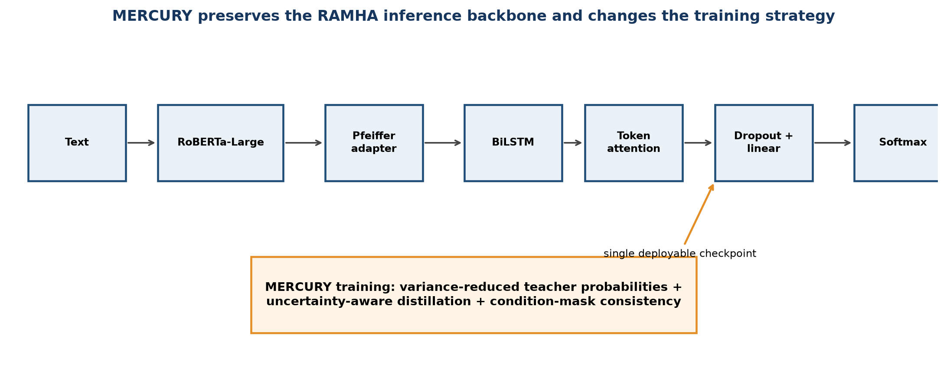
Figure 1. MERCURY architecture and training-only additions. The deployed model retains one RAMHA-compatible inference path.

4.1 Reproduced RAMHA backbone
Given tokenized text x of maximum length 128, RoBERTa-Large produces contextual states H. A Pfeiffer/seq_bn bottleneck adapter transforms H, after which a one-layer BiLSTM with 256 hidden units per direction yields sequential states Z. A learned 512-unit attention projection assigns a normalized weight to each valid token. The weighted sum passes through dropout 0.5 and a linear three-class head; softmax returns class probabilities.
Training uses class-balanced focal loss with γ = 2. For true class y and predicted probability p_y, the loss is −α_y(1−p_y)^γ log(p_y), where α_y is derived from the training-class frequencies. This baseline is our operational reconstruction of RAMHA, not the authors’ original checkpoint.

4.2 Variance-reduced teacher
Three independently seeded RAMHA-compatible models generate class-probability vectors. Validation-selected convex weights (0.35, 0.35, 0.30) average these probabilities. Averaging reduces model-specific variance and improves natural DAS macro-F1 from 0.9302 for the seed-42 baseline to 0.9411. Because the ensemble requires three inference passes, it is used as a teacher and an empirical upper bound rather than the final deployment model.

4.3 Uncertainty-aware distillation
The student begins from the reproduced seed-42 checkpoint. Its objective combines hard-label class-balanced focal loss with a temperature-scaled Kullback–Leibler divergence from teacher probabilities. Temperature T = 2 and distillation weight λ = 0.35 were used for the selected student. The soft-loss contribution is reduced when teacher entropy or ensemble disagreement is high, preventing uncertain consensus from overriding the observed label. A sweep evaluated λ ∈ {0.20, 0.35, 0.50} and T ∈ {1.5, 2.0, 3.0}; selection was based on validation performance, not test scores.

4.4 Condition-mask consistency and robust selection
During robust fine-tuning, diagnostic terms were masked with probability 0.35. Checkpoints were scored by the mean of natural and masked validation macro-F1. In the five-seed study, each seed used the same relative natural-performance gate: natural validation macro-F1 could fall by no more than 0.005 from that seed’s distilled initialization. This seed-relative rule replaced the exploratory seed-42 absolute gate of 0.930 and prevents a masked-text gain from being purchased by a large natural-text collapse without privileging one seed.

4.5 GoEmotions transfer branch
The MERCURY GoEmotions branch initializes from the final robust DAS checkpoint and is fine-tuned on the mapped corpus. Its matched RAMHA comparator starts from the same pretrained architecture without MERCURY transfer. Both use the identical split, seed 6262, maximum 18 epochs, batch size 16, learning rate 2×10−5, focal loss, scheduler, and early stopping. The comparison therefore isolates initialization/history more closely than comparisons across unrelated runs.

5. Experimental Setup
Component | Setting
Encoder | roberta-large
Adapter | seq_bn / Pfeiffer-style bottleneck
BiLSTM | 1 layer; hidden size 256; bidirectional
Attention | hidden size 512; padding mask applied
Classifier | dropout 0.5 → linear 3-way logits → softmax at inference
Sequence length | 128 tokens
Baseline optimizer | AdamW; LR 2×10−5; weight decay 0.01
Robust fine-tuning | LR 2×10−6; up to 6 epochs; warm-up 0.05; max grad norm 1.0
Loss | class-balanced focal loss, γ=2; plus uncertainty-aware KL for MERCURY
Paired DAS seeds | 17, 42, 73, 101, 303
Other seeds | DAS split 42; GoEmotions split 4242; matched GoEmotions training 6262
Checkpointing | validation-only early stopping; MERCURY uses mean natural/masked macro-F1 plus a seed-relative natural-F1 gate (distilled reference minus 0.005)
Primary metric | macro-F1; accuracy and macro precision/recall secondary in the five-seed study

5.1 Hardware and software
Experiments were run on Windows with an NVIDIA GeForce RTX 5060 Ti (16,311 MiB VRAM; driver 616.56). The recorded environment used Python 3.14.6, PyTorch 2.13.0+cu130, CUDA 13.0, Transformers 4.57.6, Adapters 1.3.0, pandas 3.0.5, NumPy 2.5.2, scikit-learn 1.9.0, PyYAML 6.0.3, Matplotlib 3.11.1, and seaborn 0.13.2. Exact requirements and YAML configuration files are included with the project.

5.2 Evaluation and statistical procedure
RAMHA and MERCURY were trained under the five identical seeds 17, 42, 73, 101, and 303. Checkpoints were selected from validation results only, then evaluated on the untouched natural, balanced, and condition-masked tests. We report the mean and sample standard deviation across seeds. For macro-F1 differences, we report per-seed paired differences, Cohen’s dz, a two-sided exact sign-flip randomization test over all 32 sign assignments, and a 20,000-resample paired-seed percentile bootstrap interval. With five pairs, the smallest attainable two-sided exact p-value is 0.0625, so no comparison can reach alpha=0.05. Saved predictions were independently re-scored, and label order, probability normalization, configuration chains, and checkpoint hashes were audited.

6. Results

6.1 Primary DAS comparison
Metric | RAMHA mean ± SD | MERCURY mean ± SD | Mean Δ
Accuracy | 0.9604 ± 0.0051 | 0.9620 ± 0.0048 | +0.0015
Macro Precision | 0.9288 ± 0.0125 | 0.9329 ± 0.0110 | +0.0041
Macro Recall | 0.9261 ± 0.0086 | 0.9273 ± 0.0091 | +0.0012
Macro F1 | 0.9274 ± 0.0103 | 0.9300 ± 0.0098 | +0.0026

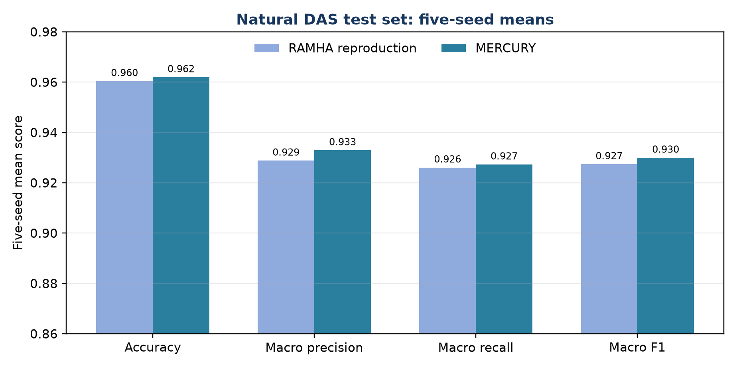
Figure 2. Natural DAS test results averaged across five paired seeds.
Natural-test macro-F1 increases from 0.927380 ± 0.010315 for RAMHA to 0.929981 ± 0.009760 for MERCURY. The mean paired difference is +0.002601 (Cohen’s dz=1.778; exact two-sided sign-flip p=0.0625; paired-seed bootstrap 95% interval [0.001313, 0.003646]). All five seed-level differences are positive, but the exact test does not establish significance at alpha=0.05.

6.2 Robustness and ablation
System | Natural F1 | Balanced F1 | Masked F1 | Inference passes
RAMHA seed 42 | 0.9302 | 0.9267 | 0.8924 | 1
Distilled student | 0.9321 | 0.9297 | 0.8918 | 1
MERCURY robust | 0.9310 | 0.9296 | 0.8944 | 1
Probability ensemble | 0.9411 | 0.9375 | 0.8967 | 3

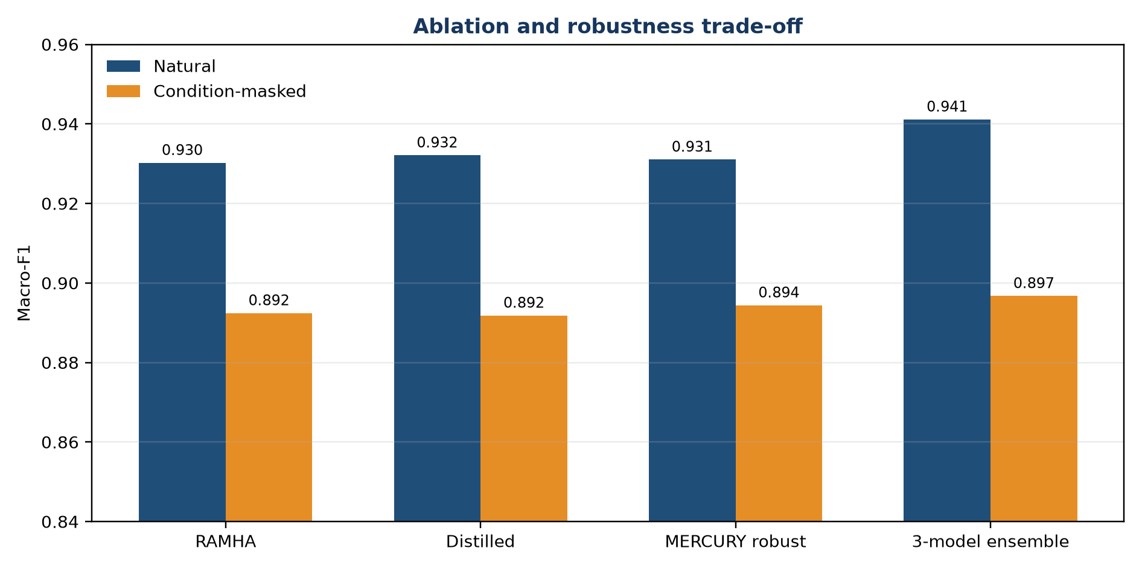
Figure 3. Ablation results separate the ensemble upper bound, distilled student, and robustness-selected single checkpoint.
Distillation alone produced the strongest single-model natural macro-F1 (0.9321) but slightly reduced masked performance relative to RAMHA. Robust fine-tuning recovered and exceeded the masked baseline while retaining a small natural advantage. The ensemble remained strongest overall, confirming useful diversity across seeds, but its three-pass cost motivated distillation.
Split | RAMHA F1 mean ± SD | MERCURY F1 mean ± SD | Mean Δ | Exact p
Natural | 0.927380 ± 0.010315 | 0.929981 ± 0.009760 | +0.002601 | 0.0625
Balanced | 0.925094 ± 0.008556 | 0.925064 ± 0.009706 | −0.000029 | 0.8750
Condition-masked | 0.878510 ± 0.016461 | 0.885669 ± 0.011001 | +0.007159 | 0.0625

Across five seeds, MERCURY’s largest mean improvement occurs under condition masking (+0.7159 percentage points). The balanced split is effectively a tie and includes both positive and negative seed-level differences. Consequently, the multi-seed evidence does not support the earlier wording that MERCURY improves every split.

6.3 Matched mapped-GoEmotions comparison
Metric | RAMHA matched | MERCURY branch | Absolute Δ
Accuracy | 0.6723 | 0.6766 | +0.0044
Macro precision | 0.6856 | 0.6775 | -0.0080
Macro recall | 0.6722 | 0.6767 | +0.0044
Macro F1 | 0.6741 | 0.6770 | +0.0029
Macro PR-AUC | 0.7575 | 0.7671 | +0.0096
Macro ROC-AUC | 0.8453 | 0.8507 | +0.0054

MERCURY improves macro-F1 by 0.0029 and improves accuracy, recall, PR-AUC, and ROC-AUC. RAMHA has higher macro precision by 0.0080. MERCURY’s macro-F1 95% interval is [0.6535, 0.7003], compared with [0.6484, 0.6991] for RAMHA; the overlap is substantial.

7. Error Analysis
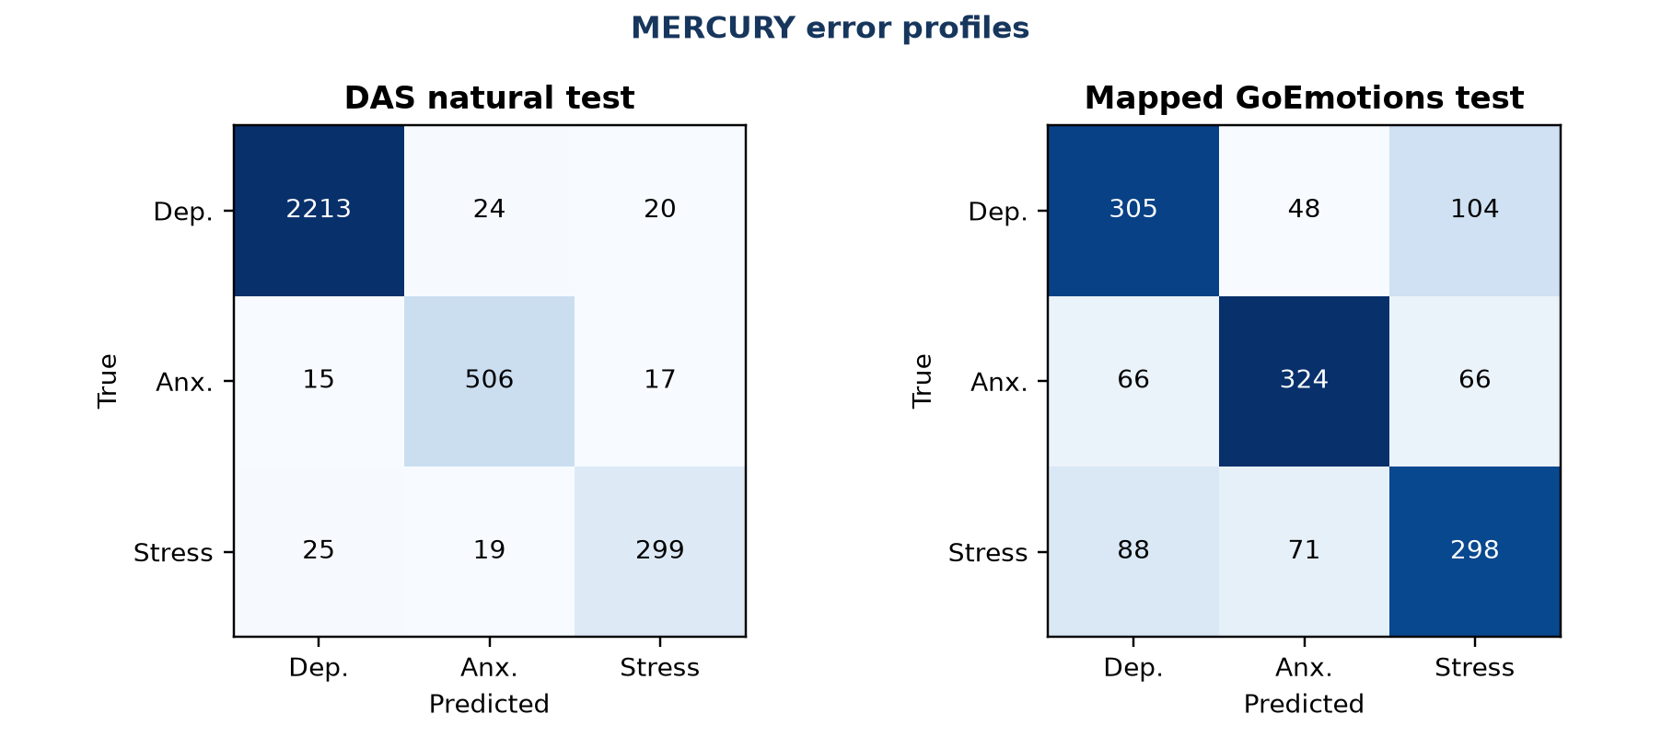
Figure 4. Confusion matrices for the final MERCURY DAS checkpoint and the matched mapped-GoEmotions branch.
On DAS, Depression is easiest (F1 0.9814), reflecting both class prevalence and strong topical cues. Stress remains hardest (F1 0.8807 natural; 0.8160 masked). In the masked test, Stress is confused with Depression 34 times and Anxiety 34 times, consistent with overlapping distress language after diagnostic terms are removed. Anxiety is comparatively stable (masked F1 0.8912). The largest methodological concern is therefore not aggregate accuracy but minority-class robustness.
On mapped GoEmotions, Depression is most often confused with Stress (104 cases), and Stress is confused with Depression (88) or Anxiety (71). The mapping itself creates semantic overlap: disgust/disapproval are assigned to Depression, while annoyance/anger belong to Stress; short Reddit comments often lack enough context to resolve that boundary. Anxiety has the highest F1 (0.7208), likely because fear and nervousness form a more coherent cluster. These errors support future hierarchical or multilabel treatment rather than forcing every comment into one diagnosis-like category.

8. Discussion

8.1 Answers to the research questions
RQ1: Across five paired seeds, MERCURY has higher mean natural macro-F1 by 0.2601 percentage points and higher mean condition-masked macro-F1 by 0.7159 points. All five paired differences are positive on both splits. Balanced macro-F1 is effectively tied, with MERCURY lower by 0.0029 points on average. The exact two-sided p-values are 0.0625, 0.0625, and 0.8750, respectively; none meets alpha=0.05.
RQ2: The ensemble establishes that seed diversity can yield a materially stronger upper bound (+1.09 macro-F1 points over RAMHA natural). Distillation compresses much of the teacher behavior into one model and improves natural performance, but robustness selection is needed to avoid degradation under masking. The components therefore play complementary roles.
RQ3: MERCURY initialization improves the matched mapped-GoEmotions macro-F1 point estimate by 0.29 percentage points and improves most aggregate metrics, but not macro precision. This is evidence of modest transfer, not proof that MERCURY dominates RAMHA on all measures.
RQ4: Stress is the persistent failure mode, and condition masking exposes meaningful shortcut dependence. The multi-seed effect estimates favor MERCURY on natural and masked tests, but five pairs provide insufficient exact-test resolution for a statistical-superiority claim at alpha=0.05.

8.2 Comparison with the RAMHA paper
RAMHA reports approximately 88% multiclass accuracy for its paper setting [1], whereas our audited DAS reproduction exceeds 96% accuracy. These numbers are not directly comparable: the dataset construction, inherited labels, split, duplicate policy, and test definition differ, and our primary corpus contains strong source/topical cues. The correct base comparison is the RAMHA architecture retrained under our exact split and protocol. MERCURY should therefore be presented as improving a reproduced RAMHA baseline on the audited datasets—not as reproducing or universally surpassing the original paper’s experimental result.

8.3 Practical interpretation
MERCURY’s strongest practical result is a single checkpoint with no additional inference path and a repeatable mean advantage under condition masking. The balanced-test result is a tie, so robustness should be described specifically rather than as universal improvement. The corpus can still expose source and topic cues; even the masked result remains an upper-bound dataset benchmark.

9. Limitations
- The primary combined dataset does not retain source-dataset, author, platform, or annotation-provenance fields; source-held-out and user-held-out evaluation are impossible.
- Labels are inherited categories rather than clinician-verified diagnoses, and explicit condition language is common.
- The RAMHA paper does not provide a complete executable reference implementation, exact immutable split, or all architectural details; our baseline is a documented reconstruction.
- The mapped GoEmotions task is a constructed single-label proxy with subjective category assignments and is not the official 28-label benchmark.
- Five paired seeds are an improvement over a single run but remain too few for an exact two-sided sign-flip test to attain p<0.05; confidence intervals and effect sizes should be interpreted cautiously.
- The GoEmotions comparison remains single-seed and therefore does not establish cross-domain statistical superiority.
- Hyperparameter searches may induce validation overfitting even though test sets were held out.
- Only English text and one local GPU environment were studied; demographic and cross-cultural fairness were not measurable.
- No calibration, abstention, inference-latency, energy, or human-in-the-loop evaluation was completed.

10. Ethics and Safety
This study concerns sensitive health-related language. It follows a non-diagnostic framing: predictions indicate dataset categories only and must not be used for clinical decisions, crisis response, employment, insurance, policing, or individual surveillance. Public availability does not eliminate privacy risk. Releases should avoid republishing raw user text, preserve platform terms, minimize identifiers, and distribute only scripts, hashes, mappings, and permissible derived artifacts where licensing allows.
Before publication, the authors should obtain institutional ethics/IRB determination, verify the terms and licenses of every source corpus, document data retention and access control, and perform a privacy review. Any deployment study requires clinical and lived-experience stakeholders, subgroup fairness evaluation, calibration and abstention, human review, and a clear escalation policy. Model outputs should include uncertainty and a warning that they are not medical advice.
AI-assisted writing disclosure: this draft was prepared with assistance from OpenAI Codex and must be reviewed, verified, and rewritten as necessary by the listed authors. IEEE Access currently requires disclosure of AI-generated text in the acknowledgments and places responsibility for the final content on the authors.

11. Conclusion
MERCURY provides a robustness-oriented extension of a reproduced RAMHA architecture. Across five paired DAS seeds, it yields small, consistent natural-test and condition-masked macro-F1 gains, while the balanced test is effectively tied. Exact two-sided sign-flip p-values of 0.0625 for the favorable comparisons do not establish superiority at alpha=0.05. A matched mapped-GoEmotions branch also improves macro-F1 and most aggregate measures in a single-seed proxy experiment, while RAMHA retains higher precision. The evidence supports MERCURY as a promising training and evaluation framework, not a claim of statistical, universal, or clinical superiority. The next decisive experiment is a larger paired study on an independently sourced, expert-annotated corpus.

12. Future Work
- Increase the paired RAMHA–MERCURY study beyond five seeds so the exact randomization test has adequate resolution and power; predeclare multiplicity correction for multiple splits.
- Repeat the matched GoEmotions comparison under multiple shared seeds.
- Evaluate on an independent corpus with retained source/user groups and expert or clinically grounded labels.
- Replace forced three-class GoEmotions mapping with hierarchical or multilabel learning and test sensitivity to alternative mappings.
- Add calibration, abstention, uncertainty decomposition, and selective-risk evaluation.
- Measure inference latency, GPU memory, energy, and carbon impact for baseline, ensemble, and student.
- Conduct demographic, dialect, and cross-cultural fairness audits with appropriately consented metadata.
- Release code, immutable split manifests, environment lockfiles, model cards, and a data statement after license review.

Acknowledgments
[Insert funding, institutional support, conflicts of interest, data-access acknowledgments, and required AI-assistance disclosure before submission.] The authors remain solely responsible for the study design, verification, interpretation, and manuscript.

References
[1] M. Kumar, L. Khan, and A. Choi, “RAMHA: A Hybrid Social Text-Based Transformer with Adapter for Mental Health Emotion Classification,” Mathematics, vol. 13, no. 18, art. 2918, 2025, doi: 10.3390/math13182918.
[2] Y. Liu et al., “RoBERTa: A Robustly Optimized BERT Pretraining Approach,” arXiv:1907.11692, 2019.
[3] J. Pfeiffer et al., “AdapterHub: A Framework for Adapting Transformers,” in Proc. EMNLP 2020: System Demonstrations, 2020, pp. 46–54, doi: 10.18653/v1/2020.emnlp-demos.7.
[4] T.-Y. Lin, P. Goyal, R. Girshick, K. He, and P. Dollár, “Focal Loss for Dense Object Detection,” in Proc. ICCV, 2017, pp. 2980–2988, doi: 10.1109/ICCV.2017.324.
[5] G. Hinton, O. Vinyals, and J. Dean, “Distilling the Knowledge in a Neural Network,” arXiv:1503.02531, 2015.
[6] G. Huang, Y. Li, G. Pleiss, Z. Liu, J. Hopcroft, and K. Weinberger, “Snapshot Ensembles: Train 1, Get M for Free,” in Proc. ICLR, 2017.
[7] A. Benton, G. Coppersmith, and M. Dredze, “Ethical Research Protocols for Social Media Health Research,” in Proc. First ACL Workshop on Ethics in NLP, 2017, pp. 94–102, doi: 10.18653/v1/W17-1612.
[8] D. Demszky, D. Movshovitz-Attias, J. Ko, A. Cowen, G. Nemade, and S. Ravi, “GoEmotions: A Dataset of Fine-Grained Emotions,” in Proc. ACL, 2020, pp. 4040–4054, doi: 10.18653/v1/2020.acl-main.372.
[9] J. Devlin, M.-W. Chang, K. Lee, and K. Toutanova, “BERT: Pre-training of Deep Bidirectional Transformers for Language Understanding,” in Proc. NAACL-HLT, 2019, pp. 4171–4186, doi: 10.18653/v1/N19-1423.
[10] S. Hochreiter and J. Schmidhuber, “Long Short-Term Memory,” Neural Computation, vol. 9, no. 8, pp. 1735–1780, 1997, doi: 10.1162/neco.1997.9.8.1735.
[11] Z. Yang et al., “Hierarchical Attention Networks for Document Classification,” in Proc. NAACL-HLT, 2016, pp. 1480–1489, doi: 10.18653/v1/N16-1174.
[12] C. Guo, G. Pleiss, Y. Sun, and K. Q. Weinberger, “On Calibration of Modern Neural Networks,” in Proc. ICML, 2017, pp. 1321–1330.
[13] P. Branco, L. Torgo, and R. P. Ribeiro, “A Survey of Predictive Modeling on Imbalanced Domains,” ACM Computing Surveys, vol. 49, no. 2, art. 31, 2016, doi: 10.1145/2907070.
[14] E. M. Bender and B. Friedman, “Data Statements for Natural Language Processing,” Transactions of the ACL, vol. 6, pp. 587–604, 2018, doi: 10.1162/tacl_a_00041.
[15] S. Chancellor, M. L. Birnbaum, E. D. Caine, V. M. B. Silenzio, and M. De Choudhury, “A Taxonomy of Ethical Tensions in Inferring Mental Health States from Social Media,” in Proc. FAT*, 2019, pp. 79–88, doi: 10.1145/3287560.3287587.
[16] J. Cohen, “A Coefficient of Agreement for Nominal Scales,” Educational and Psychological Measurement, vol. 20, no. 1, pp. 37–46, 1960, doi: 10.1177/001316446002000104.
[17] B. Efron and R. J. Tibshirani, An Introduction to the Bootstrap. New York, NY, USA: Chapman & Hall, 1993.
[18] IEEE Access, “Preparing Your Article” and “Submission Guidelines for Authors,” accessed Sep. 2, 2026. [Online]. Available: https://ieeeaccess.ieee.org/authors/

Appendix A. Reproducibility Manifest
Item | Recorded specification / artifact
DAS source | Kaggle suchintikasarkar/sentiment-analysis-for-mental-health; Combined Data.csv; SHA-256 in §3.1
GoEmotions source | Demszky et al. [8]; three raw CSV shards; transformation metadata recorded
Preprocessing | Missing/short removal; URL/platform normalization; normalized-text deduplication; conflict removal before split
Splits | DAS 70/15/15, seed 42; GoEmotions balanced 6,392/1,370/1,370, seed 4242
Architecture | RoBERTa-Large + seq_bn adapter + BiLSTM-256 + attention-512 + dropout-0.5 + 3-way head
Hyperparameters | Table in §5; exact YAML files in project configs
Hardware/software | §5.1
Paired DAS seeds | 17, 42, 73, 101, 303
Evaluation | Natural, balanced, and masked tests; exact paired sign-flip test, Cohen’s dz, and 20,000-resample paired-seed bootstrap
Code | Local project: E:\Uni\RAMHA; publication repository URL to be assigned after license and secret review
Evidence | outputs/paired_5seed/paired_5seed_results.json, PAIRED_5SEED_REPORT.md, and PAIRED_5SEED_AUDIT.json
Integrity | Prediction labels, metrics, configs, initialization chains, rejected runs, and checkpoint SHA-256 hashes independently audited

Appendix B. Research and Paper Checklist
Checklist cluster | Status
Clear problem/questions/objectives/gap/novelty | Covered in §§1.1–1.4
Strong literature review/base paper/public data | Covered in §§2–3; RAMHA [1], public DAS and GoEmotions
Reproducible baseline/proposed improvement | Covered in §§4–5 and Appendix A
Multiple experiments/baseline/ablation | Natural, balanced, masked, ensemble, distilled, robust, matched transfer in §6
Evaluation/statistics/error analysis | Metrics, bootstrap intervals, confusion matrices in §§5–7
Limitations/ethics | Covered in §§9–10
Title/authors/affiliations/abstract/keywords | Present; author fields intentionally marked for completion
Full manuscript sections/references/figures/tables | Present, including supplementary appendices
Dataset versions/splits/model/hyperparameters/hardware/software/seeds | Recorded in §§3–5 and Appendix A
Code availability | Local code complete; public release URL pending license review

Appendix C. Publication Readiness
Requirement | Current status / required action
Target venue | Provisional: IEEE Access, Applied Research / Research Article; broad IEEE scope is compatible
Correct template | NOT YET APPLIED. Transfer this content to the current official IEEE Access double-column, single-spaced Word/LaTeX template
Citation style | IEEE numeric style drafted; verify every DOI, capitalization, and bibliographic field
Page/word limit | IEEE Access currently states no general page limit; verify current fees and article-type rules before submission
Ethical requirements | Obtain IRB/ethics determination; verify licenses/terms; add data/privacy statement and conflicts
Originality/plagiarism | Run institutional similarity check; manually verify paraphrases and all prior-work attribution
Figures | Original figures at high resolution; re-export to template-required dimensions and verify color accessibility
References | Primary-source references included; complete independent DOI and metadata verification required
AI disclosure | Required by current IEEE Access guidance; finalize acknowledgment language
Submission package | Matching Word and PDF, ≤40 MB each; all authors, biographies, supplementary material, and repository link
Statistical completion | Five-seed DAS comparison completed and audited; expand beyond five seeds for p<0.05 resolution and repeat GoEmotions with multiple seeds
Author metadata | Replace all placeholders; establish author order, ORCIDs, affiliations, corresponding author, and biographies

Submission decision gate: the manuscript is suitable as a comprehensive research draft, but it should not be submitted until author metadata, ethics determination, source licenses, reference verification, official template conversion, and a larger paired study (including multi-seed GoEmotions evaluation) are complete.

