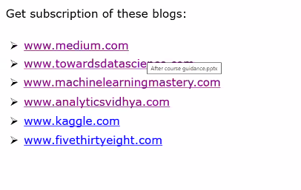

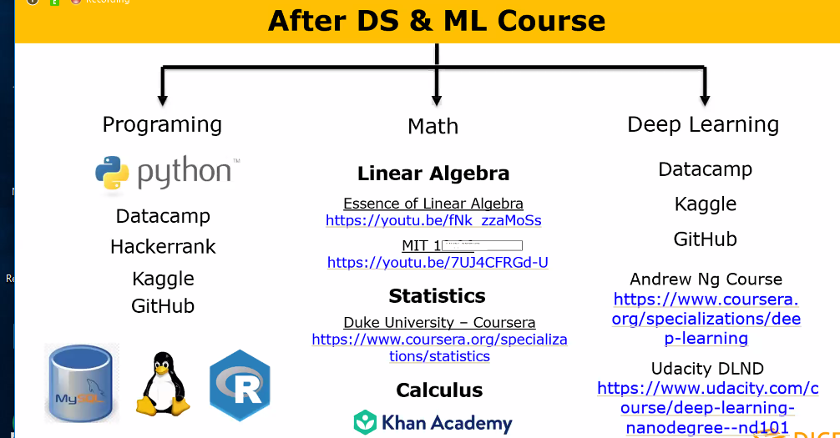

SQL zoo good place for learning SQL.

3Blue1Brown

**EDA and Advanced Classification**