Machine Learning Assignment 1

# Task1:

In your terminal, run >> conda info

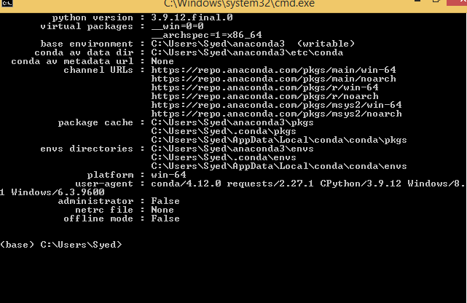

# Task2:

Run the following script in IPython and paste the figure created by the script into your report import matplotlib.pyplot as plt plt.plot([1,2,3,4], [1,2,7,14]) plt.axis([0, 6, 0, 20]) plt.show()

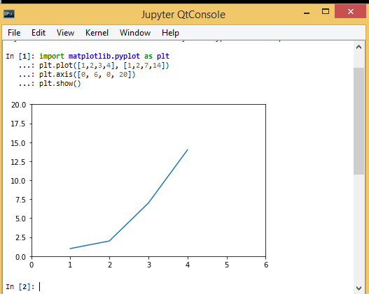

# Task3:

Use Matplotlib to create a figure of your choice in IPython. Paste your code and figure into your report.

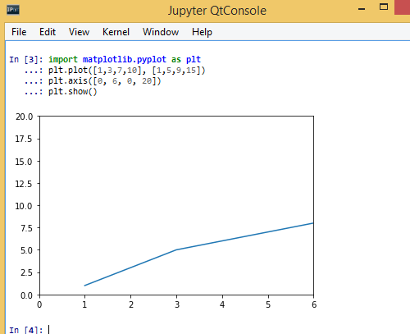

# Task4:

register for a student account here for free private repository access for future projects and go through these tutorials. insert a screenshot of your user page in github in your report.

