Task1

Create a Linear Dataset:

# Machine Learning Assignment 2 NumPy

1. Assign a sequence of integers from 6 to 20 (inclusive) to a NumPy array named feature.
2. Assign 15 values to a NumPy array named label such that:

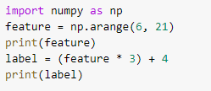Code:

Output:



Task 2:

Add Some Noise to the Dataset

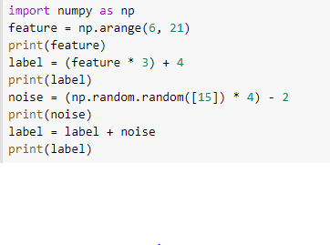Code:

Output:

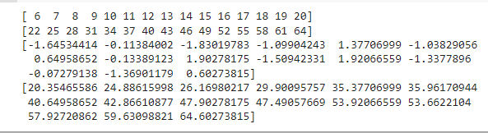

# Pandas DataFrame

Task 1: Create a DataFrame

Do the following:

1. Create an 3x4 (3 rows x 4 columns) pandas DataFrame in which the columns are named Eleanor, Chidi, Tahani, and Jason. Populate each of the 12 cells in the DataFrame with a random integer between 0 and 100, inclusive.
2. Output the following:
   * the entire DataFrame
   * the value in the cell of row #1 of the Eleanor column
3. Create a fifth column named Janet, which is populated with the row-by-row sums of Tahani and Jason

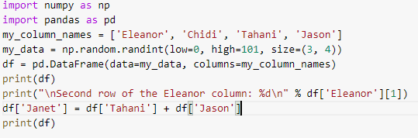Code:

Output:

