

**Fundamental of Software Engineering**

**Assignment 02: Project Deliverable 02**

**Instructor:**

Ma’amSaba Kanwal

**Members:**

* Syeda Areeba Nadeem 21I-0307
* Moawiz bin Yamin 21I-0323
* Rameen Tariq 21-0306
* Jannat Butt 21I-0259

**Section:**

AI-K

**EFFICIENT DISEASE PREDICTION AND DOCTOR – PATIENT PORTAL**

**BASED ON MEDICAL HISTORY**

**Snapshot-1 (Product Backlog):**

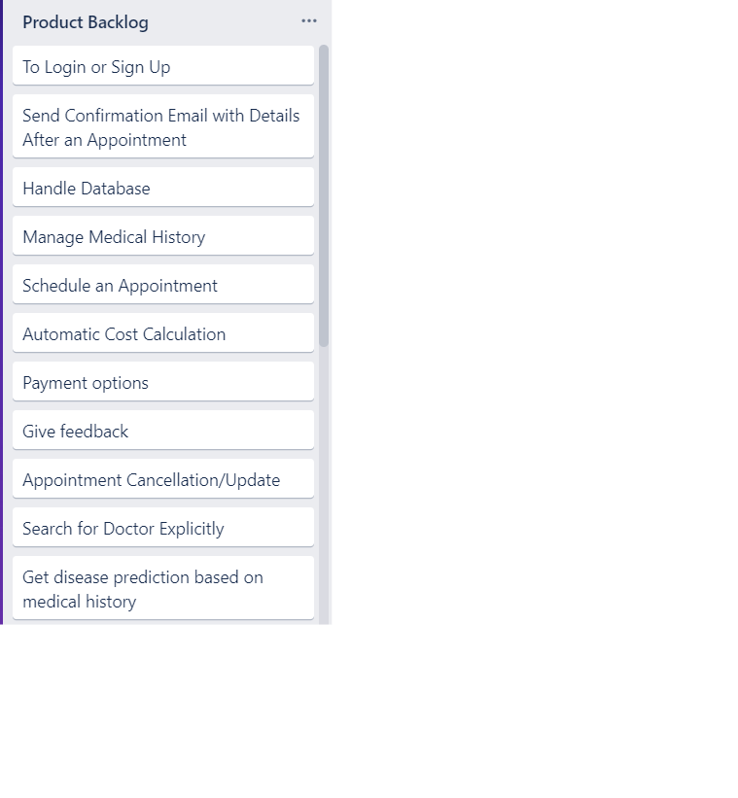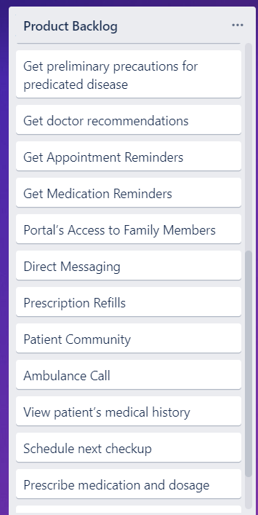

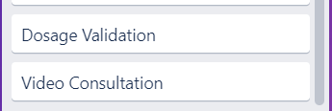

**Snapshot-1 (Sprint 1 Backlog):**

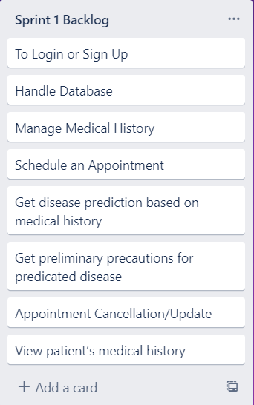

**Snapshot-2 (Trello Board in mid of sprint):**

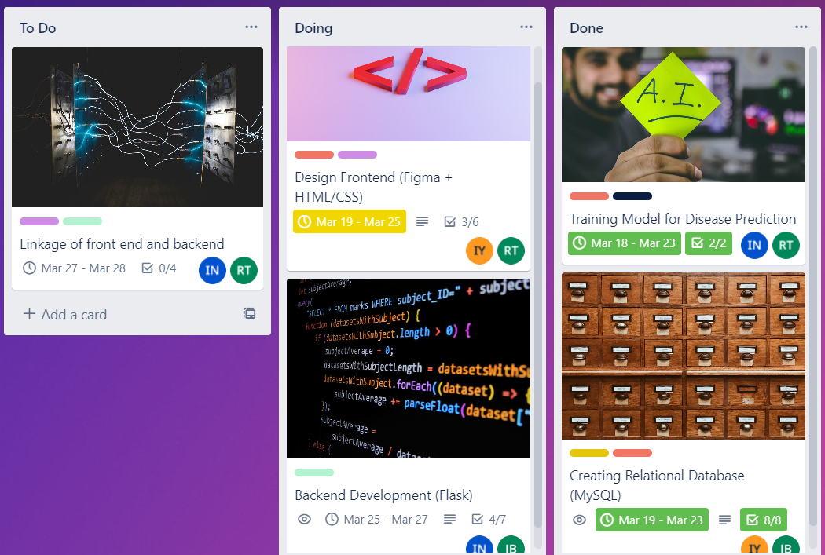

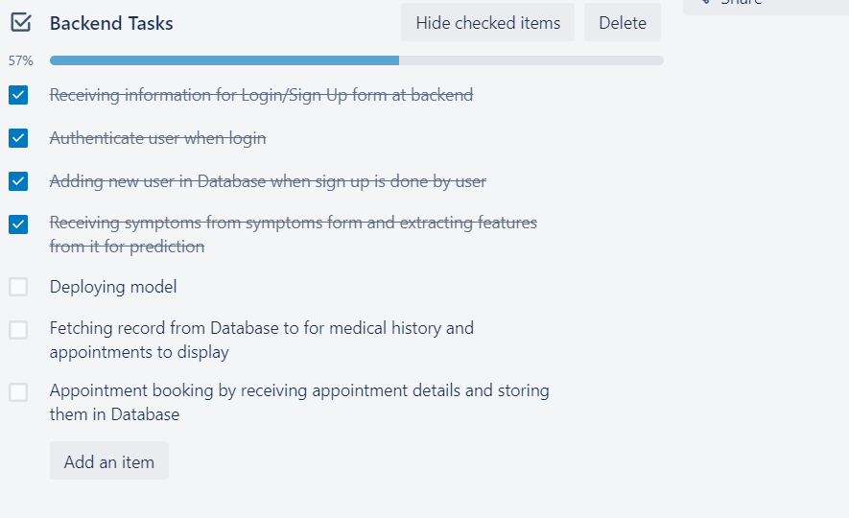

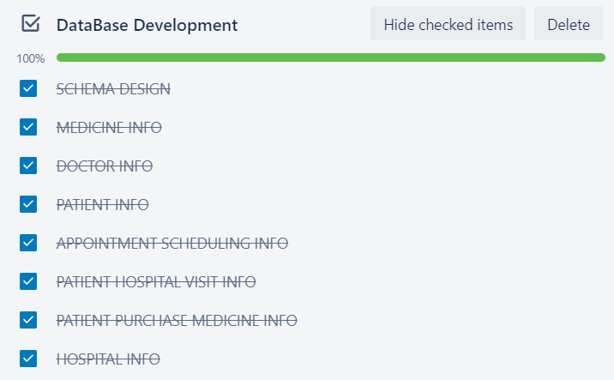

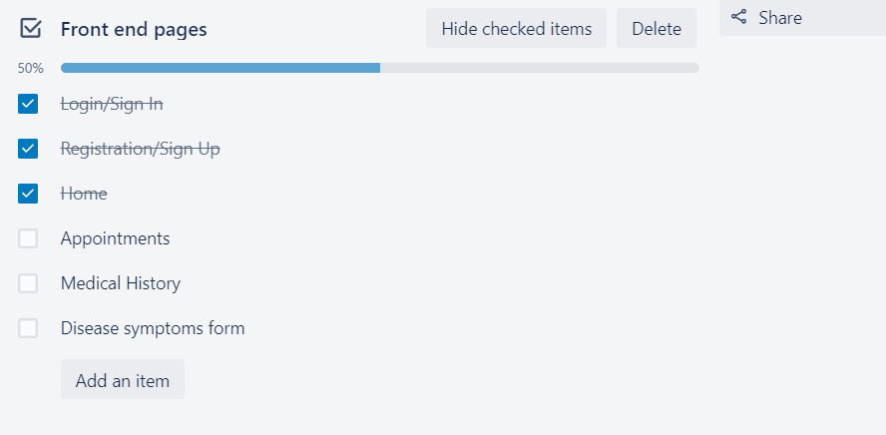

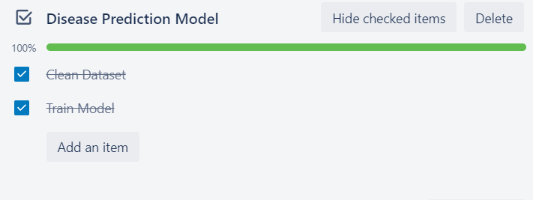

**Snapshot-3 (At the end of the sprint):**

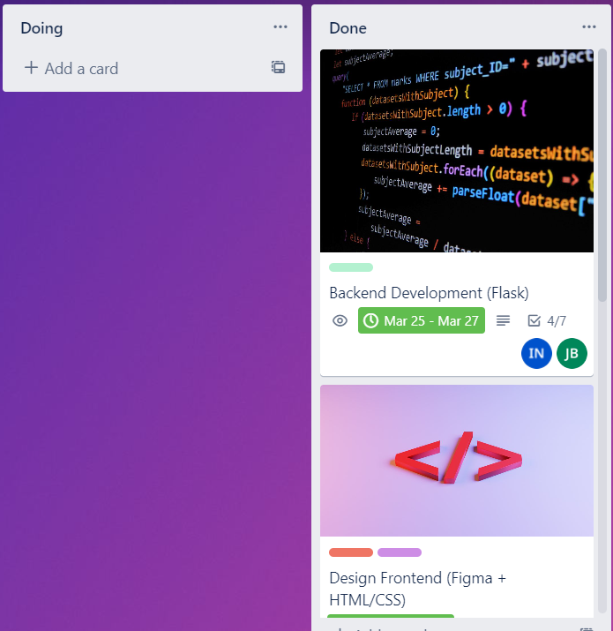

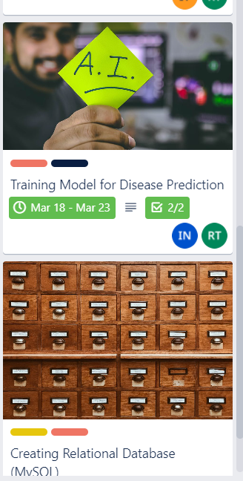 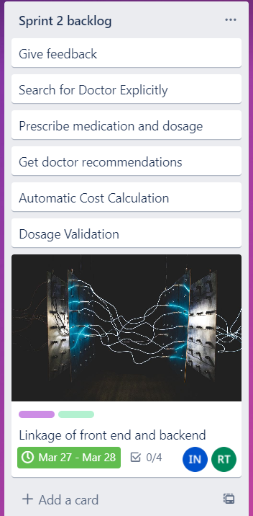

**Left over card from sprint 1**

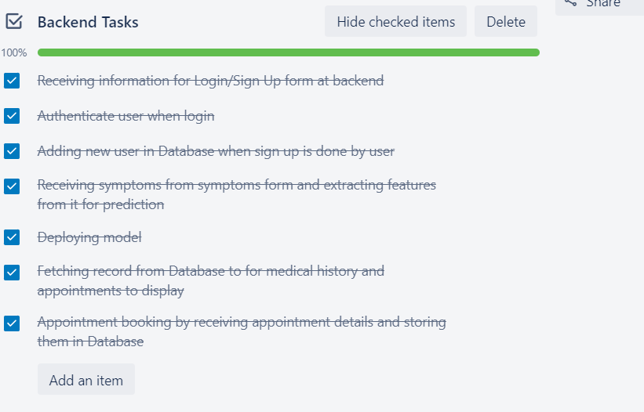



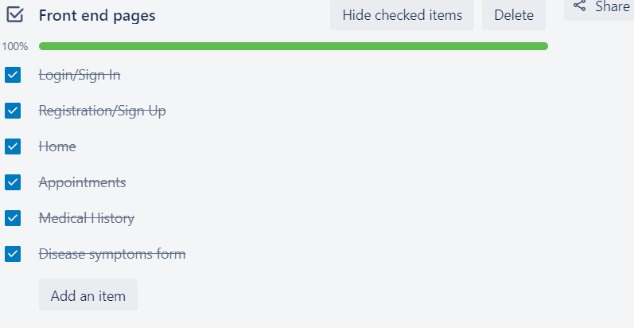



**Snapshot-4 (Scrum Master activities):**

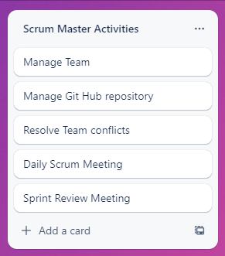

**GitHub repository link:**

[*https://github.com/Syeda-Areeba/My-Health-Mate*](https://github.com/Syeda-Areeba/My-Health-Mate)

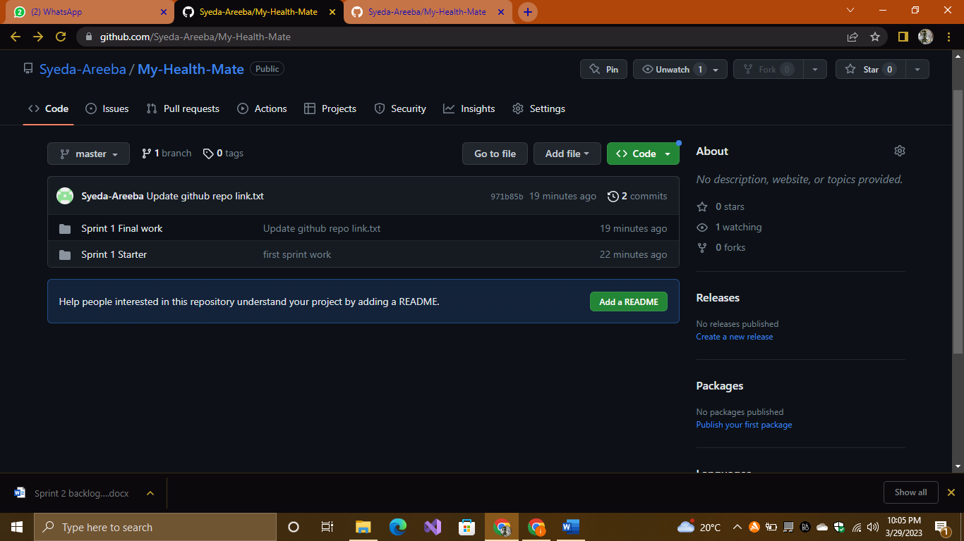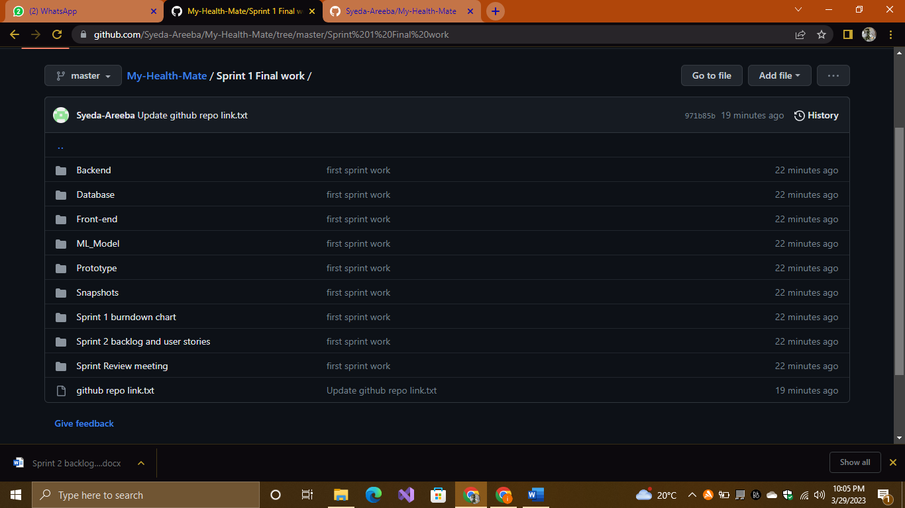

**Burn down Chart for sprint 1:**

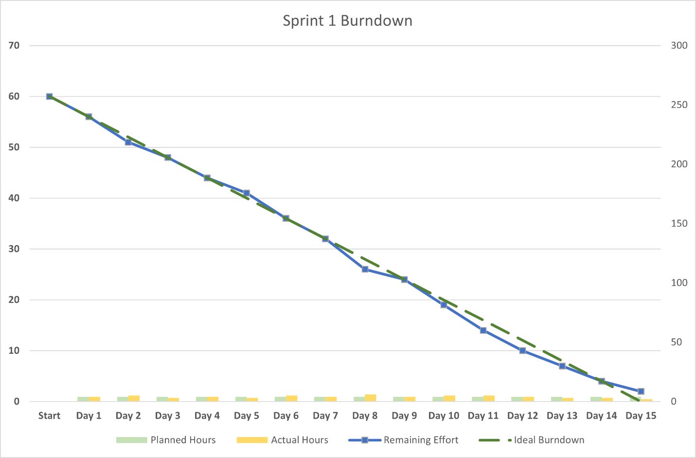

**Sprint 2 Backlog User stories**

**Patient Module:**

1. **Give Feedback:**

As a patient I want to give the feedback on the services provided to facilitate me so that the managers can have a better understanding of my experience with the software and its facilities and can improve it, if needed, to provide more convenience to me.

1. **Automatic Cost Calculation:**

As a patient I want my total cost to be calculated prior to my check up so that I can have a rough estimate of overall treatment and manage my budget.

1. **Search for Doctor Explicitly:**

As a patient I want a system to provide me with the freedom of choosing a doctor of my own choice in addition to having suggestions for the doctors so that I am not bound to just system recommended doctors.

1. **Get Doctor Recommendation:**

As a patient I want doctor recommendations based on the predicted disease like which type of doctor or specialist is best suited to treat my condition so that I don’t waste time while searching for the one and can readily book an appointment to start my treatment as soon as possible.

**Doctor Module:**

1. **Prescribe Medication and Dosage:**

As a doctor I want to prescribe the appropriate medications along with their dosages to my patients so that their disease can be treated and the medications are stored in their portal and they don’t have to carry paper prescriptions.

1. **Dosage Validation:**

As a doctor I want to have my prescribed dosage of medications to be checked by the system so that the patients don’t receive extremely high or low dosages that can prove to be dangerous for their health.

**Left Over Task from Sprint 1:**

1. **Front end & back-end Linkage:**

Some pages are left to be connected with Database at backend which will be done in next sprint.

