

Assignment no 1
Name: Syeda Mutzahra Batool
RegNo: 23-ARID-604
Program: BSCS (B) 5th M
Course Name: Mobile App Development
Submitted to: Muhammad Azhar

Qno1:

Android Development Environment & Key Components
- Android Studio: Official IDE for Android, provides code editor, debugger, and tools to run apps on emulators or devices.
- SDK (Software Development Kit): Libraries and tools required to build Android apps.
- AVD (Android Virtual Device): Emulator to test apps without a physical device.
- Gradle: Build tool that compiles code, manages dependencies, and packages the app.

Role of Project Components
- AndroidManifest.xml: Declares app components, permissions, and themes.
- Gradle Scripts: Handle dependencies, build configurations, SDK versions, and build variants.
- res Directory: Stores layouts, images, colors, and strings for UI and themes.
- java Directory: Contains source code like activities, classes, and app logic.

Common Dependency Issues & Fixes
- Gradle sync errors: Fix by syncing Gradle or updating plugin versions.
- SDK version mismatch: Install required SDK via SDK Manager or adjust build.gradle.
- Library conflicts: Force compatible versions in build.gradle.

Qno2:

Android Studio Installation and Configuration Guide

Step 1: Install Android Studio
- Download from https://developer.android.com/studio.
- Run the installer and follow default instructions.
- During setup, ensure Android SDK, Platform Tools, and Android Virtual Device (AVD) are installed.

Step 2: Create a New Project
- Open Android Studio → New Project → Empty Activity → Next
- Name the project: HelloWorldApp
- Set package name (e.g., com.example.helloworldapp) and language (Java/Kotlin).
- Select minimum SDK (API 21 is fine) → Click Finish

Step 3:

- Running app
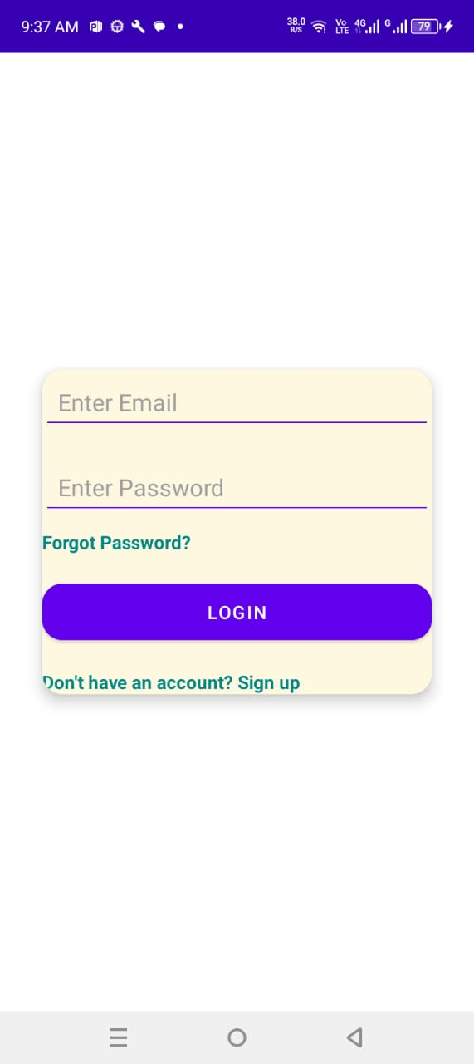

2.project structure
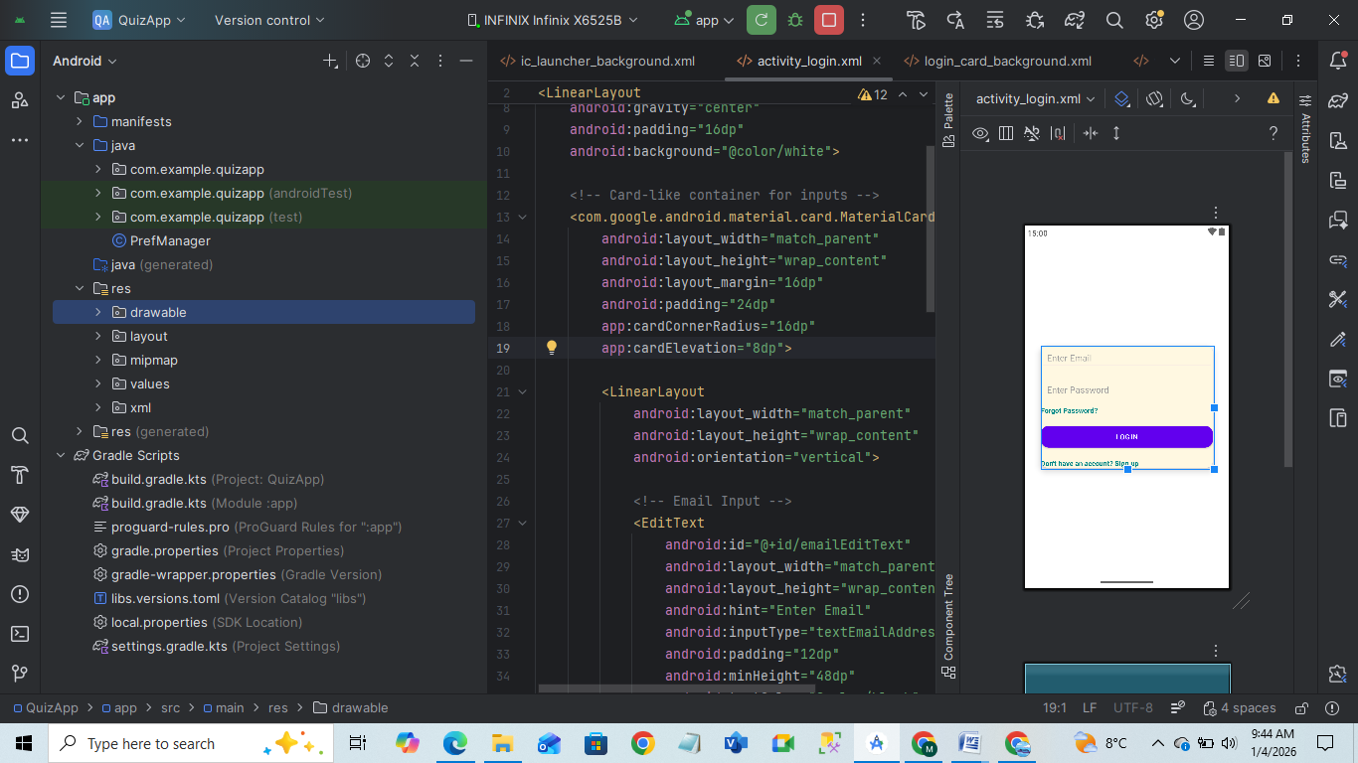

3. A short reflection:
During the setup of Android Studio, I had to download the correct SDK version and configure the emulator. I faced an initial error due to missing platform tools, but after installing them via SDK Manager, the app ran successfully. Running the app on the emulator took longer on my system, but on a real device, it worked smoothly. I learned how project structure organizes resources and Java/Kotlin files, which will help in future projects.

