

Assignment no 2
Name: Syeda Mutahra Batool
RegNo: 23-ARID-603
Program: BSCS (B) 5th M
Course Name: Mobile App Development
Submitted to: Muhammad Azhar

Screenshots of my app output
1.login screen
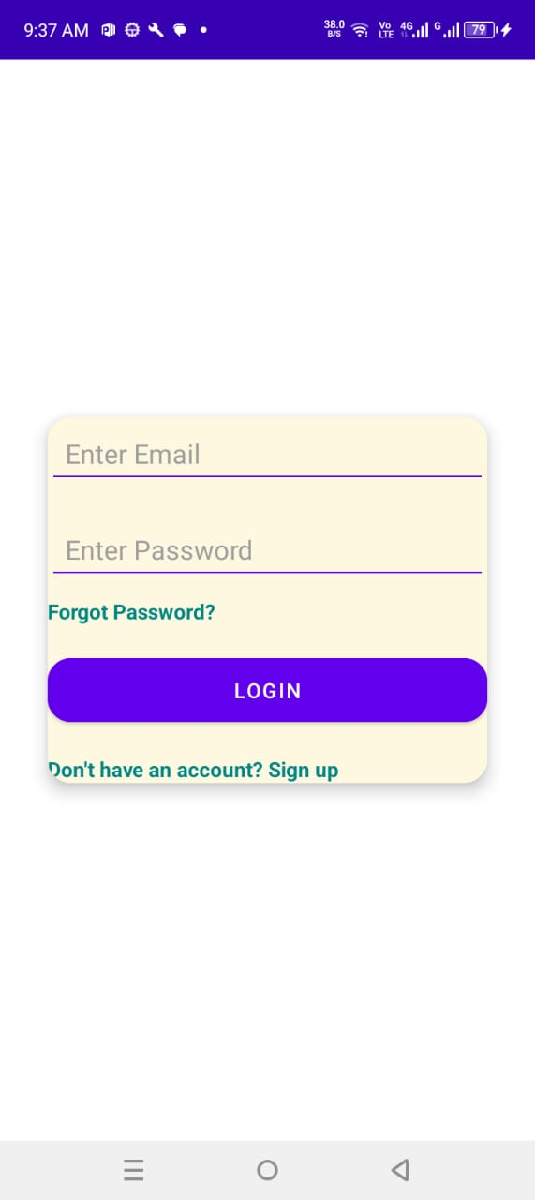

2. Reset Password screen
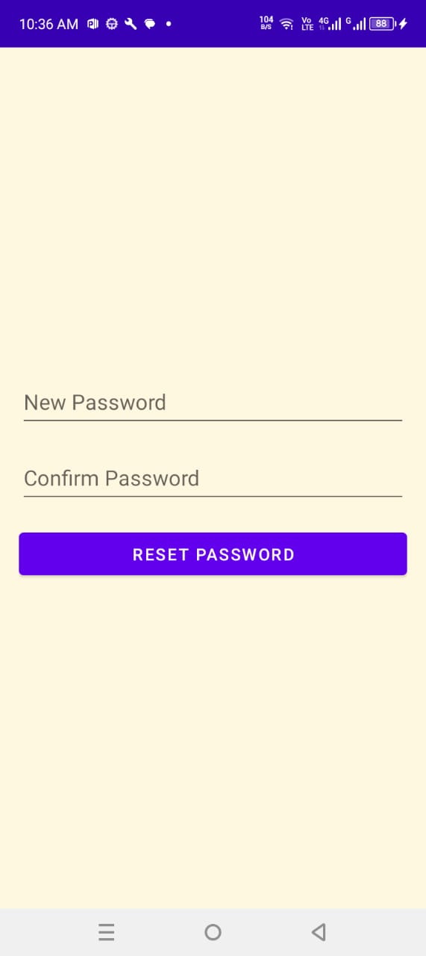

3. forget password screen
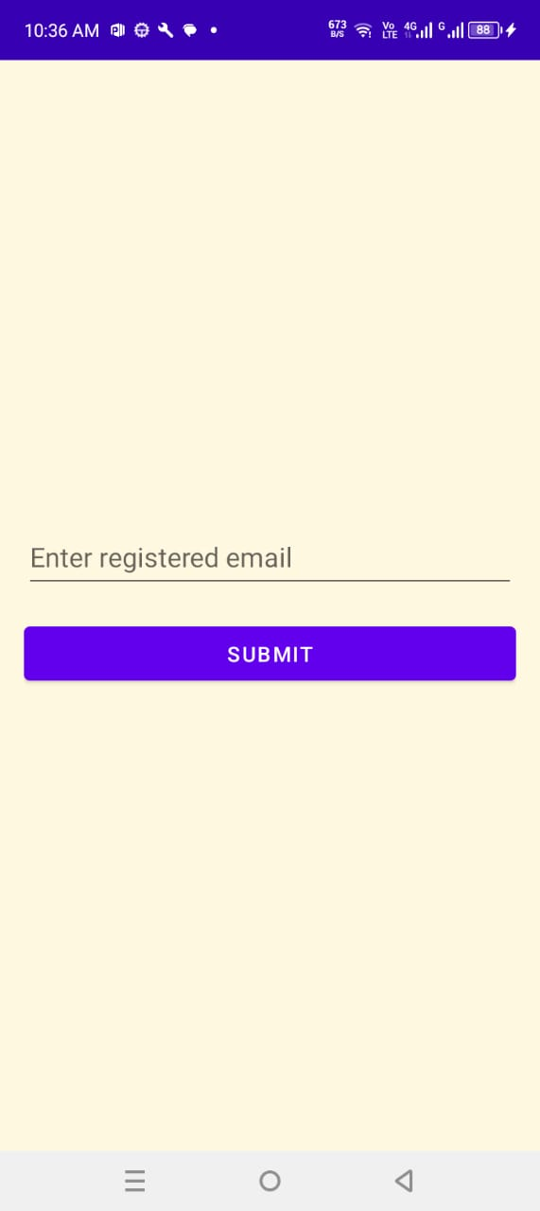

4. home screen
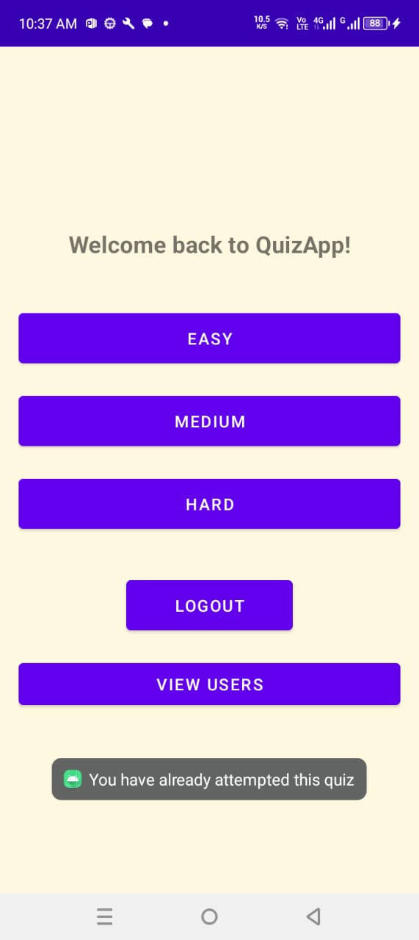

5. Result screen
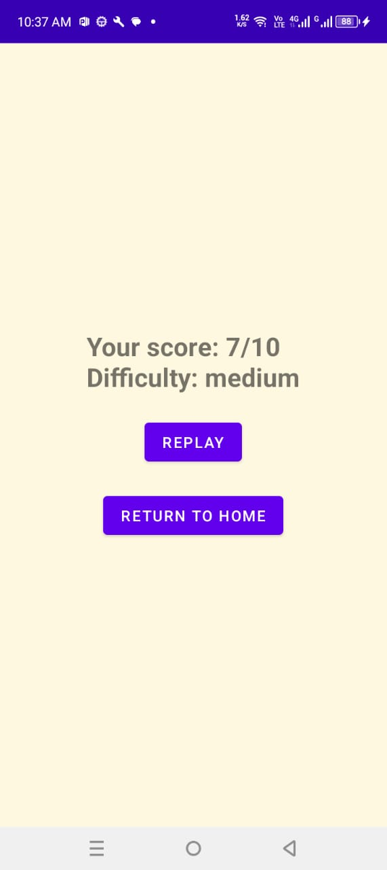

6. Signup screen
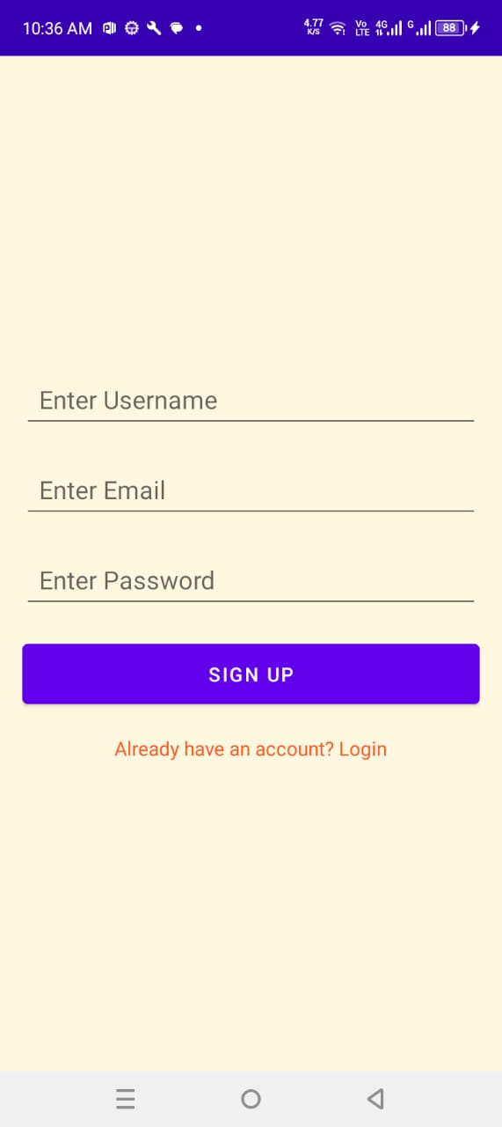

7. Users view screen
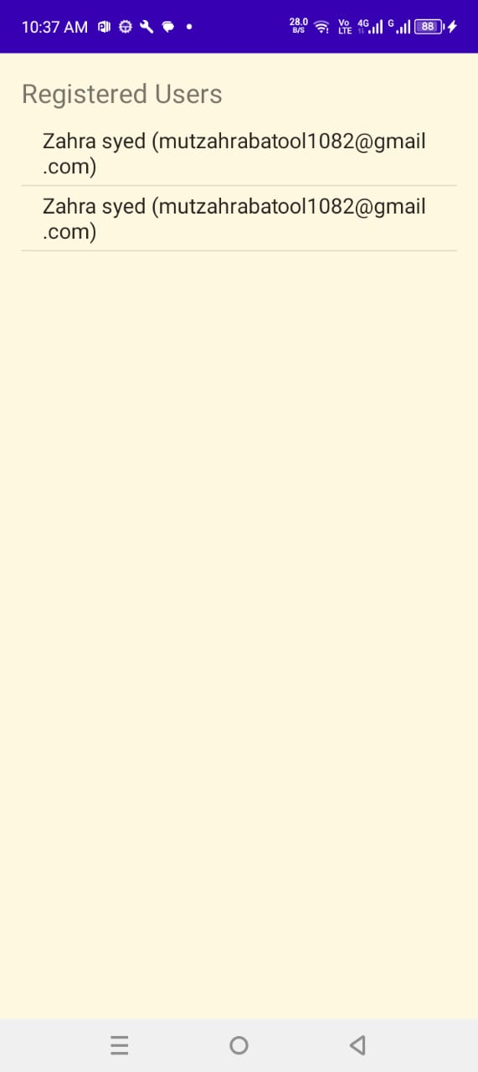
8. quiz screen
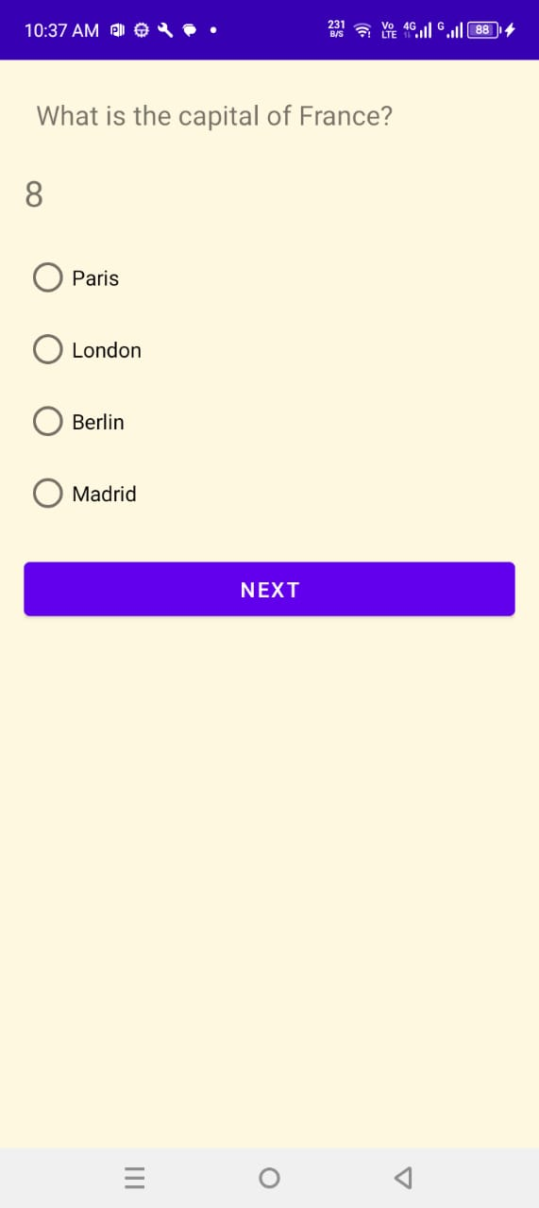
9. Splash Screen
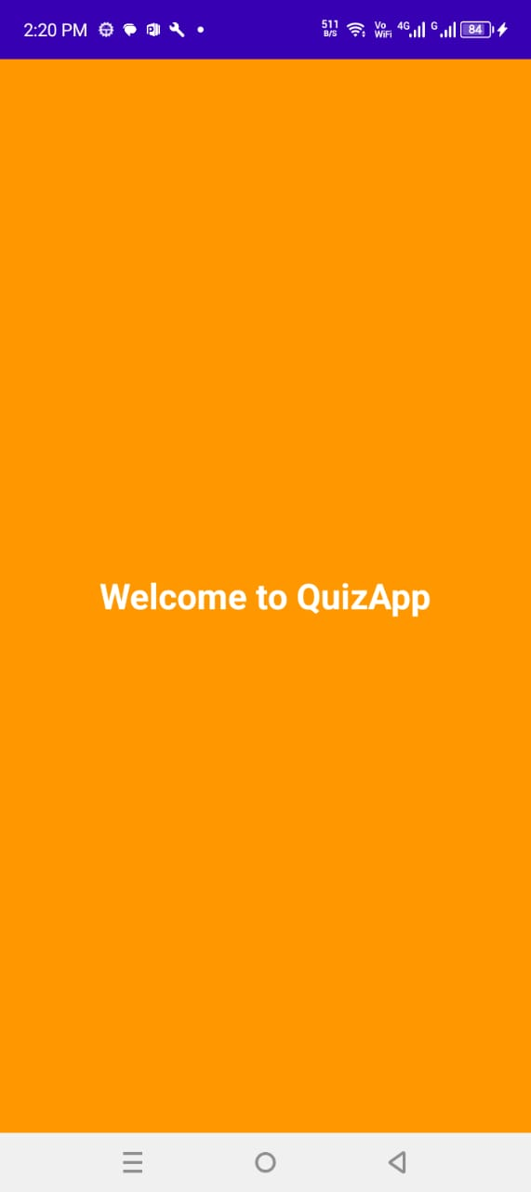

Link of my github repository
https://github.com/Syeda-Mutahra-Batool/quizzApp

