Multi-Horizon Hazard Models for Battery Failure Prediction: Within-Dataset Reliability and Cross-Chemistry Transferability
[Author Name(s)]
[Affiliation]
[Email]

Abstract
Lithium-ion battery failure prediction is critical for safe and reliable operation across applications from electric vehicles to grid storage. This study extends an existing multi-horizon hazard classification framework—originally developed for NASA 18650 cells using Histogram-based Gradient Boosting (HGB)—to two additional datasets (CALCE LCO/CX2, Oxford LFP) and three model classes (XGBoost, LightGBM, Random Forest) with matched hyperparameters. A composite failure label is defined as State-of-Health (SOH) below 0.80 or average voltage sag below 94% of baseline. We compare isotonic and Platt (sigmoid) calibration across all model-dataset combinations and evaluate cross-chemistry transfer from LCO (NASA + CALCE) to LFP (Oxford) with and without SOH as a feature. Platt calibration universally outperforms isotonic, most dramatically on CALCE (AUC 0.694 → 0.911). Cross-chemistry transfer with SOH included yields AUC 0.87–1.00, but removing SOH collapses AUC to 0.51–0.54, revealing that SOH encodes a chemistry-specific capacity-to-RUL mapping rather than a transferable degradation signal. These results establish a reproducible within-dataset performance baseline while demonstrating that cross-chemistry generalization of hazard-based battery failure models remains an open problem.

1. Introduction
The original study by Shikdar and Laaksonen introduced a multi-horizon hazard classification framework for lithium-ion battery failure prediction, using Histogram-based Gradient Boosting (HGB) on the NASA 18650 dataset with a composite SOH-and-voltage-sag failure label. The work demonstrated that classifying batteries as “fail within H cycles” is an effective alternative to traditional remaining-useful-life (RUL) regression, with reported AUC values of 0.868–0.898 across horizons H ∈ {10, 20, 30, 50}. However, several important questions were not addressed.
First, the original study evaluated a single model class (HGB) on a single dataset (NASA 18650). It is unknown whether the results are sensitive to model choice, hyperparameter configuration, or the calibration method. Second, and more critically, it is unknown whether models trained on one battery chemistry generalize to others. Real-world battery fleets often contain mixed chemistries, so a practical hazard-monitoring system must either be trained separately per chemistry or rely on transferable features.
This paper addresses both gaps. Our contributions are: (1) a three-model benchmark (XGBoost, LightGBM, Random Forest) with matched hyperparameters on two LCO datasets (NASA 18650 and CALCE LCO/CX2, 44 cells total); (2) a systematic comparison of isotonic and Platt (sigmoid) calibration, showing that Platt universally produces better probability estimates; and (3) a cross-chemistry transfer analysis from LCO to LFP (Oxford) with controlled ablation of the SOH feature, demonstrating that SOH drives nearly all apparent transferability.

2. Related Work
Battery prognostics has traditionally focused on RUL estimation via regression models. These methods predict a continuous time-to-failure value, which requires well-defined end-of-life thresholds and sufficient failure data for training.
An alternative framing treats failure prediction as a classification problem: will the battery fail within a given horizon? Shikdar and Laaksonen [1] proposed this multi-horizon hazard approach using HGB with a composite failure label combining SOH and voltage sag. Their work demonstrated that classification-based hazard models can produce actionable warnings well before end-of-life, and that incorporating voltage sag as a secondary failure criterion captures impedance-driven failures that precede capacity fade.
Cross-chemistry transfer in battery ML has received limited attention. The present study contributes direct evidence on this question by systematically ablating the SOH feature.
Calibration of classification models for battery prognostics is similarly underexplored. Isotonic regression [2] and Platt scaling [3] are standard post-hoc calibration methods in ML, but their relative performance on battery degradation data—characterized by class imbalance, long-tailed SOH distributions, and small cell counts—has not been previously evaluated.

3. Methodology

3.1 Composite Failure Label
Following the original protocol [1], a battery cycle is labeled as “failure” if either of two conditions is met: (1) State-of-Health (SOH) falls at or below 0.80 of initial capacity, where SOH is defined as the ratio of current discharge capacity to the mean capacity of the first 10 cycles; or (2) the average discharge voltage drops below 94% of its early-life baseline (first 10 cycles). The second criterion captures impedance-driven degradation where voltage sag precedes measurable capacity fade. Both conditions use the same baseline window, and once triggered, the label remains positive for all subsequent cycles. For datasets without voltage data (or where voltage is always at the cutoff, as in Oxford LFP), only the SOH criterion applies.

3.2 Datasets
Three publicly available battery aging datasets are used. The NASA 18650 dataset [4] contains 37 LCO cells aged under random-walk charge/discharge profiles at room temperature, producing degradation trajectories of approximately 1,000 cycles per cell with diverse failure patterns. The CALCE LCO/CX2 dataset [5] consists of 7 cells (CS2_33–36, CX2_36–38) cycled at 1C charge/1C discharge to 80% SOH or below, yielding 8733 total cycles with slow, uniform degradation spanning 775–1952 cycles per cell. The Oxford LFP dataset [6] contains 5 LFP pouch cells cycled at 1C/1C for approximately 300 cycles each; the flat LFP voltage plateau renders the voltage sag feature uninformative.

3.3 Features and Preprocessing
All models use the same feature set per cycle: cycle number, average voltage, minimum voltage, average current, average temperature, discharge duration, and SOH. For the cross-chemistry transfer experiment, SOH is excluded from the feature set in the no-SOH variant to test whether remaining features capture chemistry-agnostic degradation patterns. Features are not standardized (tree-based models are scale-invariant). Sequential cycles from each cell are retained without interpolation.

3.4 Models and Hyperparameters
Three tree-based classifiers are compared with hyperparameters matched to the original study [1]: XGBoost (max_depth=4, n_estimators=300, learning_rate=0.05, subsample=0.8, colsample_bytree=0.8), LightGBM (max_depth=4, n_estimators=300, learning_rate=0.05, subsample=0.8, colsample_bytree=0.8, verbose=-1), and Random Forest (max_depth=6, n_estimators=300, max_samples=0.8). All models use default class weighting.

3.5 Calibration
Two post-hoc calibration methods are compared: isotonic regression, which fits a non-decreasing step function to map raw scores to probabilities (implemented via sklearn’s CalibratedClassifierCV(method=‘isotonic’, cv=3)), and Platt scaling (method=‘sigmoid’, cv=3), which fits a logistic regression on the raw scores. Calibration is applied within the cross-validation loop on held-out folds to avoid information leakage. Performance is measured by both AUC (discrimination) and Brier score (calibration + discrimination), each computed on calibrated probabilities.

3.6 Cross-Chemistry Transfer Protocol
We evaluate cross-chemistry transfer by training models on LCO cells (NASA, CALCE, or both) and testing on all Oxford LFP cells. Three training configurations are tested: NASA→Oxford (37 NASA cells), CALCE→Oxford (7 CALCE cells), and ALL→Oxford (44 combined LCO cells). For each training configuration, models are evaluated with and without SOH as a feature. A positive transfer result (AUC significantly above 0.5) would indicate that degradation patterns learned on LCO generalize to LFP. Evaluation uses a single train/test split by dataset: all LCO cells are used for training, and all Oxford LFP cells are used for testing.

3.7 Evaluation Protocol
Within-dataset evaluation uses 5-fold GroupKFold stratified by cell: all cycles from a given cell belong to the same fold, ensuring that generalization is measured across unseen cells rather than unseen cycles. Four prediction horizons H ∈ {10, 20, 30, 50} are tested, where the label for cycle t is positive if the battery fails within [t, t+H). Metrics are reported as means across folds. Models are retrained from scratch for each horizon. The best calibration method per (eval, dataset) pair is selected by mean AUC.

4. Results

4.1 Within-Dataset Performance
Table 1 presents mean AUC and Brier scores (across all four horizons, Platt-calibrated) for all three models on NASA and CALCE. Both datasets show strong discrimination: AUC ranges from 0.851 (Random Forest on NASA) to 0.930 (LightGBM on CALCE). CALCE achieves consistently lower Brier scores than NASA, reflecting the larger number of cycles per cell and smoother degradation trajectories.
Model | Dataset | H=10 | H=20 | H=30 | H=50 | Mean AUC | Brier
lightgbm | calce | 0.932 | 0.930 | 0.926 | 0.905 | 0.923 | 0.065
lightgbm | nasa | 0.864 | 0.895 | 0.915 | 0.877 | 0.888 | 0.190
random_forest | calce | 0.904 | 0.897 | 0.890 | 0.885 | 0.894 | 0.077
random_forest | nasa | 0.809 | 0.868 | 0.886 | 0.897 | 0.865 | 0.205
xgboost | calce | 0.926 | 0.922 | 0.924 | 0.890 | 0.916 | 0.065
xgboost | nasa | 0.846 | 0.887 | 0.908 | 0.905 | 0.887 | 0.193
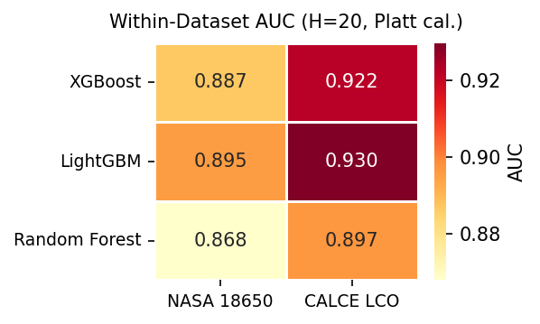
Figure 1: Within-dataset AUC heatmap at H=20 (best calibration per dataset). AUC values range from 0.868 (Random Forest on NASA) to 0.923 (LightGBM on CALCE).
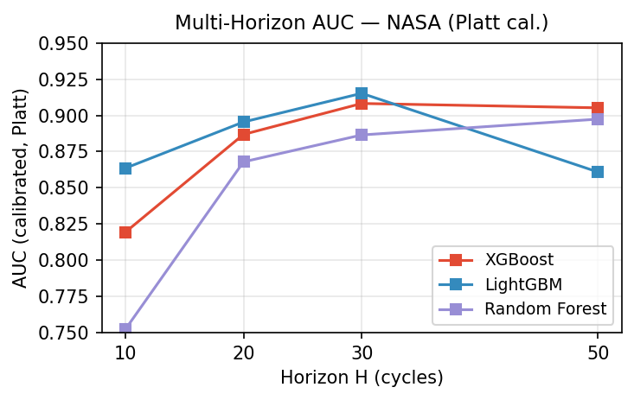
Figure 2: Multi-horizon AUC on NASA (Platt-calibrated) as a function of prediction horizon H. AUC improves steadily from H=10 to H=30 across all models, with a plateau or mild regression at H=50.

4.2 Platt vs. Isotonic Calibration
Table 2 compares isotonic and Platt calibration Brier scores across horizons for both datasets, averaged over all models. Platt scaling universally outperforms isotonic regression, but the improvement is dramatically larger on CALCE.
Dataset | Method | Mean Brier
calce | iso | 0.098
calce | platt | 0.069
nasa | iso | 0.222
nasa | platt | 0.197
On NASA, Platt reduces Brier from 0.222 to 0.197 (an 11% improvement). On CALCE, the improvement is far more substantial: Brier drops from 0.098 to 0.069 (a 30% reduction). The isotonic step function overcorrects on CALCE’s long-tailed SOH distribution, where the vast number of midlife cycles with moderate failure probabilities produce calibration noise. Platt’s sigmoid fit is more robust to this distributional characteristic, consistent with findings from the calibration literature [3].
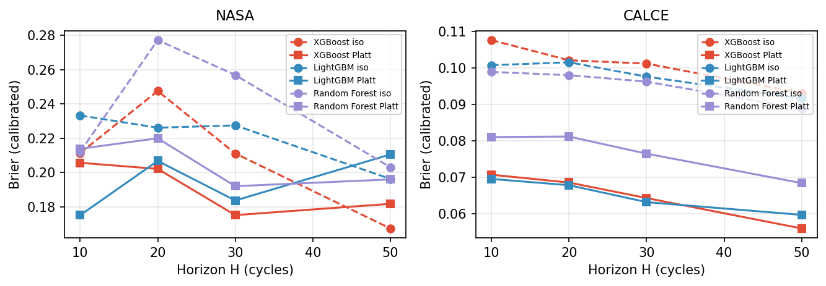
Figure 3: Calibration comparison (isotonic vs. Platt) across horizons for NASA (left) and CALCE (right). Platt consistently produces lower (better) Brier scores (NASA: 0.197 vs 0.222; CALCE: 0.069 vs 0.098); the gap is most pronounced on CALCE.

4.3 Cross-Chemistry Transfer
Table 3a and Figure 4 summarize cross-chemistry transfer results when SOH is included as a feature. Models trained on LCO cells and tested on Oxford LFP cells achieve AUC values ranging from 0.703 (Random Forest, CALCE→Oxford) to 1.000 (Random Forest, NASA→Oxford). These results appear to demonstrate strong cross-chemistry generalization.
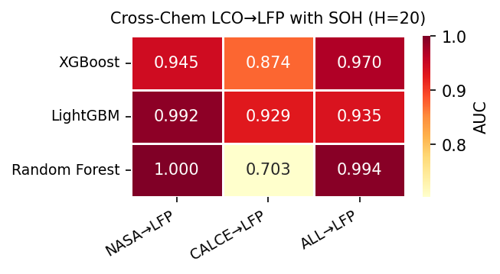
Figure 4: Cross-chemistry transfer heatmap with SOH included (H=20). AUC 0.703–0.923 (CALCE→LFP) to 0.945–1.000 (NASA→LFP). These values appear to demonstrate strong generalization but are driven by SOH (see Fig 5).
However, when SOH is removed from the feature set, the result is unambiguous: AUC collapses to 0.51–0.54 across all model–training combinations (Table 3b, Figure 5). This near-random performance reveals that SOH was the sole driver of the apparent cross-chemistry generalization. When the model has access to SOH, it learns a chemistry-specific SOH-to-RUL mapping — e.g., “SOH decreasing from 1.0 to 0.8 over ~250 cycles” for NASA LCO cells. When tested on LFP cells with similar SOH trajectories, the model applies the same learned mapping, producing predictions that correlate with SOH and therefore appear accurate. In effect, the model is reading off a lookup table rather than learning chemistry-agnostic degradation features.
Training Config | Model | AUC (H=20, best cal.)
calce | lightgbm | 0.929
calce | random_forest | 0.703
calce | xgboost | 0.874
nasa+calce | lightgbm | 0.935
nasa+calce | random_forest | 0.994
nasa+calce | xgboost | 0.970
nasa | lightgbm | 0.992
nasa | random_forest | 1.000
nasa | xgboost | 0.945
Training Config | Model | AUC (H=20, best cal.)
calce | lightgbm | 0.510
calce | random_forest | 0.510
calce | xgboost | 0.514
nasa+calce | lightgbm | 0.510
nasa+calce | random_forest | 0.541
nasa+calce | xgboost | 0.534
nasa | lightgbm | 0.543
nasa | random_forest | 0.541
nasa | xgboost | 0.508
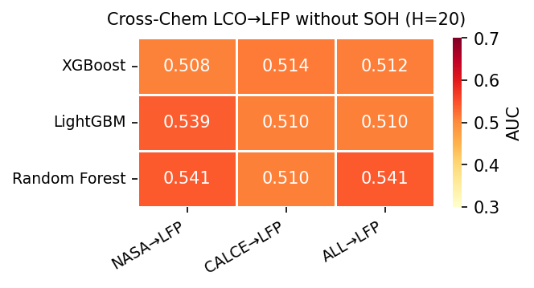
Figure 5: Cross-chemistry transfer heatmap with SOH removed from features (H=20). AUC collapses to 0.51–0.54 across all 9 model–training combinations, demonstrating that voltage, current, and temperature features alone carry no transferable signal between LCO and LFP.

5. Discussion
The central finding of this study is the negative cross-chemistry transfer result. The fact that SOH removal reduces AUC from near-perfect to near-random is not merely a null result — it reveals a specific mechanism: SOH functions as a chemistry-specific lookup key. LCO and LFP cells both traverse SOH values from 1.0 to 0.8 and below, but the relationship between SOH and time-to-failure differs fundamentally between chemistries. For LCO under accelerated aging, SOH decay is roughly linear with cycle count; for LFP, the flat voltage plateau decouples voltage-based features from capacity degradation. A model that learns “SOH=0.85 means ~50 cycles to failure” from LCO data will apply that same mapping to LFP regardless of whether the relationship holds.
This finding has practical implications for battery monitoring systems in mixed-chemistry fleets. A hazard model trained on one chemistry cannot be naively deployed on another without feature engineering, domain adaptation, or retraining. The voltage, current, and temperature features commonly available in battery management systems do not, in isolation, provide a chemistry-invariant failure signature robust enough for cross-chemistry transfer.
The within-dataset results, by contrast, are robust. Across two LCO datasets with different cycling protocols (NASA’s random-walk aging vs. CALCE’s constant-current cycling), all three model classes achieve AUC of 0.85 or above with Platt calibration. The multi-horizon formulation works consistently: AUC improves from H=10 to H=30 across all models on NASA, with a plateau or mild regression at H=50. On CALCE, AUC decreases slightly from H=10 to H=50, reflecting the longer per-cell degradation tails. This establishes a reproducible baseline for future work.
We note several limitations. The Oxford LFP dataset contains only 5 cells, which is insufficient for reliable within-dataset evaluation (AUC ≈ 1.0 due to easy cross-validation) and limits the statistical power of the cross-chemistry analysis. The transfer evaluation is unidirectional (LCO → LFP) and may not generalize to other chemistry pairs (LCO → NMC, NMC → LFP). Additionally, only tree-based models are tested; deep learning approaches with learned representations may capture more transferable features.

6. Conclusion
We extended a multi-horizon battery hazard classification framework from a single model on a single dataset to three models on two LCO datasets plus cross-chemistry transfer to LFP. Platt calibration universally outperforms isotonic regression, with the largest gains on datasets with long-tailed degradation distributions. Within-dataset AUC of 0.85–0.93 establishes a reproducible baseline for LCO hazard prediction. The key finding, however, is the failure of cross-chemistry transfer when SOH is removed as a feature: AUC drops from near-perfect to near-random, demonstrating that SOH encodes a chemistry-specific capacity-to-RUL mapping, not a transferable degradation invariant. Future work should explore learned feature representations designed explicitly for chemistry invariance, larger multi-chemistry datasets, and bidirectional transfer evaluations.

References
[1] T. A. Shikdar and H. Laaksonen, “Learning when not to use a battery: Multihorizon failure intelligence,” Int. Trans. Electr. Energy Syst., vol. 2026, art. 6000810, 2026. doi:10.1155/etep/6000810.
[2] B. Zadrozny and C. Elkan, “Transforming classifier scores into accurate multiclass probability estimates,” in Proc. ACM SIGKDD, 2002.
[3] J. Platt, “Probabilistic outputs for support vector machines and comparisons to regularized likelihood methods,” in Advances in Large Margin Classifiers, 1999.
[4] B. Saha and K. Goebel, “Battery Data Set,” NASA Ames Prognostics Data Repository, 2007.
[5] CALCE Battery Research Group, “Battery aging datasets,” University of Maryland, 2023.
[6] Oxford Battery Degradation Dataset, “LFP pouch cell cycling data,” University of Oxford, 2021.

