**Name: Syeda Alaina**

**Id: BIT-23F-040**

**Semester: 03**

**Section: A**

**Course: AI**

**Lab: 08**

**Lab 08:**

**Task 01:**

Write a Python class named Car that represents a car. The class should have the following attributes:

* make: the car's make (e.g., "Toyota")
* model: the car's model (e.g., "Corolla")
* year: the car's manufacturing year (e.g., 2020)
* mileage: the number of miles driven by the car

**Code:**

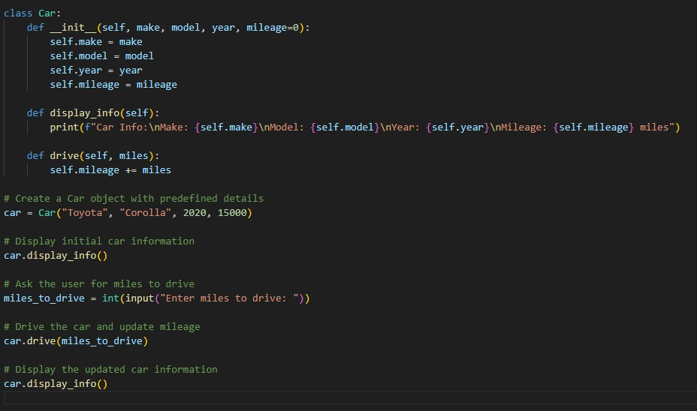

**Output:**

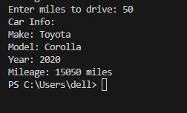

**Task 02:**

write a Python class named Student that represents a student. The class should have the following attributes:

* name: the student's name.
* age: the student's age.
* marks: a list of the student's marks.

**Code:**

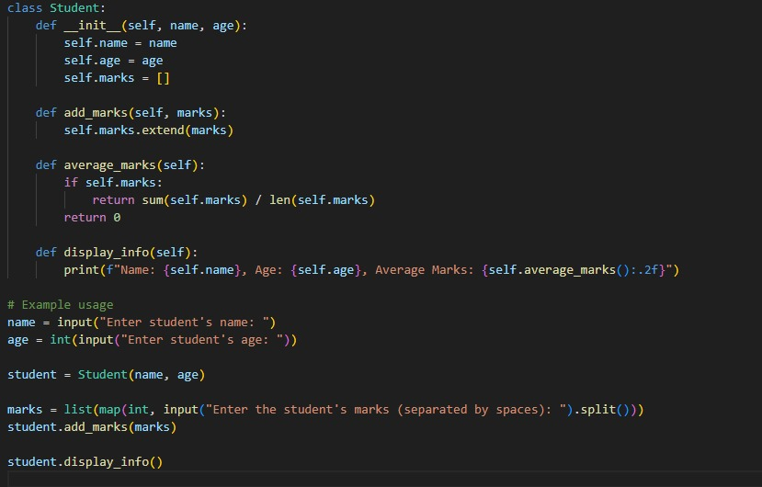

**Output:**

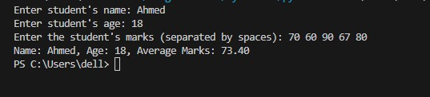

**Task 3:**

Write a Python class named Bank Account that represents a bank account. The class should have the following attributes:

* account_holder: the name of the account holder.
* balance: the balance of the account.

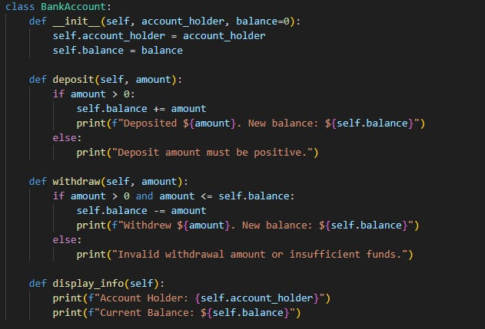**Code:**

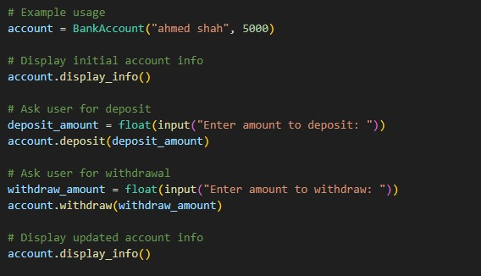

**Output:**

