## Project Report:

## Library Management System

## Made By: Syeda Anoosha Iqtidar

## Roll Number: 21SW004

## Submitted to: Sir Sajjad

## What is Library Management System?

As the name suggest the Library Management System is a software which handles the entire data of library. It makes the work of librarian very easy instead of writing data in a notebook. In past the librarians were using notebooks to write the data of books along with students name who borrowed that book. So it was very difficult to keep track on each and every book.

**Features of Library Management System Project in C++**

* I have created separate logins for students and the librarian, in which the librarian is password protected.
* In this project, the librarian can add books and can issue the books to the students.
* The students can also view the list of the books available in the entire library database.
* The students can also search book by name or by book ID.
* The students can request to issue a book from a librarian.
* This project uses file handling to store the data of books such as booklist, requested books and issued books in a project.

Working Of Project:

a) Main screen

When you run the project from any compiler or directly clicking on the executable .exe file you’ll see the following screen shown in the picture.

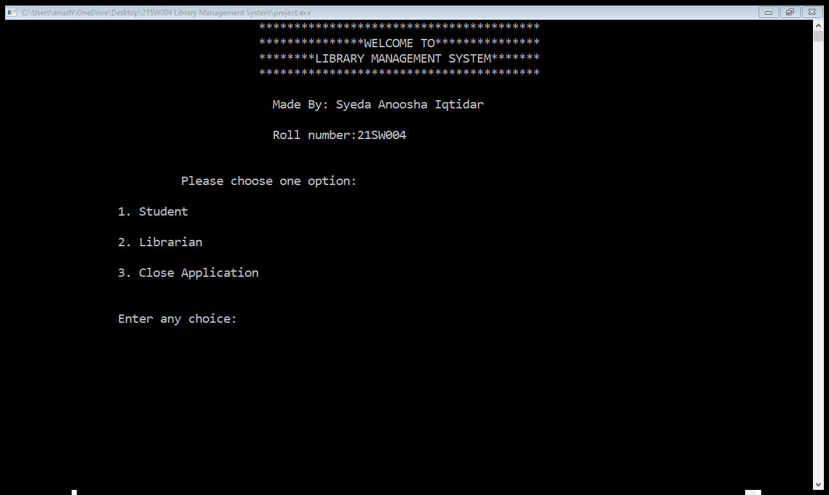

I have displayed the menu of Student, Librarian and close the application. If you’re a student then your choice will be 1 and if you are a librarian then your choice will be 2 and for closing application choose 3.

Student options:

Students will not require additional sign in, they will be able to access the software directly. When the student enter the choice as 1 then following screen will be appeared:

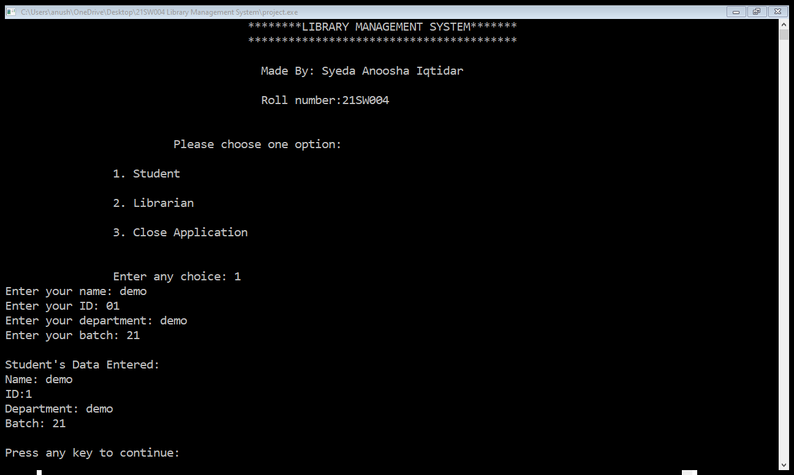

They are first asked to enter their necessary information which is then showed to them as well. Then after pressing any key following window appears on the console:

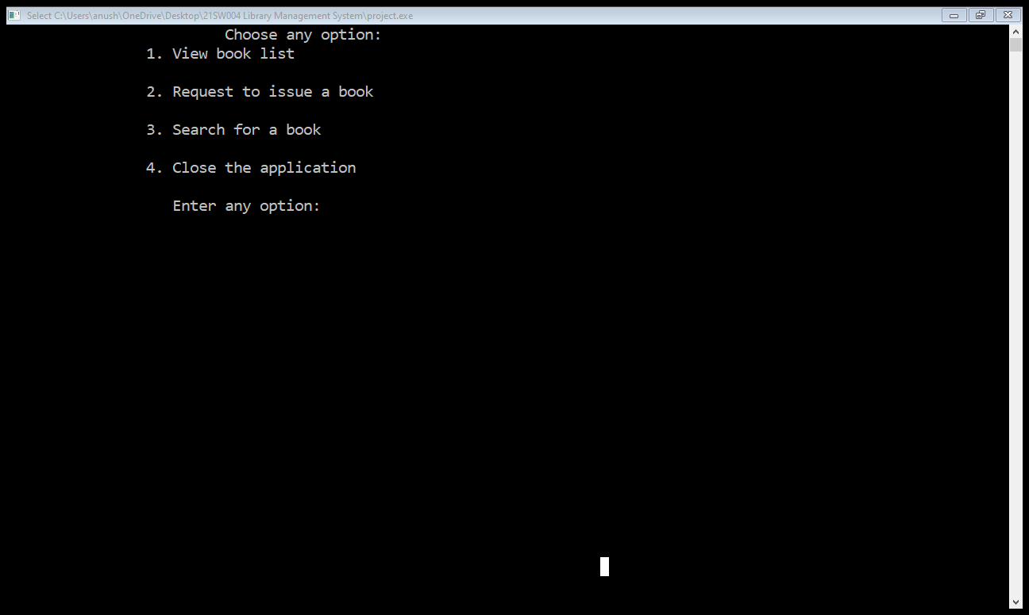

This screen includes options among viewing booklist, searching book, request to issue a book and closing the application.

a) Booklist:

In this menu option all the students will be able to view the books present in the database along with their details.

b) Request to issue book:

Here the student is just asked to enter book’s ID to initiate the process

c) **Search for a Book:**

We have given access to the students to search for a particular book. The student can search book either by book name or by book id. Both the options are available in the project.

d) **Close Application:**

By pressing the choice as 4 the application will be closed.

Librarian options

Librarian will be required to sign in to access the software. When the librarian enter the choice as 2 then following screen will be appeared:

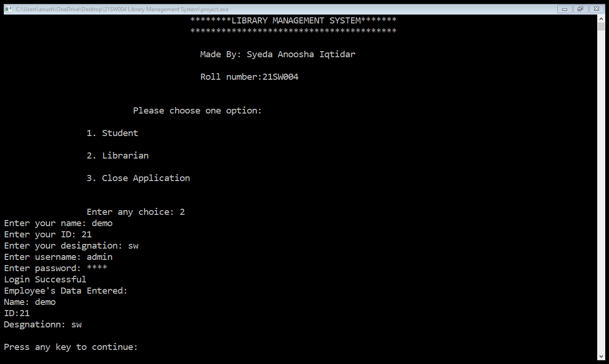

The librarian also needs to enter his personal data to login. If the password is incorrect the application will show the error of wrong password. And if the password is correct then the librarian menu will be visible to the user where he or she can do the operations displayed in the menu.

The following menu will be visible to the Librarian:

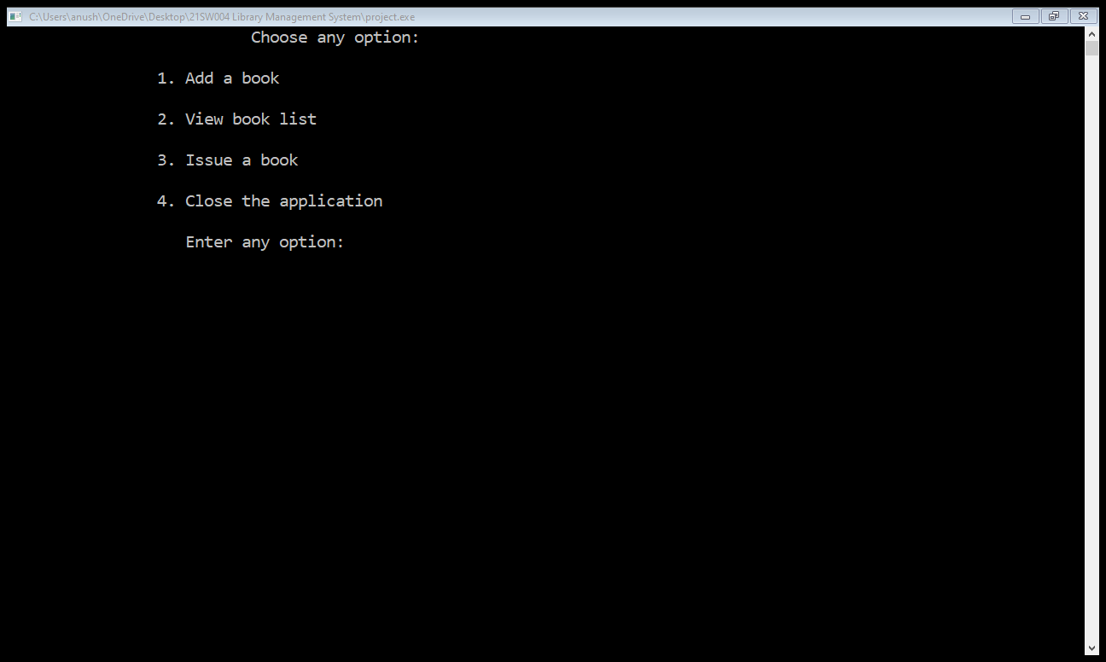

1. View Booklist:

Same as students view booklist, librarians will also able to see the books available in the library database.

2. Add Book:

In this menu option Librarian can adding a book. As we are using the file handling methods in this project, every time new file is generated to store the details of the books. i.e. Book4.csv.

3. Issue a Book:

By using this option a librarian can issue a book to a student by using the data from file RequestBook.csv. The data of issued books are then stored in a new file as IssuedBooks.csv