Block Ciphers (Already partially covered)
- Operation: Encrypts fixed-size blocks (e.g., 128-bit for AES)
- Modes of Operation:
  - ECB (Electronic Codebook): Each block encrypted independently
    - Problem: Identical plaintext blocks → identical ciphertext blocks
    - Example: Image encryption shows patterns
  - CBC (Cipher Block Chaining): Each block XORed with previous ciphertext
    - Uses IV (Initialization Vector) for first block
    - Advantage: Patterns hidden
  - CTR (Counter): Encrypts counter values, XORs with plaintext
    - Advantages: Parallelizable, random access
  - CFB, OFB: Other feedback modes

Stream Ciphers
- Operation: Encrypts individual bits/bytes, one at a time
- How it works:
text
Plaintext: 01011001
Key stream: 10011100 (generated by PRNG)
Ciphertext: 11000101 (XOR result)
- Characteristics:
  - No block size constraints
  - Faster for real-time communication
  - Less error propagation
- Key generation: Uses PRNG (Pseudo-Random Number Generator) with seed
- Synchronization: Must maintain sync between sender/receiver

Comparison Table
Aspect | Block Cipher | Stream Cipher
Unit of encryption | Fixed blocks | Individual bits/bytes
Speed | Slower (block operations) | Faster (bit operations)
Error propagation | High in CBC mode | Limited
Memory requirement | Higher | Lower
Parallelization | Possible in some modes | Limited
Common examples | AES, DES, 3DES | RC4, ChaCha20, Salsa20

Part 3: Message Authentication Codes (MACs) & HMAC (Chapter 2.2)

Detailed Explanation

What is a MAC?
- Purpose: Verify both integrity and authenticity of a message
- Unlike hash: MAC uses a secret key
- Formula: MAC = F(message, secret_key)

Types of MACs:
- CBC-MAC: Uses block cipher in CBC mode
  - Encrypt message with CBC, take last block as MAC
- HMAC (Hash-based MAC): Most common
  - Uses cryptographic hash function (SHA-256, etc.)
  - Formula: HMAC(K, m) = H((K ⊕ opad) || H((K ⊕ ipad) || m))
  - ipad = inner padding (0x36 repeated)
  - opad = outer padding (0x5C repeated)

HMAC Algorithm Steps:
text
1. If key longer than block size: hash it
2. Pad key with zeros to block size
3. Compute inner hash: H((K ⊕ ipad) || message)
4. Compute outer hash: H((K ⊕ opad) || inner_hash)
5. Result is the MAC

Security Properties:
- Message integrity: Any change to message changes MAC
- Message authenticity: Only key holders can generate valid MAC
- Non-repudiation: NOT provided (both parties have same key)

MAC vs Digital Signature:
Aspect | MAC | Digital Signature
Key type | Symmetric | Asymmetric
Non-repudiation | No | Yes
Performance | Faster | Slower
Key distribution | Problematic | Easier (public keys)
Common use | Internal systems, SSL/TLS | Documents, certificates

Common Attacks on MACs:
- Length extension attack (on simple hash MACs)
  - Solution: HMAC structure prevents this
- Key recovery attacks
- Birthday attacks (theoretical)

Public-Key Cryptography Algorithms (Chapter 2.3)

Detailed Explanation

RSA (Rivest-Shamir-Adleman)
- Based on: Difficulty of factoring large numbers
- Key generation:
  - Choose two large primes p and q
  - Compute n = p × q
  - Compute φ(n) = (p-1)(q-1)
  - Choose e such that 1 < e < φ(n) and gcd(e, φ(n)) = 1
  - Compute d such that d × e ≡ 1 mod φ(n)
  - Public key: (e, n)
  - Private key: (d, n)
- Encryption: c = m^e mod n
- Decryption: m = c^d mod n
- Key sizes: Typically 2048 or 4096 bits
- Use cases: SSL/TLS, digital signatures, key exchange

Diffie-Hellman Key Exchange
- Purpose: Secure key exchange over insecure channel
- Based on: Discrete logarithm problem
- Algorithm:
  - Public parameters: large prime p, generator g
  - Alice: chooses a, sends A = g^a mod p
  - Bob: chooses b, sends B = g^b mod p
  - Alice computes: K = B^a mod p = g^(ab) mod p
  - Bob computes: K = A^b mod p = g^(ab) mod p
- Result: Shared secret K without transmitting it
- Vulnerability: Man-in-the-middle attack (no authentication)

Elliptic Curve Cryptography (ECC)
- Based on: Elliptic curve discrete logarithm problem
- Equation: y² = x³ + ax + b over finite field
- Key advantage: Smaller keys for same security
  - 256-bit ECC ≈ 3072-bit RSA in security
- Operations:
  - Point addition
  - Point doubling
  - Scalar multiplication (base for encryption)
- ECDH: Elliptic Curve Diffie-Hellman
- ECDSA: Elliptic Curve Digital Signature Algorithm

Comparison of Algorithms
Algorithm | Based on | Key Size | Speed | Use Cases
RSA | Factorization | 2048-4096 bits | Slow | Encryption, signatures
DH | Discrete log | 2048-4096 bits | Medium | Key exchange
ECC | Elliptic curve | 256-521 bits | Fast | Mobile, IoT, signatures

Security Considerations:
- RSA: Vulnerable to quantum computing (Shor's algorithm)
- DH: Requires large parameters for security
- ECC: Patent issues historically, now widely adopted
- Key sizes must increase over time as computing power grows

Biometric Accuracy Metrics (Chapter 3.4)

Detailed Explanation

Key Terminology:
- Genuine user: Authorized person
- Impostor: Unauthorized person
- Template: Stored biometric reference
- Live sample: Current biometric reading
- Threshold: Similarity score cutoff for acceptance

Error Types:
- False Acceptance (Type I error)
  - Impostor accepted as genuine
  - FAR = (False Accepts) / (Impostor Attempts)
- False Rejection (Type II error)
  - Genuine user rejected
  - FRR = (False Rejects) / (Genuine Attempts)
- Failure to Enroll (FTE)
  - Cannot create usable template (poor quality)
- Failure to Acquire (FTA)
  - Cannot capture biometric sample

Performance Metrics:
- Equal Error Rate (EER)
  - Point where FAR = FRR
  - Lower EER = better system
  - Typical values: 0.1% (fingerprint) to 5% (face recognition)
- Receiver Operating Characteristic (ROC) Curve
  - Plots FAR vs. FRR at different thresholds
  - Area Under Curve (AUC): Larger = better
- Detection Error Tradeoff (DET) Curve
  - Similar to ROC but with logarithmic scale
  - Shows tradeoff between errors

Calculations Example:
text
Test with 1000 genuine attempts, 1000 impostor attempts:
- 20 genuine users rejected
- 5 impostors accepted

FRR = 20/1000 = 2%
FAR = 5/1000 = 0.5%

Threshold Selection:
- High security (bank): Low threshold → Low FAR, High FRR
- Convenience (phone): High threshold → High FAR, Low FRR
- Balanced: Choose threshold at EER point

Factors Affecting Accuracy:
- Biometric modality: Fingerprint vs. iris vs. face
- Quality of sensor
- Environment: Lighting, noise
- User factors: Age, health, occupation
- Template aging: Biometrics change over time

Multimodal Biometrics:
- Combine multiple biometrics
- Fusion levels:
  - Sensor level: Combine raw data
  - Feature level: Combine extracted features
  - Score level: Combine matching scores
  - Decision level: Combine decisions
- Advantages: Lower error rates, harder to spoof

RBAC vs Traditional Models:
Aspect | DAC | MAC | RBAC
Control | User owns objects | System enforces policy | Roles define access
Flexibility | High | Low | Medium
Administration | Distributed | Centralized | Centralized
Example | Unix file permissions | Military systems | Enterprise applications

Viruses vs Worms:
Characteristic | Virus | Worm
Requires host | Yes | No
Self-replicating | Yes | Yes
Spreads via | User action | Network automatically
Primary goal | Infect files | Spread rapidly
Example | ILOVEYOU | Morris Worm

Virus Types:
- Boot Sector Virus
  - Infects MBR (Master Boot Record)
  - Loads before OS
  - Example: Stoned, Michelangelo
- File Infector Virus
  - Attaches to executable files (.exe, .com)
  - Types:
    - Overwriting: Destroys host code
    - Appending: Adds to end of file
    - Cavity: Hides in empty spaces
    - Companion: Creates infected file with similar name
- Macro Virus
  - Infects documents with macros
  - Example: Melissa (Word/Excel)
- Script Virus
  - Written in scripting languages (VBS, JavaScript)
  - Example: ILOVEYOU (VBScript)
- Polymorphic Virus
  - Changes code each infection
  - Encryption with variable key
  - Harder to detect by signature
- Metamorphic Virus
  - Rewrites itself completely
  - Changes code structure
  - Even harder to detect

Virus Components:
- Infection mechanism: How it spreads
- Trigger: Condition to activate
- Payload: Malicious action

Worm Propagation Methods:
- Email worms: Send themselves via email
- File sharing worms: P2P networks
- Internet worms: Scan for vulnerabilities
- Instant messaging worms
- Mobile worms: Bluetooth, MMS

Worm Architecture:
- Target Discovery
  - Random scanning
  - Hit-list scanning (pre-compiled targets)
  - Topological scanning (use local information)
  - Permutation scanning (shared permutation)
- Infection
  - Transfer copy
  - Activate
- Communication
  - With attacker (C&C)
  - With other worms

Famous Worms:
- Morris Worm (1988)
  - First major worm
  - Exploited buffer overflow in fingerd
  - Caused significant slowdown
- Code Red (2001)
  - IIS web server vulnerability
  - Defaced websites
  - DDoS attacks
- SQL Slammer (2003)
  - MS SQL Server vulnerability
  - Extremely fast spread (10 minutes worldwide)
- Conficker (2008)
  - Windows vulnerability
  - Complex update mechanism
  - Still active in some networks

Worm Defense:
- Patch management
- Network segmentation
- Intrusion detection
- Rate limiting
- Honeypots (to study worms)

Advanced Techniques:
- Zero-day worms: Use unknown vulnerabilities
- Fast worms: Optimized scanning (Warhol, Flash worms)
- Stealth worms: Slow spread to avoid detection
- Polymorphic worms: Change code to evade IDS

What is a Botnet?
- Bot: Compromised machine (zombie)
- Botnet: Network of bots controlled by attacker (bot herder)
- Botmaster/Herder: Person controlling the botnet
- C&C: Command and Control server

Botnet Architecture Types:
- Centralized (Star)
  - All bots connect to central C&C
  - Protocols: IRC, HTTP
  - Advantage: Simple to manage
  - Disadvantage: Single point of failure
- Decentralized (P2P)
  - Bots communicate with each other
  - Protocols: Custom P2P protocols
  - Advantage: Resilient to takedown
  - Disadvantage: Complex to manage
- Hybrid
  - Combination of both
  - Supernodes act as mini-C&Cs

C&C Communication Methods:
- IRC-based
  - Early method
  - Bot joins channel, awaits commands
  - Easy to detect
- HTTP-based
  - Bots poll web server for commands
  - Blends with normal traffic
  - Use of encryption, obfuscation
- DNS-based
  - Use DNS queries for commands
  - TXT records or subdomain names
  - Hard to block (DNS needed for everything)
- Social Media-based
  - Use Twitter, Facebook for commands
  - Steganography in images
- Cloud-based
  - Use cloud services (Dropbox, Google Docs)
  - Legitimate services hard to block

Botnet Lifecycle:
- Exploitation
  - Infect via vulnerability, phishing, drive-by download
- Injection
  - Install bot software
  - Persistence mechanisms
- Connection
  - Contact C&C
  - Receive further instructions
- Malicious Activity
  - Execute attacks
- Update/Maintenance
  - Update bot software
  - Change C&C if discovered

Botnet Uses:
- DDoS Attacks
  - Flood target with traffic
  - Types: SYN flood, HTTP flood, DNS amplification
- Spamming
  - Send bulk email
  - Evade spam filters (distributed sending)
- Click Fraud
  - Fake clicks on ads
  - Generate revenue for attackers
- Data Theft
  - Steal credentials, financial data
  - Keylogging, form grabbing
- Cryptocurrency Mining
  - Use victim's CPU/GPU
  - Mine Monero, Bitcoin
- Ransomware Distribution
  - Spread ransomware
  - Pay-as-you-go ransomware services

Famous Botnets:
- Zeus (2007)
  - Banking Trojan
  - Form grabbing, keylogging
  - Sold as crimeware kit
- Conficker (2008)
  - Worm + botnet
  - Complex update mechanism
  - Estimated 10+ million bots
- Mirai (2016)
  - IoT botnet
  - DDoS attacks up to 1 Tbps
  - Default password attacks
- Emotet (2014-2021)
  - Modular malware
  - Initial access for other malware
  - Very sophisticated

Botnet Detection:
- Network-based
  - Unusual traffic patterns
  - C&C communication detection
  - DDoS traffic detection
- Host-based
  - Unknown processes
  - Unusual network connections
  - Resource usage
- Honeypots
  - Capture bot samples
  - Study behavior
  - Sinkhole C&C traffic

Botnet Takedown Methods:
- Sinkholing
  - Redirect C&C traffic to controlled server
  - Seize domain names
- Takedown of C&C servers
  - Law enforcement action
  - Hosting provider cooperation
- Peer-to-peer poisoning
  - For P2P botnets
  - Inject fake peers/nodes
- Software updates
  - Patch vulnerabilities used
  - Break bot functionality

IoT Botnets (Special Case):
- Target: IoT devices (cameras, routers)
- Why vulnerable: Default passwords, no updates
- Examples: Mirai, Hajime, BrickerBot
- Defense: Change defaults, segment IoT networks

Chapter 11: Software Security (Sections 11.1–11.3)

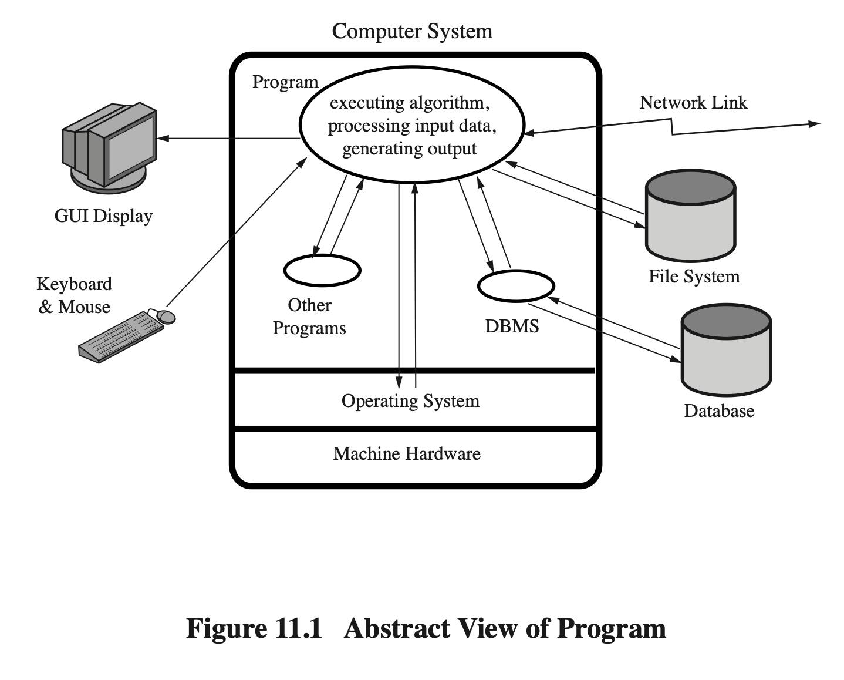

Software Security Overview
- Goal: Understand common software vulnerabilities and how to write secure code.
- CWE/SANS Top 25 Most Dangerous Software Errors (2011):
  - Listed in Table 11.1 (textbook p. 359).
  - Highlights critical flaws due to insufficient validation and error handling.

Security Flaws
- Occur due to poor checking/validation of data and errors.
- Awareness is the first step toward writing secure code.
- Critical Web App Flaws:
  - Unvalidated input
  - Cross-site scripting (XSS)
  - Buffer overflow
  - Injection flaws
  - Improper error handling

Reducing Software Vulnerabilities
- NISTIR 8151 recommends:
  - Prevent: Use better specification and building methods.
  - Detect: Use efficient testing.
  - Reduce impact: Build resilient architectures.

Software Security vs. Quality/Reliability
- Quality/Reliability: Deals with accidental failures from random inputs.
- Security: Attacker targets specific bugs to exploit.
- Security flaws often triggered by unexpected inputs, not caught by normal testing.

Defensive Programming
- Design software to function even under attack.
- Check all assumptions, handle errors gracefully.
- Requires mindset shift: understand failures and reduce their chances.
- Conflicts with business pressure to deliver quickly.

Security by Design
- Security and reliability are standard in engineering; software is catching up.
- SAFECode: Industry best practices for secure development.

Writing Safe Program Code
- Correct Algorithm Implementation: Ensure machine code matches source (rarely checked, except in high-assurance systems like EAL 7).
- Correct Data Interpretation: Strongly typed languages are safer.
- Correct Use of Memory:
  - Dynamic allocation risks: memory leaks.
  - Modern languages handle automatically; older ones use libraries.
- Race Conditions: Occur in concurrent code; use synchronization.
- Deadlock: Processes wait on each other; may require termination.

Operating System Interaction
- Environment Variables: Bash can execute malicious commands if unquoted.
- Example Attack: hacker ; cat /etc/passwd injects shell commands.
- Why Still Vulnerable?: PATH sanitization doesn’t remove shell metacharacters.

Vulnerable Compiled Programs
- Use Least Privilege: Avoid running as root/admin.
- Prevent Race Conditions: Use lockfiles (but relies on cooperation).
- Safe Temporary Files: Use random names, not predictable ones like PID.

Other Program Interaction
- Handling Output: Ensure output is valid, sanitized, and uses specified character sets.

Software Security – Key Concepts
- Unvalidated Input: Validate type/length (e.g., age.isdigit()).
- SQL Injection: Use parameterized queries.
- Buffer Overflow: Check input size (e.g., fgets() instead of gets()).
- Memory Misuse: Free memory, use safe structures.
- Race Conditions: Use locks/synchronization.
- Least Privilege: Minimize permissions.
- Improper Error Handling: Show generic messages; log details privately.
- Unsafe Temp Files/Output: Use random names, validate before output.

Main Rule
- Always assume user input is malicious → validate everything.

Examples
- Unvalidated Input: Use isdigit() to check age.
- SQL Injection: Use cursor.execute() with parameters.
- Buffer Overflow: In C, use fgets() with size limit.
- Memory Leak: In C++, use delete[].
- Race Condition: In Python, use with lock:.
- Least Privilege: Run as normal user, not sudo.
- Error Handling: Don’t reveal system paths.
- Temp Files: Use tempfile.NamedTemporaryFile().

Control Hijacking Attacks & Defenses

Basic Control Hijacking Attacks
- Goal: Take over target machine by hijacking control flow.
- Examples: Buffer overflow, integer overflow, format string bugs.
- How: Overwrite return address on stack to execute attacker’s code.

Prerequisites
- Understanding C, stack/heap, system calls (exec()).
- Know CPU/OS details (x86, Linux/Windows, endianness).

Buffer Overflow Example
- strcpy() without length check → overwrite return address → execute shellcode.
- NOP Slide: Used when exact address unknown; increases exploit success.

More Hijacking Attacks
- Integer Overflow: Fixed-size wrap-around → bypass checks → buffer overflow.
- Double Free: Corrupts heap → possible code execution.
- Format String Bugs: printf(user) with user = "%s%s%s" → read memory; %n → write to memory.

Platform Defenses
- Fix Bugs: Audit code, use tools (Coverity), rewrite in type-safe languages.
- Non-executable Memory (W^X/NX/XD bit): Prevents code execution on stack/heap.
- ASLR: Randomizes memory layout to hinder attacks.
- StackGuard: Uses canaries to detect stack corruption.

Run-Time Defenses
- StackGuard Canaries:
  - Random canary: Secret value checked before return.
  - Terminator canary: Uses chars that stop string functions.

Chapter 14: IT Security Management (Sections 14.1–14.3)

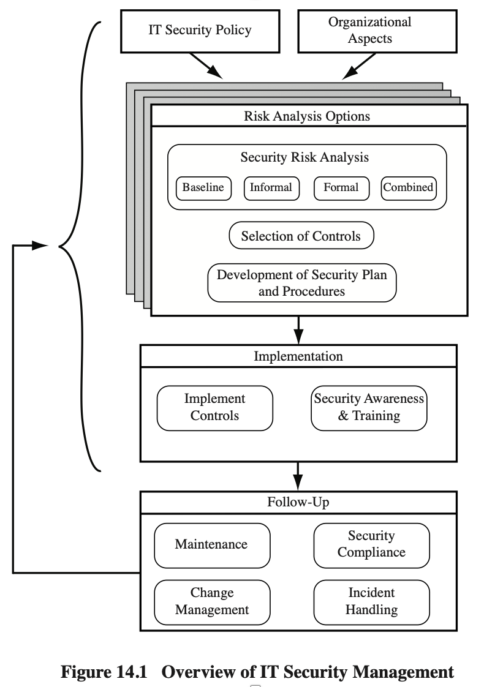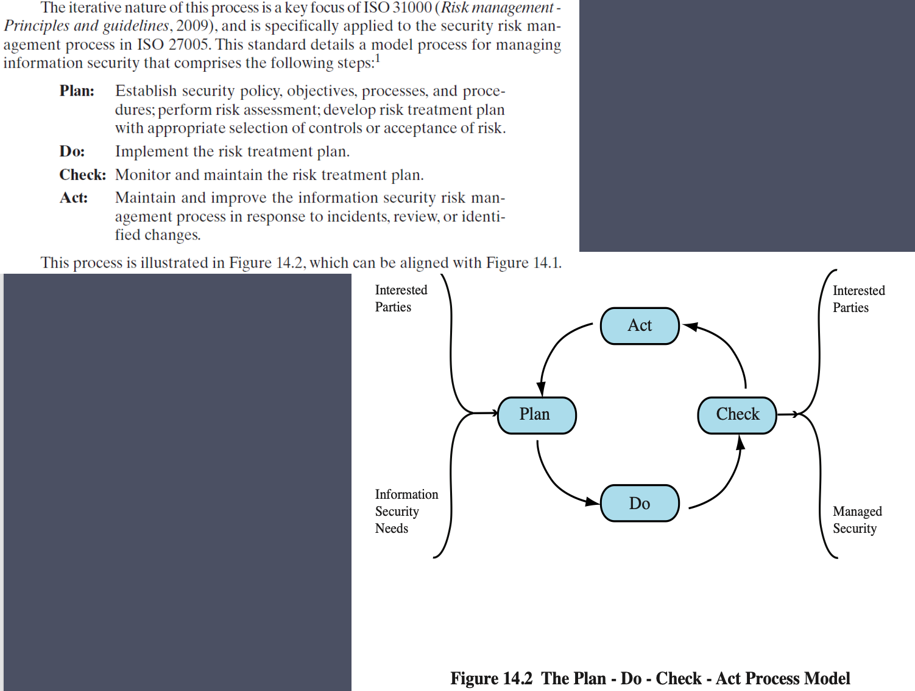

14.1 IT Security Management Overview
- Ensures critical assets are protected cost-effectively.
- Requires risk assessments for each asset.
- Determines needed management, operational, and technical controls.

14.2 Organizational Context & Security Policy
- Policies must be regularly updated via security reviews.
- Must reflect changing tech/risk environments.
- Security Policy: Must have senior management support.
- IT Security Officer: Oversees policy, incidents, training.
- Project Security Officers: Manage security in large projects.

14.3 Security Risk Assessment
- Baseline Approach: Implements common controls based on best practices.
  - Good for small organizations.
  - May over/under-secure.
- Informal Approach: Less formal, quicker, but less thorough.
- Detailed Risk Analysis: Thorough, asset-focused, costly.
- Combined Approach:
  - Start with baseline for all systems.
  - Identify high-risk/critical systems.
  - Perform informal then detailed analysis over time.

Chapter 19: Legal & Ethical Aspects (Sections 19.1–19.4)

19.1 Cybercrime & Computer Crime
- Definition: Criminal activity involving computers as tool, target, or place.
- Types (U.S. DoJ):
  - Computer as target
  - Computer as storage
  - Computer as communications tool
- Law Enforcement Challenges:
  - Lack of skilled investigators
  - Budget limits
  - Global nature, lack of cooperation
- Working with Law Enforcement:
  - Understand investigation process
  - Provide necessary inputs
  - Cooperate positively

Pakistan’s Prevention of Electronic Crimes Act 2016
- Applies to citizens and residents.
- Offenses include:
  - Unauthorized access/data interference
  - Cyber terrorism glorification
  - Hate speech/recruitment
  - Electronic forgery/fraud
  - Identity theft
  - SIM issuance without verification
  - Defamation/modesty violations
  - Child pornography
  - Malicious code
  - Cyberstalking
  - Spamming

19.2 Intellectual Property
- Types:
  - Copyright
  - Patents
  - Trademarks
  - Trade secrets
- Relevant to Security: Protects software, algorithms, data.
- DMCA: Anti-circumvention laws.
- DRM: Controls digital content use.

19.3 Privacy
- Overlaps with security.
- EU Data Protection Directive (1998): Protects privacy, enables data flow.
- U.S.: Various privacy laws.
- ISO 27002: Recommends privacy policy, privacy officer.
- Privacy vs. Big Data/Social Media:
  - Tension between utility and individual rights.
  - Technical controls: privacy settings, anonymization.
- Policy Needs: Consent, confidentiality, data ownership, governance.

19.4 Ethical Issues
- Ethics: Moral principles guiding actions.
- Unique IT Issues:
  - Scale of impact
  - New types of entities
- Professional/Ethical Responsibilities:
  - Codes of conduct (IEEE, ACM, etc.)
  - Themes: dignity, integrity, responsibility, confidentiality, public welfare
- The Rules (Responsible Computing):
  - Designers/deployers are morally responsible.
  - Responsibility is shared, not reduced by more people.
  - Users are responsible for their use.
  - Consider sociotechnical systems.
  - Do not deceive users.

Chapter 8: Intrusion Detection

8.1 Intruders
Intruder Behavior:
- Masqueraders: Outsiders without legitimate access
- Misfeasors: Legitimate users who misuse privileges
- Clandestine users: Users who avoid auditing/logging
- Behavior examples: Password cracking, privilege escalation, installing backdoors, data exfiltration

8.2 Intrusion Detection
Basic Principles:
- Monitor system/network for malicious activities
- Detect violations of security policies
- Components: Sensors, Analyzers, User Interface
- Goals: Detect in real-time, provide alerts, enable response
The Base-Rate Fallacy:
- Statistical problem: If intrusion rate is low, even good IDS will produce many false positives
- Example: If only 1 in 10,000 sessions is malicious, even 99% accurate IDS will generate 100 false alarms for every true positive
- Implication: Too many false alerts → analyst fatigue → real threats missed
Requirements for IDS:
- Must run continuously without human supervision
- Must be fault-tolerant and resist subversion
- Must impose minimal overhead
- Must adapt to changing behavior patterns
- Must be difficult to evade
- Must provide timely response

8.3 Analysis Approaches
Anomaly Detection:
- Creates baseline of "normal" behavior
- Flags deviations from baseline
- Advantages: Can detect novel attacks
- Disadvantages: High false positive rate, requires training period
- Methods: Statistical, machine learning, data mining
Signature/Heuristic Detection:
- Uses known patterns of malicious behavior
- Signature: Specific byte patterns, system call sequences
- Heuristic: General rules for suspicious behavior
- Advantages: Low false positives for known attacks
- Disadvantages: Cannot detect new/unknown attacks
- Methods: Pattern matching, stateful matching

8.4 Host-Based Intrusion Detection (HIDS)
Data Sources and Sensors:
- System Call Traces:
  - Records sequence of system calls by processes
  - Preferred for Unix/Linux HIDS
  - Problematic on Windows due to DLLs obscuring process-system call mapping
  - Monitored via OS hooks (e.g., BSM audit module)
- Audit/Log Records:
  - Built-in OS accounting software
  - Advantage: No additional collection needed
  - Disadvantages: May lack needed info; intruders may tamper with logs
- File Integrity Checksums:
  - Periodic scanning of critical files
  - Compare current cryptographic checksums with known good values
  - Example: Tripwire
  - Disadvantages: Must protect checksum database; difficult for frequently changing files
- Registry Access (Windows):
  - Monitor Windows registry access
  - Limited success due to Windows-specific nature
Specific System Calls Monitored (Table 8.2a - Ubuntu Linux):
- open, read, write, close, fork, execve, connect, bind, chmod, chown, setuid, ptrace
Windows DLLs Monitored (Table 8.2b):
- kernel32.dll, user32.dll, ws2_32.dll, ntdll.dll, advapi32.dll
- Key executables: cmd.exe, powershell.exe, regedit.exe
HIDS Architecture Components:
- Host Agent Module: Background process collecting security events
- LAN Monitor Agent Module: Analyzes LAN traffic (like NIDS for local segment)
- Central Manager Module: Correlates reports from multiple agents
Anomaly HIDS:
- Learns normal user/application behavior
- Flags unusual patterns (e.g., user logging in at 3 AM, accessing unusual files)
Signature/Heuristic HIDS:
- Matches known malicious patterns in system calls or log entries
- Example: Detecting setuid(0) call from non-root process
Distributed HIDS:
- Multiple host agents report to central manager
- Enables correlation across systems
- Can detect coordinated attacks
Agent Module Detailed Architecture (Figure 8.3):
- Capture audit records from native audit system
- Apply filter → keep only security-relevant records
- Reformat → Host Audit Record (HAR) standard format
- Template-driven logic module analyzes for suspicious activity
- Lowest level: Scan for notable events independent of past events

8.5 Network-Based Intrusion Detection (NIDS)
Definition:
- Monitors traffic at selected network points
- Examines packets in real/near-real time
- Can analyze network, transport, and application layers
- Components: Sensors, management servers, consoles
Types of Network Sensors:
- Inline Sensor:
  - Traffic passes through sensor
  - Can block attacks (becomes IPS)
  - Implementations: Combined with firewall/switch, or standalone
  - Disadvantage: Adds latency
- Passive Sensor:
  - Monitors copy of traffic via network tap/port mirroring
  - No impact on traffic flow
  - NIC Configuration: Monitoring NIC has no IP address; second NIC for management
NIDS Sensor Deployment (Figure 8.5):
- Location 1: Inside external firewall
  - Sees attacks that penetrate perimeter
  - Highlights firewall policy issues
  - Sees attacks targeting DMZ servers
  - Can see outgoing traffic from compromised servers
- Location 2: Between firewall and Internet
  - Sees all unfiltered traffic
  - Documents attack volume/types from Internet
  - Highest processing burden
- Location 3: Internal backbone networks
  - Monitors traffic to internal servers/databases
  - Detects insider threats
  - Can be tuned to specific protocols
- Location 4: Departmental/critical networks
  - Protects high-value assets
  - Allows focused resource allocation
  - Tunable to specific needs
Intrusion Detection Techniques:
- Signature Detection Suitable For:
  - Application layer reconnaissance/attacks
  - Transport layer attacks
  - Network layer attacks
  - Unexpected application services
  - Policy violations
- Anomaly Detection Suitable For:
  - Denial-of-Service (DoS) attacks
  - Scanning activity
  - Worm propagation
- Stateful Protocol Analysis (SPA):
  - Subset of anomaly detection
  - Compares traffic against vendor-supplied benign protocol profiles
  - (vs. organization-specific trained models)
  - Tracks protocol states to ensure expected progression
  - Disadvantage: High resource usage
Logging of Alerts (Typical NIDS Log Fields):
- Timestamp
- Connection/Session ID
- Event/Alert type and Rating
- Network, transport, application protocols
- Source/Destination IP addresses
- Source/Destination ports (TCP/UDP) or ICMP types/codes
- Number of bytes transmitted
- Decoded payload data
- State-related information

8.6 Distributed or Hybrid Intrusion Detection
Architecture (Figure 8.6):
- Platform Policies: Local rules on individual systems
- Adaptive Feedback Policies: Adjust based on detected events
- Collaborative Policies: Shared intelligence between systems
- Components:
  - Policy Enforcement Points (PEP)
  - Distributed Detection and Inference (DDI) modules
  - Gossip protocol for information sharing
Benefits:
- Correlates data from multiple sources
- Reduces false positives through cross-validation
- Enables coordinated response
- Adapts to evolving threats

🔥 Chapter 9: Firewalls & IPS

9.1 The Need for Firewalls
- Internet connectivity = necessity + threat
- Firewall: Controlled link between trusted/untrusted networks
- Functions: Single choke point, security enforcement, auditing, insulates internal systems
- Can be single system or multiple cooperating systems

9.2 Firewall Characteristics and Access Policy
Firewall Access Policy:
- Critical planning component
- Specifies authorized traffic types
- Based on: Address ranges, protocols, applications, content types
- Derived from organizational risk assessment
- Development: Broad specification → detailed filter elements → implementation
Default Policies:
- Default Deny (Discard): "Prohibit unless expressly permitted"
  - More conservative, secure
  - More visible to users (blocks legitimate traffic if misconfigured)
- Default Allow (Forward): "Permit unless expressly prohibited"
  - Easier to manage
  - Less secure (allows unknown threats)
Firewall Filter Characteristics:
- IP addresses and address ranges
- Protocol types (TCP, UDP, ICMP)
- Port numbers
- Application-level protocols
- Content types
- Direction (inbound/outbound)
- Interface

9.3 Types of Firewalls

Packet Filtering Firewall
- Operates at network/transport layers
- Applies rules to each IP packet
- Rules based on: Source/dest IP, protocol, port numbers, flags
- Table 9.1 Example Rules:
  - Allow outgoing TCP to port 80
  - Allow incoming TCP from port 80
  - Allow outgoing TCP to port 25
  - Problem Rule: Allow incoming TCP from port 25 to any internal port >1023
    - Vulnerability: Too broad; attackers can use source port 25 to target high internal ports
Rule 4 Problem Example:
- Attacker (external IP, source port 5150) sends malicious packets to internal server port 8080
- Both ports >1023 → firewall permits (matches rule 4)
- Result: Unauthorized access allowed
Improvements:
- Add Source Port Filtering:
  - Specify source port must be 25 (for SMTP)
  - Limitation: Attackers can forge packets with source port 25
- ACK Flag Filtering (Final Fix):
  - Allow inbound packets only if ACK flag = 1
  - Why: ACK indicates response to established connection
  - Blocks new incoming connections from outside
  - Still allows legitimate SMTP responses
Packet Filtering Limitations:
- No payload inspection
- Limited logging (IPs, ports only)
- No user authentication
- Vulnerable to IP/TCP attacks
- Cannot prevent application-layer attacks
- Misconfiguration risks
Advantages:
- Simple, fast, transparent to users
- Low cost, widely available

Stateful Inspection Firewall
- Tracks connection state in state table
- Table 9.2 Example State Table:
  - Entry includes: Source/dest IP/port, connection state, timeout
- Only allows packets belonging to established sessions
- Advantages over packet filtering:
  - Can detect session hijacking
  - Better handles FTP, VoIP (dynamic ports)
  - More secure against spoofing

Application-Level Gateway (Proxy)
- Operates at Layer 7 (Application)
- Acts as relay for application traffic
- Process:
  - User contacts gateway with application request
  - Gateway authenticates user
  - Gateway connects to remote host
  - Relays traffic between user and server
Advantages:
- Examines full payload
- Can restrict specific application features
- Better logging/auditing
- Hides internal network details
Disadvantages:
- High processing overhead
- Requires proxy for each application
- May break some applications
- Performance bottleneck

Circuit-Level Gateway
- Sets up two TCP connections: User↔Gateway and Gateway↔Host
- Relays segments without examining content
- Security: Determines which connections allowed
- SOCKS v5 (RFC 1928):
  - Framework for TCP/UDP applications through firewall
  - Components: SOCKS server (on firewall), client library (on hosts)
  - Process:
    - Client connects to SOCKS server (port 1080)
    - Authentication negotiation
    - Client sends relay request
    - Server establishes/denies connection
  - UDP: Forwarded via TCP-authenticated session
Advantages:
- Lower overhead than application proxy
- Works with any TCP application
- Provides user authentication
Disadvantages:
- No content inspection
- Requires client configuration

9.6 Intrusion Prevention Systems (IPS)
Definition: IDS + blocking capability
- Can be host-based, network-based, or hybrid
- Uses anomaly or signature detection
- Can block traffic like firewall but uses IDS algorithms

Host-Based IPS (HIPS)
Detection Techniques:
- Signature: Looks for known malicious patterns in system calls/network traffic
- Anomaly: Detects behavior patterns indicating malware
Types of Malicious Behavior Addressed:
- Modification of system resources: Rootkits, Trojans changing libraries, registry, accounts
- Privilege-escalation exploits: Attempts to gain root/admin access
- Buffer-overflow exploits: Memory corruption attacks
- Access to email contact list: Worm propagation method
- Directory traversal: Web server attacks accessing unauthorized files
HIPS Protection Areas:
- System calls: Kernel access monitoring
- File system access: Policy enforcement on file operations
- System registry settings: Integrity protection
- Host input/output: Network/device interaction control
Capabilities:
- Tailored to specific platforms
- Specialized for servers (Web, database)
- Sandbox approach: Quarantines mobile code (Java applets, scripts), monitors behavior
Role of HIPS:
- Endpoints are primary hacker target
- Integrates with antivirus, antispyware, personal firewall
- Advantages: Comprehensive protection, easier management
- Strategy: Part of defense-in-depth with network firewalls/NIPS

Network-Based IPS (NIPS)
Definition: Inline NIDS with authority to modify/drop packets
- Requires packet reassembly for application payload inspection
Detection Methods:
- Pattern matching: Byte sequence signatures
- Stateful matching: Signatures across traffic stream
- Protocol anomaly: Deviation from RFC standards
- Traffic anomaly: Unusual activities (UDP floods, new services)
- Statistical anomaly: Deviation from normal traffic baselines

Distributed or Hybrid IPS
Concept: Coordinates multiple HIPS/NIPS sensors
- Central analysis correlates data
- Returns updated signatures/patterns to all systems
- Example: Digital Immune System (IBM/Symantec)
Digital Immune System Process (Figure 9.5):
- Sensors detect potential malware
- Alerts sent to central correlation server
- Server forwards to protected analysis environment
- Malware sandboxed and tested
- Vulnerability identified
- Patch generated and tested
- Patch deployed to affected hosts
Snort Inline:
- Enables Snort as IPS (not just IDS)
- Replace option: Modifies packets instead of dropping
- Use case: Honeypots - attackers see failure but not cause
- Example: Change shellcode to harmless values

