## **Task No 1:**

Create a Flutter application that displays a sign-up form with the following requirements:

1. A Name input field.

2. A Password input field.

3. A Confirm Password input field that validates the password.

4. A Submit button that triggers form validation and displays a success message (e.g. “ Signed up successfully! “)

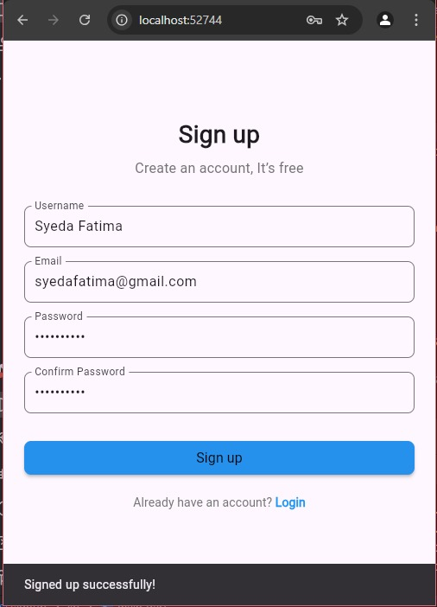

## **Task No 2:**

Create a Flutter application that displays:

1. An image placed at the top of the screen (you can use a local asset or network image).

2. Some text displayed below the image, styled with a larger font size and centered alignment.

