

American International University-Bangladesh (AIUB)

Department of Computer Science Faculty of Science &Technology (FST) Semester:2022-2023, Spring

Software Quality Assurance and Testing

Pharmacy24

Section: B

## Group-

A Report submitted By

|  |  |  |
| --- | --- | --- |
| **SN** | **Student Name** | **Student ID** |
| 1 | SYEDA AYNUL KARIM | 19-41829-3 |
| 2 | SANJIDA HOQUE SATHI | 20-42019-1 |
| 3 | IRIN ZAMAN MUNNI | 20-42316-1 |
| 4 | SHAHRIA SIRAJ RAJU | 20-43449-1 |

Under the supervision of -

**ABHIJIT BHOWMIK**

Associate Professor & Special Assistant [OSA] Department of Computer Science Faculty of Science & Technology

Software Test Plan

for

Pharmacy24

## Version 9.0 approved

Prepared by

|  |
| --- |
| SYEDA AYNUL KARIM |
| SANJIDA HOQUE SATHI |
| IRIN ZAMAN MUNNI |
| SHAHRIA SIRAJ RAJU |

## Checked By Industry Personnel

Name:

Designation:

Company:

Sign:

Date:

**Table of Contents**

1. Revision History 1
2. Test Plan Identifier **1**
3. References **1**
4. Introduction **1**
   1. Background to the problem 1
   2. Solution to the problem 1
5. Requirement Specifications **2**
   1. System Features 2
   2. System Quality Attributes 4
   3. Project Requirements 4
6. TEST CASES/TEST ITEMS (Pharmacy24) 7
   1. Sign Up 7
   2. Login 8
   3. Logout 8
   4. View Medicine List 9
   5. Add to Cart 10
   6. Payment Method 11
   7. Settings 11
   8. Change Password 12
   9. Update Profile 13
7. Item Pass/Fail Criteria 14
8. TEST DELIVERABLES 14
9. Testing Approach 15
   1. Testing Levels 15
   2. Testing Tools 16
   3. Meetings 18
10. Staffing and Training Needs 18
11. Testing Responsibilities 18
12. Testing Schedule 19
13. Planning risks and Contingencies for testing 20

# Revision History

|  |  |  |  |
| --- | --- | --- | --- |
| **Revision** | **Date** | **Updated by** | **Update Comments** |
| 1 | 20.4.2023 | Sanjida Hoque Sathi | First Draft |
| 2 | 24.4.2023 | Syeda Aynul Karim | Second Draft |
| 3 | 27.4.2023 | Irin Zaman Munni | Third Draft |
| 4 | 30.4.2023 | Shahria Siraj Raju | Forth Draft |

1. **Test Plan Identifier:** Pharmacy24-01.9

# References

* 1. Software Requirement Engineering Document
  2. Software Quality and Testing Course PowerPoint Slides
  3. [Types of software Testing- geeksforgeeks.org](https://www.geeksforgeeks.org/software-testing-techniques/)
  4. Team Gantt (Trello): Time Scheduling & Management
  5. Selenium Tool

# Introduction

## Background to the problem

Physically going to a pharmacy can take up a lot of time, especially for individuals who face mobility or transportation issues. Furthermore, brick-and-mortar pharmacies may not have the required medications or healthcare products available, resulting in treatment delays and multiple trips to different pharmacies. Additionally, some people may feel uneasy purchasing certain medications in person due to privacy concerns, which can deter them from seeking treatment or buying necessary medications.

## Solution to the problem

PHARMACY’24 is an online store that specializes in selling baby food, healthcare products, and rare medicines. The store provides a more extensive selection of medications and healthcare products than traditional physical pharmacies, and customers can conveniently search for what they need and compare prices and brands.

The website allows customers to purchase their medication from a computer or mobile device, and receive home delivery. This saves time, especially for those with mobility issues or those who live far from a pharmacy and eliminates the need to visit a physical pharmacy in person.

# Requirement Specifications

## System Features

### Log in / create account:

* + System allows new user to sign up to the system.
  + The user must enter username and password.

Priority level: High

Precondition: User have valid user id and password

### Registration:

* + User open an account by doing registration.
  + Provide Name, User name, Age, Email, Password & Mobile.
  + Verify Name, User name, Age, Email, Password & Mobile.
  + Sign up and create the account.

Priority Level: High

Precondition: verify all information

### User History

* + User can see his/her history any time and can see the transactions.

Priority level: High.

Precondition: User have seen history any time

### Block user:

* + Admin can block fake accounts (user, service provider) for security purpose.

Priority level: High.

Precondition: User have block fake account

### Verification:

* + To confirm the user's ID, a verification code will be provided to their email or phone number.

Priority level: High.

Precondition: User have valid email address or phone number

### Delete account:

* + User can delete his account so that he doesn’t get any further update Priority level: High.

Precondition: User can delete account

### Google Map:

* + System can show the location to the user using google map.

Priority level: High.

Precondition: User have used Google map

### Payment:

* + User can pay through mobile banking using Bkash, Nagad. Also, can pay cash.

Priority level: High.

Precondition: User have valid numbers

### Voucher:

* + System gives different badges like premium, gold, silver to the regular users.
  + User can get voucher using the badges.

Priority level: High.

Precondition: verify all information

## System Quality Attributes

* Security: The Pharmacy 24 have been secured and protected sensitive information, such as personal health information (PHI) and payment details, from unauthorized access or malicious attacks.
* Performance: The Pharmacy 24 website load quickly and respond to user actions in a timely manner to provide a smooth and efficient user experience.
* Usability: The Pharmacy 24 website is user-friendly and easy to navigate, with clear and concise content, intuitive menus, and appropriate feedback mechanisms.
* Accessibility: The Pharmacy 24 website is accessible to people with disabilities, such as visual impairments, hearing impairments, or mobility impairments, in accordance with web accessibility guidelines.
* Compatibility: The Pharmacy 24 website is working across a range of web browsers, operating systems, and devices, including desktop computers, laptops, tablets, and smartphones.
* Scalability: The Pharmacy 24 website is able to handle increasing traffic and user demands without compromising its performance or functionality.
* Reliability: The Pharmacy 24 website is available and functioning correctly at all times, with minimal downtime or errors.
* Maintainability: The Pharmacy 24 website is easy to maintain and update, with clear documentation and well-structured code that follows industry best practices.
* Data privacy: The Pharmacy 24 website is complied with data privacy regulations and protect the privacy of the users’ data.

## Project Requirements

An algorithmic software cost estimating methodology is the Constructive Cost Model

(COCOMO). We will be using an organic software project type. It is a software project that must be worked on in a hardware-dependent environment.

### Constructive Cost Model

We are assuming that the SLOC (Source Lines of Code) that we require here after analyzing all the components.

SLOC = 10,000

Now we need to figure out the effort, development time, and required number of people. Suppose that, our software project type is organic, the values of the Coefficient<Effort Factor>

=2.4

P = project complexity = 1.05 SLOC= 10,000

T= SLOC-dependent coefficient = 0.38 Now,

Effort = PM = Coefficient*(SLOC/1000)^P PM = 2.4*(10000/1000)^1.05

= 26.93

Development Time= DM= 2.5*(PM)^T

= 2.5*(26.93)^0.38

= 8.74

= 9 [In months] Required Number of People = ST

= PM/DM

= 26.93/8.74

= 3.08

= 3

**Budget Estimation**

Duration in weeks = 9*4 = 36 weeks Office days Per week working days = 5 days

Working hours = 7 Hours

So, per week working hours is = (5*7) hours = 35 hours

So Total Working hours is = 35*36= 1260 hours. Developer salary is = 800 Taka/ Hour

Total developers Salary = (800* 1260)

= 1008000 Taka

|  |  |  |
| --- | --- | --- |
| **Expanse** | **Amount** | **Total Amount** |
| Salary for 3 developers |  | 10,08,000 |
| For Requirement analysis Cost for 1 months | 22*8*400 | 70,400 |
| Transport Cost |  | 10,000 |
| 9 months office rent | 9*25000 | 2,25,000 |
| Hardware Expanse |  | 80,000 |
| 4 months maintenance cost | 16*9*1200 | 1,72,800 |
| Training Cost |  | 10,000 |
| Project Manager salary for 9 months | 25,000*9 | 2,25,000 |
| Now Total Estimation Cost is |  | 18,00,400 |

**Profit**

20% of total estimation cost = 18,00,400 *20%=3,60,080 Total budget for the project = 18,00,400+3,60,080

= 21,60,480

**The total budget for the project is 21,60,480 Taka.**

# TEST CASES/TEST ITEMS (Pharmacy24)

## Sign Up:

This Test case is for testing the sign-up details

|  |  |  |  |  |
| --- | --- | --- | --- | --- |
| Project Name: Online based medicine delivery system -  (Pharmacy24) | | | Test Designed by: Sanjida Hoque  Sathi | |
| Test Case ID: FP_01 | | | Test Designed date: 18, Mar,2023 | |
| Test Priority (Low, Medium, High): High | | | Test Executed by: Syeda Aynul  Karim | |
| Module Name: Sign Up | | | Test Execution date: 18, Mar,2023 | |
| Test Title: Verify sign up sending verification code | | |  | |
| Description: Test the sign-up verification | | |  | |
| Precondition: User should have valid email or phone number | | |  | |
| Test Steps | Test Data | Expected  Results | Actual Results | Status  (Pass/Fail) |
| 1. Go to the website sign up page 2. Enter first name 3. Enter last name 4. Enter valid email 5. Enter valid phone number 6. Select reason for choosing us 7. Click sign up | First Name: Syeda  Last Name: Karim Email: [Syedaishmee19@gmai](mailto:Syedaishmee19@gmail.com) [l.com](mailto:Syedaishmee19@gmail.com)  Phone no:01713456778 | Verification code should be sent to the user email or phone no | As expected, | Pass |
| Post Condition: User should get the verification code and confirm it  and get sign up in to the system successfully. | | |  | |

## Login:

This Test case tests the login that a user can login using their id and password

|  |  |  |  |  |  |  |
| --- | --- | --- | --- | --- | --- | --- |
| Project Name: Online based medicine delivery system -(Pharmacy24) | | | Test Designed by: Syeda Aynul  Karim | | | |
| Test Case ID: FP_02 | | | Test Designed  Mar,2023 | | date: | 19, |
| Test Priority (Low, Medium, High): High | | | Test Executed by: Sanjida Hoque  Sathi | | | |
| Module Name: Login | | | Test Execution  Mar,2023 | | date | :19, |
| Test Title: Verify login with valid email or phone number and  password | | |  | | | |
| Description: Test the system login | | |  | | | |
| Precondition: User should have registered mail address/phone number  and password | | |  | | | |
| Test Steps | Test Data | Expected Results | Actual Results | Status  (Pass/Fail) | | |
| 1. Go to the login page 2. Enter valid email/ phone number 3. Enter password  4. Click login | Email: [Syedaishmee19@gm](mailto:Syedaishmee19@gmail.com) [ail.com](mailto:Syedaishmee19@gmail.com)  or  Phone: 01713456778 | User should login to the system | As expected, | Pass | | |
|  | password: 123456 |  |  |  | | |
| Post Condition: User should have logged in to the system successfully | | |  | | | |

## Logout

This Test case is for checking the user can logout successfully or not.

|  |  |
| --- | --- |
| Project Name: Online based medicine  delivery system - (Pharmacy24) | Test Designed by :Syeda Aynul  Karim |

|  |  |  |  |  |  |  |  |
| --- | --- | --- | --- | --- | --- | --- | --- |
| Test Case ID: FP_06 | | | | Test Designed date: 22, Mar,2023 | | | |
| Test Priority (Low, Medium, High): High | | | | Test Executed  Munni | by: | | Irin Zaman |
| Module Name: Logout | | | | Test Execution date: 22,Mar,2023 | | | |
| Test Title: Verify the logout Module | | | |  | | | |
| Description: Test the logout session. | | | |  | | | |
| Precondition (If any): User need to Login  into the system. | | | |  | | | |
| Test Steps | | Test Data | Expected Results | Actual Results | | Status  (Pass/Fail) | |
| 1. Go to the website home page 2. Click to the   “logout”button | | N/A | Successful logout | As expected, | | Pass | |
| Post Condition:  login page. | user may go back to the | |  |  | | | |

## View Medicine List

This Test case will check that the feature is showing all the medicines with their corresponding details or not

|  |  |
| --- | --- |
| Project Name: Online based medicine delivery system -  (Pharmacy24) | Test Designed by: Irin Zaman  Munni |
| Test Case ID: FP_03 | Test Designed date: 19, Mar,2023 |
| Test Priority (Low, Medium, High): High | Test Executed by: Syeda Aynul  Karim |
| Module Name: View Medicine List | Test Execution date: 19, Mar,2023 |
| Test Title: Showing all the medicine with their corresponding  details |  |
| Description: Test all the medicines are visible or not |  |
| Precondition: Some medicines must be added before viewing cart. |  |

|  |  |  |  |  |
| --- | --- | --- | --- | --- |
| Test Steps | Test Data | Expected Results | Actual Results | Status  (Pass/Fail) |
| 1. Go to the website in Pharmacy24 2. Login to the page 3. Go to the Medicine page |  | User should see all the medicines in details with the price | As expected, | Pass |
| Post Condition: Added medicines must view in the cart section. | | |  | |

## Add to Cart

This Test case is for checking the user whether he/she can order multiple medicines.

|  |  |  |  |  |
| --- | --- | --- | --- | --- |
| Project Name: Online based medicine delivery system -  (Pharmacy24) | | | Test Designed by: : Syeda Aynul  Karim | |
| Test Case ID: FP_04 | | | Test Designed date: 21, Mar,2023 | |
| Test Priority (Low, Medium, High): High | | | Test Executed by: : Syeda Aynul  Karim | |
| Module Name: Add to cart | | | Test Execution date: 21, Mar,2023 | |
| Test Title: Adding items in the cart | | |  | |
| Description: Test whether multiple items are added in the cart | | |  | |
| Precondition (If any): Cart should be empty. | | |  | |
| Test Steps | Test Data | Expected Results | Actual Results | Status  (Pass/Fail) |
| 1. Go to the Pharmacy24 page. 2. Select multiple medicine items. |  | User should see all the selected items on cart. | As expected, | Pass |
| Post Condition: Added medicine items must show in the cart  section. | | |  | |

## Payment Method

This Test case tests the payment method. There is used two types of payment method. Users can either pay with cash or using mobile banking named Bkash.

|  |  |  |  |  |
| --- | --- | --- | --- | --- |
| Project Name: Online based medicine delivery system -  (Pharmacy24) | | | Test Designed by: Syeda Aynul  Karim | |
| Test Case ID: FP_05 | | | Test Designed date: 21, Mar,2023 | |
| Test Priority (Low, Medium, High): High | | | Test Executed by: Syeda Aynul  Karim | |
| Module Name: Cash Payment Method | | | Test Execution date: 21, Mar,2023 | |
| Test Title: Showing options for paying with cash | | |  | |
| Description: Test Bkash cash validation | | |  | |
| Precondition (If any): Items should be added to the cart. | | |  | |
| Test Steps | Test Data | Expected Results | Actual Results | Status  (Pass/Fail) |
| 1. Add 1 Cough   Syrup and 1 Paracetamol   1. Pay with Bkash. | Pay 245 BDT  by Bkash | The system must accept cash 270 BDT | As expected, | Pass |
| Post Condition: Must accept Bkash terms and conditions. | | |  | |

## Settings:

The test case is for the settings options

|  |  |
| --- | --- |
| Project Name: Online based medicine delivery system -  (Pharmacy24) | Test Designed by: Sanjida Hoque  Sathi |
| Test Case ID: FP_07 | Test Designed date: 22, Mar,2023 |
| Test Priority (Low, Medium, High): Low | Test Executed by: Syeda Aynul  Karim |
| Module Name: Settings | Test Execution date: 22, Mar,2023 |

|  |  |  |  |  |
| --- | --- | --- | --- | --- |
| Test Title: Test all the settings option | | |  | |
| Description: Test all the orders are visible or not | | |  | |
| Precondition: User have logged in and went to system list | | |  | |
| Test Steps | Test Data | Expected Results | Actual Results | Status  (Pass/Fail) |
| 1. Go to Pharmacy24 page 2. Login to the page 3. Go to system bar 4. Then from option click setting   option | . | In setting section user can change the language, floating icon, receive push notifications, receive offers by email | As expected, | Fail |
| Post Condition: | | |  | |

## Change Password

This Test case is for Change password

|  |  |
| --- | --- |
| Project Name: Online based medicine delivery system -  (Pharmacy24) | Test Designed by: Syeda  Aynul Karim |
| Test Case ID: FP_08 | Test Designed date: 23,  Mar,2023 |
| Test Priority (Low, Medium, High): Medium | Test Executed by: Syeda  Aynul Karim |
| Module Name: Change password | Test Execution date: 23,  Mar,2023 |
| Test Title: Test the changing password |  |
| Description: Test the password is changing or not |  |
| Precondition: User have to logged into the system then go to  profile option |  |

|  |  |  |  |  |
| --- | --- | --- | --- | --- |
| Test Steps | Test Data | Expected Results | Actual Results | Status (Pass/Fail  ) |
| 1. Login to the website 2. Go to option 3. Click on the “change password’   option | Password: 45897 | Password should be added by the user and stored in database. | As expected, | Pass |
| Post Condition: Database should be updated password | | |  | |

## Update Profile:

This Test case is for update the profile

|  |  |  |  |  |
| --- | --- | --- | --- | --- |
| Project Name: Online based medicine delivery system - (Pharmacy24) | | | Test Designed by: Syeda Aynul  Karim | |
| Test Case ID: FP_09 | | | Test Designed date: : 23,  Mar,2023 | |
| Test Priority (Low, Medium, High): Low | | | Test Executed by: Syeda Aynul  Karim | |
| Module Name: Update Profile | | | Test Execution date: : 23,  Mar,2023 | |
| Test Title: Test the update profile | | |  | |
| Description: Test the profile is update or not | | |  | |
| **Precondition:** User have logged in and went to system menu | | |  | |
| Test Steps | Test Data | Expected  Results | Actual Results | Status  (Pass/Fail) |

|  |  |  |  |  |
| --- | --- | --- | --- | --- |
| 1. Login to the website 2. Go to menu option 3. Click profile option | Email: [Syedaishmee19@gmail.](mailto:Syedaishmee19@gmail.com) [com](mailto:Syedaishmee19@gmail.com) First Name: Syeda Last Name: Karim Phone No: 01713456778 | User provide information email and phone number should be  verified and User edit their name and click save it will show that the profile is  update | As expected, | Pass |
| Post Condition: After changing their name email, phone number profile  show is update | | |  | |

# Item Pass/Fail Criteria

To develop Pharmacy24, nine test cases were employed initially. During unit testing, 95% of these test cases were successful, while the remaining 5% failed. This failure was attributed to difficulties with database queries. However, after addressing the query-related issues, all test cases were executed effectively, and none of them failed.

# TEST DELIVERABLES

* Test plan
* Test results documents
* Test summary
* Defect reports and summaries

# Testing Approach

## Testing Levels

### Unit Testing:

Unit testing is a fundamental software testing process that focuses on testing individual units, components, or elements of software. The primary objective of unit testing is to verify that each unit of code functions correctly and is free of bugs, errors, and flaws. During unit testing, the lead developer approves the module, integrates it with the system, and transfers it to the QA team. This process detects any defects present in the specific unit, and developers must work to resolve them to ensure that the unit meets the expected functionality.

Unit testing is considered a "white box" testing method, as the code can be viewed but typically not modified. It is recommended that unit testing is performed early in the software development process to save costs, time, and effort in the long run.

### Integration Testing:

Integration testing is a level of software testing where multiple units or modules of the software are combined and tested as a group. The main purpose of integration testing is to ensure that the individual units function correctly when combined, and that the software operates as a complete system. During integration testing, issues such as interface errors, communication problems, and incorrect data sharing between modules can be identified and addressed.

Integration testing is also known as I & T (integration and testing), thread testing, or string testing. This method focuses on checking the flow of data from one module to the next, and it is typically performed by testers. This level of testing is critical because it verifies that everything is working together as a unified whole.

### System Testing:

The subsequent level of software testing is system testing, which aims to determine whether the system meets the necessary requirements. System testing involves

evaluating the software in various operating environments, configurations, and scenarios to ensure its proper functionality. Performance, load, reliability, and security are among the components scrutinized during system testing, with the objective of assessing the end-to-end system specifications.

Typically, professional testing agents perform this method on the finished software product before it is released to the market for use by actual users. This stage is crucial because the project is almost complete, and the software must be tested in an environment that is similar to what the user will encounter once it is ready.

### Acceptance Testing:

This is the final stage of testing before the software is released to the end-users. Acceptance testing is performed by the end-users or stakeholders to ensure that the software meets the business requirements and is ready for deployment. The focus of acceptance testing is on the software's functionality, usability, and performance, and it involves a variety of tests to ensure that the software works as intended and meets the needs of the end-users.

## Testing Tools

### Selenium IDE-testing Tool

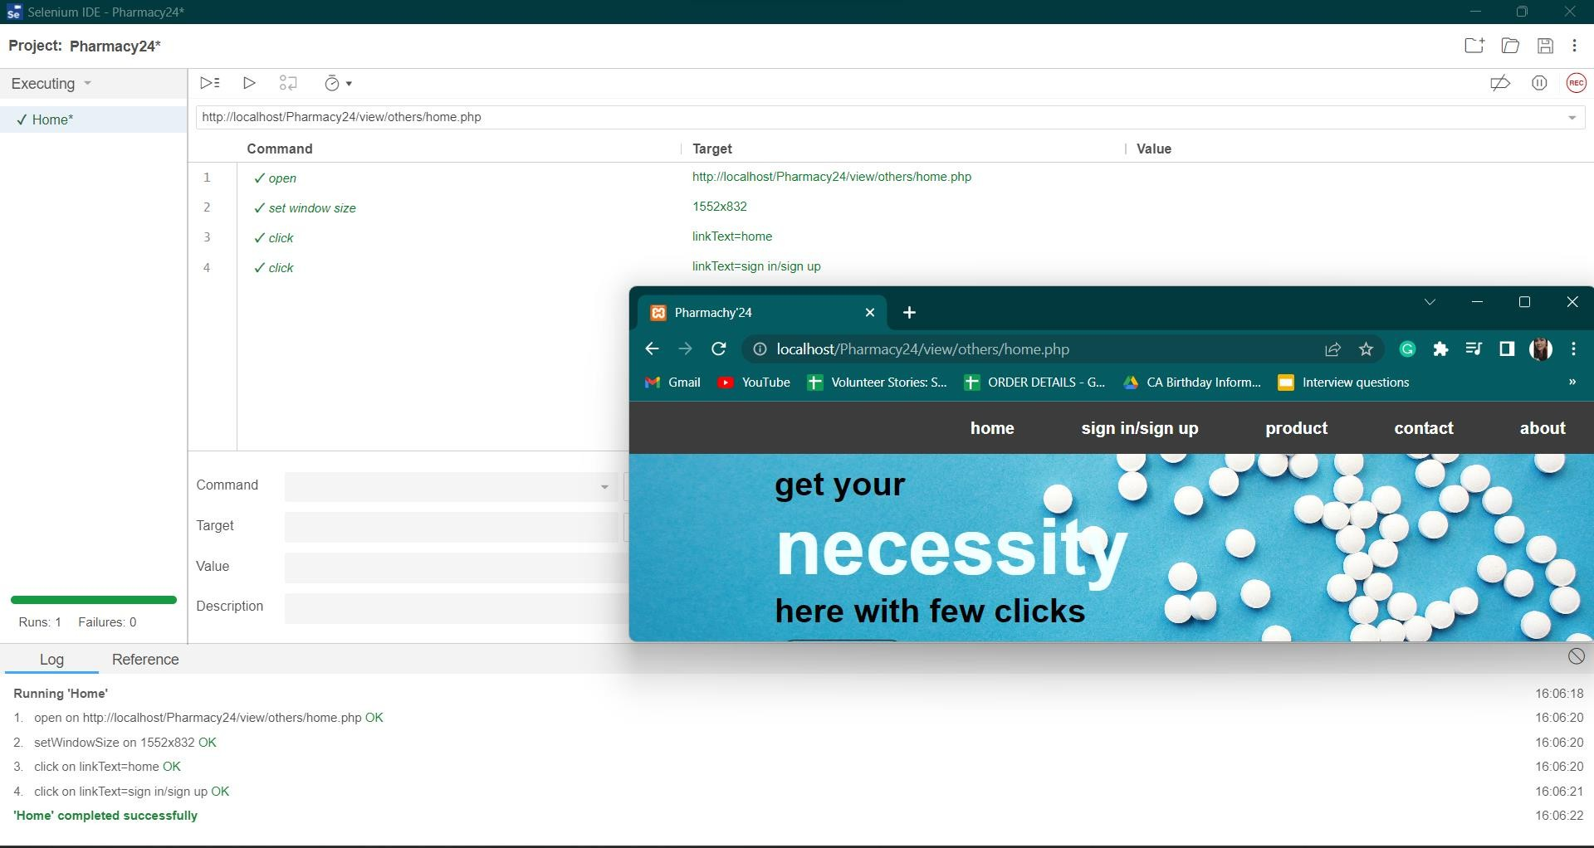

*Fig.01: Selenium IDE for testing interactions and basic functionality of Pharmacy’24 site home page*

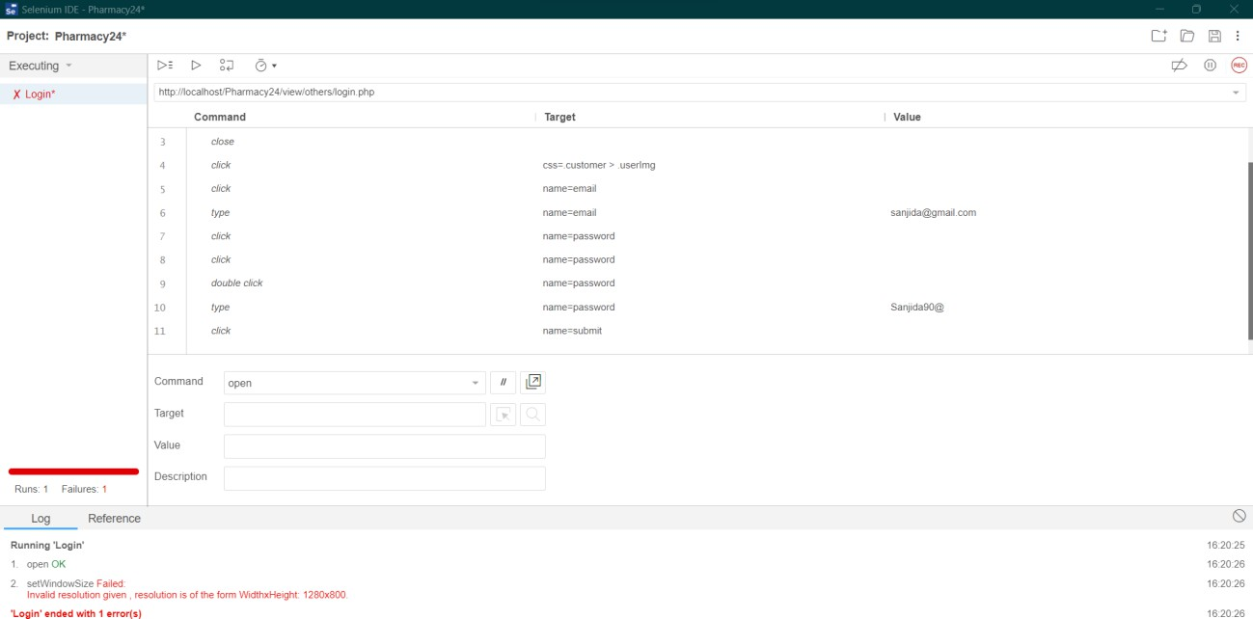

*Fig.02: Selenium IDE for testing interactions and basic functionality of Pharmacy’24 site login page*

## Meetings

This entire project duration is about 4 weeks. Every day our group member has to report how much progress was done. All the members also provided suggestion for improving various functionality.

# Staffing and Training Needs

For the project's system/integration and acceptance testing phases, it is desirable that at least one

(1) full-time tester be allocated to the task. In order to participate in evaluations, meetings, etc., a person will need to be assigned part-time at the start of the project. After around six months, they will be assigned full-time. The project manager/test manager will take on this responsibility if a separate test person is not readily accessible. A full-time professional communicator should be required. sufficient numbers of operation staff should be needed. The following training needs to be handled in order for this project to be effective.

* The operation employees will need to receive communication and language training from a professional communicator.
* Instruction on the fundamental functions of the EDI interface will be required for the developers and testers for the project's final acceptance.

# Testing Responsibilities

|  |  |  |
| --- | --- | --- |
| Name | Role | Responsibilities |
| SANJIDA HOQUE SATHI | Product Manager | 1. Ensure the completion of the project in due time. 2. Conduct required interactions with customers 3. Manage the whole project and team 4. Match the completed project with the requirements |
| SYEDA AYNUL  KARIM | Senior Developer & Lead  Quality Control Engineer | 1 Research, design, implement and manage  software programs |

|  |  |  |
| --- | --- | --- |
|  |  | 2, Write and implement efficient code  3, Deploy software tools, process and metrics 4, Execute all the test cases and report  defects |
| IRIN ZAMAN MUNNI | Lead Quality Assurance Engineer | 1, Create test plans, test forms, test cases and test information  2, Prioritize testing activities |
| SHAHRIA SIRAJ RAJU | Test Engineer | 1, Characterize the testing activities of test planning  2, Check if the fundamental assets are  available to execute the test cases |

# Testing Schedule

Time has been allocated within the project plan for the following testing activities.

|  |  |  |
| --- | --- | --- |
| **Task Name** | **Duration** | **Responsible** |
| Requirement Analysis | 5 days | Project Manager |
| Design | 7 days | Project Manager |
| Writing codes | 8 days | Developers |
| Unit Test | 10 days | Developers |
| Documentation | 6 days | Test Engineer |
| Maintenance | 6 days | Developers & End User |

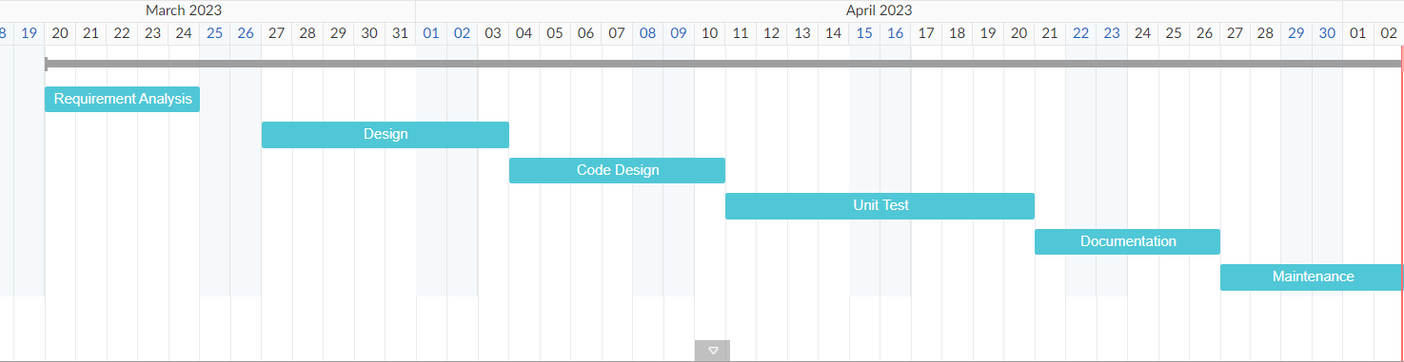

# Planning risks and Contingencies for testing

Pharmacy’24 may be pricey and the upkeep may be a problem because the hardware and software must cooperate. There is relatively little interaction between people. Given that it is a self-service system, the user must be cautious when choosing the products.