REACT-REDUX

What Is Redux?

Redux is State management system.

Why to use Redux?

To cover the props drilling issue.

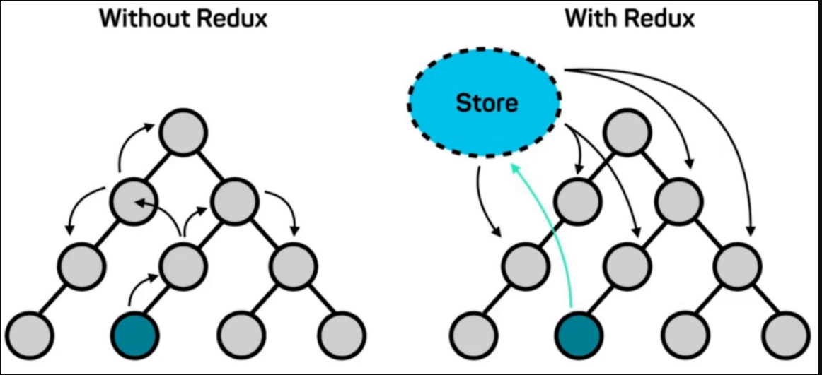

MAIN:

1. Store
2. Actions
3. Reducers
4. Satate
5. Constants

redux has 3 things

1)state

2)Actions

3)Reducers

all these three steps are connected through Store

store is the brain of redux which connect react with redux.

state: value in UI ( User Interface)

actions: Updater code that causes an update to the state when something happens

reducers: LOGIC BUILDER == logic building (

action.type.INCREAMENT

increase : state+1 , decrease : state-1 , reset: 0)

state=0

1)incremenet

3)decrement

3)reset

increament =click===> action

decreament =click===> action

reset =click===> action