
National University of Computer and Emerging Sciences
Karachi Campus
EL-2003 Computer Organization and Assembly Language (COAL) Lab
Fall 2026
PROJECT PROPOSAL REPORT
Project Title | Mario's Cement Factory: A Retro Arcade Game in x86 Assembly using Irvine32
Group ID | G06
Group Leader (Name & Roll No.) | Syeda Marium Fatima (25K-0970)
Member 2 (Name & Roll No.)
Lab Section | BCS3C
Lab Instructor | Muhammad Owais
Submission Date | 15 October 2026

Part B: Project Proposal

1. Project Title
Mario's Cement Factory: A Retro Arcade Game in x86 Assembly using Irvine32

2. Group Information
S. No. | Name | Roll Number | Role
1 | Syeda Marium Fatima | 25K-0970 | Group Leader

3. Abstract
This project is a retro arcade game written in x86 assembly language, inspired by the Nintendo Game & Watch title Mario's Cement Factory. The player controls Mario, who moves between three levels of a cement factory to catch cement released from two hoppers and load it onto a waiting truck. Each successful delivery earns points, every missed block costs one of three lives, and the falling speed increases as the score rises, so the game becomes steadily harder. The game runs in the Windows console using MASM and the Irvine32 library, with coloured text-mode graphics, keyboard control, sound effects and a saved high score. It demonstrates registers, loops, arrays, procedures, macros and library calls in one complete, playable program.

4. Introduction and Problem Statement
Game & Watch handhelds from the early 1980s were simple but addictive: a few fixed screen positions, one character and a rising difficulty curve. In Mario's Cement Factory, cement keeps falling from hoppers, and the player must be at the right level at the right moment to catch it and load it onto trucks. A missed block costs a life, so the game tests timing and reflexes.
The problem this project addresses is how to build a complete real-time interactive program, with input handling, a game loop, collision detection, scoring and difficulty scaling, using only low-level instructions and no game engine. Assembly language suits this task well because every part of the game state lives in registers and memory, the programmer controls the timing of each frame, and the game logic is small enough to be fully understood instruction by instruction. The project therefore exercises most of the COAL course in one application.

5. Objectives
- Implement a keyboard-controlled Mario who moves between three levels and two chute positions without leaving the play area.
- Implement falling cement blocks, stored in an array, that spawn at random from two hoppers and are caught when Mario is at the matching level and column.
- Implement scoring (+10 per delivery, with a bonus for a full truck) and a three-life system that ends the game when lives reach zero.
- Implement difficulty scaling so that the frame delay shrinks as the score grows, down to a fixed minimum.
- Provide a main menu, a pause option, sound effects and a high score that is saved to a file between runs.

6. Scope of the Project
The project WILL include: a single-player game in the Windows console (80 × 25 text mode, coloured characters); three levels, two hoppers and one truck; scoring, lives and a speed that rises with score; a title menu, instructions and pause; simple beep sound effects; and a high score file.
The project will NOT include: graphical sprites or animation beyond text characters; a two-player mode; mouse or gamepad input; the original Nintendo artwork or sound; multiple stages or level editors; and save/load of a game in progress.

7. Proposed Features / Modules
No. | Feature / Module | Description
1 | Menu and instructions | Title screen with Start, Instructions and Exit options.
2 | Input and Mario movement | Reads arrow keys with ReadKey and moves Mario between levels and chute positions with boundary checks.
3 | Cement spawner | Randomly releases a new block from the left or right hopper using an array of active blocks.
4 | Falling and catching | Moves each block down one row per frame and tests it against Mario's level and column.
5 | Truck and scoring | Adds 10 points per caught block, fills the truck, and awards a bonus when it is full.
6 | Lives and game over | Deducts a life when a block reaches the floor; shows the game over screen at zero lives.
7 | Difficulty scaling | Recomputes the frame delay from the current score using arithmetic instructions.
8 | Display and HUD | Draws the factory, Mario, blocks, truck, score and lives using Gotoxy and text colours.
9 | Sound and high score | Plays beeps on catch and miss; reads and writes the best score in a file.

8. Assembly Language Concepts to be Used
Concept | Where it is used
Registers and data movement | MOV, XCHG and MOVZX to hold coordinates, score, lives and loop counters.
Arithmetic and logical instructions | ADD, SUB, MUL and DIV for score and delay (delay = 200 − 15 × (score ÷ 50)); AND and TEST for flags.
Conditional jumps and loops | CMP with Jcc for boundaries, collisions and game-over checks; LOOP for the main game loop and block updates.
Arrays and addressing modes | Parallel arrays of block X, Y and active flag, accessed with indexed and base-index addressing.
Procedures and the stack | PROC, CALL, RET, USES, PUSH and POP for modules such as DrawScreen, MoveMario and UpdateBlocks.
String instructions | REP STOSB to clear the screen buffer and reset arrays.
Macros | Reusable macros such as mGotoXY and mWriteAt for repeated drawing code.
Irvine32 procedures | Clrscr, Gotoxy, SetTextColor, WriteChar, WriteString, WriteDec, ReadKey, Delay, RandomRange and Randomize.
File handling | CreateOutputFile, OpenInputFile, ReadFromFile, WriteToFile and CloseFile for the high score.

9. Tools and Environment
The game will be built with the Microsoft Macro Assembler (MASM) in Visual Studio 2022 on Windows, linked with the Irvine32 library as used in the lab. The program runs in the Windows console. Version control will be done with Git or a shared folder, and the flowchart and screen sketch will be drawn with draw.io.

10. Proposed System Design
Figure 1 shows the main program flow. After initialisation the program shows the menu and then repeats a game loop: read input, move Mario, update the cement blocks, check catches and misses, update the speed, redraw and delay. The loop ends when lives reach zero. Figure 2 is a sketch of the main game screen.
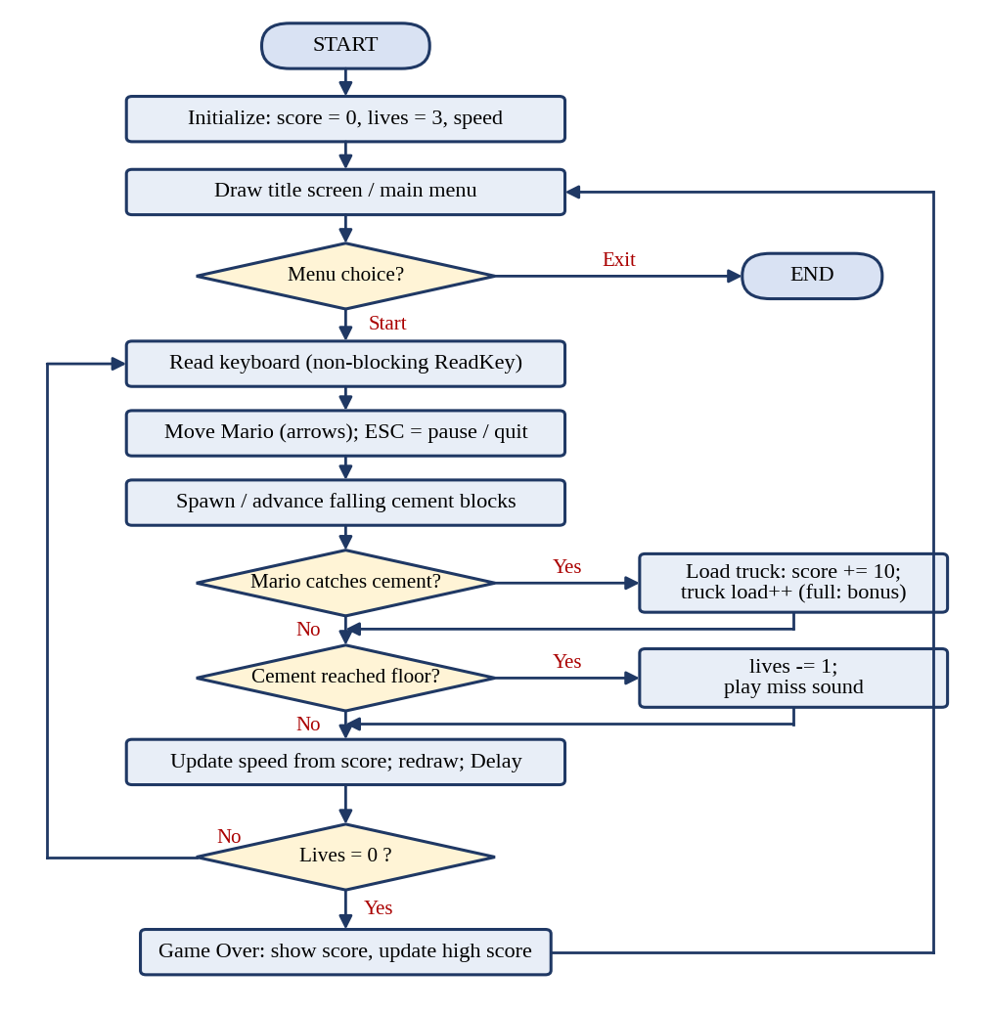
Figure 1: Main program flow
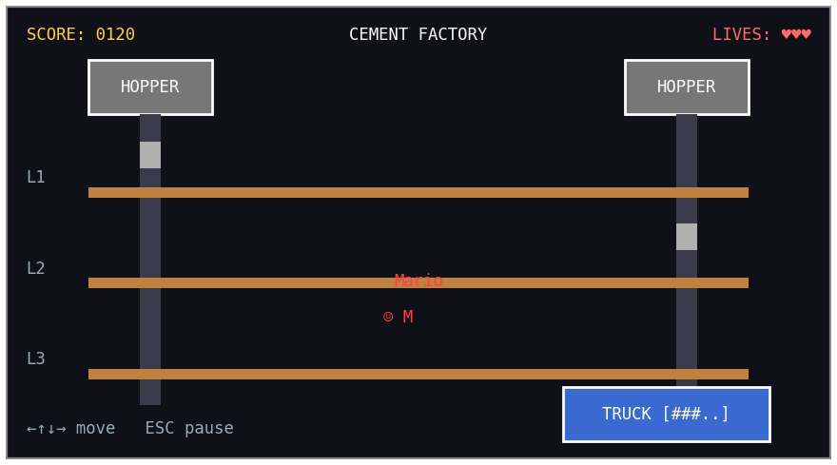
Figure 2: Sketch of the main game screen

11. Work Division
Individual project.
Syeda Marium Fatima (25K-0970) will implement all nine modules: menu and instructions, input and Mario movement, cement spawner, falling and catching, truck and scoring, lives and game over, difficulty scaling, display and HUD, and sound and high score. She will also do the integration, testing and final report.

12. Tentative Timeline
Week / Dates | Task | Responsible
16 Oct – 25 Oct | Finalise design; set up project; draw screen and HUD; implement input and Mario movement. | Marium
26 Oct – 8 Nov | Implement block array, spawning, falling, catching, truck, scoring and lives. | Marium
9 Nov – 18 Nov | Add speed scaling, menu, pause, sound and high score file; polish the display. | Marium
19 Nov – 22 Nov | Testing, debugging and final report | Marium

13. Expected Outcome
The finished game opens in the console with a title menu. After choosing Start, the player sees the factory with two hoppers, three levels, Mario and a truck, and a score and lives display at the top. Pressing the arrow keys moves Mario between levels and chute positions to catch each falling block, which loads onto the truck for 10 points. A missed block removes a life with a short beep, the blocks fall faster as the score grows, and when all three lives are gone the game over screen shows the final score and the saved high score before returning to the menu.

14. References
[1] K. R. Irvine, Assembly Language for x86 Processors, 7th ed., Pearson, 2014.
[2] Nintendo, Game & Watch: Mario's Cement Factory, handheld LCD game, 1983.
[3] K. R. Irvine, “Assembly Language for x86 Processors: book website and Irvine32 library,” kipirvine.com.
[4] Microsoft, “Microsoft Macro Assembler (MASM) reference,” Microsoft Learn, learn.microsoft.com.

