**Question No. 1**

* **Input: Transaction details → amount, date, time, country.**
* **Process:**

**Check transaction limit**

* **Output: Flag transaction as "Suspicious" or "Normal".**

|  |  |  |
| --- | --- | --- |
| **Input** | **Process** | **Output** |
| **- Transaction Amount** | **1. Compare daily total with limit.** | **"Suspicious" / "Normal"** |
| **- Country of Transaction** |  |  |
| **- Time and Count of Transactions** |  |  |

**Algorithm**

1. **Start**
2. **Input transaction details (amount, country, time).**
3. **Update daily total.**
4. **If daily total > 5000 → Mark suspicious.**
5. **Else if country not in {Pakistan, UAE} → Mark suspicious.**
6. **Else if transactions in same hour > 3 → Mark suspicious.**
7. **Else → Normal transaction.**
8. **Display result.**
9. **Stop.**

**Pseudocode**

**BEGIN**

**INPUT amount, country, transactionCountInHour, dailyTotal**

**dailyTotal = dailyTotal + amount**

**IF dailyTotal > 5000 THEN**

**PRINT "Suspicious: Daily limit exceeded"**

**ELSE IF country != "Pakistan" AND country != "UAE" THEN**

**PRINT "Suspicious: Unusual country"**

**ELSE IF transactionCountInHour > 3 THEN**

**PRINT "Suspicious: Too many transactions in short time"**

**ELSE**

**PRINT "Normal transaction"**

**ENDIF**

**END**

**C Program**

**#include <stdio.h>**

**int main() {**

**int amount, dailyTotal, transactionCountInHour;**

**int countryCode;  // use integer instead of string**

**// Input**

**printf("Enter transaction amount: ");**

**scanf("%d", &amount);**

**printf("Enter daily total so far: ");**

**scanf("%d", &dailyTotal);**

**printf("Enter transaction count in this hour: ");**

**scanf("%d", &transactionCountInHour);**

**printf("Enter country code (1=Pakistan, 2=UAE, others=Unusual): ");**

**scanf("%d", &countryCode);**

**// Update daily total**

**dailyTotal = dailyTotal + amount;**

**// --- Decision checks ---**

**if (dailyTotal > 5000) {**

**printf("Suspicious: Daily limit exceeded\n");**

**}**

**else if (countryCode != 1 && countryCode != 2) {**

**printf("Suspicious: Unusual country\n");**

**}**

**else if (transactionCountInHour > 3) {**

**printf("Suspicious: Too many transactions in short time\n");**

**}**

**else {**

**printf("Normal transaction\n");**

**}**

**return 0;**

**}**

**Question # 2: (Quadrants one)**

**PAC Chart:**

|  |  |
| --- | --- |
| **Given Data**  X and Y coordinates | **Required Results**  The coordinates that the (X,Y) coordinates are on |
| **Processing Required**  Checking if the X and Y are greater or less than 0 using if-else conditions to figure out which coordinate they lie in | **Solution Alternatives**  N/A, but can modify to mention if point lies on Origin or X/Y axes. |

**IPO:**

|  |  |  |
| --- | --- | --- |
| **Input** | **Process** | **Output** |
| X and Y coordinates | * If x > 0 and y > 0 then Quadrant I * If x < 0 and y > 0 then Quadrant II * If x < 0 and y < 0 then Quadrant III * If x > 0 and y < 0 then Quadrant IV * Otherwise, lies on origin or X/Y axes | The quadrant that the point lies in |

**Algorithm:**

1. Start
2. If both x and y are greater than zero, then the point lies in Quadrant I.
3. Otherwise, if x is less than zero and y is greater than zero, then the point lies in Quadrant II.
4. Otherwise, if both x and y are less than zero, then the point lies in Quadrant III.
5. Otherwise, if x is greater than zero and y is less than zero, then the point lies in Quadrant IV.
6. Otherwise, if x is equal to zero but y is not equal to zero, then the point lies on the Y-axis.
7. Otherwise, if y is equal to zero but x is not equal to zero, then the point lies on the X-axis.
8. Otherwise, if both x and y are equal to zero, then the point lies at the Origin.
9. Stop

**Pseudocode:**

START

INPUT x, y

IF x > 0 AND y > 0 THEN

PRINT "The point (X,Y) lies in Quadrant I"

ELSE IF x < 0 AND y > 0 THEN

PRINT " The point (X,Y) lies in Quadrant II"

ELSE IF x < 0 AND y < 0 THEN

PRINT " The point (X,Y) lies in Quadrant III"

ELSE IF x > 0 AND y < 0 THEN

PRINT " The point (X,Y) lies in Quadrant IV"

ELSE IF x == 0 AND y != 0 THEN

PRINT " The point (X,Y) lies in Y-axis"

ELSE IF y == 0 AND x != 0 THEN

PRINT " The point (X,Y) lies in X-axis"

ELSE

PRINT " The point (X,Y) lies in Origin"

END IF

END

**Flowchart:**

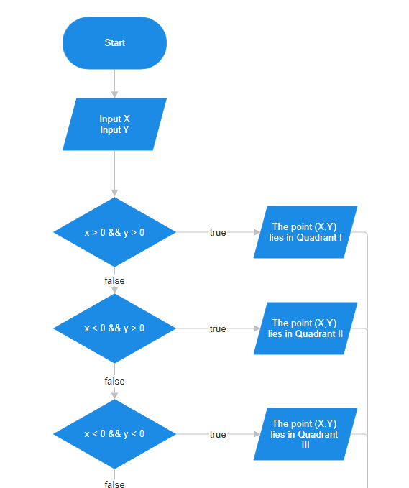

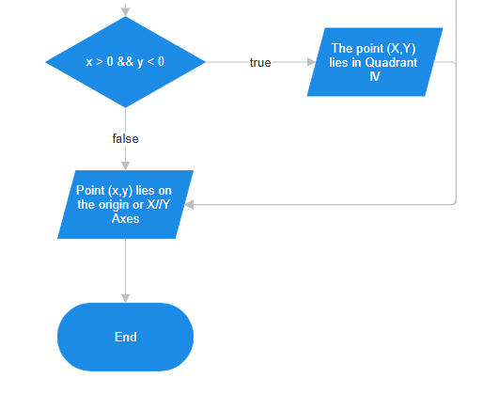

**Code:**

// Online C compiler to run C program online

#include <stdio.h>

int main() {

int x, y;

// Input coordinates

printf("Enter the value of x: ");

scanf("%d", &x);

printf("Enter the value of y: ");

scanf("%d", &y);

// Decision making

if (x > 0 && y > 0)

printf("The point (%d,%d) lies in Quadrant I\n");

else if (x < 0 && y > 0)

printf("The point (%d,%d) lies in Quadrant II\n");

else if (x < 0 && y < 0)

printf("The point (%d,%d) lies in Quadrant III\n");

else if (x > 0 && y < 0)

printf("The point (%d,%d) lies in Quadrant IV\n");

else if (x == 0 && y != 0)

printf("The point (%d,%d) lies on Y-axis\n");

else if (y == 0 && x != 0)

printf("The point (%d,%d) lies on X-axis\n");

else

printf("The point (%d,%d) lies at the Origin\n");

return 0;

}

**Question # 3: (Driving License One)**

**PAC Chart:**

|  |  |
| --- | --- |
| **Given Data**  Age, P/F Eyesight exam, P/F Written test, P/F driving test, fitness certificate availability | **Required Results**  To know if the user is eligible for a driving license based on the inputs provided |
| **Processing Required**  Nested if-else conditions for each question regarding age, eyesight exam, written test, driving test, fitness certificate. | **Solution Alternatives**  N/A |

**IPO:**

|  |  |  |
| --- | --- | --- |
| **Input** | **Process** | **Output** |
| Age, P/F Eyesight exam, P/F Written test, P/F driving test, fitness certificate availability | Following will be in nested if-else conditions   * If age < 18 then Not eligible. * If eyesight test failed then Suggest prescription glasses. * If written test failed then Must retake written test. * If driving test failed then Not eligible. * If driving test passed and age ≤ 60 then eligible. * If driving test passed and age > 60 then Check medical certificate. If yes then eligible, else not eligible. | Eligible or Not eligible |

**Algorithm:**

1. Start.
2. Ask the applicant to enter their age.
3. If the age is less than 18, display that they are not eligible for a driving license and stop.
4. Otherwise, ask the applicant if they passed or failed their eyesight test.
5. If they failed the eyesight test, display that they may need prescription glasses and stop.
6. Otherwise, ask the applicant if they passed or failed their written test.
7. If they failed the written test, display that they must retake it and stop.
8. Otherwise, ask the applicant if they passed or failed their driving test.
9. If they failed the driving test, display that they are not eligible and stop.
10. If they passed the driving test and their age is 60 or below, display that they are eligible for the licese.
11. If they passed the driving test and their age is greater than 60, ask them if they have a medical fitness certificate.
12. If they have the certificate, display that they are eligible for the license. Otherwise, display that they are not eligible.
13. End.

Pseudocode:

START

INPUT age

IF age < 18 THEN

PRINT "Not eligible for the driving license"

ELSE

INPUT eyesight (P/F)

IF eyesight = 'F' THEN

PRINT "Need to get glasses"

ELSE

INPUT written (P/F)

IF written = 'F' THEN

PRINT "You must retake the written test"

ELSE

INPUT driving (P/F)

IF driving = 'F' THEN

PRINT "Not eligible for driving license"

ELSE

IF age <= 60 THEN

PRINT "You are eligible for driving license"

ELSE

INPUT medical certificate (Y/N)

IF medical = 'Y' THEN

PRINT "You are eligible for the driving license"

ELSE

PRINT "You are not eligible for the driving license"

ENDIF

ENDIF

ENDIF

ENDIF

ENDIF

ENDIF

END

**Flowchart:**

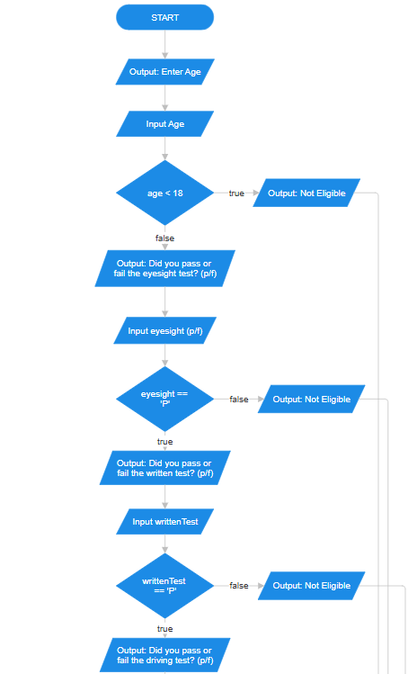

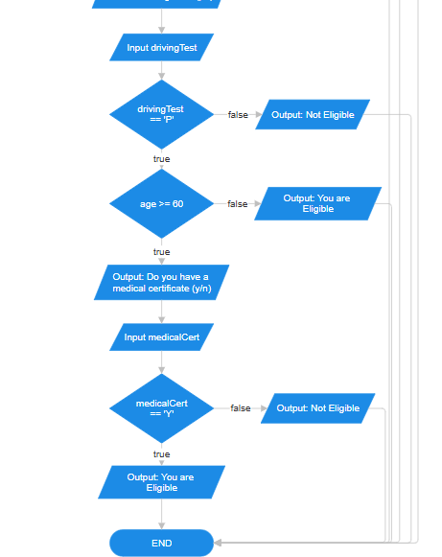

**Code:**

// Online C compiler to run C program online

#include <stdio.h>

int main() {

int age;

char eyeTest, writtenTest, drivingTest, medicalCert;

printf("Enter your age: ");

scanf("%d", &age);

if (age >= 18) {

printf("Did you pass eyeTest test? (P/F): ");

scanf(" %c", &eyeTest);

if (eyeTest == 'P' || eyeTest == 'p') {

printf("Did you pass the written test? (P/F): ");

scanf(" %c", &writtenTest);

if (writtenTest == 'P' || writtenTest == 'p') {

printf("Did you pass driving test? (P/F): ");

scanf(" %c", &drivingTest);

if (drivingTest == 'P' || drivingTest == 'p') {

if (age <= 60) {

printf("You are eligible for a driving license.\n");

}

else {

printf("Do you have a medical fitness certificate? (Y/N): ");

scanf(" %c", &medicalCert);

if (medicalCert == 'Y' || medicalCert == 'y') {

printf("You are eligible for the driving license.\n");

} else {

printf("You are not eligible for the driving license.\n");

}

}

}

else {

printf("You are not eligible for the driving license.\n");

}

}

else {

printf("You must retake the written test.\n");

}

}

else {

printf("You need to get glasses.\n");

}

}

else {

printf("You are not eligible for the driving license.\n");

}

return 0;

}

**Question No. 4**

**PAC (Problem Analysis Chart)**

* Input: 5 integers (card values 1–13) representing a poker hand.
* Output: Print whether the hand is a *Full House* or *Not a Full House*.
* Processing:  
    
  + Count occurrences of each card value.
  + Check if one rank occurs exactly 3 times and another rank occurs exactly 2 times.
  + If true → Full House, else → Not a Full House.

**IPO (Input-Processing-Output Chart)**

|  |  |  |
| --- | --- | --- |
| **Input** | **Processing** | **Output** |
| 5 integers (cards) | Count frequency of each card rank (using decision logic only). | "Full House" / "Not a Full House" |

**Algorithm**

1. Start.
2. Input 5 card values: c1, c2, c3, c4, c5.
3. Check frequency of each unique value (without arrays).
4. Find if one rank appears exactly 3 times and another exactly 2 times.
5. If condition is satisfied → print "Full House".
6. Else → print "Not a Full House".
7. End.

**Pseudocode**

START

Input c1, c2, c3, c4, c5

Set fullhouse = false

For each unique card value among c1..c5:

   Count its frequency (using if comparisons)

   If frequency == 3 then set three_found = true

   If frequency == 2 then set two_found = true

If three_found AND two_found are true

   Print "Full House"

Else

   Print "Not a Full House"

END

**Flowchart**

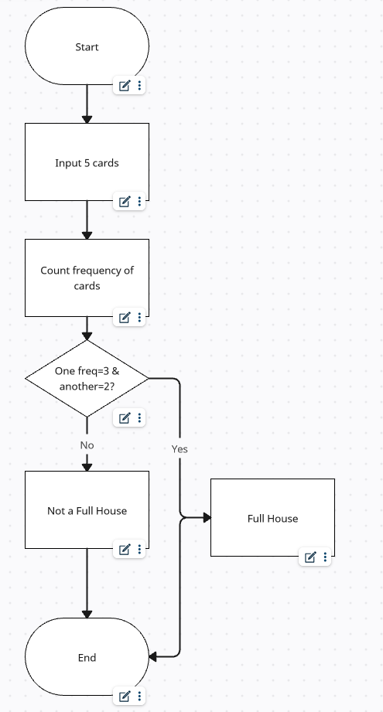

**C code:**

#include <stdio.h>

int main() {

    int c1, c2, c3, c4, c5;

    int three_found = 0, two_found = 0;

    printf("Enter 5 cards (1-13): ");

    scanf("%d %d %d %d %d", &c1, &c2, &c3, &c4, &c5);

    // Check frequency for c1

    int count1 = (c1==c1) + (c2==c1) + (c3==c1) + (c4==c1) + (c5==c1);

    if (count1 == 3) three_found = 1;

    if (count1 == 2) two_found = 1;

    // Check frequency for c2 if different from c1

    if (c2 != c1) {

        int count2 = (c1==c2) + (c2==c2) + (c3==c2) + (c4==c2) + (c5==c2);

        if (count2 == 3) three_found = 1;

        if (count2 == 2) two_found = 1;

    }

    // Check frequency for c3 if new

    if (c3 != c1 && c3 != c2) {

        int count3 = (c1==c3) + (c2==c3) + (c3==c3) + (c4==c3) + (c5==c3);

        if (count3 == 3) three_found = 1;

        if (count3 == 2) two_found = 1;

    }

    // Check frequency for c4 if new

    if (c4 != c1 && c4 != c2 && c4 != c3) {

        int count4 = (c1==c4) + (c2==c4) + (c3==c4) + (c4==c4) + (c5==c4);

        if (count4 == 3) three_found = 1;

        if (count4 == 2) two_found = 1;

    }

    // Check frequency for c5 if new

    if (c5 != c1 && c5 != c2 && c5 != c3 && c5 != c4) {

        int count5 = (c1==c5) + (c2==c5) + (c3==c5) + (c4==c5) + (c5==c5);

        if (count5 == 3) three_found = 1;

        if (count5 == 2) two_found = 1;

    }

    if (three_found && two_found)

        printf("Full House\n");

    else

        printf("Not a Full House\n");

    return 0;

}

**Question # 5: (Number Counting)**

**PAC Chart:**

|  |  |
| --- | --- |
| **Given Data**  User input (assuming num) repeatedly | **Required Results**  Count for occurrence of each “num” entered by the user |
| **Processing Required**  A loop, where user can repeatedly input values and variables that store the occurrence of each number. | **Solution Alternatives**  Can be solved via an array, but not allowed to :D |

**IPO:**

|  |  |  |
| --- | --- | --- |
| **Input** | **Process** | **Output** |
| “num” – a number between 0-9 repeatedly provided by the use | Count the occurrence of each number from 0-9 and store it in its corresponding count variable. Stop doing it when encountering and invalid number | Count for each occurrence of numbers entered by the user. |

**Algorithm:**

1. Start.
2. Initialize counters for digits 0–9, each set to 0.
3. Prompt the user to enter a number.
4. If the input is a digit between 0 and 9, increase the counter for that digit by 1.
5. Go to step 3 if num was in the range of 0-9 otherwise go to step 6
6. Display a table with two columns: "Number" and "Number of Occurrences".
7. Print each digit (0–9) along with its occurrence count.
8. End.

**Pseudocode:**

START

INIT c0, c1, c2, c3, c4, c5, c6, c7, c8, c9 = 0

INIT num = 0

REPEAT

INPUT num

IF num = 0 THEN

c0 = c0 + 1

ELSE IF num = 1 THEN

c1 = c1 + 1

ELSE IF num = 2 THEN

c2 = c2 + 1

ELSE IF num = 3 THEN

c3 = c3 + 1

ELSE IF num = 4 THEN

c4 = c4 + 1

ELSE IF num = 5 THEN

c5 = c5 + 1

ELSE IF num = 6 THEN

c6 = c6 + 1

ELSE IF num = 7 THEN

c7 = c7 + 1

ELSE IF num = 8 THEN

c8 = c8 + 1

ELSE IF num = 9 THEN

c9 = c9 + 1

ENDIF

UNTIL (num < 0 || num > 9 )

PRINT "Number \tNumber of Occurrences"

PRINT "0\t", c0

PRINT "1\t", c1

PRINT "2\t", c2

PRINT "3\t", c3

PRINT "4\t", c4

PRINT "5\t", c5

PRINT "6\t", c6

PRINT "7\t", c7

PRINT "8\t", c8

PRINT "9\t", c9

STOP

**Flowchart:**

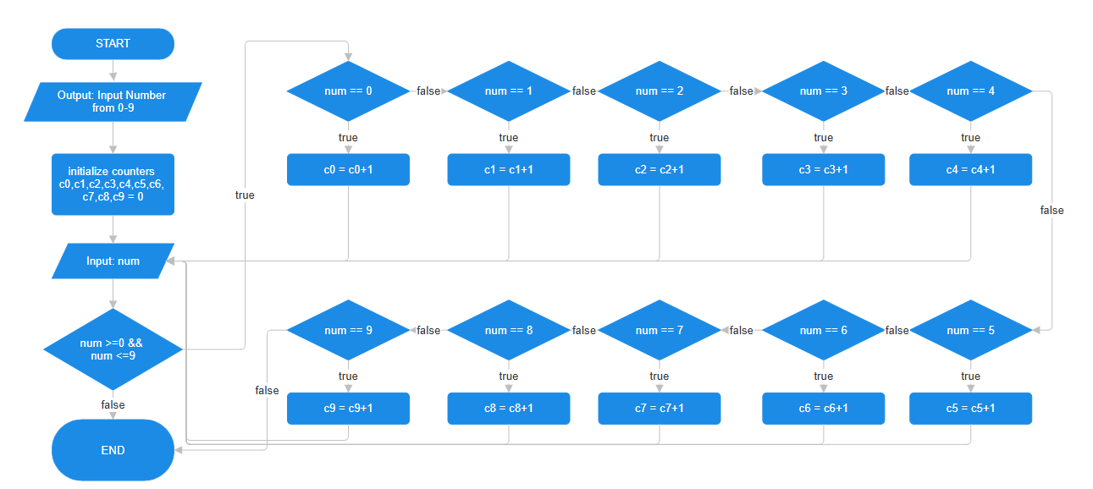

**Code: (without while loop, assuming user can input 5 times)**

// Online C compiler to run C program online

#include <stdio.h>

int main() {

int num;

int c0=0, c1=0, c2=0, c3=0, c4=0, c5=0, c6=0, c7=0, c8=0, c9=0;

printf("Enter one-digit numbers (0-9). Enter anything else to stop.\n");

printf("Enter a number: ");

scanf("%d", &num);

if (num >= 0 && num <= 9) {

if (num == 0) c0++;

else if (num == 1) c1++;

else if (num == 2) c2++;

else if (num == 3) c3++;

else if (num == 4) c4++;

else if (num == 5) c5++;

else if (num == 6) c6++;

else if (num == 7) c7++;

else if (num == 8) c8++;

else if (num == 9) c9++;

printf("Enter a number: ");

scanf("%d", &num);

if (num >= 0 && num <= 9) {

if (num == 0) c0++;

else if (num == 1) c1++;

else if (num == 2) c2++;

else if (num == 3) c3++;

else if (num == 4) c4++;

else if (num == 5) c5++;

else if (num == 6) c6++;

else if (num == 7) c7++;

else if (num == 8) c8++;

else if (num == 9) c9++;

printf("Enter a number: ");

scanf("%d", &num);

if (num >= 0 && num <= 9) {

if (num == 0) c0++;

else if (num == 1) c1++;

else if (num == 2) c2++;

else if (num == 3) c3++;

else if (num == 4) c4++;

else if (num == 5) c5++;

else if (num == 6) c6++;

else if (num == 7) c7++;

else if (num == 8) c8++;

else if (num == 9) c9++;

printf("Enter a number: ");

scanf("%d", &num);

if (num >= 0 && num <= 9) {

if (num == 0) c0++;

else if (num == 1) c1++;

else if (num == 2) c2++;

else if (num == 3) c3++;

else if (num == 4) c4++;

else if (num == 5) c5++;

else if (num == 6) c6++;

else if (num == 7) c7++;

else if (num == 8) c8++;

else if (num == 9) c9++;

printf("Enter a number: ");

scanf("%d", &num);

if (num >= 0 && num <= 9) {

if (num == 0) c0++;

else if (num == 1) c1++;

else if (num == 2) c2++;

else if (num == 3) c3++;

else if (num == 4) c4++;

else if (num == 5) c5++;

else if (num == 6) c6++;

else if (num == 7) c7++;

else if (num == 8) c8++;

else if (num == 9) c9++;

}

}

}

}

}

printf("\nNumber \tNumber of Occurrences\n");

printf("0\t\t%d\n", c0);

printf("1\t\t%d\n", c1);

printf("2\t\t%d\n", c2);

printf("3\t\t%d\n", c3);

printf("4\t\t%d\n", c4);

printf("5\t\t%d\n", c5);

printf("6\t\t%d\n", c6);

printf("7\t\t%d\n", c7);

printf("8\t\t%d\n", c8);

printf("9\t\t%d\n", c9);

return 0;

}

**Code: (using while loop)**

// Online C compiler to run C program online

#include <stdio.h>

int main() {

int num;

int c0=0, c1=0, c2=0, c3=0, c4=0, c5=0, c6=0, c7=0, c8=0, c9=0;

printf("Enter one-digit numbers (0-9). Enter anything else to stop.\n");

while (num>=0 && num<=9) {

printf("Enter a number: ");

scanf("%d", &num);

if (num == 0)

c0++;

else if (num == 1)

c1++;

else if (num == 2)

c2++;

else if (num == 3)

c3++;

else if (num == 4)

c4++;

else if (num == 5)

c5++;

else if (num == 6)

c6++;

else if (num == 7)

c7++;

else if (num == 8)

c8++;

else if (num == 9)

c9++;

}

printf("\nNumber \tNumber of Occurrences\n");

printf("0\t\t%d\n", c0);

printf("1\t\t%d\n", c1);

printf("2\t\t%d\n", c2);

printf("3\t\t%d\n", c3);

printf("4\t\t%d\n", c4);

printf("5\t\t%d\n", c5);

printf("6\t\t%d\n", c6);

printf("7\t\t%d\n", c7);

printf("8\t\t%d\n", c8);

printf("9\t\t%d\n", c9);

return 0;

}