**DAY-7**

## 

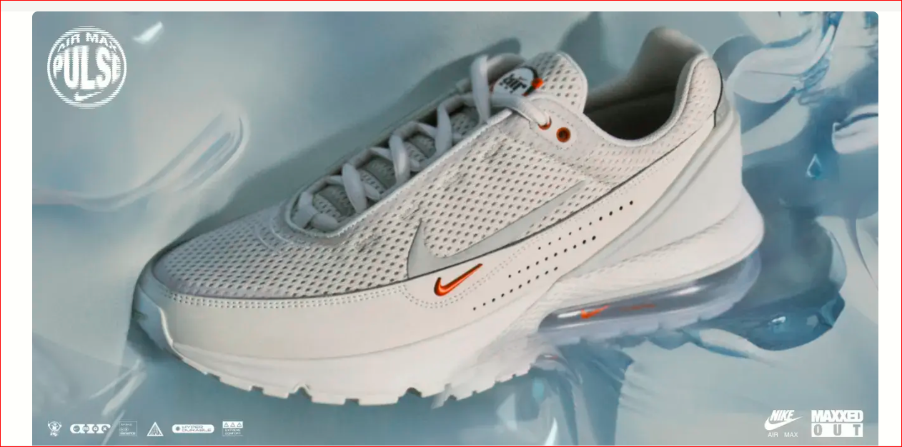

NIKE SHOE HAVEN: REVOLUTIONIZING ONLINE FOOTWEAR SHOPPING

Mehak Shah

**NIKE SHOE HAVEN: REVOLUTIONIZING ONLINE FOOTWEAR SHOPPING** Transforming E-Commerce with Seamless Management and User-Friendly Features

**NIKE SHOE HAVEN: REVOLUTIONIZING FOOTWEAR E-COMMERCE FOR EASY MANAGEMENT AND SEAMLESS SHOPPING**

**INTRODUCING NIKE SHOE HAVEN** Welcome to Nike Shoe Haven, where we are transforming the way you shop for Nike shoes online. Our platform is designed to provide a seamless and intuitive shopping experience, making it easier than ever to find and purchase the perfect pair for your lifestyle. We focus on easy order management and user-friendly navigation to enhance your e-commerce journey.

**THE CHALLENGES IN FOOTWEAR E-COMMERCE** The online footwear shopping experience comes with its own set of challenges. Customers often encounter:

* Limited product details
* Poor website navigation
* Difficulties in managing and tracking orders  
   These issues can lead to frustration and a subpar shopping experience, which our website aims to resolve.

**NIKE SHOE HAVEN SOLUTION TO SIMPLIFY FOOTWEAR SHOPPING**

**NIKE SHOE HAVEN ADDRESSES THESE CHALLENGES HEAD-ON WITH:**

* Dynamic product pages featuring comprehensive details
* Intuitive category search functionality
* A user-friendly order management system powered by Sanity

Our platform is designed to provide a smooth, hassle-free shopping experience.

**KEY FEATURES OF NIKE SHOE HAVEN:** Our website is packed with features to enhance your shopping experience:

* Responsive design for all devices
* Add to cart and seamless checkout functionality
* Dynamic product details page
* Advanced category search and filter options
* User order management integrated with Sanity

**WHO WE SERVE:** Our target audience includes:

* Sneaker enthusiasts looking for the latest Nike releases
* Athletes and fitness lovers in search of high-performance footwear
* Casual buyers seeking stylish and comfortable Nike shoes

**HOW NIKE SHOE HAVEN WORKS:** Our business model simplifies the shopping process:

1. Browse our extensive range of Nike shoes
2. Use category search and filters to find the perfect pair
3. Add selections to your cart and proceed to checkout
4. Easily manage orders with our backend system powered by Sanity

**WHY NIKE SHOE HAVEN IS THE BEST CHOICE FOR CLIENTS:** Choosing Nike Shoe Haven means:

* A user-friendly interface for easy shopping
* Cost-effective solutions without sacrificing quality

**READY TO TRANSFORM YOUR FOOTWEAR SHOPPING EXPERIENCE?** JOIN US AT NIKE SHOE AND REVOLUTIONIZE YOUR FOOTWEAR SHOPPING EXPERIENCE. WHETHER FOR SPORTS, CASUAL WEAR, OR FASHION, OUR PLATFORM OFFERS A SEAMLESS TRANSITION FROM BROWSING TO OWNING THE PERFECT NIKE SHOES.

**GET IN TOUCH:** We'd love to hear from you! Reach out to us through:

* Website: <https://nike-website-o6jq.vercel.app/>