PROJECT: STUDENT MARKS PREDICTION USING LOGISTIC REGRESSION

PROJECT DESCRIPTION
This project predicts the average marks (mean score) of students based on their demographic and educational background data. Using logistic regression, the aim is to understand how factors such as gender, race/ethnicity, lunch type, parental level of education, and test preparation course impact the students' performance.

METHODOLOGY
- Data Loading & Exploration
  - Imported the dataset (StudentsPerformance.xlsx) and explored its basic statistics and structure.
  - Created a new column, "mean score", by averaging the math, reading, and writing scores.
  - Visualized relationships using count plots, bar plots, pie charts, pair plots, and heatmaps.
- Data Preprocessing
  - Categorical columns (gender, race/ethnicity, parental level of education, lunch, test preparation course) were converted to numeric using LabelEncoder.
  - Dropped individual scores (math, reading, writing) to focus on predicting the "mean score".
- Model Building
  - Split the data into training and testing sets (80/20).
  - Used logistic regression (LogisticRegression with liblinear solver) to train the model.
- Evaluation
  - Made predictions on the test data.
  - Calculated the average error in predicted vs. actual scores (~11.03 marks).

CODE & RESULTS (Snapshots):
#load the data
import seaborn as sns
import pandas as pd
import matplotlib.pyplot as plt

data = pd.read_excel(r'C:\Users\Wajiz.pk\Desktop\Machine Learning Project\StudentsPerformance.xlsx')
print(data)
output:
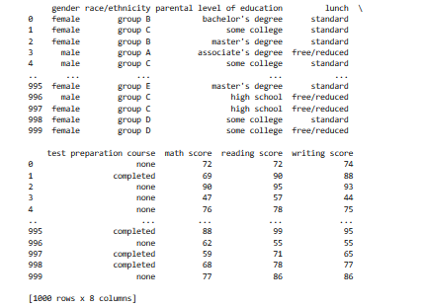

#print first 10 rows

data.head(10)

output:

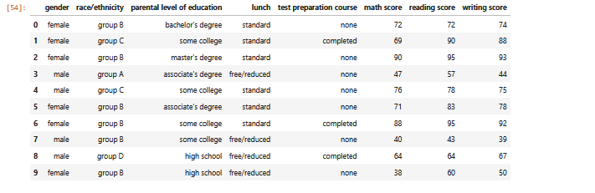

#print last 10 rows

data.tail(10)

output:

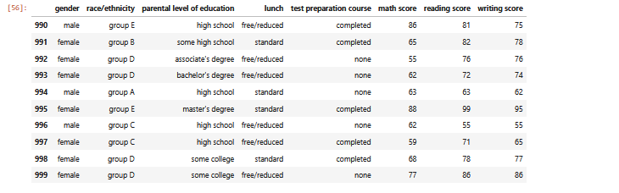

#Check total no of col and rows using shape

data.shape

output:

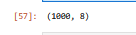

#stats

data.describe()

output:

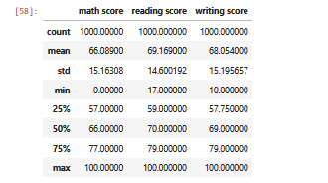

#Create a new column for the rounded average of the three scores and display the first 10 rows.

data["mean score"] = ((data["math score"] + data["reading score"] + data["writing score"]) / 3).round()

data.head(10)

output:

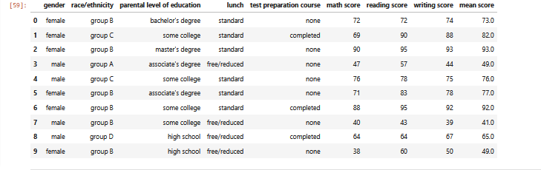

#check how many females and males

data['gender'].value_counts()

output:

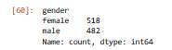

#The code converts categorical columns to numeric using `LabelEncoder`.

from sklearn.preprocessing import LabelEncoder

lc = LabelEncoder()

data['gender'] = lc.fit_transform(data['gender'])

data['race/ethnicity'] = lc.fit_transform(data['race/ethnicity'])

data['parental level of education'] = lc.fit_transform(data['parental level of education'])

data['lunch'] = lc.fit_transform(data['lunch'])

data['test preparation course'] = lc.fit_transform(data['test preparation course'])

data.head(10)

output:

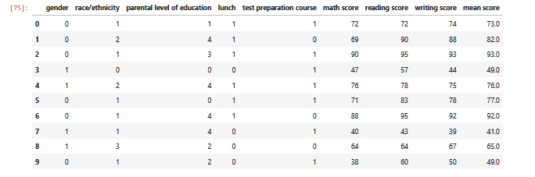

#Analysis Gender & Race

import seaborn as sns

sns.countplot(x='gender', data=data, hue='race/ethnicity' )

plt.show()

#0 means female

#1 means male

Output:

#mostly females belongs to group C

#mostly males belongs to group

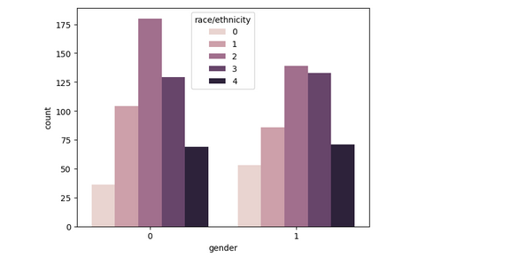

#Analysing Test Preparation Course

data['test preparation course'].value_counts()

# 1 means None

# 0 means Completed

Output:

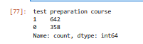

#Pie chart of analysing Test Preparation Course

labels = ['None', 'Completed']

colors = ['lightblue', 'blue']

plt.pie(data['test preparation course'].value_counts() , labels = labels, colors = colors)

output:

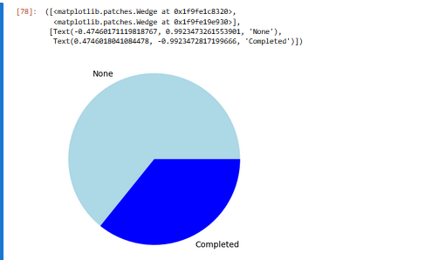

plt.figure(figsize = (8,5))

sns.barplot(x = 'test preparation course', y = 'mean score', data=data)

plt.show()

output:

#Students have done the course means 0 they are scoring good scores

#Students have not done the course means 1 they are scoring less scores

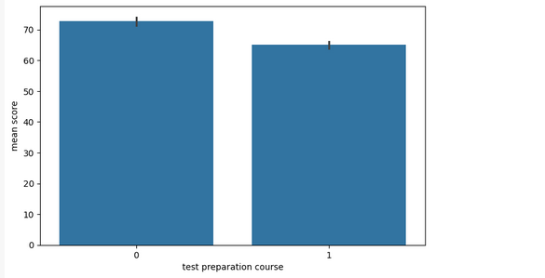

#Analysing Lunch

sns.barplot(x='lunch', y='mean score', hue='lunch', data=data, palette='dark', legend=False)

plt.show()

#0 free lunch from government

#1 bringing own lunch

Output:

#Those students mean score is more who bringing own lunch rather than the those students with free/reduced lunch

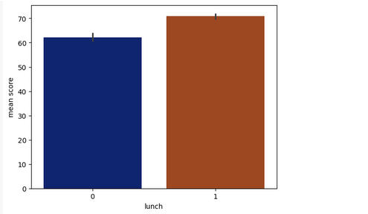

#Analysing parental level of education

sns.barplot(x = 'parental level of education', y = 'mean score', data = data)

output:

#3rd category students performing in good marks beacuse their parents have masters degree

#2nd Category of Parental Education belongs to High School and 3rd Category belongs to Master Degree

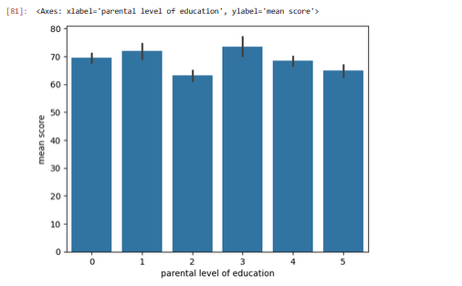

#this is pair plot for my data , in this check relationship of each col with each other

plt.figure(figsize = (12,6))

sns.pairplot(data)

plt.show()

output:

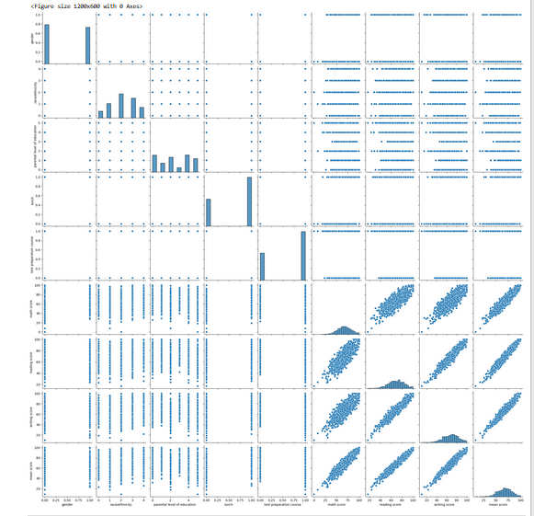

#this is heatmap, in this check correlation

sns.heatmap(data.corr())

plt.show()

output:

#in this see math,reading,writing and mean are good correlation with mean score

#gender not good correlation

#race is good correlation

#parental level is ok

#lunch is good relationships

#test preparation not much but ok

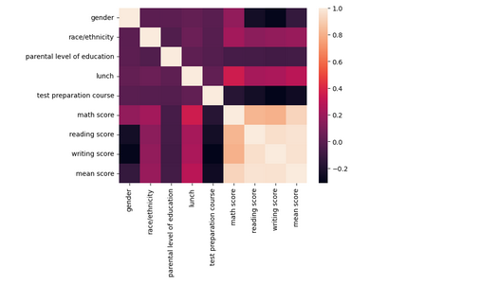

#Data Preprocessing

#In this droping math , writing and reading score beacuse main target class is mean score

df = data.drop(['math score', 'writing score', 'reading score'],axis = 1)

df.head()

output:

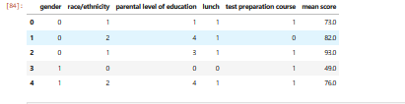

from sklearn.model_selection import train_test_split

y = df['mean score']

x = df.drop(['mean score'], axis = 1)

x_train, x_test, y_train, y_test = train_test_split(x,y,test_size = 0.2, random_state = 0)

#Model Building

#using logistic regression

from sklearn.linear_model import LogisticRegression

from sklearn.metrics import classification_report, confusion_matrix

model = LogisticRegression(solver='liblinear', random_state=0)

model.fit(x_train, y_train)

output:

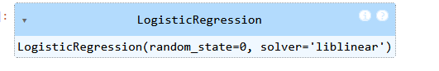

predictions = model.predict(x_test)

predictions

output:

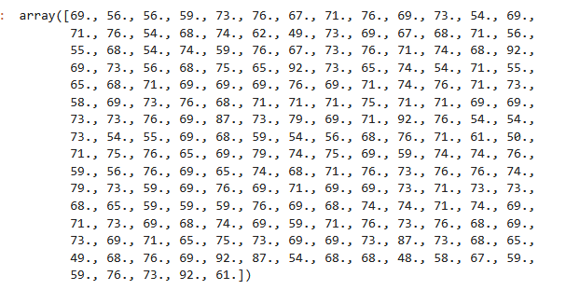

y_test

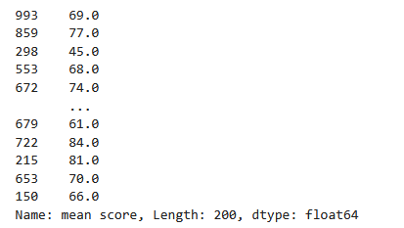

difference = abs(predictions - y_test)

difference.mean()

#Average error is 11.03 marks

CONCLUSION
The project highlights how certain student factors (like lunch type, parental education, and test preparation course) are associated with their average scores. Despite using a logistic regression model (better suited for classification tasks), it still provided reasonable insight into trends in student performance. However, using a regression model (like LinearRegression) instead of logistic regression might yield more accurate continuous predictions for numeric outcomes like mean scores.

