BookVision

**PROBLEM STATEMENT**

In a digital era where conventional reading has lost its appeal, our application creates a new way to animate books. Through NLP and animation, it changes the static text into dynamic stories, which leads to the interest and understanding of the readers.

**PROPOSED SOLUTION**

The app offers users the ability to upload their favorite e-books, which are then processed using natural language techniques to extract the text and create corresponding visual scenarios. These scenarios are presented as pictures and animations, providing an engaging and dynamic storytelling experience. Users can interact with the animated story through a flip book-like interface and adjust the playback speed to their preference. Additionally, the app includes an export feature, allowing users to save their animated books as videos or share them on online platforms. It is designed to handle large books and complex animations smoothly, ensuring a high-quality, seamless user experience.

**FLOW OF THE PROJECT**

**1ST PAGE :** LOGIN AND LOGIN DETAILS

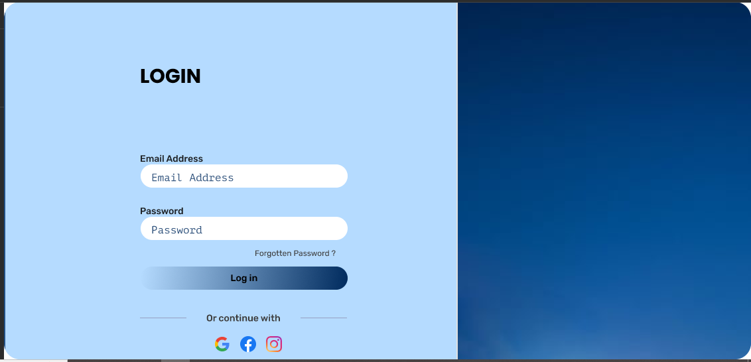

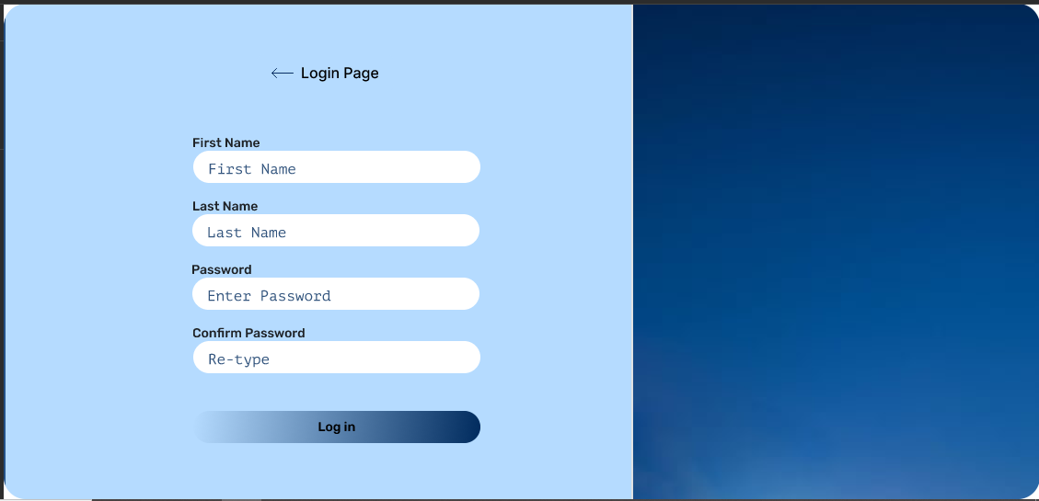

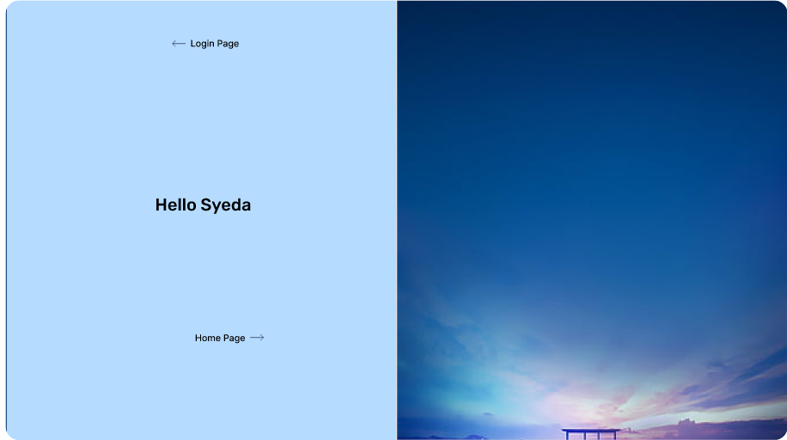

The user is supposed to all the necessary details to access the app.

**2nd PAGE: HOME PAGE**

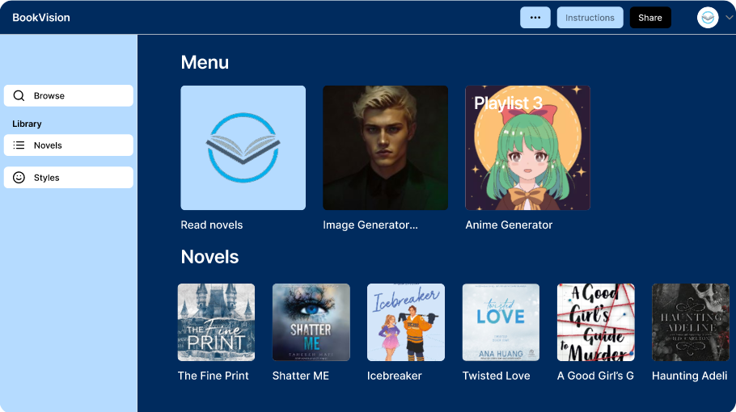

3RD PAGE: UPLODING OF THE NOVEL

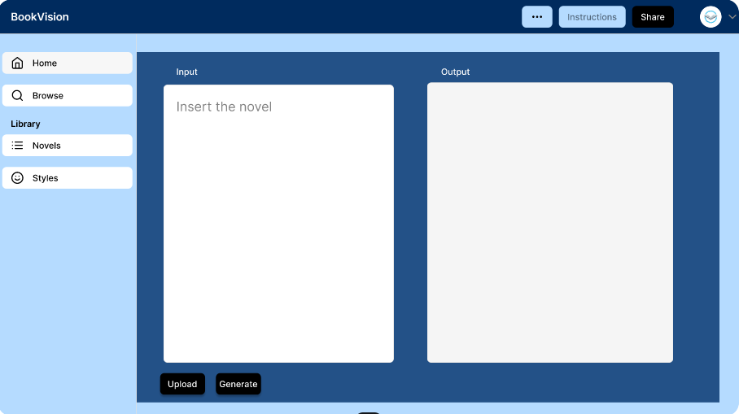

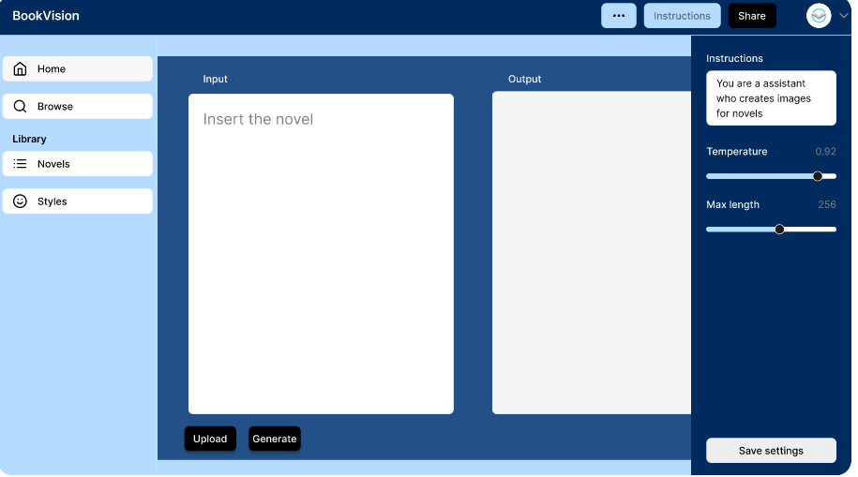 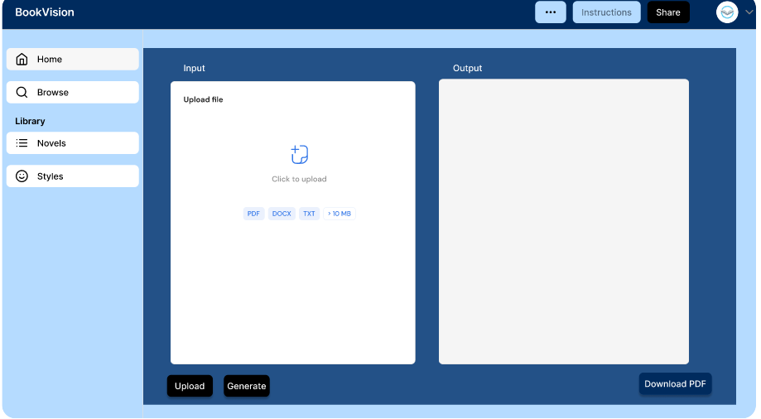

Users are supposed to upload their desired novel or book so that the pictures can be generated.

4TH PAGE: ONCE THE PICTURES ARE GENERATED

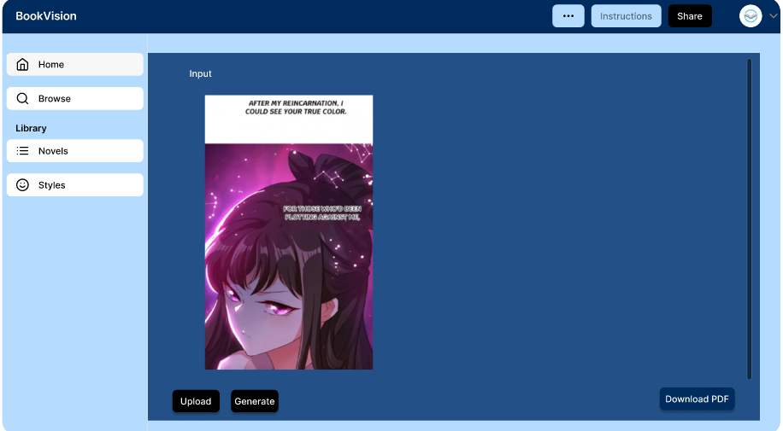

Once the animation is created, users can download their favorite novel or book.