**MEDIGUID**

**INTRODUCTION:**

In today's fast-paced world, it can be challenging to find trustworthy medical information, especially for those who prioritize their health. That's where MediGuide comes in as your personal health assistant, available 24/7 to offer tailored guidance and support. Whether you're seeking clarity on symptoms or need advice for managing a chronic condition, MediGuide is here to support you on your journey to improved health and well-being. With its personalized approach, MediGuide empowers you to make well-informed decisions about your health, providing reassurance in an era flooded with information.

When you're feeling unwell or overwhelmed by health issues, MediGuide is available around the clock to cater to your specific needs and offer support through chat. Regardless of your symptoms or chronic condition, MediGuide provides immediate assistance. As a proactive partner, it keeps track of your health history and habits, enabling it to offer advice on prevention and healthy living. What sets MediGuide apart is its reliance on reliable, evidence-based information, countering misinformation found elsewhere. With knowledge and support, MediGuide empowers you to make informed health decisions, leading to better outcomes. In today's intricate healthcare landscape, MediGuide stands as a trusted companion on your journey to wellness.

**PROBLEM STATEMENT:**

Accessing medical care can be a daunting and stressful task, particularly during emergencies or urgent medical needs. Patients often face delays in consulting healthcare professionals, securing appointments, and receiving timely medical advice and treatment. These delays can lead to worsened health outcomes, increased stress levels, and an overall unsatisfactory healthcare experience for patients. It's crucial to find a solution that simplifies the healthcare process and reduces these delays, ensuring timely and effective medical care for everyone.

Getting medical help, mainly in emergencies, is really tough for patients. It leads to stress and poor health outcomes. Delays in seeing professionals, getting appointments, and getting timely care make health problems worse and make patients unhappy with healthcare. Delays don't just affect physical health but also make stress levels higher, hurting mental health too. Longer delays can worsen conditions, so patients need intense treatment and take longer to recover. Feeling uncertain about getting care also burdens patients and families emotionally.

**PROPOSED SOLUTION:**

We have a vision for the future where everyone can access medical care efficiently. To make this a reality, we are proposing the development of an intelligent healthcare chatbot that seamlessly integrates with healthcare providers' systems. This chatbot will allow users to easily access their medical records and treatment plans, and receive timely medical advice. Our solution also includes the implementation of a comprehensive database and the use of NLP and AI tools containing valuable information on injuries, causes, symptoms, treatment options, consultation processes, and associated costs. This database and AI tool will empower users to make informed decisions about their healthcare needs, enabling them to take control of their health. We are committed to ensuring the chatbot's effectiveness and relevance in addressing evolving healthcare challenges, and we will continuously update and improve it based on user feedback and healthcare trends. Our collaborations with healthcare professionals will uphold standards of accuracy, best practices, and regulatory compliance, ensuring the overall quality and reliability of the healthcare chatbot's services. Join us in creating a future where quality healthcare is accessible to all.

**FLOW OF THE PROJECT**

**1ST PAGE:**

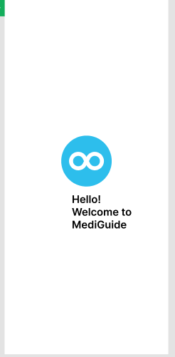

2ND PAGE:

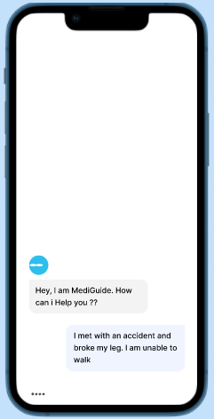

Users can access the chatbot, which is designed to provide effective answers to their inquiries. The chatbot is available to assist users with a wide range of questions and provide helpful responses in real time.

**MARKET OPPORTUNITIES:**

The proposal for an intelligent healthcare chatbot offers an exciting opportunity to address the pressing need for accessible and efficient medical care. By seamlessly integrating with healthcare providers' systems, this chatbot provides a user-friendly platform for accessing medical information, treatment plans, and timely advice. Its comprehensive database, covering injuries, symptoms, treatments, and associated costs, empowers users to make informed healthcare decisions, promoting autonomy and control over their health. This not only improves accessibility by providing 24/7 access to medical information but also offers convenience by enabling users to avoid the hassle of scheduling appointments.

Furthermore, the chatbot's provision of information on treatment options and related costs promotes cost-effectiveness, catering to individuals seeking affordable healthcare solutions. In addition, its commitment to continuous updates and improvements based on user feedback and healthcare trends ensures relevance and effectiveness in addressing evolving healthcare challenges. Collaborations with healthcare professionals further ensure the highest standards of accuracy, best practices, and regulatory compliance, instilling trust in users regarding the quality and reliability of the chatbot's services.

Overall, the development of an intelligent healthcare chatbot represents a transformative opportunity to revolutionize healthcare delivery, making quality healthcare more accessible and efficient for individuals worldwide.