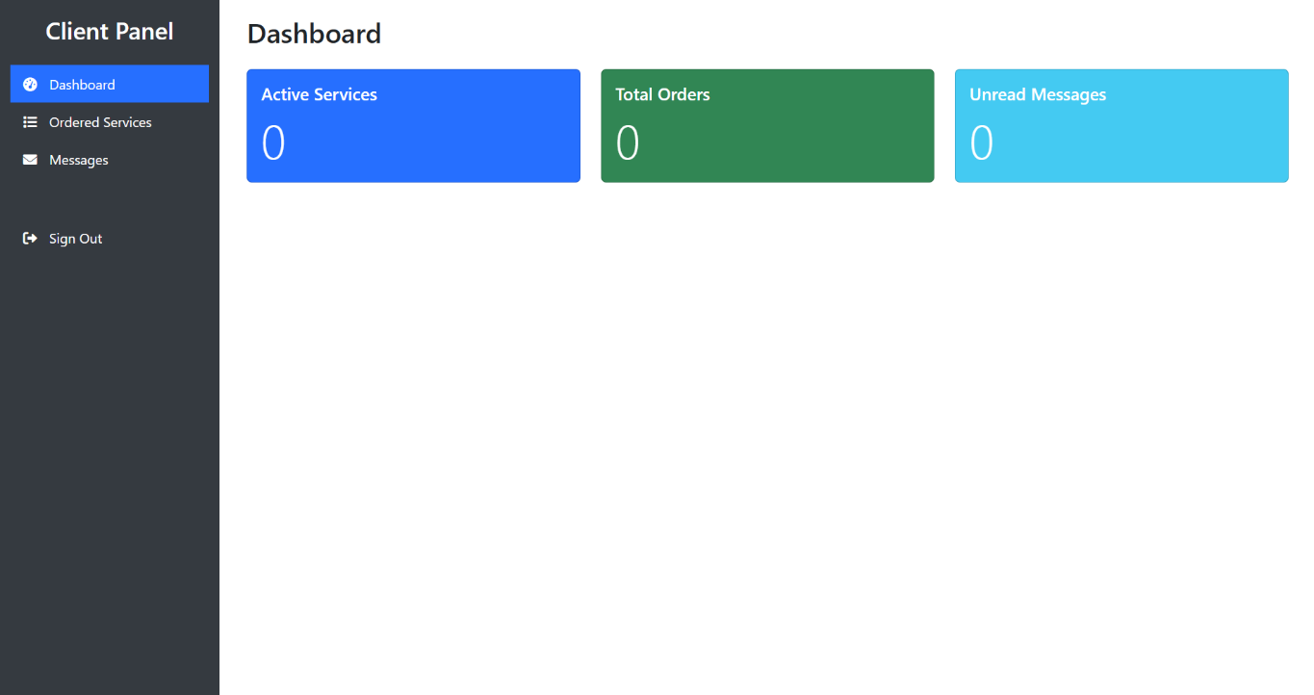Changings in client , admin, user dashboard

**Freelancer Search/Explore CTA**  
Add a button or card: **“Find a Freelancer”** or **“Browse Services”** to encourage discovery.

**Feedback Prompt**  
Encourage clients to leave feedback on completed orders (REVIEWS)

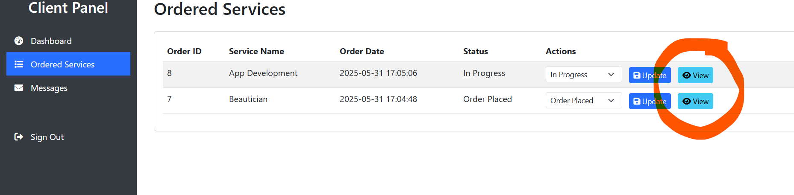

VIEW IS NOT WORKING

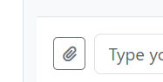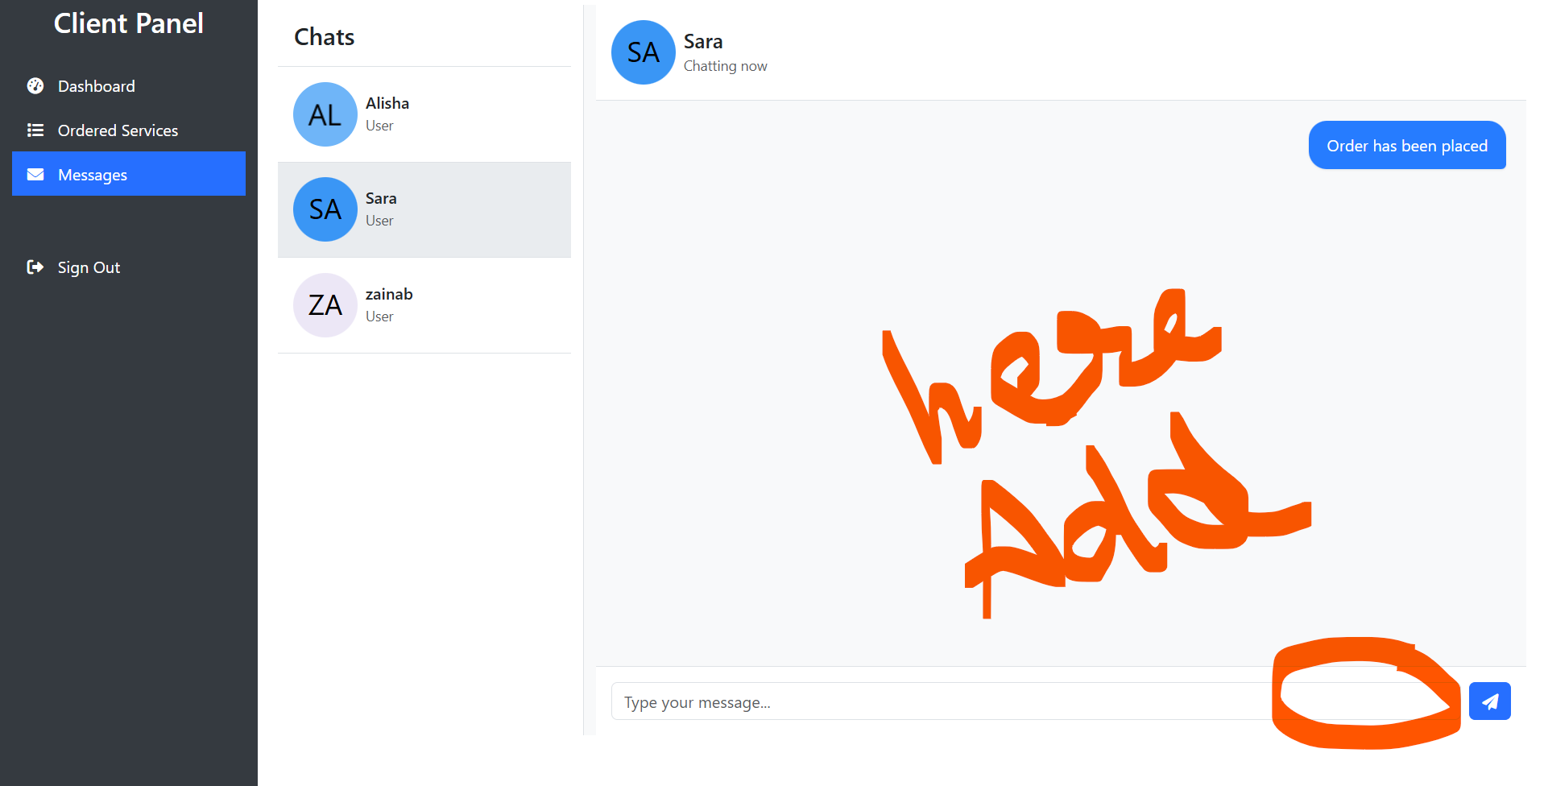

CREATE AN OFFER button 🡺 BUDGET OF PROJECT

HAR CLIENT FREELANCER KO RATE BTA SKTA NEGOTIATE KR SKTA AMOUNT   
then payment method (jazzcash/easypaisa)

AND ALSO ADD UPLOAD PDF, IMAGES ETC IN CHATBOT

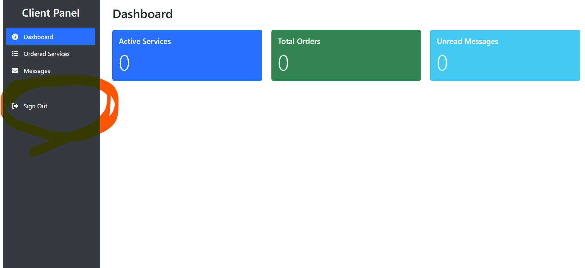

Signout is not working

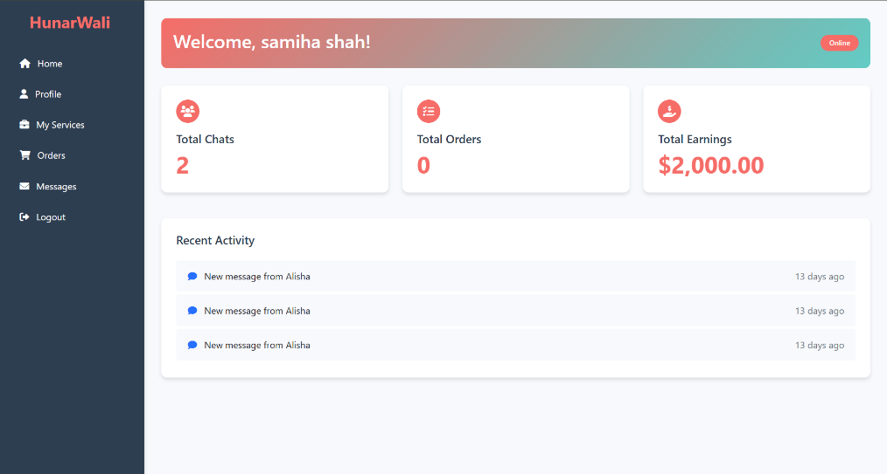in freelancer panel add ;  
**CTA for Adding Services**

If there are no orders yet, suggest: “Add your first service to start earning!”

**Ratings & Reviews Panel**

Space to show reviews once orders begin.

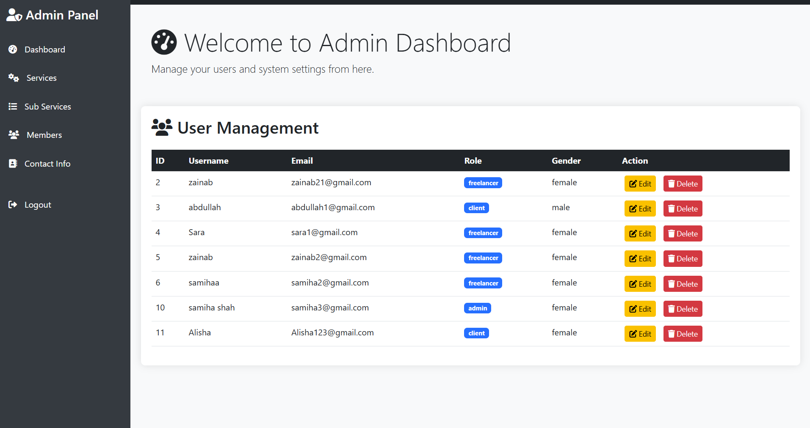

HERE IN MENU, AIK OR CHEEZ BANY GI TO BLOCK USERS/CLIENTS 🡺 **Reports / Abuse Management** to handle harassment or inappropriate content reports

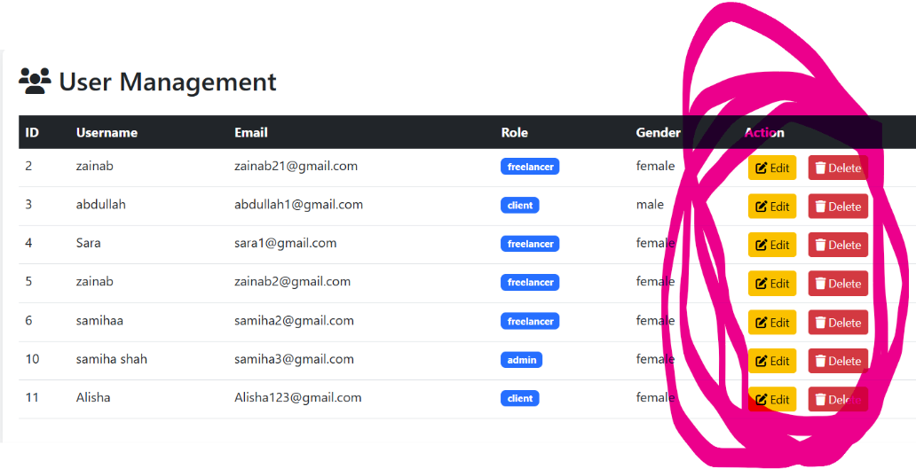Delete or edit work ni kr rha

Idhar hi approve/reject freelancer/client add krna ha, validation & verification ho takay… to manually approve verified freelancer profiles

 Delete this

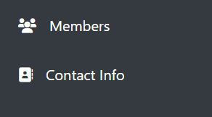 Not working

Client , admin, user dashboard yeh teeno jb khulty they can’t go to homepage, servicespage, or any other page. Khultyhi homepage aye, or whenever they want to see their dashboard, tb dashboard khul jaye..

Client & user reviews (fiverr) 🡺 both can give reviews, client freelancer ko abt work done,and freelancer to client🡺 how was experience working with buyer

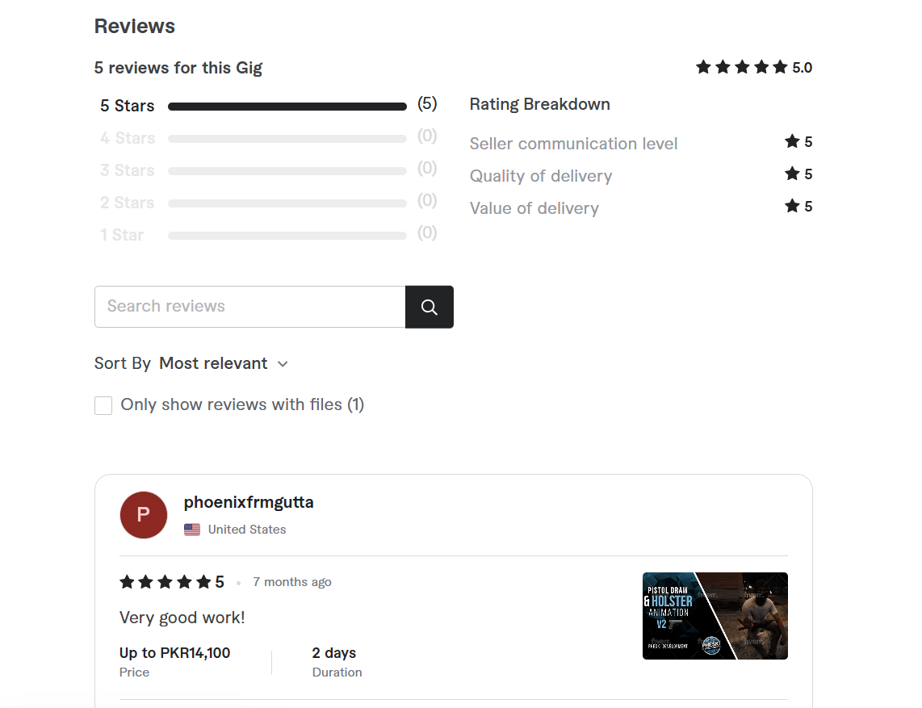

Chatbot 🡺 change the interface of chatbot

ADD how it works page

<https://www.fiverr.com/cp/how-fiverr-works>

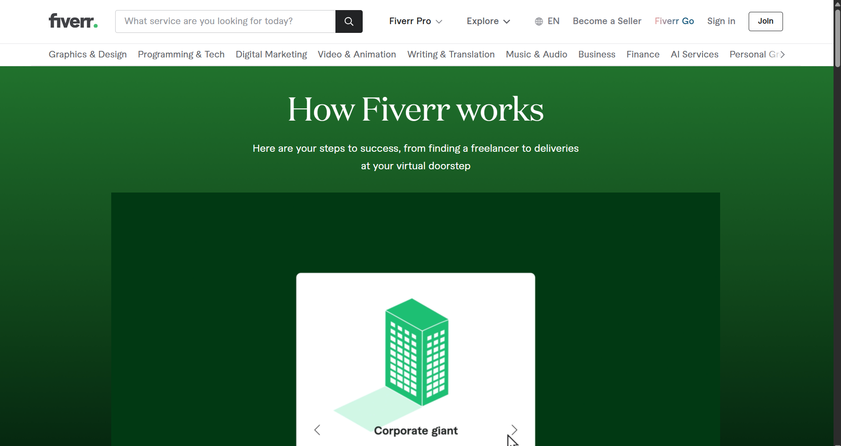

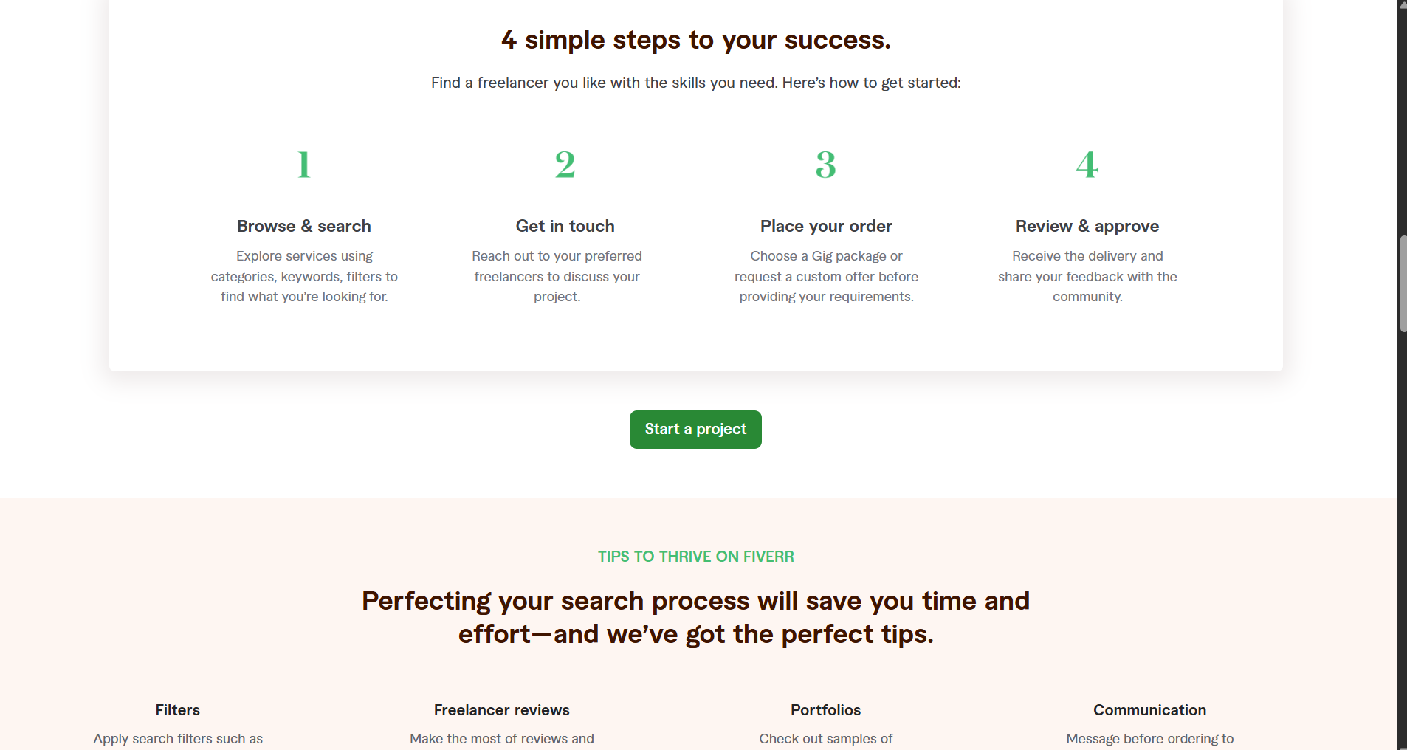

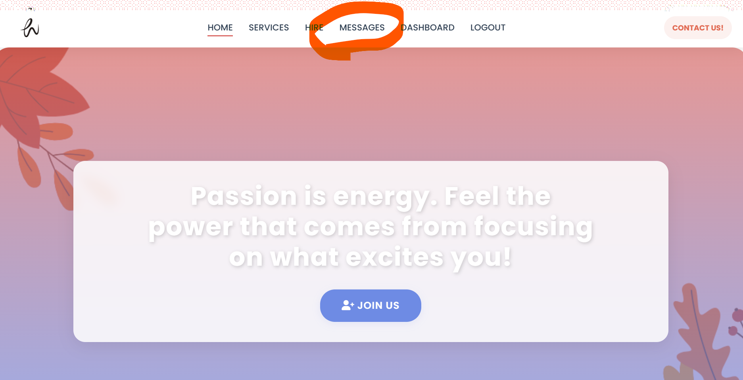  
MESSAGES NOT WORKING  
  
  
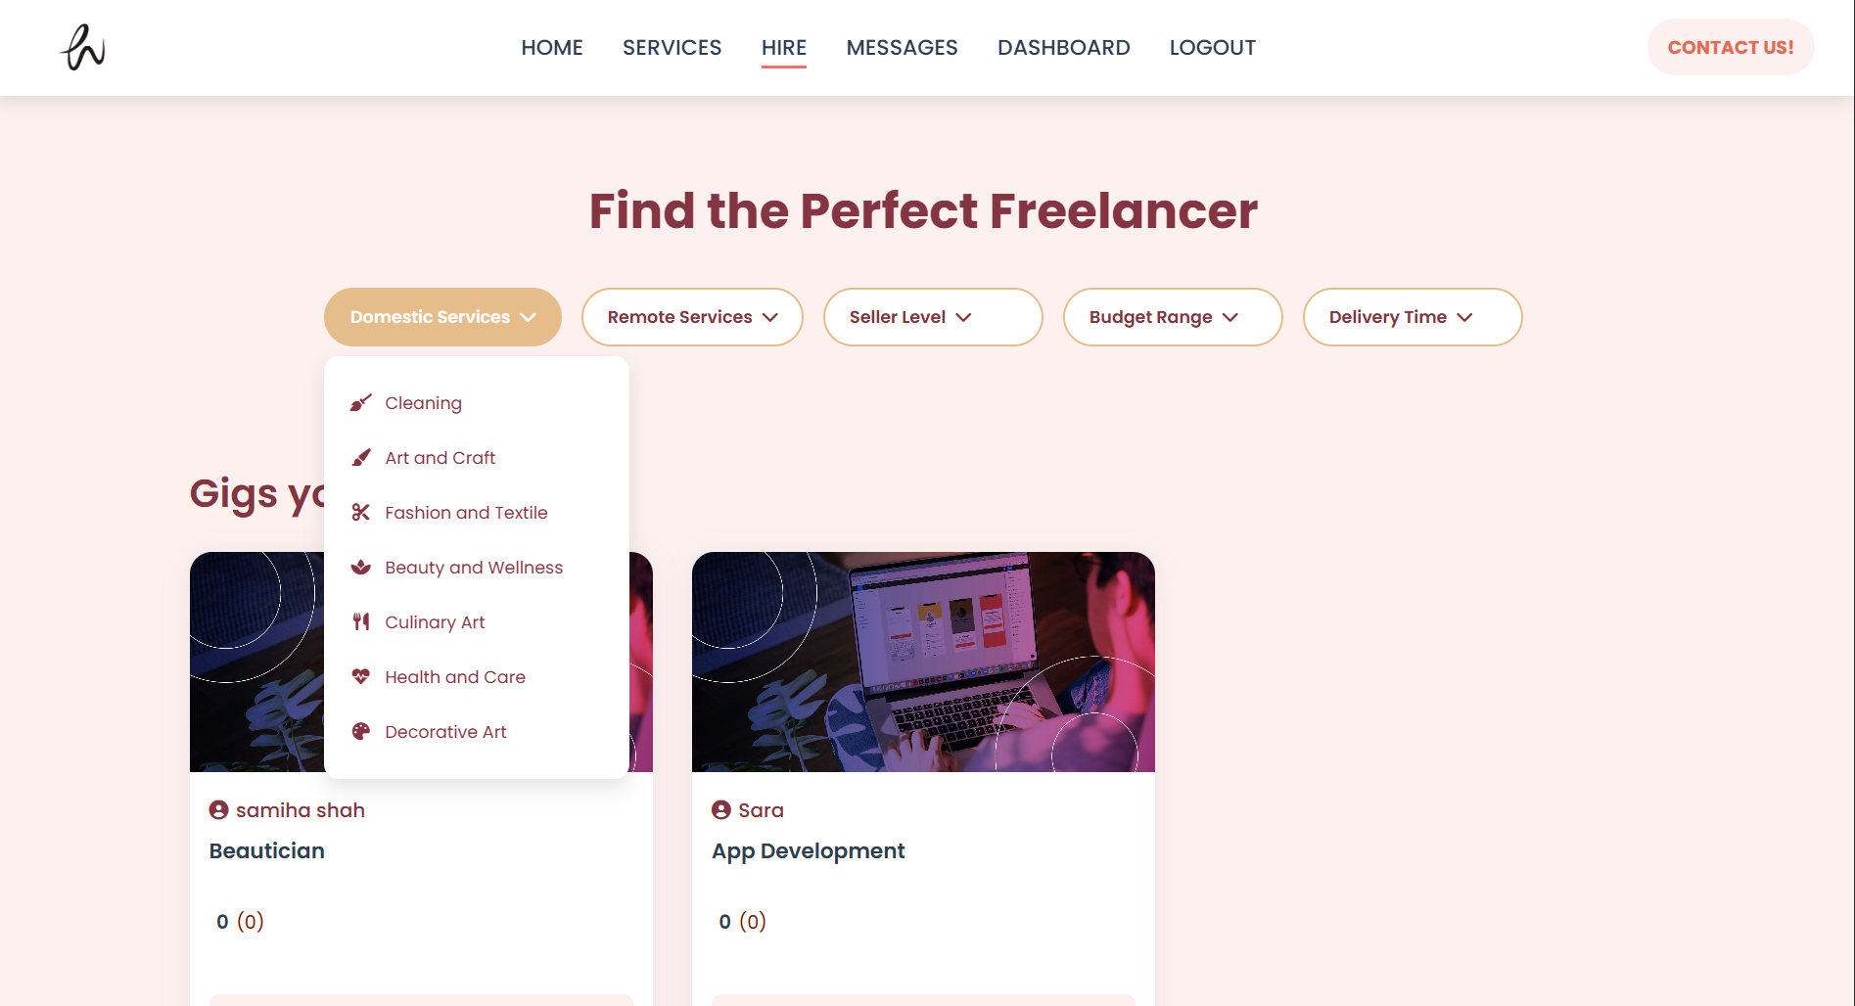

THESE ALL FILTERS ARE NOT Functional….  
**CHANGE EVERY $ TO PKR EVERYWHERE**

**SOME CHANGINGS:**

PAYMENT PAGE AFTER ORDER COMPLETION  
ORDER HISTORY AND TRACKING