

Artificial Intelligence(Lab)
Lab Report 5
Submitted By:
Syeda Urwa Zainab
SU92-BSSEM-S25-030
BSSE-4A
Submitted To:
Sir Rasikh Ali

Task 1: Trace the Game Tree Using Minimax

1. Objective
The objective is to calculate the best possible result from a game tree using the Minimax algorithm. MAX tries to get the highest score, while MIN tries to get the lowest score for MAX.

2. Given Scores
The original scores are:
[3, 5, 2, 9, 0, 7]
The supplied code adds two zeros to complete the binary tree. The final scores are:
[3, 5, 2, 9, 0, 7, 0, 0]

3. Game Tree Diagram

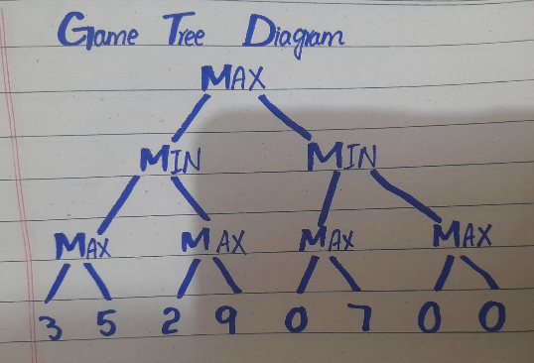

The diagram shows three decision levels followed by the terminal scores. MAX selects the larger value, and MIN selects the smaller value.

4. Step-by-Step Calculations

Step 1: Calculate MAX values
MAX selects the highest value from each pair of scores.
Calculation | Result
MAX(3, 5) | 5
MAX(2, 9) | 9
MAX(0, 7) | 7
MAX(0, 0) | 0

Step 2: Calculate MIN values
MIN selects the lowest value from each pair of MAX results.
Calculation | Result
MIN(5, 9) | 5
MIN(7, 0) | 0

Step 3: Calculate the root value
The root belongs to MAX so it selects the higher of the two MIN results.
Calculation | Result
MAX(5, 0) | 5

5. Final Values of the Tree
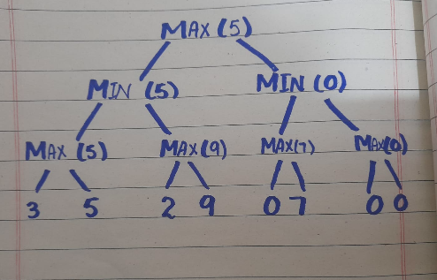

6. Final Result
The optimal Minimax value is 5.

7. Interpretation
First, each MAX node selects the higher score from its children. Next, each MIN node selects the lower score from its children. Finally, the root MAX node compares the two results 5 and 0 and selects 5.

8. Conclusion
The Minimax algorithm helps an AI choose the best result while considering the opponent's decisions. By calculating the game tree from the bottom to the top we obtained the final optimal value of 5.

Task 2: Leaf Evaluation Counter

1. Objective
The objective is to add a counter to Minimax and Alpha-Beta pruning to count how many leaf nodes each algorithm evaluates.

2. Method
I used the same scores for both algorithms:
[3, 5, 2, 9, 3, 5, 2, 9]
A counter increases by 1 whenever an algorithm reaches a leaf node and reads its score. Both algorithms use the same tree so their results can be compared fairly.

3. Results
Algorithm | Root Value | Leaf Evaluations
Minimax | 5 | 8
Alpha-Beta | 5 | 6

4. Source Code

import math

# Minimax with leaf counter

def minimax(curDepth, nodeIndex, maxTurn, scores, targetDepth, count):

if curDepth == targetDepth:

count[0] += 1

return scores[nodeIndex]

if maxTurn:

return max(

minimax(curDepth + 1, nodeIndex * 2, False,

scores, targetDepth, count),

minimax(curDepth + 1, nodeIndex * 2 + 1, False,

scores, targetDepth, count)

)

else:

return min(

minimax(curDepth + 1, nodeIndex * 2, True,

scores, targetDepth, count),

minimax(curDepth + 1, nodeIndex * 2 + 1, True,

scores, targetDepth, count)

)

# Alpha-Beta with leaf counter

def alphabeta(depth, index, maxTurn, scores, target,

alpha, beta, count):

if depth == target:

count[0] += 1

return scores[index]

if maxTurn:

value = float('-inf')

for i in range(2):

result = alphabeta(

depth + 1, index * 2 + i, False, scores,

target, alpha, beta, count

)

value = max(value, result)

alpha = max(alpha, value)

if alpha >= beta:

break

return value

else:

value = float('inf')

for i in range(2):

result = alphabeta(

depth + 1, index * 2 + i, True, scores,

target, alpha, beta, count

)

value = min(value, result)

beta = min(beta, value)

if alpha >= beta:

break

return value

# Same scores for both algorithms

scores = [3, 5, 2, 9, 3, 5, 2, 9]

depth = int(math.log2(len(scores)))

# Run Minimax

minimax_count = [0]

minimax_value = minimax(0, 0, True, scores, depth, minimax_count)

# Run Alpha-Beta

alphabeta_count = [0]

alphabeta_value = alphabeta(

0, 0, True, scores, depth,

float('-inf'), float('inf'), alphabeta_count

)

# Display results

print("Minimax root value:", minimax_value)

print("Minimax leaf evaluations:", minimax_count[0])

print("Alpha-Beta root value:", alphabeta_value)

print("Alpha-Beta leaf evaluations:", alphabeta_count[0])

5. Output

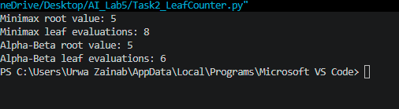

6. Explanation
Minimax evaluates all eight leaf nodes. Alpha-Beta evaluates only six because it prunes a branch when that branch cannot change the final decision.
Both algorithms return the same root value, 5. Alpha-Beta evaluates two fewer leaves in this example.

7. Conclusion
The counter shows that Alpha-Beta pruning can reduce unnecessary work while preserving the Minimax result. The number of evaluated leaves depends on the order in which branches are explored.

8. Limitation
This experiment uses a small, fixed game tree. A larger tree may show a different amount of pruning depending on the order of the branches.

Task 3: Effect of Branch Ordering

1. Objective
The objective is to change the order of branches in the game tree and observe how it affects Minimax and Alpha-Beta pruning.

2. Method
I first tested the original leaf scores:
[3, 5, 2, 9, 3, 5, 2, 9]
Then I changed the branch order to:
[2, 9, 3, 5, 2, 9, 3, 5]
I ran both algorithms on both arrangements and counted the leaf nodes evaluated.

3. Results
Branch Order | Algorithm | Root Value | Leaves Evaluated
Original | Minimax | 5 | 8
Original | Alpha-Beta | 5 | 6
Reordered | Minimax | 5 | 8
Reordered | Alpha-Beta | 5 | 8

4. Source Code

import math

# Minimax with leaf counter

def minimax(curDepth, nodeIndex, maxTurn, scores, targetDepth, count):

if curDepth == targetDepth:

count[0] += 1

return scores[nodeIndex]

if maxTurn:

return max(

minimax(curDepth + 1, nodeIndex * 2, False,

scores, targetDepth, count),

minimax(curDepth + 1, nodeIndex * 2 + 1, False,

scores, targetDepth, count)

)

else:

return min(

minimax(curDepth + 1, nodeIndex * 2, True,

scores, targetDepth, count),

minimax(curDepth + 1, nodeIndex * 2 + 1, True,

scores, targetDepth, count)

)

# Alpha-Beta with leaf counter

def alphabeta(depth, index, maxTurn, scores, target,

alpha, beta, count):

if depth == target:

count[0] += 1

return scores[index]

if maxTurn:

value = float('-inf')

for i in range(2):

result = alphabeta(

depth + 1, index * 2 + i, False,

scores, target, alpha, beta, count

)

value = max(value, result)

alpha = max(alpha, value)

if alpha >= beta:

break

return value

else:

value = float('inf')

for i in range(2):

result = alphabeta(

depth + 1, index * 2 + i, True,

scores, target, alpha, beta, count

)

value = min(value, result)

beta = min(beta, value)

if alpha >= beta:

break

return value

# Original and reordered leaf scores

original_scores = [3, 5, 2, 9, 3, 5, 2, 9]

reordered_scores = [2, 9, 3, 5, 2, 9, 3, 5]

depth = int(math.log2(len(original_scores)))

# Test original branch order

mini_count1 = [0]

mini_value1 = minimax(

0, 0, True, original_scores, depth, mini_count1

)

ab_count1 = [0]

ab_value1 = alphabeta(

0, 0, True, original_scores, depth,

float('-inf'), float('inf'), ab_count1

)

# Test reordered branches

mini_count2 = [0]

mini_value2 = minimax(

0, 0, True, reordered_scores, depth, mini_count2

)

ab_count2 = [0]

ab_value2 = alphabeta(

0, 0, True, reordered_scores, depth,

float('-inf'), float('inf'), ab_count2

)

# Display comparison

print("Original Branch Order")

print("Minimax value:", mini_value1)

print("Minimax leaves:", mini_count1[0])

print("Alpha-Beta value:", ab_value1)

print("Alpha-Beta leaves:", ab_count1[0])

print("\nReordered Branches")

print("Minimax value:", mini_value2)

print("Minimax leaves:", mini_count2[0])

print("Alpha-Beta value:", ab_value2)

print("Alpha-Beta leaves:", ab_count2[0])

5. Output

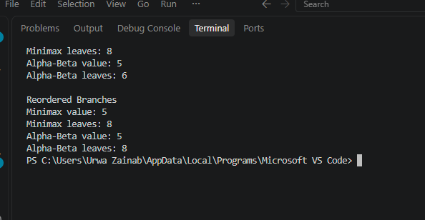

6. Explanation
Minimax evaluates all eight leaf nodes in both arrangements and returns a root value of 5.
With the original order, Alpha-Beta evaluates six leaves because it can prune two leaves. After reordering the branches, Alpha-Beta evaluates all eight leaves in this example.
The root value remains 5 for both algorithms. However, the number of evaluated leaves changes because Alpha-Beta pruning depends on the order in which branches are explored.

7. Conclusion
Branch ordering affects the efficiency of Alpha-Beta pruning but does not change the Minimax result for this complete game tree. A suitable branch order can reduce unnecessary evaluations.

8. Limitation
This experiment uses a small game tree. The amount of pruning may differ for larger trees and other branch orders.

