

Artificial Intelligence(LAB)
Lab Report 1
Submitted By:
Syeda Urwa Zainab
SU92-BSSEM-S25-030
BSSE-4A
Submitted To:
Sir Rasikh Ali

Task 1
Timeline of Major AI Milestone
Year/Period | AI Milestone | Significance | Source (click to open)
1956 | Dartmouth Conference | The term Artificial Intelligence was introduced, establishing AI as a distinct research field. | Dartmouth College
1974–1980 | First AI Winter | Disappointing results and reduced research funding slowed AI development during this period. | Cloudflare – History of AI
1997 | Deep Blue Defeats Garry Kasparov | IBM’s Deep Blue defeated world chess champion Garry Kasparov, demonstrating computers’ ability to solve specialized problems. | IBM – Deep Blue
2012 | AlexNet and Deep Learning | AlexNet used a large image dataset and GPU computing to achieve a major breakthrough in image recognition. | IEEE Spectrum
2017 | Transformer Architecture | Researchers introduced the Transformer architecture, improving how AI systems process language and sequences. | Research Paper – Attention Is All You Need
Task 2

Task 2: Rule-Based System

Objective:
The objective of this task is to modify the given rule-based system by adding two new conditions and testing four cases.

Conditions Used:
- Score must be 70 or above.
- All required documents must be complete.
- Attendance must be at least 75%.
- The application form must be verified.
The attendance limit of 75% and form verification are synthetic lab assumptions selected for this task.

Implementation:
I modified the original function by adding attendance and form verification. The program uses an if else statement. It returns "Review" when all four conditions are satisfied otherwise it returns "Hold".

Testing:
I tested four cases. The first checks when all conditions are satisfied. The second checks attendance below 75%. The third checks when the application form is not verified. The fourth checks the minimum score of 70 and attendance of 75%.For each case the program prints the input, expected result, actual result and reason.

Result:
The actual results matched the expected results in all four test cases.

Conclusion:
I learned how to add conditions to a rule-based system and test different inputs including failed conditions and minimum threshold values.
Code Output:
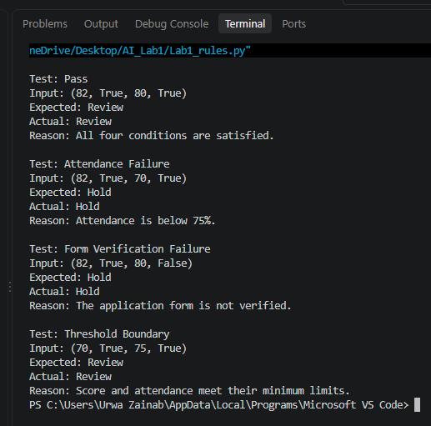
Task 3

Conversational Test and General Intelligence
Conversation test:
This is a test to see if the AI can talk like a human and give natural responses. However, it does not prove the AI has general intelligence as it could be very confident but provide false information. A test called the ‘Turing Test’ was created by Alan Turing in 1950 to test if a machine could mimic human conversation. [Source: https://plato.stanford.edu/entries/turing-test/]
Scholarship example:
In the case of a scholarship the AI may be able to clearly explain why certain people are eligible and provide fluent responses. This however does not guarantee that the AI will accurately check their marks, documents etc. and follow all the rules.
False reasoning example:
“Since the student has high marks they must be eligible.” While this is reasonable to assume it may not be correct as they may not have provided all of the documents.
Testing accuracy:
To ensure the AI can perform reliably we can test it on various scholarship examples where we know what the correct answer is. We can then compare the decisions the AI makes to what we expect to see if they are following the rules accurately.
Conclusion:
The conversation test checks how naturally the AI can talk while the task performance test checks if they can do a particular task correctly. As both tests are useful simply passing a conversation test does not prove it has general intelligence.

