

Artificial Intelligence(Lab)
Lab Report 3
Submitted By:
Syeda Urwa Zainab
SU92-BSSEM-S25-030
BSSE-4A
Submitted To:
Sir Rasikh Ali

TASK 1: BFS AND DFS MANUAL TRACING

1. Objective
The objective of this task is to understand and implement BFS and DFS algorithms using a given graph. We also have to trace the searching process manually and find the path from the starting node to the goal node.

2. Problem Statement
In this task, we are given a graph containing seven nodes from A to G. We have to start searching from node A and find the goal node G using BFS and DFS.
We also have to show the queue and stack states, processed nodes, final path and visiting order.

3. Graph Representation

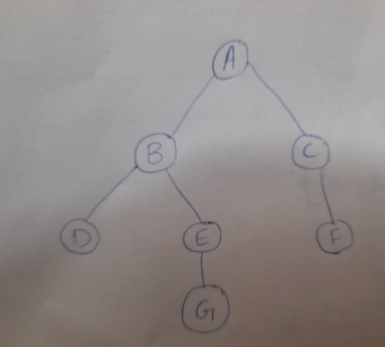
The given graph contains seven nodes: A, B, C, D, E, F and G.
- Starting node: A
- Goal node: G
The connections are:
- A B, C
- B D, E
- C F
- E G

4. Task 1(a): Breadth First Search (BFS)

Introduction
BFS stands for Breadth First Search. It visits nodes level by level. It uses a queue, which follows the First In, First Out (FIFO) method.

Manual Trace of BFS
Step | Processed Node | Queue After Processing
1 | A | B, C
2 | B | C, D, E
3 | C | D, E, F
4 | D | E, F
5 | E | F, G
6 | F | G
7 | G | Empty

BFS Result
Final Path: A B E G
Visit Order: A, B, C, D, E, F, G

5. Task 1(b): Depth First Search (DFS)

Introduction
DFS stands for Depth First Search. It explores one branch deeply before moving to another branch. It uses a stack, which follows the Last In, First Out (LIFO) method.
The neighbours are inserted in reverse order so that the first listed neighbour is visited first.

Manual Trace of DFS
Step | Processed Node | Stack After Processing
1 | A | C, B
2 | B | C, E, D
3 | D | C, E
4 | E | C, G
5 | G | C

DFS Result
Final Path: A B E G
Visit Order: A, B, D, E, G

6. Program Output

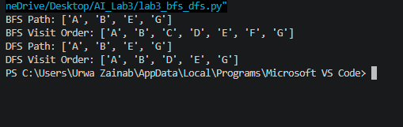

7. Result and Discussion
Both algorithms successfully found the goal node G.
BFS visited all nodes level by level, while DFS explored one branch deeply before moving to another branch.
Both algorithms returned the same final path, but their visiting orders were different.

8. Conclusion
In this task, I learned how BFS and DFS work on a graph. I also learned the difference between a queue and a stack. BFS searches level by level, whereas DFS explores one branch at a time. Both methods successfully found the goal node.

Task 2: Depth Limited Search (DLS) and Iterative Deepening DFS (IDDFS)

1. Objective
The objective of this task is to implement Depth-Limited Search (DLS) and Iterative Deepening Depth-First Search (IDDFS). We test both algorithms with different depth limits and observe how they find the goal node.

2. Problem Statement
In this task, we have a graph with nodes A, B, C, D, E, F and G.
- Starting node: A
- Goal node: G
- We have to find a path from A to G.
- The root node A is counted at depth 0.
The main purpose is to understand how changing the depth limit affects the search.

3. Graph Used
The following graph is used in this task:
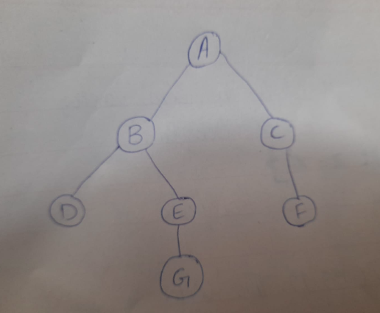
The correct path from the starting node to the goal is:
A B E G
The goal node G is at depth 3.

4. Task 2 Implementation of DLS
Depth Limited Search is similar to Depth-First Search, but it does not go beyond a given depth limit.
In this task, I tested four different limits.

DLS Results
Depth Limit | Result | Path
1 | CUTOFF | Not found
2 | CUTOFF | Not found
3 | FOUND | A B E G
4 | FOUND | A B E G

Explanation
- At limit 1, the goal cannot be reached.
- At limit 2, the goal is still too deep.
- At limit 3, the algorithm reaches G and finds the path.
- At limit 4, it also finds the same path.
CUTOFF means the search stopped because the depth limit was reached while more nodes could still be explored.
FOUND means the goal node was successfully reached.

5. Task 2 Implementation of IDDFS
Iterative Deepening DFS runs DLS again and again with increasing depth limits.
It starts from depth 0 and increases the limit until it finds the goal or reaches the maximum depth.

IDDFS Results
Maximum Depth | Limits Attempted | Result
1 | 0, 1 | Goal not found
2 | 0, 1, 2 | Goal not found
3 | 0, 1, 2, 3 | FOUND
4 | 0, 1, 2, 3 | FOUND
Found Path: A B E G

Explanation
IDDFS repeats the search with a new depth limit each time.
At maximum depth 1 and 2, it cannot reach G because the goal is at depth 3. At maximum depth 3, it successfully finds the goal.
At maximum depth 4, it also finds the goal at depth 3, so it does not need to continue to depth 4.

6. Program Output
The following is the expected output from the final DLS and IDDFS program.
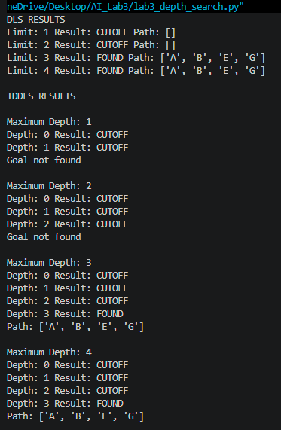
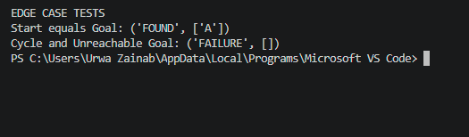

7. Edge Case Testing
I also tested two special cases to check how the program behaves.
Test Case | Input | Result | Explanation
Start equals Goal | Start A, Goal A | FOUND | The goal is already the starting node.
Cycle and unreachable goal | Added F A, Goal X | FAILURE | The goal cannot be reached and the path check prevents going around the cycle forever.

Failure Analysis
In the second test, I added a connection from F back to A and used X as the goal.
The program returned FAILURE because it could not find the goal. The path local cycle check stopped it from visiting a node that was already on the current path.
One possible improvement is to give a clear message when the goal is not found and test the program with more graphs.

8. Comparison of DLS and IDDFS
DLS | IDDFS
Uses one fixed depth limit. | Uses increasing depth limits.
Searches only up to the given limit. | Repeats the search from the beginning.
Does not repeat earlier levels. | Repeats some earlier work.
Result depends on the selected limit. | Can find a deeper goal by increasing the limit.
IDDFS performs some repeated work because it searches the earlier levels again. However, it is useful when we do not know how deep the goal is.

9. Result and Discussion
Both algorithms successfully found the path A B E G when the depth limit was at least 3.
The results show that limits 1 and 2 are not enough to reach the goal. The goal is found at limit 3.
DLS uses a fixed limit, while IDDFS increases the limit step by step. IDDFS repeats some work, but it does not require us to guess the correct depth at the beginning.
The cycle test also showed that the path local check helps prevent repeated visits on the same path.

10. Conclusion
In this task, I implemented and tested DLS and IDDFS on the given graph.
I learned how depth limits work and how IDDFS searches with increasing limits. Both algorithms found the correct path when the depth limit was sufficient.
The edge case tests also helped me understand how the program handles an already reached goal and an unreachable goal.

Task 3: Weighted Graph and Uniform Cost Search (UCS)
Objective:
To implement Uniform Cost Search (UCS) on a weighted graph and compare its result with Breadth First Search (BFS).

1. Introduction
In this task, we used a graph containing seven nodes from A to G. Each edge has a different cost. We implemented BFS and UCS to find a path from A to G.
BFS finds a path with fewer edges, while UCS finds a path with the lowest total cost.

2. Weighted Graph
The following edge weights were used:
Edge | Cost
A → B | 1
A → C | 10
B → D | 5
B → E | 1
C → F | 4
C → G | 2
E → G | 1
An extra corridor C G was added as required by the lab manual.

3. Algorithm Used
Breadth First Search (BFS):
BFS uses a queue and visits nodes level by level. It finds a path with fewer edges.
Uniform Cost Search (UCS):
UCS selects the node having the lowest total path cost. It uses a priority-based queue to find the cheapest path.

4. Implementation
I implemented both BFS and UCS in Python. A dictionary was used to store the graph and its edge costs.
In UCS, the queue was sorted according to the total cost so that the lowest cost node was selected first.

5. Program Output
The following output was obtained after running the program:
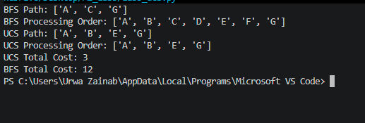

6. Cost Calculation
BFS Path:
A C G
Total Cost = 10 + 2 = 12
UCS Path:
A B E G
Total Cost = 1 + 1 + 1 = 3

7. Comparison Between BFS and UCS
BFS | UCS
Finds fewer edges. | Finds minimum total cost.
Uses a normal queue. | Uses a priority-based queue.
Path: A C G | Path: A B E G
Total cost: 12 | Total cost: 3
UCS selected a path with more edges, but its total cost was lower than BFS.

8. Edge Case Testing
I also considered an unreachable goal by using Z as the goal node.
Since Z does not exist in the graph, the algorithm cannot find a path and returns None.
This test shows how the program handles a goal that cannot be reached.

9. Conclusion
In this task, I learned how to implement BFS and UCS on a weighted graph. BFS found the path with fewer edges, while UCS found the path with the minimum total cost.
BFS returned a cost of 12 whereas UCS returned a cost of 3. This helped me understand the difference between the two search algorithms.

