

Project Name: ServiceSathi.pk
Course: Fundamentals of Software Engineering
Deliverable: Iteration 1 (Sprint 1)

Group Members:
Syeda Faryal Zehra (24L-2556)
Ibrahim Qaiser (24L-2513)
Syeda Ume Abeeha Naqvi (24L-2528)

Class: BDS-4B
Submission Date: 22nd-March-2026

Service Sathi
ServiceSathi.pk is an online service marketplace that connects customers with service providers such as plumbers, cleaners, cooks, and electricians throughout Lahore.
The system includes three main actors: users, sellers, and administrators. Users can browse and book services, sellers can list their services, and administrators manage platform activity. The system is implemented using Flask(python), HTML/CSS, and a SQL database.

Sprint 1
Module Name: User and Service Management Module
Description:
The User and Service Management Module handles the core functionality of the ServiceSathi platform. It allows users and sellers to register and log in to the system. Sellers can add services that are displayed to users. Administrators can access the admin panel to monitor users, sellers, and services. This module establishes the main interaction between users, sellers, and the system.The following features are a part of the sprint 1 of this project.

Sprint Backlog
Tasks | Description
Registration | Allows users and sellers to create accounts
Login System | Authenticates seller and user
Admin Login | Admin access panel
Add Service | Allowing seller to add a service
Service Listing | List of all the services
Seller/User Dashboard | Seller and users profile display
Admin Dashboard | Admin view page
Database Connection | Connect Flask with SQL

User Stories
Story ID: US-01  Story title: User Registration | Priority: High  Estimated Hours: 3
User Story:
As a user, I want to create an account so that I can access the services available on the platform.

Description:

This story involves developing a user registration system where users can enter their personal details, which are validated and stored securely in the database.

Sub User Stories:
• Enter personal details (name, email, password)
• System validates input
• Store user data in database
• Show registration confirmation

Acceptance Criteria:
• Form accepts user data
• Input validation works correctly
• Data stored in database
• Success message displayed

Story ID: US-02  Story title: User Login | Priority: High  Estimated Hours: 2
User Story:
As a user, I want to log in to my account so that I can access my profile and available services.

Description:

Implements authentication to verify credentials and redirect users based on their role.

Sub User Stories:
• Enter email and password
• System verifies credentials
• Identify role (user/seller/admin)
• Redirect to dashboard

Acceptance Criteria:
• Login form works
• Credentials validated
• Role correctly identified
• Proper dashboard redirection

Story ID: US-03  Story title: Seller Registration | Priority: High  Estimated Hours: 2
User Story:
As a seller, I want to register my account so that I can offer my services to customers.

Description:
Allows sellers to register using business and personal details which are validated and stored.

Sub User Stories:
• Open seller registration page
• Enter business & personal details
• Validate input
• Store seller data

Acceptance Criteria:
• Registration form accessible
• Input validation works
• Data stored in database
• Confirmation shown

Story ID: US-04  Story title: Seller Login | Priority: High  Estimated Hours: 2
User Story:
As a seller, I want to log in to my account so that I can manage my services.

Description:
As a seller, I want to log in to my account so that I can manage my services.

Sub User Stories:
• Enter email & password
• Select seller role
• Verify credentials
• Redirect to dashboard

Acceptance Criteria:
• Login form available
• Credentials validated
• Role identified correctly
• Redirect works

Story ID: US-05  Story title: Admin Login | Priority: High  Estimated Hours: 3
User Story:
As an admin, I want to log in to the admin panel so that I can manage users, sellers, and services.

Description:
Enables admin authentication and access to administrative controls.

Sub User Stories:
• Enter admin credentials
• Select admin role
• Verify credentials
• Access admin dashboard

Acceptance Criteria:
• Admin login works
• Credentials verified
• Role correctly identified
• Panel access granted

Story ID: US-06  Story title: Add Service | Priority: High  Estimated Hours: 2
User Story:
As a seller, I want to add my services to the platform so that customers can view and request them.

Description:
Allows sellers to create and publish services with relevant details.

Sub User Stories:
• Login as seller
• Enter service details
• Validate input
• Store service in database

Acceptance Criteria:
• Form accessible
• Data validated
• Service stored
• Appears in listings

Story ID: US-07  Story title: Service Listing | Priority: High  Estimated Hours: 2
User Story:
As a user, I want to view available services so that I can choose a suitable provider.

Description:
Displays services from the database in a structured format for users and sellers.

Sub User Stories:
• Retrieve services from database
• Display on listing page
• View provider details

Acceptance Criteria:
• Services fetched correctly
• UI displays services properly
• User can view details

Story ID: US-08  Story title: Seller/User Dashboard | Priority: High  Estimated Hours: 3
User Story:
As a user or seller, I want to access my dashboard so that I can view and manage my profile and activities.

Description:
Allows users to view their profile and activities, while sellers can manage their services and related information.

Sub User Stories:
• View profile information
• View and manage my services
• Get activity details (viewed/booked services)

Acceptance Criteria:
• Display user/seller information
• Sellers should be able to view their added services.
• Users should be able to view their activity.
• Dashboard should load correctly after login.

Story ID: US-9  Story title: Admin Dashboard | Priority: High  Estimated Hours: 1
User Story:
As an admin, I want to access the dashboard so that I can monitor and manage users, sellers, and services.

Description:
Allows administrators to view platform data including users, sellers, and services.

Sub User Stories:
• View profile information of all users and sellers
• View all services
• Monitor system activity

Acceptance Criteria:
• Display users, sellers, and services
• Data should be fetched correctly from the database.
• Admin should have a clear overview of platform activity.
• Dashboard should be accessible only to admin users.

Structured Specifications

US-01: User Registration
Actor: User
Description:
This functionality allows a new user to create an account on the ServiceSathi platform so they can access and book services.
Input:
- Name
- Email
- Password
- Username
- Cnic
- Address
- Date of birth
Process:
- User opens the registration page.
- User enters personal information including name, email, and password.
- System validates the entered information (checks for empty fields and correct email format).
- System checks whether the email already exists in the database.
- If validation is successful, the system shows confirmation and stores the user information in the database.
Output
User account is successfully created and confirmation is displayed.

Sub-User Stories
1. Enter Personal Details
- Input: Name, Email, Password,Username, Cnic, Address, Date of birth

- Process: User fills registration form
- Output: Data submitted
2. Validate Input
- Input: Entered data
- Process: Check format, empty fields, password rules
- Output: Valid/Invalid response
3. Store User Data
- Input: Valid data
- Process: Insert into database
- Output: User record created
4. Show Confirmation
- Input: Successful registration
- Process: Generate response
- Output: Success message

US-02: User Login
Actor: User
Description:
This functionality allows an existing user to log into the system and access their dashboard.
Input:
- Email
- Password
- Selected Role (User/Seller/Admin)
Process:
- User opens the login page.
- User enters email and password.
- User selects the login role.
- System retrieves user data from the database.
- System verifies whether the entered credentials match the stored credentials.
- If credentials are correct, the system redirects the user to the appropriate dashboard.
Output:
User is successfully logged into the system and redirected to their dashboard.
Sub-User Stories
1. Enter Credentials
- Input: Email, Password, Role
- Process: Submit form
- Output: Data sent
2. Verify Credentials
- Input: Login data
- Process: Match with database
- Output: Success/Failure
3. Identify Role
- Input: User record
- Process: Check role
- Output: Role identified
4. Redirect User
- Input: Role
- Process: Routing logic
- Output: Dashboard opened

US-03: Seller Registration
Actor: Seller
Description:
This functionality allows a new seller to create an account on the ServiceSathi platform so they can access and book services.
Input:
- Name
- Email
- Password
- Username
- Cnic
- Address
- Date of birth
- Professional Bio
Process:
- Seller opens the registration page.
- Seller enters personal information including name, email, and password.
- System validates the entered information (checks for empty fields and correct email format).
- System checks whether the email already exists in the database.
- If validation is successful, the system shows confirmation and stores the seller information in the database.
Output
Seller account is successfully created and confirmation is displayed.
Sub-User Stories
1. Open Registration Page
- Input: User action
- Process: Navigate to page
- Output: Form displayed
2. Enter Business Details
- Input: Personal + Professional info
- Process: Fill form
- Output: Data submitted
3. Validate Seller Data
- Input: Entered data
- Process: Validation checks
- Output: Valid/Invalid
4. Store Seller Data
- Input: Valid data
- Process: Save in database
- Output: Seller account created

US-04: Seller Login
Actor: Seller
Description:
This functionality allows an existing seller to log into the system and access their dashboard.
Input:
- Email
- Password
- Selected Role (User/Seller/Admin)
Process:
- Seller opens the login page.
- Seller enters email and password.
- Seller selects the login role.
- System retrieves seller data from the database.
- System verifies whether the entered credentials match the stored credentials.
- If credentials are correct, the system redirects the seller to the appropriate dashboard.
Output:
Seller is successfully logged into the system and redirected to their dashboard.
Sub-User Stories
1. Enter Credentials
- Input: Email, Password
- Process: Submit form
- Output: Data sent
2. Select Role
- Input: Seller role
- Process: Role selection
- Output: Role passed
3. Verify Credentials
- Input: Credentials
- Process: Match database
- Output: Success/Failure
4. Redirect to Dashboard
- Input: Valid seller
- Process: Redirect
- Output: Seller dashboard

US-05: Add Service
Actor: Seller
Description:
This functionality allows a seller to add services that will be displayed to customers on the platform.
Input:
- Service Name
- Service Description
- Price per hour
- Category
Process:
- Seller logs into the system.
- Seller opens the Add Service page.
- Seller enters service details such as service name, description, and price.
- System validates the entered information.
- System stores the service information in the database.
- System updates the service listing page.
Output:
Service is successfully added and becomes visible in the service listing.
Sub-User Stories
1. Login as Seller
Input: Seller credentials
Process: Authentication
Output: Access granted
2. Enter Service Details
Input: Service info
Process: Fill form
Output: Data submitted
3. Validate Service Data
Input: Service details
Process: Validation
Output: Valid/Invalid
4. Store Service
Input: Valid data
Process: Save to database
Output: Service available
US-06: Services Listing
Actor: User,Seller
Description:
This functionality allows users and sellers to browse and view all available services listed by sellers but only users can book.
Input:
- User request to view services.
Process:
- The user opens the services listing page.
- The system sends a request to the database to retrieve all available services.
The system collects service details including service name, description, price, and seller information.
- The system displays the retrieved services on the webpage.
Output:
User and sellers can view the list of available services along with their details.
Sub-User Stories
1. Retrieve Services
- Input: Request
- Process: Query database
- Output: Service list
2. Display Services
- Input: Service data
- Process: Render UI
- Output: Services visible
3. View Provider Details
- Input: Selected service
- Process: Fetch details
- Output: Provider info displayed

US-08: Seller/User Dashboard
Actor: User, Seller

Description:
This functionality allows users and sellers to access their personalized dashboard where they can view profile information and manage their activities and services.

Input:
- User/Seller login request
- session data

Process:
1. The user/seller logs into the system.
2.The system verifies the credentials and identifies the role (user or seller).
3. The system retrieves user/seller profile information from the database.
4. For sellers, the system retrieves the list of services added by them.
5. For users, the system retrieves their activity data.
6.The system displays the dashboard with relevant information.

Output:
User/Seller can view their dashboard with profile details and relevant activities/services.
Sub-User Stories

1. View Profile Information
Input: User/Seller session
Process: Fetch profile data from database
Output: Profile information displayed

2. Manage Seller Services
Input: Seller request
Process: Retrieve seller services
Output: List of seller services displayed

3. View User Activity
Input: User request
Process: Retrieve activity data
Output: User activity displayed

US-9: Admin Dashboard
Actor: Admin

Description:
This functionality allows the admin to access a centralized dashboard to monitor and manage users, sellers, and services on the platform.

Input:
- Admin login request
- session data

Process:
1. The admin logs into the system.
2.The system verifies admin credentials.
3. The system retrieves all users from the database.
4.The system retrieves all sellers from the database.
5. The system retrieves all services from the database.
6. The system displays all retrieved data in the admin dashboard.

Output:
Admin can view and monitor users, sellers, and services through the dashboard.

Sub-User Stories

1. View All Users/Sellers
Input: Admin request
Process: Query database for users/sellers
Output: List of users/sellers displayed

3. View All Services
Input: Admin request
Process: Query database for services
Output: List of services displayed

4. Monitor System Activity
Input: Admin request
Process: Retrieve system data
Output: System activity displayed

Scrum Board
1.
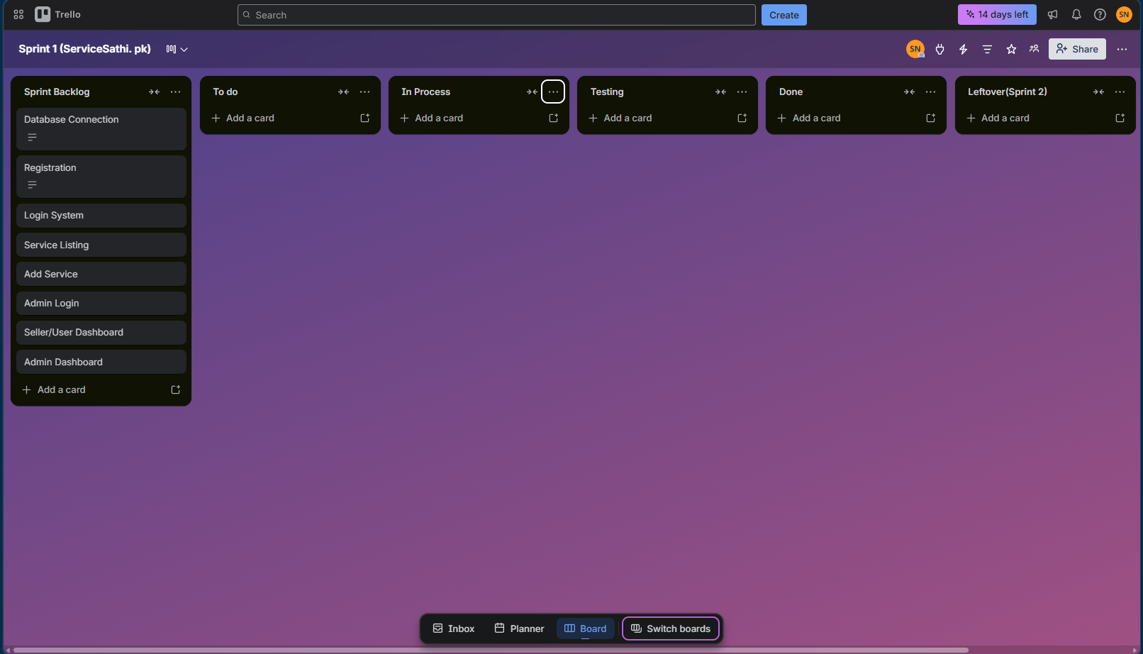
2.
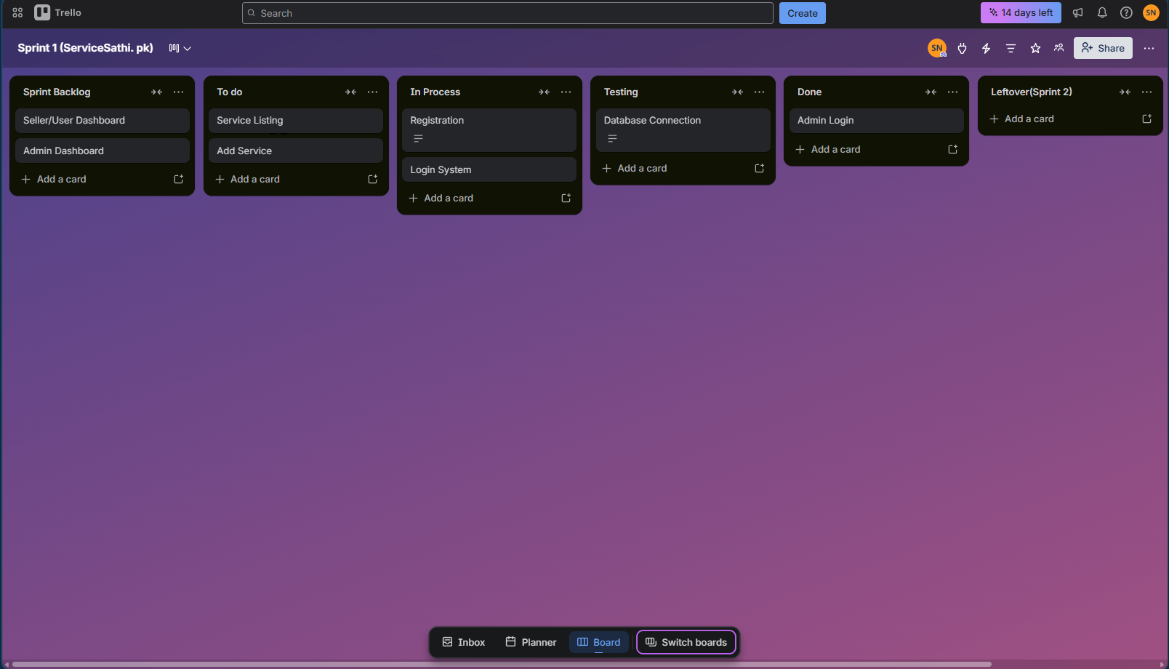
3.
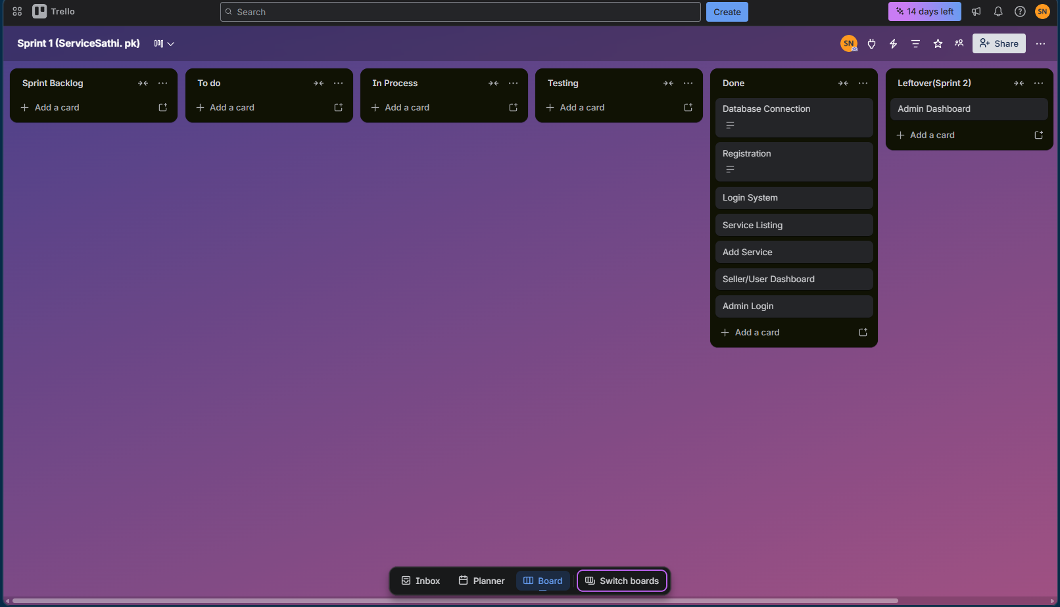

Product Burn Down Chart

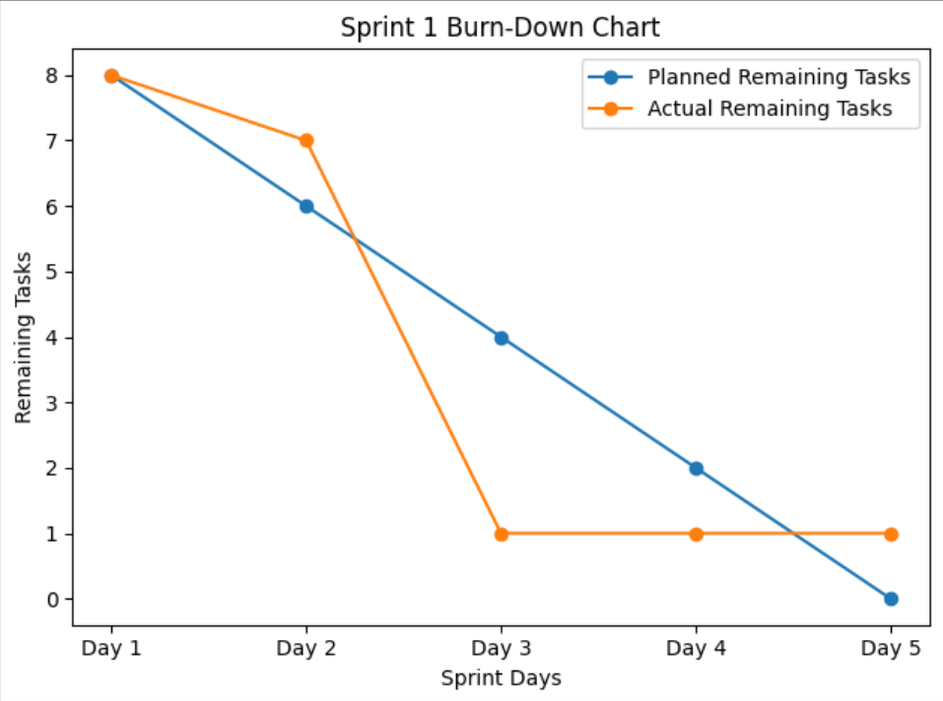

Non-Functional Requirements (NFRs)

1. Performance
The system should provide smooth and efficient performance during normal usage. Pages such as service listings, dashboards, and login should load within 2 seconds under standard conditions. The system must handle at least 100 concurrent users without significant slowdowns. Database queries for fetching services and user data should execute quickly to ensure seamless browsing and booking experience.

2. Usability
The platform should be simple and intuitive for users, sellers, and administrators. A new user should be able to register, log in, and view services within 5 minutes without guidance. The interface should provide clear navigation, readable text, and structured layouts. Error messages (e.g., invalid login, missing fields) should be clear and user-friendly.

3. Scalability
The system should support growth in users, services, and transactions. It must efficiently handle at least 100+ services and 50+ active users without performance degradation. The database and backend should be designed in a way that allows future expansion, such as adding online payments, reviews, or additional service categories.

4. Reliability
The system should operate consistently with minimal failures. It should not crash more than once in 10 hours of continuous usage under normal conditions. User data, service listings, and login sessions must remain stable. In case of server or system failure, the system should recover without losing critical data.

5. Responsiveness
All user interactions should feel fast and smooth. Actions such as clicking buttons, loading dashboards, searching services, and submitting forms should respond within 1 second. Navigation between pages should be seamless, ensuring a good user experience even with moderate load.

6. Compatibility
The system should work consistently across different platforms and devices. It must fully support modern web browsers such as Google Chrome, Microsoft Edge, and Mozilla Firefox. The application should be accessible on both desktop and mobile devices with a responsive design. The system should run smoothly on Windows and Linux environments where the Flask server is deployed.
Implementation
1.login
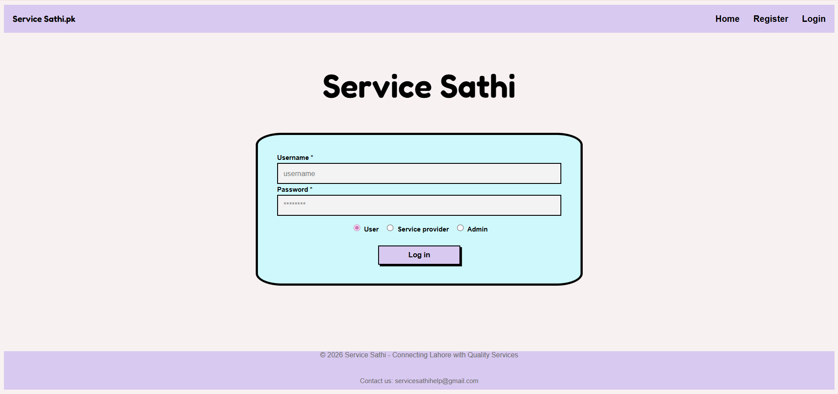
2.registeration
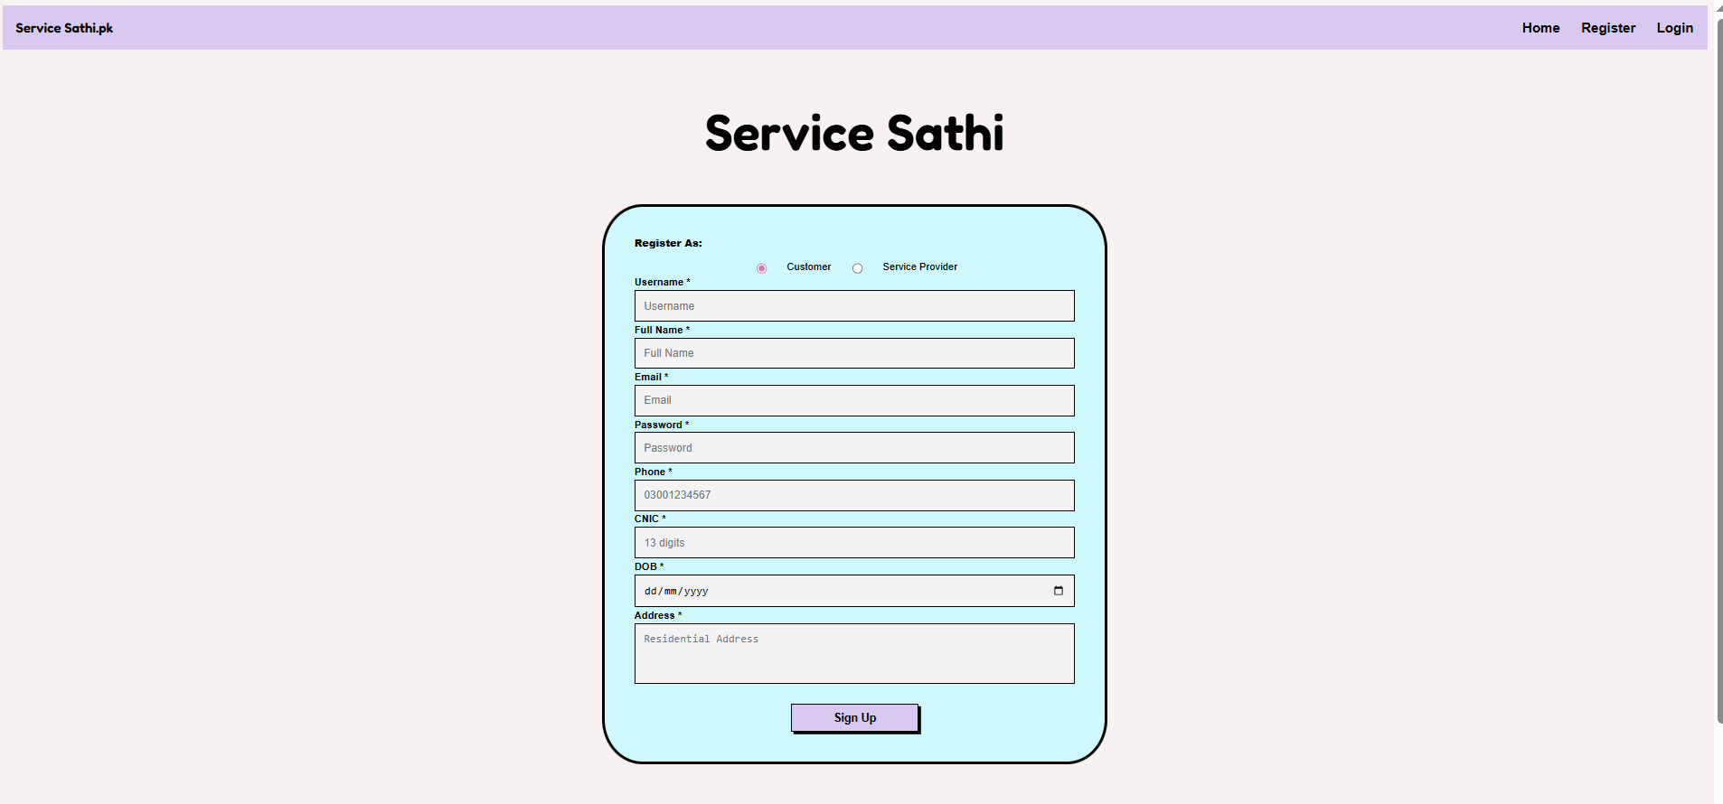
3.Admin panel
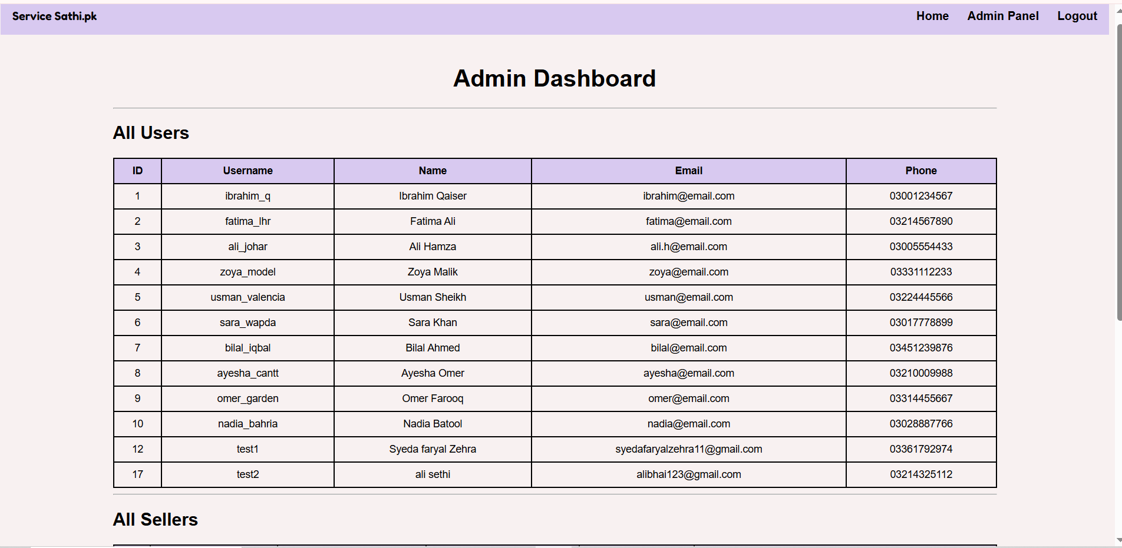
4.Add service
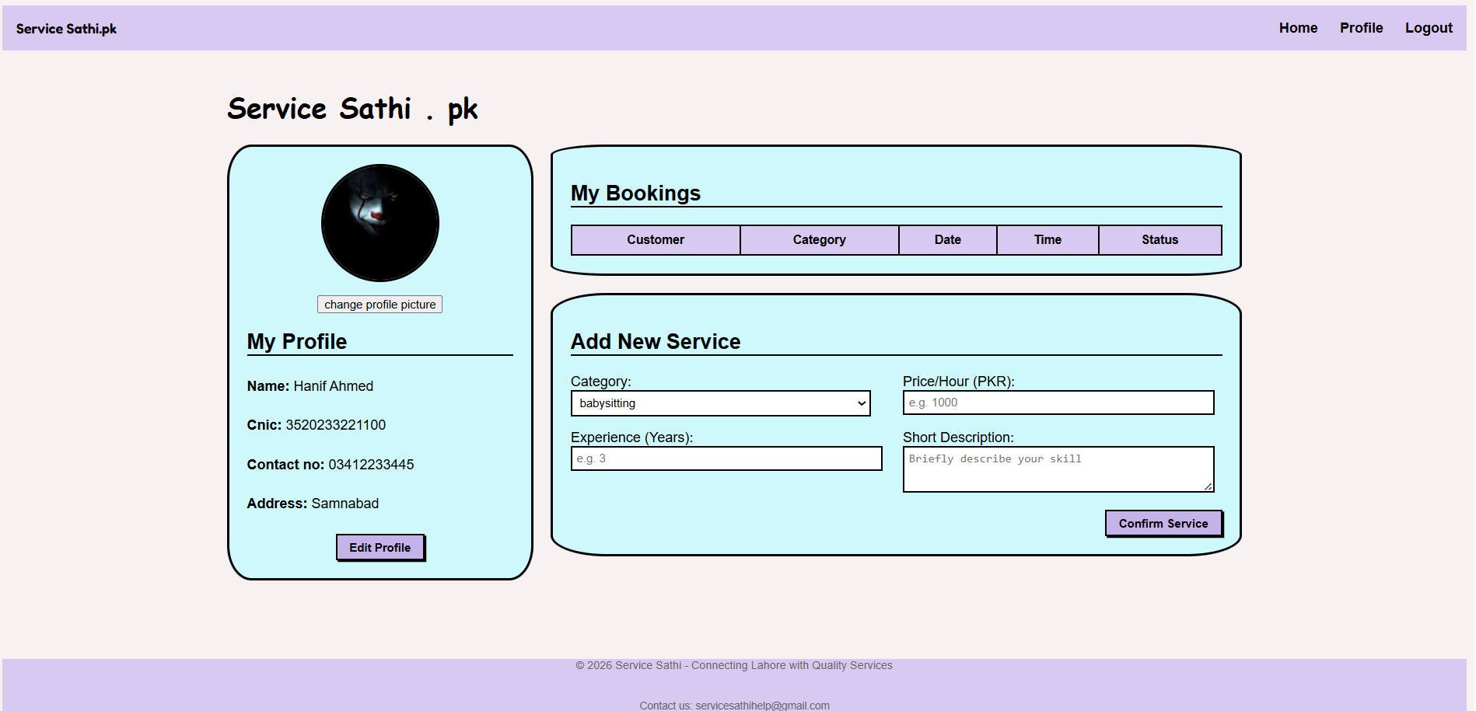
5.Homepage
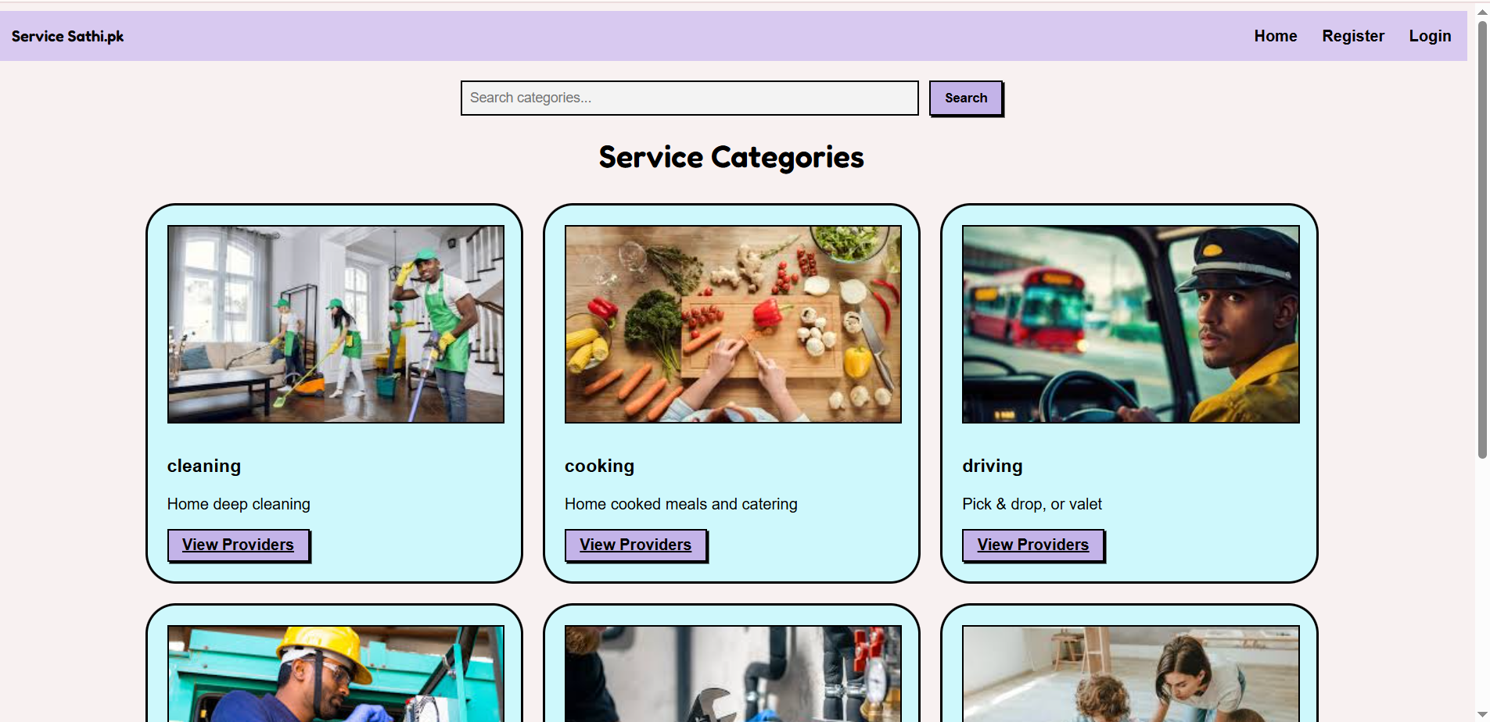
6.Viewservices
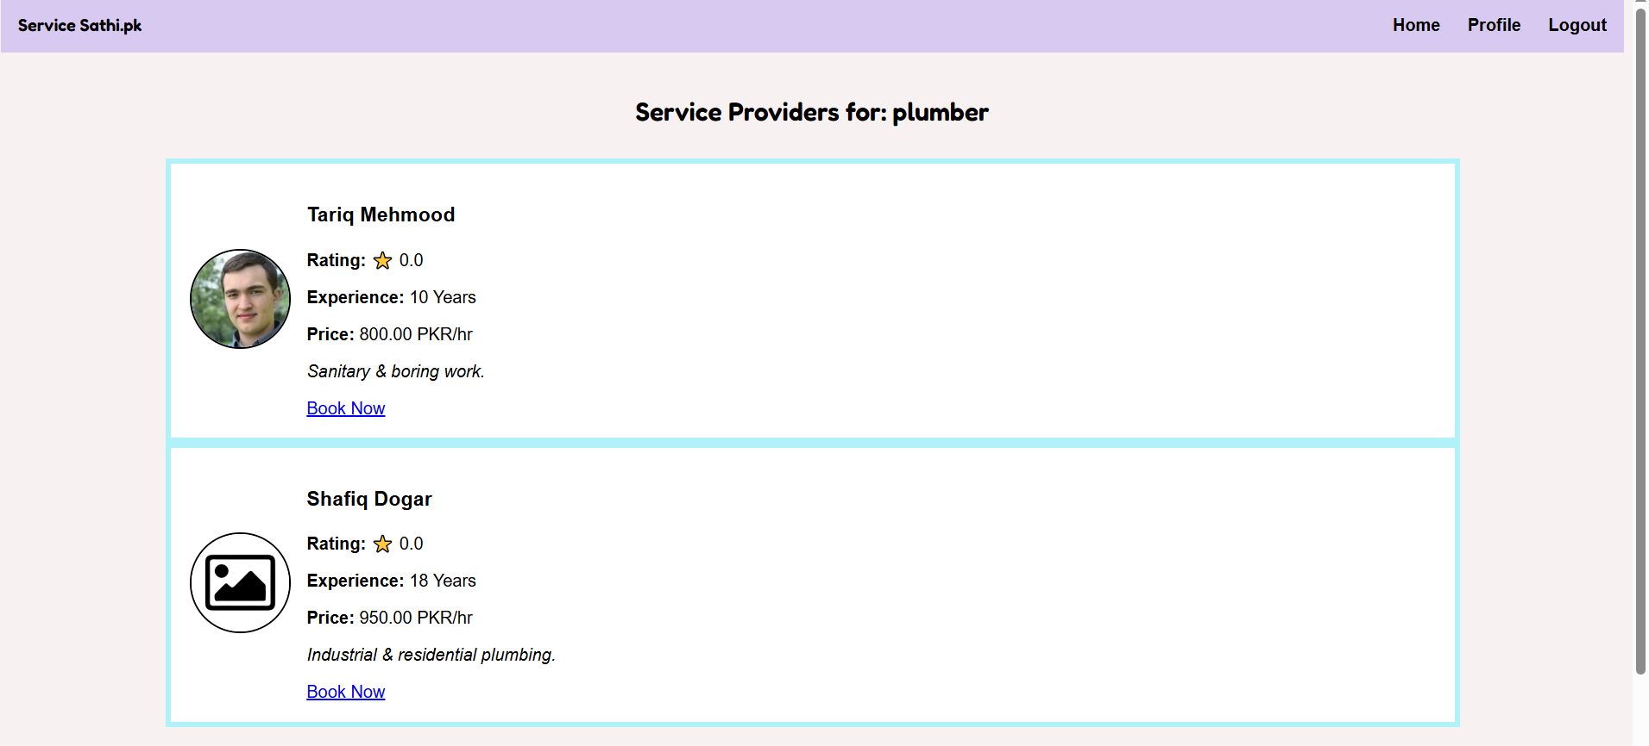
7. User Dashboard
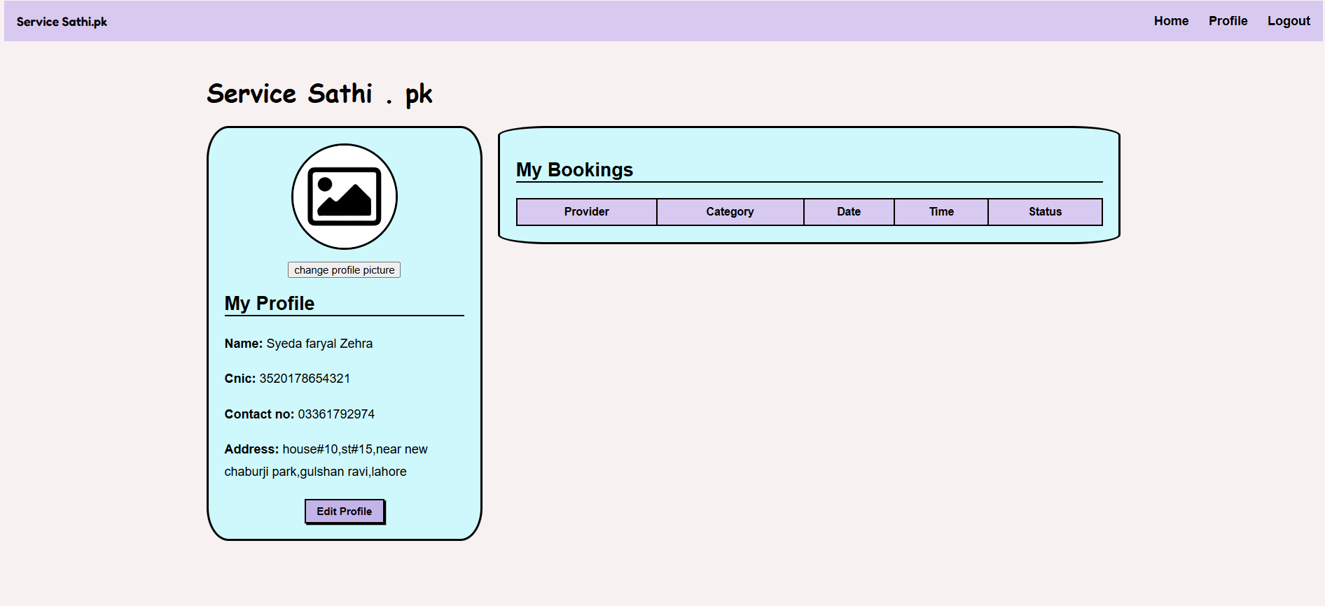

Work distribution

Team members | Tasks
Syeda Faryal Zehra | UI design, Documentation,  Trello management, Burn-down chart
Ibrahim Qaiser | Flask backend, Login authentication, Database queries, API integration
Syeda Ume Abeeha Naqvi | Database setup, Service logic, Testing, User stories, Take screenshots

